Terms of Reference
Integrated Public Health Rapid Assessment (IPHRA)
TBD
20693
Version:

Table of Contents
Right-click and update field to generate table of contents.
List of Figures
Right-click and update field to generate table of figures.
List of Tables
Right-click and update field to generate table of tables.

1. Executive Summary
Country of intervention | Type of Emergency | Type of Crisis | Mandating Body/ Agency | IMPACT Project Code
TBD |  |  | Example Agency
Geographic Coverage | Population(s) | Stratification
 |  | [Specify stratification, e.g. by geographic area, population group, etc.]
Rationale

1.1 Tools and Methods
Tool | Sampling.Method | Sample.Size
 |  | 0

1.2 Research Timeline
No timeline milestones available.

1.3 Dissemination
Audience Type | Expected Output Type | Dissemination Strategy | Access | Visibility
Cluster(s)
Donor(s)
Operational Actor(s)
Other(s)

2. Rationale
 Note
Drafter Note: Complete sections 2.1 and 2.2 to clearly explain the context in which the assessment would be conducted, key information needs, and the intended impact of the assessment.
- Background This section should minimally include: ** What is the type of crisis and type of emergency setting the context for the assessment. ** For how long has the population been affected? ** What is the size and displacement status of the population? ** What information is known about severity and service coverage? This may include most recent current and projected IPC classifications, JIAF severity, sectoral People in Need, or other prioritization frameworks. This may include information on current FSL, WASH, Health, or Nutrition service providers from HERAMS, 4Ws or other available sources. ** What information gaps on severity or service coverage are not known?
- Intended Impact This should should minimally include: ** ‘In order to fill these information gaps, REACH will conduct an IPHRA from XX/XX/XXXX to XX/XX/XXXX…’ ** Describe who the key stakeholders you will inform with the assessment are: Clusters, Operational Partners, etc.and what decisions you aim to inform.
Reviewer Note: Please ensure the above minimum information is included in the text.
DELETE THIS NOTE BEFORE SUBMITTING DOCUMENT

2.1 Background
 Note
Reviewer Note: Complete section 2.1 with no more than 2-3 paragraphs.
- Background This section should minimally include: ** What is the type of crisis and type of emergency setting the context for the assessment. ** For how long has the population been affected? ** What is the size and displacement status of the population? ** What information is known about severity and service coverage? This may include most recent current and projected IPC classifications, JIAF severity, sectoral People in Need, or other prioritization frameworks. This may include information on current FSL, WASH, Health, or Nutrition service providers from HERAMS, 4Ws or other available sources. ** What information gaps on severity or service coverage are not known?
DELETE THIS NOTE BEFORE SUBMITTING DOCUMENT

2.2 Intended Impact
 Note
Reviewer Note: Complete section 2.2 with no more than 1-2 paragraphs.
- Intended Impact This should should minimally include: ** ‘In order to fill these information gaps, REACH will conduct an IPHRA from XX/XX/XXXX to XX/XX/XXXX…’ ** Describe who the key stakeholders you will inform with the assessment are: Clusters, Operational Partners, etc.and what decisions you aim to inform.
DELETE THIS NOTE BEFORE SUBMITTING DOCUMENT

- Who are the key actors/ what are the key decision-making processes and milestones this research aims to inform?
- What would be the impact of this research be on at least one of the following: (1) Bringing about positive change in the day-to-day lives of the population of interest (2) Improving understanding of the current situation to inform ongoing or planned humanitarian interventions (3) Improving understanding of the current situation to inform strategic decision-making processes, including funding allocations (4) Contributing towards system-wide change

3. Goals and Objectives
 Note
Drafter Note: The primary goal for IPHRAs is standard and should not be changed. All IPHRAs should be focused on evaluating severity of the situation and identifying service gaps for affected populations. If the intention of the IPHRA is to inform an ANA analysis, then the secondary goal should be added as well.
The specific research objectives and questions in section 3.1 are based on indicators present in selected tools. If indicators are added or removed from data collection tools, these can be objectives and questions should be revised accordingly.
Reviewer Note: Please ensure the overall goals are aligned with standard IPHRA goals.
DELETE THIS NOTE BEFORE SUBMITTING DOCUMENT

Primary Goal: To assess the severity of the public health outcomes and identify initial public health priorities for response to mitigate excess morbidity, malnutrition, and mortality.
The below table summarizes the specific research objectives and questions for this assessment, based on the various pillars and sub-pillars of the ANA Framework.

3.1 Specific Objectives and Research Questions
Table 1
Table 1. Specific objectives and research questions
Pillar | Sub.Pillar | Objective | Research.Question

4. Methodology
 Note
Drafter Note: The methodology section should be pre-populated based on the user’s entry for sample size calculations, key indicators, and strata included. Please review for accuracy with your assessment’s intended methods. Please check specifically that: * Planned sampling approaches are correctly matched and described for each sample stratum in sections 4.1 and 4.5. * Secondary data review is properly recorded and matches intended uses. * Key definitions capture household definition and any other key indicators planned for the assessment. * Sample size calculations have appropriate sources and justifications added. * Any context specific limitations, such as access constraints or timing, are noted in section 4.7
Reviewer Note: Please ensure the above criteria are included in the appropriate sections.
DELETE THIS NOTE BEFORE SUBMITTING DOCUMENT

The general research design for the Integrated Public Health Rapid Assessment (IPHRA) (1) will consist of a mixed-methods approach constituting three main methods: household surveys; Key Informant Interviews (KIIs); and observation checklists, each of these methods having core and supplemental specialized tools and information that can be collected.

4.1 Methodology Overview
PLEASE SPECIFY METHODOLOGY HERE.

4.2 Population of Interest
 Minimal requirements in describing the population
Drafter Note: Please ensure your population description follows recommendations from the CE-DAT Completeness Checklist Guidelines (2) below: * The type of population assessed (e.g. refugee, IDP, host, livelihood group, etc.) * The geographic area assessed, with clearly defined bounds defining the sampling frame (e.g. the admin2 or group of camps being assessed) * Any areas that are excluded from sampling and the reason that area was excluded (e.g. insecurity) * Ideally a map could be included in this section, if capacity allows.
If geographic coverage, and
Reviewer Note: Please ensure the above criteria are included in the text.
DELETE THIS NOTE BEFORE SUBMITTING TO REPOSITORY

The geographic coverage of the assessment includes: . The total population consists of 10000 people with approximately 8000 people included in the survey and approximately 2000 people excluded from the survey.

4.3 Secondary Data Review
 Note
Drafter Note: Integrated public health assessments recognize that excess morbidity, malnutrition, and mortality are driven by a number of factors across multiple sectors including Food Security and Livelihoods, WASH, Health, Nutrition, and more. In order to ensure a holistic and comprehensive understanding of public health priorities in the population, it’s important to capture a variety of information across these sectors at different levels (individual, household, community).
It is recommended to first map out available secondary data sources that match these dimensions and identify what information gaps exist, then plan the primary objectives of your assessment based on what information is still needed. This will ensure we do not collect unnecessary information in the IPHRA, and can keep the tools lighter and easier to implement.
Reviewer Note: Please confirm that: * The below figure matches your intended primary objectives. * The secondary data sources listed in the table below are still recent and applicable, and match the stated ANA framework pillars and sub-pillars.
DELETE THIS NOTE BEFORE SUBMITTING TO REPOSITORY

The main assessment design is based off guidance documents and tools for Integrated Public Health Rapid Assessment (IPHRA), available on the IMPACT Intranet (soon, link to intranet). Secondly, the IPHRA toolkit is designed to align with the Acute Needs Framework (ANF) utilized by IMPACT Initiatives in their Acute Needs Analysis workstreams (3). The intention of the Secondary Data Review step is to identify existing data sources for various ANF Pillars and Sub-Pillars, and to identify data gaps which will inform the design of the primary data collection component of the IPHRA. The below figure illustrates the ANF framework and how it maps against the planned primary data collection, as well as secondary data sources planned to be utilized for this assessment.
Figure: Acute Needs Framework (ANF) and Data Collection Mapping
**Figure 1. Acute Needs Framework (ANF) and Data Collection Mapping**
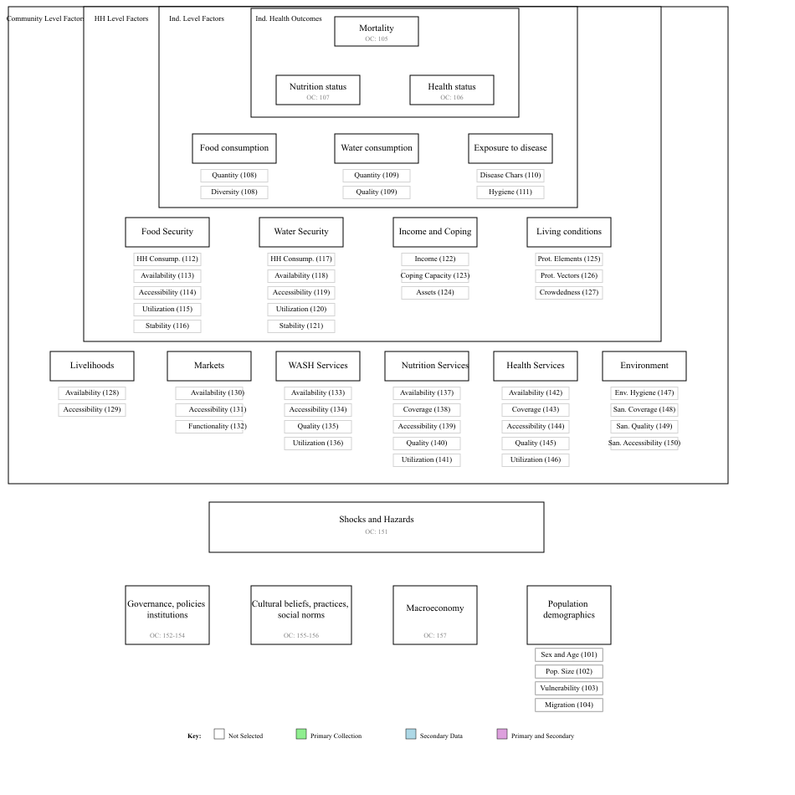
The below table cites relevant secondary data sources for each of the ANF Pillars and Sub-Pillars, as well as the purpose for which each data source will be utilized in the assessment.
Table 2. Secondary Data Sources
Objective | Source | Purpose

4.4 Key Definitions
 Note
Drafter Note: Please ensure that key definitions reflect the working definitions for the household, population groups of interest (such as IDP or other displacement status) in the assessment, or key standardized indicators. Most globally standardized indicators in the IPHRA should be automatically included, but if other standard indicators are included they should be added manually.
Reviewer Note: Please confirm that: * The household definition is appropriate. * If different population groups are included in the assessment, each has a clear definition. * Any key standard indicator have definitions included.
DELETE THIS NOTE BEFORE SUBMITTING TO REPOSITORY

Within this population, specific indicators will target sub-populations. All eligible sub-populations within sampled households will be included in the survey. Sub-populations for indicators include:
- Household Definition: A group of people who ate from the same cooking and slept under the same roof the previous night

4.5 Primary Data Collection

4.5.0.1 Sample Size Calculations
Household sample size calculations were done in R version 4.6.1 (2026-06-24 ucrt) and made using a 95% confidence level and the following sampling parameters summarized in the table below, resulting in a final target sample size of 400 households.
The sample size for the general household survey was calculated using the parameters in the table below:
 Sample Size Parameter Justifications
Reviewer Note: Please add justifications to the sample size tables to explain why each parameter was selected for sampling. Where possible, cite sources from previous surveys from the same or similar population. Refer to the IPHRA Technical Guidance manual for assumptions when limited information exists.
DELETE THIS NOTE BEFORE SUBMITTING DOCUMENT

Table 3. General sample size calculation parameters
Parameter | Value | Justification
Indicator Name
Sampling Design
Estimated Prevalence (%)
Desired Precision
Estimated population size
Design Effect
Finite Population Correction (FPC) used?
Non-Response Rate
Households to be Included

4.5.0.2 Site Selection Methods

4.5.0.3 Household Selection Methods

4.5.0.4 Team Composition, Training and Planning
The exact composition of teams will depend on the number of tools being implemented. For household surveys, teams will consist of one field supervisor and 3 enumerators. Where possible, teams should incorporate a mix of male and female enumerators. For key informant and observational tools, dedicated enumerators separate from the household survey enumerators will be selected and trained to implement them. One enumerator should not implement more than one or two specific tools to ensure adequate time for use in the field and data quality.
Teams will receive a base three-day training prior to data collection covering purpose of the survey, good interview practices and ethical conduct during public health assessment, field sampling procedures, and review of the survey, key informant and observational tools, and a one-day for pilot and planning activities. It is recommended to divide the team for separate tool review sessions to efficiently make use of training time.
Field supervisors will have a key role in ensuring research quality during data collection. Key responsibilities will include:
- Providing daily feedback sessions to the data collection team
- Monitoring completion of assessment against planned targets
- Completing cluster control forms
- Ensuring proper household sampling techniques are applied
- Providing supportive supervision to enumerators

4.6 Data Processing and Analysis
Template data collection tools with Kobo have been adapted for this assessment. Both quantitative and qualitative data will be collected using KoboCollect on Android devices and uploaded to a Kobo server.
Table 4. Example Integrated Analysis Table
Category | Pillar | Sub-Pillar | Group 1 | Group 2 | Group 3
Health Outcomes  (Individual Level) | Population Mortality | NA | High | Medium | Low
 | Nutritional Status | NA | Medium | High | Medium
 | Health Needs | NA | Low | Medium | High
Immediate Drivers  (Individual Level) | Food Consumption | Quantity | Medium | High | Medium
 |  | Quality | High | Medium | Low
 | Water Consumption | Quantity | Medium | Low | High
 |  | Quality | Low | Medium | Medium
 | Exposure to Disease | Reproductive Numbers | High | Medium | Low
 |  | Hygiene | Not assessed | Not assessed | Not assessed
Direct Contributing Factors  (Household Level) | Household Food Security | HH Food Consumption | Medium | High | Low
 |  | Availability | High | Medium | Medium
 |  | Accessibility | High | Low | High
 |  | Utilization | Medium | Medium | High
 |  | Stability | Low | High | Medium
 | Household Water Security | HH Water Consumption | Medium | High | Low
 |  | Availability | High | Medium | Medium
 |  | Accessibility | Medium | Low | High
 |  | Utilization | Low | Medium | Medium
 |  | Stability | Not assessed | High | Low
 | HH Income and Coping | Income | Not assessed | Not assessed | Not assessed
 |  | Coping Capacity | Medium | Low | High
 |  | Assets | Low | Medium | Medium
 | Living Conditions | Protection from Elements | Medium | High | Low
Indirect Contributing Factors  (Community Level) |  | Protection from Vectors | High | Medium | Medium
 |  | Crowdedness | Medium | Low | High
 | Livelihoods | Availability | Low | Medium | High
 |  | Accessibility | Medium | High | Medium
 | Markets | Availability | High | Medium | Low
 |  | Accessibility | Medium | High | Medium
 |  | Functionality | Low | Medium | High
 | WASH Services | Availability | Medium | Low | High
 |  | Accessibility | High | Medium | Medium
 |  | Quality | Medium | High | Low
 |  | Utilization | Low | Medium | Medium
 | Nutrition Services | Coverage | Not assessed | High | Low
 |  | Availability | Medium | Low | High
 |  | Accessibility | High | Medium | Medium
 |  | Quality | Medium | High | Low
 |  | Utilization | Low | Medium | Medium
 | Health Services | Coverage | High | Not assessed | Medium
 |  | Availability | Medium | High | Low
 |  | Accessibility | Low | Medium | High

4.7 Limitations
The IPHRA methodology is intended to be a rapid assessment toolkit to provide an indication of the most key public health outcomes and service coverage indicators compared to other more robust methods. Given the suggested IPHRA methods, there are a few limitations to keep in mind:
- Not a Causal Analysis – The intent of the IPHRA methods is to understand the severity of public health needs and service gaps, however given this focus it may not fully explain the reasons or causes of the results. Some analysis and triangulation with qualitative components may given an indication, but it will likely be limited.
- Likely Not Reaching Saturation – For the qualitative components, sample sizes are likely not adequate to reach a full saturation of responses in the population. The intent of these is to provide some light-touch information to triangulate with household survey results.
- Accessibility – IPHRA is not a hard-to-reach methodology, and should only be applied to populations which the assessment team can physically access.
- The sampling approach is not a cluster design and is intended for a more localized population, therefore the results may not be generalizable and representative of the wider population.

5. Key Ethical Considerations and Related Risks
 Note
Drafter Note: For any ethical consideration that is not met below, please specify any mitigation strategies and liaise with the Research Quality Unit (RQA).
Reviewer Note: Please ensure all proposed ethical considerations and mitigation strategies are aligned with IMPACT RQA standards.

The proposed research design meets / does not meet the following criteria:
Table 5. Ethical Considerations and Risks
The proposed research design... | Yes/No | Details if no (including mitigation)
... Has been coordinated with relevant stakeholders to avoid unnecessary duplication of data collection efforts?
... Respects respondents, their rights and dignity (specifically by: seeking informed consent, designing length of survey/discussion while being considerate of participants’ time, ensuring accurate reporting of information provided)?
... Does not expose data collectors to any risks as a direct result of participation in data collection?
... Does not expose respondents / their communities to any risks as a direct result of participation in data collection?
... Does not involve data collection with minors i.e. anyone less than 18 years old?
... Does not involve data collection with other vulnerable groups e.g. persons with disabilities, victims/survivors of protection incidents, etc.?
... Follows IMPACT SOPs for management of personally identifiable information?
... will assessment teams be aware of basic complaints and referral mechanisms in case needed during the course of the assessment?

6. Roles and Responsibilities
 Note
Drafter Note: Please review the RACI Matrix and revise as needed on agreement with relevant country and HQ teams.
Reviewer Note: Please ensure the RACI is aligned with Traffic Light Review (TLR) or other program support guidance.

Table 6. RACI Matrix
Task Description | Responsible | Accountable | Consulted | Informed
Research design | Assessment Officer | Research Manager | IMPACT STU | IMPACT RQA
Supervising data collection | Field Officer | Assessment Officer | Research Manager | Country Representative
Data processing (checking, cleaning) | Data Officer | Assessment Officer | IMPACT STU | IMPACT RQA
Data analysis | Data Officer | IMPACT RQA | IMPACT STU | Assessment Officer
Output production | Assessment Officer | IMPACT RQA | IMPACT STU | Assessment Officer
Dissemination | Assessment Officer | Research Manager | IMPACT Comms | IMPACT STU
Monitoring & Evaluation | Assessment Officer | Research Manager | Country Representative | IMPACT MEL
Lessons learned | Assessment Officer | IMPACT STU | Research Manager | IMPACT MEL

7. Data Analysis Plans (DAPs)
 Note
Drafter Note: These data analysis plan (DAP) tables are automatically generated from the tools and indicators selected within the IPHRA application. If additional indicators, questions, or response options have been modified please make sure to update the corresponding DAP table below. highlight in yellow If any indicators have been manually revised or added, please highlight in yellow for ease of identifying by reviewers.
Please also review the planned disaggregations for various indicators. Suggested disaggregation variables are included by default, by can be reduced or revised as needed. Please ensure minimum disaggregation of individual data by sex and age, and of all indicators by survey strata.
Reviewer Note: Please review any non-standard changes to the DAP tables and ensure minimum required disaggregations are planned.

8. References
1. IMPACT Initiatives. Integrated public health rapid assessment (IPHRA) guidelines. Geneva, Switzerland: IMPACT Initiatives; 2026.
2. Oleg Bilukha, Alessandro Colombo, Richard Garfield, Colleen Mone Hardy, Jon Pederson, Paul Spiegel, Michel Van Herlp. CE-DAT completeness checklist guidelines. Geneva, Switzerland: Centre for Research on the Epidemiology of Disasters (CRED);Comples Emergency Database (CE-DAT);Universite catholique de Louvain - School of Public Health; 2010.
3. IMPACT Initiatives. The acute needs framework. Geneva, Switzerland: IMPACT Initiatives; 2026.

