Supporting Information
A Controlled Benchmark of Molecular Dynamics Derived Descriptors for Ligand Potency Prediction
Said Moshawih and co-authors

Contents
Figure S1. Comparison of 50 ns and 100 ns simulations.
Figure S2. Deep neural network architectures across random seeds.
Figure S3. Y-scrambling null distributions.
Table S1. Descriptor sets benchmarked, with provenance.
Table S2. Reproduction of the previously reported model.
Table S3. Performance of every descriptor set under both partitions.
Table S4. Paired comparison of descriptor sets.
Table S5. Statistical validation.
Table S6. Deep neural network architectures.
Table S7. Corrections applied relative to the earlier form of this study.
Table S8. Alignment of the retained principal components with potency.

Comparison of Simulation Lengths
Simulations of 50 ns and 100 ns were compared across the principal dynamic and energetic measures for all four proteins. Differences were negligible for solvent-accessible surface area, root-mean-square deviation and fluctuation of both complex and ligand, the ligand principal component metrics, and the residue-resolved interactions. Isolated differences were confined to electrostatic terms in two proteins, reaching 43.97 kcal per mole in the protein electrostatic term for MAPK1 and 33.94 kcal per mole in the water electrostatic term for TP53. Trajectories of 50 ns were therefore judged sufficient and were used throughout.
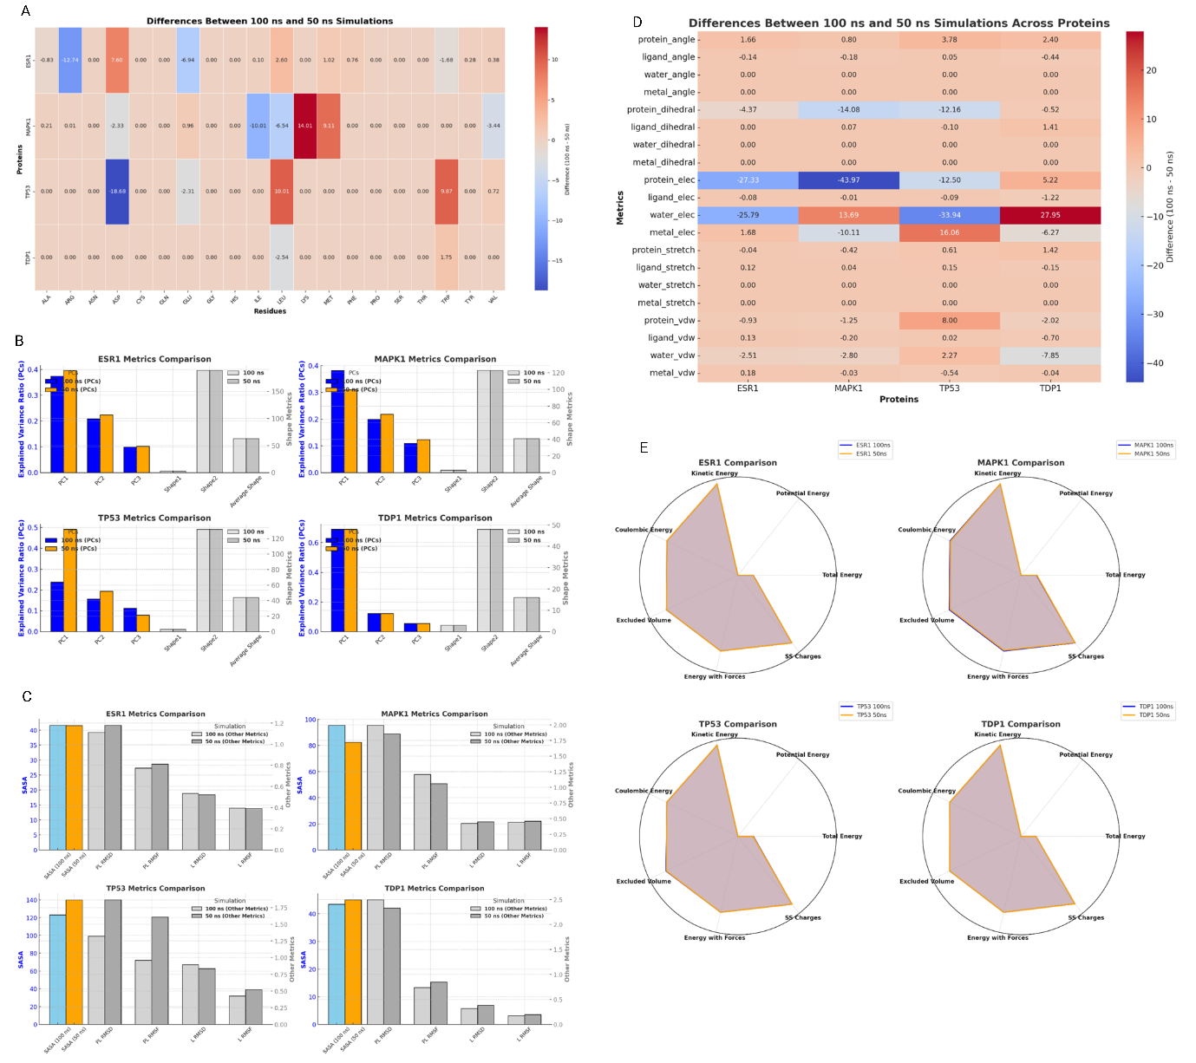
Figure S1. Differences between 100 ns and 50 ns simulations for the four proteins. (A) Residue-resolved interaction differences. (B) Ligand principal component metrics. (C) Solvent-accessible surface area and root-mean-square deviation and fluctuation. (D) Interaction geometry and energy terms. (E) Energy descriptors. Values close to zero indicate agreement between the two simulation lengths.

Deep Neural Network Architectures
Four architectures of increasing depth and regularisation were each trained with five random seeds under the shared partition. Mean test performance ranged from -0.109 to 0.463 across the four, while the standard deviation between seeds within a single architecture reached 0.797. Seed-to-seed variation therefore exceeds the difference between architectures, and the four cannot be distinguished at this sample size.
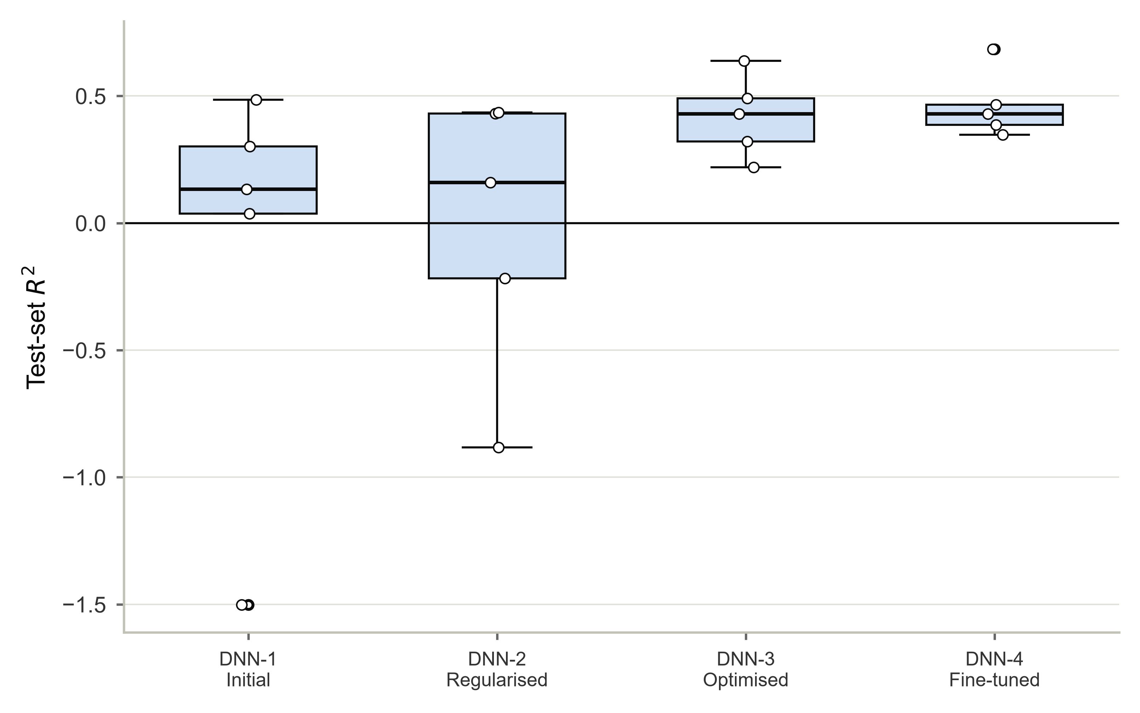
Figure S2. Test-set performance of four deep neural network architectures, each trained with five random seeds. Points are individual seeds.

Table S6 lists the four architectures with their parameter counts and the mean and standard deviation of performance over the five seeds.

Y-Scrambling
Each model was refitted against 100 random permutations of the potency labels in the training partition. Null distributions are centred well below the observed performance for every descriptor set that carries signal, confirming that the models do not fit noise.
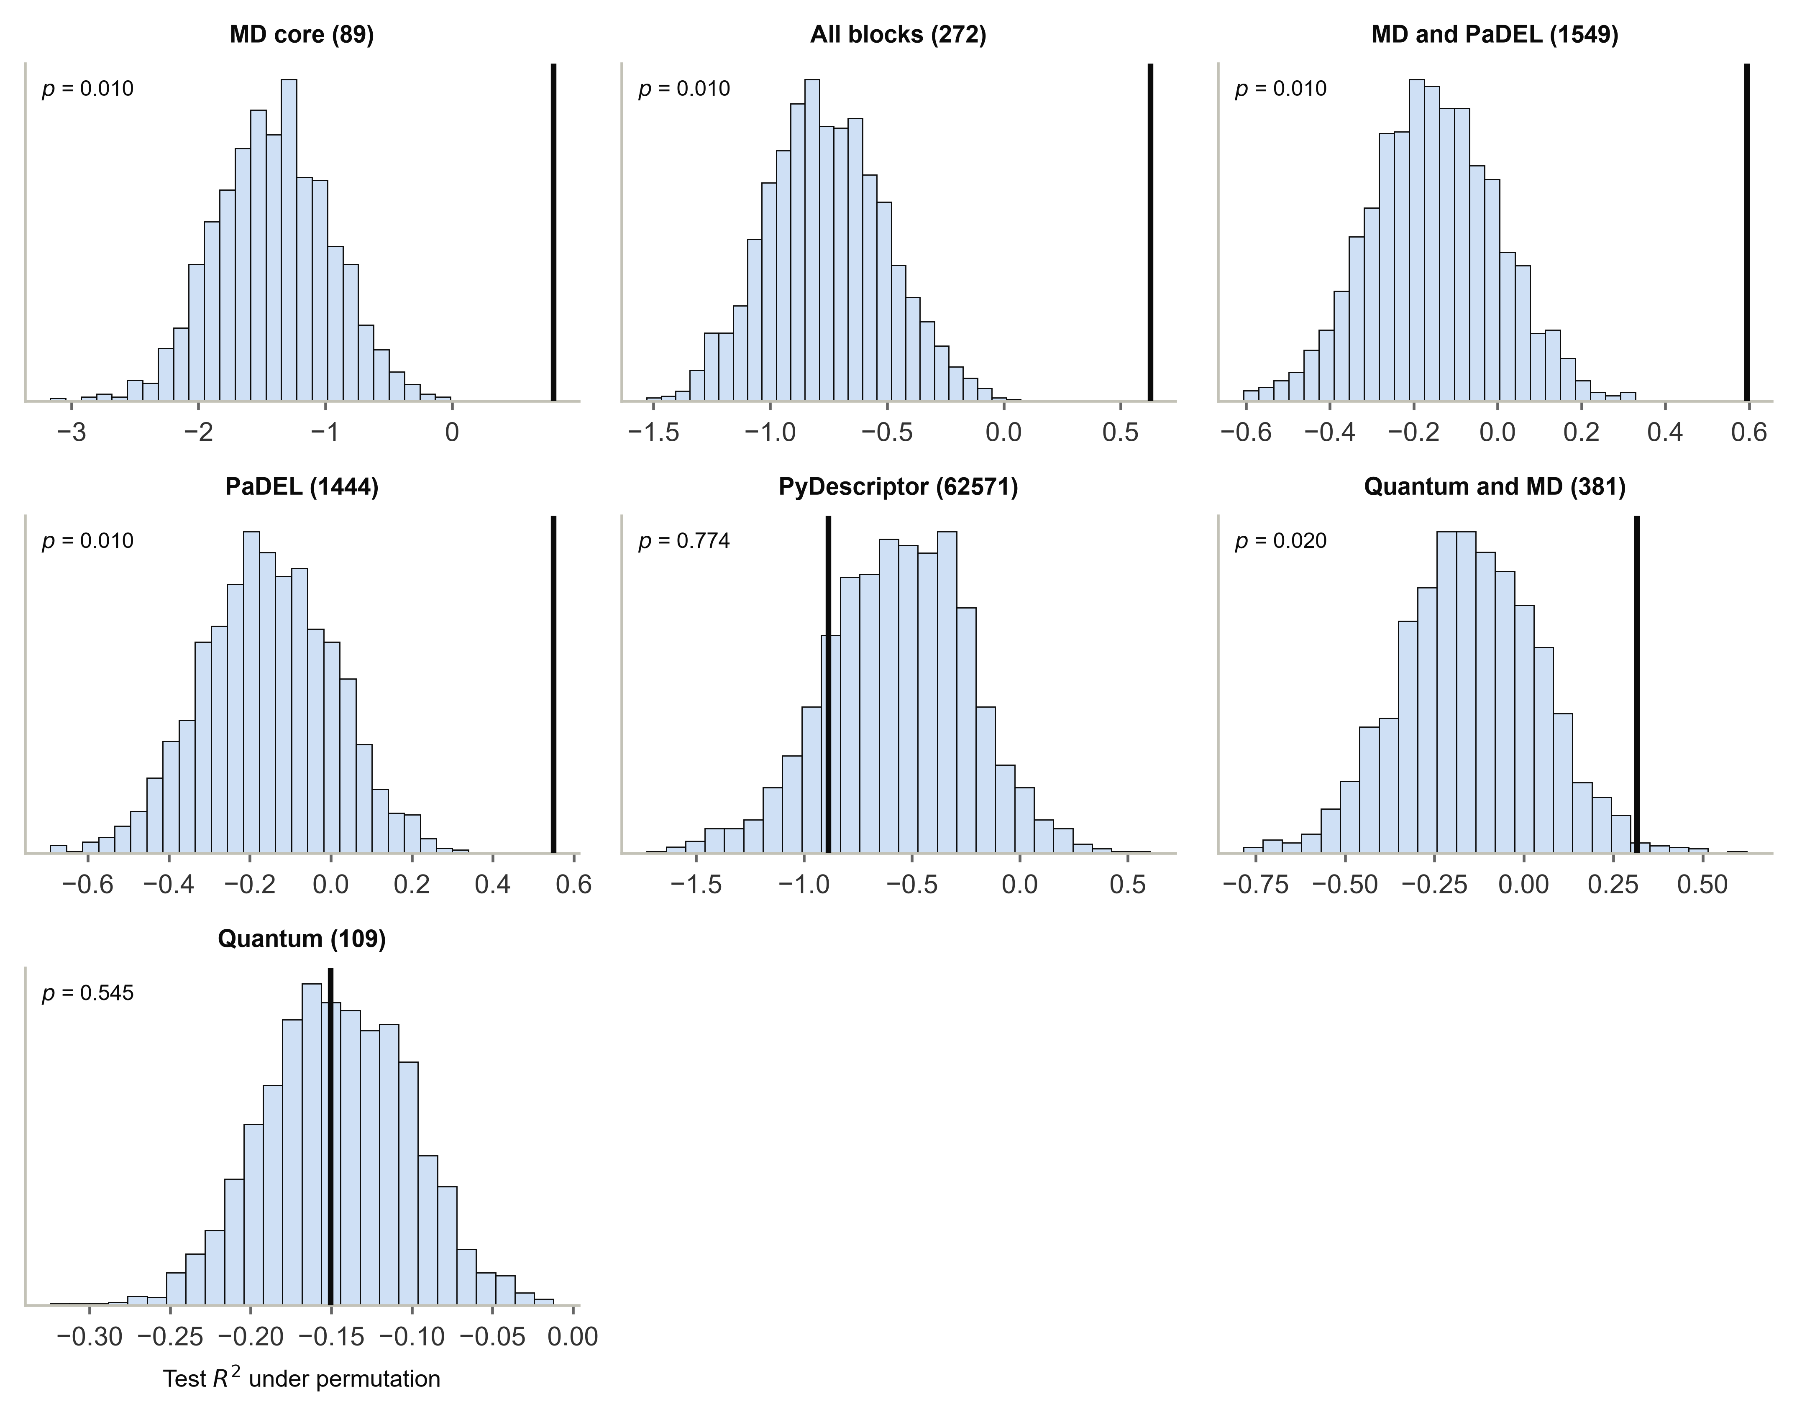
Figure S3. Null distributions of test-set performance under 100 label permutations. The vertical line marks the observed value.

Tables
Table S1. Descriptor sets benchmarked, with provenance.
Descriptor set | Molecules | Descriptors | Missing cells | pIC50 source | Source file | SHA-256 (16)
MD + AlphaFold + MACCS (272) | 122 | 272 | 0 | in-file | 2.csv | ce27987600db0bf7
MD + AlphaFold + MACCS, outliers removed (272) | 115 | 272 | 0 | in-file | 2 cleaned.csv | 0350e164e74e1c90
MD + energetics + ligand-PCA + residue forces (89) | 122 | 89 | 0 | in-file | 2.csv | ce27987600db0bf7
MACCS fingerprints only (167) | 122 | 167 | 0 | in-file | 2.csv | ce27987600db0bf7
AlphaFold pLDDT/PAE only (16) | 122 | 16 | 0 | in-file | 2.csv | ce27987600db0bf7
PaDEL 2D/3D descriptors (1444) | 122 | 1444 | 189 | attached by row index from 2.csv | JDes output3.csv | 0cd4af60bfafbc07
MD block + PaDEL block (1549) | 122 | 1549 | 0 | in-file | 5 imputed.csv | 60a2fb1693c83f7d
PyDescriptor descriptors (112194) | 122 | 62571 | 0 | in-file | merged descriptors with pic50.csv | fb621e7f17c2d622
DFT/xTB quantum descriptors (this work) | 122 | 109 | 0 | in-file | quantum descriptors.csv | 55a7065419d6812e
DFT quantum + MD block (this work) | 122 | 381 | 0 | in-file | (derived) | -
All sets share the same molecules and potency values. Checksum prefixes identify the exact input files used.

Table S2. Reproduction of the previously reported model.
Metric | Published | Reproduced | Difference
R2 train | 0.8582 | 0.8581 | -0.0001
R2 CV (5-fold) | 0.5423 | 0.5743 | 0.032
R2 test | 0.6532 | 0.6647 | 0.0115
R2 holdout | 0.6668 | 0.6537 | -0.0131
MSE test | 0.8591 | 0.8305 | -0.0286
RMSE test | 0.9269 | 0.9113 | -0.0156
MAE test | 0.6265 | 0.6137 | -0.0128
W new | 0.3068 | 0.3318 | 0.025
Reproduced on the same data and partition with hyperparameters ranked by the original composite criterion. Training performance agrees to four decimal places.

Table S3. Performance of every descriptor set under both partitioning regimes.
Descriptor set | Split | Model | R2 train | R2 CV | R2 test | R2 test 95% CI | R2 holdout | RMSE test | MAE test
MD + AlphaFold + MACCS (272) | Random | DNN | 0.0847 | -7.8412 | -0.3218 | [-12.30, 0.31] | 0.1636 | 1.6132 | 1.4413
MD + AlphaFold + MACCS (272) | Random | Hybrid | 0.8704 | 0.6252 | 0.6217 | [-1.59, 0.79] | 0.8356 | 0.8631 | 0.6722
MD + AlphaFold + MACCS (272) | Structure-disjoint | DNN | 0.1004 | -3.3932 | -0.2247 | [-3.74, 0.39] | -0.4829 | 1.181 | 1.0436
MD + AlphaFold + MACCS (272) | Random | Nu-SVR | 0.8264 | 0.6604 | 0.5751 | [-0.94, 0.71] | 0.8144 | 0.9147 | 0.6693
MD + AlphaFold + MACCS (272) | Structure-disjoint | Nu-SVR | 0.633 | 0.5722 | 0.6267 | [-0.85, 0.87] | 0.6849 | 0.652 | 0.491
MD + AlphaFold + MACCS (272) | Structure-disjoint | Hybrid | 0.7053 | 0.4536 | 0.5658 | [-1.33, 0.89] | 0.5747 | 0.7032 | 0.5061
MD + AlphaFold + MACCS, outliers removed (272) | Random | Hybrid | 0.8601 | 0.484 | 0.5668 | [0.20, 0.76] | 0.447 | 1.0359 | 0.7739
MD + AlphaFold + MACCS, outliers removed (272) | Random | DNN | -0.1952 | -6.0314 | -0.3314 | [-1.97, 0.15] | -1.0124 | 1.816 | 1.5797
MD + AlphaFold + MACCS, outliers removed (272) | Structure-disjoint | DNN | 0.1458 | -12.2071 | -1.8245 | [-5.35, -0.70] | 0.1858 | 1.5503 | 1.4408
MD + AlphaFold + MACCS, outliers removed (272) | Random | Nu-SVR | 0.8578 | 0.6298 | 0.6515 | [0.38, 0.87] | 0.6204 | 0.9291 | 0.6416
MD + AlphaFold + MACCS, outliers removed (272) | Structure-disjoint | Nu-SVR | 0.8351 | 0.6527 | 0.4549 | [0.01, 0.67] | 0.5939 | 0.681 | 0.5507
MD + AlphaFold + MACCS, outliers removed (272) | Structure-disjoint | Hybrid | 0.8413 | 0.5963 | 0.4129 | [-0.04, 0.64] | 0.6038 | 0.7068 | 0.5729
MD + energetics + ligand-PCA + residue forces (89) | Random | Hybrid | 0.8117 | 0.5865 | 0.6354 | [-0.35, 0.72] | 0.7138 | 0.8472 | 0.6033
MD + energetics + ligand-PCA + residue forces (89) | Random | DNN | -0.3826 | -4.04 | -0.6847 | [-11.69, 0.13] | -0.2718 | 1.8212 | 1.6227
MD + energetics + ligand-PCA + residue forces (89) | Structure-disjoint | DNN | 0.1423 | -5.217 | -0.1111 | [-4.55, 0.54] | -0.2179 | 1.1249 | 0.953
MD + energetics + ligand-PCA + residue forces (89) | Random | Nu-SVR | 0.8134 | 0.7088 | 0.6445 | [-0.34, 0.73] | 0.7149 | 0.8366 | 0.5967
MD + energetics + ligand-PCA + residue forces (89) | Structure-disjoint | Nu-SVR | 0.9049 | 0.6718 | 0.7984 | [0.10, 0.93] | 0.8435 | 0.4792 | 0.394
MD + energetics + ligand-PCA + residue forces (89) | Structure-disjoint | Hybrid | 0.8942 | 0.6396 | 0.7493 | [-0.16, 0.91] | 0.8099 | 0.5343 | 0.4375
MACCS fingerprints only (167) | Structure-disjoint | DNN | -10.936 | -4.5916 | -18.2048 | [-71.49, -8.96] | -17.3018 | 4.6768 | 4.5916
MACCS fingerprints only (167) | Random | Nu-SVR | 0.6535 | 0.4391 | 0.3925 | [-1.29, 0.57] | 0.6246 | 1.0937 | 0.7294
MACCS fingerprints only (167) | Structure-disjoint | Nu-SVR | 0.8714 | 0.3772 | 0.5773 | [-0.18, 0.83] | 0.2244 | 0.6939 | 0.5372
MACCS fingerprints only (167) | Structure-disjoint | Hybrid | 0.8557 | 0.2417 | 0.4732 | [-0.92, 0.78] | 0.075 | 0.7746 | 0.6665
MACCS fingerprints only (167) | Random | DNN | -1.6032 | -7.3431 | -1.3202 | [-17.08, -0.42] | -1.5308 | 2.1373 | 1.8841
MACCS fingerprints only (167) | Random | Hybrid | 0.6954 | 0.4215 | 0.4167 | [-1.81, 0.63] | 0.626 | 1.0717 | 0.7381
AlphaFold pLDDT/PAE only (16) | Random | DNN | -2.1656 | -1.8777 | -3.3687 | [-26.51, -1.85] | -2.8019 | 2.9328 | 2.5896
AlphaFold pLDDT/PAE only (16) | Random | Hybrid | 0.4673 | 0.2332 | 0.3117 | [-0.68, 0.45] | 0.4919 | 1.1641 | 0.7108
AlphaFold pLDDT/PAE only (16) | Random | Nu-SVR | 0.4497 | 0.3885 | 0.2818 | [-0.55, 0.41] | 0.4532 | 1.1891 | 0.7147
AlphaFold pLDDT/PAE only (16) | Structure-disjoint | DNN | -0.8361 | -3.5147 | -1.004 | [-6.12, -0.37] | -1.7419 | 1.5108 | 1.3233
AlphaFold pLDDT/PAE only (16) | Structure-disjoint | Hybrid | 0.4281 | 0.3226 | 0.2979 | [-1.84, 0.58] | 0.7293 | 0.8942 | 0.7255
AlphaFold pLDDT/PAE only (16) | Structure-disjoint | Nu-SVR | 0.4526 | 0.3892 | 0.5046 | [-0.42, 0.66] | 0.716 | 0.7511 | 0.5199
PaDEL 2D/3D descriptors (1444) | Random | Hybrid | 0.7217 | -4.5627 | 0.5017 | [-0.72, 0.62] | 0.6885 | 0.9905 | 0.6818
PaDEL 2D/3D descriptors (1444) | Random | DNN | -16.1537 | -383.6326 | -13.5731 | [-131.90, -7.99] | -14.3835 | 5.3565 | 5.2191
PaDEL 2D/3D descriptors (1444) | Structure-disjoint | Nu-SVR | 0.6904 | 0.4852 | 0.5497 | [-0.25, 0.82] | 0.6597 | 0.7161 | 0.569
PaDEL 2D/3D descriptors (1444) | Structure-disjoint | Hybrid | 0.7268 | 0.2263 | 0.5595 | [-0.31, 0.84] | 0.5626 | 0.7083 | 0.5549
PaDEL 2D/3D descriptors (1444) | Structure-disjoint | DNN | -0.1356 | -5.1437 | -1.6141 | [-7.54, 0.01] | -0.7664 | 1.7255 | 1.4705
PaDEL 2D/3D descriptors (1444) | Random | Nu-SVR | 0.6828 | 0.4539 | 0.4845 | [-0.24, 0.60] | 0.6935 | 1.0074 | 0.6247
MD block + PaDEL block (1549) | Random | Nu-SVR | 0.7317 | 0.4959 | 0.5094 | [-0.25, 0.64] | 0.7372 | 0.9828 | 0.604
MD block + PaDEL block (1549) | Structure-disjoint | DNN | 0.5364 | -17.9442 | 0.2736 | [-0.96, 0.67] | 0.5272 | 0.9095 | 0.685
MD block + PaDEL block (1549) | Random | Hybrid | 0.7561 | 0.3458 | 0.5345 | [-0.41, 0.68] | 0.7564 | 0.9573 | 0.6161
MD block + PaDEL block (1549) | Random | DNN | -0.5429 | -15.4156 | -0.5398 | [-13.38, 0.13] | -0.3999 | 1.7411 | 1.5649
MD block + PaDEL block (1549) | Structure-disjoint | Hybrid | 0.7452 | 0.4555 | 0.6161 | [-0.19, 0.85] | 0.7102 | 0.6612 | 0.5389
MD block + PaDEL block (1549) | Structure-disjoint | Nu-SVR | 0.7115 | 0.5047 | 0.5939 | [-0.19, 0.82] | 0.7686 | 0.6801 | 0.56
PyDescriptor descriptors (112194) | Random | Nu-SVR | 0.2589 | 0.1166 | 0.0502 | [-3.06, 0.27] | 0.1009 | 1.3675 | 0.9954
PyDescriptor descriptors (112194) | Structure-disjoint | DNN | -1.7061 | -6.3666 | -3.1109 | [-17.37, -0.65] | -3.1175 | 2.1638 | 1.8687
PyDescriptor descriptors (112194) | Structure-disjoint | Hybrid | 0.5509 | 0.1653 | -1.1203 | [-10.44, 0.38] | 0.4443 | 1.5539 | 1.0975
PyDescriptor descriptors (112194) | Structure-disjoint | Nu-SVR | 0.5272 | 0.2548 | -0.8872 | [-9.61, 0.53] | 0.5398 | 1.4661 | 0.934
PyDescriptor descriptors (112194) | Random | DNN | -3.1834 | -8.5622 | -3.7228 | [-34.59, -1.94] | -1.9457 | 3.0493 | 2.6856
PyDescriptor descriptors (112194) | Random | Hybrid | 0.2195 | -0.0641 | 0.0298 | [-2.11, 0.20] | -0.0221 | 1.3821 | 0.9413
DFT/xTB quantum descriptors (this work) | Random | Nu-SVR | 0.3492 | 0.1149 | 0.0298 | [-2.92, 0.23] | 0.0137 | 1.3821 | 0.9958
DFT/xTB quantum descriptors (this work) | Structure-disjoint | DNN | 0.1102 | -6.6641 | -1.2564 | [-11.60, 0.28] | -0.1732 | 1.603 | 1.2328
DFT/xTB quantum descriptors (this work) | Random | DNN | 0.1933 | -7.8678 | -1.0201 | [-14.29, -0.02] | -0.0449 | 1.9943 | 1.4861
DFT/xTB quantum descriptors (this work) | Random | Hybrid | 0.2398 | 0.0796 | 0.0598 | [-0.64, 0.29] | -0.1263 | 1.3605 | 0.8349
DFT/xTB quantum descriptors (this work) | Structure-disjoint | Hybrid | 0.1612 | -0.1275 | -0.5741 | [-5.43, 0.05] | -0.0949 | 1.3389 | 1.1783
DFT/xTB quantum descriptors (this work) | Structure-disjoint | Nu-SVR | 0.059 | -0.007 | -0.1505 | [-2.08, 0.01] | 0.1208 | 1.1447 | 0.9261
DFT quantum + MD block (this work) | Random | DNN | 0.1791 | -7.0017 | 0.1669 | [-6.07, 0.53] | 0.5906 | 1.2807 | 1.1325
DFT quantum + MD block (this work) | Random | Hybrid | 0.7838 | 0.6223 | 0.5 | [-2.21, 0.67] | 0.7182 | 0.9922 | 0.7149
DFT quantum + MD block (this work) | Structure-disjoint | Hybrid | 0.6518 | 0.4659 | 0.1446 | [-4.31, 0.79] | 0.5612 | 0.987 | 0.6784
DFT quantum + MD block (this work) | Structure-disjoint | Nu-SVR | 0.5368 | 0.5359 | 0.3152 | [-2.19, 0.68] | 0.8387 | 0.8831 | 0.6239
DFT quantum + MD block (this work) | Random | Nu-SVR | 0.7578 | 0.6649 | 0.4263 | [-1.39, 0.55] | 0.7257 | 1.0628 | 0.7186
DFT quantum + MD block (this work) | Structure-disjoint | DNN | -0.0976 | -5.3887 | -0.7206 | [-6.75, 0.31] | -0.5143 | 1.3999 | 1.2582
Bootstrap 95 per cent confidence intervals from 1000 resamples. Held-out partitions contain 23 to 25 molecules.

Table S4. Paired comparison of descriptor sets on identical held-out molecules.
Split | A | B | n | median diff | effect size effect size | p (Holm) | significant
Random | MD+AF+MACCS (272) | MD+AF+MACCS, no outliers (272) | 12 | -0.008 | 0.308 | 1.0 | no
Random | MD+AF+MACCS (272) | MD core (89) | 38 | 0.0552 | -0.082 | 1.0 | no
Random | MD+AF+MACCS (272) | MACCS only (167) | 38 | -0.0485 | 0.225 | 1.0 | no
Random | MD+AF+MACCS (272) | AlphaFold only (16) | 38 | 0.0482 | -0.115 | 1.0 | no
Random | MD+AF+MACCS (272) | PaDEL (1444) | 38 | 0.02 | 0.144 | 1.0 | no
Random | MD+AF+MACCS (272) | MD+PaDEL (1549) | 38 | 0.0526 | -0.177 | 1.0 | no
Random | MD+AF+MACCS (272) | PyDescriptor (112194) | 38 | -0.3419 | 0.444 | 0.6464 | no
Random | MD+AF+MACCS (272) | DFT quantum | 38 | -0.0956 | 0.225 | 1.0 | no
Random | MD+AF+MACCS (272) | DFT + MD | 38 | -0.0035 | 0.155 | 1.0 | no
Random | MD+AF+MACCS, no outliers (272) | MD core (89) | 12 | 0.0827 | 0.026 | 1.0 | no
Random | MD+AF+MACCS, no outliers (272) | MACCS only (167) | 12 | 0.155 | -0.256 | 1.0 | no
Random | MD+AF+MACCS, no outliers (272) | AlphaFold only (16) | 12 | -0.138 | 0.385 | 1.0 | no
Random | MD+AF+MACCS, no outliers (272) | PaDEL (1444) | 12 | -0.016 | 0.103 | 1.0 | no
Random | MD+AF+MACCS, no outliers (272) | MD+PaDEL (1549) | 12 | 0.0546 | -0.179 | 1.0 | no
Random | MD+AF+MACCS, no outliers (272) | PyDescriptor (112194) | 12 | -0.184 | 0.385 | 1.0 | no
Random | MD+AF+MACCS, no outliers (272) | DFT quantum | 12 | -0.2427 | 0.59 | 1.0 | no
Random | MD+AF+MACCS, no outliers (272) | DFT + MD | 12 | -0.0899 | 0.0 | 1.0 | no
Random | MD core (89) | MACCS only (167) | 38 | -0.0598 | 0.179 | 1.0 | no
Random | MD core (89) | AlphaFold only (16) | 38 | -0.0115 | 0.066 | 1.0 | no
Random | MD core (89) | PaDEL (1444) | 38 | -0.0193 | 0.182 | 1.0 | no
Random | MD core (89) | MD+PaDEL (1549) | 38 | -0.0098 | -0.047 | 1.0 | no
Random | MD core (89) | PyDescriptor (112194) | 38 | -0.332 | 0.614 | 0.02827 | yes
Random | MD core (89) | DFT quantum | 38 | -0.1417 | 0.428 | 0.8078 | no
Random | MD core (89) | DFT + MD | 38 | -0.03 | 0.093 | 1.0 | no
Random | MACCS only (167) | AlphaFold only (16) | 38 | 0.0077 | -0.034 | 1.0 | no
Random | MACCS only (167) | PaDEL (1444) | 38 | 0.0038 | -0.128 | 1.0 | no
Random | MACCS only (167) | MD+PaDEL (1549) | 38 | 0.0754 | -0.317 | 1.0 | no
Random | MACCS only (167) | PyDescriptor (112194) | 38 | -0.2141 | 0.425 | 0.8196 | no
Random | MACCS only (167) | DFT quantum | 38 | -0.0717 | 0.198 | 1.0 | no
Random | MACCS only (167) | DFT + MD | 38 | -0.016 | -0.047 | 1.0 | no
Random | AlphaFold only (16) | PaDEL (1444) | 38 | -0.0707 | 0.08 | 1.0 | no
Random | AlphaFold only (16) | MD+PaDEL (1549) | 38 | 0.0243 | -0.155 | 1.0 | no
Random | AlphaFold only (16) | PyDescriptor (112194) | 38 | -0.3437 | 0.471 | 0.4395 | no
Random | AlphaFold only (16) | DFT quantum | 38 | -0.1652 | 0.382 | 1.0 | no
Random | AlphaFold only (16) | DFT + MD | 38 | -0.0423 | 0.028 | 1.0 | no
Random | PaDEL (1444) | MD+PaDEL (1549) | 38 | 0.1151 | -0.371 | 1.0 | no
Random | PaDEL (1444) | PyDescriptor (112194) | 38 | -0.19 | 0.563 | 0.08325 | no
Random | PaDEL (1444) | DFT quantum | 38 | -0.0483 | 0.247 | 1.0 | no
Random | PaDEL (1444) | DFT + MD | 38 | 0.0186 | -0.08 | 1.0 | no
Random | MD+PaDEL (1549) | PyDescriptor (112194) | 38 | -0.3074 | 0.652 | 0.01178 | yes
Random | MD+PaDEL (1549) | DFT quantum | 38 | -0.1099 | 0.447 | 0.6351 | no
Random | MD+PaDEL (1549) | DFT + MD | 38 | -0.0742 | 0.19 | 1.0 | no
Random | PyDescriptor (112194) | DFT quantum | 38 | 0.0682 | -0.163 | 1.0 | no
Random | PyDescriptor (112194) | DFT + MD | 38 | 0.2506 | -0.401 | 1.0 | no
Random | DFT quantum | DFT + MD | 38 | 0.0965 | -0.25 | 1.0 | no
Structure-disjoint | MD+AF+MACCS (272) | MD+AF+MACCS, no outliers (272) | 15 | -0.1024 | 0.517 | 1.0 | no
Structure-disjoint | MD+AF+MACCS (272) | MD core (89) | 38 | 0.0408 | -0.196 | 1.0 | no
Structure-disjoint | MD+AF+MACCS (272) | MACCS only (167) | 38 | -0.3094 | 0.457 | 0.4045 | no
Structure-disjoint | MD+AF+MACCS (272) | AlphaFold only (16) | 38 | -0.1671 | 0.406 | 0.7679 | no
Structure-disjoint | MD+AF+MACCS (272) | PaDEL (1444) | 38 | -0.0881 | 0.185 | 1.0 | no
Structure-disjoint | MD+AF+MACCS (272) | MD+PaDEL (1549) | 38 | -0.0564 | 0.115 | 1.0 | no
Structure-disjoint | MD+AF+MACCS (272) | PyDescriptor (112194) | 38 | -0.3759 | 0.574 | 0.05428 | no
Structure-disjoint | MD+AF+MACCS (272) | DFT quantum | 38 | -0.7587 | 0.822 | 6.068e-05 | yes
Structure-disjoint | MD+AF+MACCS (272) | DFT + MD | 38 | -0.1331 | 0.328 | 1.0 | no
Structure-disjoint | MD+AF+MACCS, no outliers (272) | MD core (89) | 15 | 0.2513 | -0.383 | 1.0 | no
Structure-disjoint | MD+AF+MACCS, no outliers (272) | MACCS only (167) | 15 | -0.2058 | 0.433 | 1.0 | no
Structure-disjoint | MD+AF+MACCS, no outliers (272) | AlphaFold only (16) | 15 | -0.0505 | 0.017 | 1.0 | no
Structure-disjoint | MD+AF+MACCS, no outliers (272) | PaDEL (1444) | 15 | -0.0538 | 0.217 | 1.0 | no
Structure-disjoint | MD+AF+MACCS, no outliers (272) | MD+PaDEL (1549) | 15 | -0.0028 | 0.133 | 1.0 | no
Structure-disjoint | MD+AF+MACCS, no outliers (272) | PyDescriptor (112194) | 15 | -0.3963 | 0.317 | 1.0 | no
Structure-disjoint | MD+AF+MACCS, no outliers (272) | DFT quantum | 15 | -0.6586 | 0.567 | 1.0 | no
Structure-disjoint | MD+AF+MACCS, no outliers (272) | DFT + MD | 15 | 0.062 | 0.0 | 1.0 | no
Structure-disjoint | MD core (89) | MACCS only (167) | 38 | -0.33 | 0.582 | 0.04841 | yes
Structure-disjoint | MD core (89) | AlphaFold only (16) | 38 | -0.1528 | 0.412 | 0.759 | no
Structure-disjoint | MD core (89) | PaDEL (1444) | 38 | -0.117 | 0.414 | 0.759 | no
Structure-disjoint | MD core (89) | MD+PaDEL (1549) | 38 | -0.0985 | 0.347 | 1.0 | no
Structure-disjoint | MD core (89) | PyDescriptor (112194) | 38 | -0.299 | 0.733 | 0.001232 | yes
Structure-disjoint | MD core (89) | DFT quantum | 38 | -0.6993 | 0.938 | 2.095e-07 | yes
Structure-disjoint | MD core (89) | DFT + MD | 38 | -0.1568 | 0.395 | 0.8615 | no
Structure-disjoint | MACCS only (167) | AlphaFold only (16) | 38 | 0.0749 | -0.171 | 1.0 | no
Structure-disjoint | MACCS only (167) | PaDEL (1444) | 38 | 0.1136 | -0.382 | 0.9973 | no
Structure-disjoint | MACCS only (167) | MD+PaDEL (1549) | 38 | 0.157 | -0.487 | 0.2627 | no
Structure-disjoint | MACCS only (167) | PyDescriptor (112194) | 38 | -0.2787 | 0.32 | 1.0 | no
Structure-disjoint | MACCS only (167) | DFT quantum | 38 | -0.5089 | 0.576 | 0.05277 | no
Structure-disjoint | MACCS only (167) | DFT + MD | 38 | 0.1009 | -0.271 | 1.0 | no
Structure-disjoint | AlphaFold only (16) | PaDEL (1444) | 38 | 0.054 | -0.193 | 1.0 | no
Structure-disjoint | AlphaFold only (16) | MD+PaDEL (1549) | 38 | 0.069 | -0.358 | 1.0 | no
Structure-disjoint | AlphaFold only (16) | PyDescriptor (112194) | 38 | -0.3633 | 0.382 | 0.9973 | no
Structure-disjoint | AlphaFold only (16) | DFT quantum | 38 | -0.6347 | 0.682 | 0.004889 | yes
Structure-disjoint | AlphaFold only (16) | DFT + MD | 38 | 0.0509 | -0.047 | 1.0 | no
Structure-disjoint | PaDEL (1444) | MD+PaDEL (1549) | 38 | 0.0387 | -0.282 | 1.0 | no
Structure-disjoint | PaDEL (1444) | PyDescriptor (112194) | 38 | -0.3452 | 0.466 | 0.3661 | no
Structure-disjoint | PaDEL (1444) | DFT quantum | 38 | -0.664 | 0.668 | 0.006784 | yes
Structure-disjoint | PaDEL (1444) | DFT + MD | 38 | 0.0324 | 0.001 | 1.0 | no
Structure-disjoint | MD+PaDEL (1549) | PyDescriptor (112194) | 38 | -0.3634 | 0.53 | 0.1242 | no
Structure-disjoint | MD+PaDEL (1549) | DFT quantum | 38 | -0.6684 | 0.727 | 0.001414 | yes
Structure-disjoint | MD+PaDEL (1549) | DFT + MD | 38 | -0.0356 | 0.123 | 1.0 | no
Structure-disjoint | PyDescriptor (112194) | DFT quantum | 38 | -0.2469 | 0.614 | 0.02442 | yes
Structure-disjoint | PyDescriptor (112194) | DFT + MD | 38 | 0.2661 | -0.414 | 0.759 | no
Structure-disjoint | DFT quantum | DFT + MD | 38 | 0.609 | -0.717 | 0.001895 | yes
Wilcoxon signed-rank test on per-molecule absolute error. A negative median difference and a positive effect size indicate that descriptor set A is more accurate. Significance values are Holm-corrected within each partition.

Table S5. Statistical validation for every descriptor set and partition.
Descriptor set | Split | n train/test/holdout | PCs retained | Q2 (LOO) | Hybrid R2 test | 95% CI | Permutation null R2 | p (y-scrambling) | Leaked test rows
MD + AlphaFold + MACCS (272) | Random | 84/25/13 | 19 | 0.6647 | 0.6217 | [-1.59, 0.79] | -0.081 +/- 0.161 | 0.0099 | 10
MD + AlphaFold + MACCS (272) | Structure-disjoint | 84/25/13 | 15 | 0.5779 | 0.5658 | [-1.33, 0.89] | -0.760 +/- 0.255 | 0.0099 | 0
MD + AlphaFold + MACCS, outliers removed (272) | Random | 80/23/12 | 15 | 0.6855 | 0.5668 | [0.20, 0.76] | -0.235 +/- 0.147 | 0.0099 | 5
MD + AlphaFold + MACCS, outliers removed (272) | Structure-disjoint | 77/24/14 | 15 | 0.6597 | 0.4129 | [-0.04, 0.64] | -0.079 +/- 0.175 | 0.0099 | 0
MD + energetics + ligand-PCA + residue forces (89) | Structure-disjoint | 84/25/13 | 19 | 0.7057 | 0.7493 | [-0.16, 0.91] | -1.402 +/- 0.453 | 0.0099 | 0
MD + energetics + ligand-PCA + residue forces (89) | Random | 84/25/13 | 15 | 0.7524 | 0.6354 | [-0.35, 0.72] | -0.087 +/- 0.154 | 0.0099 | 10
MACCS fingerprints only (167) | Structure-disjoint | 84/25/13 | 15 | 0.5784 | 0.4732 | [-0.92, 0.78] | -0.435 +/- 0.427 | 0.0099 | 0
MACCS fingerprints only (167) | Random | 84/25/13 | 15 | 0.4441 | 0.4167 | [-1.81, 0.63] | -0.073 +/- 0.155 | 0.0099 | 10
AlphaFold pLDDT/PAE only (16) | Structure-disjoint | 84/25/13 | 15 | 0.4167 | 0.2979 | [-1.84, 0.58] | -0.075 +/- 0.176 | 0.0099 | 0
AlphaFold pLDDT/PAE only (16) | Random | 84/25/13 | 15 | 0.4225 | 0.3117 | [-0.68, 0.45] | -0.054 +/- 0.164 | 0.0099 | 10
PaDEL 2D/3D descriptors (1444) | Random | 84/25/13 | 15 | 0.4751 | 0.5017 | [-0.72, 0.62] | -0.093 +/- 0.114 | 0.0099 | 10
PaDEL 2D/3D descriptors (1444) | Structure-disjoint | 84/25/13 | 15 | 0.4989 | 0.5595 | [-0.31, 0.84] | -0.157 +/- 0.159 | 0.0099 | 0
MD block + PaDEL block (1549) | Structure-disjoint | 84/25/13 | 15 | 0.5206 | 0.6161 | [-0.19, 0.85] | -0.157 +/- 0.154 | 0.0099 | 0
MD block + PaDEL block (1549) | Random | 84/25/13 | 22 | 0.523 | 0.5345 | [-0.41, 0.68] | -0.096 +/- 0.120 | 0.0099 | 10
PyDescriptor descriptors (112194) | Random | 84/25/13 | 22 | 0.133 | 0.0298 | [-2.11, 0.20] | -0.107 +/- 0.090 | 0.0645 | 10
PyDescriptor descriptors (112194) | Structure-disjoint | 84/25/13 | 22 | 0.1982 | -1.1203 | [-10.44, 0.38] | -0.575 +/- 0.338 | 0.7742 | 0
DFT/xTB quantum descriptors (this work) | Random | 84/25/13 | 15 | 0.1187 | 0.0598 | [-0.64, 0.29] | -0.080 +/- 0.091 | 0.0792 | 10
DFT/xTB quantum descriptors (this work) | Structure-disjoint | 84/25/13 | 15 | 0.0057 | -0.5741 | [-5.43, 0.05] | -0.146 +/- 0.046 | 0.5446 | 0
DFT quantum + MD block (this work) | Random | 84/25/13 | 17 | 0.6637 | 0.5 | [-2.21, 0.67] | -0.171 +/- 0.182 | 0.0099 | 10
DFT quantum + MD block (this work) | Structure-disjoint | 84/25/13 | 19 | 0.4145 | 0.1446 | [-4.31, 0.79] | -0.150 +/- 0.196 | 0.0198 | 0
Significance values are the empirical fraction of 100 label permutations reaching the observed performance. Leaked rows count held-out molecules whose structure also appears in training, zero by construction under the structure-disjoint regime.

Table S6. Deep neural network architectures, mean and standard deviation over five random seeds.
Architecture | Neurons | Parameters | R2 train | R2 train SD | R2 test | R2 test SD | R2 holdout | R2 holdout SD | RMSE test
DNN-1 Initial | 672 | 94817 | 0.3325 | 0.6731 | -0.109 | 0.7967 | -0.9606 | 1.121 | 1.5888
DNN-2 Regularised | 1216 | 269697 | 0.1777 | 0.5151 | -0.0152 | 0.5535 | -1.1615 | 1.4893 | 1.542
DNN-3 Optimised | 2112 | 674817 | 0.5343 | 0.1827 | 0.4196 | 0.16 | -0.1659 | 0.5179 | 1.1894
DNN-4 Fine-tuned | 1792 | 566721 | 0.6073 | 0.1439 | 0.4625 | 0.1318 | -0.3293 | 0.7717 | 1.1457

Table S7. Corrections applied relative to the earlier form of this study.
Issue | Where it appears | Recommended action
Hybrid MSE columns disagree between documents | Main manuscript Table 4 gives CV MSE 0.6571, test 0.4602, unseen 0.9752; Hybrid model.docx Table 1 gives CV 0.4602, test 0.9752, unseen 0.1921 | The columns are shifted by one between the two documents. Re-derive from the recomputed values in Table 2 and use a single set throughout.
Nu-SVR "Mean CV MSE" is actually the test MSE | Table 4 reports 0.8591 under "Mean CV MSE" | In the source script 0.8591 is mean squared error on the 20% test set. Relabel, or replace with the recomputed CV MSE.
DNN narrative does not match its own table | Hybrid model.docx quotes DNN-1 R2 train 0.8044 / CV 0.7373 and DNN-2 0.9532 / 0.9323; Table 1 of the same document lists neither | Reconcile the text to the table, or supply the runs those numbers came from.
Duplicated rows in the DNN table | DNN-1 and DNN-3 are identical; DNN-2 and DNN-4 are identical | Two distinct architectures cannot give bit-identical metrics across seven columns. Re-run or merge the rows.
Base learners were fitted on different splits | Nu-SVR used random state=1, all four DNNs used random state=42, and the two were then stacked | The ensemble members saw different training sets. All results here use one split per run.
Hyperparameters were selected on the test set | W new includes R2 test and the test MSE/RMSE/MAE, and the reported model is the W new maximum over the n components sweep | This makes the reported test R2 an optimistic estimate. Select on cross-validated R2 and quote the test set once, at the end.
Meta-learner trained on in-sample base predictions | No out-of-fold scheme is described for the Ridge stack | Stacking on in-sample predictions inflates the meta-learner. With out-of-fold stacking the hybrid no longer consistently beats Nu-SVR (Table 2).
Random splits leak duplicate structures | 10 of 25 test rows and 4 of 13 holdout rows share a canonical SMILES with the training set at random state=1 | Report the structure-disjoint split alongside the random one (Table 2).
Model comparisons are not statistically resolvable | Hybrid test R2 0.6560 vs Nu-SVR 0.6532, a difference of 0.0028, on 23-25 test molecules | The bootstrap 95% CI on test R2 spans roughly +/-0.5. State that the models are statistically indistinguishable rather than ranking them.
SHAP interpretation attributes importance to protein confidence | PC1 (mean |SHAP| 0.807) loads on pLDDT quantiles | The AlphaFold block is constant within a protein, so PC1 largely encodes target identity. Target dummies alone give CV R2 0.34. Reword the interpretation.
Feature count stated inconsistently | Table 3 total reads "~270-280 272" | The matrix has exactly 272 feature columns. Fix the cell.
Number of AlphaFold feature vectors | Methods describe four proteins; the data contain eight distinct pLDDT/PAE signatures | Groups 5-7 differ only in the third decimal and two are singletons. Verify which AlphaFold run each ligand was assigned.
Ligand-PCA columns are array dimensions, not deformations | Section 2.3 describes "PCA components shape" as structural deformations and "Average Structure Shape" as the mean conformation | The extraction script recorded pca.components .shape and average structure.shape. PCA-components-shape1 is the constant 3, Average-structure-shape is the ligand atom count (24 to 72) and PCA-components-shape2 is three times it. They correlate with pIC50 at r = 0.581. Describe them as ligand-size descriptors; replacement text in docs/METHODS CORRECTION LIGAND PCA.md.
Impossible PAE mean for one protein | AlphaFold block, TDP1 (6N0D) signature: PAE Mean 30.07 with Q25 1.4, Q50 1.9, Q75 2.70 and Max 30.5 | A mean cannot sit at the maximum when three quarters of the distribution is below 2.70. The source JSON gives 3.07, so a zero was inserted. The affected row carries the 17 most potent compounds. Correct to 3.07 in any revised matrix.
Hydrogen bonds and water bridges were never counted | ligand protein interaction forces.py passed the same atom twice to the angle function, so both angles evaluated to NaN and every cutoff comparison failed | The 20 residue descriptors contain only hydrophobic and ionic contributions; cation-pi had a cutoff but no detection code. Methods should state which interaction types actually entered the features, or the descriptors should be regenerated with the corrected script.
AlphaFold pLDDT averaged over the wrong atoms | alphafold feature extraction.py zipped per-atom pLDDT against per-token residue ids, using only the first 248 of 1978 atom scores for 1SJ0 | Roughly 87 per cent of each structure was discarded. Corrected values differ materially, for example 8AOJ rises from 69.30 to 87.29.
Repository does not contain the pipeline | The README advertises scripts/classical ml pipeline.py, hybrid model training.py, data/, models/ and outputs/; none exist in the repository | Publish the actual training code, or point the manuscript at this benchmark repository.

Table S8. Alignment of the retained principal components with potency, computed on the 84 training molecules of the structure-disjoint partition.
Representation | Descriptors | Variance in 17 components (%) | Largest component correlation with potency | Rank of that component
Simulation-derived | 89 | 93.1 | 0.66 | 2
PaDEL | 1444 | 86.6 | 0.548 | 1
PyDescriptor | 62571 | 86.3 | 0.377 | 9
Quantum-chemical | 109 | 95.5 | 0.288 | 3

Each representation was passed through the preprocessing used for modelling, that is median imputation, removal of zero-variance columns, standardisation and reduction to 17 principal components. The final two columns give the largest absolute Pearson correlation between any retained component and potency, and the rank of that component by explained variance. No model is fitted and no held-out molecule is used.

