

**[BUPA]**

**[BBY – Web/IB Tele Test]**

**TEST PLAN**

**BACKGROUND**

|  |
| --- |
| **EVIDENCE:**  Our design team are starting to mock up designs with new orange style buttons. We would like to understand the impact of these before making a decision to roll out across the site. |

|  |
| --- |
| **PAGE(s):**  https://www.bupa.co.uk/ |

|  |  |  |  |
| --- | --- | --- | --- |
| **MUV:**  54,271 (May 2017) |  | **TEST TYPE:**  A/B |  |

_______________________________________

**OBJECTIVE**

|  |
| --- |
| **HYPHOTHESIS:**  By presenting a more prominent quote CTA button, in orange, we will see more customers clicking on this and landing on the BBY Quote and Buy journey as a result. |

|  |
| --- |
| **TEST GOAL:**   * To increase clicks on the ‘Get a quote button’ * To increase visitors reaching BBY quote and Buy |

|  |
| --- |
| **KSM(s):**   * Increased clicks to get a quote * More visits to the BBY Quote and Buy Journey * Increased BBY leads and sales |

_______________________________________

**VARIANTS**

|  |
| --- |
| **DEFAULT: The page as it is today with a ghost button style CTA for the ‘Get a quote’ button**  **Variant 1: The page as it is today with a new orange style CTA for the ‘Get a quote’ button** |

**TARGETING**

|  |
| --- |
| **DOMAINS:**   * [www.bupa.co.uk](http://www.bupa.co.uk) |

|  |
| --- |
| **URL(s):**   * <https://www.bupa.co.uk/> |

|  |  |
| --- | --- |
| **DEVICES:**   * Desktop * Tablet * Mobile | **BROWSERS:**   * Chrome 45+ * Firefox 45+ * IE9+ |

**Please see the attached browser lists on Trello.

|  |
| --- |
| **OTHER:**  URL must contain &utm-source=’yes’  Cookie **ab_yes** must have value (**yes**) |

_______________________________________

**METRICS**

|  |  |  |  |
| --- | --- | --- | --- |
| **NAME** | **TYPE** | **DESCRIPTION** | **STATUS** |
| 1. Get a quote clicks | Clicks | Number of users clicking the ‘Get a quote’ button |  |
| 1. Health insurance overlay clicks | Clicks | Number of customers clicking the health insurance option within the ‘Get a quote’ overlay |  |
| 1. Travel insurance overlay clicks | Clicks | Number of customers clicking the travel insurance option within the ‘Get a quote’ overlay |  |
| 1. Dental insurance clicks | Clicks | Number of customers clicking the dental insurance option within the ‘Get a quote’ overlay |  |
| 1. Step 1: Your Details | Pageview | Number of users reaching step 1 |  |
| 1. Step 2: Choose your cover | Pageview | Number of users reaching step 2 |  |
| 1. Step 3: Adapt your cover | Pageview | Number of users reaching step 3 |  |
| 1. Step 4: Your Quote | Pageview | Number of users reaching step 4 |  |
| 1. Step 5: Further Details | Pageview | Number of users reaching step 5 |
| 1. Step 6: Payment | Pageview | Number of users reaching step 6 |
| 1. Step 7: Thank you page | Pageview | Number of sales |
| 1. Web Revenue | Revenue | Revenue |
| 1. Web conversion | Pageview | Step 2 (leads) to step 7 (sales) |
| 1. IB call volume | Calls | Number of RT calls in Quote and Buy |
| 1. Hero link clicks | Clicks | Clicks on the links within the hero – separated by link |
| 1. Engaement | Bounce rate | How many users bounce |

**ATTRIBUTES**

|  |  |  |
| --- | --- | --- |
| **SEGMENT** | **DESCRIPTION** | **STATUS** |
| Device: Desktop | - |  |
| Device: Table | - |  |
| Device: Mobile | - |  |

* Attributes are utilised to segment results’ data

_______________________________________

**INTEGRATIONS**

|  |  |
| --- | --- |
| **TOOL** | **SLOT / TAG INFORMATION** |
| GA Universal | Slot 3 |
| HotJar | - |
| **NOTES:**  Lorem ipsum dolor sit amet, consectetur adipiscing elit. | |

**DEFAULT**

|  |  |
| --- | --- |
| **DESKTOP:** |  |

**Mobile:**

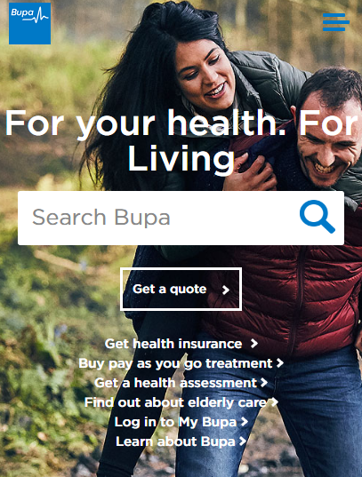

**DESIGN CHANGES**

n/a

**CONSIDERATIONS**

The homepage image on the control will be changing soon. A brief has gone in today to change this.

**VARIATION #1**

**Desktop:**

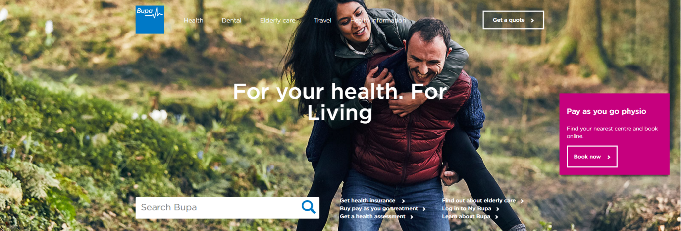

**Mobile:**

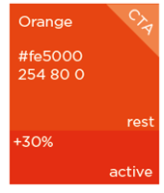

**DESIGN CHANGES**

Update the ‘Get a quote’ button to the orange colour with white copy and rounded edges. Colour guide above for rest/active state of the button.

**CONSIDERATIONS**

The homepage image on the control will be changing soon. A brief has gone in today to change this.

**QA: VARIATION 1**

**USER STORY:**

n/a

**QA SCRIPT**

|  |  |  |  |  |  |  |  |  |  |  |  |
| --- | --- | --- | --- | --- | --- | --- | --- | --- | --- | --- | --- |
|  | **DESKTOP** | | | | | | | **TABLET** | | **MOBILE** | |
| **INTERACTION** | **IE9** | **IE10** | **IE11** | **EDGE** | **CHM** | **SF** | **FF** | **iPad** | **Other** | **iPhone** | **Other** |
| [WWW.URL.COM](http://WWW.URL.COM) | | | | | | | | | | | |
| Element name |  |  |  |  |  |  |  |  |  |  |  |
| Element name |  |  |  |  |  |  |  |  |  |  |  |
| Element name |  |  |  |  |  |  |  |  |  |  |  |
| Element name |  |  |  |  |  |  |  |  |  |  |  |
| [WWW.URL.COM](http://WWW.URL.COM) | | | | | | | | | | | |
| Element name |  |  |  |  |  |  |  |  |  |  |  |

_______________________________________

**QA: VARIATION 2**

**USER STORY:**

n/a

**QA SCRIPT**

|  |  |  |  |  |  |  |  |  |  |  |  |
| --- | --- | --- | --- | --- | --- | --- | --- | --- | --- | --- | --- |
|  | **DESKTOP** | | | | | | | **TABLET** | | **MOBILE** | |
| **INTERACTION** | **IE9** | **IE10** | **IE11** | **EDGE** | **CHM** | **SF** | **FF** | **iPad** | **Other** | **iPhone** | **Other** |
| [WWW.URL.COM](http://WWW.URL.COM) | | | | | | | | | | | |
| Element name |  |  |  |  |  |  |  |  |  |  |  |
| Element name |  |  |  |  |  |  |  |  |  |  |  |
| Element name |  |  |  |  |  |  |  |  |  |  |  |
| Element name |  |  |  |  |  |  |  |  |  |  |  |
| [WWW.URL.COM](http://WWW.URL.COM) | | | | | | | | | | | |
| Element name |  |  |  |  |  |  |  |  |  |  |  |

**SOW**

|  |  |  |  |
| --- | --- | --- | --- |
| **DESIGN:** |  | **ESTIMATED HOURS:** |  |
| **TEST PLAN:** |  | **ESTIMATED HOURS:** |  |
| **DEVELOPMENT:** |  | **ESTIMATED HOURS:** |  |
| **QA:** |  | **ESTIMATED HOURS:** |  |
| **ANALYSIS:** |  | **ESTIMATED HOURS:** |  |
| **DEBRIEF:** |  | **ESTIMATED HOURS:** |  |
|  | | **TOTAL:** |  |

_______________________________________

**DELIVERABLES**

|  |  |  |  |
| --- | --- | --- | --- |
| **DELIVERABLE** | **SCHEDULLED** | **DELIVERED** | **LINK / NOTES** |
| Designs |  |  |  |
| Test Plan |  |  |  |
| Preview links |  |  |  |
| Data extract (Overall) |  |  |  |
| Data extract (Mobile) |  |  |  |
| Insights report (Overall) |  |  |  |
| Insights report (mobile) |  |  |  |
| Debrief Call |  |  |  |

**NOTES:**

Preview link: ?optimizely_xExperimentID=variationNumber

QA Videos: www.url.com

Results link: www.url.com



**RedEye Milton Keynes**

38 Shenley Pavilions,

Chalkdell Drive, Milton Keynes, Bucks, MK5 6LB

Tel: +44 (0) 1908 340 990

**RedEye Crewe**

Oak House, Crewe Hall Farm,  
Crewe, Cheshire, CW1 5UE

Tel: +44 (0) 1270 848 490

**RedEye London**35-38 New Bridge,  
London, EC4V 6BW

Tel: +44 (0) 207 730 9958

**Thank You**

For further information or to ask any questions, please contact:

Phone: 01270 242 658

www.redeye.com