

[BUTLIN’S]

*TEST PLAN #10514   
LMW: Mobile: Sitewide: Newsletter Pop Up*

**BACKGROUND**

|  |
| --- |
| **EVIDENCE:**  Insights from a similar test on Butlins mobile site showed that a pop up on the brochure pages offering an incentive increased newsletter sign ups through the mobile site by 2600%. |

|  |
| --- |
| **PAGE(s):**  All brochure pages (i.e. excluding booking funnel steps) |

|  |  |  |  |
| --- | --- | --- | --- |
| **MUV:**  TBC |  | **TEST TYPE:**  AB |  |

_______________________________________

**OBJECTIVE**

Please fill in the areas in <>

|  |
| --- |
| **HYPHOTHESIS:**  By presenting the newsletter sign up in a pop up and offering an incentive to returning visitors we will improve its visibility and also encourage users to sign up to receive a discount. This results in an estimated uplift of 2600% in newsletter signs up on the mobile site. |

|  |
| --- |
| **TEST GOAL:**  Increase newsletter sign ups |

|  |
| --- |
| **KSM(s):**  Completed newsletter sign up submissions |

_______________________________________

**VARIANTS**

|  |
| --- |
| **INFORMATION:**  Control – N/A  Variation 1 – Newsletter sign up presented in a pop up with an incentive |

**TARGETING**

|  |
| --- |
| **DOMAINS:**  m.bigweekends.com |

|  |
| --- |
| **URL(s):**  m.bigweekends.com – substring match  URL’s to exclude - mobile.butlins.com/sw/ – substring match |

|  |  |
| --- | --- |
| **DEVICES:**  Devices included in the test and that will be used for QA purposes   * Mobile | **BROWSERS:**  Browsers included in the test and that will be used for QA  purposes   * IOS * Android |

|  |
| --- |
| **OTHER:**  All booking funnel pages to be excluded: mobile.butlins.com/sw/ – substring match  Returning visitors only  Do not show the user the pop up for 3 months once they have closed it |

_______________________________________

**METRICS**

All metrics that should be tracked for reporting purposes

|  |  |  |  |  |
| --- | --- | --- | --- | --- |
| **NAME** | | **TYPE** | **DESCRIPTION** | **STATUS** |
| 1. Successful newsletter sign ups | | Custom | Users successfully submitting a newsletter sign up |  |
| 1. Step 9 Mobile: Booking confirmation | | Pageview | Users reaching step 9 of the booking funnel |  |
| 1. Steps 1-8 Mobile | | Pageview | Users reaching the different funnel steps |  |
| 1. Total Revenue | | Custom | Revenue from completed booking |  |
| 1. **Pop Up: Close overlay** | | Click (this one is over done – I’m already tracking closing of the popup at step1,2,3,etc) | Users clicking to close the pop up |  |
| 1. Pop Up: email input field engagement | | Click | Users engaging with the pop up email field |  |
| 1. Pop Up: Title button engagement | | Click | Users engaging with the pop up title button |  |
| 1. Pop Up: First name field engagement | | Click | Users engaging with the pop up first name field |  |
| 1. Pop Up:Last name field engagement | | Click | Users engaging with the pop up last name field |  |
| 1. Pop Up: Subscribe/Sign up CTA clicks | | Click | Users engaging with the pop up Subscribe/Sign up CTA |  |
| 1. ` | | Custom | Users that trigger the pop up error message |  |
| 1. Pop Up: Close overlay step 1 | | Click | Users that close the pop up on step 1 |  |
| 1. Pop Up: Close overlay step 2 | | Click | Users that close the pop up on step 2 |  |
| 1. Pop Up: Close overlay step 3 | | Click | Users that close the pop up on step 3 |  |
| 1. **-=Overall engagement** | | **Click Created by optimizely and is called engagement.** | Users that click on any element on the page |  |
| 1. WELCOME10 promo code submission | | Custom W11 | Users that complete a booking using the promo code WELCOME10 |  |
| 1. Footer: Newsletter: Submit CTA | | Click | Users successfully submitting an email sign up from the footer |  |
|  |
|  | |  |  |  |

**ATTRIBUTES**

Attributes are utilised to segment test results for data analysis

|  |  |  |
| --- | --- | --- |
| **SEGMENT** | **DESCRIPTION** | **STATUS** |
| Returning visitors | Visitors that have visited the site for the second time |  |
|  |  |  |
|  |  |  |

_______________________________________

**INTEGRATIONS**

Any tools that should be integrated with the test e.g. analytics, heat mapping, etc.

|  |  |
| --- | --- |
| **TOOL** | **SLOT / TAG INFORMATION** |
| NA | NA |
|  |  |

**CONTROL**

|  |  |
| --- | --- |
| **DESKTOP:** | **MOBILE:** |

**DESIGN CHANGES**

n/a

**CONSIDERATIONS**

n/a

**VARIATION #1**

Mobile:

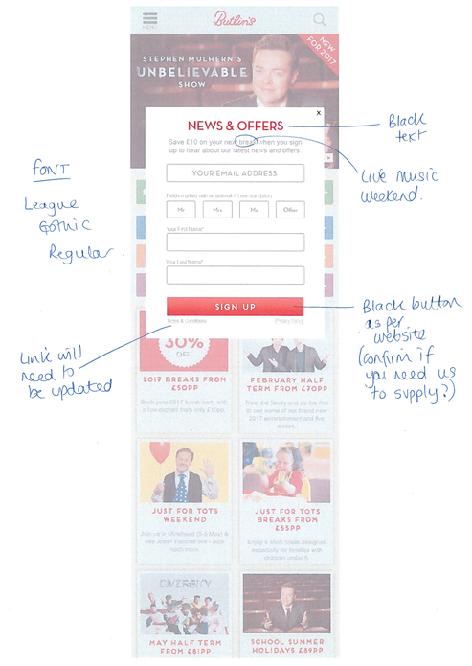

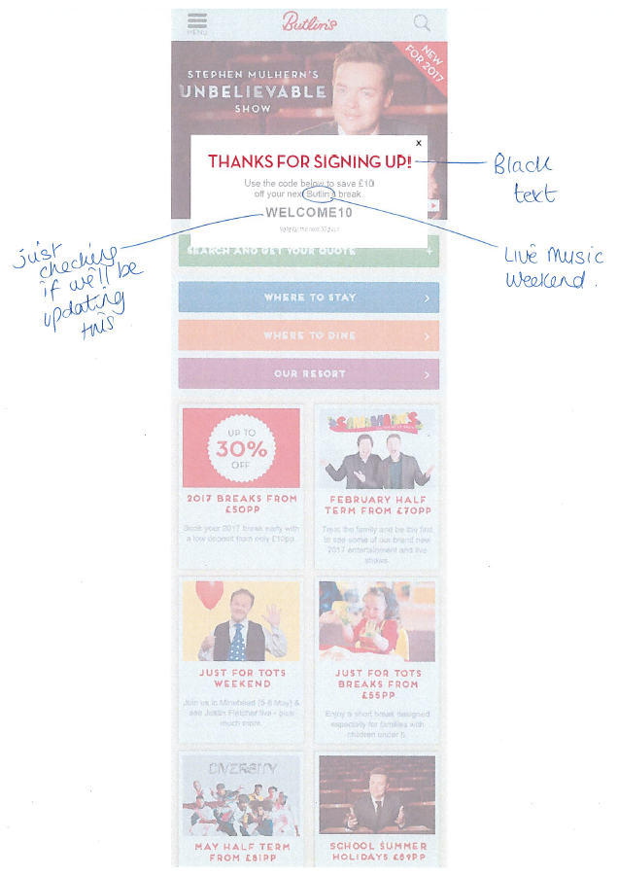

**DESIGN CHANGES**

Use pop up from Butlin’s.com test as a template with following changes;

* News and offers heading text black instead of red
* Butlin’s copy changed to Live music weekend
* Font in main copy changed to League Gothic Regular
* Black CTA instead of Red

**CONSIDERATIONS**

Pop up appears to return visitors only

Pop up appears once a user has been on the website for 15 seconds

Pop up uses existing email sign up fields:

<https://m.bigweekends.com/h5/bookingHub?pagePath=https%3A%2F%2Fwww.bigweekends.com%2Flinks%2Fother-links%2Fkeep-me-updated%2Findex.aspx%3Femailaddress%3D>

A user will not see the pop up again for 3 months once they have closed the overlay

**QA: VARIATION 1**

This area of the test plan is filled in by RedEye’s QA Manager.

**USER STORY:**

n/a

**QA SCRIPT**

|  |  |  |  |  |  |  |  |  |  |  |  |
| --- | --- | --- | --- | --- | --- | --- | --- | --- | --- | --- | --- |
|  | **DESKTOP** | | | | | | | **TABLET** | | **MOBILE** | |
| **INTERACTION** | **IE9** | **IE10** | **IE11** | **EDGE** | **CHM** | **SF** | **FF** | **iPad** | **Other** | **iPhone** | **Other** |
| [WWW.URL.COM](http://WWW.URL.COM) | | | | | | | | | | | |
| Element name |  |  |  |  |  |  |  |  |  |  |  |
| Element name |  |  |  |  |  |  |  |  |  |  |  |
| Element name |  |  |  |  |  |  |  |  |  |  |  |
| Element name |  |  |  |  |  |  |  |  |  |  |  |
| [WWW.URL.COM](http://WWW.URL.COM) | | | | | | | | | | | |
| Element name |  |  |  |  |  |  |  |  |  |  |  |

_______________________________________

**SOW**

|  |  |  |  |
| --- | --- | --- | --- |
| **DESIGN:** |  | **ESTIMATED HOURS:** | NA |
| **TEST PLAN:** |  | **ESTIMATED HOURS:** | 2 |
| **DEVELOPMENT:** |  | **ESTIMATED HOURS:** | 12 |
| **QA:** |  | **ESTIMATED HOURS:** | 5 |
| **ANALYSIS:** |  | **ESTIMATED HOURS:** | 3 |
| **DEBRIEF:** |  | **ESTIMATED HOURS:** | 0.5 |
|  | | **TOTAL:** | 22.5 |

_______________________________________

**DELIVERABLES**

|  |  |  |  |
| --- | --- | --- | --- |
| **DELIVERABLE** | **SCHEDULLED** | **DELIVERED** | **LINK / NOTES** |
| Designs | NA |  |  |
| Test Plan | 12/07/2017 |  |  |
| Preview links | TBC |  |  |
| Data extract (Overall) | TBC |  |  |
| Data extract (Mobile) | TBC |  |  |
| Insights report (Overall) | TBC |  |  |
| Insights report (mobile) | TBC |  |  |
| Debrief Call | TBC |  |  |

**NOTES:**

Preview link: ?optimizely_xExperimentID=variationNumber

QA Videos: www.url.com

Results link: www.url.com



**RedEye Milton Keynes**

38 Shenley Pavilions,

Chalkdell Drive, Milton Keynes, Bucks, MK5 6LB

Tel: +44 (0) 1908 340 990

**RedEye Crewe**

Oak House, Crewe Hall Farm,  
Crewe, Cheshire, CW1 5UE

Tel: +44 (0) 1270 848 490

**RedEye London**35-38 New Bridge,  
London, EC4V 6BW

Tel: +44 (0) 207 730 9958

**Thank You**

For further information or to ask any questions, please contact:

Phone: 01270 242 658

www.redeye.com