# No Tickets Found (NTF) messaging on EDP

# Hypothesis

* Increasing the prominence of primary tickets on the NTF alert will increase Ticketmaster orders and conversion
* An improved design will reduce exit rates

**Background**

* **The No Tickets Found (NTF) status appears when tickets have sold out for the selected event**. **The aim of NTF is to direct customers to other dates and platinum if available**. **If tickets are available on Seatwave, these will also be shown**. However, the **priority** is to sell all primary tickets (other dates and platinum) first
* We would like to test a design that increase the prominence of primary tickets whilst still providing access to Seatwave tickets
* Of the 2 million visits to this page last year, 60% exited the Ticketmaster site:

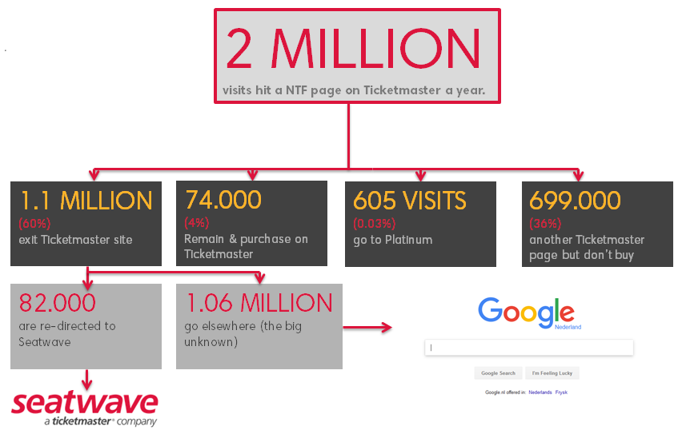

**Related KPI (s)**

|  |  |  |  |
| --- | --- | --- | --- |
| **Increase site conversion (general)**  Increase site conversion on desktop by 1%  Increase site conversion on mobile by 10%  Increase site conversion on tablet by 4% | **Increase EDP conversion (general)**  Increase EDP conversion on desktop by 6%  Increase EDP conversion on mobile by 10%  Increase EDP conversion on tablet by 3% | | **Increase checkout conversion by 6%**  **Increase Digital Ticket take-up by 3%**  **Other:** |
| **Device types included** | | Domains included | |
| |  |  | | --- | --- | | **Desktop***SC_Laptop.png* | **Tablet**  SC_Tablet.png | | **Mobile**  SC_Mobile.png | **Apps**  SC_Mobile.png | | | |  |  | | --- | --- | | **Denmark** | **Norway** | | **Finland** | **Sweden** | | **Germany** | **Spain** | | **Netherlands** |  | |  |  | | |
|  | |  | |

**Targeting the Ticketmaster apps (embedded checkout)**

The variable **evar65** identifies when embedded checkout mode is running. This value should be used in Monetate to include or exclude app traffic from a test.

Indicate below whether **evar65** should be included or excluded for this test:

**Yes** –inclusion is required (test will appear in the apps)

**No** – exclusion is required (test will not appear in the apps)

**Target Audience** (if relevant)

* n/a

**List of variants**

Default

1. Redesign the current NTF message (with icons)

**Use cases/considerations** (please include referenceable examples, where relevant)

* Links to each option will disappear dynamically when tickets are no longer available (e.g. don’t show link to ‘select another date’ if there are no other dates)
* There are several combinations depending on availability in each category. Refer to default section

**Metrics**

**Required for all tests:**

* Revenue per variant

**Additional metrics:**

* Track number of clicks on each button (needs to be tracked separately)
* Purchase conversion
* Visits from EDP> confirmation
* Exit rate from the EDP

### Desired segmentation of results (if relevant)

* N/A

**Test event URLs**

**DE -** http://www.ticketmaster.de/event/DEMVVK04  
**DK –** http://www.billetnet.dk/event/365533   
**DK –** <http://www.billetnet.dk/event/396437> (real demo - credit card can be used)   
**FI –** http://www.lippupalvelu.fi/event/test-event-ei-myyntia-not-on-sale-lippuja/117127  **NL –** http://www.ticketmaster.nl/event/testvoorstelling-tickets/116999  **SE –** http://www.ticnet.se/event/DEMFUNK3

**Targeting**

* The following is set when Platinum/ Seatwave + other dates are available:

**prop18= EDP - No availability fallback**

* The following is set when other dates are available with no other options:

**prop18= EDP - Sold out**

**Variant detail**

**Default (Control)**

**Platinum + other dates**

* This is the NTF view when other dates and Platinum tickets are available.
* The ‘Select more options’ link redirects to the artist page where other dates are displayed
* The Platinum link at the top anchors to the Platinum module lower down. The ‘view tickets’ link in the Platinum module goes to the Platinum EDP
* From pricing is displayed in the Platinum module

Examples:

<http://www.ticketmaster.nl/event/pet-shop-boys-tickets/186711?language=en-us>

<http://www.ticketmaster.nl/event/andrea-bocelli-tickets/179323?language=en-us>

<http://www.ticketmaster.nl/event/jamiroquai-tickets/184701?language=en-us>

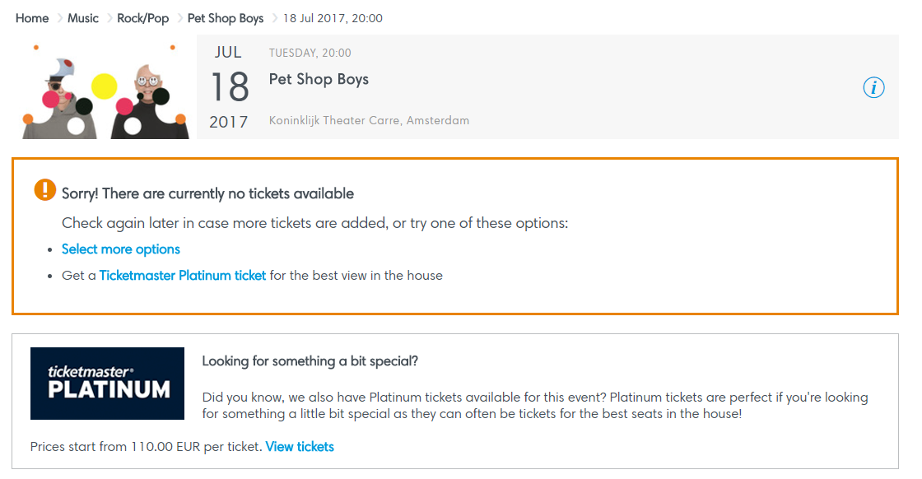

**Seatwave + other dates**

* This NTF message will appear when Platinum tickets are not available
* Seatwave from pricing is displayed at the top. Each available price type is listed in a table with a link to Seatwave.
* The link to more dates will also appear if available
* The Seatwave referral is currently deactivated in NL

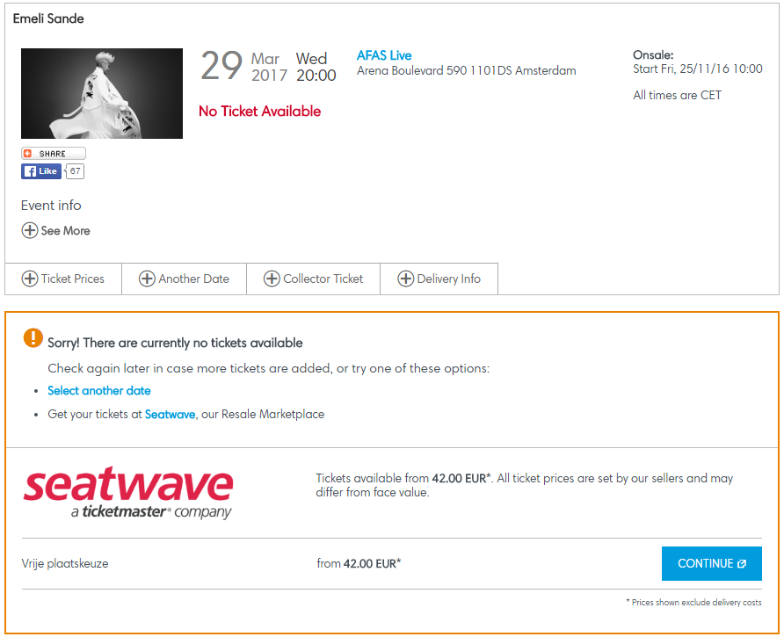

**All options available (Platinum, Seatwave and other dates)**

* Below is an example with availability in each category
* Each available price type is listed in a table with a link to Seatwave. The link to each price type is identical
* The Seatwave referral is currently deactivated in NL

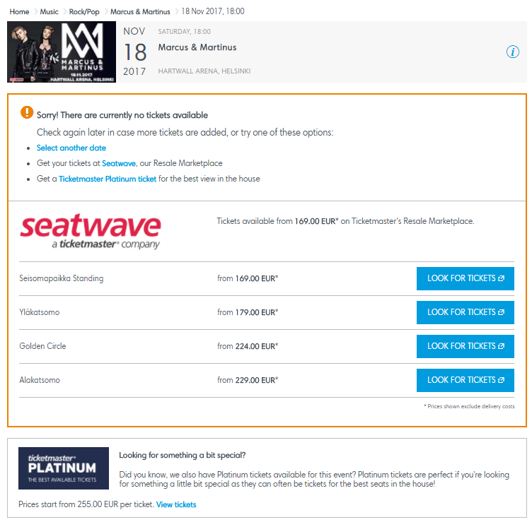

<http://www.ticketmaster.fi/event/marcus-martinus-lippuja/208513>

**Other dates available (no other options)**

* ‘Select more options’ links to the Artist page where other dates can be chosen

Examples:

<http://www.ticketmaster.nl/event/ed-sheeran-supports-tickets/191175?language=en-us>

<http://www.ticketmaster.nl/event/royal-blood-tickets/188979?language=en-us>

<http://www.ticketmaster.nl/event/the-national-tickets/188379?language=en-us>

<http://www.ticketmaster.nl/event/harry-styles-tickets/188233?language=en-us>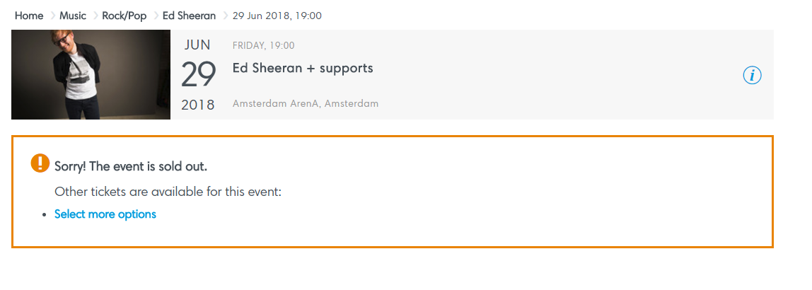

**Variant 1**

**Description:**

* Test new design
* View other dates – goes to the artist page where other dates can be chosen. **Note:** the ‘view dates’ link is not working currently due to a bug. Bug fix is being released on 12th July
* Platinum link – goes to Platinum version of the EDP
* View Resale Tickets – external link to Seatwave (opens in a new window). **Note**: on the default, each price type is listed in a table. In this test, the table is replaced with a single button
* Seatwave and Platinum from pricing should be pulled from the default. For Seatwave, if there are multiple options on the default, the lowest price should be shown
* Use English and Dutch copy shown in the design

**Screenshot/s:**

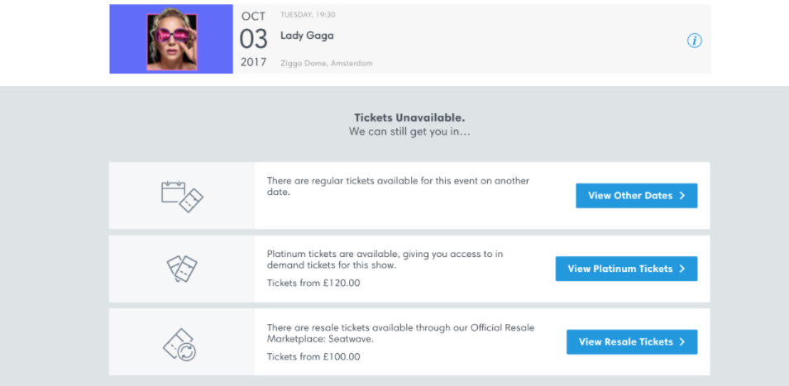

**Links to designs on Zeplin:**

Desktop/ mobile:

English copy

<https://app.zeplin.io/project/573c76f48971b5cf51432bb7/screen/595b698b53a31f948d90fd3e>

Dutch copy

<https://app.zeplin.io/project/573c76f48971b5cf51432bb7/screen/595b698785ef51d4294c434b>

**Translations**

|  |  |  |
| --- | --- | --- |
|  | **MFOL MVT - No Tickets Found** |  |
| Element | English Copy | Translation NL |
| Title | Tickets Unavailable | Helaas, er zijn geen tickets meer beschikbaar. |
| Sub title | We can still get you in... | We kunnen je nog steeds aan tickets helpen! |
| Copy | Continue to Platinum, to get access to in demand tickets for this show | Ga naar Platinum tickets, dit zijn de best beschikbare zitplaatsen. |
| CTA | View Platinum Tickets | Bekijk Platinum Tickets |
| Copy | There are regular tickets available for this event on another date | Er zijn nog tickets beschikbaar voor een andere dag, bekijk de beschikbaarheid hier. |
| CTA | View Other Dates | Bekijk Andere Datum |
| Copy | There are resale tickets available through our Official Resale Marketplace: Seatwave | Er zijn tweedehands tickets beschikbaar op ons officiële marktplaats Seatwave. |
| CTA | View Resale Tickets | Bekijk Seatwave Tickets |
| CTA | Continue to Platinum | Ga naar Platinum Tickets |
| Copy | Platinum tickets are available, giving you access to in demand tickets for this show | Er zijn Platinum tickets beschikbaar, dit zijn de best beschikbare zitplaatsen. |
| Copy | Tickets from [price] | Tickets vanaf [price] |