Dockerfile contents

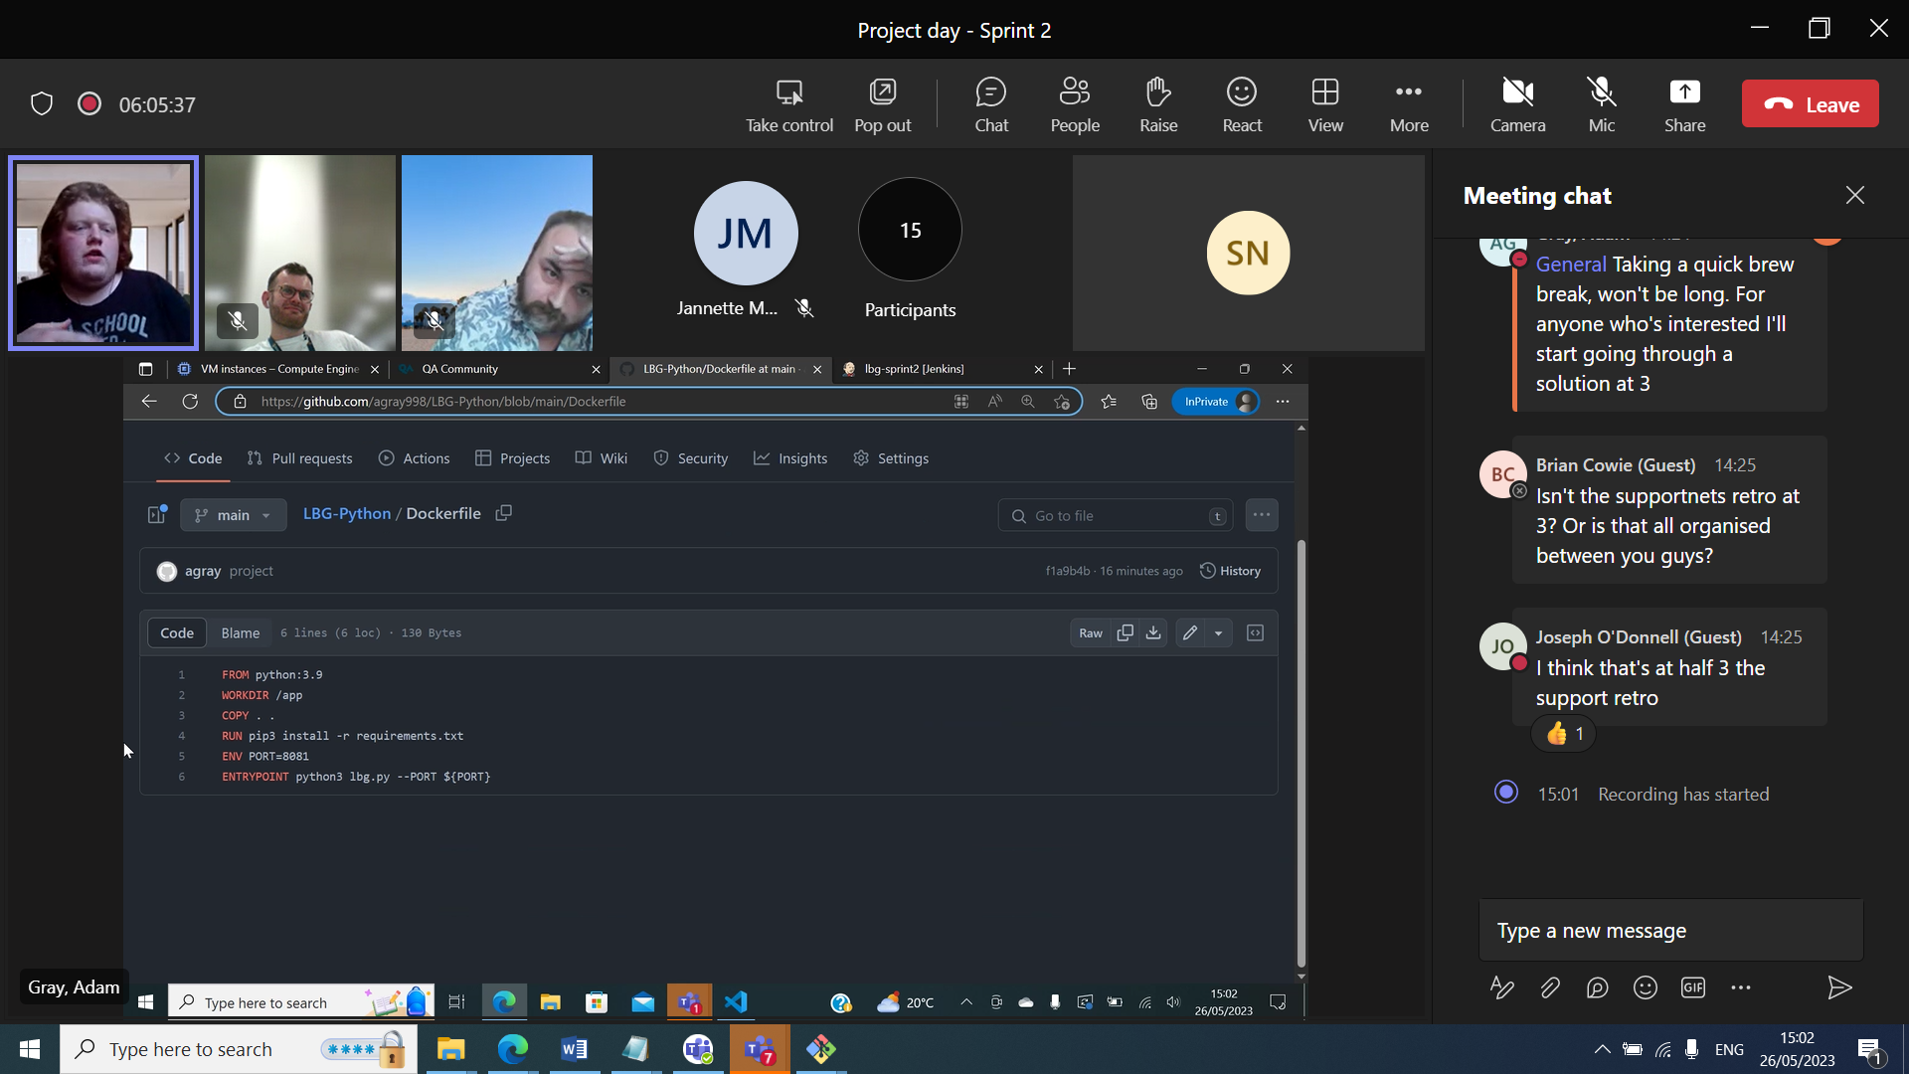

*Problem with python type hint so need newer version of python such as 3.11or change code

Need all files so copy over all . .

--PORT can be specified as above or can modify application to specify

**Docker-compose.yaml**

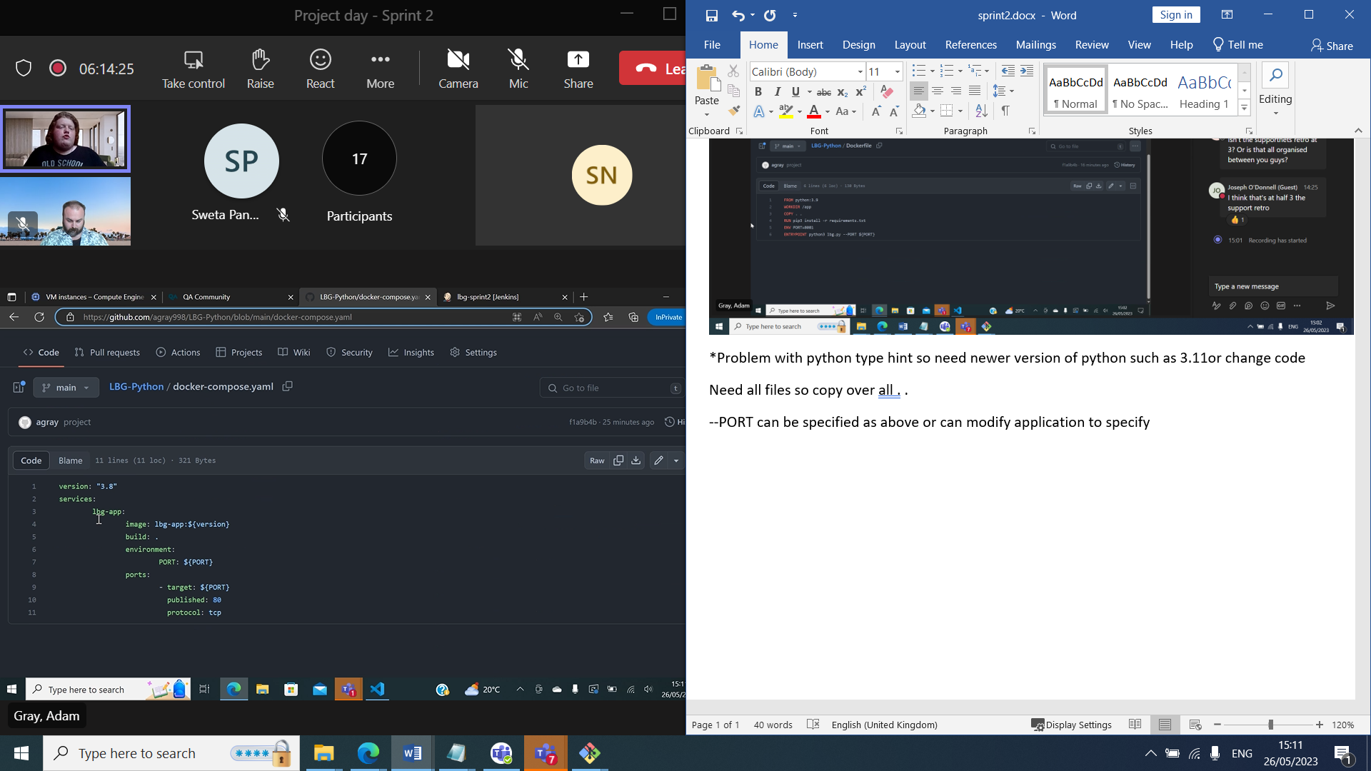

Setting variables allows you to dynamically set the ports etc and additional parameterisation ${version} defaults to latest if not specified . Here an image is built using build using the Dockerfile, not instead of yaml, has to have both.

**Bash script**

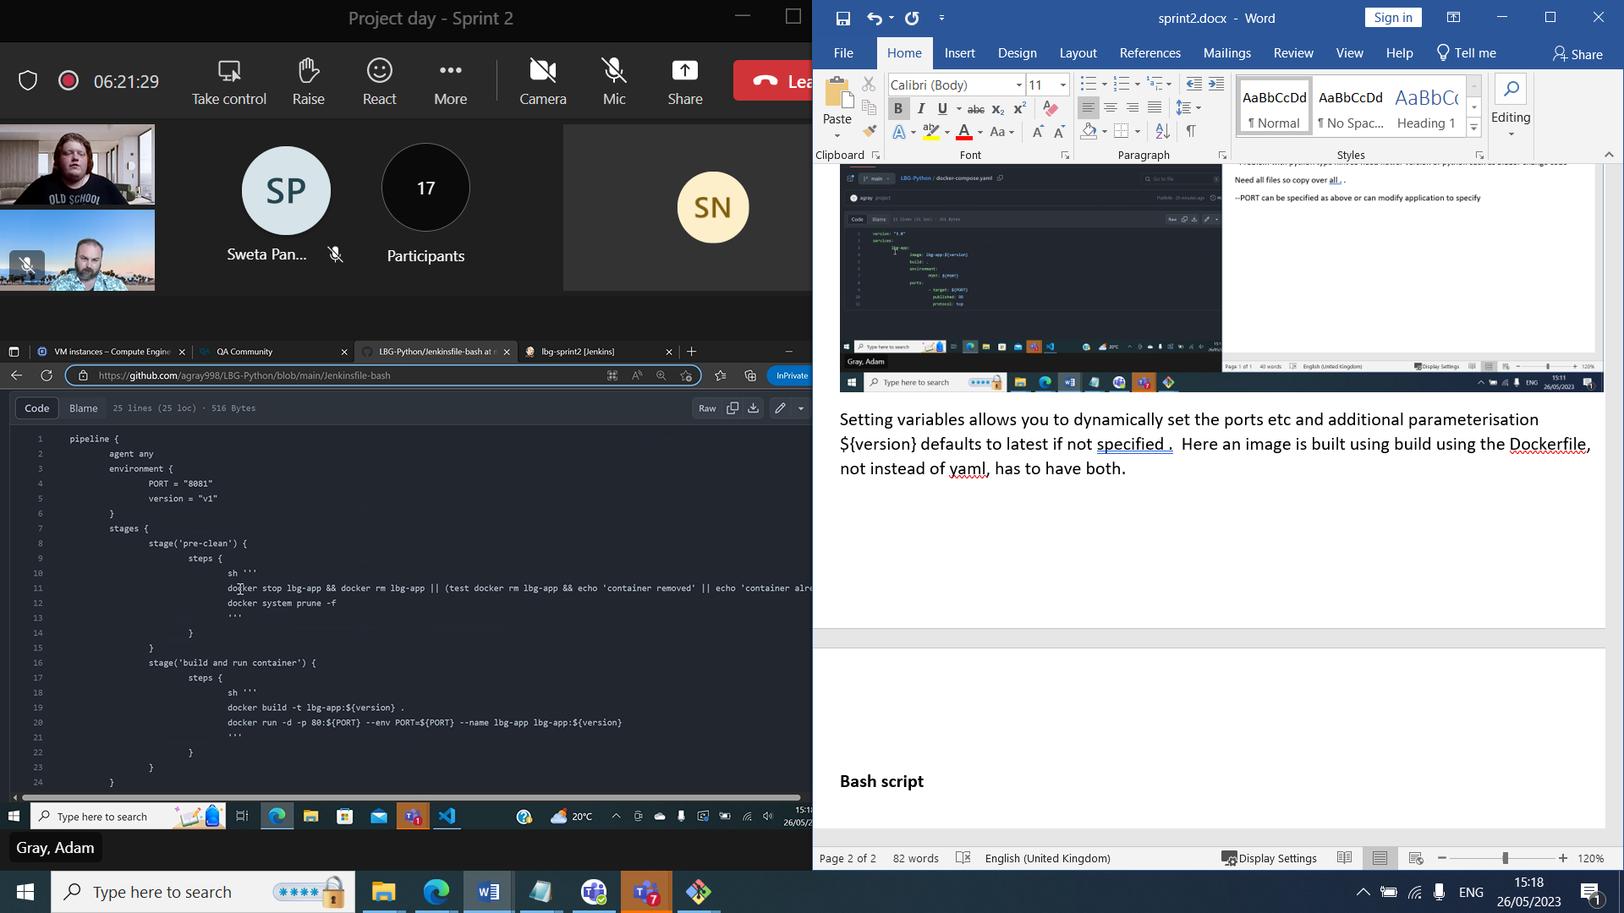

This can be created as a shell file in repo and run in terminal ./name

Jenkinsfile using docker-compose script

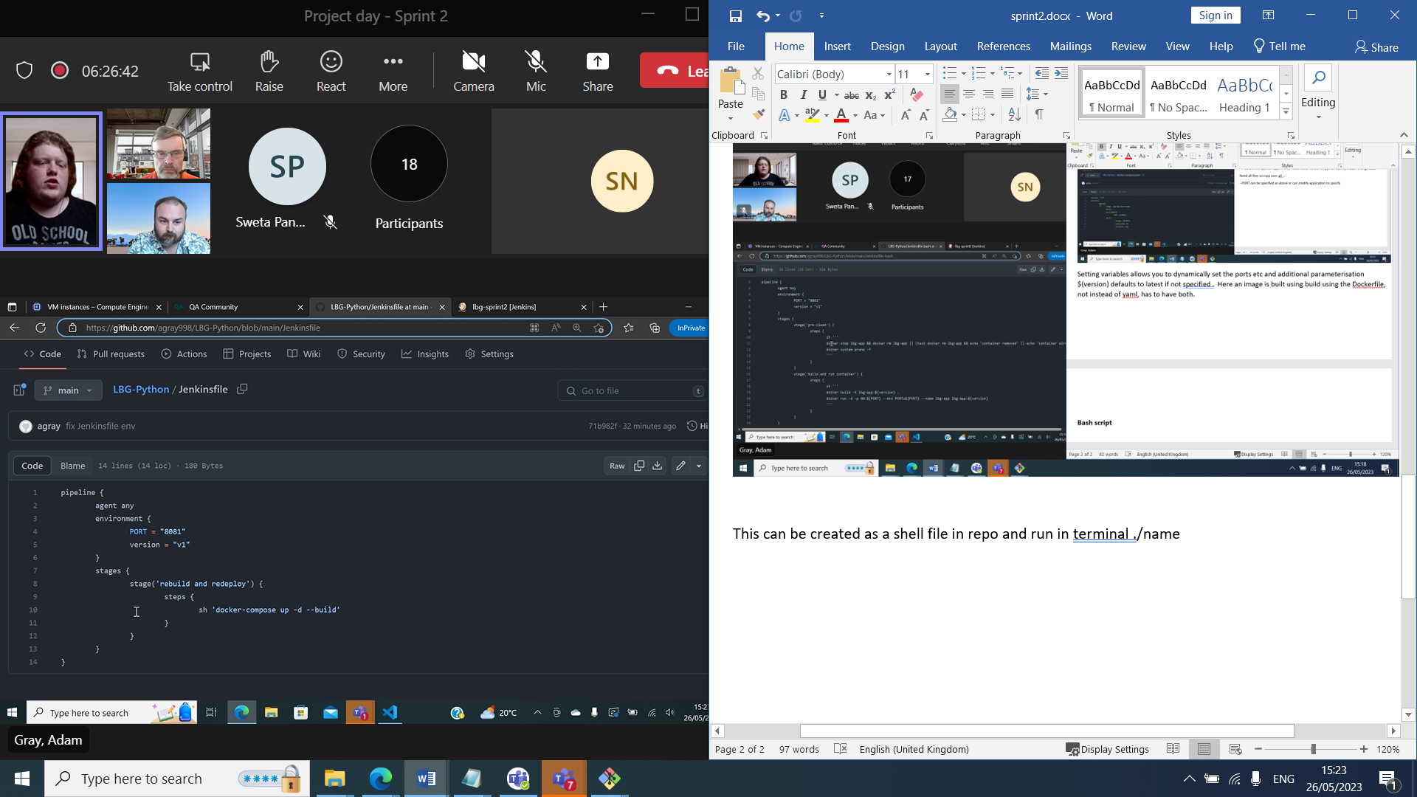

Jenkinsfile using bash script

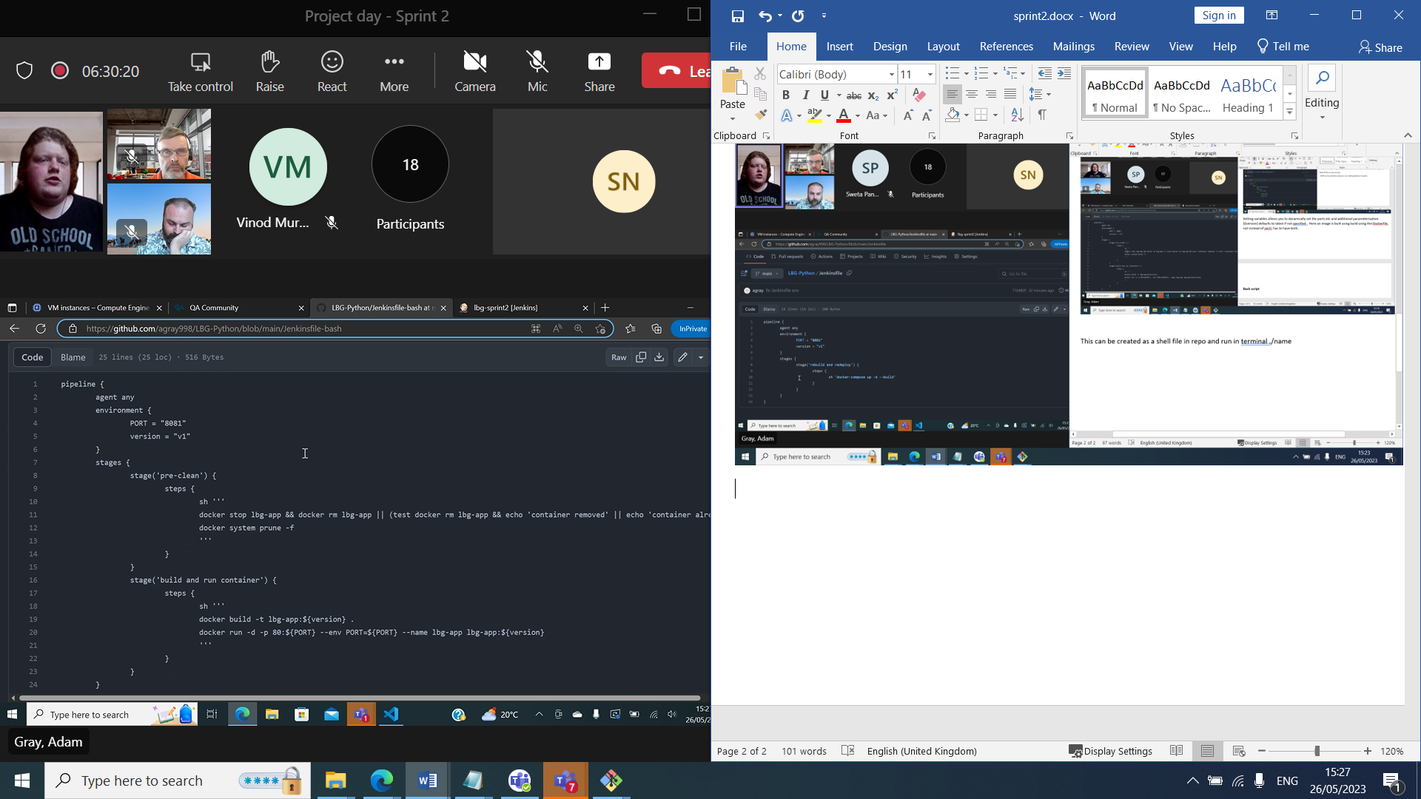

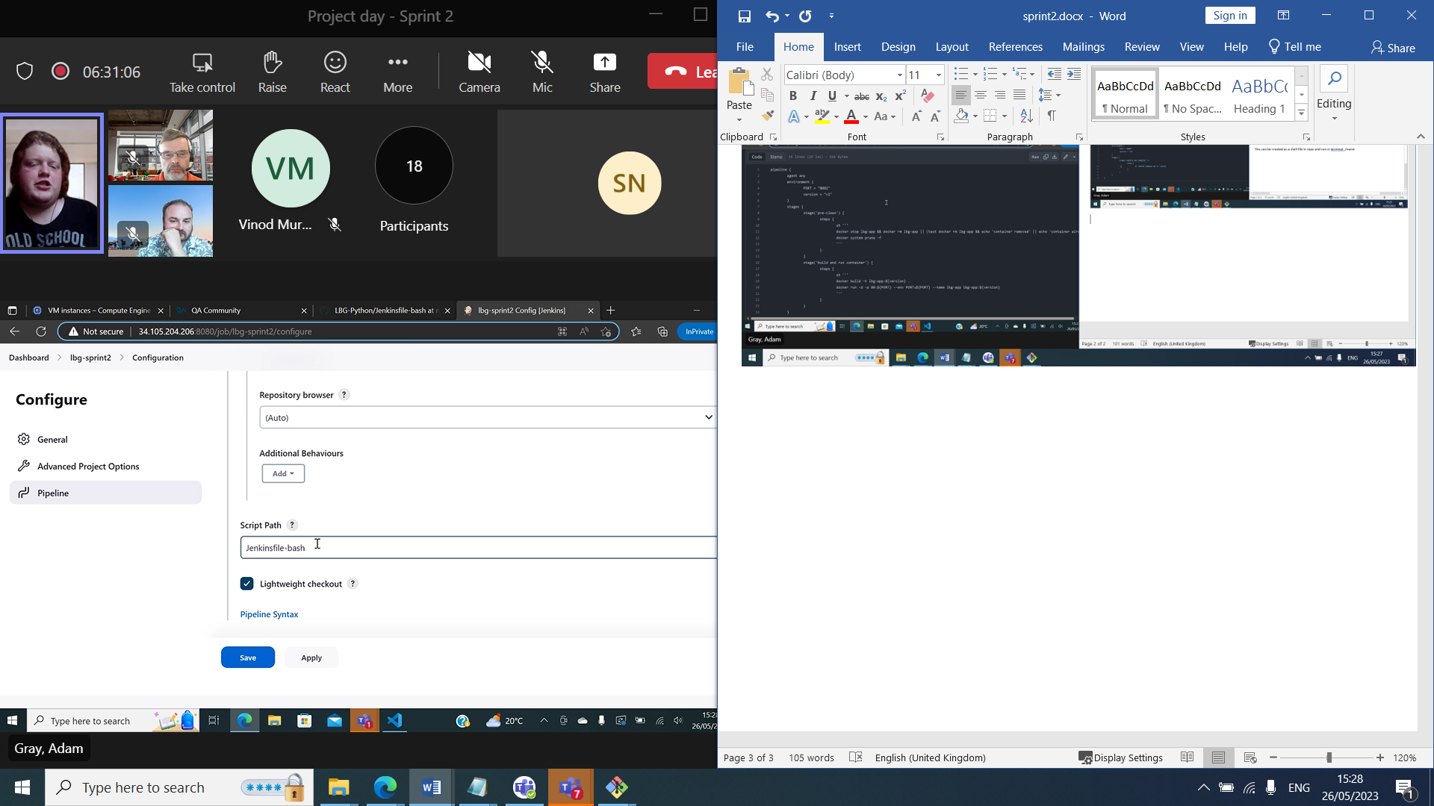

Change between script and compose in script path configs