

DEPARTMENT OF CREATIVE TECHNOLOGIES

Project Title: CPU Process Scheduler
Course Name: Data Structures Lab
Course Code: CS216L
Class: BSSE-F-24-A
Submitted To: Ms. Aisha Sattar
Date of Submission: 12/21/2025

Group members:
Name
Hashir Ahtesham
Safeera Saleem
Fatima Tahir

Table of Contents
- Why this project?……………………………………………………………………….....3
- Problem Statement……………………………………………………………………...…3
- Proposed Solution………………………………………………………………………....3
- Methodology………………………………………………………………………...…….4
- Algorithms to be implemented……………………………………………………………4
- DSA Concepts……………………………………………………………….………...…..4
- Application of techniques……...…………………………………………….……………5
- Flow Of Operations…….……………………………………………………………….....5
- Entity Resource Diagram…………………………………………………………….……8
- Flowchart………………………………………………………………………………….9
- Output……………………………………………………………………………………10
- Future work………………………………………………………………………………18
- References………………………………………………………………………………..19
- Conclusion…………………………………………………………………………….…19

Why This Project?
CPU scheduling is a fundamental concept in modern operating systems, and this project provides a practical way to apply and strengthen Data Structures and Algorithms knowledge. By implementing multiple scheduling algorithms, we can observe how different data structures impact performance, efficiency, and execution order in a system where timing and priorities matter.
This project also bridges the gap between theory and practice, allowing us to use queues, heaps, arrays, and trees together to solve a real system-level problem. It demonstrates how DSAs operate behind the scenes in actual OS schedulers and gives a deeper understanding of process management in real computing environments.

Problem Statement:
In a computer system, multiple processes often need the CPU at the same time, but the processor can only execute one process at a moment. Without an organized way to decide which process should run first, the system can become slow, unfair, or unresponsive. Some processes might wait too long, while others may take up too much CPU time. The challenge is to design a scheduling method that manages these processes efficiently, keeps the system responsive, and ensures fairness among all running tasks.

Proposed Solution:
We propose a CPU Process Scheduler simulation system that implements multiple scheduling algorithms to manage processes efficiently. The system will:
- Accept process input (arrival time, burst time, priority).
- Allow selection of scheduling algorithms (FCFS, SJF, SRTF, Priority, Preemptive Priority, Round Robin, Multilevel Queue).
- Optionally include Multilevel Feedback Queue (MLFQ).
- Calculate and display process execution order, waiting time, turnaround time, and CPU utilization.
- Include Gantt chart simulation to visualize CPU execution timeline.

Methodology:
The project uses a simulation-based approach to model CPU scheduling in an operating system. Process details are collected from the user and stored in structured process records. The processes are then sorted based on their arrival time to maintain the correct execution order. After selecting a scheduling algorithm, the system simulates CPU execution step by step while recording execution details. Once all processes are complete, performance metrics are calculated and displayed for analysis.

Algorithms to be Implemented:
We will implement seven core CPU scheduling algorithms and one optional advanced feature, giving maximum depth, coverage, and DSA usage:
- FCFS (First Come First Served)
- SJF (Shortest Job First)
- SRTF (Shortest Remaining Time First)
- Priority Scheduling

DSA Concepts:
To implement the CPU Process Scheduler effectively and demonstrate strong DSA usage, we will utilize a combination of basic and advanced data structures:
- Queue: Used for FCFS, Round Robin, MLQ, and MLFQ scheduling.
- Priority Queue (Min / Max Heap): Applied in SJF, SRTF, Priority, Preemptive Priority, and high-priority queues in MLQ / MLFQ to ensure that the process with the shortest burst time or highest priority executes next. (New concept)
- Linked List: Manages the ready queue, Gantt chart timeline, and maintains a dynamic list of processes. Already studied in the course.
- Dynamic Array / List: Stores final results such as burst times, waiting times, turnaround times, and process details after input. (New concept)
- Iteration and Traversal: Repeated scanning of process list to check arrival and completion
- Preemption: Running process can be interrupted when a shorter job arrives. Implemented in SRTF
- Greedy Algorithms: SJF and SRTF select the process with the minimum execution time. Priority scheduling selects the highest priority process.
- Time Complexity Awareness: Scheduling decisions are made at each time unit (SRTF). Trade-off between accuracy and efficiency.

Application of techniques:
- Linked Lists for Process Storage: Used to dynamically store process information since the number of processes can vary at runtime.
- Queues for Scheduling Order: Applied in FCFS scheduling to maintain processes in first-come, first-served order.
- Time-Based Simulation: Simulates CPU execution step by step to accurately model real scheduling behavior.
- Preemption Handling: Implemented in SRTF to allow interruption of a running process when a shorter job arrives.
- Gantt Chart Construction: Records execution and idle intervals to visualize CPU scheduling flow.
- Performance Metrics Calculation: Waiting time, turnaround time, response time, CPU utilization, and throughput are calculated to evaluate scheduling efficiency.
- File Logging: Results are saved in text and XML formats for record-keeping and future analysis.

Flow of Operations:
- System Initialization
The program starts by initializing required variables and displaying a menu for CPU scheduling simulation.

- Process Input
The user enters the total number of processes.
For each process, the user provides the arrival time, burst time, and priority.
Each process is stored in a Process Control Block (PCB) with initialized attributes such as remaining time, start time, and completion status.

- Process Arrangement
All processes are sorted based on their arrival time to ensure correct scheduling order during execution.

- Scheduling Algorithm Selection
The user selects one scheduling algorithm from the available options:
- First-Come, First-Served (FCFS)
- Shortest Job First (SJF)
- Shortest Remaining Time First (SRTF)
- Priority Scheduling

- Scheduler Execution
The system clock is initialized, and the CPU scheduling simulation begins.
At each time step, the scheduler checks for processes that have arrived and are not yet completed.

- Process Selection
The next process to execute is selected based on the chosen scheduling algorithm.
For preemptive scheduling (SRTF), the currently executing process may be interrupted if a process with a shorter remaining time arrives.

- CPU Execution & Gantt Chart Construction
The selected process is executed on the CPU.
Execution intervals, including idle CPU times, are recorded in the Gantt Chart structure to represent the scheduling timeline.

- Process Completion Handling
When a process finishes execution, its completion time is recorded, and it is marked as completed.

- Performance Metrics Calculation
After all processes complete, the system calculates performance metrics such as:
- Waiting Time
- Turnaround Time
- Response Time
- CPU Utilization
- Throughput
- Maximum and Average Times

- Result Display
The process table and Gantt Chart are displayed along with all computed scheduling statistics.

- Result Logging
The simulation results are saved to a text file and exported to an XML file for future reference.

- Program Termination
The user is prompted to run another simulation or exit the program.
The system terminates gracefully after completion.

Entity Resource Diagram:

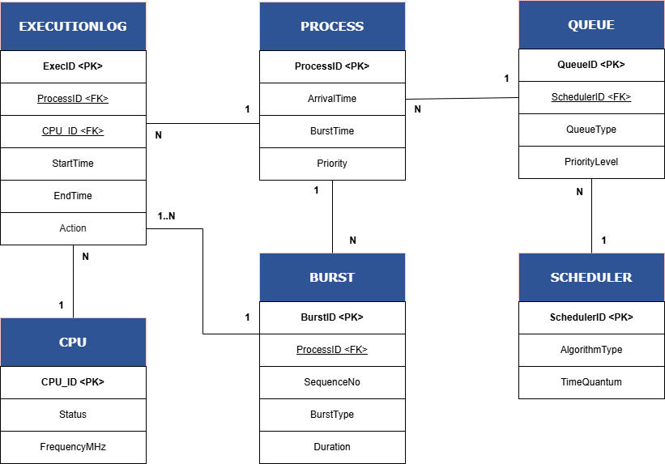

Flowchart:
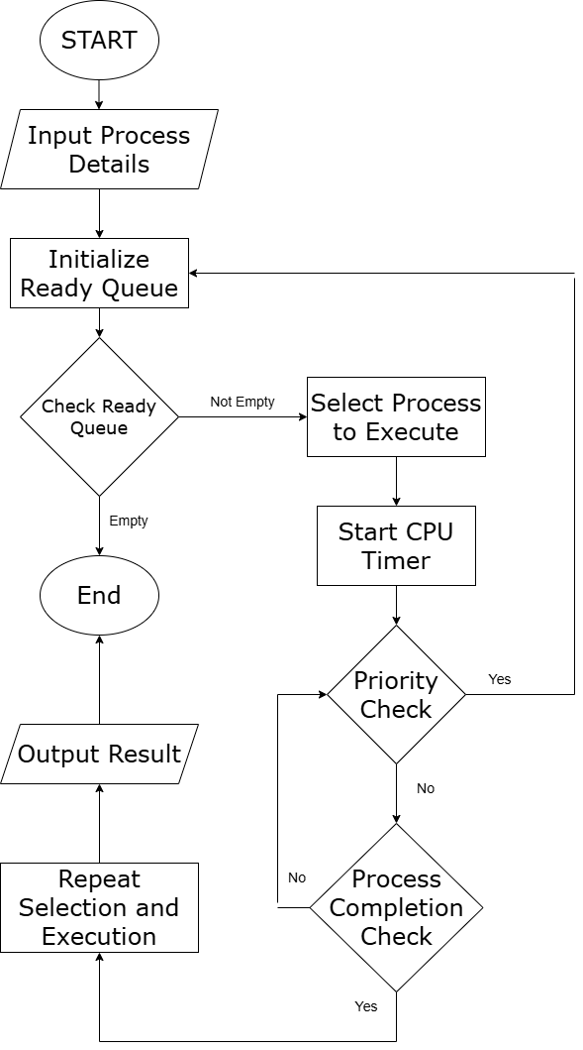

Output:
TEST CASE 1 — SHORTEST REMAINING TIME FIRST (SRTF)
1.1 Test Case Overview
Algorithm: Shortest Remaining Time First (SRTF)
Number of Processes: 4
Scheduling Type: Preemptive
Priority: User input (not used for selection)
Purpose:
- To test preemption
- To observe dynamic process switching
- To evaluate response time and CPU utilization
1.2 Input Details
Process | Arrival Time | Burst Time | Priority
P1 | 0 | 8 | 2
P2 | 1 | 4 | 1
P3 | 2 | 2 | 3
P4 | 10 | 3 | 0

1.3 Gantt Chart (Actual Program Output)
P1* (0–1) | P2* (1–2) | P3* (2–4) | P2* (4–7) | P1* (7–10) | P4* (10–13) | P1 (13–17)

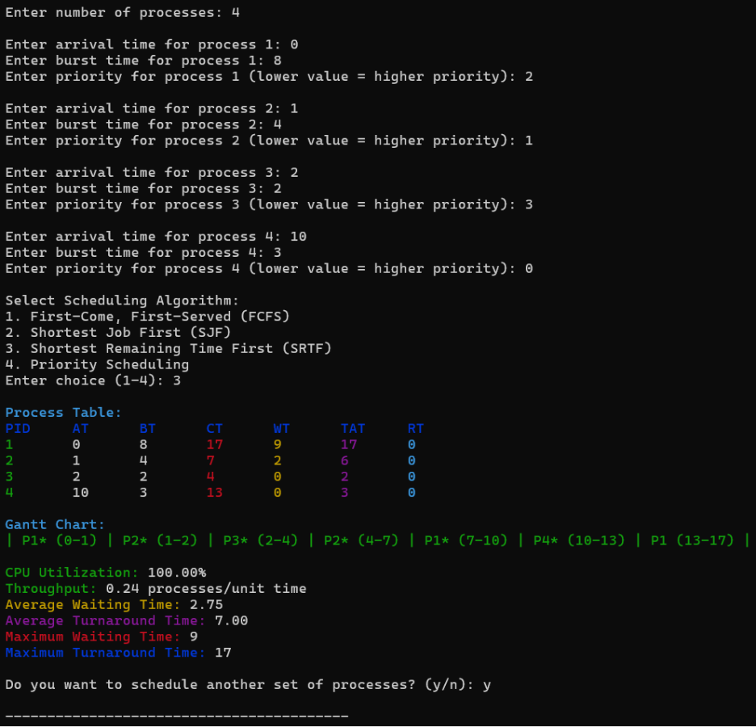
1.4 Detailed Explanation
At time 0, P1 begins execution as it is the only available process.
At time 1, P2 arrives with a shorter remaining time, causing P1 to be preempted.
At time 2, P3 arrives with the shortest burst time and is immediately scheduled.
After P3 completes, P2 resumes execution until completion.
P1 continues execution until time 10, when P4 arrives with a shorter burst time and preempts P1 again.
After P4 finishes, P1 resumes and completes execution.
TEST CASE 2 — PRIORITY SCHEDULING (NON-PREEMPTIVE)
2.1 Test Case Overview (For Slide & Report)
Algorithm: Priority Scheduling
Number of Processes: 4
Scheduling Type: Non-Preemptive
Arrival Time: Same for all processes
Scheduling Based On: Priority value
2.2 Input Details
Process | Arrival Time | Burst Time | Priority
P1 | 0 | 6 | 3
P2 | 0 | 3 | 1
P3 | 0 | 4 | 2
P4 | 0 | 2 | 0
(Lower value = higher priority)
2.3 Gantt Chart
P4 (0–2) | P2 (2–5) | P3 (5–9) | P1 (9–15)
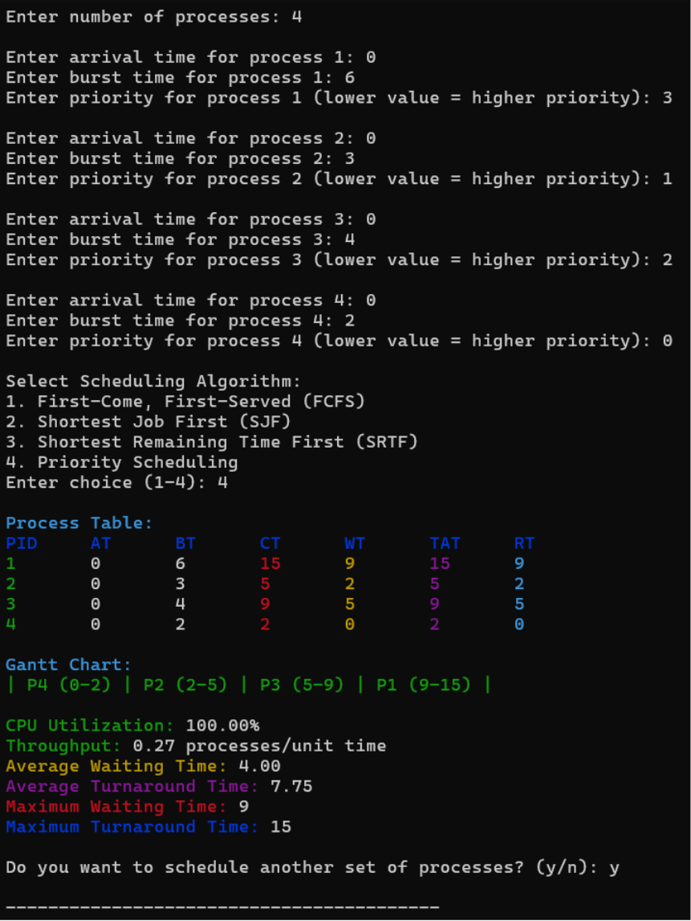

2.4 Detailed Explanation
Since all processes arrive at the same time, arrival order does not affect scheduling.
The scheduler selects processes strictly based on priority values.
P4 executes first due to highest priority, followed by P2, P3, and finally P1.
2.5 Key Observations
- Priority overrides arrival order
- No preemption occurs
- Low-priority processes wait longer
- Risk of starvation exists
TEST CASE 3 — FIRST COME FIRST SERVE (FCFS)
3.1 Test Case Overview
Algorithm: First Come First Serve
Number of Processes: 4
Scheduling Type: Non-Preemptive
Scheduling Based On: Arrival time
3.2 Input Details
Process | Arrival Time | Burst Time | Priority
P1 | 0 | 7 | 2
P2 | 2 | 4 | 1
P3 | 4 | 1 | 3
P4 | 6 | 3 | 0
3.3 Gantt Chart
P1 (0–7) | P2 (7–11) | P3 (11–12) | P4 (12–15)
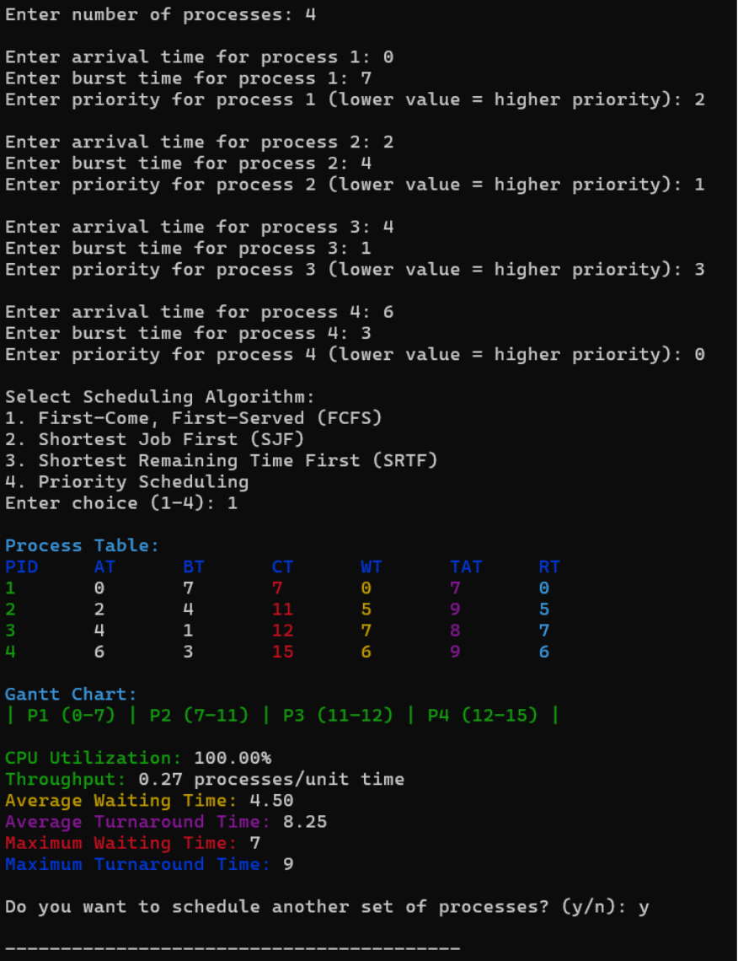

3.4 Detailed Explanation
Processes are executed strictly in the order they arrive.
P1 occupies the CPU for a long time, causing all other processes to wait.
This demonstrates the convoy effect, where shorter jobs suffer due to long jobs ahead.
3.5 Key Observations
- Simple and fair
- High waiting time
- Poor response time
- No starvation
TEST CASE 4 — SHORTEST JOB FIRST (SJF)
4.1 Test Case Overview
Algorithm: Shortest Job First
Number of Processes: 4
Scheduling Type: Non-Preemptive
Scheduling Based On: Burst time
4.2 Input Details
Process | Arrival Time | Burst Time | Priority
P1 | 0 | 6 | 2
P2 | 1 | 2 | 1
P3 | 2 | 4 | 3
P4 | 3 | 1 | 0

4.3 Gantt Chart
P1 (0–6) | P4 (6–7) | P2 (7–9) | P3 (9–13)
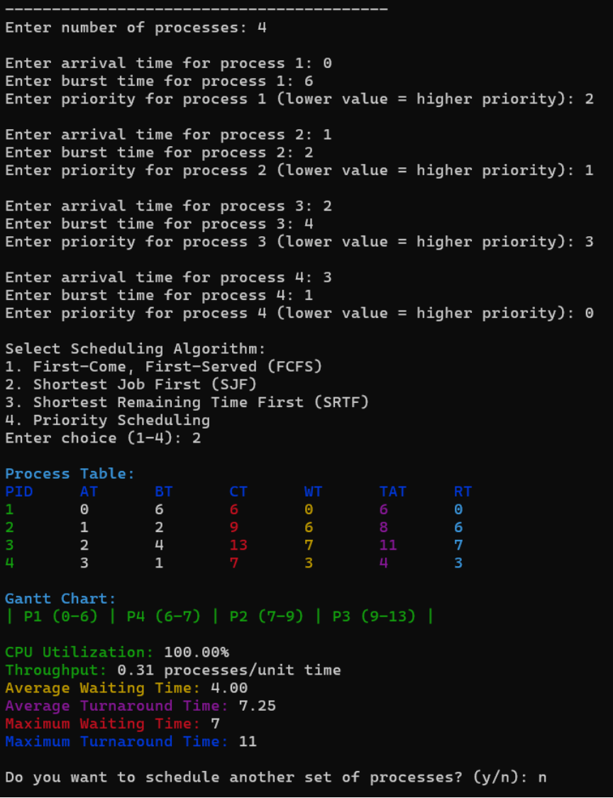

4.4 Detailed Explanation
Once P1 completes, the scheduler selects the shortest available job.
SJF improves average waiting time compared to FCFS but can cause starvation if short jobs keep arriving.
Priority input is ignored in SJF.
4.5 Key Observations
- Better average waiting time
- Non-preemptive
- Starvation possible
- Requires burst time knowledge
IN SHORT
- Priority input is taken for all processes
- Only Priority Scheduling uses priority for selection
- SRTF and SJF optimize response time
- FCFS is simple but inefficient.

Future Work:
The project can be further enhanced by implementing advanced scheduling algorithms such as Round Robin, Multilevel Queue (MLQ), and Multilevel Feedback Queue (MLFQ). Additional improvements may include incorporating context switch overhead, real-time scheduling constraints, and graphical visualization of the Gantt chart. Integrating a database for storing execution history and optimizing algorithm efficiency can also improve scalability and practical applicability.

References:
This project was developed based on standard concepts and theoretical knowledge of CPU scheduling taught in Operating Systems courses. No external libraries, third-party code, or online sources were directly referenced or copied during implementation. The algorithms and performance metrics were implemented using general OS principles. However, the following academic resource was used for conceptual understanding:
- Data Structure and Algorithm Analysis – Mark Allen Wiess.

Conclusion:
This project successfully implements a CPU Scheduling Simulator that demonstrates the working of major scheduling algorithms such as FCFS, SJF, SRTF, and Priority Scheduling. The system accurately simulates process execution, generates Gantt charts, and computes key performance metrics like waiting time, turnaround time, response time, CPU utilization, and throughput. The simulator provides a clear understanding of how different scheduling strategies impact CPU performance and process behavior.

