**In Linux environment, create a python file for addition of two lists. Run piece of code from terminal.**

**Code:** a=[1,2,3,4,5,6]

b=[7,8,9,1,2,4]

print(a+b)

Open Terminal and write the command to execute python file which is shown below.

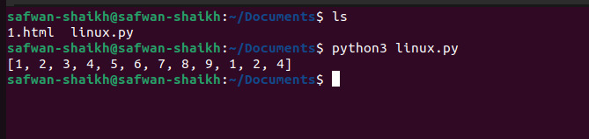

**In Linux environment create two folders named Folder1 and Folder2. Place some .txt file in Folder1. Write needful commands in terminal to move the contents from Folder1 to Folder2.**

**Steps:**

* Open terminal
* Go to the folder where file is located.
* Using mv command move to the destination.

