

Student Name: __________________________
Student ID: __________________________
Instructor: __________________________
Submission Date: June 07, 2026

1. Project Overview
Task Manager is a full-stack web application built with the Laravel framework that allows users to create, organize, and track their personal tasks. The system provides secure authentication, a real-time analytics dashboard, and complete task management (create, read, update, delete) with search and filtering capabilities — all wrapped in a clean, responsive, Arabic RTL interface powered by Bootstrap 5.
This report documents the practical implementation of the project: the technology stack, application architecture, database design, core features, user interface, and the steps required to set up and run the system locally.
1.1 Key Highlights
- Built on Laravel 13 following the MVC (Model-View-Controller) architectural pattern
- Authentication powered by Laravel Breeze (login, registration, password reset, remember-me)
- Custom middleware for resource-level authorization (EnsureTaskOwner) and session security (PreventBackHistory)
- Interactive dashboard showing live statistics: total, completed, pending, in-progress and overdue tasks
- Full CRUD operations for tasks with server-side validation and Bootstrap confirmation modals
- Search and multi-criteria filtering (by title, status, and priority) with pagination
2. Technology Stack
The project was built using a modern, well-supported technology stack. Each tool was chosen for its reliability, documentation quality, and suitability for rapid yet maintainable web development:
Technology | Version | Role in the Project
Laravel | 13.x | Core PHP framework — handles routing, ORM (Eloquent), authentication, and MVC structure
PHP | ^8.3 | Server-side scripting language that powers the Laravel backend
MySQL / SQLite | — | Relational database for storing users and tasks (SQLite for development, MySQL for production)
Laravel Breeze | 2.x | Pre-built authentication scaffolding (login, register, password reset)
Bootstrap 5 (RTL) | 5.3 | Front-end CSS framework providing a responsive, Arabic right-to-left UI
Bootstrap Icons | 1.11 | Icon library used throughout the interface
JavaScript | ES6 | Client-side interactivity — confirmation modals, auto-dismiss alerts
Composer | 2.x | Dependency manager for PHP / Laravel packages
Node.js & npm / Vite | 22.x / 10.x | Front-end asset bundling and the local development server
Git & GitHub | — | Version control and source code hosting

3. Application Architecture
The application follows Laravel's MVC architecture, which cleanly separates data handling (Models), business logic (Controllers), and presentation (Views/Blade templates). This separation makes the codebase easier to read, test, and extend.
3.1 Project Structure
File / Folder | Purpose
app/Http/Controllers/TaskController.php | Handles all task operations: index, create, store, show, edit, update, destroy
app/Http/Controllers/DashboardController.php | Aggregates task statistics for the dashboard view
app/Http/Controllers/Auth/ | Authentication controllers provided by Laravel Breeze
app/Http/Middleware/EnsureTaskOwner.php | Verifies that the requested task belongs to the logged-in user (returns 403 otherwise)
app/Http/Middleware/PreventBackHistory.php | Adds no-cache headers to prevent viewing protected pages after logout via browser back button
app/Models/Task.php | Eloquent model for tasks — defines status/priority constants, accessors, and the isOverdue() helper
app/Models/User.php | Eloquent model for users — defines the one-to-many relationship with tasks
resources/views/layouts/app.blade.php | Main authenticated layout: sidebar navigation, top bar, flash messages, confirmation modal
resources/views/tasks/ | Blade views for listing, creating, editing, and viewing tasks
routes/web.php | Defines all application routes, grouped by authentication and ownership middleware
database/migrations/ | Database schema definitions for users, cache, jobs, and tasks tables

3.2 Routing Overview
Routes are grouped under the auth and verified middleware to ensure only authenticated users can access the dashboard and task management pages. An additional task.owner middleware is applied specifically to routes that operate on a single task (show, edit, update, destroy):
Method | URI | Controller Action | Middleware
GET | /dashboard | DashboardController@index | auth, verified
GET | /tasks | TaskController@index | auth, verified
GET | /tasks/create | TaskController@create | auth, verified
POST | /tasks | TaskController@store | auth, verified
GET | /tasks/{task} | TaskController@show | auth, verified, task.owner
GET | /tasks/{task}/edit | TaskController@edit | auth, verified, task.owner
PUT | /tasks/{task} | TaskController@update | auth, verified, task.owner
DELETE | /tasks/{task} | TaskController@destroy | auth, verified, task.owner

4. Data Model (Eloquent Relationships)
Rather than focusing on database design itself, the data layer here exists mainly to show how Laravel's Eloquent ORM is used in practice. The application defines two simple models, User and Task, connected by a one-to-many relationship declared directly on the models (User::tasks() returns hasMany(Task::class) and Task::user() returns belongsTo(User::class)). A foreign key with onDelete('cascade') ensures that removing a user automatically removes their tasks — all expressed through Laravel migrations and Eloquent rather than raw SQL.
5. Core Features
Authentication System
Implemented via Laravel Breeze, supporting registration, login with a 'remember me' option, logout, and password reset through emailed reset links. After registering, the user is redirected to the login page with a success message rather than being signed in automatically.
Interactive Dashboard
Displays four live statistic cards (total, completed, pending, in-progress tasks) with a progress indicator for completion percentage, an alert banner for overdue tasks, a table of the most recent tasks, and a quick-action panel with a priority breakdown.
Task Management (CRUD)
Users can create tasks with a title, description, status, priority, and due date; view full task details on a dedicated page; edit existing tasks through a pre-filled form; and delete tasks through a styled Bootstrap confirmation modal rather than the browser's default confirm dialog.
Search & Filtering
A search bar filters tasks by title, while two dropdown filters narrow results by status and priority. All criteria can be combined, and filter values persist across pagination.
Authorization & Data Isolation
A custom EnsureTaskOwner middleware checks, on every task-specific request, that the task belongs to the currently authenticated user — returning a 404 if the task does not exist, or a 403 if it belongs to someone else.

6. Learning Outcomes — Laravel Concepts Applied
This project was built as a hands-on application of the Laravel concepts covered in the course. The list below maps each concept to where it is concretely used in the codebase.
Routing
All application routes are declared in routes/web.php using Route::get/post/put/delete and resource-style grouping, with route groups that share the auth and verified middleware.
Eloquent ORM
The User and Task models use Eloquent relationships (hasMany / belongsTo) and the $fillable property for safe mass assignment, replacing manual SQL queries entirely.
Blade Templating
A shared layouts/app.blade.php master layout is extended by every page using @extends, @section and @yield, with @if/@foreach directives driving the dynamic task lists, badges, and statistic cards.
Authentication (Breeze)
Laravel Breeze scaffolds registration, login, logout and password-reset flows out of the box, including the auth guard checks used throughout the app.
Custom Middleware
Two custom middleware classes were written and registered in bootstrap/app.php: EnsureTaskOwner (authorization check on every task route) and PreventBackHistory (adds no-cache headers after logout).
Form Requests & Validation
Controllers validate incoming input with Laravel's validate() / Request rules before touching the database, and redirect back with errors and old() input on failure.
Artisan CLI
The project was scaffolded and maintained with Artisan commands such as make:model, make:controller, make:middleware, migrate, and serve.

7. User Interface Walkthrough
7.1 Login Page
A clean, centered card over a dark gradient background. It includes email and password fields, a remember-me checkbox, and a link to the password reset page.
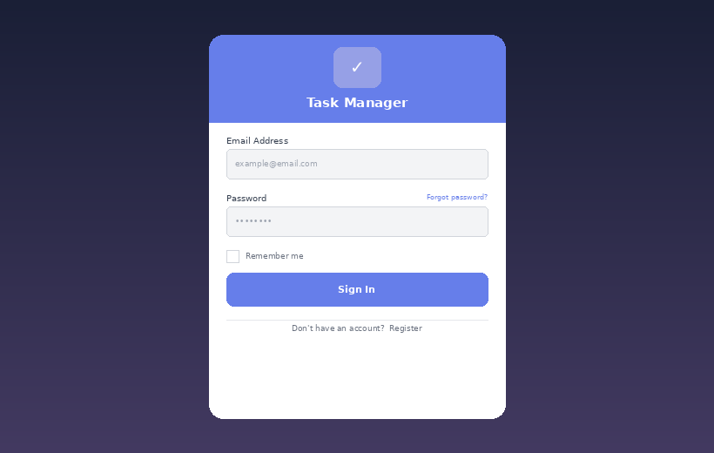
Figure: Login Page

7.2 Dashboard
The landing page after authentication. It surfaces key metrics at a glance and lists the most recently created tasks for quick access.
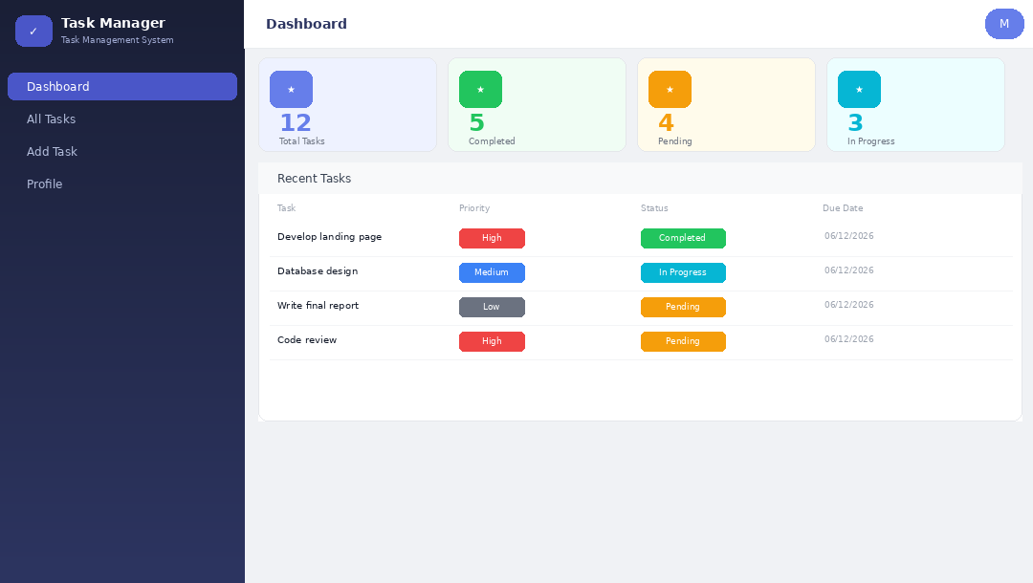
Figure: Dashboard with statistics and recent tasks

7.3 Task List
A sortable, searchable table of all tasks belonging to the current user, with color-coded priority and status badges and inline action buttons for view, edit, and delete.
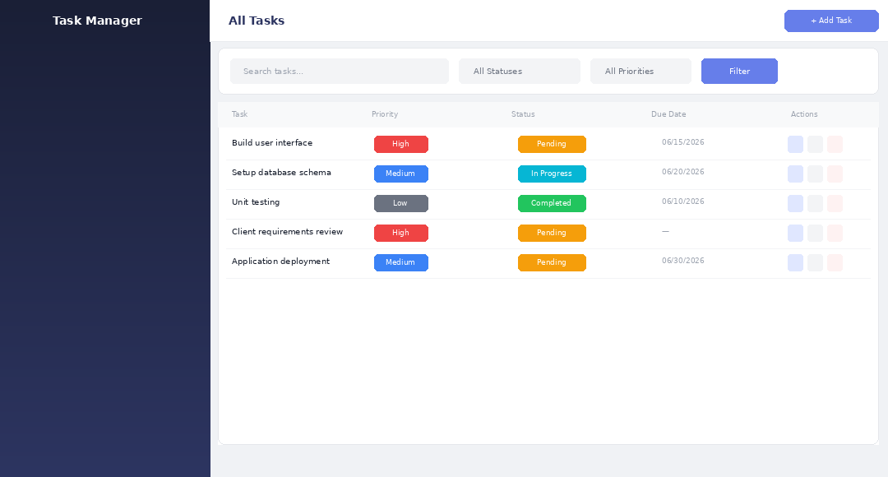
Figure: Task list with search and filter bar

7.4 Create / Edit Task
A validated form for entering or updating a task's title, description, status, priority, and due date. Validation errors are shown inline beneath each field.
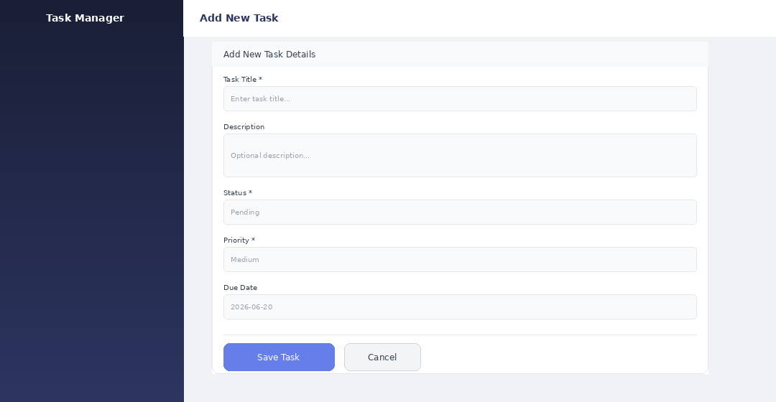
Figure: Add/Edit Task form

7.5 Delete Confirmation Modal
Instead of relying on the browser's plain confirm() dialog, the system shows a custom Bootstrap modal with a contextual icon, the task's name, and a clear warning before any destructive action.
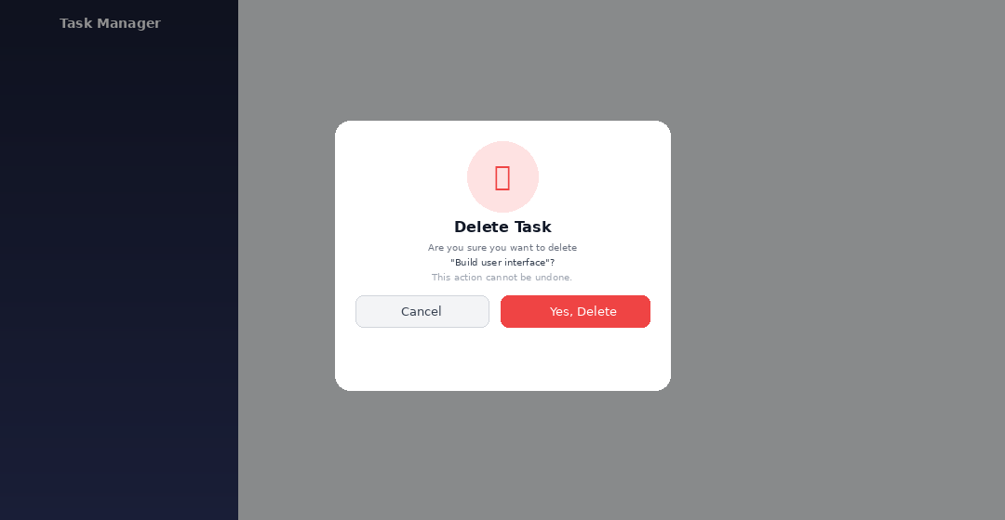
Figure: Delete confirmation modal

8. Security Measures
Mechanism | Implementation Detail
CSRF Protection | Every form includes Laravel's @csrf token; requests without a valid token are rejected
Password Hashing | Passwords are hashed with bcrypt via Hash::make() — never stored in plain text
Mass-Assignment Protection | Each Eloquent model defines an explicit $fillable array
Resource Authorization | The task.owner middleware blocks access to other users' tasks (404 / 403)
Server-Side Validation | All form input is validated on the server before being persisted
SQL Injection Prevention | Eloquent ORM uses parameterized queries / prepared statements by default
XSS Prevention | Blade's {{ }} syntax automatically escapes output
Session Hardening | PreventBackHistory middleware stops cached pages from being shown after logout

9. Installation & Setup Guide
Follow these steps to run the project on a local machine:
Step 1 — Clone the repository
git clone <repository-url>
cd task-management
Step 2 — Install dependencies
composer install
npm install
Step 3 — Configure the environment
cp .env.example .env
php artisan key:generate
Step 4 — Set up the database (MySQL example)
# In .env:
DB_CONNECTION=mysql
DB_DATABASE=task_management
DB_USERNAME=root
SESSION_DRIVER=file

php artisan migrate
Step 5 — Run the application
php artisan serve
# Open http://127.0.0.1:8000 in your browser
9.1 Useful Artisan Commands
Command | Purpose
php artisan serve | Starts the local development server
php artisan migrate | Runs pending database migrations
php artisan migrate:fresh | Drops all tables and re-runs migrations from scratch
php artisan route:list | Lists every registered application route
php artisan optimize:clear | Clears all cached config, routes, and views
php artisan test | Runs the PHPUnit test suite

10. Conclusion
This project successfully delivers a complete, production-style task management application built on Laravel's MVC architecture. It demonstrates practical, hands-on application of core web development concepts covered in the course: authentication and authorization, Eloquent ORM and database relationships, middleware, form validation, RESTful routing, and building a responsive, localized user interface with Bootstrap.
Beyond meeting the functional requirements, the project also addresses real-world engineering concerns such as protecting user data through ownership checks, securing forms against CSRF, and replacing default browser dialogs with a polished, consistent UI experience.
10.1 Possible Future Enhancements
- Email notifications for tasks approaching their due date
- Task categories/tags for better organization across larger task lists
- A REST API (e.g., via Laravel Sanctum) to support a future mobile application
- Team/shared tasks with role-based permissions
- Advanced analytics with charts and exportable reports (PDF/Excel)
— End of Report —

