IS 463 Homework

Name: Safa Abdullah Moallim

ID: 331215795

Knowledge facts and rules:

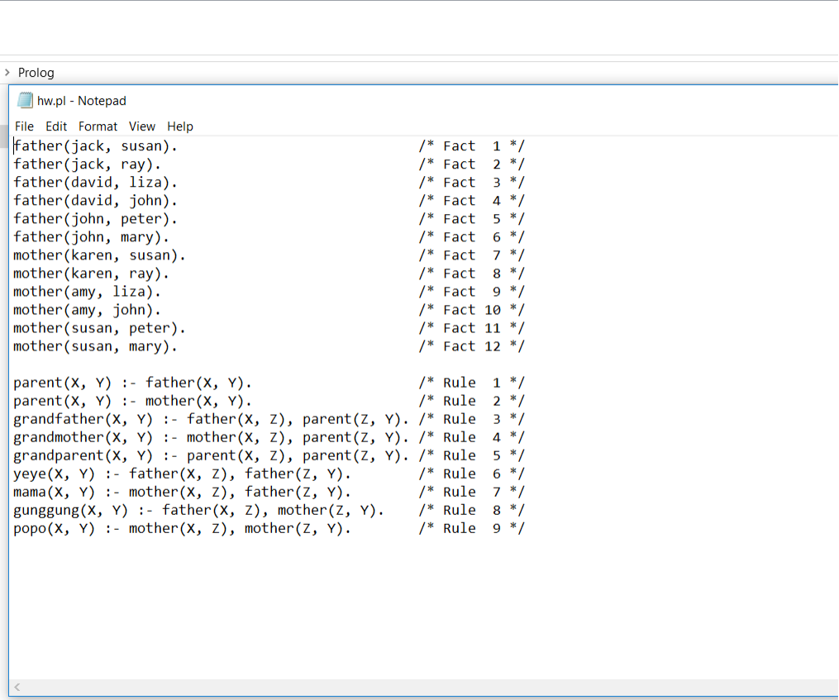

Knowledge queries :

