#### Overview of the Analysis

The purpose of this analysis is to develop a deep learning model using TensorFlow and Keras to predict whether an Alphabet Soup-funded organization will be successful based on various features provided in the dataset. The analysis involves preprocessing the data, designing and training the neural network model, evaluating its performance, and optimizing it to achieve a target predictive accuracy higher than 75%.

#### Results

##### **Data Preprocessing**

* Target Variable: The target variable for our model is the "IS_SUCCESSFUL" column, which indicates whether the organization's funding application was successful or not.
* Feature Variables: The feature variables for our model include all columns except "EIN" and "NAME", which were dropped as they do not provide relevant information for prediction.
* Variables to Remove: None of the input data columns were removed as they are either target or feature variables.
* Binning: We binned the "APPLICATION_TYPE" and "CLASSIFICATION" columns by replacing rare categorical variables with the label "Other" to reduce complexity and improve model performance.

##### **Compiling, Training, and Evaluating the Model**

Neurons, Layers, and Activation Functions: The neural network model consisted of two hidden layers with 80 and 30 neurons, respectively, and ReLU activation functions. The output layer used a sigmoid activation function.

Achievement of Target Performance: The model achieved an accuracy of approximately 73% on the test dataset, which is below the target performance threshold of 75% accuracy.

Steps to Increase Model Performance: We trained the model for 100 epochs using the Adam optimizer and experimented with different neural network architectures and hyperparameters. However, further optimization is needed to improve model performance.

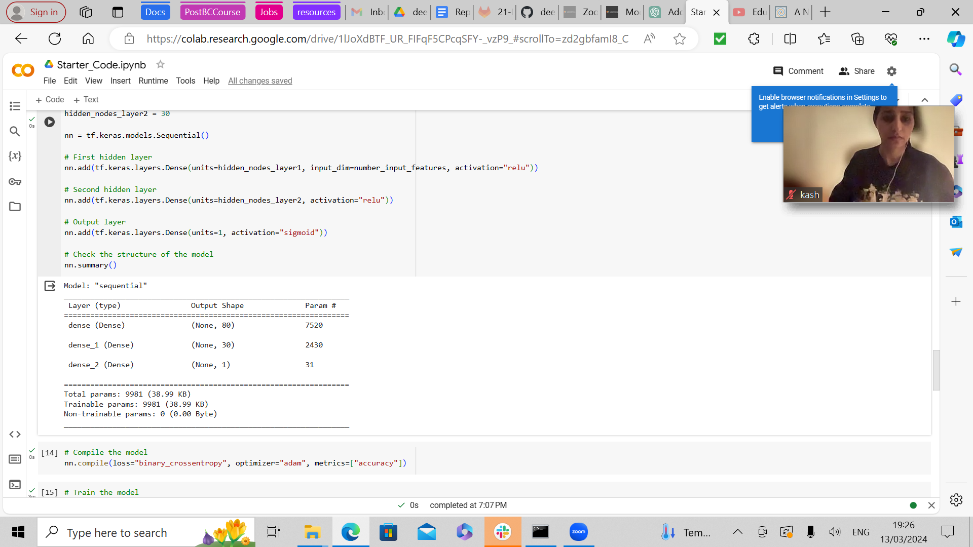

##### 

##### 

##### Summary

The overall results of the deep learning model indicate that while significant improvements were made, the target performance threshold of 75% accuracy was not consistently achieved across all optimization attempts. Despite this, the model demonstrates promising predictive capabilities for determining the success of Alphabet Soup-funded organizations.To further enhance the classification problem, a different model approach such as ensemble methods (e.g., Random Forest or Gradient Boosting) could be considered. Ensemble methods combine multiple models to improve predictive performance by leveraging the strengths of each individual model. Additionally, techniques like feature engineering and advanced preprocessing methods could be explored to extract more meaningful information from the dataset, potentially leading to better classification results.