HW-484 Magnetic Switch Module (Reed Switch)
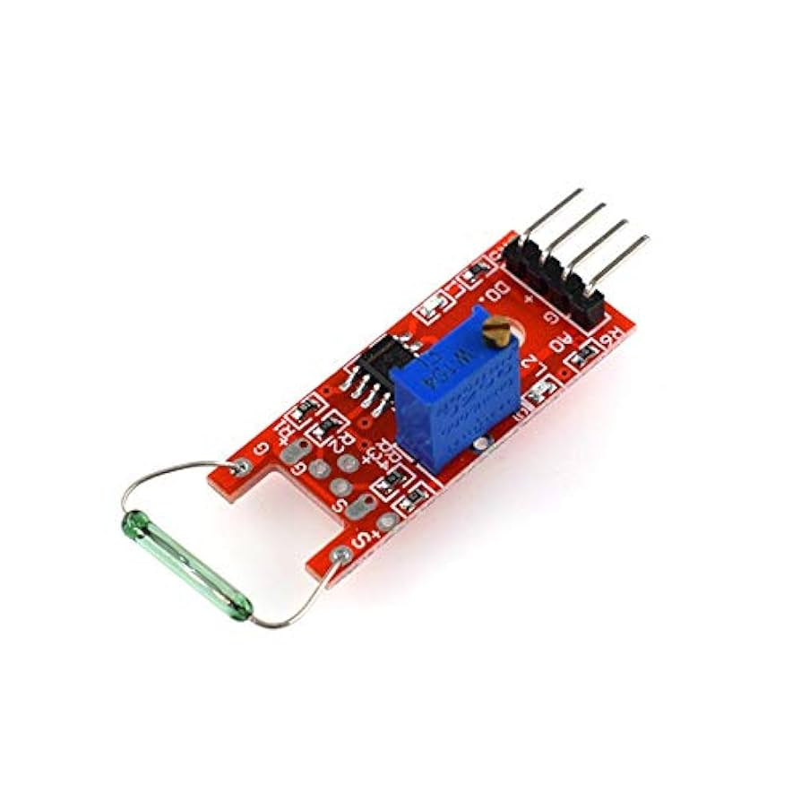

This sensor detects the presence of a magnet. When a magnet comes near the glass-encased reed switch on the module, the contacts inside close, sending a signal. It’s often used for detecting door open/close, security systems, or robot triggers.

Pin Description:
Pin | Function
VCC | Power (3.3V/5V)
GND | Ground
DO | Digital Output

Sensor type: Dry Reed Switch
Power: 3.3V to 5V
Output:
- DO (Digital Output): Goes LOW when magnet is near
- AO (Analog Output): Not always present, depends on the version
LED indicator: Lights up when the switch is triggered
TRISHALI SJ [23ECB53]

HW-488( Infrared Obstacle-Avoidance Sensor Module)

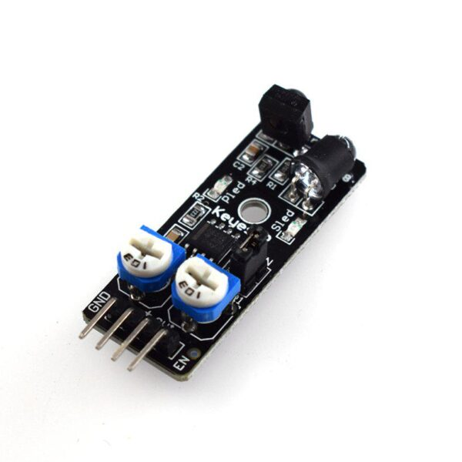

DESCRIPTION:
This project uses an IR obstacle sensor (HW-488) and an LED to detect nearby objects. When an obstacle is detected, the sensor sends a LOW signal to the Arduino, which turns ON the LED. If no object is present, the LED remains OFF. This system is ideal for basic obstacle detection and automation projects.

COMPONENTS:
- Arduino UNO
- HW-488 IR Obstacle Sensor (4-pin)
- 1 LED (any color)
- 220Ω resistor
- Jumper wires

CONNECTION:
IR Sensor | Arduino
VCC | 5V
GND | GND
DO | D2
AO | A0 (optional)

PROGRAM:
int sensorPin = 2;
int ledPin = 13;

void setup() {
pinMode(sensorPin, INPUT);
pinMode(ledPin, OUTPUT);
Serial.begin(9600);
}

void loop() {
int sensorValue = digitalRead(sensorPin);

Serial.print("DO Pin Value: ");
Serial.println(sensorValue); // This shows 0 or 1

if (sensorValue == LOW) {
Serial.println("Obstacle Detected!");
digitalWrite(ledPin, HIGH);
} else {
Serial.println("No Obstacle");
digitalWrite(ledPin, LOW);
}

delay(200);
}

BOARD SETUP:

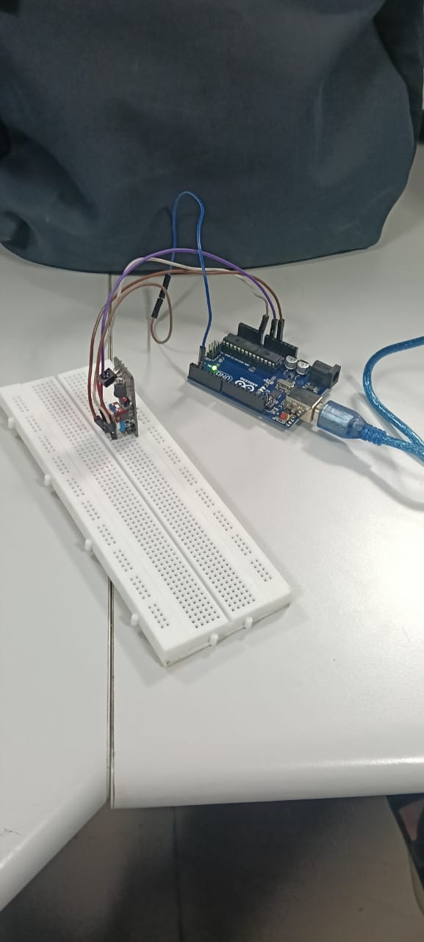

OUTPUT:
