04/08/2025
CUBICLE 5:
TEAM A:
SARMATHA S [23ECB28]
SUBAGARNIYA M [23ECB46]
SYED ALI FATHIMA A [23ECB50]

Sound-Activated LED Control Using HW-485 Sensor

HW 485:
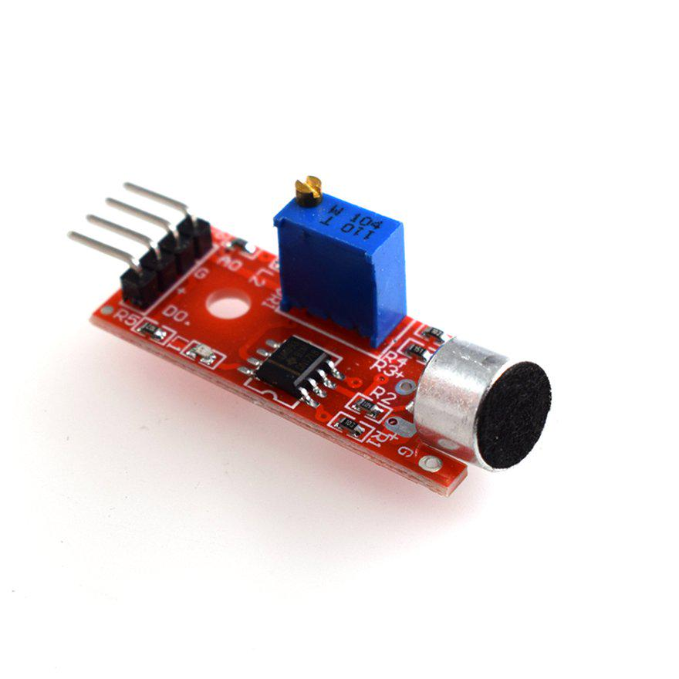
HW-485 High-Sensitivity Sound Sensor
A microphone-based module designed to detect ambient sound levels. It outputs both analog and digital signals depending on the sound intensity
Purpose:
- Measure ambient noise levels in the environment.
- Often used for sound-activated projects, like gesture-based lighting, clapping switches, or alarm triggers.
Components & Features:
- Microphone element (electret or condenser) to capture sound
- Pre-amplifier circuit to boost microphone output
- Comparator with potentiometer threshold to select digital output (HIGH/LOW)
- Analog output pin provides continuous voltage proportional to sound intensity.
- Digital output pin changes state when sound exceeds a set threshold.
- Onboard LED visually indicates sound detection through blinking or lighting.

DESCRIPTION:
This project uses the HW-485 sound sensor and Arduino to detect loud sounds like claps and automatically turn an LED ON. When no sound is present, the LED remains OFF. The sensor sends a digital signal to the Arduino when it detects sound, and the Arduino controls the LED based on that signal. It's a simple hands-free light control system useful for home automation and DIY electronics learning.

CONNECTION:

Sound Sensor | Arduino
VCC | 5V
GND | GND
DO | D2

LED | Arduino
Anode | D8
Cathode | GND through 220Ω resistor

BOARD SETUP:

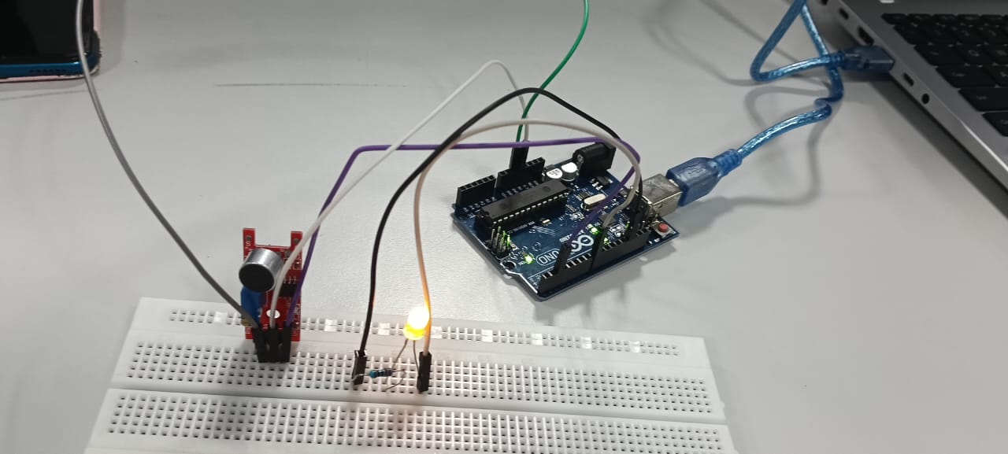

PROGRAM:

int soundPin = 2; // Digital Output from sound sensor
int ledPin = 8; // LED pin
void setup() {
pinMode(soundPin, INPUT);
pinMode(ledPin, OUTPUT);
Serial.begin(9600);
}

void loop() {
int soundState = digitalRead(soundPin);

if (soundState == HIGH) {
digitalWrite(ledPin, HIGH);
Serial.println("👂 Sound Detected – LED ON");
} else {
digitalWrite(ledPin, LOW);
Serial.println("🔇 No Sound – LED OFF");
}
delay(100); // Small delay to avoid flickering
}

OUTPUT:
