08/08/2025
CUBICLE 5:
TEAM A:
SUBAGARNIYA M [23ECB46]
SYED ALI FATHIMA A [23ECB50]

HW-486 Night Light (Analog Control)
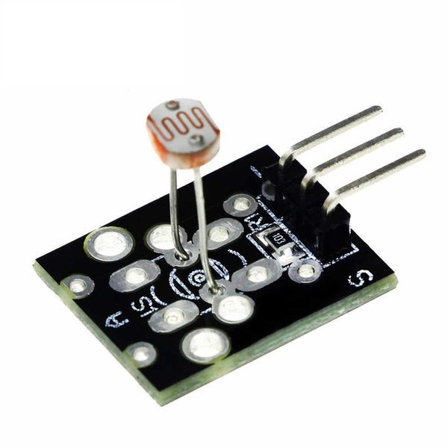
DESCRIPTION:
The HW-486 night light project uses a photoresistive sensor (LDR) to detect ambient light levels and automatically control an LED through an Arduino. The sensor outputs an analog signal (0–1023) to indicate light intensity. The Arduino reads this value and adjusts the LED brightness using PWM — brighter in darkness and dimmer in bright light. This system is commonly used in automatic lighting for energy saving.
PIN CONNECTIONS:
HW-486 Pin | Arduino Pin | Description
VCC | 5V | Powers the sensor module
GND | GND | Common ground connection
A0 | A0 | Analog output to measure light level

LED Pin | Arduino Pin | Description
Anode (+, long leg) | D3 (via 220 Ω resistor) | LED positive terminal, PWM pin for brightness control
Cathode (–, short leg) | GND | LED negative terminal

PROGRAM:
const int sensorPin = A0; // HW-486 A0 to Arduino A0
const int ledPin = 3; // LED connected to pin 3 (PWM pin)

void setup() {
pinMode(ledPin, OUTPUT);
Serial.begin(9600);
}

void loop() {
int lightValue = analogRead(sensorPin); // 0 = dark, 1023 = bright
Serial.print("Light value: ");
Serial.println(lightValue);

// Map light value to LED brightness (invert so dark = bright LED)
int ledBrightness = map(lightValue, 1023, 0, 0, 255);

analogWrite(ledPin, ledBrightness);

delay(100);
}

OUTPUT:

