05/08/2025
CUBICLE 5:
TEAM A:
SARMATHA S [23ECB28]
SUBAGARNIYA M [23ECB46]
SYED ALI FATHIMA A [23ECB50]

Gas Detection System Using Red LED Indicator

DESCRIPTION:
This project uses an MQ-3 gas sensor and a red LED to detect alcohol or gas in the air. Based on the gas level, the LED gives a visual alert:
- LED off = safe
- Slow blink = moderate gas
- Fast blink = high gas
It’s a simple system to monitor gas presence using just Arduino, a gas sensor, and an LED.

CONNECTION:

MQ-3 Sensor | Arduino
VCC | 5V
GND | GND
A0 | A0

PROGRAM:
const int gasPin = A0;
const int redLED = 9;
const int greenLED = 10;

void setup() {
pinMode(redLED, OUTPUT);
pinMode(greenLED, OUTPUT);
Serial.begin(9600);
}

void loop() {
int gasValue = analogRead(gasPin);
Serial.print("Gas Value: ");
Serial.println(gasValue);

if (gasValue < 300) {
digitalWrite(redLED, LOW);
digitalWrite(greenLED, HIGH);
}
else if (gasValue >= 300 && gasValue < 800) {
digitalWrite(redLED, HIGH);
digitalWrite(greenLED, HIGH);
}
else {
digitalWrite(redLED, HIGH);
digitalWrite(greenLED, LOW);
}

delay(5000);
}
LED CODE:
const int redLED = 9;
const int greenLED = 10;

void setup() {
pinMode(redLED, OUTPUT);
pinMode(greenLED, OUTPUT);
}

void loop() {
digitalWrite(redLED, HIGH); // RED ON
digitalWrite(greenLED, LOW); // GREEN OFF
delay(1000);

digitalWrite(redLED, LOW); // RED OFF
digitalWrite(greenLED, HIGH); // GREEN ON
delay(1000);
}

BOARD SETUP AND OUTPUT:
CASE 1:
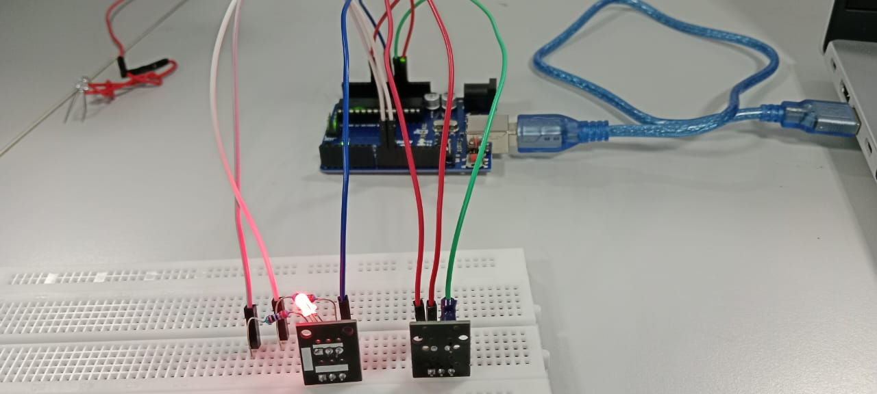
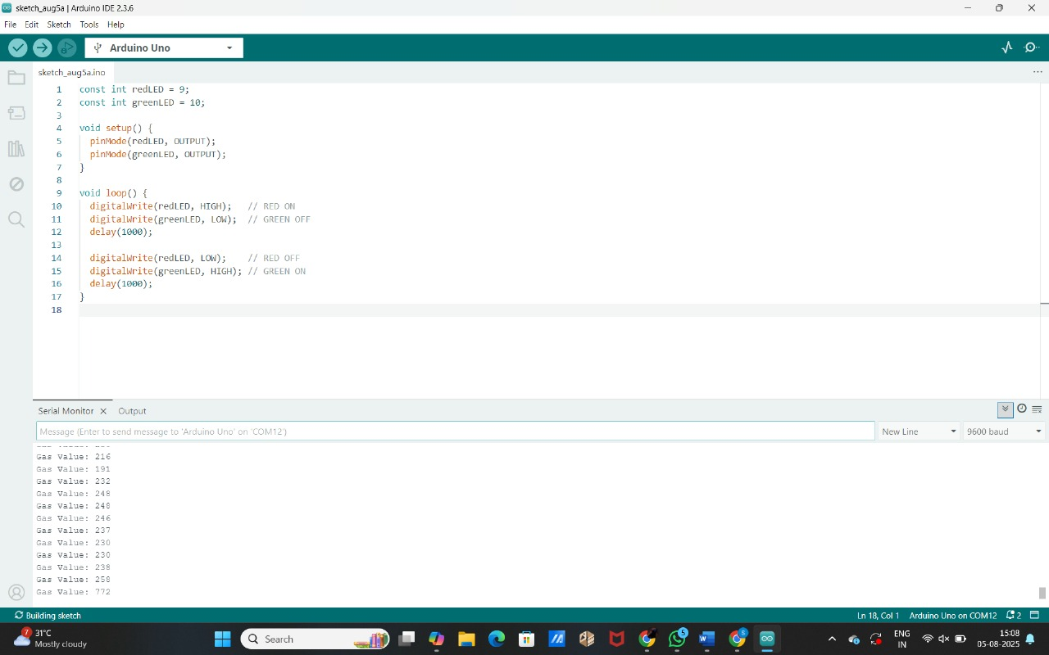
CASE 2:
