07/08/2025
CUBICLE 5:
TEAM A:
SUBAGARNIYA M [23ECB46]
SYED ALI FATHIMA A [23ECB50]

LED Brightness Control using Rotary Encoder
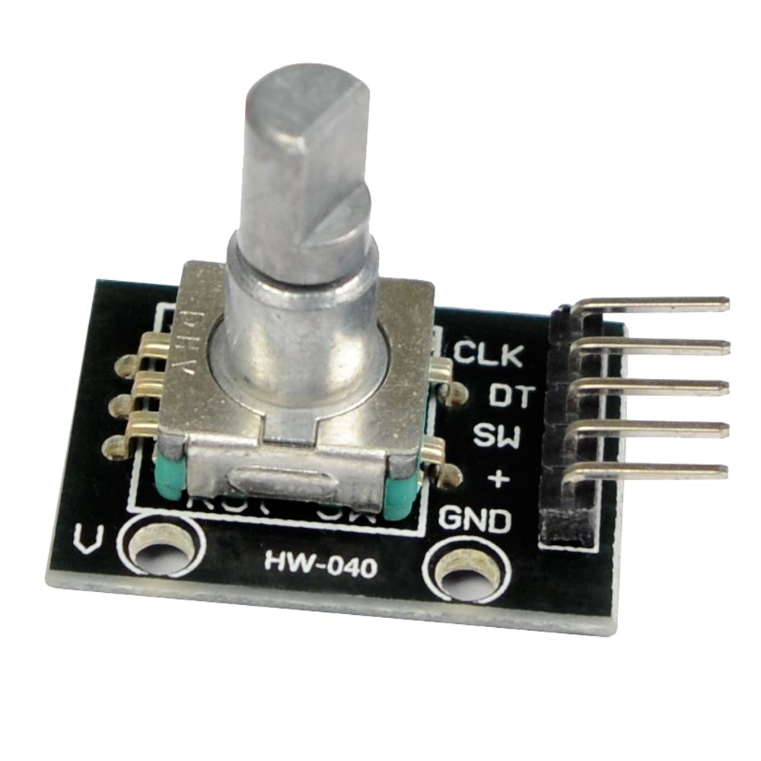
DESCRIPTION:

This project allows you to control the brightness of an LED using a rotary encoder module (HW-040). As you rotate the knob, the LED will get brighter or dimmer depending on the direction. Pressing the encoder knob will reset the brightness to zero (turn the LED off). This is a basic embedded project that teaches digital input reading, PWM output, and user interaction with hardware.

PIN CONNECTION:
LED Pin | Connects To
Long leg (+) | Arduino Pin 9
Short leg (-) | GND

Rotary Encoder Pin | Connects To Arduino Pin
VCC | 5V
GND | GND
CLK | 4
DT | 3
SW (button) | 5

BOARD SETUP:
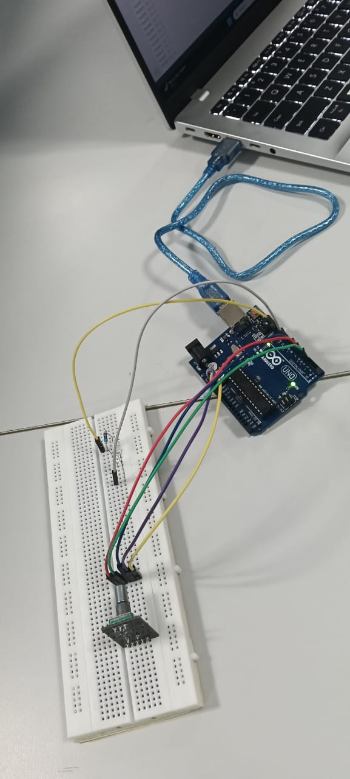
PROGRAM:

int clk = 4;
int dt = 3;
int sw = 5;
int led = 9;

int lastClk = HIGH;
int brightness = 0;

void setup() {
pinMode(clk, INPUT);
pinMode(dt, INPUT);
pinMode(sw, INPUT_PULLUP);
pinMode(led, OUTPUT);

Serial.begin(9600);
lastClk = digitalRead(clk);
}

void loop() {
int currentClk = digitalRead(clk);

if (currentClk != lastClk) {
if (digitalRead(dt) != currentClk) {
brightness += 10;
Serial.println("Turned Right ➕");
} else {
brightness -= 10;
Serial.println("Turned Left ➖");
}

if (brightness > 255) brightness = 255;
if (brightness < 0) brightness = 0;

analogWrite(led, brightness);

Serial.print("Brightness: ");
Serial.println(brightness);
}

lastClk = currentClk;

if (digitalRead(sw) == LOW) {
brightness = 0;
analogWrite(led, brightness);
Serial.println("Reset to 0");
delay(300);
}

delay(1);
}

OUTPUT:

