19/08/2025
CUBICLE 5:
TEAM A:
SARMATHA S [23ECB28]
SUBAGARNIYA M [23ECB46]
SYED ALI FATHIMA A [23ECB50]

Hall Effect Sensor Switch Module
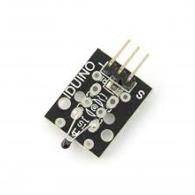

DESCRIPTION:

The Hall Effect sensor is an electronic switch that detects the presence of a magnetic field. When a magnet comes close, the sensor changes its output (ON/OFF). It works without touching, so it is often used as a contactless switch.

CONNECTION:
Module / Part | Pin Name | Connects To (Arduino Pin)
HW-492 Sensor | VCC | 5V
 | GND | GND
 | OUT | D2
Relay Module | VCC | 5V
 | GND | GND
 | IN | D8
Arduino UNO Pins | D2 | Sensor OUT
 | D8 | Relay IN
 | 5V | Sensor VCC + Relay VCC
 | GND | Sensor GND + Relay GND

BOARD SETUP:

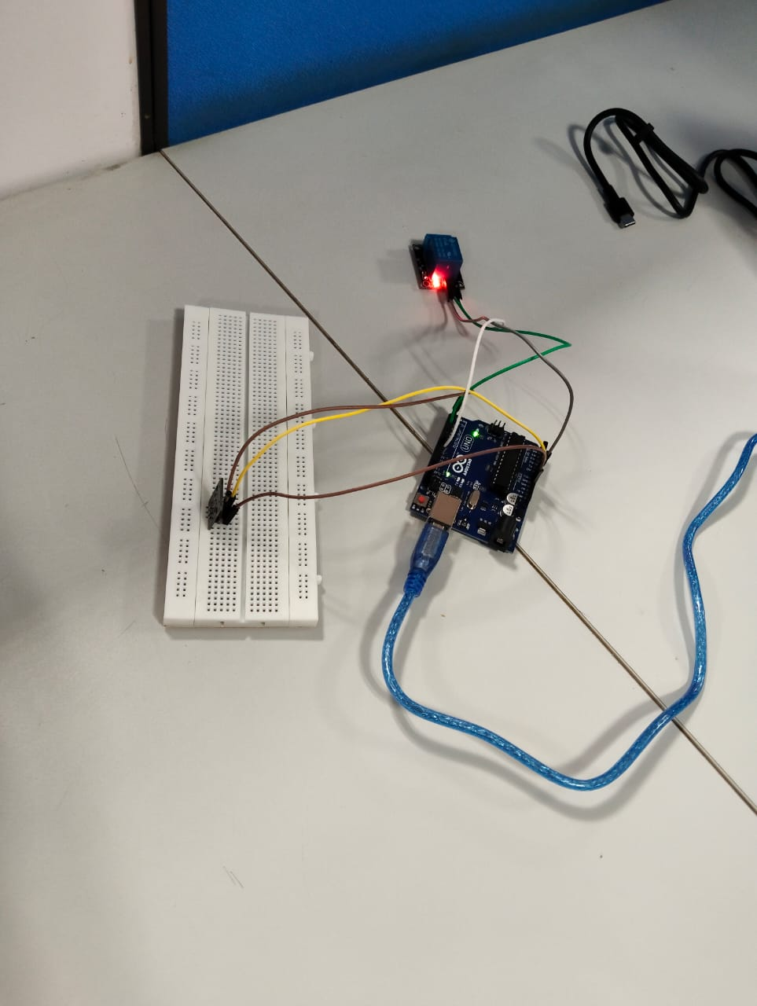
PROGRAM:
int hallSensor = 2; // HW-492 OUT pin connected to D2
int relayPin = 8; // Relay IN pin connected to D8

void setup() {
pinMode(hallSensor, INPUT); // Hall effect sensor as input
pinMode(relayPin, OUTPUT); // Relay as output
digitalWrite(relayPin, LOW); // Keep relay OFF at start
Serial.begin(9600); // For debugging
}

void loop() {
int sensorState = digitalRead(hallSensor); // Read sensor

if (sensorState == LOW) {
// Magnet detected
digitalWrite(relayPin, HIGH); // Turn relay ON
Serial.println("Magnet Detected → Relay ON");
} else {
// No magnet
digitalWrite(relayPin, LOW); // Turn relay OFF
Serial.println("No Magnet → Relay OFF");
}

delay(100); // Small delay for stability
}

OUTPUT:
