11/08/2025
CUBICLE 5:
TEAM A:
SARMATHA S [23ECB28]
SUBAGARNIYA M [23ECB46]
SYED ALI FATHIMA A [23ECB50]

DISTANCE MEASURING USING ULTRASONIC SENSOR, INDICATING USING LED AND BUZZER

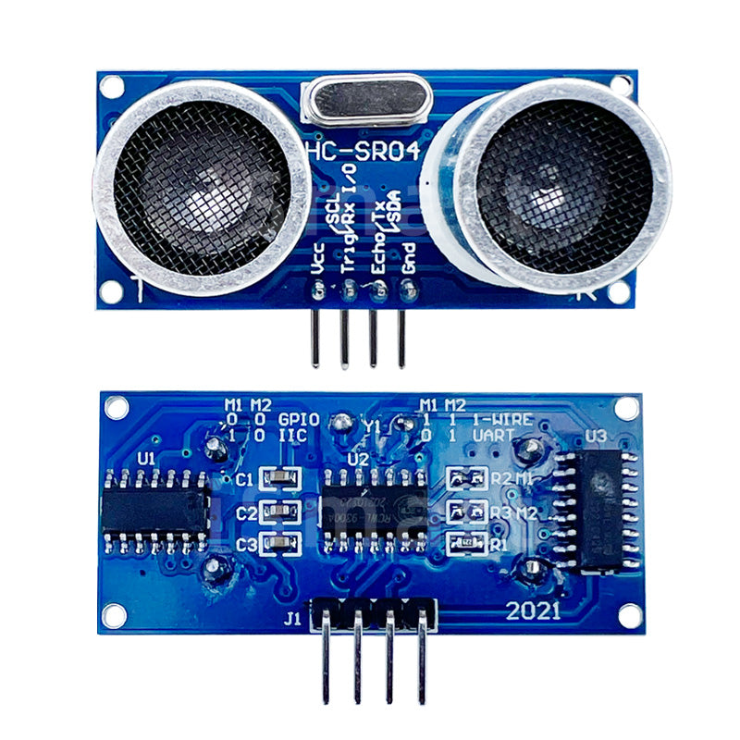
DESCRIPTION:
This setup uses an HC-SR04 ultrasonic sensor to measure distance, with an LED and buzzer providing visual and audible alerts. A push button (configured with INPUT_PULLUP) is used to control or reset the system.

PIN CONNECTIONS:

Component | Pin Connection | Arduino Pin | Notes
HC-SR04 VCC | VCC → 5V | — | Power supply for the sensor
HC-SR04 GND | GND → GND | — | Common ground
HC-SR04 Trig | Trig → D9 | D9 | Trigger pin for sending ultrasonic pulse
HC-SR04 Echo | Echo → D8 | D8 | Receives echo signal
LED Positive | Positive leg → Resistor → D3 | D3 | Use 220Ω–330Ω resistor in series
LED Negative | Negative leg → GND | — | Common ground
Buzzer Positive | Positive → D4 | D4 | Active or passive buzzer
Buzzer Negative | Negative → GND | — | Common ground
Push Button Leg 1 | One leg → D2 | D2 | Configured with INPUT_PULLUP
Push Button Leg 2 | Other leg → GND | — | Common ground
BOARD SETUP:

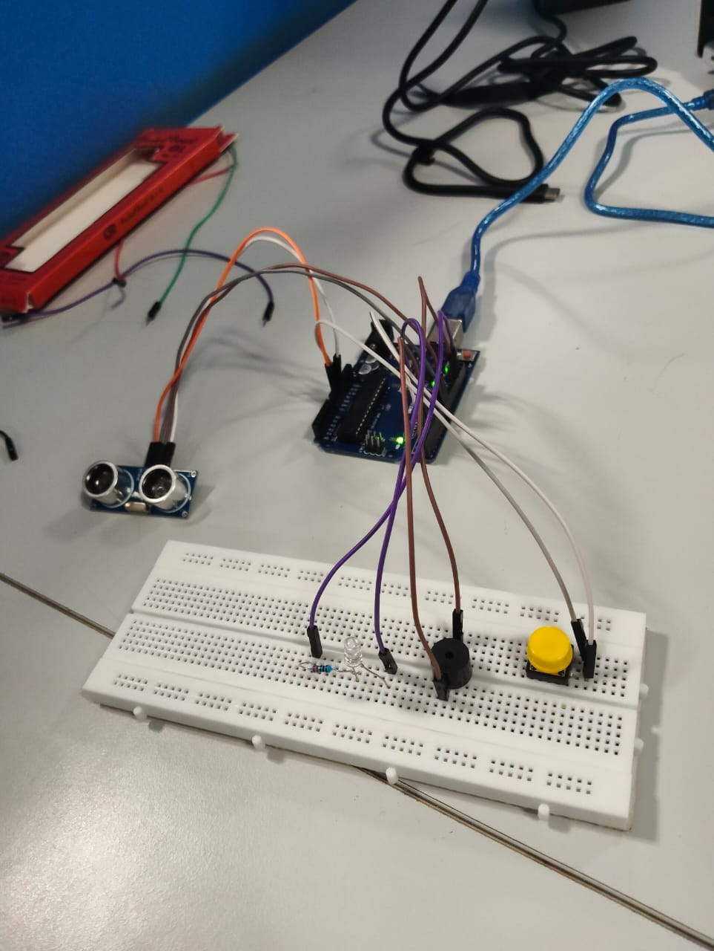

PROGRAM:
// Pin definitions
const int trigPin = 9; // Ultrasonic Trigger
const int echoPin = 8; // Ultrasonic Echo
const int ledPin = 3; // LED output
const int buzzerPin = 4; // Buzzer output
const int buttonPin = 2; // Push button input

// Variables
long duration;
float distance;

void setup() {
pinMode(trigPin, OUTPUT);
pinMode(echoPin, INPUT);
pinMode(ledPin, OUTPUT);
pinMode(buzzerPin, OUTPUT);
pinMode(buttonPin, INPUT_PULLUP); // Button with internal pull-up resistor

Serial.begin(9600);
}

void loop() {
// --- Ultrasonic Sensor Measurement ---
digitalWrite(trigPin, LOW);
delayMicroseconds(2);

digitalWrite(trigPin, HIGH);
delayMicroseconds(10);
digitalWrite(trigPin, LOW);

duration = pulseIn(echoPin, HIGH);
distance = duration * 0.0343 / 2; // Convert to cm

Serial.print("Distance: ");
Serial.print(distance);
Serial.println(" cm");

// --- Button Press Action ---
if (digitalRead(buttonPin) == LOW) { // Button pressed
digitalWrite(ledPin, HIGH); // Turn LED on
digitalWrite(buzzerPin, HIGH); // Turn buzzer on
delay(200);
digitalWrite(ledPin, LOW); // Turn LED off
digitalWrite(buzzerPin, LOW); // Turn buzzer off
delay(200);
}
}

OUTPUT:

