18/08/2025
CUBICLE 5:
TEAM A:
SARMATHA S [23ECB28]
SUBAGARNIYA M [23ECB46]
SYED ALI FATHIMA A [23ECB50]

GY-521
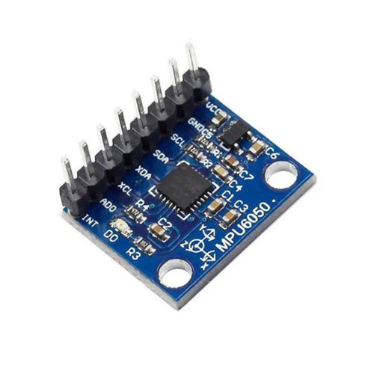
- MPU-6050 chip
  - A 3-axis accelerometer + 3-axis gyroscope
- Built-in Digital Motion Processor (DMP) for motion tracking
- I2C interface (SCL and SDA pins) for communication with Arduino or other microcontrollers
What does it do?
The GY-521 can:
- Measure acceleration (tilt, movement)
- Measure rotation (angular velocity)
- Detect orientation (for balancing robots, drones, etc.)
- Combine data from both sensors using the DMP for better motion tracking
Common Projects Using GY-521:
- Self-balancing robots
- Gesture-controlled devices
- Drones and RC planes
- Fitness trackers or fall detection
- Motion-activated lights or alarms

Arduino Temperature-Controlled Relay with LED
(HW-506)
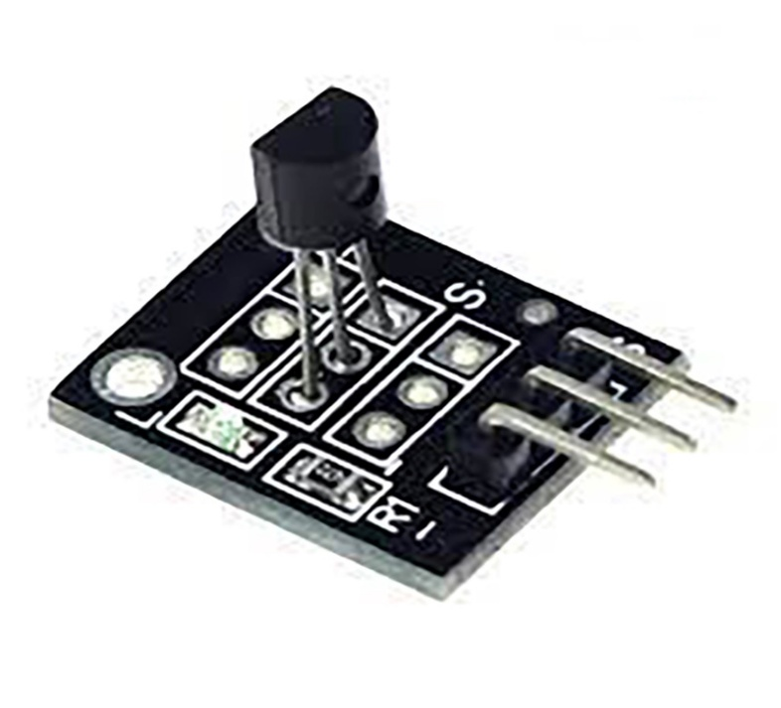

DESCRIPTION:
This is a standalone Arduino project that reads temperature using the HW-506 DS18B20 module and controls a relay based on a temperature setpoint.
- When the temperature exceeds the setpoint, the relay turns ON (to drive a fan, heater, or light).
- When the temperature drops below the setpoint, the relay turns OFF.
- An LED indicates relay status: ON when the relay is ON, OFF otherwise.
- No Wi-Fi, Bluetooth, or smartphone required — fully offline.

PIN CONNECTIONS:

Function | Module Pin | Arduino Pin
HW-506 DQ (data) | DQ | D2
HW-506 VCC | VCC | 5V
HW-506 GND | GND | GND
Relay IN | IN | D7
Relay VCC | VCC | 5V
Relay GND | GND | GND
LED anode (+) | – | D8 (with 220 Ω resistor)
LED cathode (−) | – | GND

BOARD SETUP:

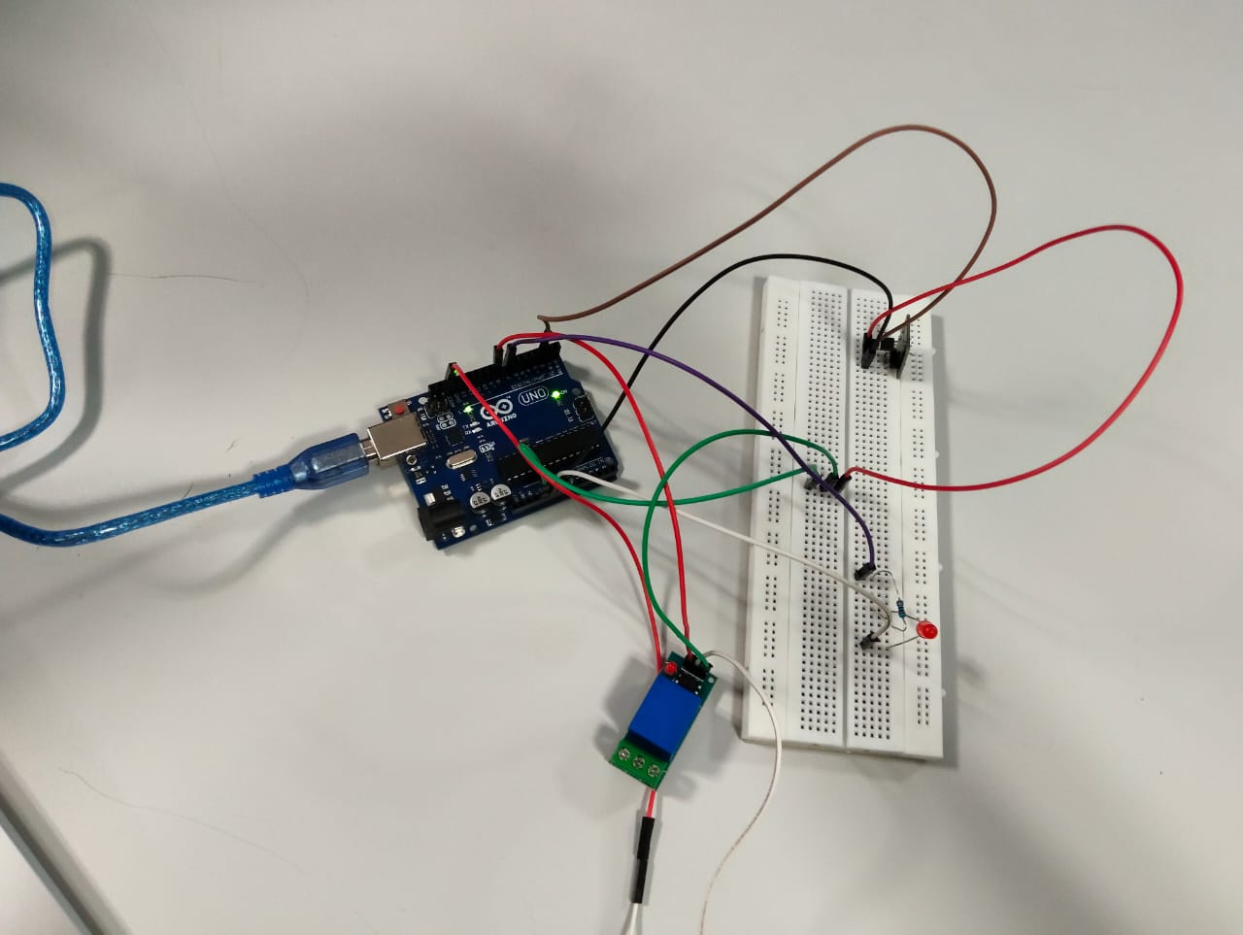

PROGRAM:

#include <OneWire.h>
#include <DallasTemperature.h>

// Pins
const int tempPin = 2; // DS18B20 DQ
const int relayPin = 8; // Relay control
const int ledPin = 7; // Status LED

// Temperature control
const float setPoint = 30.0; // Set temperature in °C

// Setup DS18B20
OneWire oneWire(tempPin);
DallasTemperature sensors(&oneWire);

void setup() {
Serial.begin(9600);
sensors.begin();

pinMode(relayPin, OUTPUT);
pinMode(ledPin, OUTPUT);

digitalWrite(relayPin, LOW); // Relay OFF initially
digitalWrite(ledPin, LOW); // LED OFF initially
}

void loop() {
sensors.requestTemperatures();
float tempC = sensors.getTempCByIndex(0);

Serial.print("Temperature: ");
Serial.print(tempC);
Serial.println(" °C");

if (tempC >= setPoint) {
digitalWrite(relayPin, HIGH); // Turn ON relay
digitalWrite(ledPin, HIGH); // Turn ON LED
} else {
digitalWrite(relayPin, LOW); // Turn OFF relay
digitalWrite(ledPin, LOW); // Turn OFF LED
}

delay(2000); // 2-second interval
}

OUTPUT:
