21/07/2025
CUBICLE 7:
NAMES
Vidunasri R [23ecb57]
Syed Ali Fathima A [23ecb50]
Sarmatha S [23ecb28]
Vaishnavi R [23ecb54]
Vaishnavi S [23ecb55]
Sruthi S [23ecb45]
Trishali SJ [23ecb53]
Subagarniya M [23ecb46]
Thangamalar M [23ecb52]

LED:

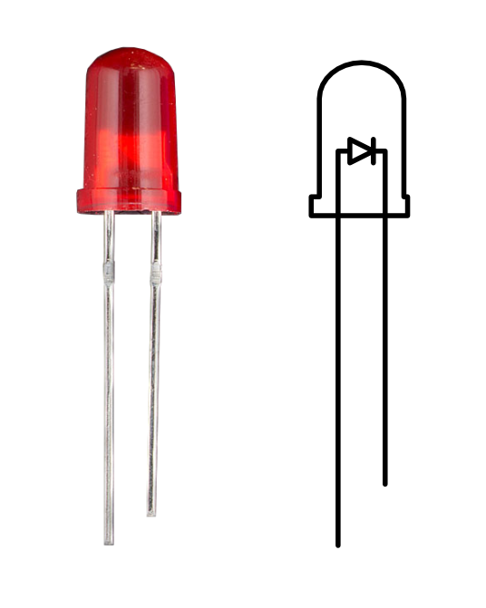

The LED Blink project is a basic Arduino program that turns an LED on and off repeatedly. It helps to learn how to use digital pins and control external components using code. The LED is connected to a pin, and the Arduino sends signals to make it blink with a delay.

PIN CONNECTIONS:

Component | Arduino Pin | Description
LED (Anode +) | Digital Pin 13 | Positive leg of LED connected to pin 13
LED (Cathode -) | GND (Ground) | Connect through a 220Ω resistor to protect the LED

PROGRAM:
// Define the pin number
int ledPin = 13; // On most Arduino boards, pin 13 has a built-in LED

void setup() {
// Set the LED pin as output
pinMode(ledPin, OUTPUT);
}

void loop() {
digitalWrite(ledPin, HIGH); // Turn the LED on
delay(1000); // Wait for 1 second (1000 milliseconds)
digitalWrite(ledPin, LOW); // Turn the LED off
delay(1000); // Wait for 1 second
}

