29/07/2025
CUBICLE 7:
NAMES
Vidunasri R [23ecb57]
Syed Ali Fathima A [23ecb50]
Sarmatha S [23ecb28]
Vaishnavi R [23ecb54]
Vaishnavi S [23ecb55]
Sruthi S [23ecb45]
Trishali SJ [23ecb53]
Subagarniya M [23ecb46]

DHT11:

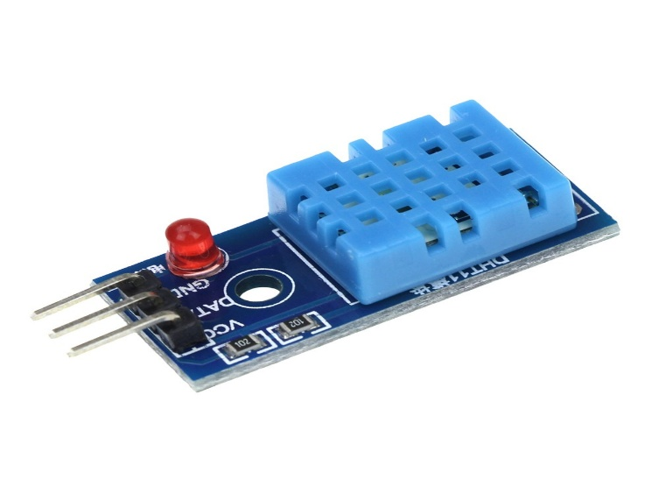

The DHT11 is a digital temperature and humidity sensor that provides reliable measurements with ease of use. It uses a capacitive humidity sensor and a thermistor to measure the surrounding air and provides the data in digital format, making it easy to interface with microcontrollers like Arduino.
It is widely used in weather monitoring, environmental sensing, greenhouse automation, and IoT projects due to its low cost, simple setup, and reasonable accuracy.

PIN DESCRIPTION:
Pin | Name | Connect To
1 | VCC | 3.3V or 5V
2 | DATA | Digital pin (like D2)
3 | GND | Ground (GND)

BOARD SETUP:

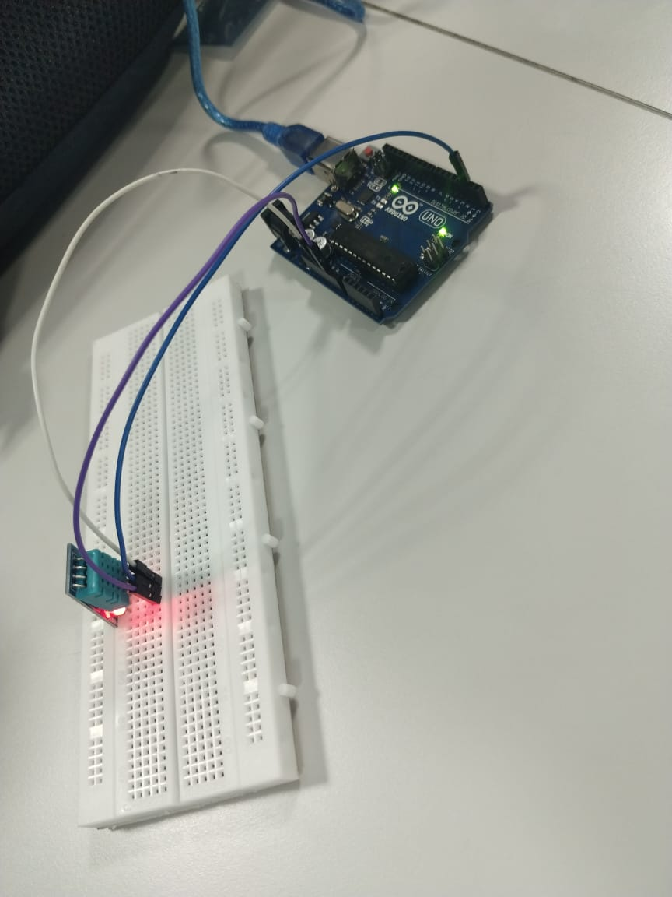

PROGRAM:
#include <DHT.h>

// Define DHT11 sensor pin and type
#define DHTPIN 2
#define DHTTYPE DHT11

DHT dht(DHTPIN, DHTTYPE);

void setup() {
Serial.begin(9600); // Start the serial monitor
dht.begin(); // Initialize the DHT sensor
Serial.println("DHT11 Temperature and Humidity Monitor");
}

void loop() {
// Wait a few seconds between measurements
delay(2000);

// Read humidity and temperature
float humidity = dht.readHumidity();
float temperature = dht.readTemperature(); // Celsius

// Check if readings are valid
if (isnan(humidity) || isnan(temperature)) {
Serial.println("Error reading from DHT11 sensor!");
return;
}

// Display readings
Serial.print("Temperature: ");
Serial.print(temperature);
Serial.print(" °C, Humidity: ");
Serial.print(humidity);
Serial.println(" %");

// Alert conditions
if (temperature > 35) {
Serial.println("Alert: High temperature!");
} else if (temperature < 15) {
Serial.println("Alert: Low temperature!");
}

if (humidity < 30) {
Serial.println("Alert: Low humidity!");
} else if (humidity > 70) {
Serial.println("Alert: High humidity!");
}

Serial.println("-----------------------------------");
}

PROGRAM DESCRIPTION:
- Reads data every 2 seconds.
- Shows temperature and humidity.
- Prints alert messages if temperature or humidity is beyond safe limits.

OUTPUT:
CASE 1: ROOM TEMPERATURE:

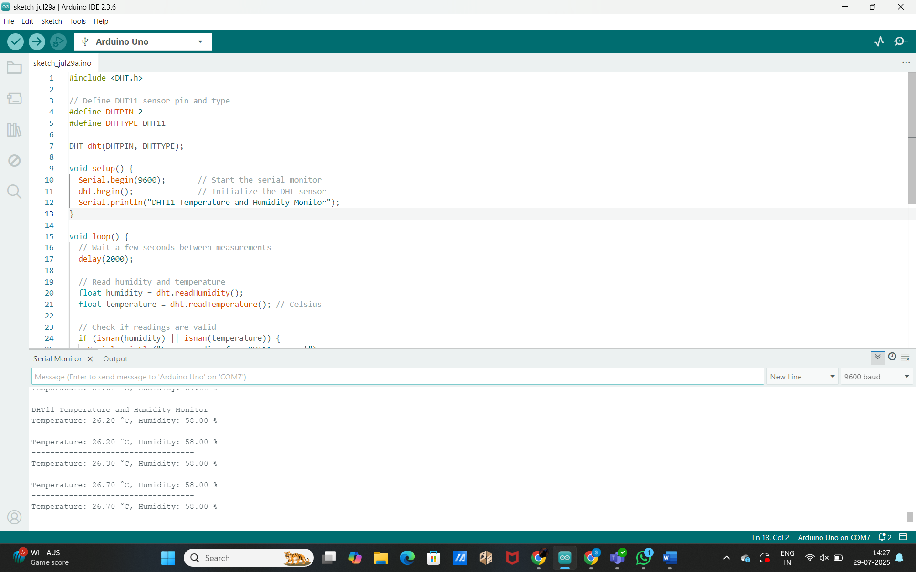
CASE2: HIGH TEMPERATURE:

