30/07/2025
CUBICLE 5:
TEAM A:
SARMATHA S [23ECB28]
SUBAGARNIYA M [23ECB46]
SYED ALI FATHIMA A [23ECB50]

Magnetic Security Alarm using HW-497 & Buzzer

DESCRIPTION:
This project is a magnetic security alarm using an Arduino and HW-497 Hall Effect sensor. When a magnet moves away from the sensor (like when a door opens), the system triggers an LED and buzzer as an alert. It’s a simple and effective setup for basic security or door monitoring.

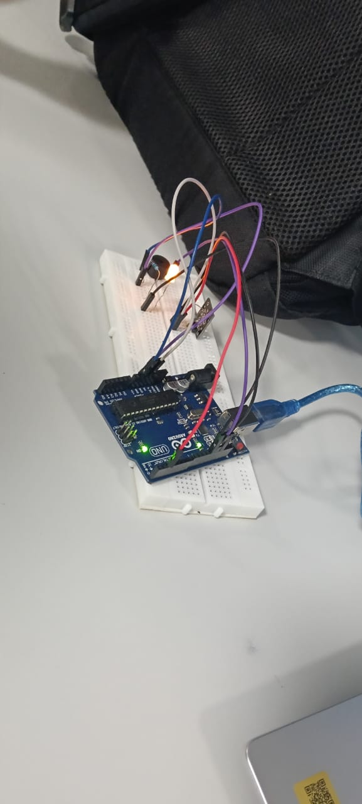
COMPONENTS:

Component | Use
Arduino UNO/Nano | The brain
HW-497 Sensor | Detects magnetic field
LED | Visual alert
Buzzer | Sound alert
Jumper Wires | Connections
Resistor (220Ω) | For LED safety

CONNECTIONS:
HW-497 Pin | Arduino Pin
VCC | 5V
GND | GND
OUT | D2

LED Pin | Arduino Pin
+ (Anode) | D12
- (Cathode) | GND via 220Ω resistor

Buzzer Pin | Arduino Pin
+ | D13
- | GND

PROGRAM:
int hallSensor = 2; // HW-497 output pin
int ledPin = 12; // LED pin
int buzzerPin = 13; // Buzzer pin

void setup() {
pinMode(hallSensor, INPUT);
pinMode(ledPin, OUTPUT);
pinMode(buzzerPin, OUTPUT);
Serial.begin(9600);
}

void loop() {
int sensorValue = digitalRead(hallSensor);

if (sensorValue == HIGH) {
// Magnet is away —> alert ON
digitalWrite(ledPin, HIGH);
digitalWrite(buzzerPin, HIGH);
Serial.println("⚠️ Alert: Door open or Magnet missing!");
} else {
// Magnet is near —> alert OFF
digitalWrite(ledPin, LOW);
digitalWrite(buzzerPin, LOW);
Serial.println("✅ Safe: Magnet detected.");
}

delay(200);
}

OUTPUT:
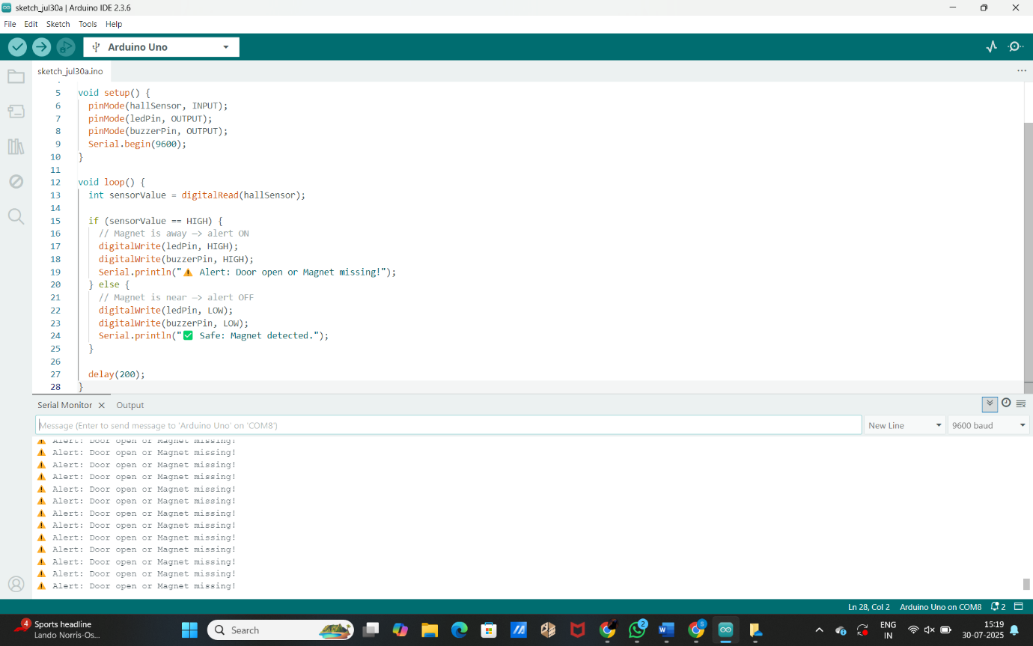

4 Relay module:
It is an electronic module that contains four relays — electromagnetic switches used to control high-voltage or high
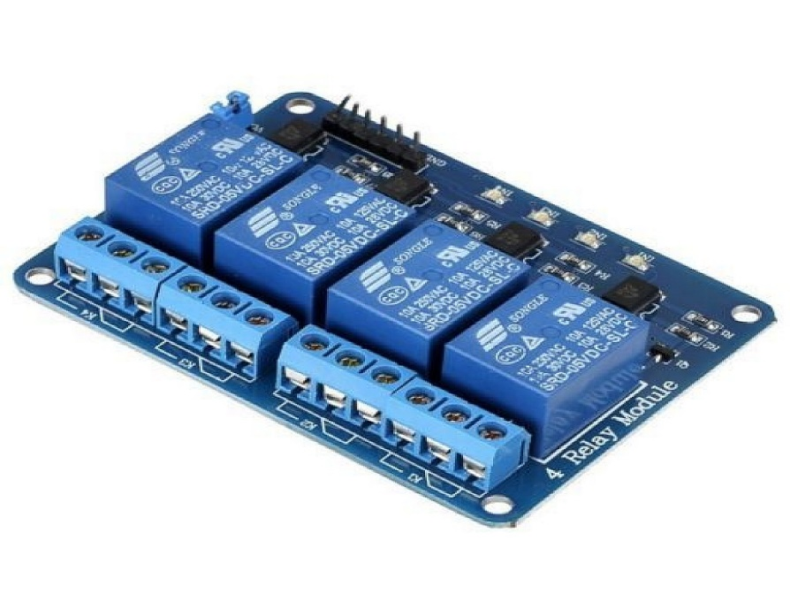

PROJECT:
1. Home Automation System
- Description: Control lights, fans, and appliances remotely using a microcontroller (like Arduino or ESP32) and a 4-relay module.
- Features: Wi-Fi/Bluetooth control, scheduled ON/OFF, voice commands (via Alexa or Google Assistant).
2. Smart Irrigation System
- Description: Automatically turn ON/OFF water pumps for different fields/zones based on soil moisture.
- Additional Components: Soil moisture sensor, water pump, ESP32, and mobile app (like Blynk).
3. Industrial Equipment Controller
- Description: Control 4 different machines or devices in a factory setup using a single embedded system.
- Features: Relay control through touchscreen or physical buttons.
4. IoT Energy Saver
- Description: Automatically turn off unused appliances (AC, heaters, lights) when no presence is detected.
- Sensors Used: PIR sensor, RTC module, or IR sensor.
5. Multi-Device Timer Switch
- Description: Turn ON/OFF 4 different appliances based on preset timer values.
- Features: LCD display, push buttons for setting time.
6. Remote-Controlled Power Distribution
- Description: Control power supply to 4 outputs using RF or IR remote.
- Modules: IR receiver or RF module with microcontroller.
7. Automatic Emergency Power Switch
- Description: Switch between main power and backup power (like inverter) for 4 devices.
- Logic: Relay-based switching with voltage sensors.
MAIN PURPOSE OF 4 RELAY MODULE:
- Act as an electronic switch to turn devices ON or OFF
- Control 4 different AC or DC loads independently
- Provide isolation between the control circuit and high-power devices using optocouplers
- Enable automation in home, industrial, or agricultural applications
Common Devices You Can Control:
- Lights
- Fans
- Motors
- Pumps
- Home appliances (TV, fridge, etc.)
- Power sockets
How It Works:
A microcontroller sends a LOW or HIGH signal → Relay coil gets activated → Switch inside the relay connects or disconnects the power to the device.

