31/07/2025
CUBICLE 5:
TEAM A:
SARMATHA S [23ECB28]
SUBAGARNIYA M [23ECB46]
SYED ALI FATHIMA A [23ECB50]

CASE 1:
4 Relay Module: Serial-Controlled Relay LEDs

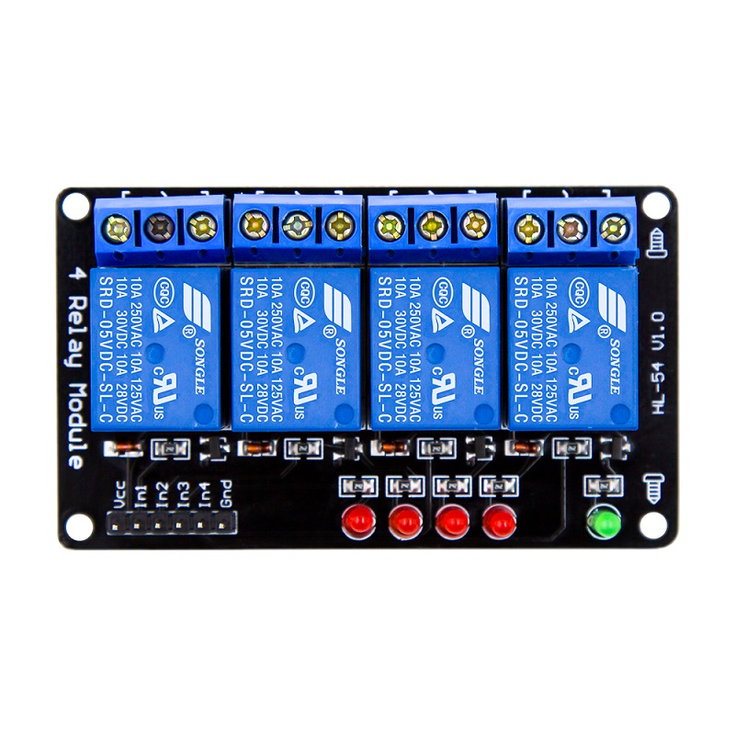
DESCRIPTION:
This project demonstrates how to control a 4-channel relay module using an Arduino UNO and the Serial Monitor. The relay module has 4 built-in indicator LEDs (one for each relay), which visually show the ON/OFF status of each relay.

CONNECTION:

Relay Module | Arduino Pin
IN1 | D2
IN2 | D3
IN3 | D4
IN4 | D5
VCC | 5V
GND | GND

PROGRAM:
int relay1 = 2;
int relay2 = 3;
int relay3 = 4;
int relay4 = 5;

void setup() {
Serial.begin(9600);

pinMode(relay1, OUTPUT);
pinMode(relay2, OUTPUT);
pinMode(relay3, OUTPUT);
pinMode(relay4, OUTPUT);

// Turn OFF all relays initially
digitalWrite(relay1, HIGH);
digitalWrite(relay2, HIGH);
digitalWrite(relay3, HIGH);
digitalWrite(relay4, HIGH);

Serial.println("Type 1, 2, 3, 4 to turn ON relays");
Serial.println("Type A, B, C, D to turn OFF relays");
}

void loop() {
if (Serial.available()) {
char command = Serial.read();

switch (command) {
case '1':
digitalWrite(relay1, LOW); // ON
Serial.println("Relay 1 ON");
break;
case '2':
digitalWrite(relay2, LOW);
Serial.println("Relay 2 ON");
break;
case '3':
digitalWrite(relay3, LOW);
Serial.println("Relay 3 ON");
break;
case '4':
digitalWrite(relay4, LOW);
Serial.println("Relay 4 ON");
break;
case 'A':
digitalWrite(relay1, HIGH); // OFF
Serial.println("Relay 1 OFF");
break;
case 'B':
digitalWrite(relay2, HIGH);
Serial.println("Relay 2 OFF");
break;
case 'C':
digitalWrite(relay3, HIGH);
Serial.println("Relay 3 OFF");
break;
case 'D':
digitalWrite(relay4, HIGH);
Serial.println("Relay 4 OFF");
break;
default:
Serial.println("Invalid command");
break;
}
}
}

BOARD SETUP:

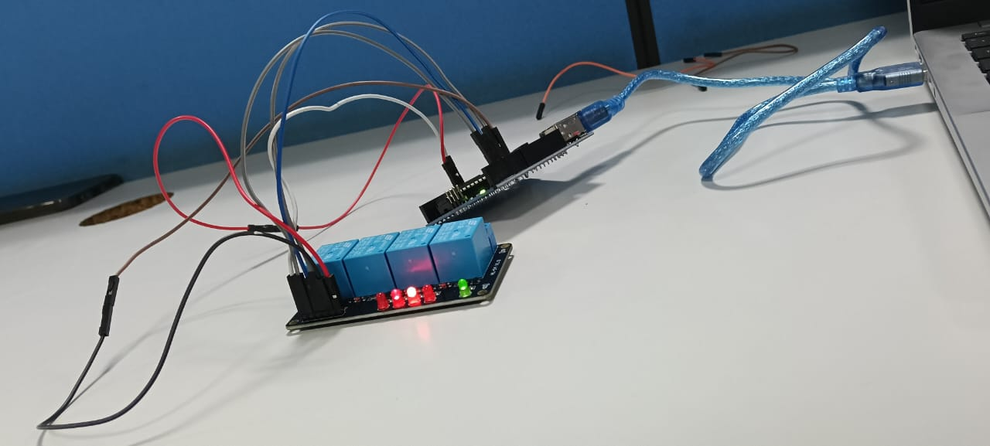

OUTPUT:
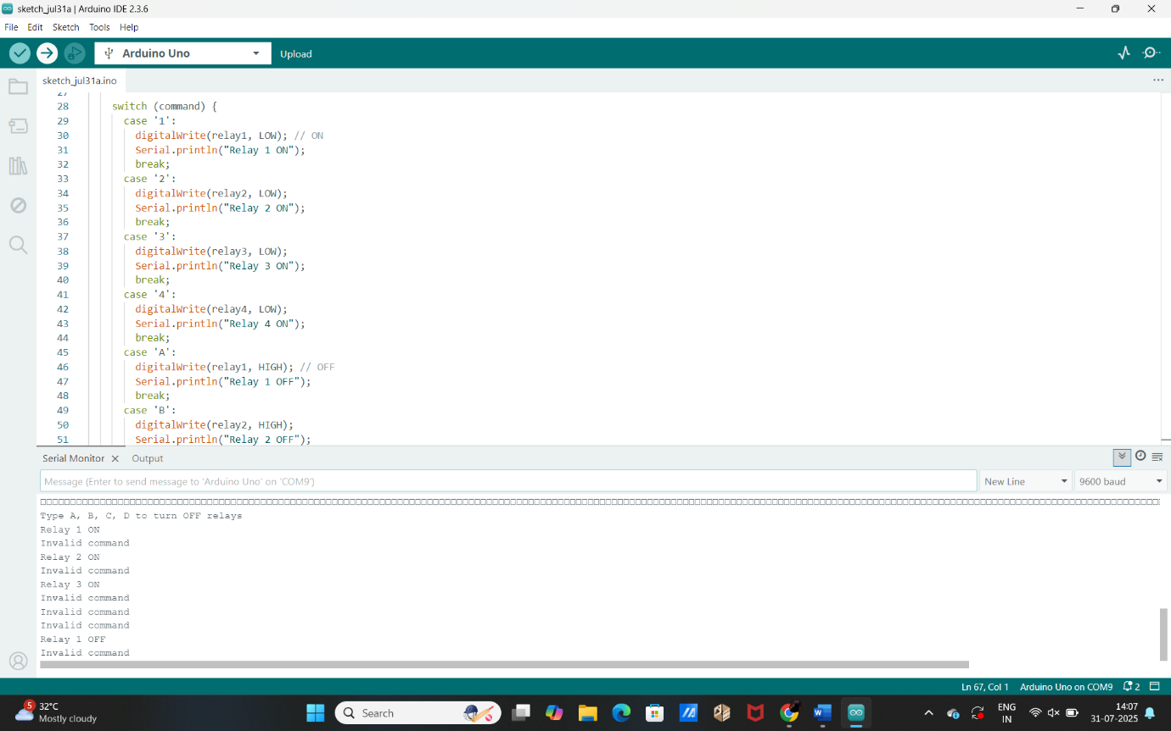

CASE 2:
4 Relay Module: Relay LED Sequence

DESCRIPTION:
This project demonstrates how to create a sequence pattern using the LED indicators on a 4-channel relay module, controlled by an Arduino UNO. The relays are turned ON and OFF in a timed sequence to create a chasing/blinking LED effect — just like a light show but using relay click sounds and their LEDs.
BOARD SETUP:

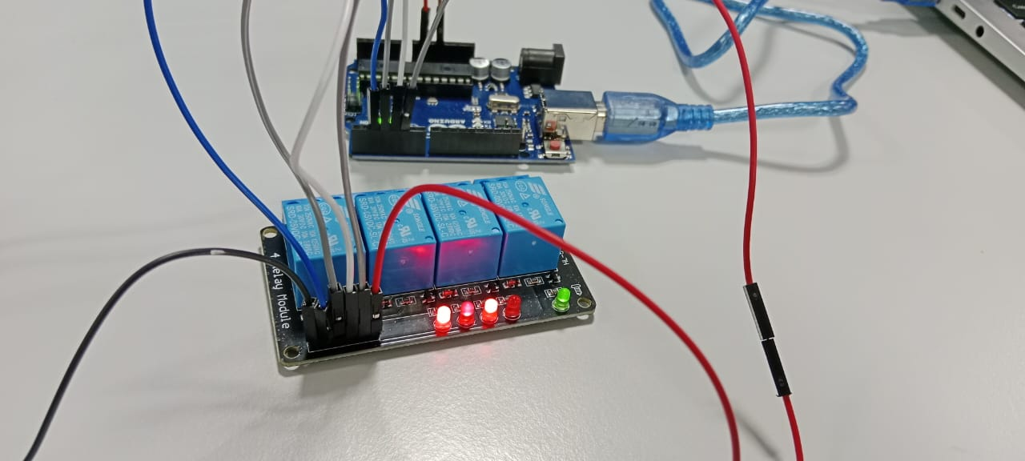

PROGRAM:
int relay1 = 2;
int relay2 = 3;
int relay3 = 4;
int relay4 = 5;

void setup() {
pinMode(relay1, OUTPUT);
pinMode(relay2, OUTPUT);
pinMode(relay3, OUTPUT);
pinMode(relay4, OUTPUT);

// Turn OFF all relays (relay OFF = HIGH for most modules)
digitalWrite(relay1, HIGH);
digitalWrite(relay2, HIGH);
digitalWrite(relay3, HIGH);
digitalWrite(relay4, HIGH);
}

void loop() {
// Relay ON = LOW, Relay OFF = HIGH

// Turn ON one by one
digitalWrite(relay1, LOW);
delay(500);
digitalWrite(relay2, LOW);
delay(500);
digitalWrite(relay3, LOW);
delay(500);
digitalWrite(relay4, LOW);
delay(500);

// Turn OFF one by one
digitalWrite(relay1, HIGH);
delay(500);
digitalWrite(relay2, HIGH);
delay(500);
digitalWrite(relay3, HIGH);
delay(500);
digitalWrite(relay4, HIGH);
delay(500);

// Blink all relays quickly
for (int i = 0; i < 3; i++) {
digitalWrite(relay1, LOW);
digitalWrite(relay2, LOW);
digitalWrite(relay3, LOW);
digitalWrite(relay4, LOW);
delay(300);
digitalWrite(relay1, HIGH);
digitalWrite(relay2, HIGH);
digitalWrite(relay3, HIGH);
digitalWrite(relay4, HIGH);
delay(300);
}

delay(1000); // pause before next loop
}

OUTPUT:



