18/08/2025
CUBICLE 5:
TEAM A:
SARMATHA S [23ECB28]
SUBAGARNIYA M [23ECB46]
SYED ALI FATHIMA A [23ECB50]

HW-492: HALL EFFECT SENSOR MODULE WITH A3144

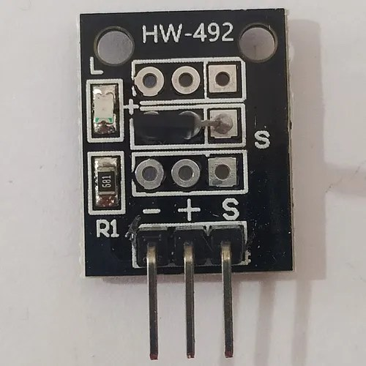

The HW-492 is a digital Hall Effect sensor module that detects magnetic fields using the A3144 Hall sensor. It is designed to sense the presence, absence, or change in magnetic fields and output a corresponding digital signal. The module is often used in proximity sensing, speed measurement, and magnetic switch applications.

PIN DESCRIPTION:
Pin | Name | Function
1 | VCC | Power supply (Connect to 3.3V or 5V)
2 | GND | Ground (Connect to GND of your microcontroller)
3 | OUT | Digital Output pin (Goes LOW when magnet is near)

- The output is HIGH (1) when no magnetic field is detected.
- The output is LOW (0) when a magnet is near the sensor.

PROGRAM:
const int hallPin = 2; // Digital pin connected to OUT of HW-492

void setup() {
pinMode(hallPin, INPUT);
Serial.begin(9600); // Start the Serial Monitor
}

void loop() {
int sensorValue = digitalRead(hallPin);

if (sensorValue == LOW) {
Serial.println("🧲 Magnet Detected!");
} else {
Serial.println("No Magnet.");
}

delay(300); // Delay to avoid spamming the monitor
}

BOARD SETUP:
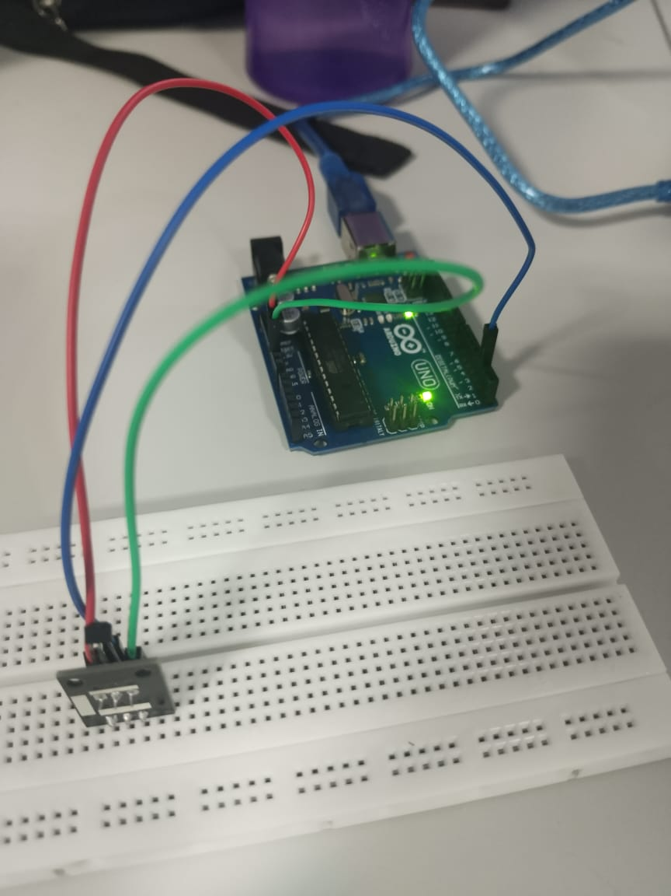

OUTPUT:
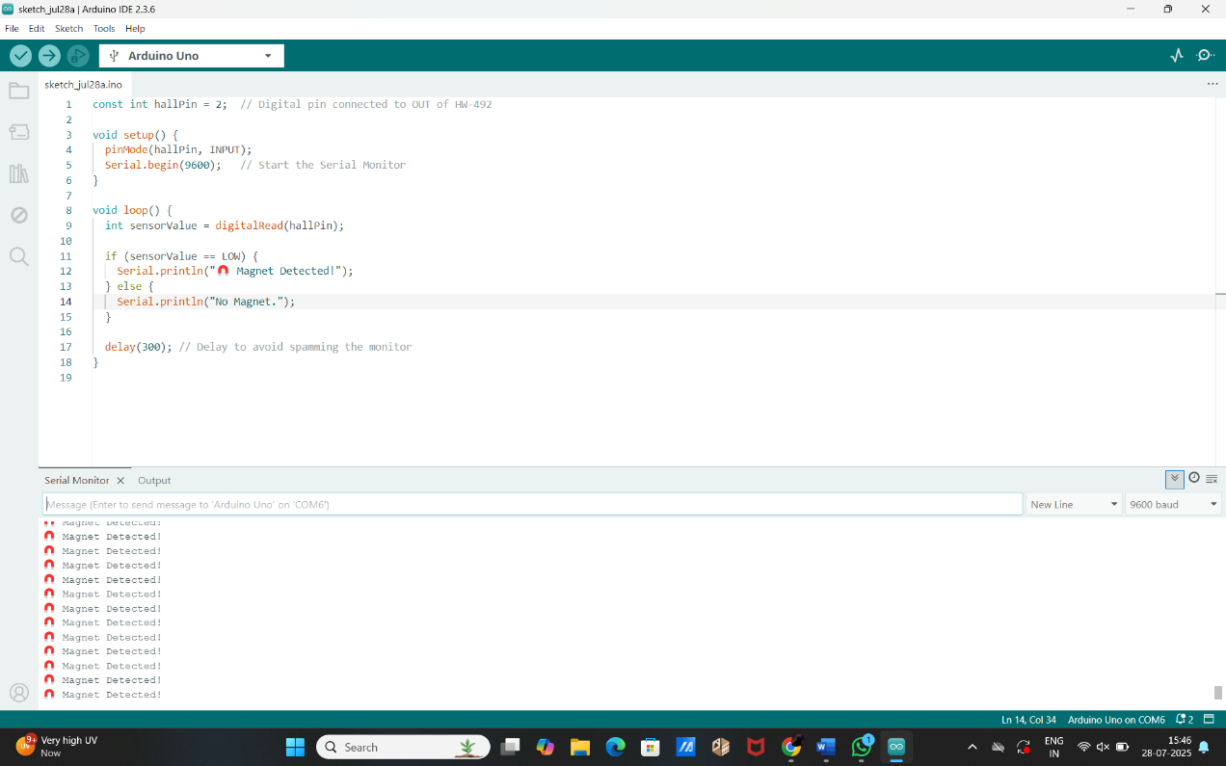

HW-504: JOYSTICK SENSOR

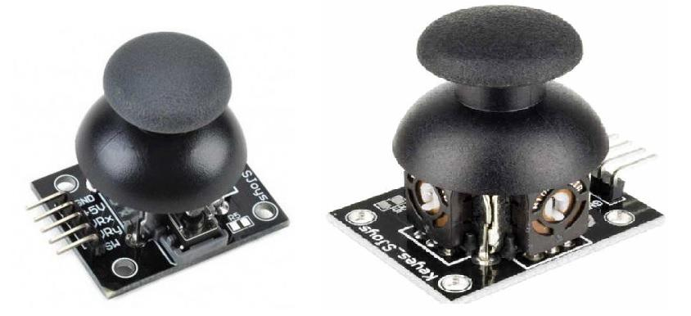

Pin | Function
GND | Ground
VCC | Power (5V/3.3V)
VRx | X-axis output
VRy | Y-axis output
SW | Button switch

Specification of Analog Joystick:
- Operating Voltage: 3V to 5V DC.
- Output Type: The output in the form of analog voltage
- Potentiometer: It has an internal 10k Ohm potentiometer used in the joystick to measure the position.
- Operating temperature: It operates on the 0 to 70 °C temperature range.
Projects:
- Joystick-controlled laser pointer for presentations.
- Remote light dimmer.
- Virtual Etch-a-Sketch (draw using joystick on screen).
- Maze game using OLED + joystick.
- Security cam angle adjuster with servo and joystick.

