HW-504: JOYSTICK SENSOR

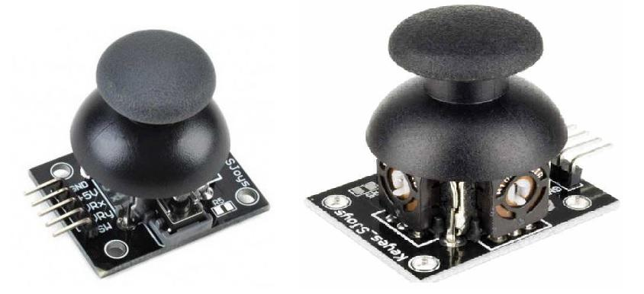

Pin | Function
GND | Ground
VCC | Power (5V/3.3V)
VRx | X-axis output
VRy | Y-axis output
SW | Button switch

Specification of Analog Joystick:
- Operating Voltage: 3V to 5V DC.
- Output Type: The output in the form of analog voltage
- Potentiometer: It has an internal 10k Ohm potentiometer used in the joystick to measure the position.
- Operating temperature: It operates on the 0 to 70 °C temperature range.
Projects:
- Joystick-controlled laser pointer for presentations.
- Remote light dimmer.
- Virtual Etch-a-Sketch (draw using joystick on screen).
- Maze game using OLED + joystick.
- Security cam angle adjuster with servo and joystick.

