Computer Networks

Project 1

Group Members

Mehmet Safa KATIRCIOĞLU – 150118047  
Mehmet Selim CAN – 150118063

**Connecting the servers**

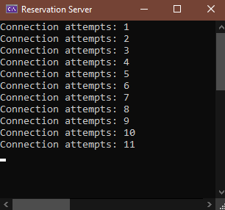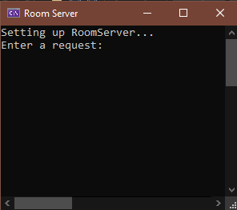

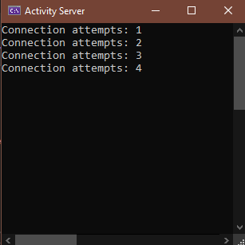

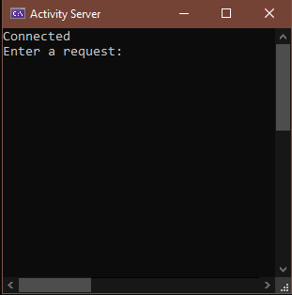

Add – Remove Room

