Assignment-1 Solutions

Name -Safaan Amin Hashmi

**Ans-1**

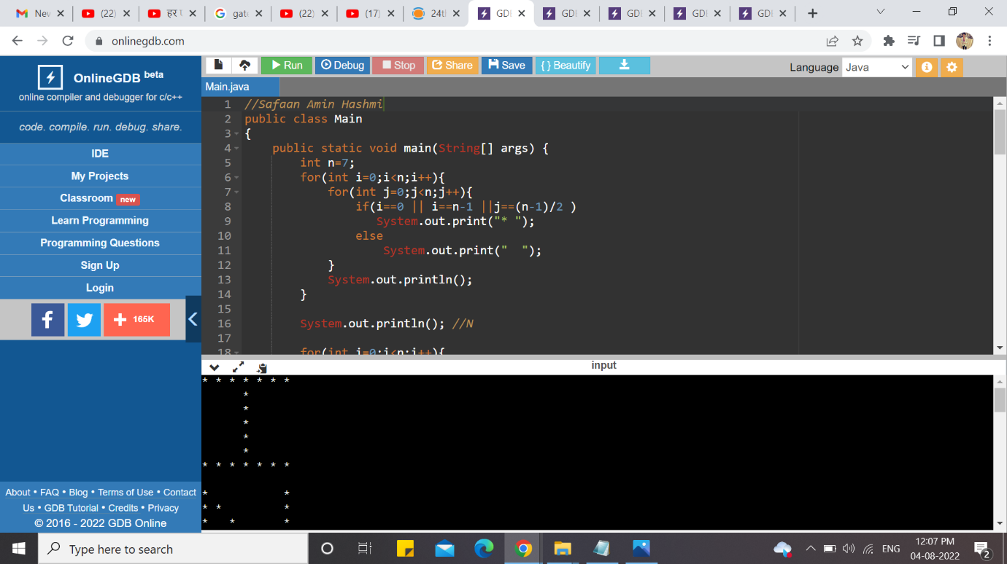

**Ans-2**

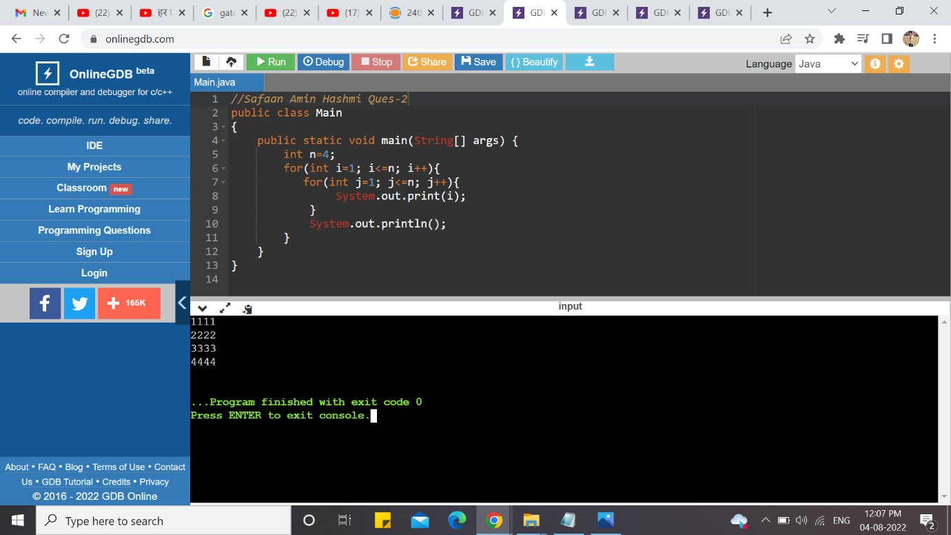

**Ans-3**

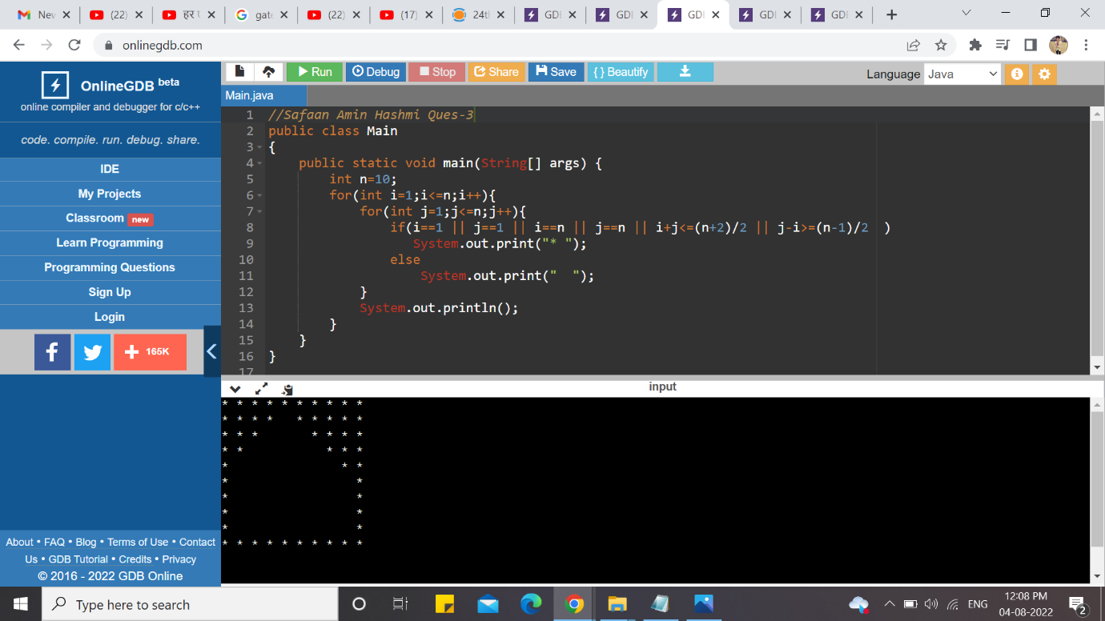

**Ans-4**

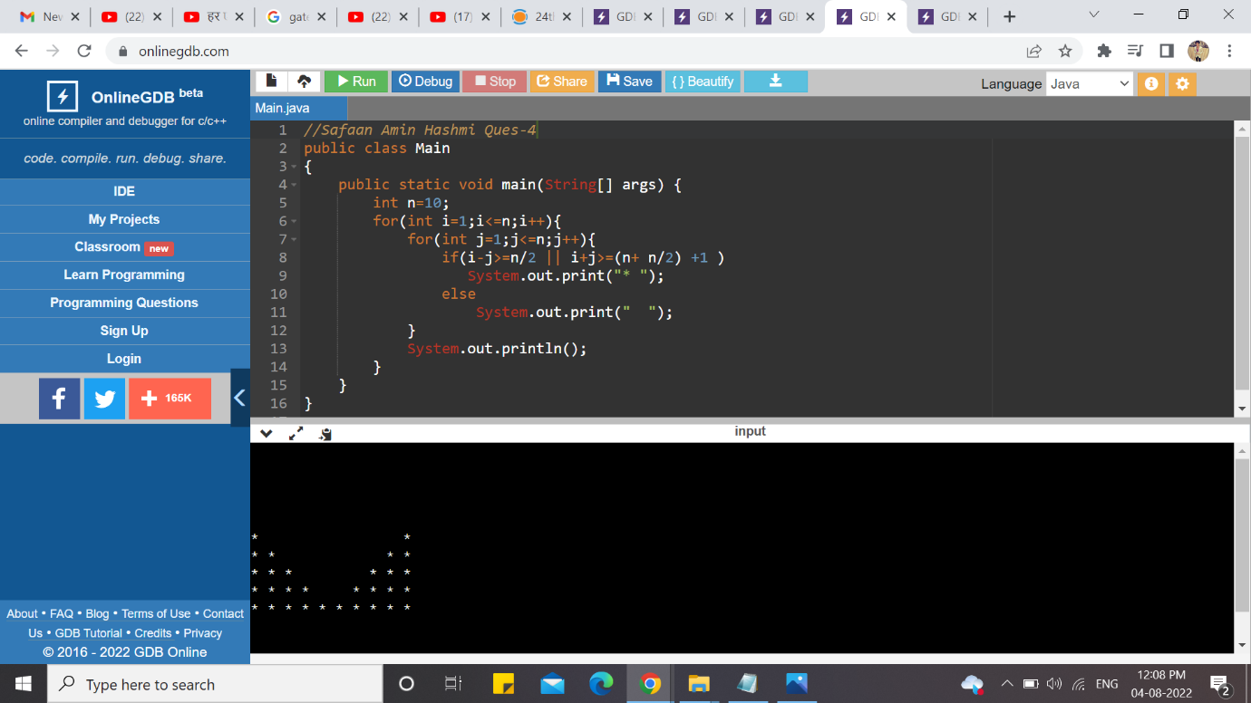

**Ans-5**

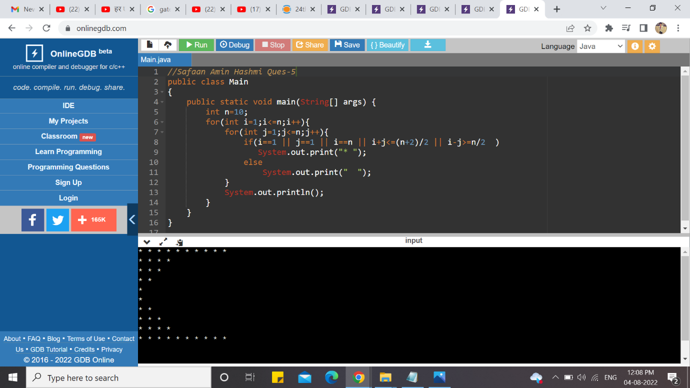

CODE

-----------------------------------------------------Ans-1 Print iNeuron------------------------------------------------------

public class Main

{

public static void main(String[] args) {

int n=7;

for(int i=0;i<n;i++){

for(int j=0;j<n;j++){

if(i==0 || i==n-1 ||j==(n-1)/2 )

System.out.print("* ");

else

System.out.print(" ");

}

System.out.println();

}

System.out.println(); //N

for(int i=0;i<n;i++){

for(int j=0;j<n;j++){

if(j==0 || j==n-1 ||i==j )

System.out.print("* ");

else

System.out.print(" ");

}

System.out.println();

}

System.out.println(); //E

for(int i=0;i<n;i++){

for(int j=0;j<n;j++){

if(j==0 || i==0 || i==n-1 ||i==(n-1)/2 )

System.out.print("* ");

else

System.out.print(" ");

}

System.out.println();

}

System.out.println(); //U

for(int i=0;i<n;i++){

for(int j=0;j<n;j++){

if(j==0 || j==n-1 ||i==n-1 )

System.out.print("* ");

else

System.out.print(" ");

}

System.out.println();

}

System.out.println(); //R

for(int i=0;i<n;i++){

for(int j=0;j<n;j++){

if(j==0 || i==0 ||i==(n-1)/2 || (j==n-1 && i<(n-1)/2) || (i>(n-1)/2 && i==j ) )

System.out.print("* ");

else

System.out.print(" ");

}

System.out.println();

}

System.out.println(); //O

for(int i=0;i<n;i++){

for(int j=0;j<n;j++){

if(j==0 || i==0 ||i==n-1 || j==n-1 )

System.out.print("* ");

else

System.out.print(" ");

}

System.out.println();

}

System.out.println(); //N

for(int i=0;i<n;i++){

for(int j=0;j<n;j++){

if(j==0 || j==n-1 ||i==j )

System.out.print("* ");

else

System.out.print(" ");

}

System.out.println();

}

}

}

------------------------------------------------------Ans-2 Print Series--------------------------------------------------------

public class Main

{

public static void main(String[] args) {

int n=4;

for(int i=1; i<=n; i++){

for(int j=1; j<=n; j++){

System.out.print(i);

}

System.out.println();

}

}

}

------------------------------------------------------Ans-3 Star Pattern-------------------------------------------------------

public class Main

{

public static void main(String[] args) {

int n=10;

for(int i=1;i<=n;i++){

for(int j=1;j<=n;j++){

if(i==1 || j==1 || i==n || j==n || i+j<=(n+2)/2 || j-i>=(n-1)/2 )

System.out.print("* ");

else

System.out.print(" ");

}

System.out.println();

}

}

}

------------------------------------------------------Ans-4 Star Pattern-------------------------------------------------------

public class Main

{

public static void main(String[] args) {

int n=10;

for(int i=1;i<=n;i++){

for(int j=1;j<=n;j++){

if(i-j>=n/2 || i+j>=(n+ n/2) +1 )

System.out.print("* ");

else

System.out.print(" ");

}

System.out.println();

}

}

}

------------------------------------------------------Ans-5 Star Pattern-------------------------------------------------------

public class Main

{

public static void main(String[] args) {

int n=10;

for(int i=1;i<=n;i++){

for(int j=1;j<=n;j++){

if(i==1 || j==1 || i==n || i+j<=(n+2)/2 || i-j>=n/2 )

System.out.print("* ");

else

System.out.print(" ");

}

System.out.println();

}

}

}