
Tribhuvan University
Institute of Humanities and Social Science

A PROJECT REPORT
ON
CITY INFORMATION SYSTEM
Submitted to
Department of Computer Application
Swastik College
In partial fulfillment of the requirements for the Bachelors in Computer Application

Submitted By
Aashika Khatiwada (6-2-1131-22-2022)
Safalta Shrestha (6-2-1131-47-2022)
3 April 2026

Tribhuvan University
Institute of Humanities and Social Science

A PROJECT REPORT
ON
CITY INFORMATION SYSTEM
Submitted to
Department of Computer Application
Swastik College

In partial fulfillment of the requirements for the Bachelors in Computer Application
Submitted By
Aashika Khatiwada (6-2-1131-22-2022)
Safalta Shrestha (6-2-1131-47-2022)
Under the Supervision of
Sagar Rana Magar
April 2026
Tribhuvan University
Institute of Humanities and Social Science
Swastik College

SUPERVISOR’S RECOMMENDATION

I hereby recommend that this project prepared under my supervision by AASHIKA KHATIWADA and SAFALTA SHRESTHA entitled “City Information System” in partial fulfillment of the requirements for the degree of Bachelor of Computer Application is recommended for the final evaluation.

..............................
Sagar Rana Magar
Lecturer
Swastik College

Tribhuvan University
Institute of Humanities and Social Science
Swastik College

LETTER OF APPROVAL

This is to certify that this project prepared by AASHIKA KHATIWADA and SAFALTA SHRESTHA entitled “City Information System” in partial fulfillment of the requirements for the degree of Bachelor of Computer Application has been evaluated. In our opinion, it is satisfactory in the scope and quality as a project for the required degree.
........................................  Mr. Sagar Rana Magar  Lecturer  Swastik College | ............................................  Ms. Susan Sunuwar  Coordinator  Swastik College
...........................................…  Internal Examiner | .............................................…  External Examiner

ACKNOWLEDGEMENT
We are obliged to a number of people who helped us to organize this project and thankful for their kind opinions, suggestions, and appropriate guidelines. We have received endless support and guidance in finalizing our project so we would like to take this opportunity to thank them all.
First and foremost, we would like to express our special thanks of gratitude to our supervisor Mr. Sagar Rana Magar, who gave us the honor to do this wonderful project on the topic City Information System (HTML, CSS, JavaScript, SQL, PHP), which has helped us a lot in sharpening our knowledge. We are also thankful for his continuous feedback and encouragement throughout the project. Without his grace, this project could not have become accomplished. Moreover, we came to know many new things while doing the project so, deeply thankful to him.
Secondly, we are overwhelmed with all the support and guidance that we got from our friends. They have assisted us from time to time in making this project satisfactorily complete by giving innovative ideas. So, we would like to thank them for helping us in making the project wonderful and unique.
At last but not least, we are thankful to all who have been always encouraging and helping us to cope with the challenges that we faced during the completion of the project.

With Regards,
Aashika Khatiwada
Safalta Shrestha

ABSTRACT
This report describes the design and development of a web-based City Information System aimed at providing a centralized and structured platform for accessing essential city-related information. With the increasing complexity of urban environments, the system addresses the challenges of scattered and unorganized data by enabling users—particularly residents, students, and tourists—to easily access information on tourism sites, healthcare facilities, educational institutions, hotels, public services, and events.
The system is developed using HTML, CSS, JavaScript, PHP, and MySQL, ensuring efficient front-end interaction and robust back-end data management. It supports key functionalities such as user registration and authentication, category-based search and filtering, interactive map visualization, and CRUD operations for managing city data.
A key feature of the system is the integration of a location-based service that utilizes the Haversine distance calculation algorithm to identify and display nearby places based on the user’s current location, thereby enhancing navigation and decision-making. The system also emphasizes usability through a simple and responsive interface, making it accessible to users with varying technical skills.Overall, the project demonstrates the practical application of web technologies in addressing urban information challenges and provides a scalable solution that can be further enhanced with features such as real-time updates and smart city integrations.
Keywords: City Information System, Web Application Development, Urban Data Management, Location-Based Services, Haversine Algorithm, Interactive Maps, Responsive Web Design, Database-Driven Application, Tourism and Public Services, PHP & MySQL Integration

TABLE OF CONTENT
ACKNOWLEDGEMENT i
ABSTRACT ii
TABLE OF CONTENT iii
LIST OF TABLES v
LIST OF FIGURES vi
LIST OF ABBREVIATIONS vii
CHAPTER 1: INTRODUCTION 1
1.1 Introduction 1
1.2 Problem Statement 2
1.3 Objectives 2
1.4 Scope and Limitation 3
1.4.1 Scope 3
1.4.2 Limitations 3
1.5 Development Methodology 4
1.6 Report Organization 4
CHAPTER 2: BACKGROUND STUDY AND LITERATURE REVIEW 6
2.1 Background Study 6
2.2 Literature Review 6
CHAPTER 3: SYSTEM ANALYSIS AND DESIGN 8
3.1 System Analysis 8
3.1.1 Requirement Analysis 8
3.1.2 Feasibility Analysis 10
3.1.3 Data Modeling (ER-Diagram) 12
3.1.4 Process Modeling(DFD) 13
3.2 System Design 14
3.2.1 Architectural Design 14
3.2.2 Database Schema Design 15
3.2.3 Interface Design 15
3.2.4 Physical DFD 17
3.3 Algorithm Details 18
CHAPTER 4: IMPLEMENTATION AND TESTING 19
4.1 Implementation 19
4.1.1 Tools Used 19
4.1.2 Implementation Details of Modules 21
4.2 Testing 24
4.2.1 Test Cases for Unit Testing 24
4.2.2 Test Cases for System Testing 27
CHAPTER 5: CONCLUSION AND FUTURE RECOMMENDATIONS 31
5.1 Lesson Learnt/Outcome 31
5.1.1 Lesson Learnt 31
5.1.2 Outcome 32
5.2 Conclusion 33
5.3 Future Recommendation 33
REFERENCES 34
APPENDICES 35

LIST OF TABLES
Table 4-1 Test Case for User Registration 24
Table 4-2 Test Case for User Login 26
Table 4-3 Test Case for Admin Login 26
Table 4-4 Test Case for User and Admin Logout 27
Table 4-5 Test Case for system testing of the city information system 27

LIST OF FIGURES

Figure 3-1 Use Case Diagram 9
Figure 3-2 Gantt Chart 11
Figure 3-3 ER-Diagram 12
Figure 3-4 0-Level DFD 13
Figure 3-5 1-Level DFD 13
Figure 3-6 Architectural Design 14
Figure 3-7 Database Schema 15
Figure 3-8 Home Page 15
Figure 3-9 Login Page 16
Figure 3-10 Dashboard 16
Figure 3-11 Admin Panel 17
Figure 3-12 Physical DFD 17
Appendices-A1 Home Section 35
Appendices-A2 About Page 35
Appendices-A3 Services Section 36
Appendices-A4 Registration Form 36
Appendices-A5 Events Section 37
Appendices-A6 Map Section 37
Appendices-A7 Login Form 37
Appendices-A8 User Dashboard 38
Appendices-A9 Profile Section 38
Appendices-A10 Event History 39
Appendices-A11 Ticket Booking and Issue Ticket 40
Appendices-A12 Admin Panel 42

LIST OF ABBREVIATIONS

CASE Computer Aided Software Engineering tools
CIS City Information System
CSS Cascading Style Sheet
DFD Data Flow Diagram
ER Entity Relationship
HTML Hypertext Markup Language
JS JavaScript
PHP PHP Hypertext Preprocessor
SQL Structured Query Languag

CHAPTER 1: INTRODUCTION

Introduction
In the modern urban landscape, cities are hubs of diverse activities, services, and opportunities. With the rapid growth of population and infrastructure, accessing accurate and organized information about city facilities, tourist attractions, public services, and essential amenities has become increasingly important. Traditional methods of gathering information, such as printed guides, word-of-mouth, or scattered online sources, are often inefficient, time-consuming, and may not provide real-time or reliable data. This project focuses on the development of a City Information System, a web-based application designed to consolidate and centralize comprehensive information about urban resources, thereby improving accessibility, usability, and efficiency for residents, tourists, and service providers.
The system aims to provide detailed information about key city components, including healthcare facilities, educational institutions, hotels, restaurants, tourism sites, government services, and emergency services. Users can navigate the application to quickly locate relevant information, plan visits, or access essential services. By integrating modern web technologies such as HTML, CSS, JavaScript, PHP, and MySQL, the system ensures a seamless and interactive user experience, while the back-end database provides robust data storage and retrieval capabilities.
A distinctive feature of this system is its location-based service, which leverages the Haversine distance calculation algorithm to determine the proximity of facilities relative to the user’s current location. Additional functionalities include user authentication, search and filter options, and CRUD (Create, Read, Update, Delete) operations for dynamic content management. The system is designed to be scalable, user-friendly, and adaptable to evolving urban needs.
By consolidating city information into a single, accessible platform, this system not only enhances navigation and decision-making but also demonstrates the practical application of web technologies in addressing real-world urban challenges. It serves as a valuable tool for both residents and visitors, promoting better engagement with city resources and improving the overall urban experience.

Problem Statement
In modern urban environments, residents and visitors often face significant challenges in accessing reliable and comprehensive information about city facilities, services, and attractions. Existing sources, such as printed guides, scattered websites, or informal recommendations, are typically fragmented, outdated, and inconsistent, making it difficult for users to make informed decisions efficiently. Key services—including healthcare, education, government offices, public transport, and tourism attractions—are often not consolidated in a single platform, resulting in wasted time and frustration. Moreover, current systems rarely provide real-time updates, location-based search, or personalized filtering, further limiting accessibility and user convenience. The lack of a centralized, integrated, and interactive platform not only hampers navigation and planning for individuals but also affects the visibility and utilization of local businesses and public services. This creates an urgent need for a unified solution that aggregates city-related information into a single user-friendly interface, allowing residents and visitors to easily search, filter, and access essential services. By addressing these challenges, such a platform can enhance urban living, improve service delivery, and foster a more connected and efficient city experience.

Objectives
The primary goal of this project is to develop an intelligent, user-centric platform that aggregates and delivers critical information about city services and infrastructure efficiently. The objectives are as follows:
- Unified Information Access: Integrate data across healthcare, education, transportation, government services, and local amenities into a single, coherent platform.
- Location-Driven Services: Leverage geospatial technologies to provide context-aware recommendations and navigation support.
Collectively, these objectives aim to enhance urban living by creating a connected, informed, and empowered community, bridging technological innovation with practical civic solutions.

Scope and Limitation

Scope
The scope of this project encompasses the development of a centralized platform designed to provide comprehensive city-related information to users efficiently. The platform aims to integrate diverse datasets covering healthcare, education, transportation, public services, and local businesses to facilitate informed decision-making. Key elements within the scope include:
- Data Integration: Aggregation of information from multiple reliable sources to provide a unified repository.
- User Interface Design: Development of an intuitive and responsive interface that supports easy navigation, filtering, and personalized experiences.
- Real-Time Information: The system provides frequently updated information through admin-managed updates,ensuring users access the most recent verified data available in the database.
- Location-Based Services: Leveraging geolocation for context-aware recommendations and proximity-based search results.
- Accessibility: Designing the system to be inclusive and usable by a diverse user base with varying technological proficiency.
- Scalability: Structuring the platform to accommodate future expansion, additional data sources, and emerging urban services.
The project does not extend to the creation of physical infrastructure, offline service provision, or advanced predictive modeling beyond the currently available urban datasets. By defining these boundaries, the project establishes a clear framework for delivering a technologically robust, user-centered solution that enhances access to essential city information.

1.4.2 Limitations
- The system is online web-based application, so poor internet connectivity can make it challenging like accessing map features.
- Data is manually updated by administrators and not automatically synchronized.
- Information is not updated automatically in real time.
- The system is limited to selected city areas and services.
- The system doesn’t provide advanced smart city analytic.

Development Methodology
This project employs a Hybrid/Incremental development model, combining the structured phases of the Waterfall approach with the flexibility and iterative nature of Incremental development. The process begins with thorough requirement analysis and system design, establishing a solid foundation for architecture, data flow, and interface specifications. Implementation proceeds in incremental modules, each developed, tested, and integrated independently, allowing early validation of system functionality and progressive delivery of features. Continuous unit testing, integration testing, and stakeholder reviews are conducted at each increment to detect issues early, gather feedback, and refine subsequent modules. This hybrid approach ensures both system reliability through upfront planning and adaptability to evolving requirements, while promoting efficient resource utilization and timely delivery. Comprehensive documentation accompanies each phase, supporting maintainability and future scalability. By integrating the strengths of structured and iterative methodologies, this development strategy delivers a robust, user-centered, and scalable solution aligned with modern software engineering best practices.

Report Organization
- he first part of the report contains the summarized introduction of the whole report. It
- includes the overview, scope and limitation, problem statement and objectives of this
- project.
- The second chapter includes background study i.e. description of fundamental theories,
- general concepts and terminology related to the project. It also includes the literature review
- i.e. review of the similar projects, research and theories done by other researchers.
- The third chapter includes the system analysis and design phase in which the report
- of functional and non-functional requirements of the project is stated using use case and
- system diagrams. It also includes the feasibility study about the system which explains
- whether the system development process is affordable and within the knowledge range of
- the developers. It shows the technical, operational and economic feasibility of the project
- development phase. The explanation of the designing of the system is also done in this
- chapter. It includes data modeling and process modeling which is explained by using ER
- diagram and Data Flow Diagram. The architectural design, database design and the user
- interface design is also listed in this chapter.
- The fourth chapter includes the implementation and testing phase of the proposed system.
- In the implementation phase, the tools like CASE tools, programming languages and
- database platforms are implemented.
- The fifth chapter includes conclusion and future recommendation. This contains the
- final paragraphs of the report and in this phase the overall outcome and the developer s‟
- point of view is written. The lesson that I learned through all the phases can also be included
- in this phasThe first part of the report contains the summarized introduction of the whole report. It includes the overview, scope and limitation, problem statement and objectives of this project.
The second chapter includes background study i.e. description of fundamental theories, general concepts and terminology related to the project. It also includes the literature review i.e. review of the similar projects, research and theories done by other researchers.
The third chapter includes the system analysis and design phase in which the report of functional and non-functional requirements of the project is stated using use case and system diagrams. It also includes the feasibility study about the system which explains whether the system development process is affordable and within the knowledge range of the developers. It shows the technical, operational and economic feasibility of the project development phase. The explanation of the designing of the system is also done in this chapter. It includes data modeling and process modeling which is explained by using ER diagram and Data Flow Diagram. The architectural design, database design and the user interface design is also listed in this chapter.
The fourth chapter includes the implementation and testing phase of the proposed system. In the implementation phase, the tools like CASE tools, programming languages and database platforms are implemented.
The fifth chapter includes conclusion and future recommendation. This contains the final paragraphs of the report and in this phase the overall outcome and the developer’s point of view is written. The lesson that I learned through all the phases can also be included in this phase.

CHAPTER 2: BACKGROUND STUDY AND LITERATURE REVIEW

2.1 Background Study
A City Information System(CIS) is an integrated software platform designed to collect, manage, and provide comprehensive information about a city’s infrastructure, services, demographics, and resources. As urban populations grow and cities become more complex, the need for efficient management and decision-making has increased.
Traditionally, city administration relied on manual processes and fragmented data stored across multiple departments, which often led to inefficiencies, delays in accessing information, and limited transparency. To overcome these issues, City Information Systems aim to organize and centralize essential city-related data on a single digital platform. In the context of this study, the system focuses on selected cities and provides structured information related to public services and tourism. It allows users to view city details, explore available services and tourist destinations, and locate nearby places through map-based visualization, thereby improving accessibility and ease of information retrieval for citizens.
The adaptation of digital tools in urban management reflects broader trends toward data-driven governance, smart city development, and increased citizen engagement. Implementing a robust CIS not only improves administrative efficiency but also enhances planning, monitoring, and public service delivery. This study explores the functionalities, advantages, and challenges of City Information Systems, aiming to provide insights into their impact on urban management and citizen participation.

2.2 Literature Review
A review of existing City Information Systems highlights best practices, common challenges, and innovation opportunities, showing how CIS improves transparency, efficiency, citizen engagement, and supports informed urban governance.
Virtual Singapore is an advanced 3D digital city model that enables urban planners and policymakers to simulate various urban scenarios. It helps in monitoring infrastructure performance, analyzing population dynamics, and improving long-term city planning strategies. [1]
Barcelona’s Smart City Platform integrates Internet of Things (IoT) devices to manage traffic flow, public utilities, and environmental data. This integration enables real-time monitoring and data-driven decision-making for city administrators, leading to more efficient urban services. [2]
India’s Smart Cities Mission utilizes Geographic Information Systems (GIS) and citizen portals to enhance municipal services. It allows authorities to track development projects, improve service delivery, and encourage citizen participation through feedback and reporting mechanisms. [3]
Urban Data Platforms focus on integrating diverse datasets from sectors such as transportation, healthcare, and public utilities. By providing a unified view of city operations, these platforms help authorities analyze trends and improve coordination across departments. [4]
The International Journal of Urban Planning highlights the use of GIS technology for mapping city resources, analyzing spatial patterns, and optimizing urban development decisions. GIS-based systems support effective land use planning and infrastructure development. [5]
Smart City Research discusses key challenges such as integrating legacy systems, ensuring data privacy and security, and scaling smart solutions for medium-sized cities. Addressing these challenges is critical for the successful implementation of city information systems. [6]
CityScope projects demonstrate how simulation-based city information systems support participatory urban planning. These tools allow stakeholders and citizens to visualize future development scenarios and contribute to collaborative decision-making processes. [7]
Urban Informatics Reports emphasize the importance of mobile applications and cloud-based platforms in delivering real-time city information. These technologies improve accessibility and ensure that citizens can easily access services and updates anytime, anywhere. [8]

CHAPTER 3: SYSTEM ANALYSIS AND DESIGN

3.1 System Analysis
System Analysis refers into the process of examining a system with the intent of improving it
through better procedures and methods. It is the process of planning a new system to either
replace or complement an existing system. It is therefore, the process of gathering and
interpreting facts, diagnosing problems and using the information to re- comment
improvements in the system. System analysis is conducted with the following objectives in
mind:
•Evaluate the system concept for feasibility.
•Perform economic and technical analysis.
•Allocate functions to hardware, software people, database and other system elements.
•Establish cost and schedule constraints.

3.1.1 Requirement Analysis
3.1.1.1 Functional Requirements
Functional requirements detail the operations and functions that the system must perform. They describe how users interact and complete actions within the system. Such as:
- Users should be able to register and log in to the system securely.
- Users should be able to view city-related information such as tourism places, hospitals, hotels, educational institutions and event.
- Users should be able to filter information by city and category.
- The system should display interactive maps showing locations of services and tourism places.
- Users should be able to find nearby services using the nearest-location finder.
- Users should be able to view detailed information including descriptions, images and contact details.
- Users should be able to book services like hospital and hotels tickets and also can register for events.
- Administrators should be able to add, update and delete city information.
- Administrators should be able to manage users, services, tourism places and events.
- The system should allow users to send message or inquiries to administrators.
- Administrators should be able to monitor and respond to user inquiries, feedback and complaints effectively.
- The system should support notifications.
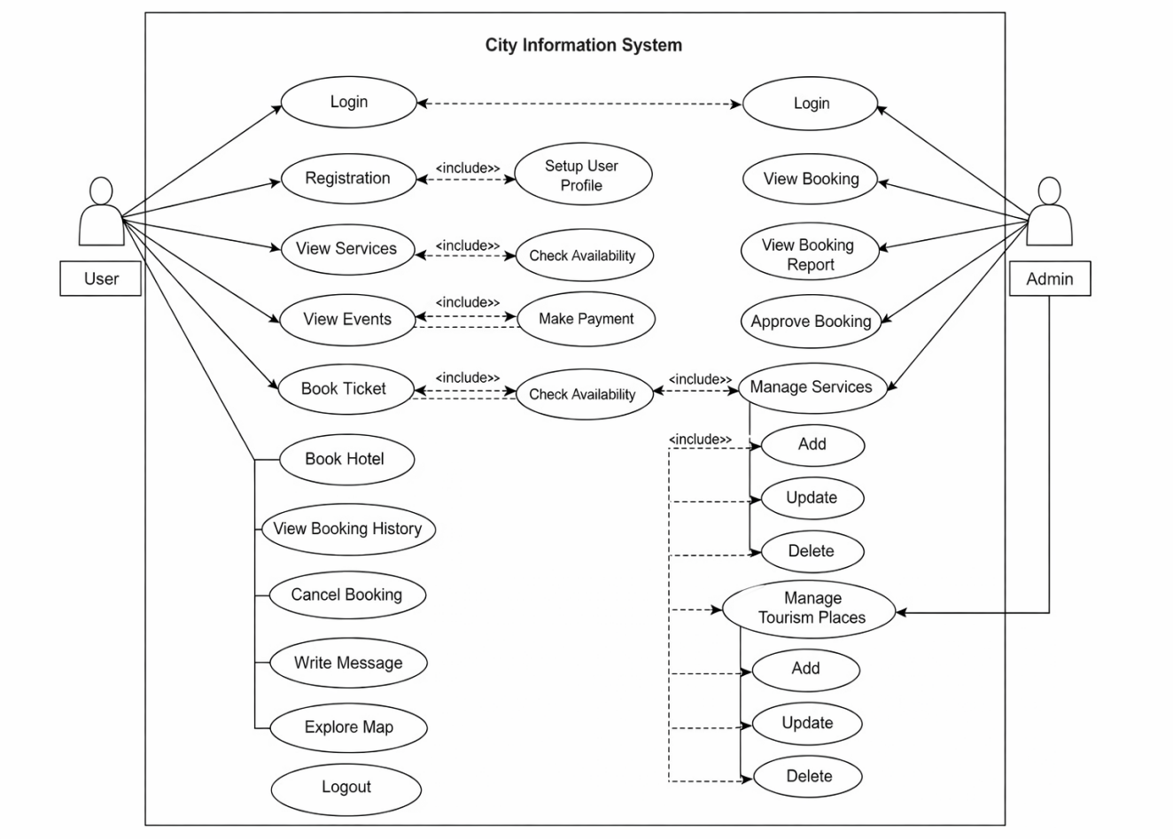
Figure 3-1 Use Case Diagram
3.1.1.2 Non Functional Requirements
Performance:
- The system should respond quickly to user actions such as page loading, map display within a seconds to ensure a smooth user experience.
- The system should be capable to supporting multiple concurrent users simultaneously without noticeable performance degradation.
Security:
- To protect user privacy all sensitive data including personal and login credentials, should be encrypted during data both transmission and storage.
Usability:
- The system should provide a simple,and easy-to-navigate user interface that can be used by people with varying technical skills.
- The application should be fully responsive and accessible across different devices, including desktops, tablets and mobile phones ensuring consistent usability on all platforms.
Reliability:
- The system should ensure data consistency and accuracy across all modules, even
during frequent updates.
- The system should be able to handle errors gracefully by displaying informative
error messages and recovering smoothly without crashing or losing data.
Scability:
- The system should be designed to support future expansion such as adding new
cities, services, modules or advanced features without major changes to the
existing architrcture.
- The database should efficiently manage city-related data while maintaining fast query performance and system stability.

3.1.2 Feasibility Analysis
3.1.2.1 Technical Feasibility
The technical feasibility of the City Information System assesses whether the necessary technology, data, and skills are available for its development and maintenance. The system relies on accurate city-related data, including public services, tourist attractions, events, and transportation. The system will be developed using HTML, CSS, and JavaScript for the front-end, and PHP with MySQL for back-end processing and database management. Visual Studio Code (VS Code) will be used as the development environment, with XAMPP providing the local server and database support. This setup ensures smooth integration, easy testing, and future scalability.
3.1.2.2 Operational Feasibility
The operational feasibility of the City Information System assesses whether the system can be effectively integrated into daily operations and used efficiently by residents, city administrators, and visitors. The system is designed to support routine tasks, such as updating information on city services, tourist attractions, and events, ensuring that data remains organized and up-to-date. With a user-friendly interface, the system provides easy access to relevant information, reducing manual effort and improving overall accessibility for users. Operational feasibility also considers the training required for administrators to manage and update content, as well as the ongoing technical support necessary to maintain smooth and reliable system operation.
3.1.2.3 Economic Feasibility
The project is economically feasible because all required tools and resources, including VS Code, XAMPP, PHP, MySQL, HTML, CSS, and JavaScript, are open-source or free to use. By leveraging these cost-effective technologies, the City Information System can be developed within budget while maintaining high quality, reliability, and scalability. The development process is planned over a three-month period, with clearly defined stages for planning, development, testing, and deployment, ensuring efficient use of time and resources throughout the project lifecycle.
3.1.2.4 Schedule Feasibility
Schedule feasibility evaluates whether the project can be completed within the allocated time frame. The development of the City Information System is planned over a three-month period, with specific time allocated for each phase to ensure timely completion.The Gantt chart is as follow:
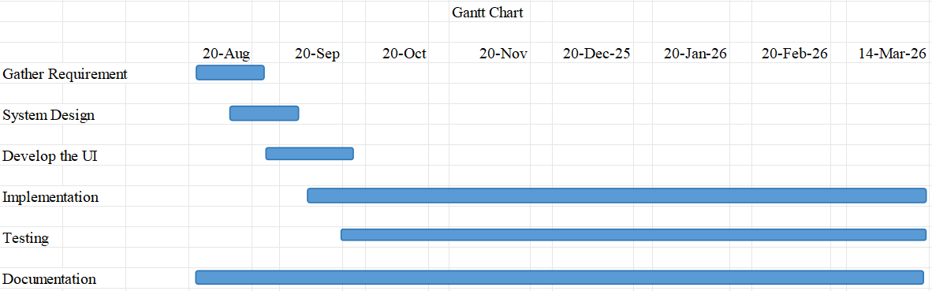
Figure 3-2 Gantt Chart

3.1.3 Data Modeling (ER-Diagram)
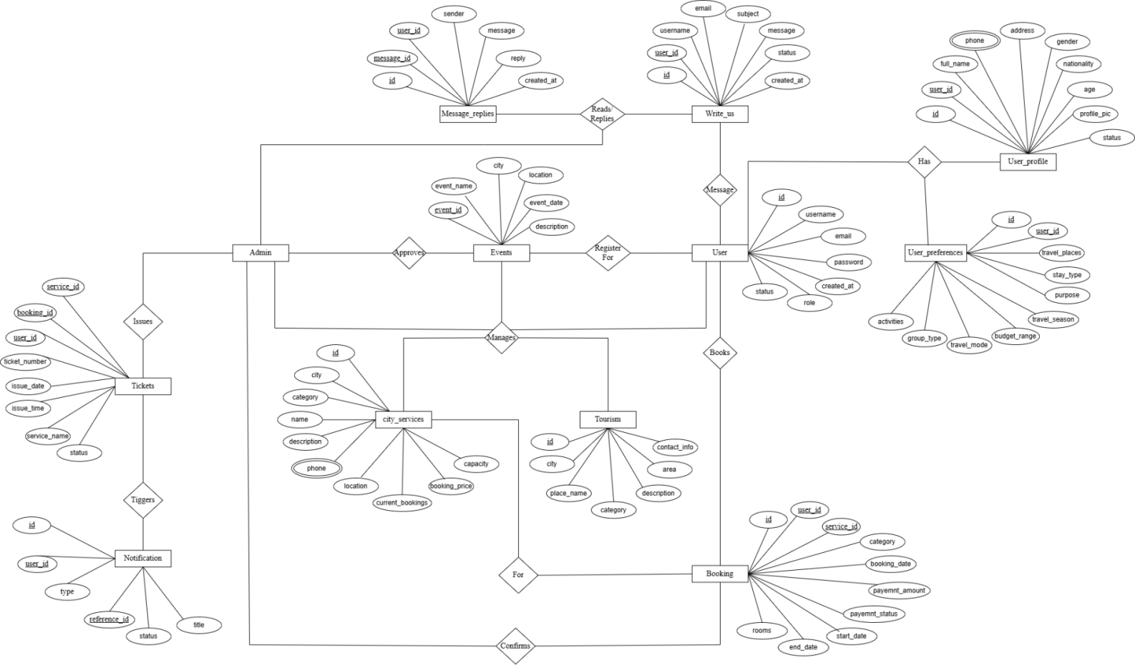
Figure 3-3 ER-Diagram

3.1.4 Process Modeling(DFD)
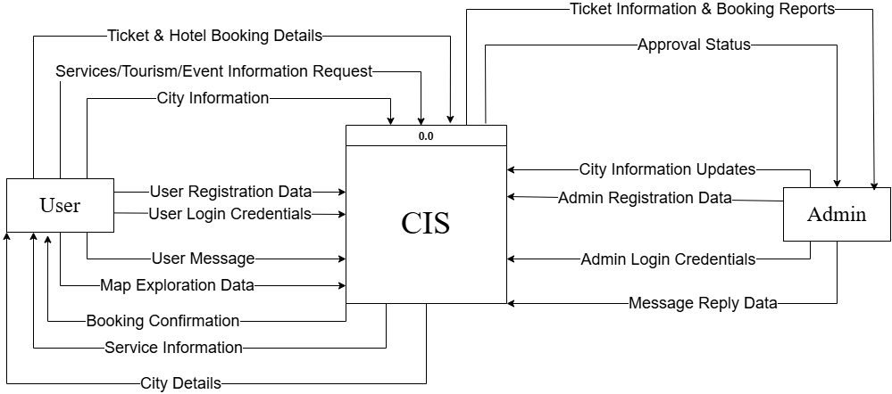
Figure 3-4 0-Level DFD
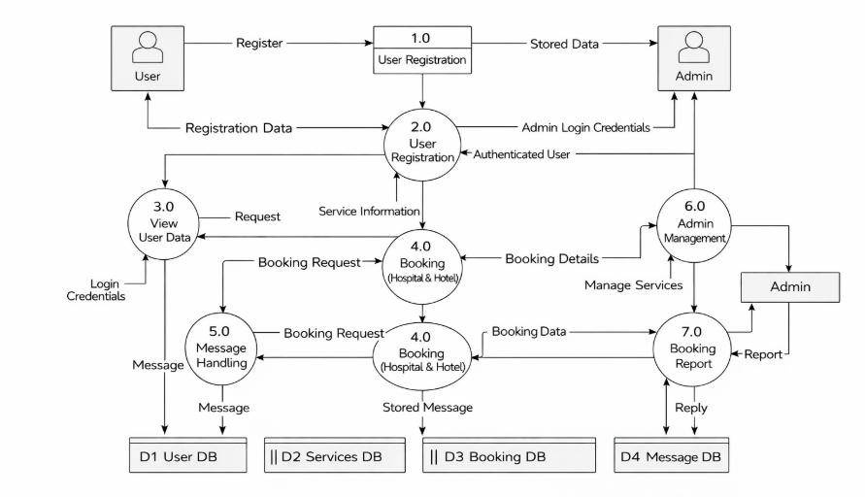

Figure 3-5 1-Level DFD

3.2 System Design

3.2.1 Architectural Design
Architectural design is a process for identifying the sub-systems making up a system and the framework for sub-system control and communication.

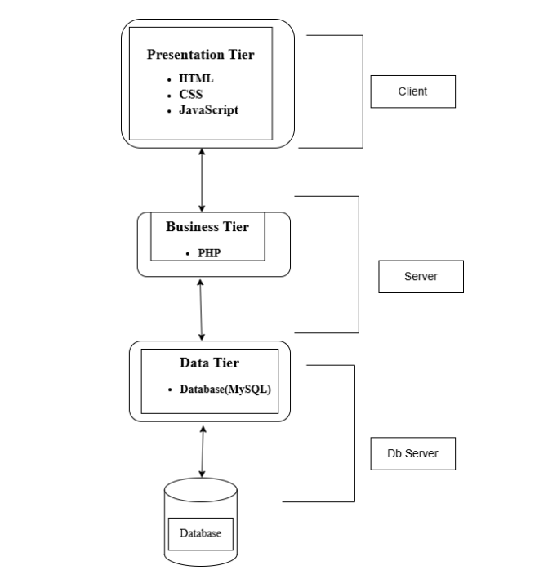
Figure 3-6 Architectural Design

3.2.2 Database Schema Design
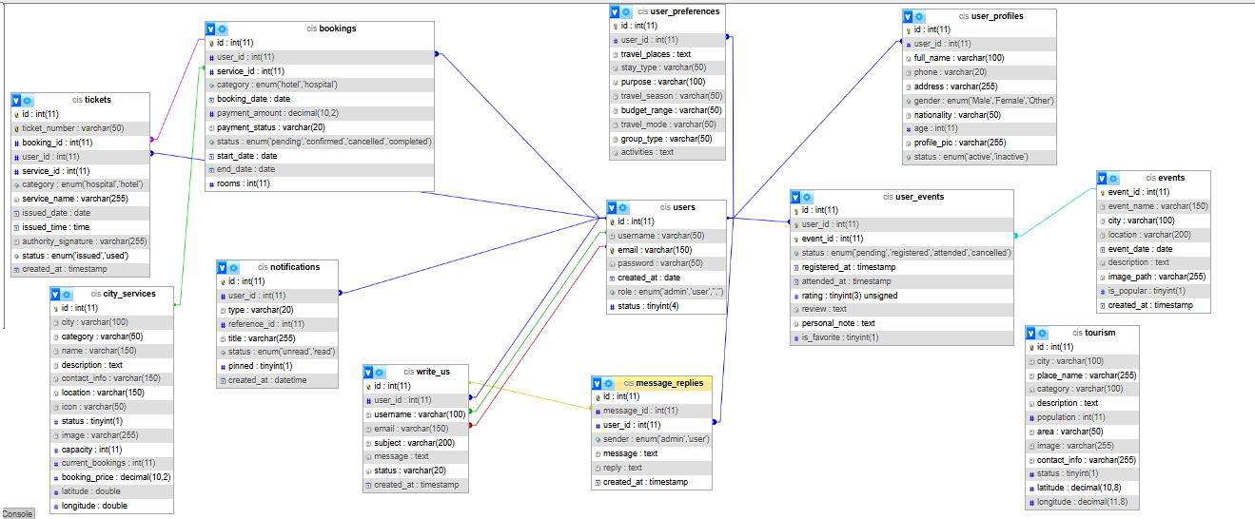
Figure 3-7 Database Schema

3.2.3 Interface Design (Interface Structure Diagrams)
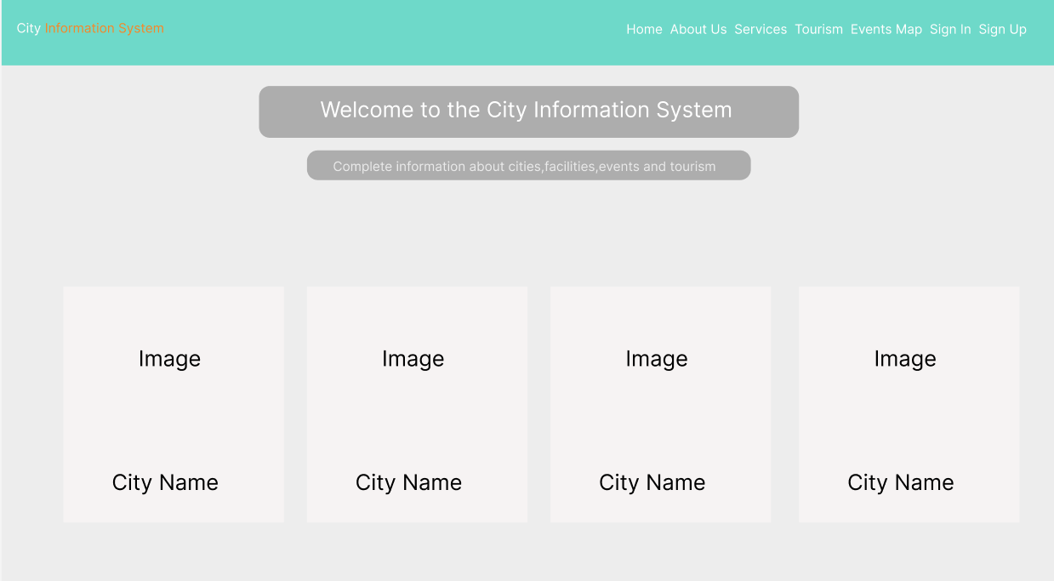
Figure 3-8 Home Page

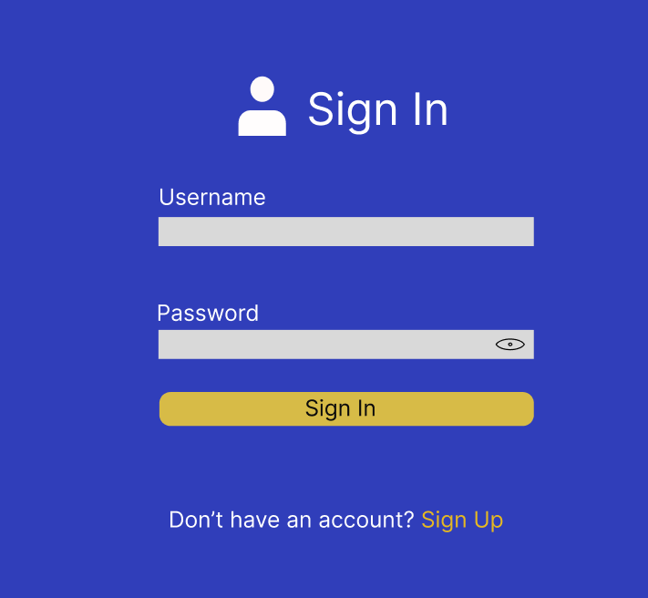

Figure 3-9 Login Page
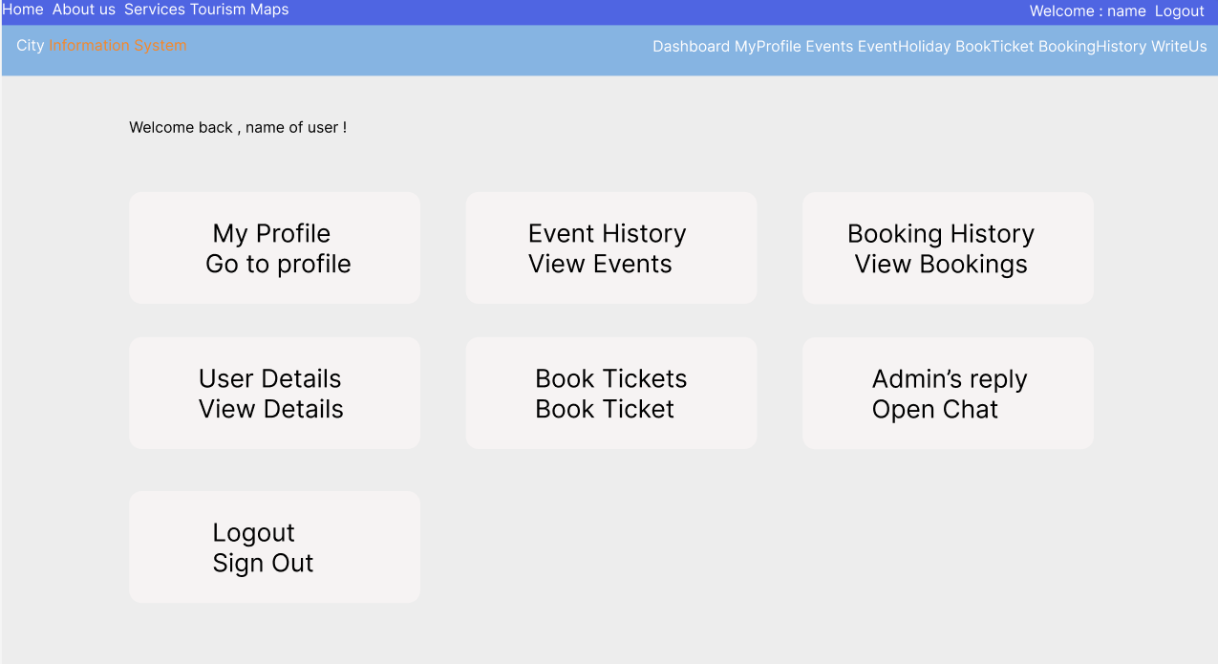
Figure 3-10 Dashboard

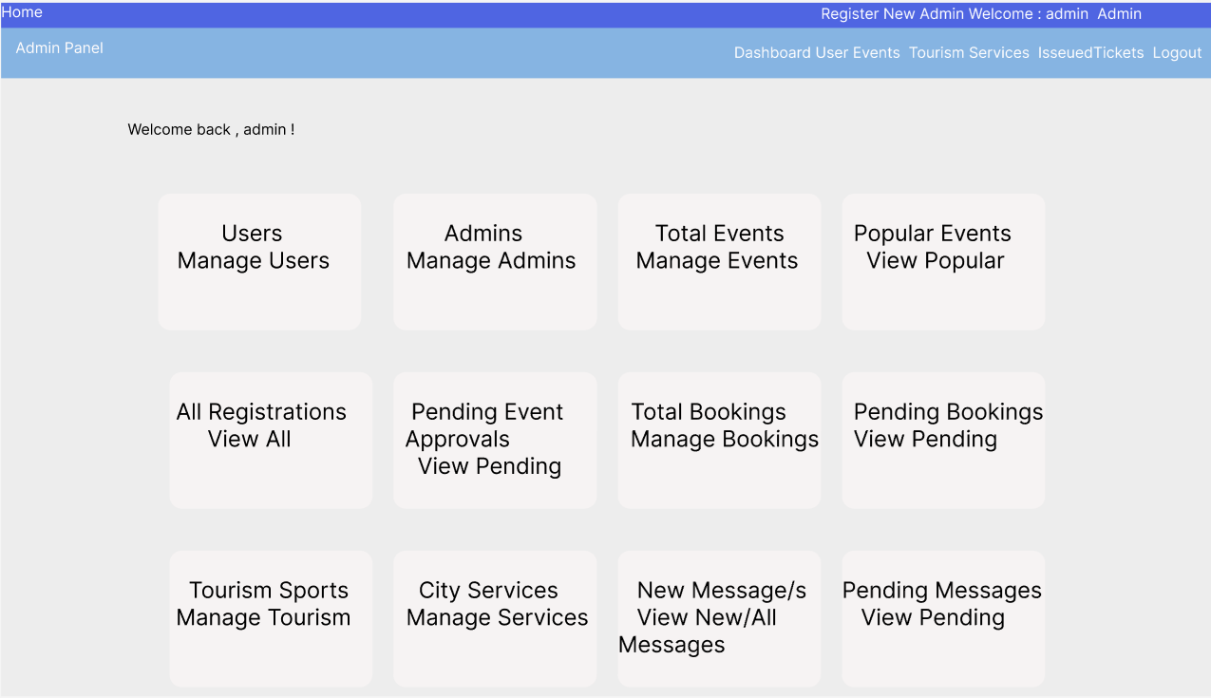
Figure 3-11 Admin Panel
3.2.4 Physical DFD
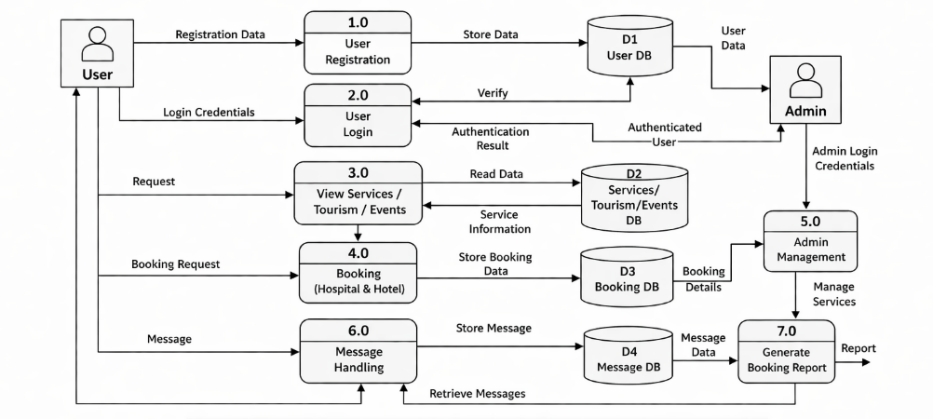
Figure 3-12 Physical DFD

3.3 Algorithm Details
In this project, the Haversine distance algorithm is used to calculate the real-world distance between the user’s current location and various points of interest on the map using their latitude and longitude coordinates. This algorithm provides accurate measurements of distances on the Earth’s surface, taking the curvature of the Earth into account.
The user’s current location is obtained through the Geolocation API, which captures precise latitude and longitude values from the user’s device. Once the distances to all locations are calculated, the system sorts them in ascending order to identify the closest places.
To make this information actionable and user-friendly, the nearest two locations are highlighted on the interactive map using Leaflet markers. This allows users to easily visualize the closest attractions or services and navigate to them efficiently.
To calculate the distance between two locations, the system uses the following formula:
a = sin²(Δlat / 2) + cos(lat₁).cos(lat₂).sin²(Δlon / 2)
d = R.2.arctan2($\sqrt{a}$, $\sqrt{1−a}$)
Where:
- d = distance between two places(in kilometers)
- R = radius of Earth(≈ 6371 km)
- lat₁, lat₂ = latitude of first and second location
- lon₁, lon₂= longitude of first and second location
- Δlat = lat₂ - lat₁
- Δlon = lon₂ - lon₁
- Sin, cos, arctan2 = mathematical functions

CHAPTER 4: IMPLEMENTATION AND TESTING

4.1 Implementation

4.1.1 Tools Used (CASE Tools, Programming Language, Database Platforms)
4.1.1.1 Frontend Tools
- HTML
HTML was used to design and structure all the web pages of the City Information System. It was used to create different components such as navigation bars, forms for user input, content sections, tables, and links between pages. It helped in organizing the overall layout of the system and displaying the content in a structured manner.
- CSS
CSS was used to enhance the visual appearance of the system. It was applied to design layouts, set colors, fonts, spacing, and alignment of elements. CSS was also used to make the system responsive so that it can be viewed properly on different screen sizes. It improved the overall user experience by making the interface clean and attractive.
- JavaScript
JavaScript was used to add interactivity and dynamic behavior to the system. It was mainly used for form validation to ensure correct data entry, displaying alerts and messages, and updating content without reloading the page. It also helped in improving user interaction and making the system more responsive.
- OpenStreetMap
OpenStreetMap was integrated into the system to provide map-based functionality. It was used to display city locations, important landmarks, and geographic information in an interactive way. Users can view and explore different locations directly through the map interface, making the system more informative and user-friendly.
4.1.1.2 Backend Tools
i. PHP
PHP was used as the backend scripting language to handle server-side operations. It was responsible for processing user requests, managing form data, and connecting the system to the database. PHP was used to perform CRUD operations such as inserting new data, retrieving records, updating existing information, and deleting data when required. It ensured smooth communication between the front-end and the database.
ii. FPDF
FPDF was used to generate PDF reports dynamically within the system. It was implemented to create downloadable documents containing structured information such as city details and user data. This feature allowed users to easily access and store information in a printable format.
4.1.1.3 Database Tools
i. MySQL
MySQL was used as the database management system to store all the application data. It was used to manage records related to cities, users, and other system information. It allowed efficient storage, retrieval, and updating of data, ensuring that the system functions properly. XAMPP was used to create a local development environment for the project. It provided the Apache server for running the application and MySQL for database management.
4.1.1.4 Design Tools
i. Draw.io
Draw.io was used to design various system diagrams required for the project. These include Data Flow Diagrams (DFD), Entity Relationship (ER) diagrams, Use Case diagrams, and system architecture diagrams. These diagrams helped in visualizing the system structure and workflow.
- Excel
Excel was used to prepare the Gantt chart for project planning. It helped in scheduling tasks, tracking progress, and managing the timeline of the project.

4.1.2 Implementation Details of Modules (Description of procedures/functions)
4.1.2.1 User Registration Module
The User Registration Module allows new users to create an account by providing a username, email, and password through an HTML form. JavaScript is used for client-side validation to ensure fields are not empty and follow required formats such as password strength and valid email structure. Upon submission, the data is sent to a PHP script using the POST method, where server-side validation is performed. The system checks for duplicate username and email entries in the database using prepared SELECT queries. If the data is valid, the password is hashed using MD5 and stored using an INSERT query along with the current timestamp. In case of invalid input or duplication, appropriate error messages are displayed. After successful registration, a success message is shown on the same page.
4.1.2.2 Login Module
The Login Module handles the authentication of users and administrators in the City Information System. Users are required to enter valid credentials (username/email and password) to gain access. Based on the user’s role (user or admin), the system redirects them to their respective dashboards, ensuring that each user accesses only the features relevant to their role. If the credentials are invalid, an error message is displayed, preventing unauthorized access and maintaining the security of the system. This module ensures secure, role-based access and protects sensitive data within the system.
4.1.2.3 City Services Module
The City Services Module provides details about various services such as hospitals, hotels, schools, and government offices. Admins can add, update, delete, and filter records stored in the database using PHP-based CRUD operations with MySQL queries. Service details including name, category, location, and images are stored in the database, and images are uploaded to the server with their file paths saved in records. Users can view services by selecting a category and optional city filter, where PHP processes GET requests and retrieves data using SELECT queries. The results are displayed dynamically in HTML card format. When a service card is clicked, its latitude and longitude are passed to a JavaScript map interface. Leaflet.js with OpenStreetMap and Leaflet Routing Machine is used to show the service location and display a route from the user’s current position to the selected service.
4.1.2.4 Tourism Information Module
The Tourism Information Module provides details about tourist destinations, including name, description, location, population, area, and images. This module is implemented using CRUD operations handled through PHP. Admins can add, update, delete, and filter tourism records using forms that trigger INSERT, UPDATE, and DELETE queries. Images are uploaded to the server, and their paths are stored in the database. Users can view tourism information dynamically, which is retrieved using SELECT queries with optional filters for city and category. Each tourism place is displayed in a card layout, and when a card is clicked, its latitude and longitude are passed to a JavaScript map interface. Leaflet.js with OpenStreetMap and Leaflet Routing Machine is used to display the location and provide navigation route from the user’s current position.
4.1.2.5 Map Services Module
The Map Services Module provides a visual representation of city services and tourism locations. It is implemented by integrating Leaflet.js with OpenStreetMap in JavaScript. Location data such as latitude and longitude is retrieved from the database using PHP and passed to the frontend using JSON encoding. The module supports filtering of places based on city and category using GET requests, which are processed through PHP SELECT queries. Markers are dynamically generated on the map to represent different services, each with category-based custom icons. User geolocation is accessed through the browser’s Geolocation API to determine the current position. A Haversine formula is used to calculate distance between the user and services for nearest location detection. The two closest places are highlighted with special markers, and the map automatically adjusts view using feature group bounds. Users can zoom, click markers to view details, and interact with map-based navigation features.
4.1.2.6 Events Management Module
The Events Management Module manages upcoming events and user participation. Administrators can add, edit, delete, and mark events as popular or unpopular using PHP forms connected to INSERT, UPDATE, and DELETE queries. Event data is stored in a MySQL database and displayed in the system using SELECT queries ordered by event date. Users can view available events with filtering and sorting options and register for participation, where registration details are stored in a separate user_events table with different statuses such as pending, registered, cancelled, and attended. Admins can manage event status and control visibility of events in the system. Users can also view their event history, cancel registrations, and provide feedback including ratings, reviews, and personal notes for completed events.
4.1.2.7 Booking and Ticket Management Module
This module enables users to book services and events within the system. Booking requests are processed using PHP forms, and details are temporarily stored and validated before payment. Depending on the selected category, users provide required information such as appointment date for hospital services or check-in and check-out dates along with room selection for hotel services. After successful booking and payment confirmation, booking records are stored in the database using INSERT queries. Administrators manage booking records and generate official tickets using the FPDF library, which includes ticket number, user details, service name, and issue date. Users can view their booking history and download generated tickets in PDF format through the system interface.
4.1.2.8 Payment Management Module
The Payment Management Module handles payment processing for bookings and event registrations through an integrated eSewa payment gateway. Booking details such as service type, category, date, number of rooms, and total amount are first collected and passed through PHP sessions. A secure payment request is then generated and redirected to the eSewa sandbox system. After successful payment, transaction details including transaction ID and amount are verified, and booking records are stored in the database using INSERT queries. The system also updates service capacity and booking counts using UPDATE queries to maintain consistency. Failed payments are handled separately, ensuring that no booking is stored unless payment is confirmed successfully.
4.1.2.9 User Profile Management Module
The User Profile Management Module allows users to view and update their personal information within the system. User details are retrieved from the database using SELECT queries from both users and user profile tables and displayed dynamically. Users can update information such as full name, phone, address, gender, nationality, age, and profile picture through a form, and changes are stored using INSERT or UPDATE queries depending on whether a profile already exists. The module also supports image upload functionality for profile pictures, which are stored in a server directory. Additionally, user preferences such as travel details are fetched and displayed from a separate table. Admins can manage user accounts by activating or deactivating them through status updates in the users table. This ensures secure control and proper management of user profiles within the system.
4.1.2.10 Communication and Notification Module
This module enables communication between users and administrators within the system. Users can send messages through a form, which are stored in the database using INSERT queries in the write_us table. Administrators can view all received messages, update their status such as new, pending, read, or replied, and manage them through the admin interface. The system also supports a chat-style reply feature where admins can respond to user messages, and all replies are stored in a separate table to maintain conversation history. Notifications are automatically generated for activities such as ticket generation and updates, and are displayed to users in the system interface. Users can also view, pin, or delete notifications and access ticket download links when available. This module ensures continuous communication between users and administrators and keeps users informed about system activities.

4.2 Testing

4.2.1 Test Cases for Unit Testing
Table 4-1 Test Case for User Registration
  Test Case ID
  Test Case Details
  Expected Result
  Test Result
  Status
TC-001
  All fields are left blank
  Registration unsuccessful
  Registration unsuccessful
  Pass
TC-002
  Email without @ (e.g., mina.com)
  Show error: “Enter a valid email address.”
  Error shown
  Pass
TC-003 |  |  |  |  | Error shown
  Email starts with @ (e.g., @mina.com)
  Show error: “Email cannot start with '@'.”
  Pass
TC-004
  Email missing dot (e.g., mina@emailcom)
  Show error: “Invalid Email! Input correct Email”
  Error shown
  Pass
TC-005
  Entered an existing username
  Show error: “This username is already in use. Try another.”
  Error shown
  Pass
TC-006
  Existing email entered
  Show error: “This email is already in use.Try another”
  Error shown
  Pass
TC-007
  Password and confirm password do not match
  Show error: “Passwords do not match!”
  Error shown
  Pass
TC-008
  Password field empty
  Show error: “Please enter password”
  Error shown
  Pass
TC-009 |  | Password without uppercase / lowercase / number or < 6 characters |  | Show error:  “Password must contain at least one number, one uppercase, one lowercase letter, and be 6 or more characters long.” |  | Error shown |  | Pass
TC-010 |  | Valid username, valid email, valid password |  | Show success message: “Signup Successful” |  | RegistrationSuccessful |  | Pass

Table 4-2 Test Case for User Login
  Test Case ID
  Test Case Details
  Expected Result
  Test Result
  Status
  T-A-001
  Both username and password are empty
  Show error messages:
  • “Please enter username”
  • “Please enter password”
  Error shown
  Pass
  T-A-002
  Username or password does not match database record
  Show error: “Either username or password do not match.”
  Error shown
  Pass
  T-A-003
  Correct username &password for user
  Redirect to dashboard.php
  Login unsuccessful
  Fail
T-A-004 | Correct username and password for user | Redirect to dashboard.php | Redirect successful | Pass
T-A-005 | User clicks “Forgot Password”, verifies email and resets password | Allow password reset and redirect user to login page | Password reset successful | Pass

Table 4-3 Test Case for Admin Login
  Test Case ID
  Test Case Details
  Expected Result
  Test Result
  Status
  TC-B-001
  Both username and password are empty
  Show error messages:
  • “Please enter username”
  • “Please enter password”
  Error shown
  Pass
  TC-B-002
  Username or password does not match database record
  Show error: “Either username or password do not match.”
  Error shown
  Pass
  TC-B-003
  Correct admin username and password
  Redirect to admin-panel.php
  Redirect successful
  Pass
Table 4-4 Test Case for User and Admin Logout
  Test Case ID
  Test Case Details
  Expected Result
  Test Result
  Status
  TC-LOG-001
  User clicks logout after successful login
  Redirect to index.php, session destroyed
  Redirect successful
  Pass
  TC-LOG-002
  Admin clicks logout after successful login
  Redirect to index.php, session destroyed
  Redirect successful
  Pass

4.2.2 Test Cases for System Testing
Table 4-5 Test Case for system testing of the city information system
  Test Case ID
  Test Case Details
  Expected Result
  Test Result
  Status
  STC-001
  User clicks logout after successful login
  Redirect to index.php, session destroyed
  Redirect successful
  Pass
STC-002 | Admin clicks logout after successful login | Redirect to index.php, session destroyed | Redirect successful | Pass
  STC-003
  User clicks on Events” from navbar
  All upcoming events are
  displayed with image, date,
  city, and description.
  Events displayed correctly
  Pass
  STC-004
  Logged-in user clicks “Register” button for an event
  Event registration request is saved with status “pending”
  Registration successful, pending approval
  Pass
  STC-005
  User clicks “Event History” from dashboard
  List of registered events is displayed
  Event history displayed successfully
  Pass
  STC-006
  User opens map.php from navbar
  Map loads with major cities and location markers
  Map loaded successfully
  Pass
  STC-007
  User selects city and category filter on map
  Only matching places are shown on the map
  Filter applied correctly
  Pass
 |  |  | Categories displayed successfully
  STC-008
  User opens services.php
  Service categories are displayed as cards
  Pass
  STC-009
  User selects a city after choosing a service category
  Services filtered by selected city
  Services filtered correctly
  Pass
  STC-010
  User clicks on a service card
  Map opens showing route from user location to service
  Route displayed correctly
  Pass
 | User opens tourism. php and filters by city and chooses category | Tourism places displayed with image and details and filtered correctly. | Tourism places loaded and filter applied succsfully.
  STC-
  011
  Pass
 |  |  | Services displayed successfully | Pass
  STC-
  012
  User clicks on book tickets selects a category (Hospital / Hotel) and filters by city. System displays services with available capacity.
  Services load correctly, available slots are shown, “Book Now” button is disabled when capacity is full
  STC-
  013
  User clicks “Book Now” and enters booking details:
  Hospital: Appointment date.
  Hotel: Check-in, Check-out, Rooms
  Invalid or empty dates are rejected and Total price updates dynamically for hotel bookings
  Validation and price calculation successful
  Pass
  STC-
  014
  User completes payment via eSewa and reaches success page
  Booking saved in database, payment status = success, Capacity updated and Booking shown in booking history with pending status
  Booking recorded successfully
  Pass
  STC-015
  User cancels or payment fails during eSewa process
  No booking inserted, User redirected to payment failed page and Capacity remains
  unchanged.
  Failure handled correctly
  Pass
STC-016 | User opens booking_history.php after booking | All past bookings displayed with service name, date, amount, and status | Booking history loaded correctly | Pass
STC-017 | Admin adds, edits, marks popular/unpopular, and deletes services, events, and tourism places from the admin panel. | Data is saved, updated, or removed from the database  Changes are reflected on user pages | Operations performed successfully | Pass
STC-018 | Admin views bookings and performs actions: confirm, cancel, complete booking, and issue ticket. | Booking status updates correctly, capacity is restored on cancellation and ticket is issued and notification is sent to the user | Booking status and ticket generation successful | Pass
STC-019 | Admin activates/deactivates users | User status changes correctly | User management successful | Pass
STC-020 | Admin reads or replies to user messages | Messages are displayed and replies are sent | Message management successful | Pass

CHAPTER 5: CONCLUSION AND FUTURE RECOMMENDATIONS

5.1 Lesson Learnt/Outcome

5.1.1 Lesson Learnt
The development of the City Information System served as a comprehensive learning experience, offering valuable insights across technical, personal, and professional domains. The project not only strengthened our understanding of software engineering principles but also enhanced our ability to approach complex system design problems in a structured and analytical manner.
From a technical perspective, the project deepened our knowledge of full-stack web development, including the integration of front-end technologies (HTML, CSS, JavaScript) with back-end systems using PHP and MySQL. Particular emphasis was placed on designing robust system models such as Entity-Relationship (ER) diagrams, Data Flow Diagrams (DFDs), and database schemas. Through iterative refinement, we learned the importance of maintaining data consistency, normalization, and clear representation of system processes. Additionally, implementing features such as location-based services using the Haversine distance algorithm provided practical exposure to real-world problem-solving and algorithmic thinking. The use of tools such as XAMPP, VSCode, and diagramming platforms further enhanced our technical workflow and development efficiency.
From a personal learning standpoint, the project cultivated critical thinking, adaptability, and resilience. Throughout the development process, we encountered challenges related to system design, debugging, and integration. Overcoming these obstacles required self-directed learning, in-depth research, and persistence. This experience improved our ability to independently explore solutions, manage time effectively, and maintain focus under constraints. It also reinforced the importance of attention to detail, especially when dealing with system logic, validation, and user experience design.
From a professional perspective, the project enhanced our collaboration, communication, and project management skills. Working as a team required clear task distribution, continuous coordination, and constructive feedback exchange. We developed an appreciation for structured development methodologies, particularly the hybrid/incremental approach, which allowed iterative improvements and ensured system reliability. Furthermore, documenting the project in a formal report improved our technical writing and presentation skills, aligning our work with academic and industry standards.
In addition, the project emphasized the significance of user-centered design and usability. Iterative interface improvements demonstrated that a system’s effectiveness is not solely defined by its functionality, but also by how intuitively users can interact with it.
Overall, this project bridged the gap between theoretical knowledge and real-world application, equipping us with a balanced combination of technical expertise, problem-solving capability, and professional competencies essential for future careers in software development and information systems.
5.1.2 Outcome
The successful development of the City Information System resulted in a functional and scalable web-based platform that centralizes diverse city-related information. It integrates multiple modules to provide structured access to essential services such as tourism, healthcare, education, hotels, and public events.
A key outcome is the interactive map-based interface, which helps users visualize locations and find nearby services efficiently. Location-based features, supported by distance calculation algorithms, enhance navigation and decision-making, especially for tourists and new residents.The system demonstrates effective data management through CRUD operations, allowing administrators to easily add, update, and manage city data, ensuring accuracy and reducing redundancy.
From a user perspective, the platform provides a simple, intuitive, and responsive interface with filtering and categorization for easy access. Seamless integration of front-end, back-end, and database technologies creates a cohesive, modular system that supports future expansion. Overall, the project delivers a practical, user-centered solution that improves access to city information and allows for future enhancements.

5.2 Conclusion
The City Information System was successfully designed and implemented as a centralized, web-based platform aimed at improving access to city-related information for both residents and tourists. The system effectively integrates multiple modules to provide structured and reliable information on tourism, healthcare, education, public services, and events within a single interface.
By incorporating features such as interactive maps, category-based filtering, and location-based search, the system enhances usability and simplifies urban navigation. The use of modern web technologies and database management techniques ensures efficient data handling, system reliability, and ease of maintenance.
Overall, the project achieves its primary objective of developing a scalable and user-friendly solution that enhances accessibility, supports informed decision-making, and improves the overall user experience. It also establishes a strong foundation for future improvements, contributing to the broader vision of digital and smart city development.

5.3 Future Recommendation
- Integrate real-time data updates and GPS-based navigation for city services and events.
- Develop a mobile application to improve accessibility and user experience.
- Expand coverage to more cities and regions for a comprehensive system.
- Add user reviews, ratings and multilingual support to enhance usability.
- Incorporate smart city features like traffic updates, emergency alerts and advanced analytic.
- Enable residents to submit complaints and reports directly to government and relevant authorities regarding issues in their residential areas.
- Integrate image scanning features that allow users to click, scan or upload photos of places to receive real-time information about the location.

REFERENCES
[1] | A. Camero and E. Alba, Smart City and Information Technology: A Review, Cities, 2019. [Online]. Available: https://www.sciencedirect.com/science/article/pii/S0264275118304025
[2] | “A Systematic Review of Smart City Research from an Urban Context Perspective,” Cities, 2024. [Online]. Available: https://www.sciencedirect.com/science/article/pii/S0264275124002415
[3] | L. Romualdo-Suzuki and A. Finkelstein, “Data as Infrastructure for Smart Cities: Linking Data Platforms to Business Strategies,” arXiv, 2020. [Online]. Available: https://arxiv.org/abs/2005.11414
[4] | H. Xu, F. Omitaomu, S. Sabri, S. Zlatanova, X. Li, and Y. Song, “Leveraging Generative AI for Urban Digital Twins: A Scoping Review
[5] | S. E. Bibri et al., “Environmentally Sustainable Smart Cities and their Converging AI, IoT, and Big Data Technology Solutions: An Integrated Literature Review,” Energy Informatics, 2023.
[6] | Building Enduring Smart City Data Platforms to Provide Urban Management Support: Lessons from UK and US,” Frontiers in Sustainable Cities, 2025.
[7] | “Study on City Digital Twin Technologies for Sustainable Smart City Design: A Review and Bibliometric Analysis,” Sustainable Cities and Society, 2022
[8] | “International Journal of Modern Science and Research Technology,” 2025.

APPENDICES
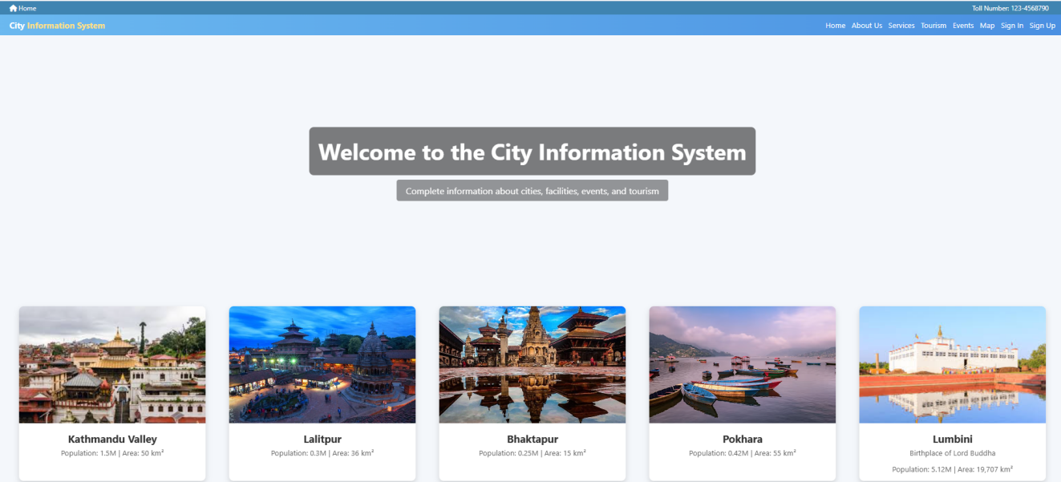
Appendices-A1 Home Section
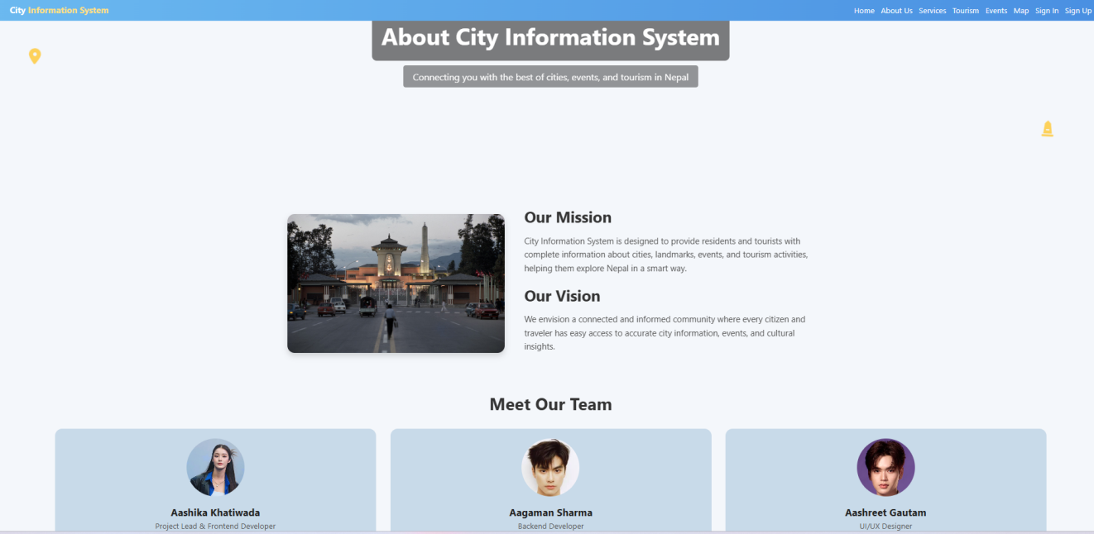
Appendices-A2 About Page
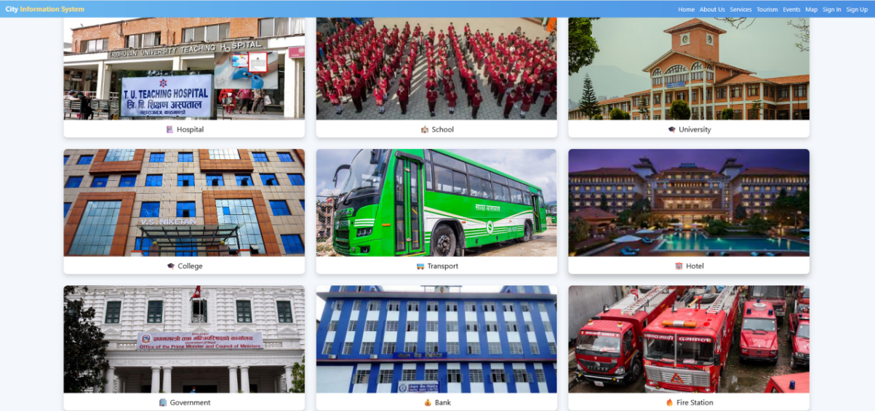
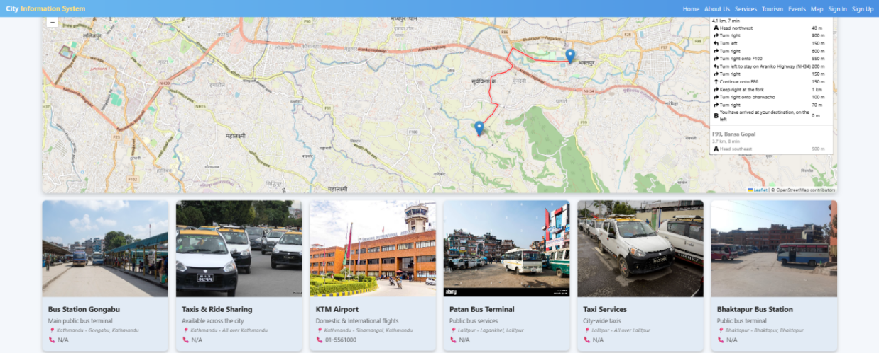
Appendices-A3 Services Section
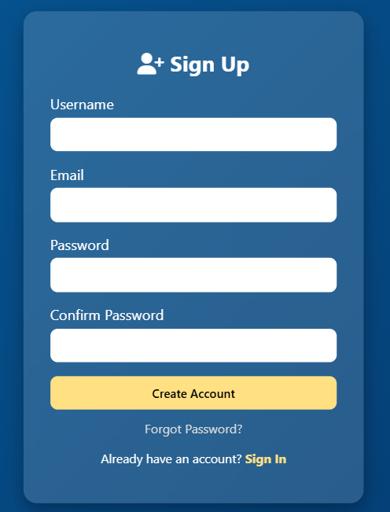
Appendices-A4 Registration Form
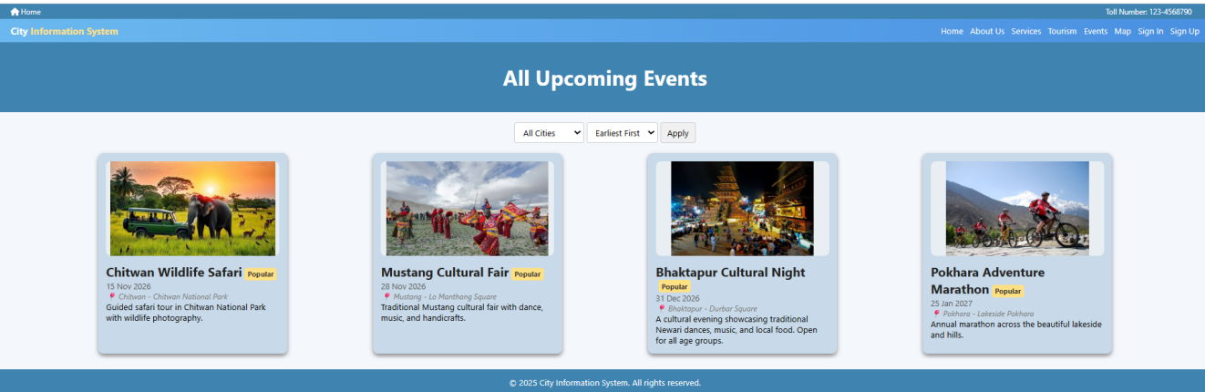
Appendices-A5 Events Section
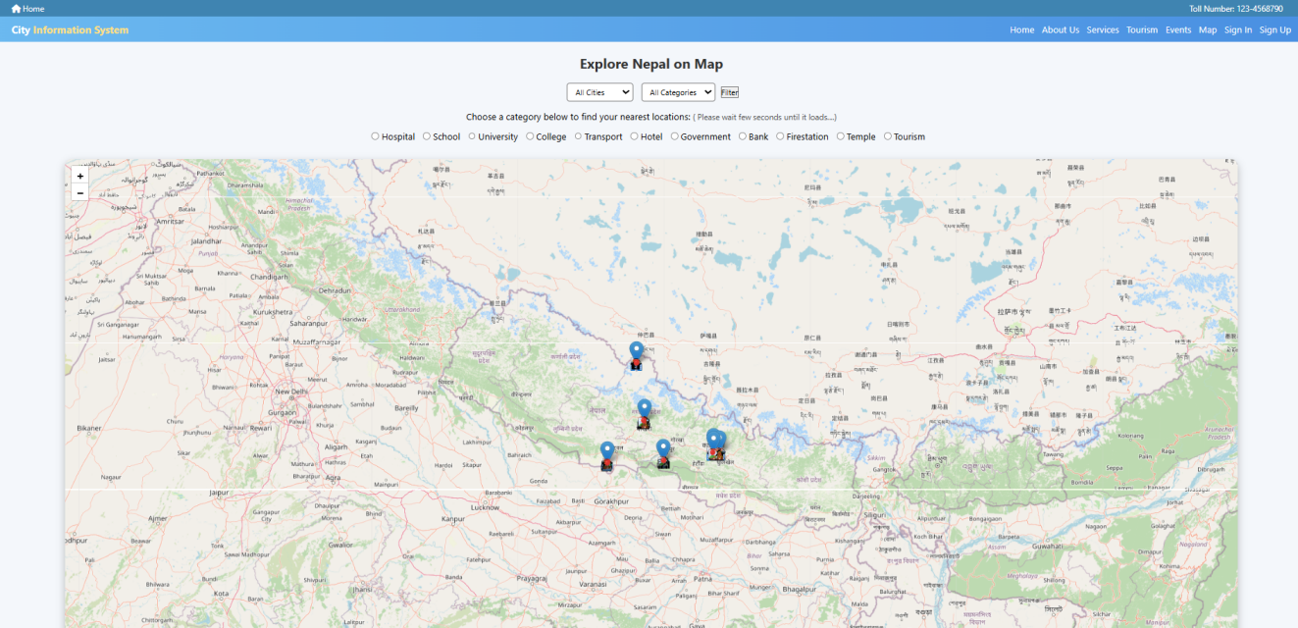
Appendices-A6 Map Section
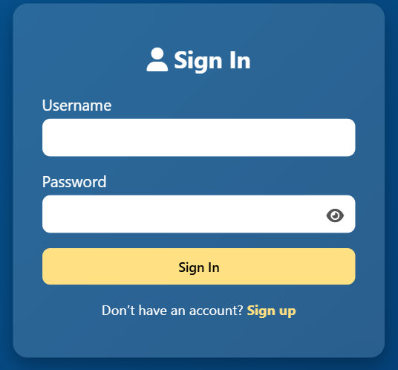
Appendices-A7 Login Form
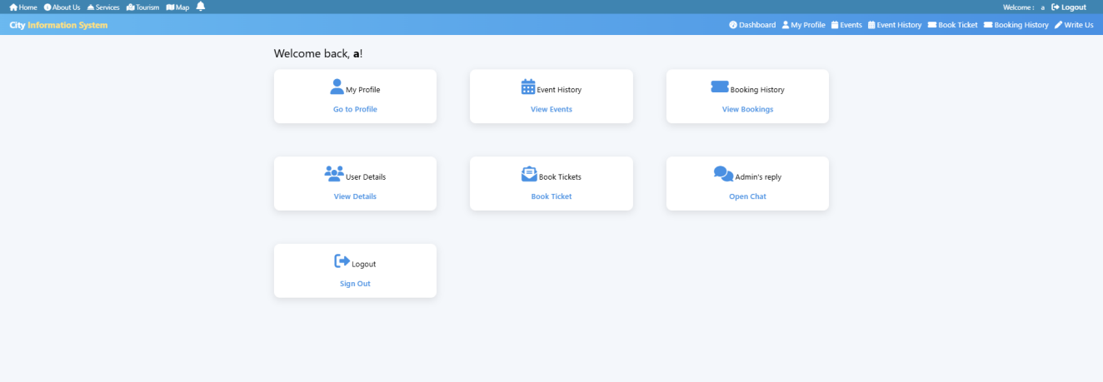
Appendices-A8 User Dashboard
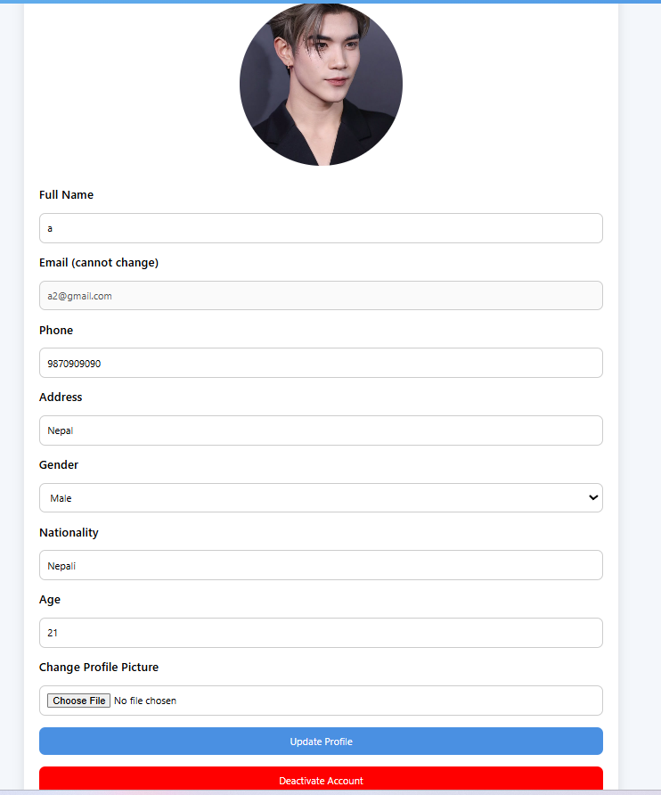
Appendices-A9 Profile Section
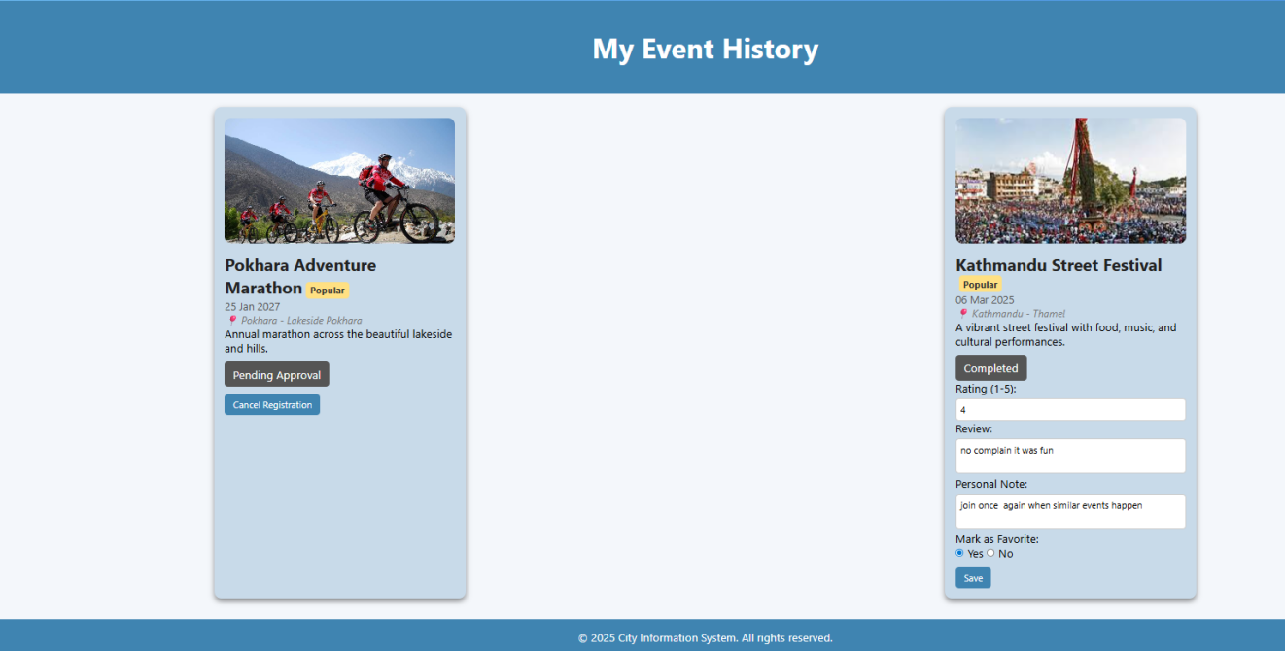
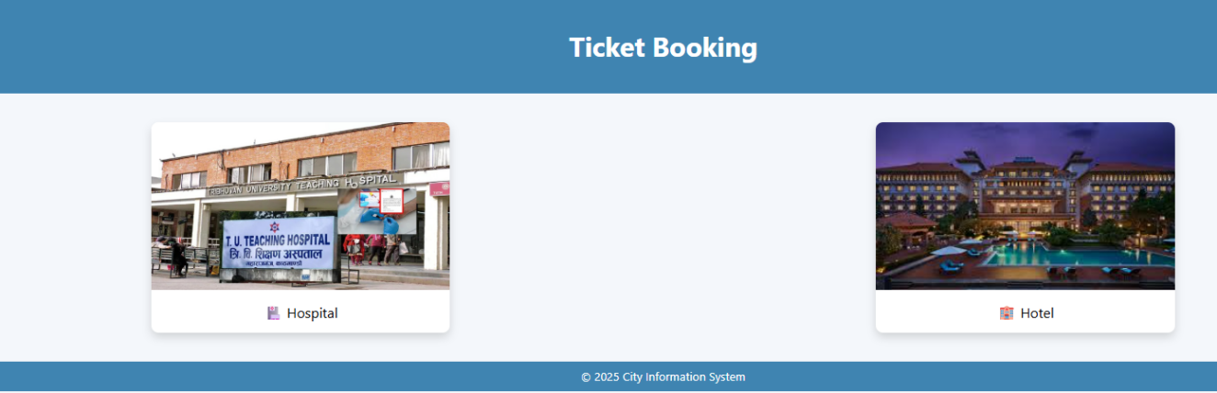
Appendices-A10 Event History
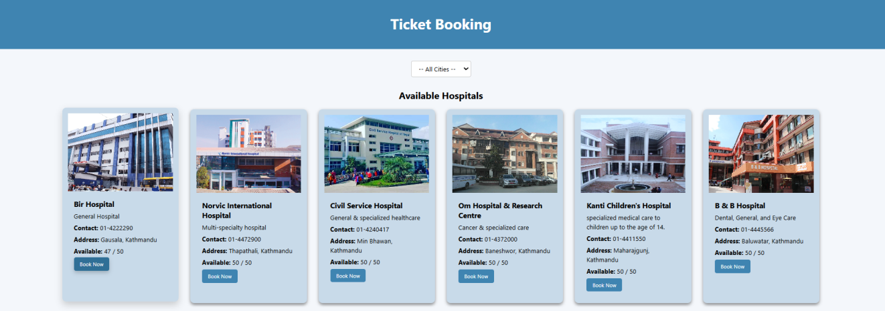

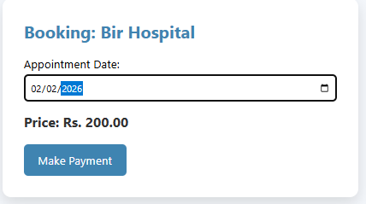

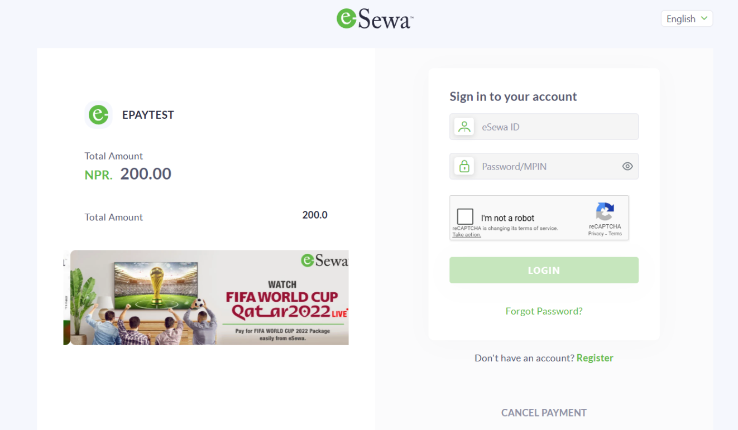
Appendices-A11 Ticket Booking and Issue Ticket
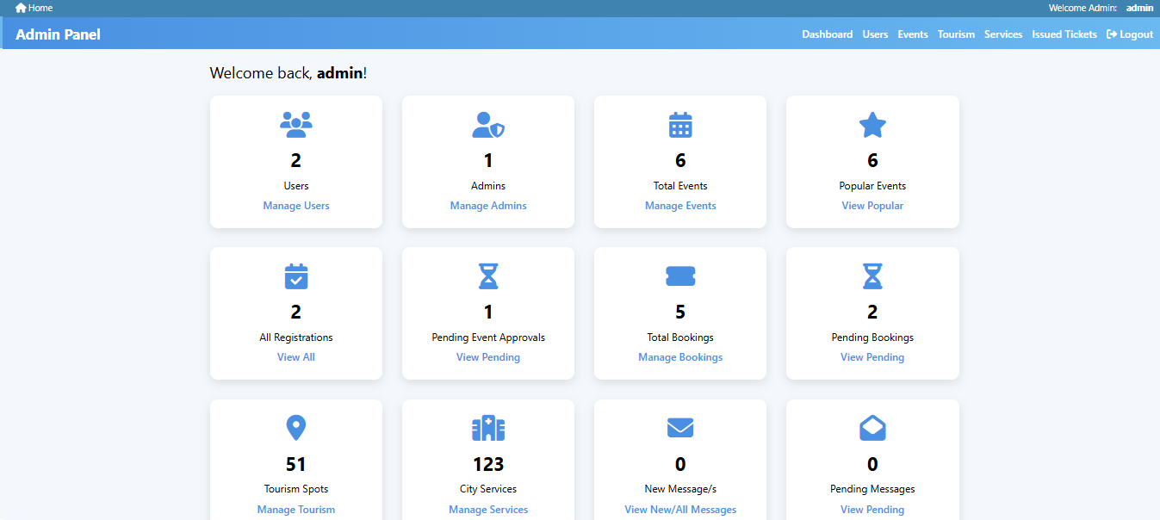
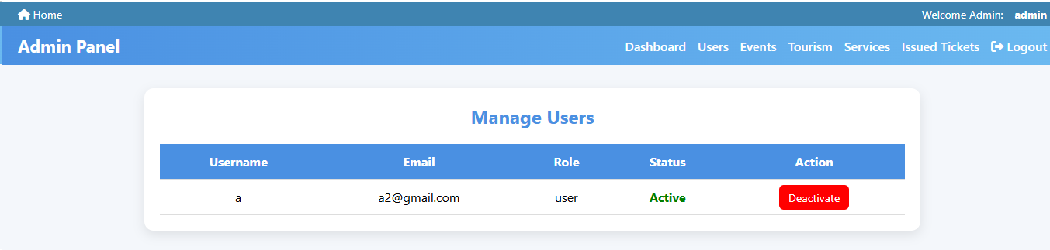
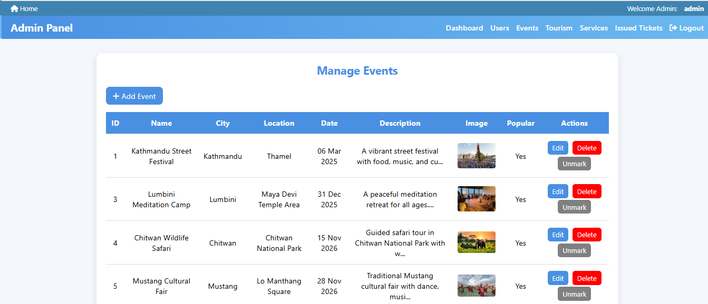

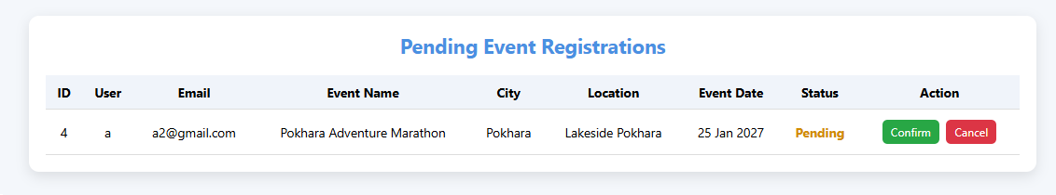
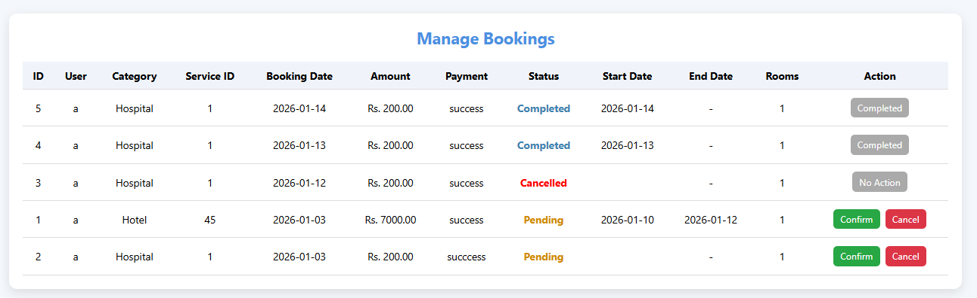
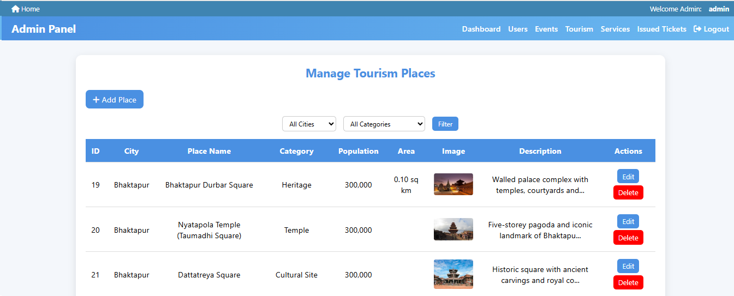
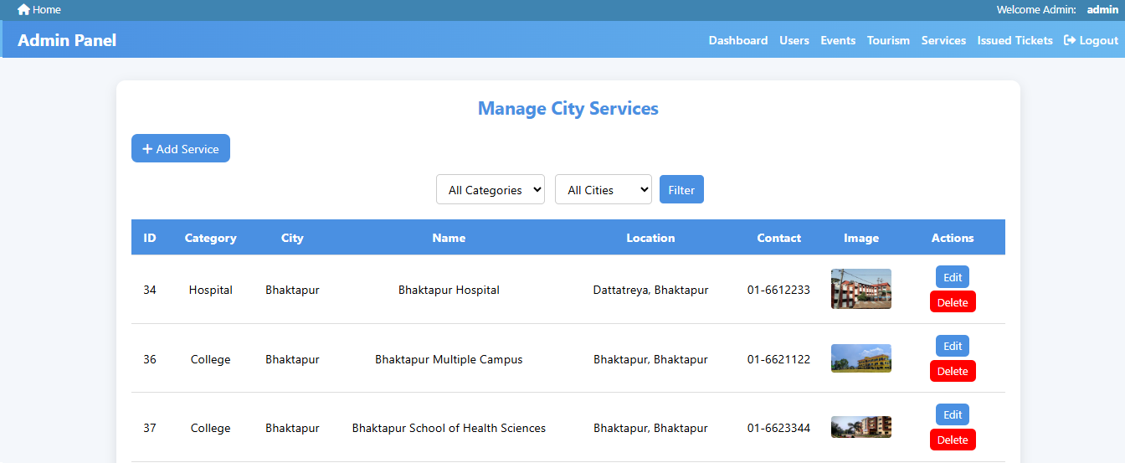

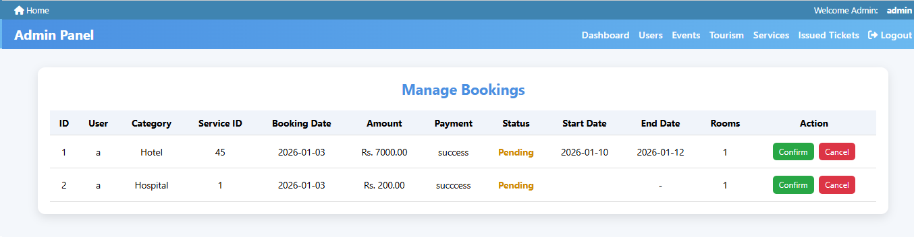
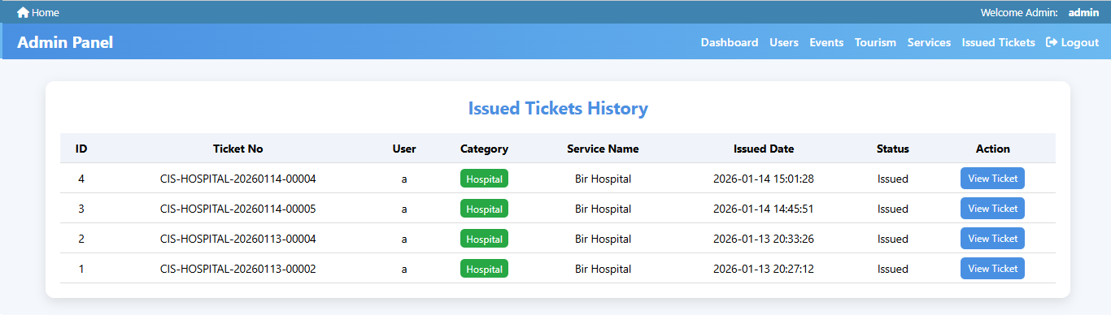
Appendices-A12 Admin Panel

