
Tribhuvan University
Faculty of Humanities and Social Science
Swastik college, Bhaktapur

Cloud Computing
Lab Report
Submitted By:
Safalta Shrestha (113102089)
BCA 7th Semester

Submitted To:
Sujan Poudel
Lecturer, BCA Department
Swastik college, Bhaktapur

Lab-1: Getting Started with Azure
Objective: To understand the Azure portal and subscription model.
Tasks:
- Create an Azure Account
- Opened a web browser and visit https://azure.microsoft.com/en-us/free/students.

- Click Start Free and sign in with a Microsoft account using school/university email
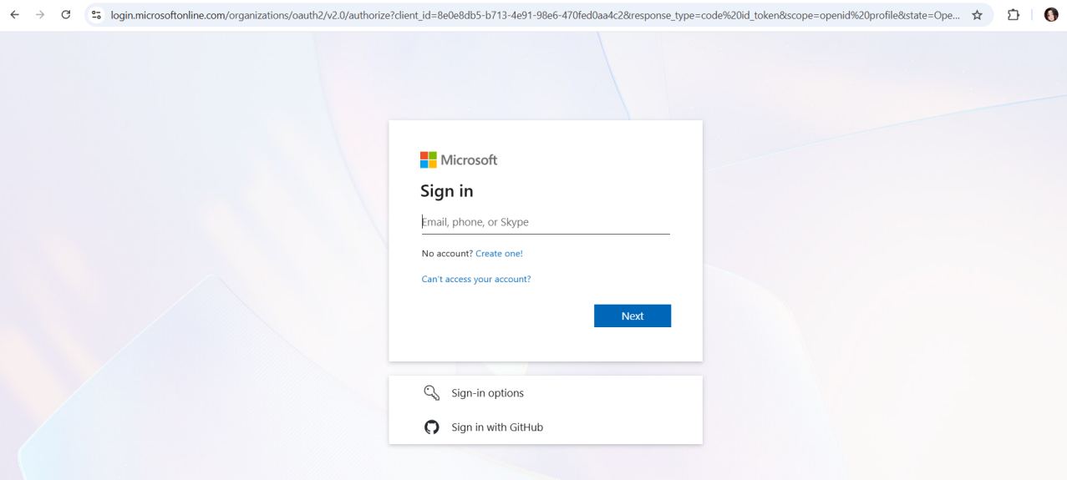

- Select Student Option to get $100 credits via Azure for Students.
- Complete the sign up and verification(phone number + identify verification).
Note: No credit card is needed for student accounts.
- Explore Azure Portal
- Login to the Azure Portal.
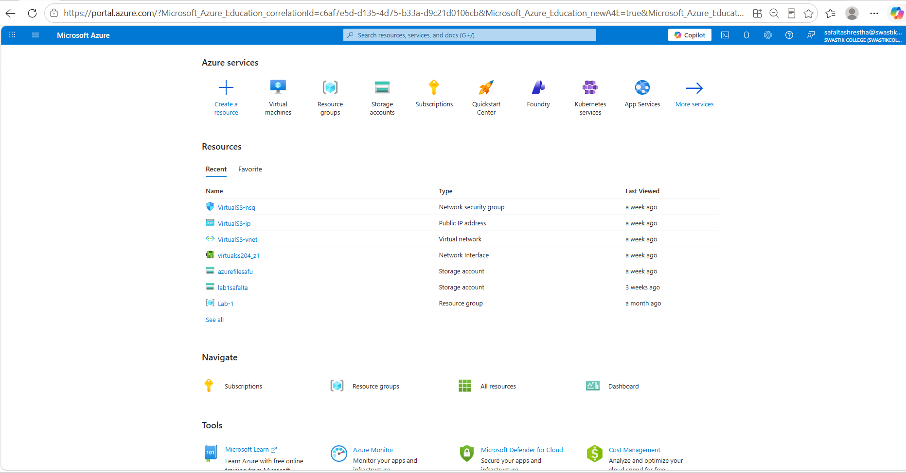
- Familiarize with Dashboard, Resource Groups, All Services, Marketplace

- Create a Resource Group
A resource group is a logical container for Azure resources.
- Go to Resource Group → Create
- Resource Group Name: lab1-safalta
- Region: East US (or nearest region)

- Verify Azure Subscription
- Go to Subscriptions and verified the Azure for students subscription.
- Confirmed that the subscription status was Active.

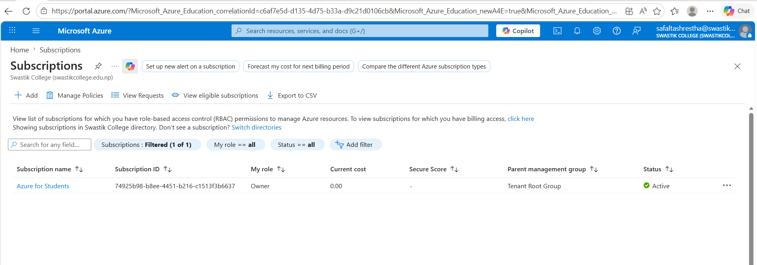

Lab-2: Azure Storage Services
Objective: To understand the creation and management of Azure Blob Storage and learn how to upload and access files using the Azure Portal.
Tasks:
Via Portal:
- Create a Storage Account
- Go to Storage accounts → Create
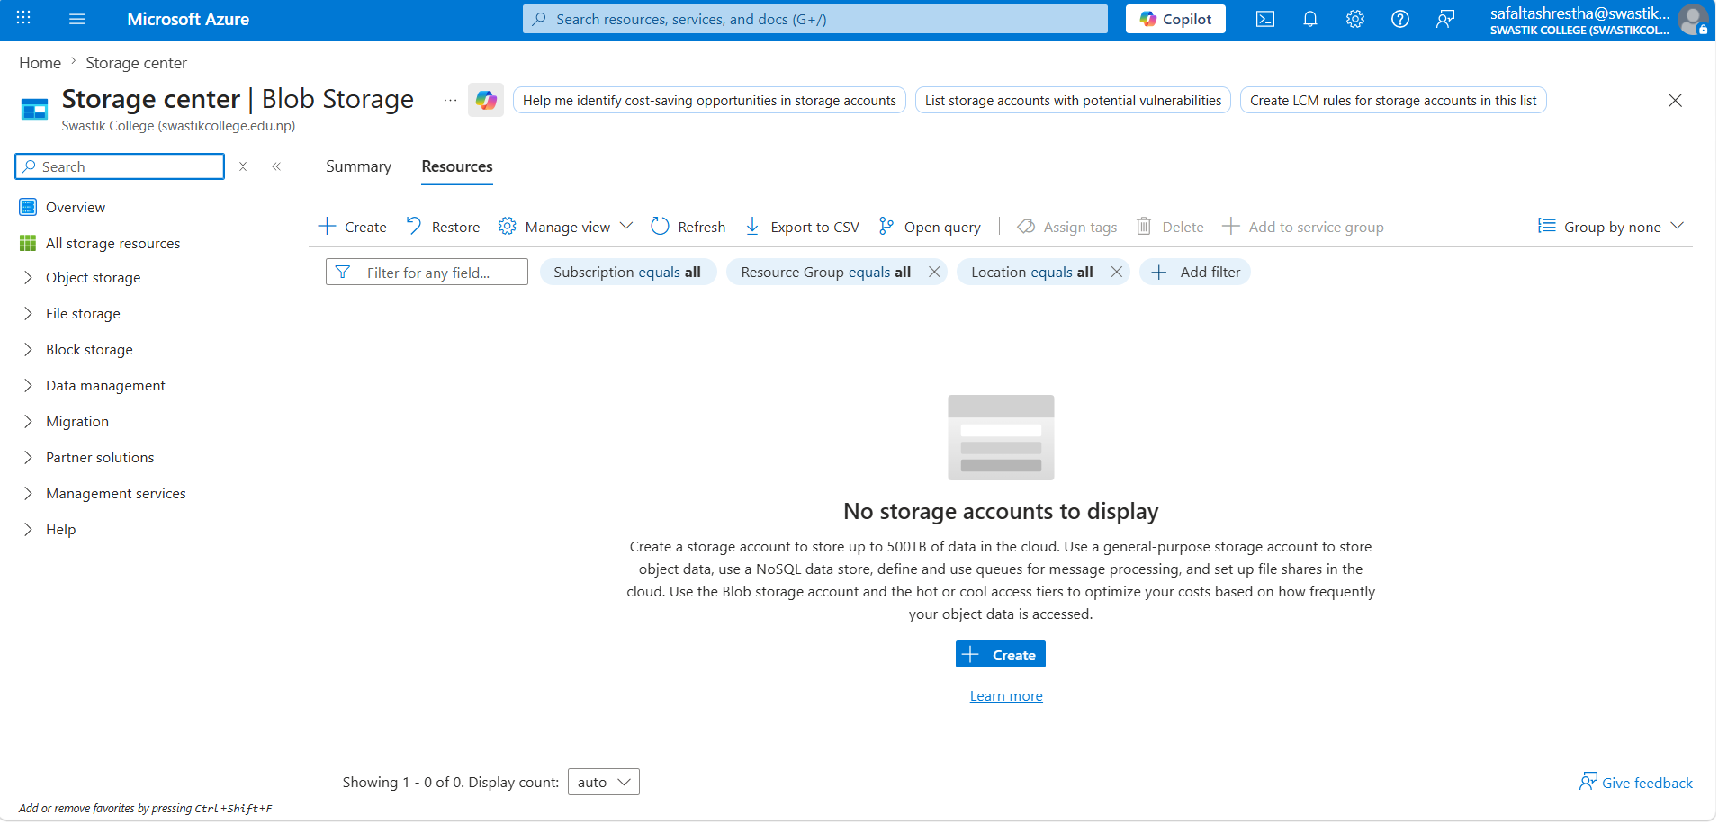

- Fill in the details:
- Subscription: (Select your active subscription).
- Resource Group: lab-1 (or create a new one)
- Storage Account Name: lab1safalta[uniqueid] (must be globally unique)
- Region: East US (or your preferred region) [(Asia Pacific) Central India]
- Performance: Standard
- Redundancy: Locally-redundant storage (LRS)

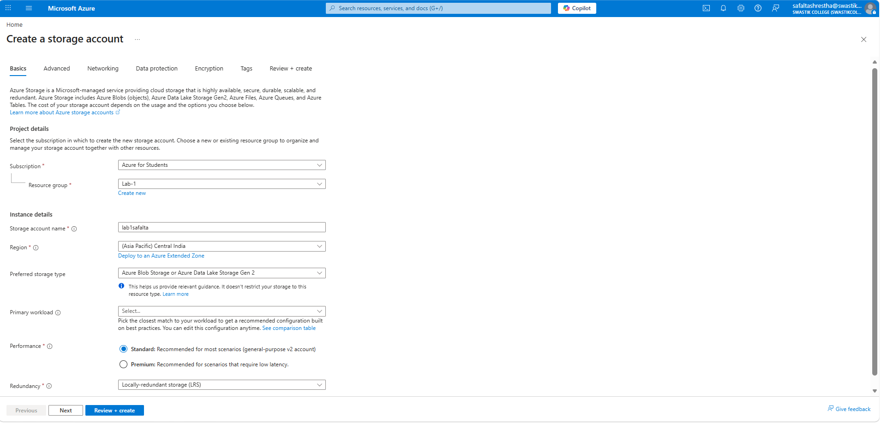

- Click Review + Create, then Create
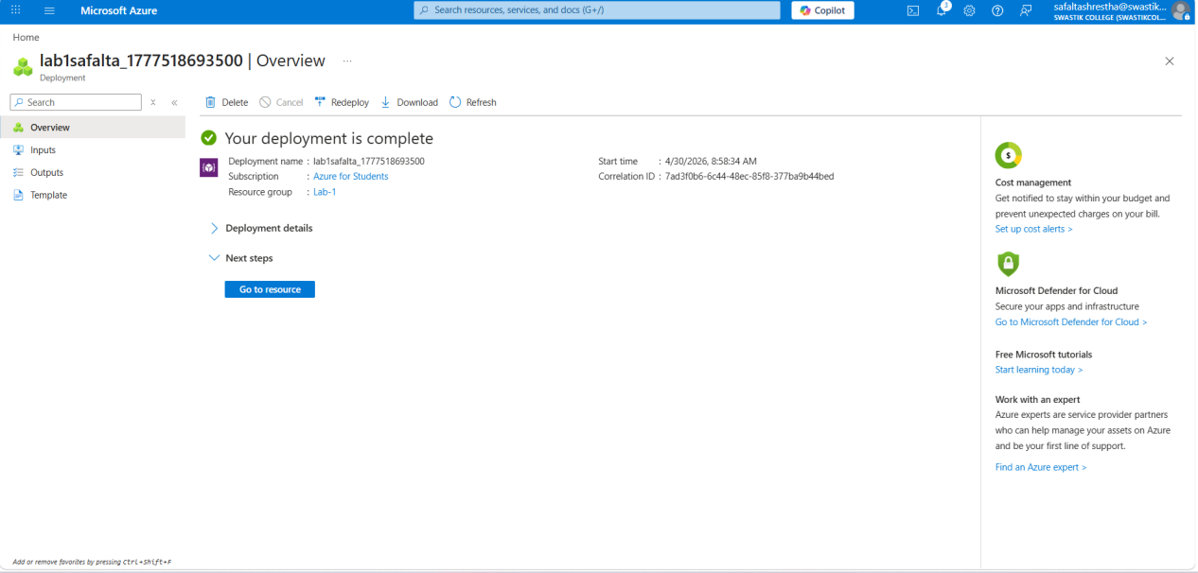
- Create a Blob Container
Via Portal:
- Navigate to your newly created Storage Account
- Under Data storage, select Containers
- Click + Container
- Name: files
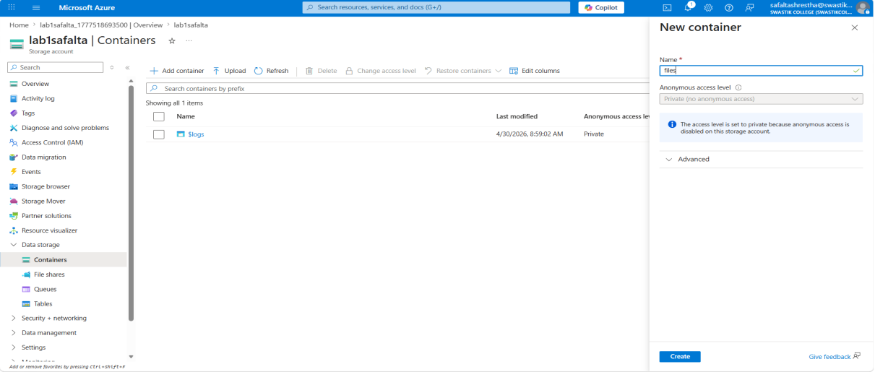

Lab-3: Azure Virtual Machines
Objective: Deploy a virtual machine and perform basic server tasks.
Tasks:
Via Portal:
- Go to Virtual Machines → Create
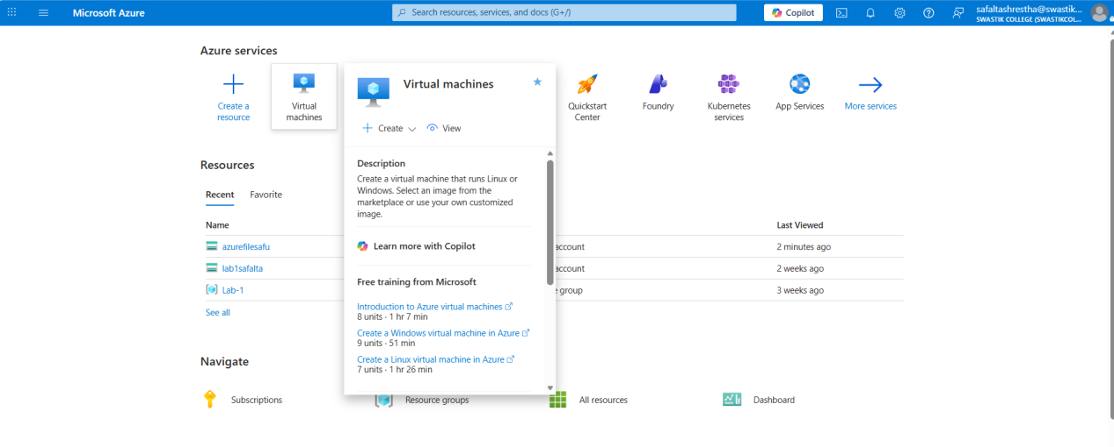

- Fill in the following:
- Subscription: Your active one
- Resource Group: file-manager
- VM name: VirtualSS
- Region: East US (or nearby)
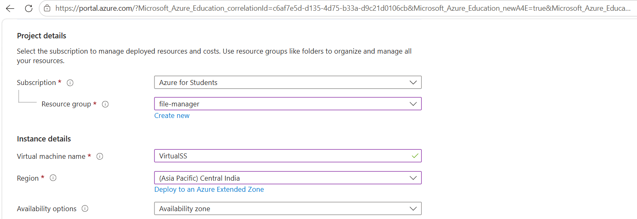
- Image: Ubuntu Server 24.04 LTS
- Size: Standard B1s (Free tier if available)

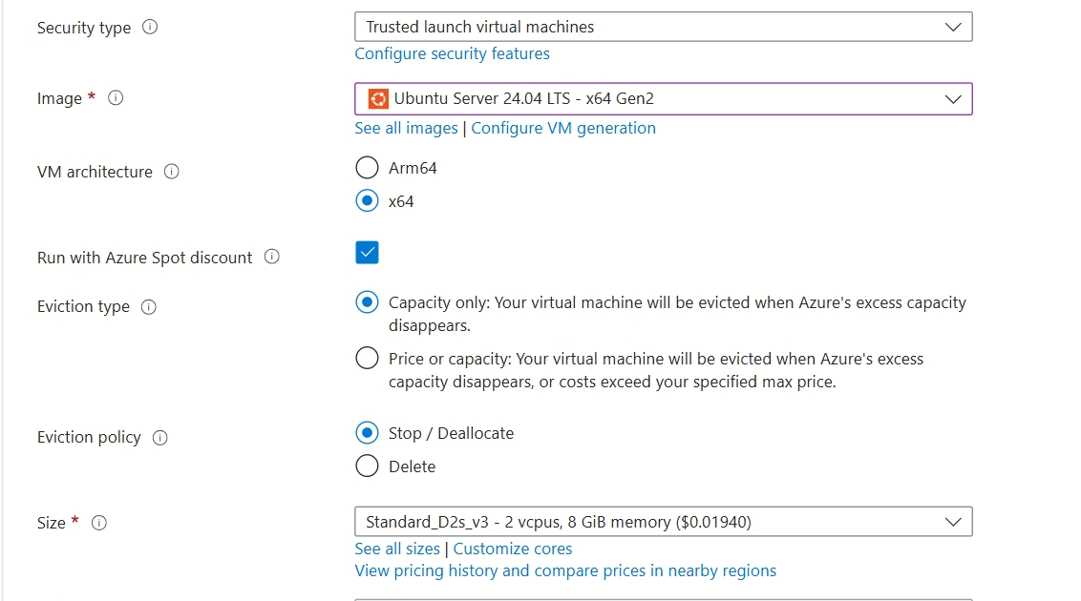
- Authentication: SSH (generate or upload key)
- Allow inbound ports: SSH (22) , HTTP (80)
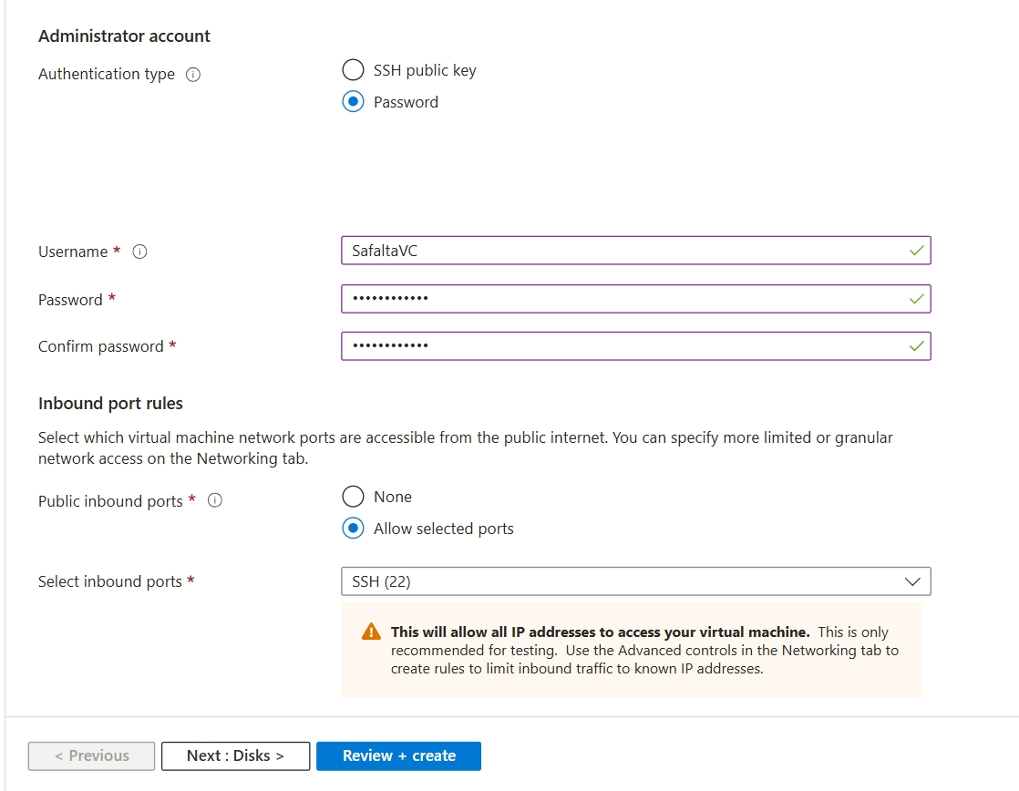

- Click Review + Create, then Create
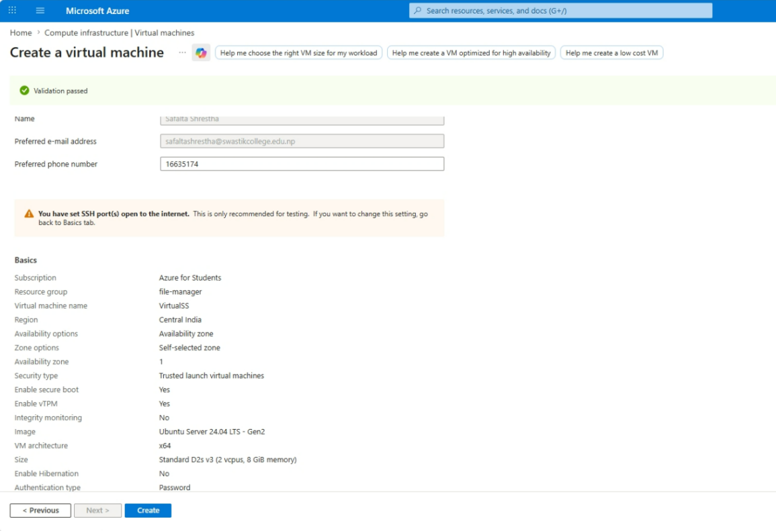
- After deployment, go to the VM → Note down the public IP address
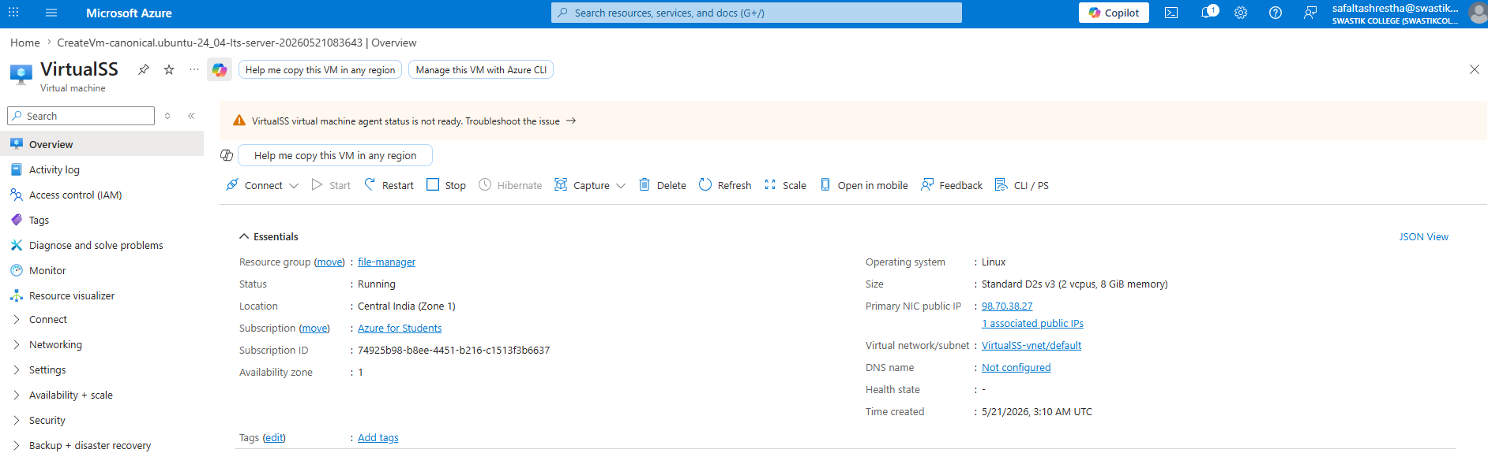
- Host a Static Website
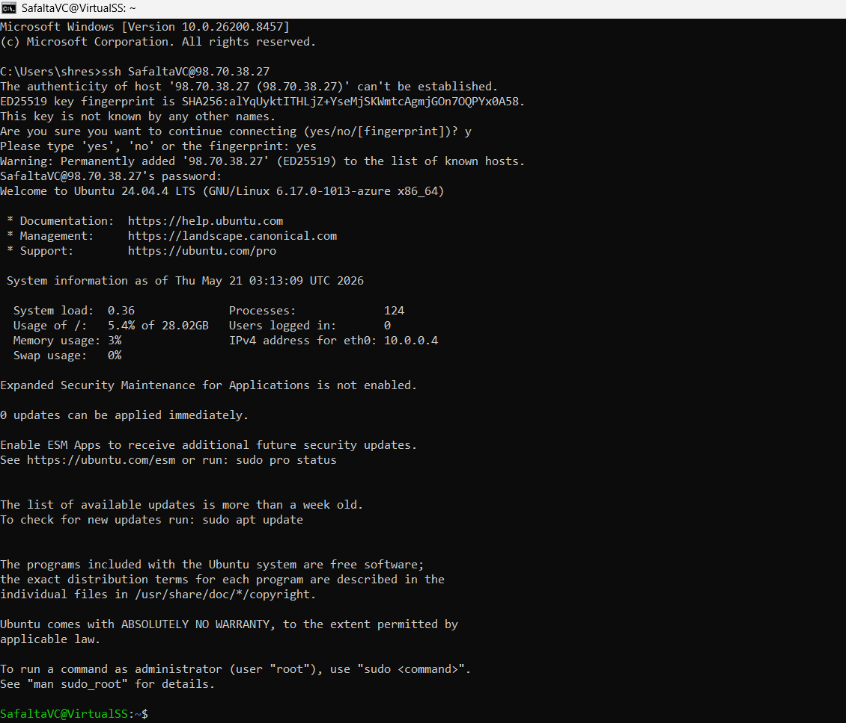

Lab-4: NGINX Configuration
- Do SSH connection with your virtual machine
Here the virtual machine name is “safaltavm” and the ip is “20.244.52.52”. After doing ssh enter password.
ssh <host-name>@<ip-address>
ssh safaltavm@20.244.52.52
safalta12345@
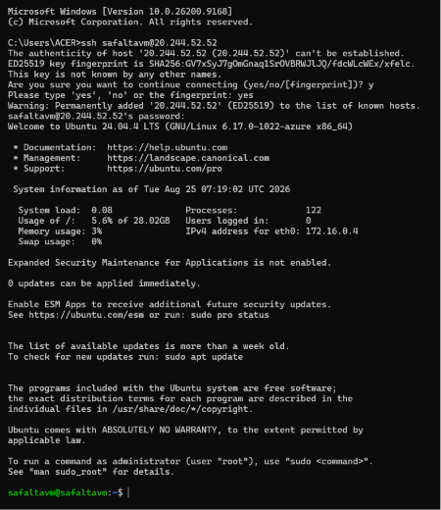

Install NGINX
Update system packages and install NGINX:
sudo apt update
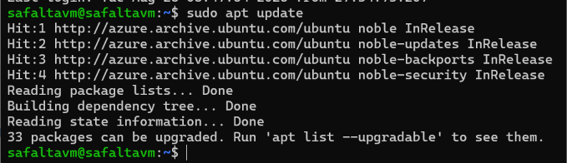
sudo apt install nginx -y
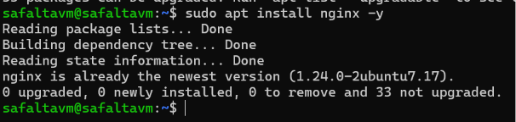
sudo systemctl status nginx
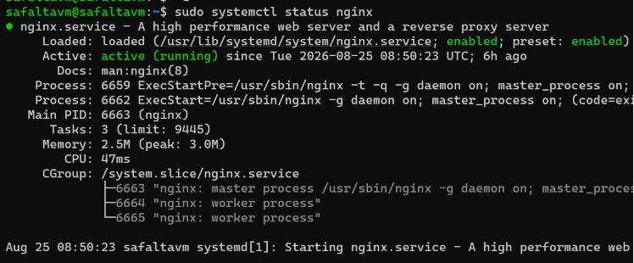

2. Connect GitHub to the Virtual Machine
If this is the first time connecting GitHub:
1. Generate SSH key:
ssh-keygen -t ed25519 -C “safaltashrestha47@gmail.com”
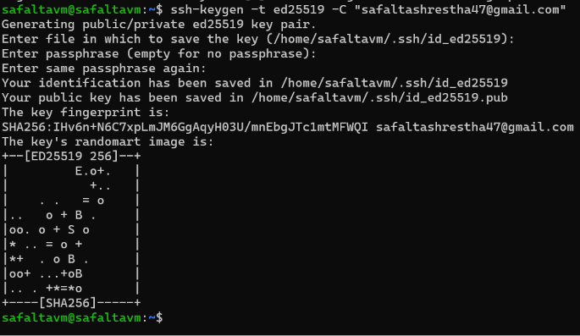
- View and copy your public key:
cat ~/.ssh/id_ed25519.pub
3. Add it to GitHub → Settings → SSH and GPG Keys → New SSH Key.
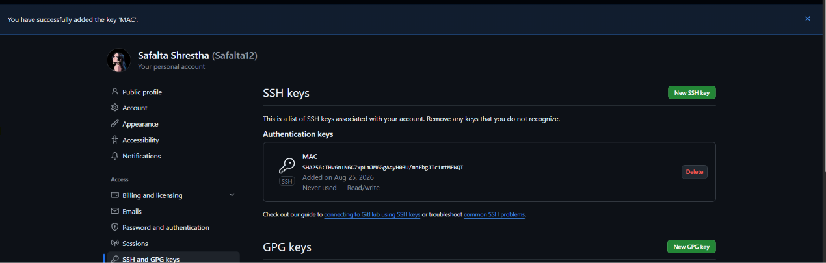
4.Test the connection:
ssh -T git@github.com

3. Pull the Repository You Want to Host
Navigate to the directory where you want the project
cd /var/www/
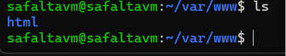
Clone the repository:
sudo git clone git@github.com:username/repository.git
If you get permission error then do;
sudo chown -R bca-lab:bca-lab /var/www
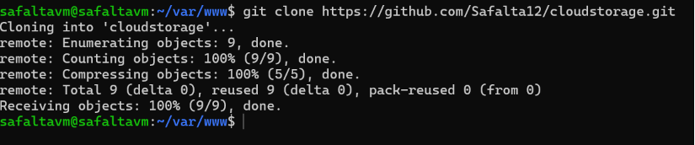

4. Run the Project & Install Dependencies
Go into the project folder:
cd repository
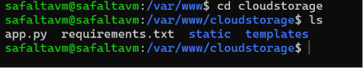

Install dependencies:
Python (FastAPI / Django / Flask)
Sudo apt update
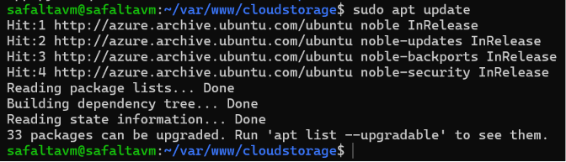
sudo apt install python3-pip
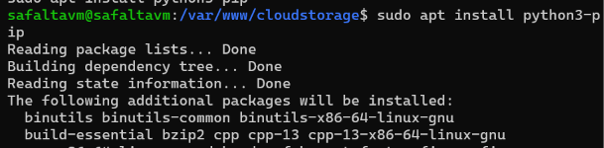
Pip install -r requirements.txt
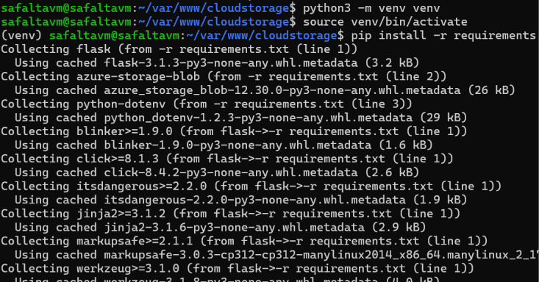

5.Create an NGINX Site Configuration File
Go to NGINX's site-available directory:
cd /etc/nginx/sites-available/
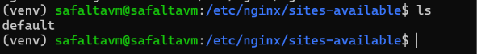
Create a config file for your project:
sudo nano project1.conf


Example NGINX Config (Reverse Proxy)
(Adjust port and folder paths as needed)
server {
listen 80;
server_name your_domain.com;

location / {
proxy_pass http://127.0.0.1:8000; # Your app port
proxy_set_header Host $host;
proxy_set_header X-Real-IP $remote_addr;
proxy_set_header X-Forwarded-For $proxy_add_x_forwarded_for;
proxy_set_header X-Forwarded-Proto $scheme;
}
}

Example
== We need a domain name for this purpose so we are using the free duckdns.org domain for the lab. 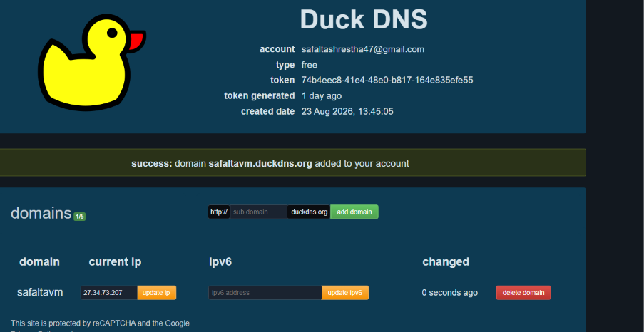
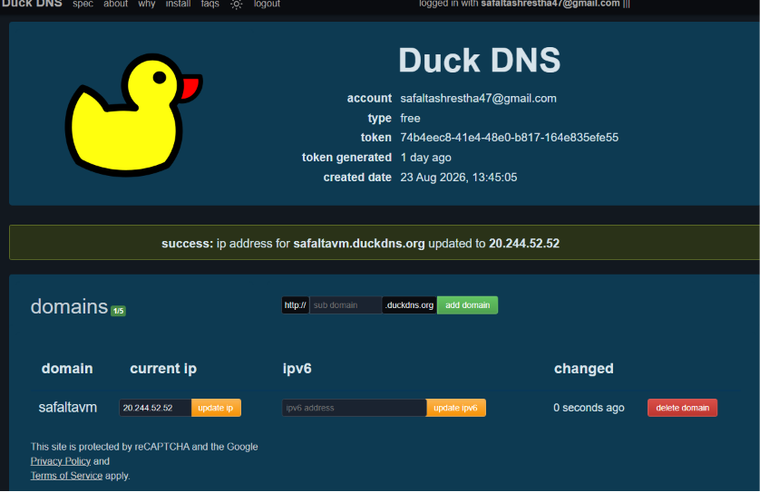
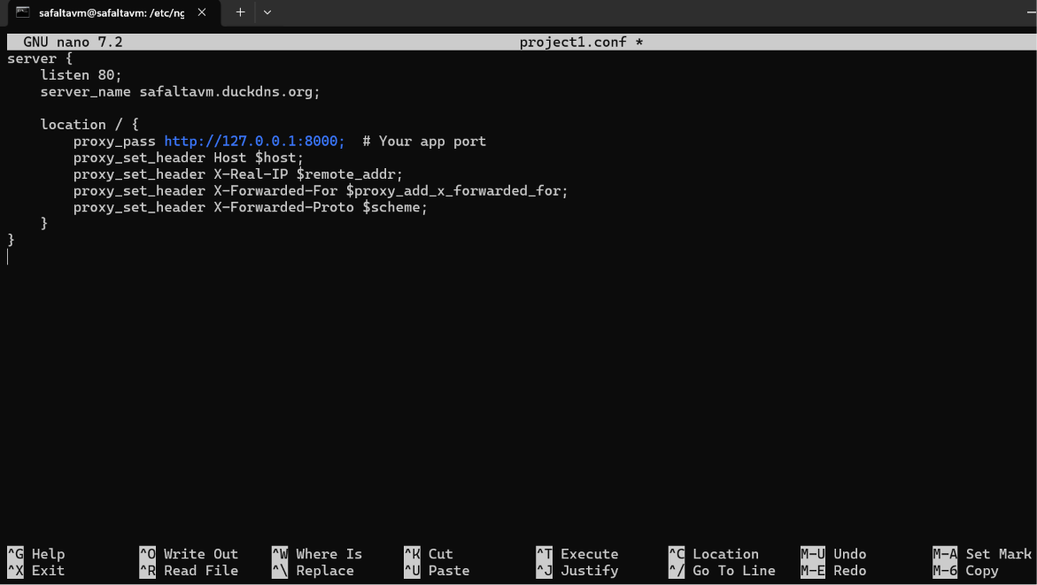

7. Create a Symlink to Enable the Site
Link your config from sites-available to sites-enabled:
sudo ln -s /etc/nginx/sites-available/project1.conf /etc/nginx/sites-enabled/

8. Test NGINX Configuration
Check for syntax errors:
sudo nginx -t
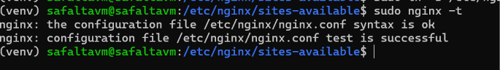
If everything is OK, proceed.

9. Reload or Restart NGINX
Apply the changes:
sudo systemctl reload nginx
Or full restart:
sudo systemctl restart nginx
Check the domain you have configure to see apply changes on the domain you configured
safaltavm.duckdns.org

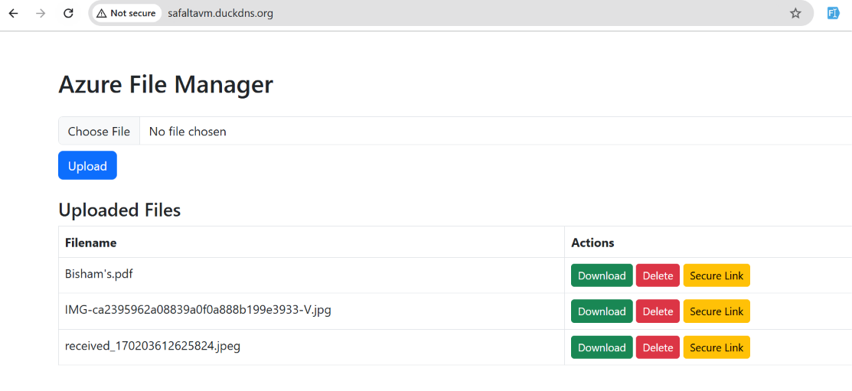

Lab-5: Virtualization
Objective: To install and configure virtualization software (VirtualBox) on a local machine and create multiple virtual machines.
Tool Used:
- Oracle VirtualBox
- Installing Linux Mint on VirtualBox
Step-1: Install VirtualBox
1. Download VirtualBox from the official website.
2. Install VirtualBox by following the on-screen instructions.
3. Open VirtualBox after installation.
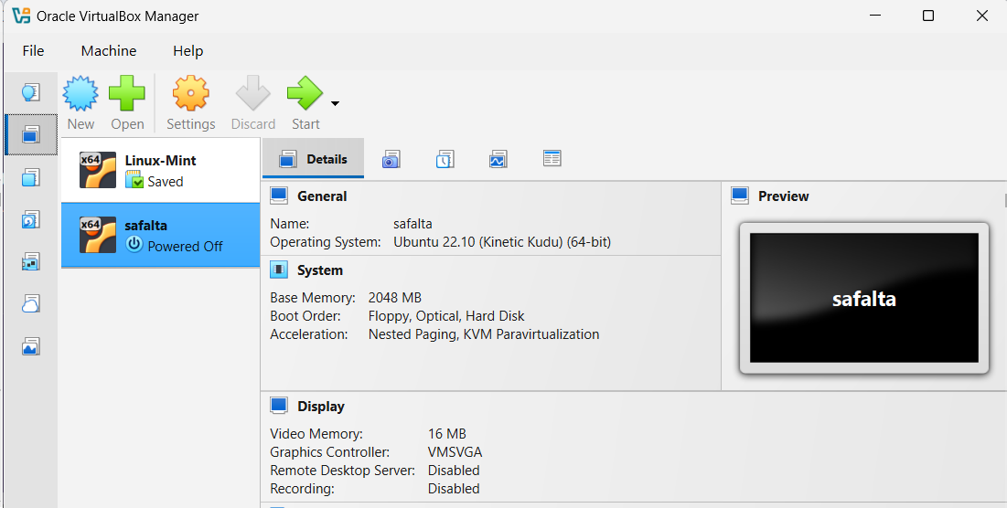
Step-2: Create a New Virtual Machine
1. Click on “New” to create a new virtual machine.
2. A pop-up window will appear. Configure the following:
a) Name: Enter a name for the VM (e.g. “Linux Mint”).
b) Folder: Choose a location to store the VM files.
c) ISO Image: Select the Linux Mint ISO file.
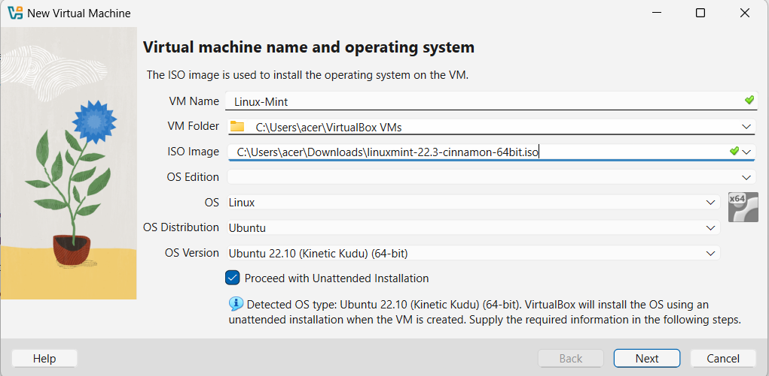
Step-3: Configure System Settings
1. Set up username, password and hostname for the VM.
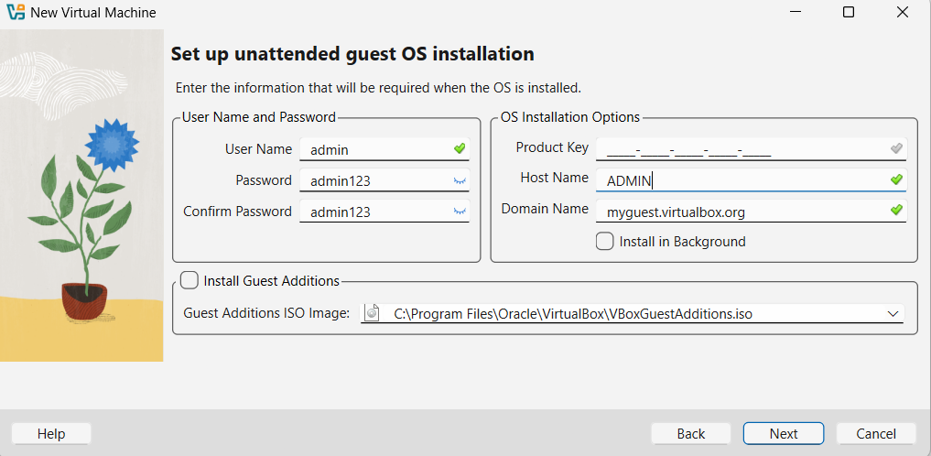
Step-4: Customize hardware resources based on system requirements:
1. Memory (RAM) allocation
2. Processor (CPU) cores
3. Storage capacity

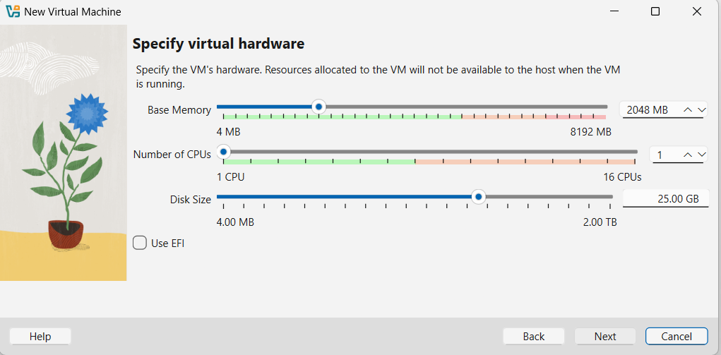
Step-5:Finalizing Setup
1. Review the summary of the virtual machine configuration.
2. Click “Finish” to complete the setup.
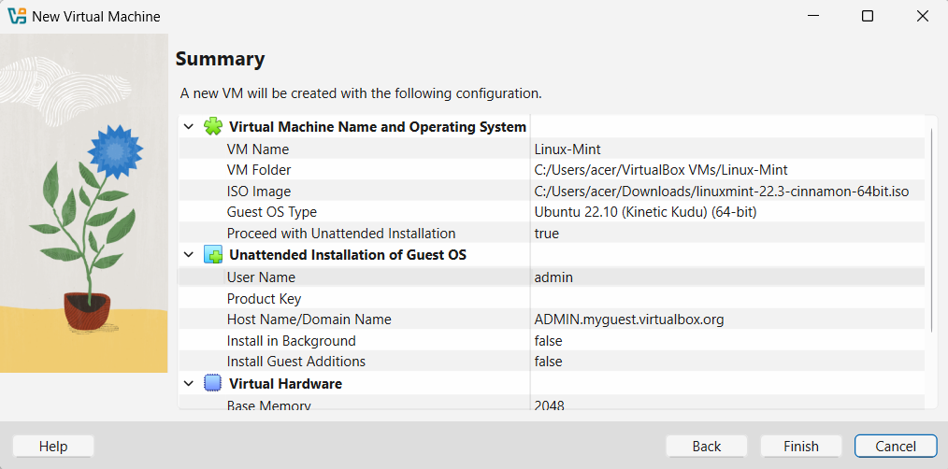
Step-6: Installing Linux Mint
1. Start the virtual machine from the VirtualBox main interface.
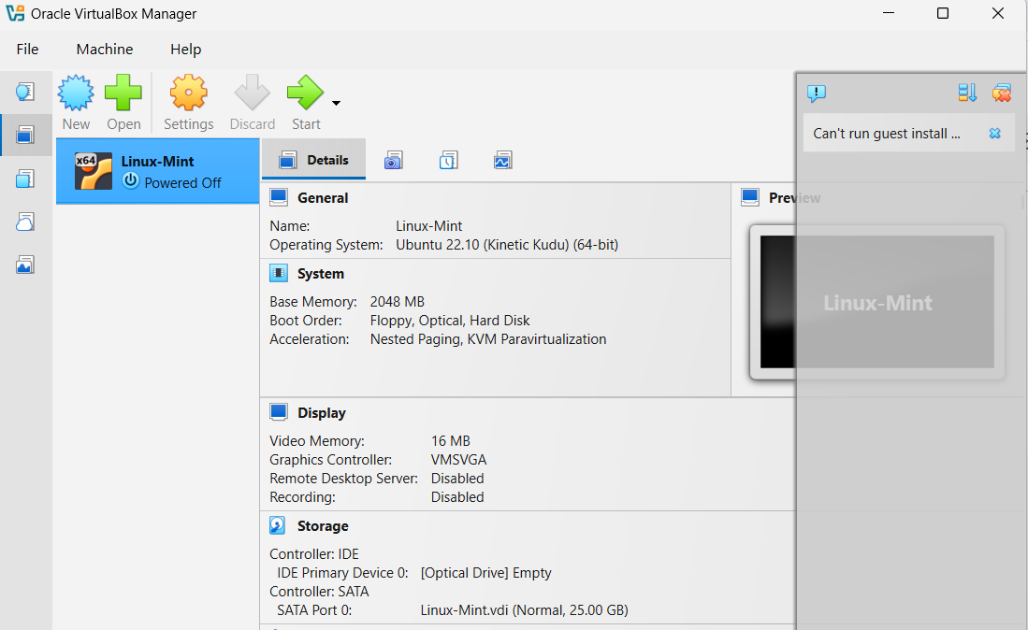
2. The installation process for Linux Mint will begin.
3. Follow on-screen instructions:
- Pick a username and password.
b) Continue with the installation process.
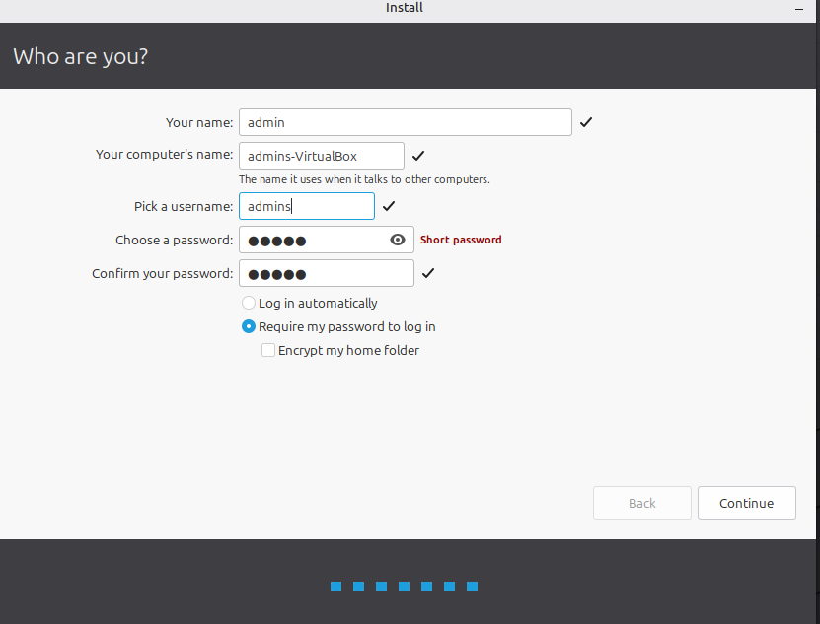
4. Once completed, Linux Mint will successfully launch inside VirtualBox.



5. Successfully launch “Linux Mint” Operating system on Virtual Box.
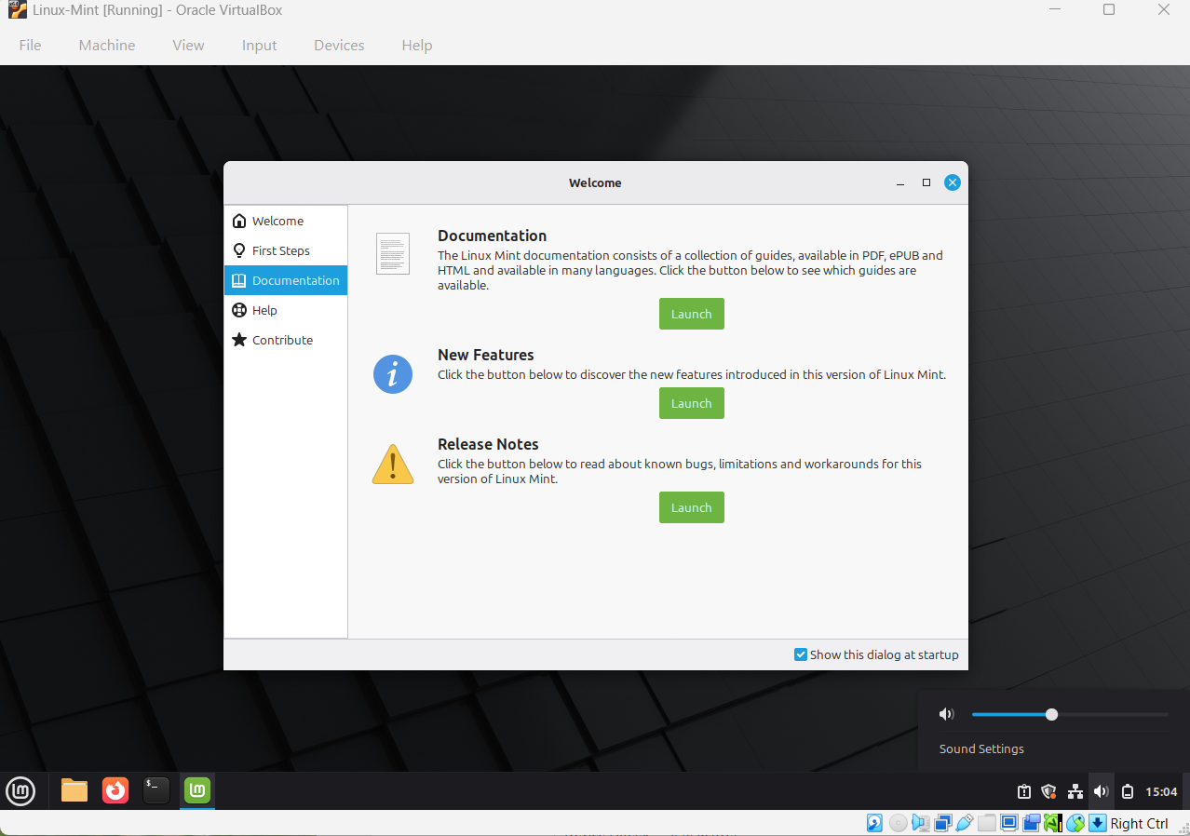

Lab-6:Map Reduce and Parallel Computing
Objective: To implement and test the MapReduce programming model using Hadoop and Python, perform word count and analyze parallel efficiency and performance improvements.
Tools Used:
- JDK x64(Windows HotSpot)
- Hadoop 3.5.0
- Python 3.12+
- Windows Command Prompt(cmd.exe)
1. Check Java Installation
Installed OpenJDK 8, setup following the instruction and then checked the installed java version using Command Prompt.
- Java Version
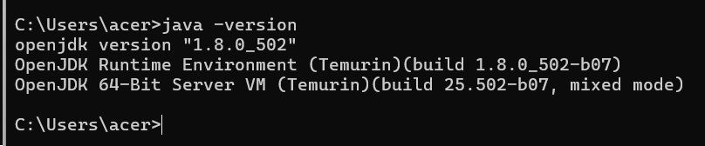
- Java Compiler Version
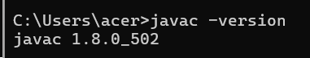
- Extract Hadoop
Download and then extract Apache Hadoop 3.5.0.
Create a new folder on desktop/download (e.g. MapReduce_Lab) and save these two files inside it using Notepad or VS Code:
mapper.py
import sys
for line in sys.stdin:
line = line.strip().lower()
words = line.split()
for word in words:
print(f"{word}\t1")
reducer.py
import sys
current_word = None
current_count = 0
for line in sys.stdin:
line = line.strip()
if not line:
continue
try:
word, count = line.split('\t', 1)
count = int(count)
except ValueError:
continue
if current_word == word:
current_count += count
else:
if current_word:
print(f"{current_word}\t{current_count}")
current_word = word
current_count = count
if current_word:
print(f"{current_word}\t{current_count}")

In the same folder, create a text file named input.txt and put some test text in it:
input.txt
hello world
hello mapreduce
hadoop mapreduce python
Then, run these command
a) cd <your folder location>
b) type input.txt | python mapper.py | sort | python reducer.py
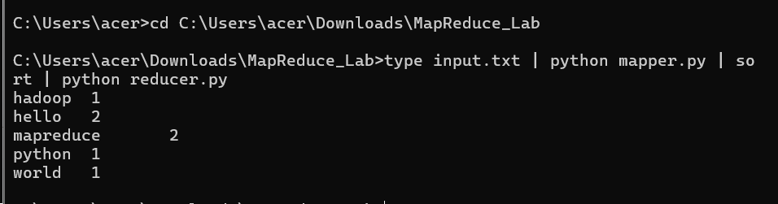
To evaluate execution performance across varying numbers of parallel processes(N) and dataset sizes (D), speedup and parallel effiency are calculated as follows:
Speedup: S_{N} = T₁ / T_{N}
Where:
T₁ = execution time with 1 process/node
T_{N} = execution time with N process/node
Parallel Efficieny: E_{N} = S_{N} / N *100%
Where:
S_{N} = speedup achieved using N processes/ nodes
N = number of process/node

