

Tribhuvan University
Faculty of Humanities and Social Science
SWASTIK COLLEGE

Course: Mobile Programming(CACS351)
Title : Smart Contact Management Android Application (V1)

Submitted To:
Sujan Poudel
Lecturer, BCA Department

Swastik College, Bhaktapur
Submitted By:
Safalta Shrestha
(6-2-1131-47-2022)

5 April 2026
Table of Contents
Smart Contact Management Android Application (V1) 1
1. Introduction 1
2. Objectives The main objectives of Version 1 are: 1
3. Scope of Version 1 1
4. Tools and Technologies Used 2
5. Application Architecture (V1) 3
6. Project Folder Structure 3
7. Git Workflow and Version Control Strategy 4
8. Implementation Details 5
9. Screenshots 6
10. Conclusion 6
11. Future Work 7

Smart Contact Management Android Application (V1)

1. Introduction
Mobile applications are essential for simplifying everyday tasks and improving productivity. A Contact Management Application allows users to efficiently store, manage, and access contact details on a mobile device.
This project, Smart Contact Management Android Application (V1), developed for the Mobile Programming (CACS351) course, has been built to a production-ready standard. It integrates fundamental Android development concepts with a clean and intuitive interface based on Google’s Material Design principles.
This version emphasizes efficient local data handling, complete CRUD operations, smooth and responsive performance, and well-organized project structure maintained through Git version control.

2. Objectives
The main objectives of Version 1 are:
- To develop a fully functional Android application using Android Studio.
- To implement complete CRUD (Create, Read, Update, Delete) operations for contact management.
- To store contact data locally using SQLite database.
- To display contact information efficiently using RecyclerView and MaterialCardView.
- To provide an intuitive and validation-enabled user interface using Material Design components.
- To perform database operations asynchronously to ensure smooth user experience.
- To follow proper Git version control practices during development.

3. Scope of Version 1
Included in Version 1
- Offline Contact Storage: Contacts are stored locally on the device using SQLite.
- Full CRUD Functionality: Users can add, view, edit, and delete contacts.
- Expanded Data Model: Each contact includes:
First Name
Last Name
Phone Number
- Modern UI/UX Design: Implementation of Activities, RecyclerView, FloatingActionButton, Standard Android Views for a polished interface.
- Contact Detail Screen: Read-only screen for viewing full contact details before editing.
- Search Functionality: Real-time filtering by name.
- Asynchronous Database Operations: Database operations are executed in background threads to avoid UI blocking.
- Database Schema Migration: Updated database version to support the expanded data model.
Excluded from Version 1
- Integration with system phone contacts.
- Caller identification functionality.
- Cloud synchronization and online backup.

4. Tools and Technologies Used
Category | Technology
Programming Language | Java
IDE | Android Studio
Platform | Android
Database | SQLite
UI Components | Activities, RecyclerView, Material Design Components
Concurrency | java.util.concurrent.Executors
Version Control | Git
Minimum SDK | API 21

5. Application Architecture (V1)
Version 1 follows an Activity-centric architecture enhanced with asynchronous data handling.
Architecture Flow:
Activity → AppExecutor → SQLite Database
Activity → RecyclerView & Adapter (UI Thread)
Explanation:
- Activities handle user interactions.
- AppExecutor manages background thread execution.
- SQLite database stores contact data locally.
- RecyclerView displays contact data efficiently.
- Background thread operations prevent UI freezing.
- Main thread updates ensure safe UI rendering.
- This architecture strengthens Android fundamentals while applying concurrency best practices.

6. Project Folder Structure
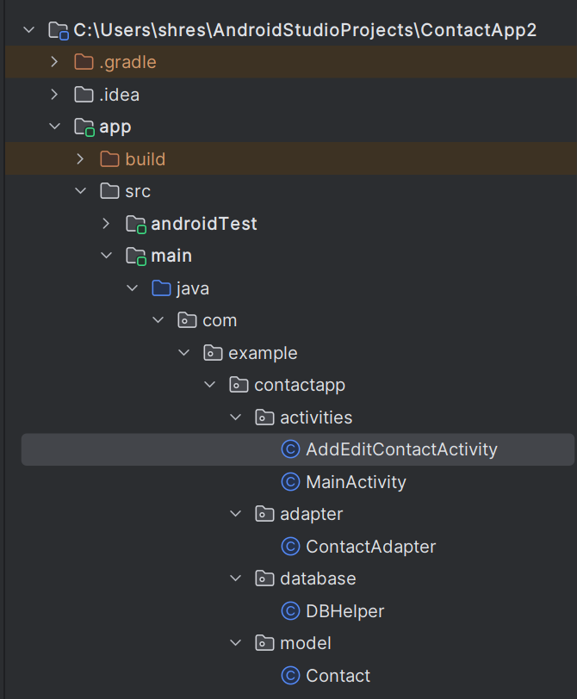
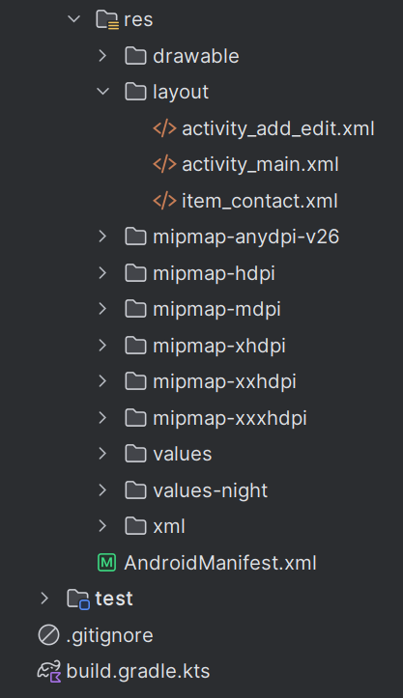

7. Git Workflow and Version Control Strategy
Version 1 of the Smart Contact Management Application was developed using Git for structured version control. All development tasks were committed incrementally to maintain proper tracking of features, improvements, and documentation updates.

7.1 Commit Timeline for V1
The following commits were made on February 24, 2026:
Initial Setup Phase
- Initial commit
Created base Android project structure.
Added initial files and folder hierarchy.
- Update README with app description
Added basic project overview and description in README file.
UI Enhancements & Layout Improvements
- Improved UI structure
Refactored layout files for better alignment and structure.
- Added margin
Improved spacing and layout consistency.
- Added underline to separate contacts
Added visual divider below contact items for better readability.
- Improved UI structure (Refinement)
Further optimized layout components and UI consistency.
Feature Enhancements
- Added alphabetical sorting
Implemented SQL-based sorting using:
ORDER BY name COLLATE NOCASE ASC
Ensured contacts display in A–Z order regardless of letter case.
Repository Synchronization
- Merge remote changes
Integrated updates from remote repository to maintain version consistency.
Documentation Enhancement
- Enhance README with features and project details
Expanded README with complete feature list and project explanation.
Prepared documentation for Version 1 submission.

7.2 Version Control Strategy
The following Git practices were followed:
- Incremental commits for each logical change.
- Clear and descriptive commit messages.
- Separation of UI improvements and feature implementations.
- Proper synchronization with remote repository.
- Documentation updates committed separately.
- Verified commits for repository authenticity.
- This structured workflow ensured traceability, organized development, and proper version tracking throughout Version 1.

8. Implementation Details

8.1 Asynchronous Execution (AppExecutor)
A Singleton class named AppExecutor was implemented to manage background and main thread execution. It uses Executors to separate disk I/O tasks from UI updates.
diskIO() → Executes database operations in background.
mainThread() → Updates UI safely on main thread.
This ensures the application remains responsive during database operations.

8.2 Main Activity
The MainActivity loads contacts asynchronously.
Process:
- Background thread fetches contact list from database.
- Main thread updates RecyclerView adapter.
- UI refreshes smoothly without freezing.

8.3 Add/Edit Contact Activity
Contact saving and updating operations are also executed in background threads.
Process:
- Validate user input.
- Execute insert/update operation using diskIO().
- Switch back to mainThread().
- Display success message and finish activity.

9. Screenshots
This is final version 1 of smart contact app.
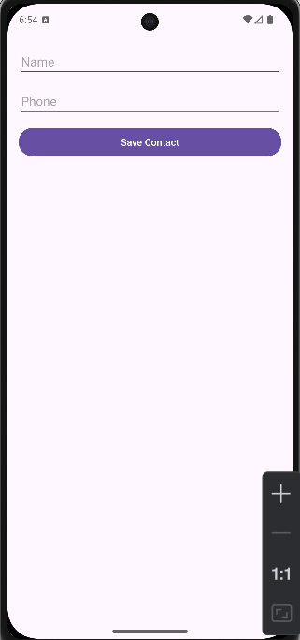
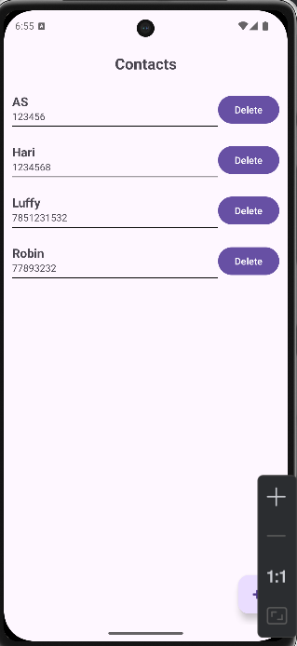

10. Conclusion
Version 1 of the Smart Contact Management Android Application has been successfully developed into a production-ready state. The application fulfills all defined objectives including:
- Complete CRUD functionality
- Expanded data model
- Material Design-based UI
- Asynchronous database execution
The implementation of background thread handling ensures smooth performance and enhanced user experience. The project demonstrates proper Android development practices and structured version control management.

11. Future Work
Version 2:
- Implement an "Empty State" UI for no contacts.
- Migrate architecture to MVVM pattern.
- Improve UI animations and transitions.
Version 3:
- Caller identification feature.
- Spam detection system.
- Cloud synchronization and online backup.
- Integration with system contacts.

