10.WAP to download a web page in Java.
Code:
import java.io.*;
import java.net.*;
public class WebPageDownload_Safalta {
public static void main(String[] args) throws Exception {
URL url = new URL("https://example.com");
URLConnection connection = url.openConnection();
InputStream raw = connection.getInputStream();
InputStream buffer = new BufferedInputStream(raw);
Reader reader = new InputStreamReader(buffer);
int c;
while ((c = reader.read()) != -1) {
System.out.print((char) c);
}
reader.close();
}
}
Output:
11.WAP to encode “This string has space” and then decode it to the original string.
Code:
import java.net.URLEncoder;
import java.net.URLDecoder;
public class EncodeDecode_Safalta {
public static void main(String[] args) {
try {
String url = "This string has space";
String encodedUrl = URLEncoder.encode(url, "UTF-8");
System.out.println(encodedUrl);
String decodedUrl = URLDecoder.decode(encodedUrl, "UTF-8");
System.out.println(decodedUrl);
} catch (Exception e) {
e.printStackTrace();
}
}
}
Output:
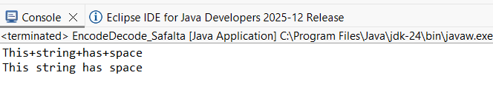
12.WAP to retrieve the cookie information and store them in the system.
Code:
import java.io.*;
import java.net.*;
import java.util.*;
public class CookieInfo_Safalta {
public static void main(String[] args) {
try {
URL url = new URL("http://www.google.com");
HttpURLConnection connection = (HttpURLConnection) url.openConnection();
connection.setRequestMethod("GET");
connection.connect();
Map<String, List<String>> headerFields = connection.getHeaderFields();
List<String> cookiesHeader = headerFields.get("Set-Cookie");
if (cookiesHeader != null) {
FileWriter fw = new FileWriter("cookies.txt");
BufferedWriter bw = new BufferedWriter(fw);
System.out.println("Cookies retrieved:");
for (String cookie : cookiesHeader) {
System.out.println(cookie);
bw.write(cookie);
bw.newLine();
}
bw.close();
System.out.println("\nCookies have been stored in cookies.txt");
} else {
System.out.println("No cookies found from the server.");
}
} catch (Exception e) {
e.printStackTrace();
}
}
}
Output:
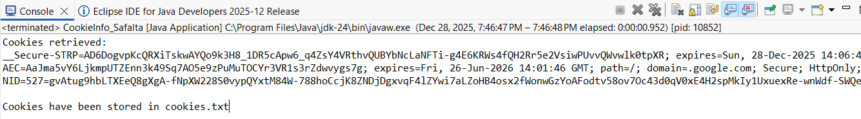

13.WAP to demonstrate the ProxySelector class in Java.
Code:
import java.net.*;
import java.util.List;
public class ProxySelector_Safalta {
public static void main(String[] args) {
try {
URI uri = new URI("http://www.example.com");
ProxySelector proxySelector = ProxySelector.getDefault();
List<Proxy> proxies = proxySelector.select(uri);
for (Proxy proxy : proxies) {
System.out.println("Proxy Type: " + proxy.type());
System.out.println("Proxy Address: " + proxy.address());
}
} catch (Exception e) {
e.printStackTrace();
}
}
}
Output:
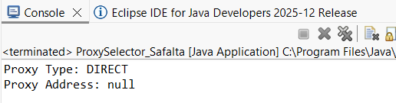

14.WAP to demonstrate the Authenticator class in Java.
Code:
import java.net.*;
import java.io.*;
public class Authenticator_Safalta {
public static void main(String[] args) {
Authenticator.setDefault(new Authenticator() {
@Override
protected PasswordAuthentication getPasswordAuthentication() {
return new PasswordAuthentication("myUsername", "myPassword".toCharArray());
}
});
try {
URL url = new URL("http://httpbin.org/basic-auth/myUsername/myPassword");
HttpURLConnection connection = (HttpURLConnection) url.openConnection();
int responseCode = connection.getResponseCode();
System.out.println("Response Code: " + responseCode);
BufferedReader in = new BufferedReader(
new InputStreamReader(connection.getInputStream()));
String inputLine;
StringBuilder response = new StringBuilder();
while ((inputLine = in.readLine()) != null) {
response.append(inputLine);
}
in.close();
System.out.println("Response: " + response.toString());
} catch (IOException e) {
e.printStackTrace();
}
}
}
Output:
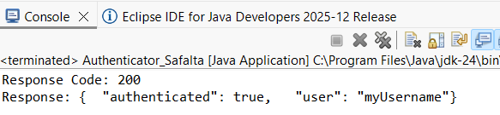
15.WAP to print the last modified date, content length, and content type
of a URL of your choice.
Code:
import java.io.*;
import java.net.*;
import java.util.*;
public class HeaderView_Safalta {
public static void main(String[] args) {
String urlString="https://example.com";
try {
URL u = new URL(urlString);
URLConnection uc = u.openConnection();
System.out.println("URL: " + u);
System.out.println("Content-type: " + uc.getContentType());
System.out.println("Content-length: " + uc.getContentLength());
if (uc.getLastModified() != 0) {
System.out.println("Last modified: " + new Date(uc.getLastModified()));
}
} catch (MalformedURLException ex) {
System.err.println(urlString + " is not a valid URL");
} catch (IOException ex) {
System.err.println(ex);
}
System.out.println();
}
}
Output:
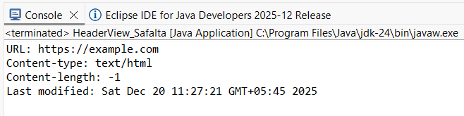
16.WAP to print all the headers and its corresponding values present in
any HTTP response.
Code:
import java.io.*;
import java.net.*;
public class PrintHeaders_Safalta {
public static void main(String[] args) {
String url= "https://swastikcollege.edu.np/";
try {
URL u = new URL(url);
URLConnection uc = u.openConnection();
for (int i = 1;; i++) {
String header = uc.getHeaderField(i);
if (header == null)
break;
System.out.println(uc.getHeaderFieldKey(i) + ": " + header );
}
} catch (MalformedURLException ex) {
System.err.println(url+": is not a URL I understand.");
} catch (IOException ex) {
System.err.println(ex);
}
}
}
Output:
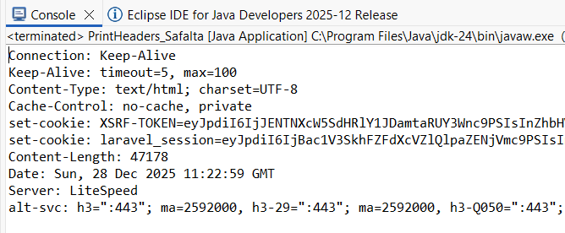

17.WAP to read from a socket.
Code:
import java.io.*;
import java.net.*;
public class ReadFromServer_Safalta {
public static void main(String[] args) {
try {
Socket socket = new Socket("localhost", 5000);
System.out.println("Connected to server...");
BufferedReader in = new BufferedReader(
new InputStreamReader(socket.getInputStream()));
String message;
System.out.println("Reading from socket:");
while ((message = in.readLine()) != null) {
System.out.println(message);
}
in.close();
socket.close();
System.out.println("Connection closed.");

} catch (IOException e) {
e.printStackTrace();
}
}
}
Output:
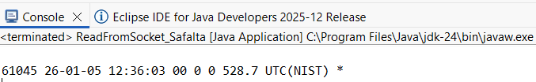
18.WAP to create a server socket and print the log message, message
on the console whenever a new client is connected, or if any error
occurs.
Code:
import java.io.*;
import java.net.*;
public class ServerSocket_Safalta {
public static void main(String[] args) {
int port = 5000;
ServerSocket serverSocket = null;
try {
serverSocket = new ServerSocket(port);
System.out.println("Server started, listening on port " + port);
while (true) {
try {
Socket clientSocket = serverSocket.accept();
System.out.println("New client connected: "
+ clientSocket.getInetAddress().getHostAddress());
PrintWriter out = new PrintWriter(
clientSocket.getOutputStream(), true);
out.println("Welcome! You are connected.");
clientSocket.close();
} catch (IOException clientError) {
System.out.println("Error while communicating with client: " + clientError.getMessage());
}
}
} catch (IOException e) {
System.out.println("Server error: " + e.getMessage());
} finally {
try {
if (serverSocket != null) {
serverSocket.close();
}
} catch (IOException e) {
System.out.println("Error closing server: " + e.getMessage());
}
}
}
}
Output:
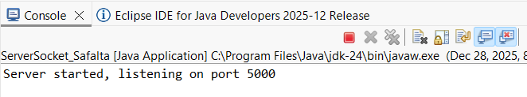
19.Write a client-server socket program such that the client program
will read an integer value from the user as standard input and send
it to a server which will return the factorial of that number.
Code:
Server_Safalta.java
import java.io.*;
import java.net.*;
public class Server_Safalta {
public static void main(String[] args) {
try {
ServerSocket serverSocket = new ServerSocket(6000);
System.out.println("Server started and waiting for client...");
Socket socket = serverSocket.accept();
System.out.println("Client connected.");
BufferedReader in = new BufferedReader(
new InputStreamReader(socket.getInputStream()));
String numStr = in.readLine();
int num = Integer.parseInt(numStr);
System.out.println("Received number: " + num);
long factorial = 1;
for (int i = 1; i <= num; i++) {
factorial *= i;
}
PrintWriter out = new PrintWriter(
socket.getOutputStream(), true);
out.println(factorial);
in.close();
out.close();
socket.close();
serverSocket.close();
System.out.println("Server closed.");
} catch (IOException e) {
System.out.println("Server error: " + e.getMessage());
}
}
}
Client_Safalta.java
import java.io.*;
import java.net.*;
import java.util.*;
public class Client_Safalta {
public static void main(String[] args) {
try {
Socket socket = new Socket("localhost", 6000);
Scanner scanner = new Scanner(System.in);
System.out.print("Enter an integer: ");
int num = scanner.nextInt();
PrintWriter out = new PrintWriter(
socket.getOutputStream(), true);
out.println(num);
BufferedReader in = new BufferedReader(
new InputStreamReader(socket.getInputStream()));
String result = in.readLine();
System.out.println("Factorial of " + num + " is " + result);
scanner.close();
in.close();
out.close();
socket.close();
} catch (IOException e) {
System.out.println("Client error: " + e.getMessage());
}
}
}
Output:
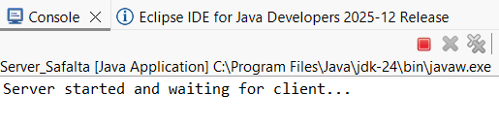
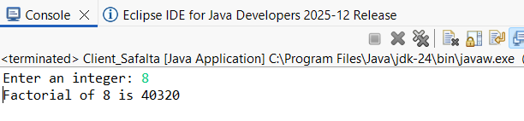
20.Write a multithreaded client server program for daytime service.
Code:
DaytimeServer_Safalta.java
import java.net.*;
import java.io.*;
import java.util.Date;
public class DaytimeServer_Safalta {
public static void main(String[] args) {
int port=13;
try (ServerSocket server = new ServerSocket(port)) {
System.out.println("Daytime Server Started on port"+port);
while (true) {
try (Socket connection = server.accept()) {
Writer out = new OutputStreamWriter(connection.getOutputStream());
Date now = new Date();
out.write(now.toString() + "\n");
out.flush();
connection.close();
}
catch (IOException ex) {
}
}
} catch (IOException ex) {
System.err.println(ex);
}
}
}

DaytimeClient_Safalta.java
import java.net.*;
import java.io.*;
public class DaytimeClient_Safalta {
public static void main(String[] args) {
String serverAddress = "localhost"; int port = 13;
try (Socket socket = new Socket(serverAddress, port)) {
BufferedReader in = new BufferedReader(new InputStreamReader(socket.getInputStream()));
String serverResponse = in.readLine();
System.out.println("Server Date and Time: " + serverResponse);
} catch (IOException ex) {
System.err.println(ex);
}
}
}
Output:
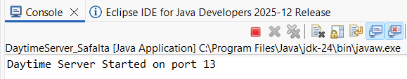
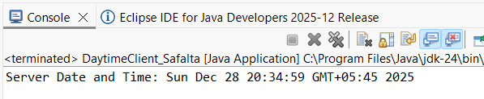
21.Write a multithreaded client server program for daytime service, use
a threadpool of 50.
Code:
DaytimeServer_Safalta.java
import java.net.*;
import java.io.*;
import java.util.Date;
import java.util.concurrent.*;
public class DaytimeServer_Safalta {
public static void main(String[] args) {
int port = 1313;
int poolSize = 50;
ExecutorService pool = Executors.newFixedThreadPool(poolSize);
try (ServerSocket server = new ServerSocket(port)) {
System.out.println("Multithreaded Daytime Server Started on port " + port);
while (true) {
Socket connection = server.accept();
pool.submit(() -> {
try {
System.out.println("Client connected: " +
connection.getInetAddress().getHostAddress());

Writer out = new OutputStreamWriter(connection.getOutputStream());
Date now = new Date();
out.write(now.toString() + "\n");
out.flush();
connection.close();
System.out.println("Connection closed.");
} catch (IOException e) {
System.err.println("Error: " + e.getMessage());
}
});
}
} catch (IOException ex) {
System.err.println(ex);
}
}
}
DaytimeClient_Safalta.java
package Multithread_ThreadPool;
import java.net.*;
import java.io.*;
public class DaytimeClient_Safalta {
public static void main(String[] args) {
String serverAddress = "localhost";
int port = 1313;
try (Socket socket = new Socket(serverAddress, port)) {
BufferedReader in = new BufferedReader(new InputStreamReader(socket.getInputStream()));
String serverResponse = in.readLine();
System.out.println("Server Date and Time: " + serverResponse);
} catch (IOException ex) {
System.err.println(ex);
}
}
}
Output:
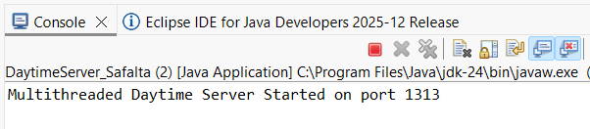
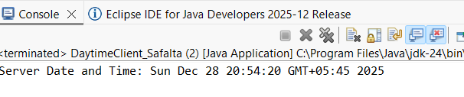
22.Create a secure client socket to read from a secure server socket.
Code:
SecureServer_Safalta.java
import java.io.*;
import java.net.*;
import javax.net.ssl.*;
public class SecureServer_Safalta {
public static void main(String[] args) {
int port = 8443; try {
SSLServerSocketFactory sslServerFactory =
(SSLServerSocketFactory) SSLServerSocketFactory.getDefault();
SSLServerSocket sslServerSocket =
(SSLServerSocket) sslServerFactory.createServerSocket(port);
System.out.println("Secure Server started on port " + port);
SSLSocket sslSocket = (SSLSocket) sslServerSocket.accept();
System.out.println("Client connected securely!");
BufferedReader in = new BufferedReader(
new InputStreamReader(sslSocket.getInputStream()));
PrintWriter out = new PrintWriter(
sslSocket.getOutputStream(), true);
String received = in.readLine();
System.out.println("Client says: " + received);
out.println("Secure Server response: received \"" + received + "\"");
out.close();
in.close();
sslSocket.close();
sslServerSocket.close();
} catch (IOException ex) {
System.err.println("Server error: " + ex.getMessage());
}
}
}
SecureClient_Safalta.java
import java.io.*;
import javax.net.ssl.*;
public class SecureClient_Safalta {
public static void main(String[] args) {
String host = "localhost";
int port = 8443;
try {
SSLSocketFactory sslSocketFactory =
(SSLSocketFactory) SSLSocketFactory.getDefault();
SSLSocket sslSocket =
(SSLSocket) sslSocketFactory.createSocket(host, port);
System.out.println("Connected securely to server!");
PrintWriter out = new PrintWriter(
sslSocket.getOutputStream(), true);
BufferedReader in = new BufferedReader(
new InputStreamReader(sslSocket.getInputStream()));
out.println("Hello Secure Server!");
System.out.println("Server says: " + in.readLine());
in.close();
out.close();
sslSocket.close();
} catch (IOException ex) {
System.err.println("Client error: " + ex.getMessage());
}
}
}
Output:
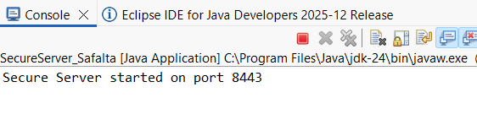
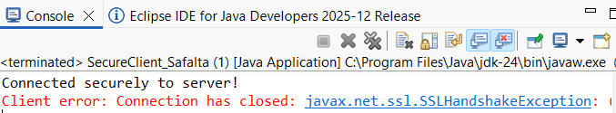
23.WAP to create a UDP client-socket echo program.
Code:package-->updClientServer
Output:
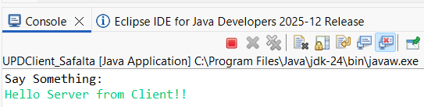
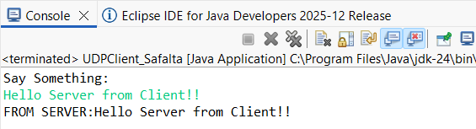
24.WAP to join a computer system in a multicast group.
Code:Package-->multicast_Safalta
Output:
