Lab 1: Virtualization

Objective:
To install and configure virtualization software (VMware or VirtualBox) on a local machine and create multiple virtual machines.

Tools Used:
- VMware Workstation
- VirtualBox
In this practical, we will install and configure Linux Mint as a virtual machine (VM) using VirtualBox and VMware Workstation. Follow the step-by-step instructions provided for each tool.

1. Installing Linux Mint on VirtualBox

Step 1: Install VirtualBox
- Download VirtualBox from the official website.
- Install VirtualBox by following the on-screen instructions.
- Open VirtualBox after installation.
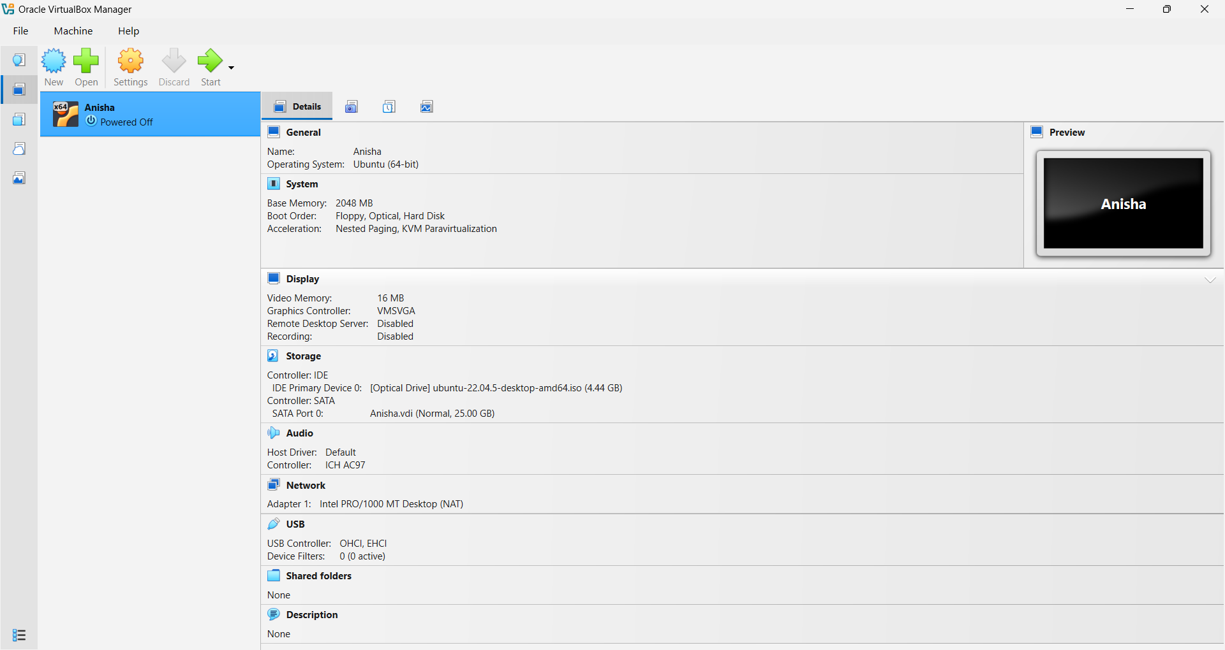

Step 2: Create a New Virtual Machine
- Click on "New" to create a new virtual machine.
- A pop-up window will appear. Configure the following:
  - Name: Enter a name for the VM (e.g., "Linux Mint").
  - Folder: Choose a location to store the VM files.
ISO Image: Select the Linux Mint ISO file
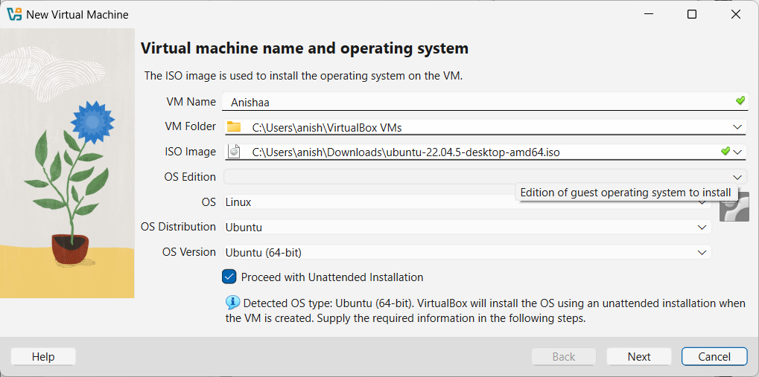
Step 3: Configure System Settings
- Set up username, password, and hostname for the VM.
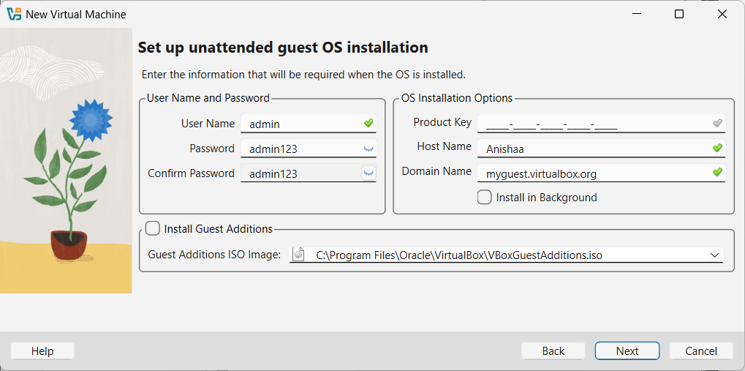

- 4. Customize hardware resources based on system requirements:
  - Memory (RAM) allocation
  - Processor (CPU) cores
  - Storage capacity
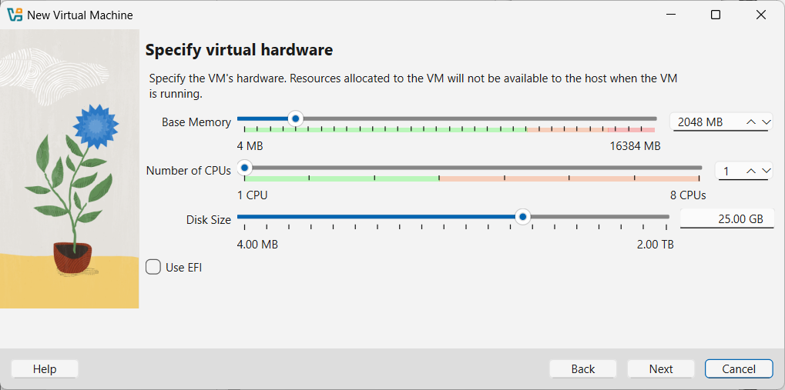

Step 4: Finalizing Setup
- Review the summary of the virtual machine configuration.
- Click "Finish" to complete the setup.
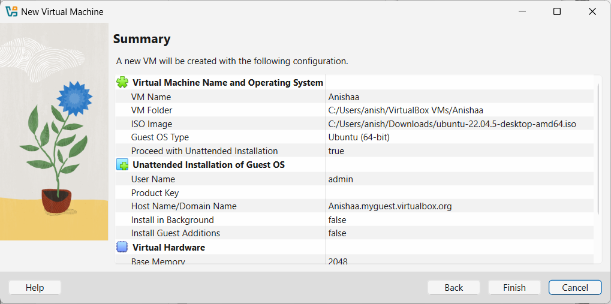

Step 5: Installing Linux Mint
- Start the virtual machine from the VirtualBox main interface.
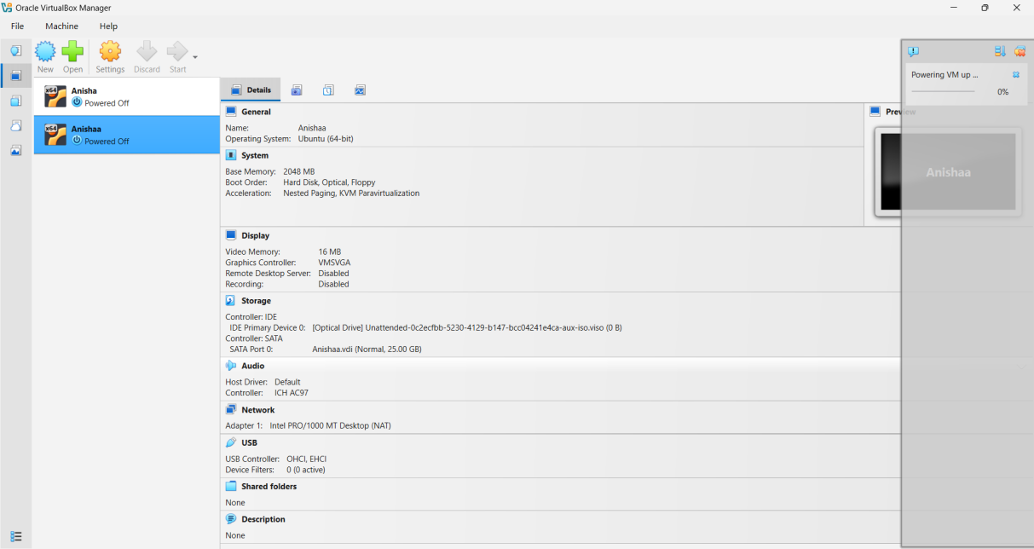

- The installation process for Linux Mint will begin.
- Follow on-screen instructions:
  - Pick a username and password.
  - Continue with the installation process.
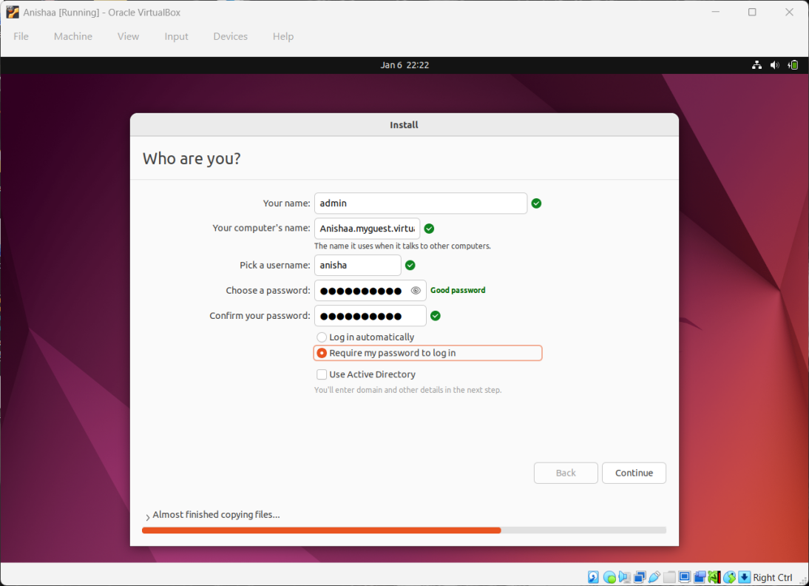
- Once completed, Linux Mint will successfully launch inside VirtualBox.
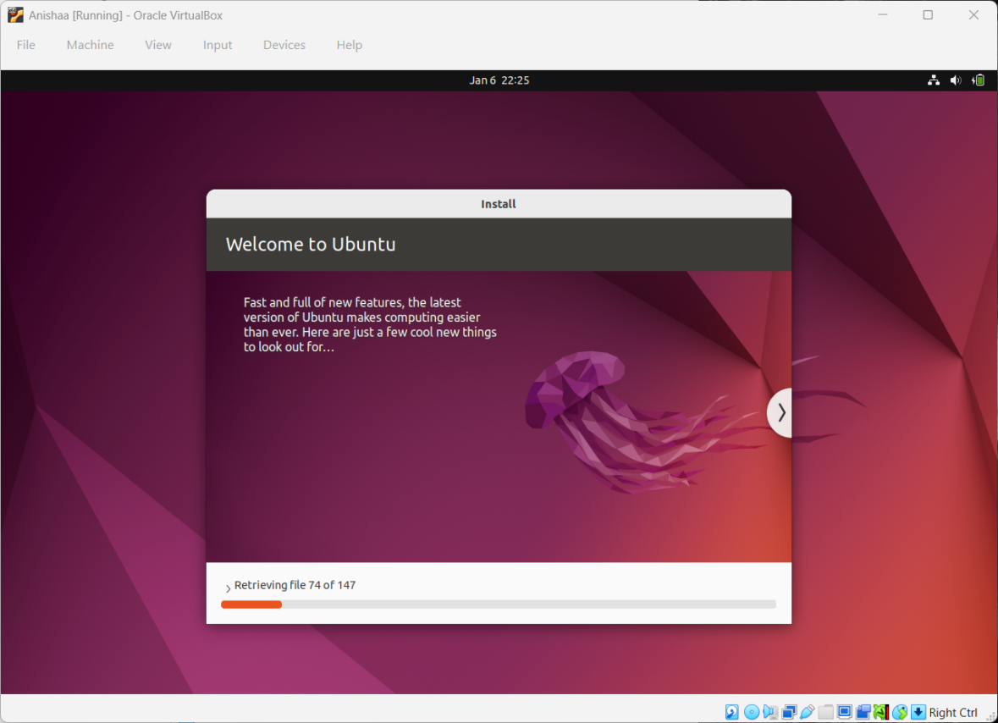
- Successfully launch “Linux Mint” Operating system on Virtual Box
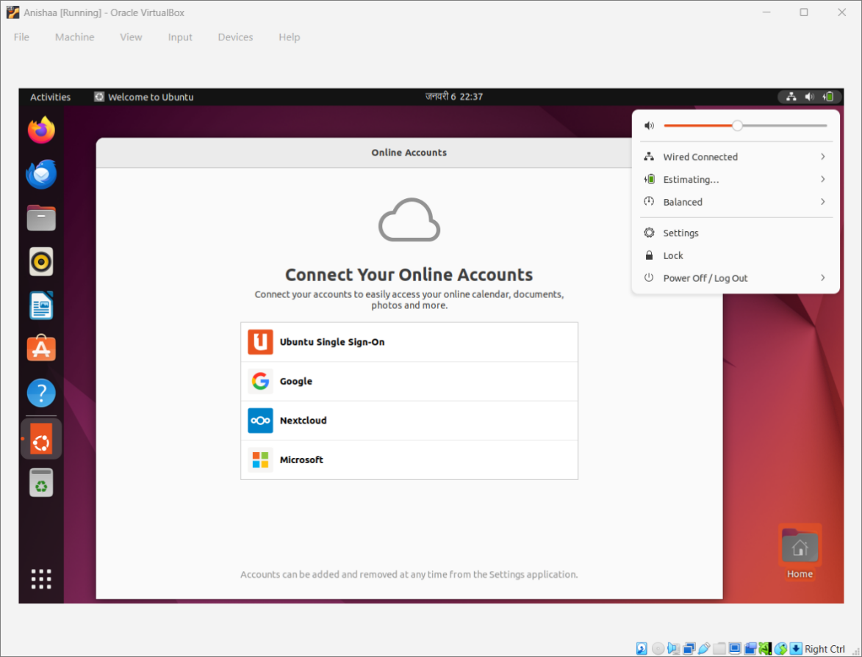

Lab 2: Getting Started with Azure
Objective: Understand the Azure portal, subscription model, and cloud terminology.

Tasks:

1. Create an Azure Account
- Visit: https://azure.microsoft.com/en-us/free/students
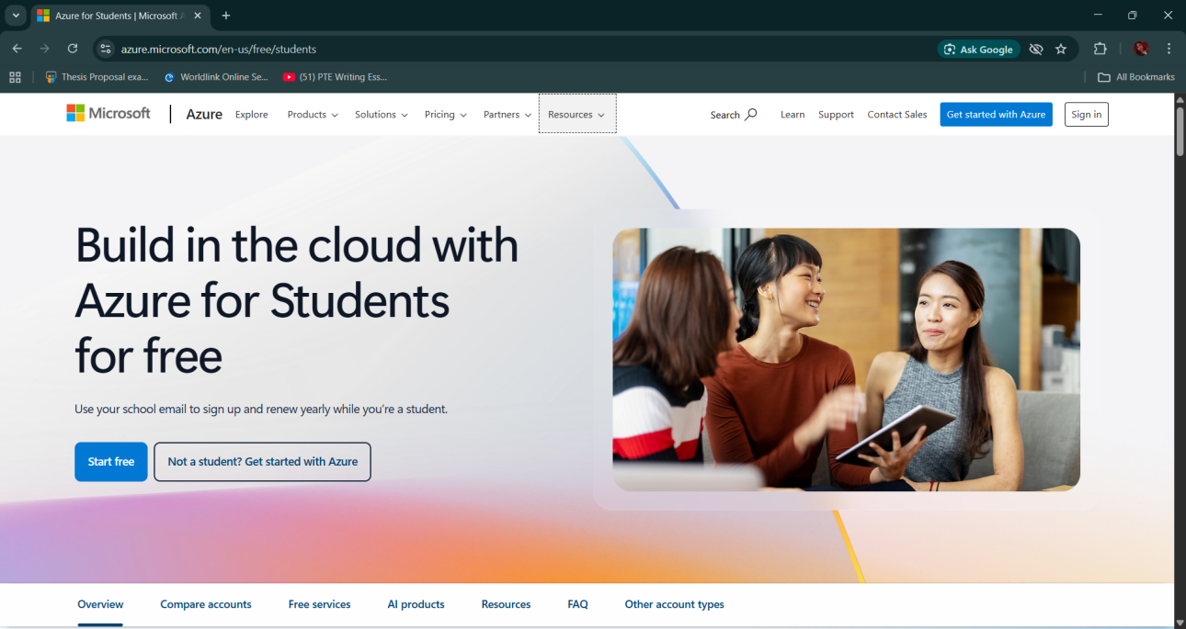
- Click Start Free and sign in with a Microsoft account (use a school/university email).
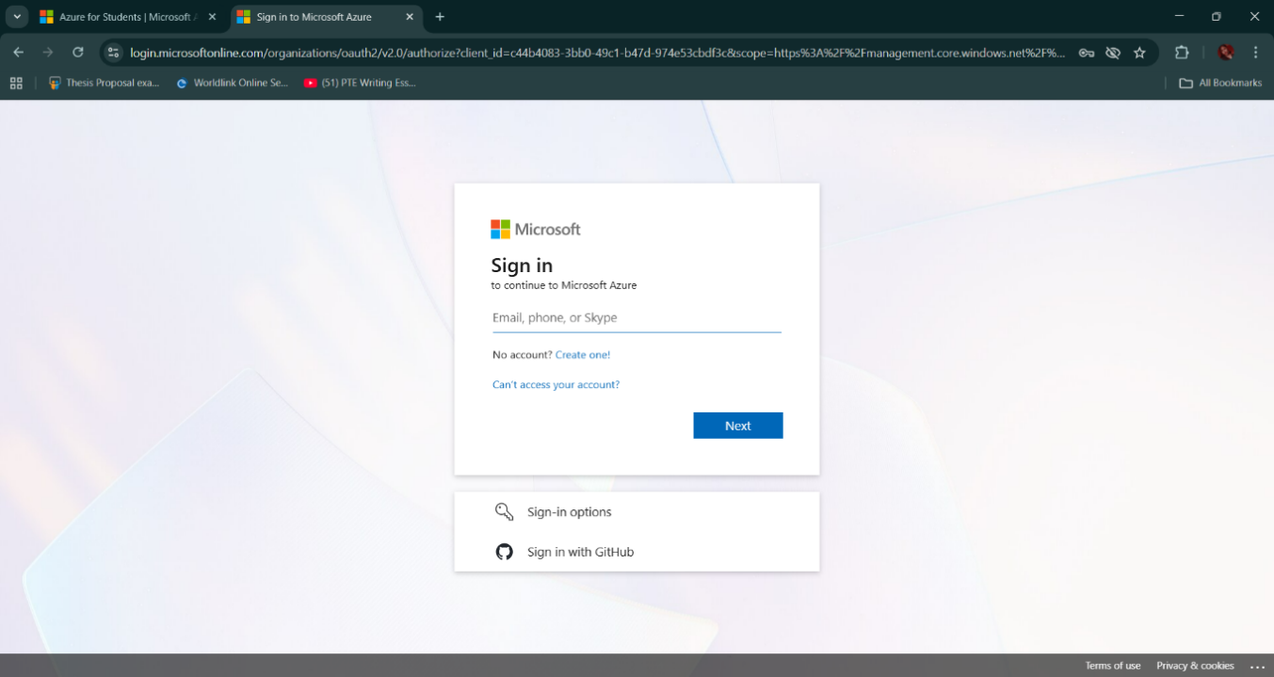
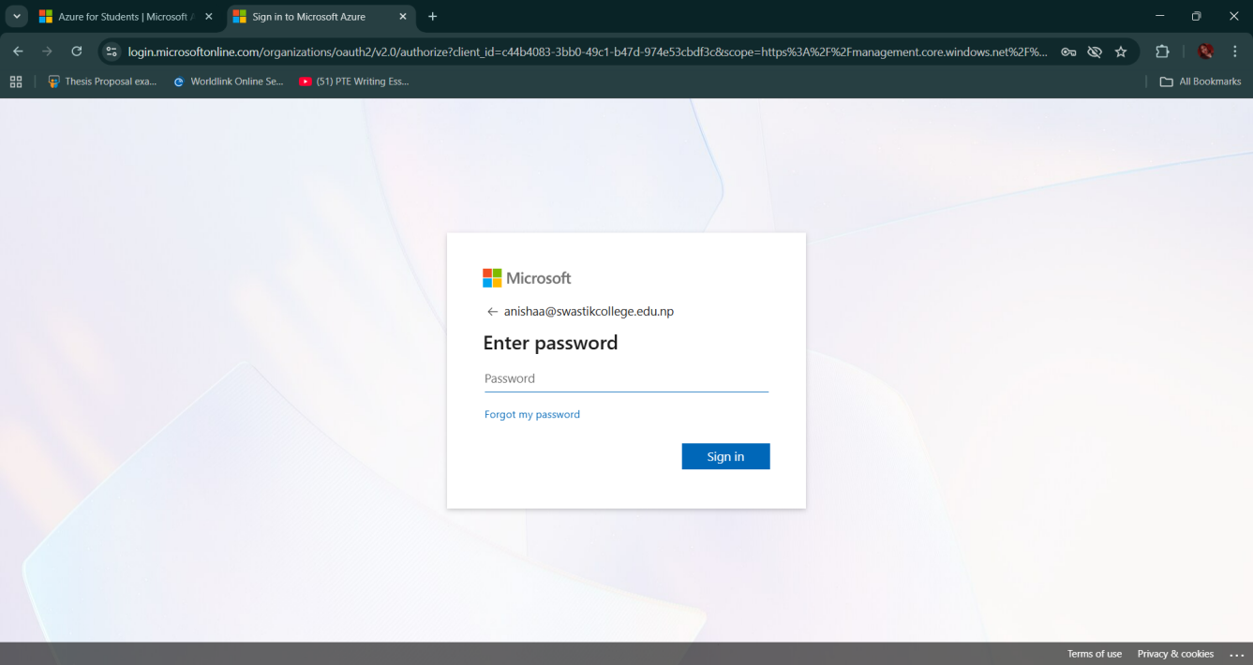

- Select Student Option to get $100 credits via Azure for Students.
- Complete the sign up and verification (phone number + identity verification).
📝 Note: No credit card is needed for student accounts.

2. Explore Azure Portal and Cloud Shell
- Login to the Azure Portal.
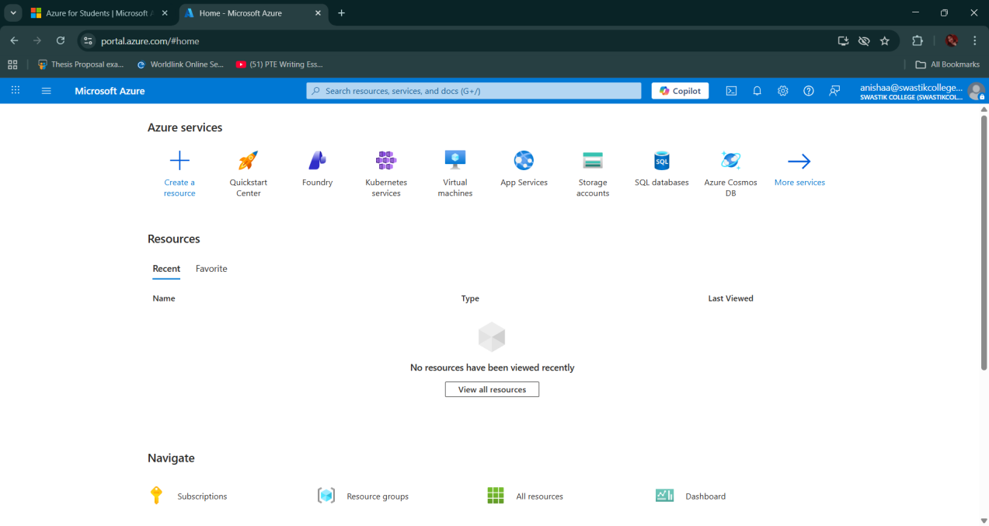
- Familiarize yourself with:
- Dashboard
- Resource Groups
- All Services
- Marketplace
- Click on Cloud Shell (top-right menu bar → terminal icon)
  - Choose Bash (or PowerShell)
  - Set up Cloud Shell storage if prompted
📝 Tip: Cloud Shell comes preinstalled with Azure CLI.

3. Create a Resource Group
A resource group is a logical container for your Azure resources.
-Via Portal:
- Go to Resource Groups → Create
Resource Group Name: cloudcomputing_lab
Region: East Asia

Lab 3: Azure Storage Services
Objective:
Learn to create and manage Azure Blob Storage, including uploading files and accessing them via public URLs using both the Portal and Azure CLI.

Via Portal:
- Go to Storage accounts → Create
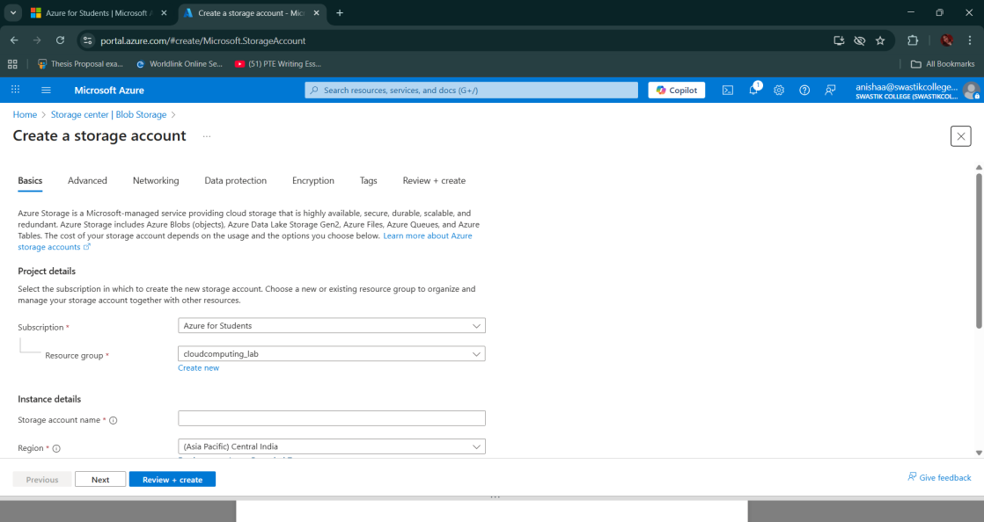

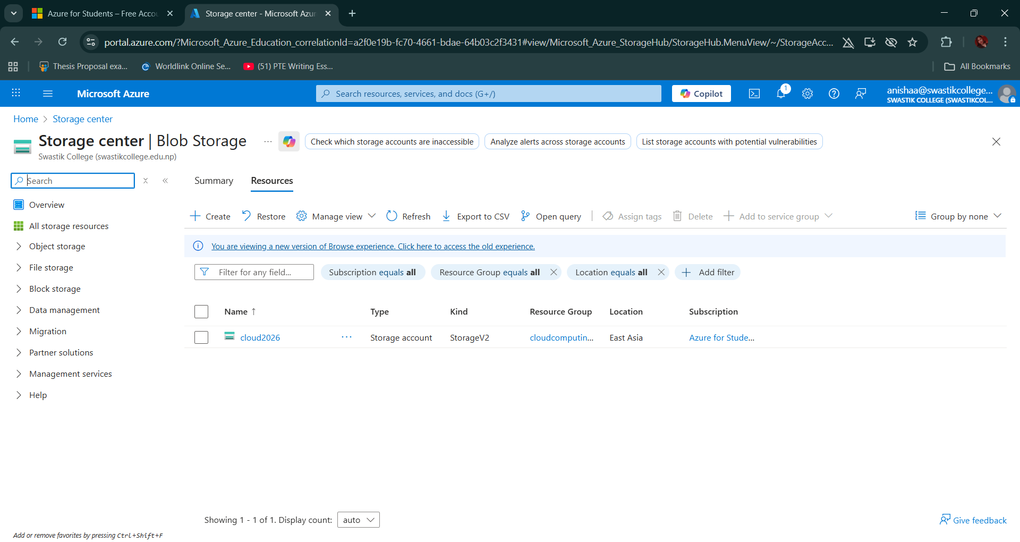

- Fill in the details:
  - Subscription: (Select your active subscription)
  - Resource Group: cloudcomputing_lab (or create a new one)
  - Storage Account Name: cloud2026[unique_id] (must be globally unique) [ cloudcomputing_lab]
  - Region: East US (or your preferred region) [(Asia Pacific) Central India]
  - Performance: Standard
  - Redundancy: Locally-redundant storage (LRS)
- Click Review + Create, then Create
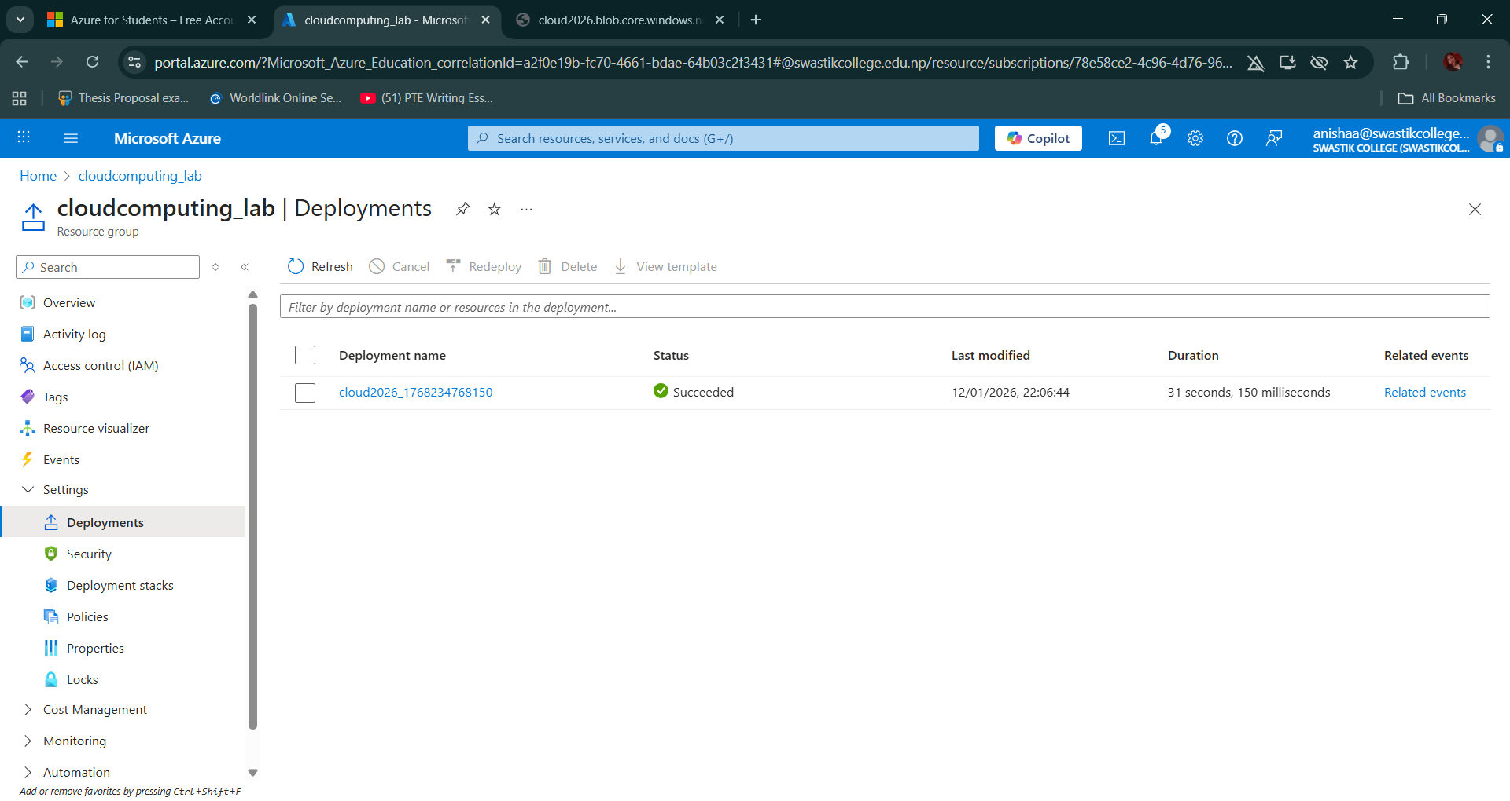

2. Create a Blob Container
Via Portal:
- Navigate to your newly created Storage Account
- Under Data storage, select Containers
- Click + Container

  - Name: static
  - Public access level: Container (anonymous read access)
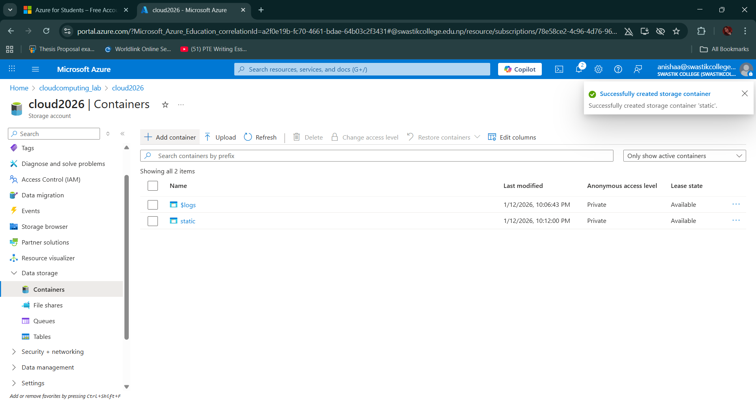
3. Upload/Download Files Using Portal and CLI
Via Portal:
- Open the container
- Click Upload
- Choose a sample file (e.g., New.txt or image)
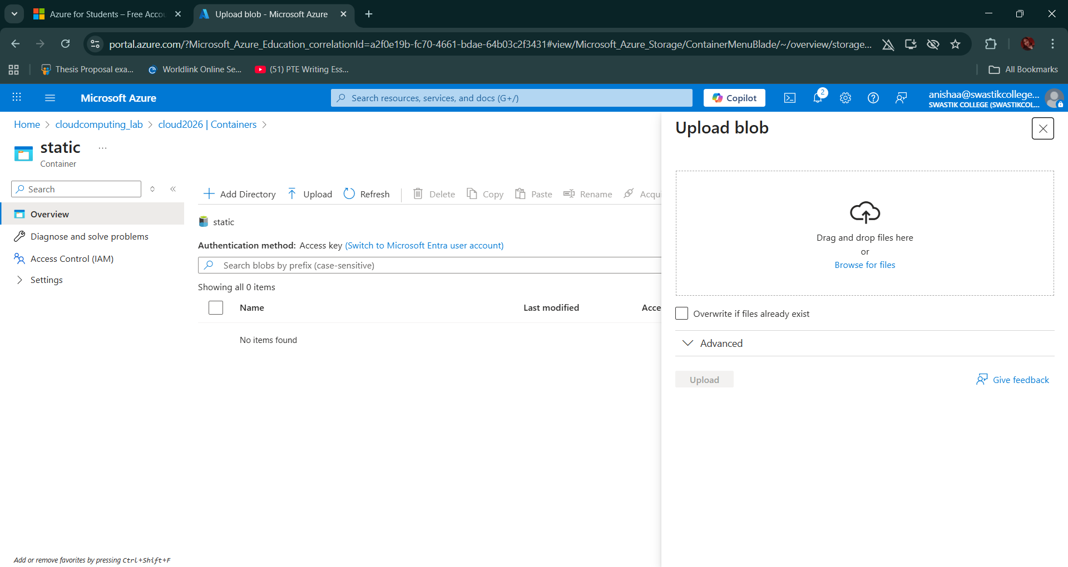
- Click on the uploaded file → Copy the Blob URL
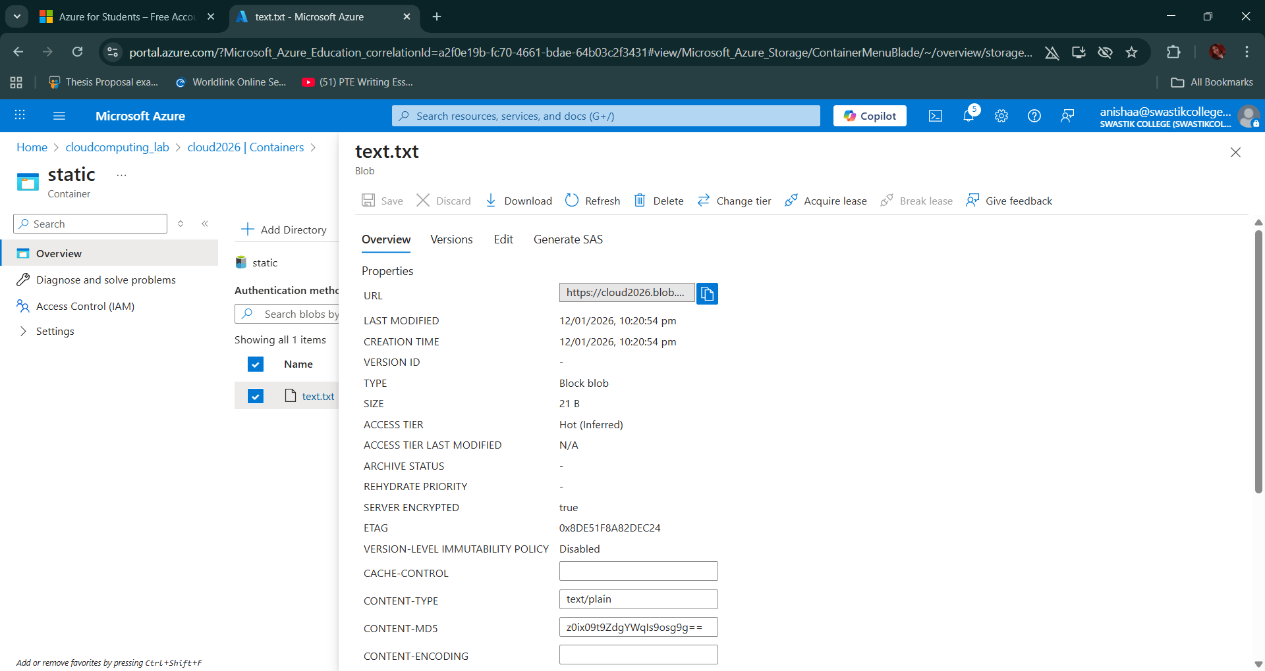
5. The copied URL paste in the browser’s search bar then see

Lab 3: Azure Virtual Machines
Objective: Deploy a virtual machine and perform basic server tasks.
Deploy a Linux virtual machine on Azure, connect to it via SSH, and host a static website using Apache or Nginx.

1. Create a Linux-based VM
Via Portal:
Go to Virtual Machines → Create
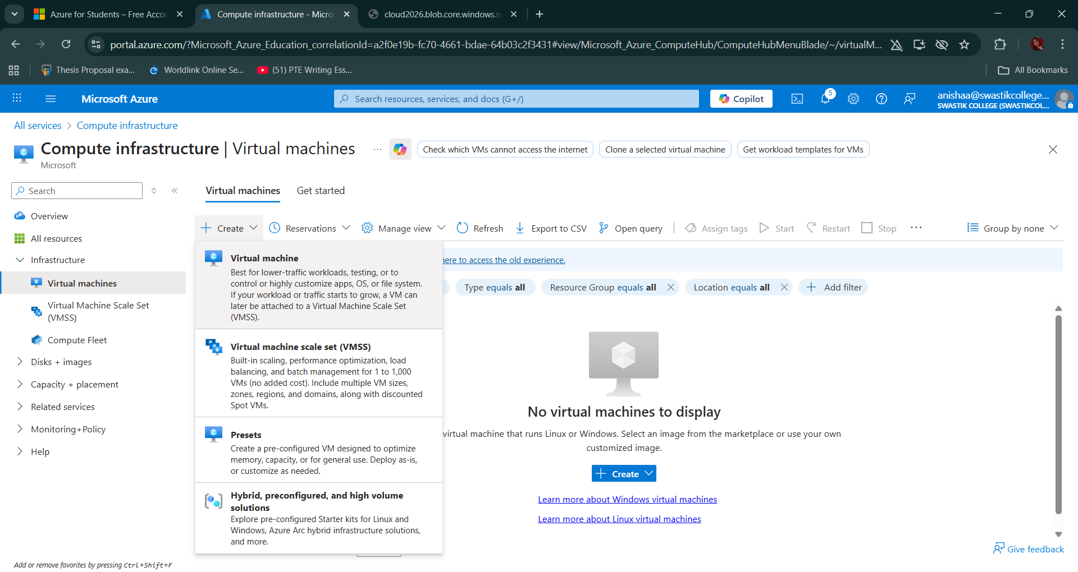
- Fill in the following:
- Subscription: Your active one
- Resource Group: cloud_lab
- VM name: anishamachine
- Region: East Asia
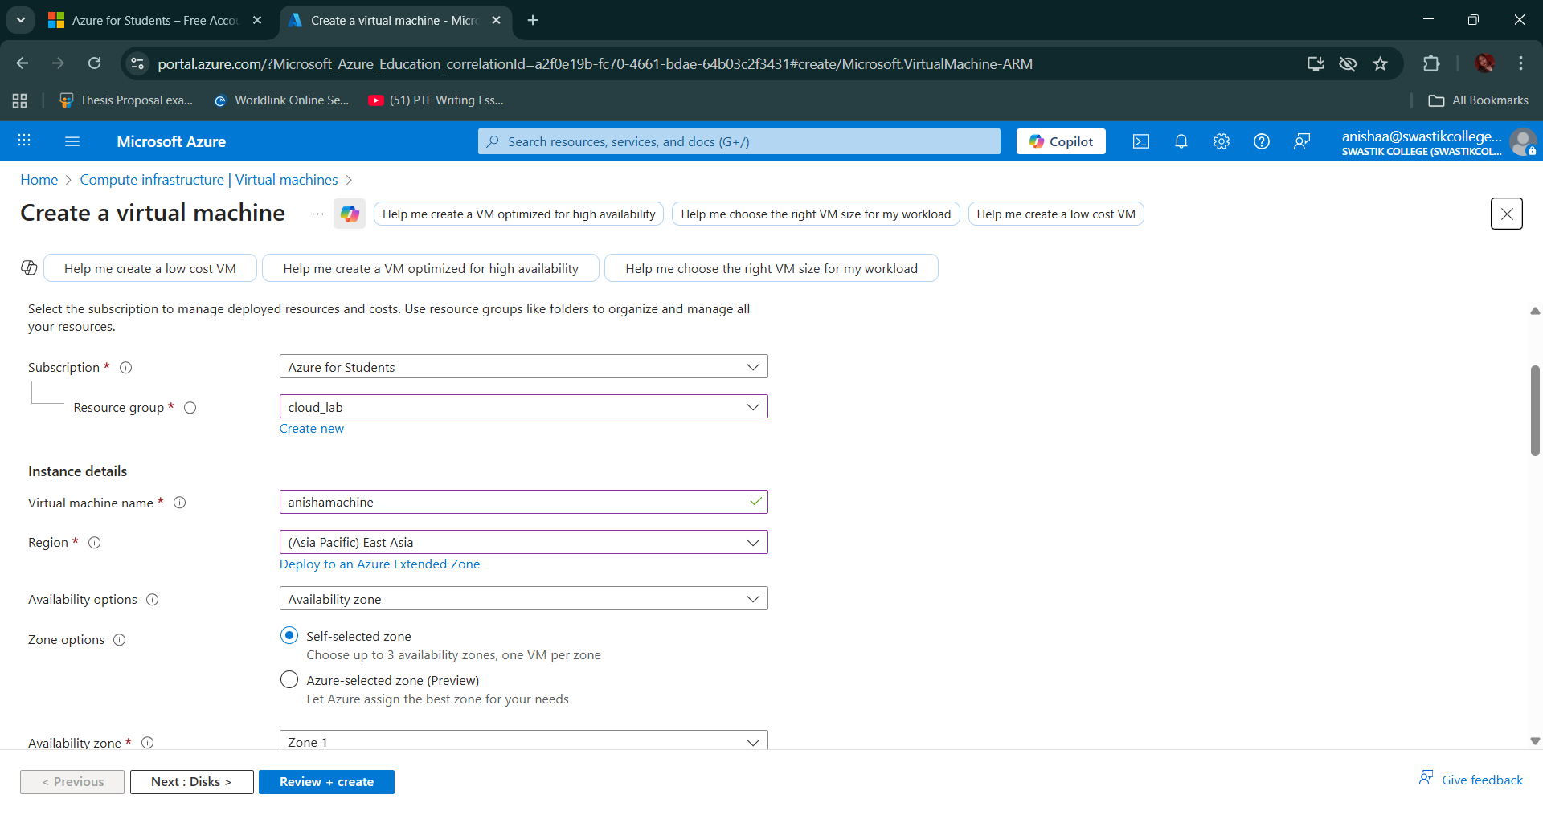
  - Image: Ubuntu Server 24.04 LTS - x64 Gen2
  - Size: Standard_D2s_v3 - 2 vcpus, 8 GiB memory ($0.02439/hour)
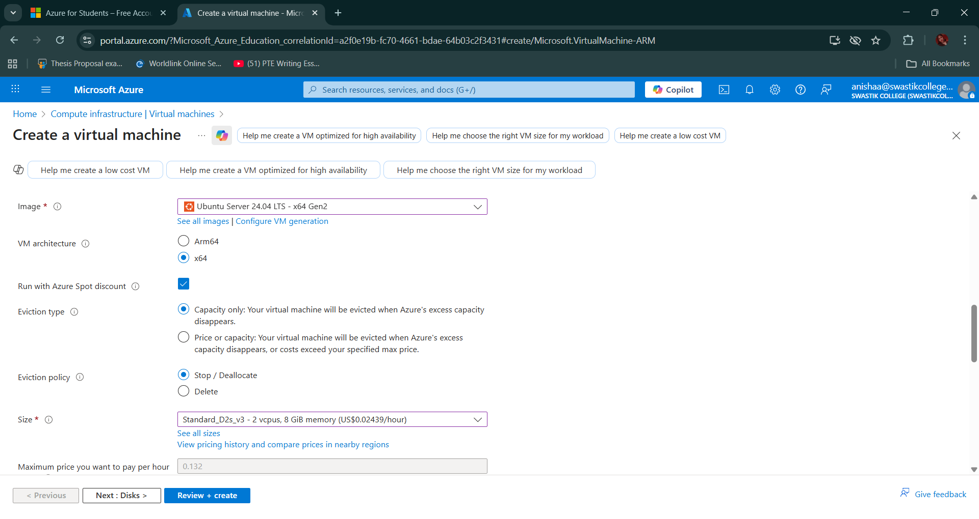

  - Authentication: SSH (generate or upload key)
  - Allow inbound ports: SSH (22), HTTP (80)
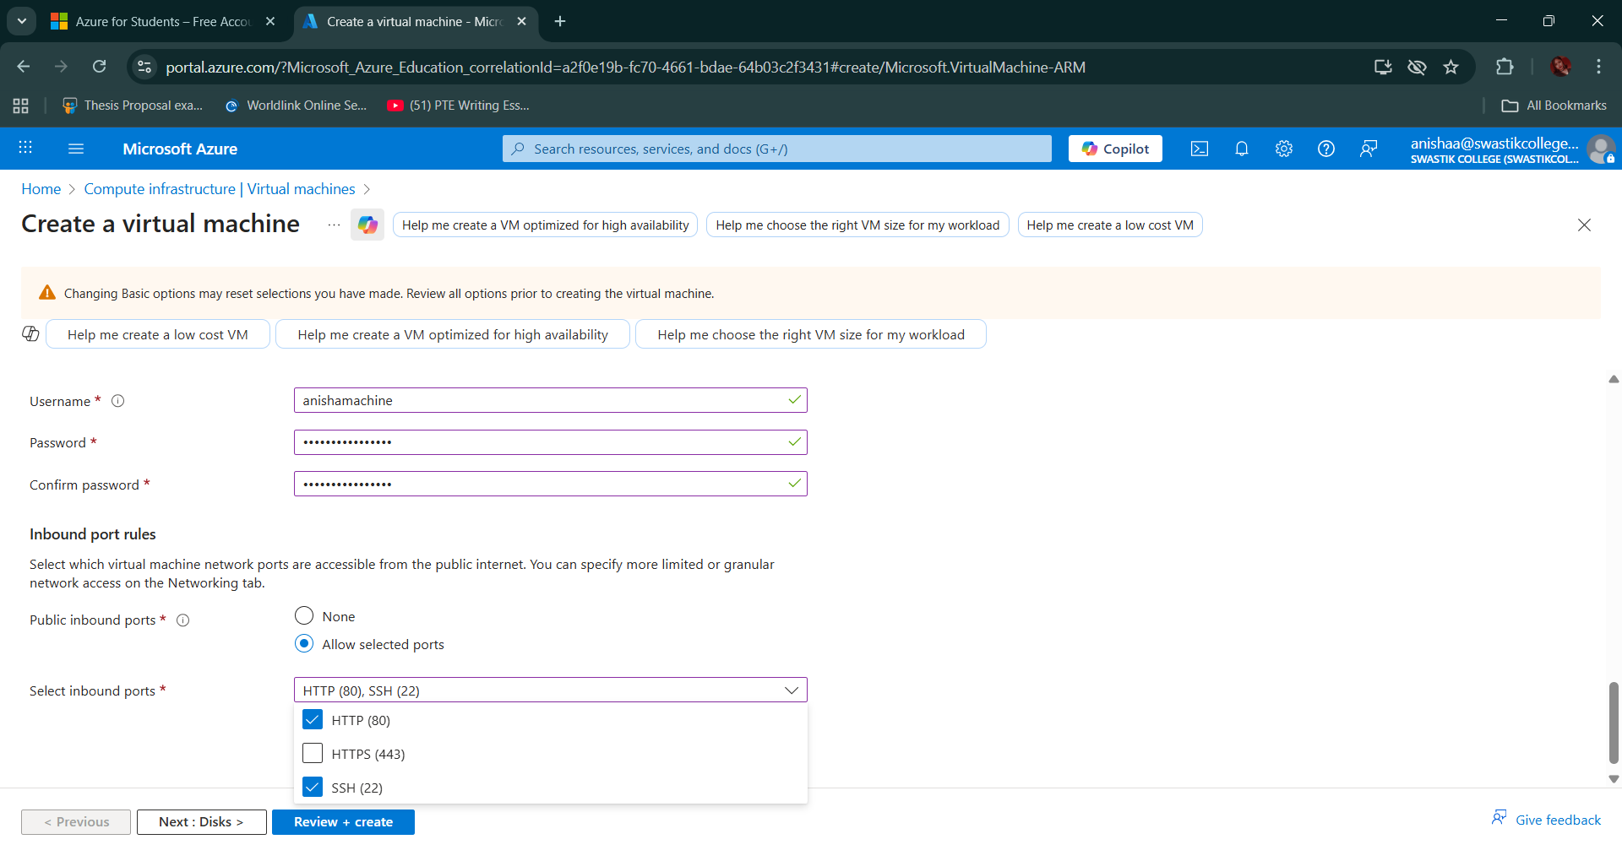

- Click Review + Create, then Create

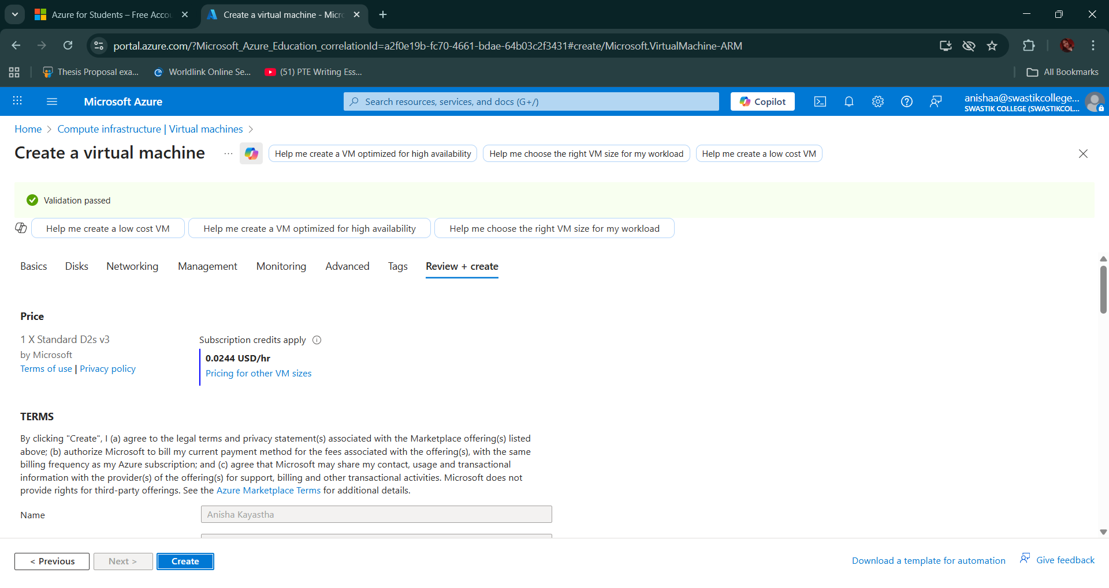

- After deployment, go to the VM → Note down the Public IP address
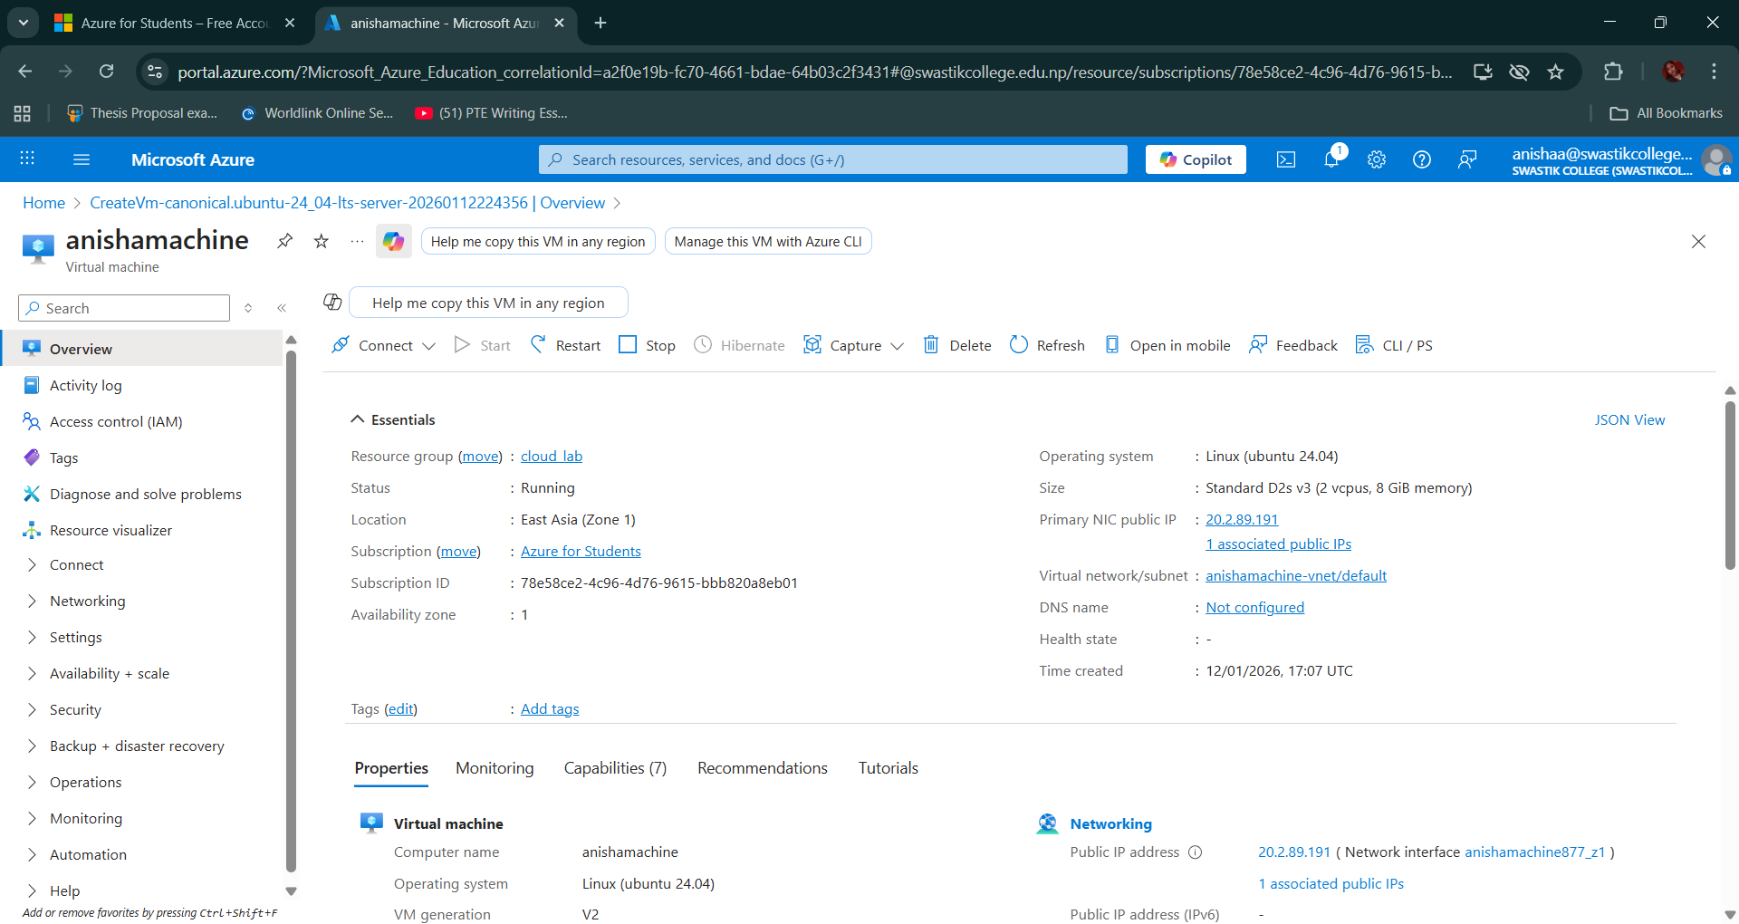

- SSH into the VM
- From Azure Cloud Shell or your local terminal

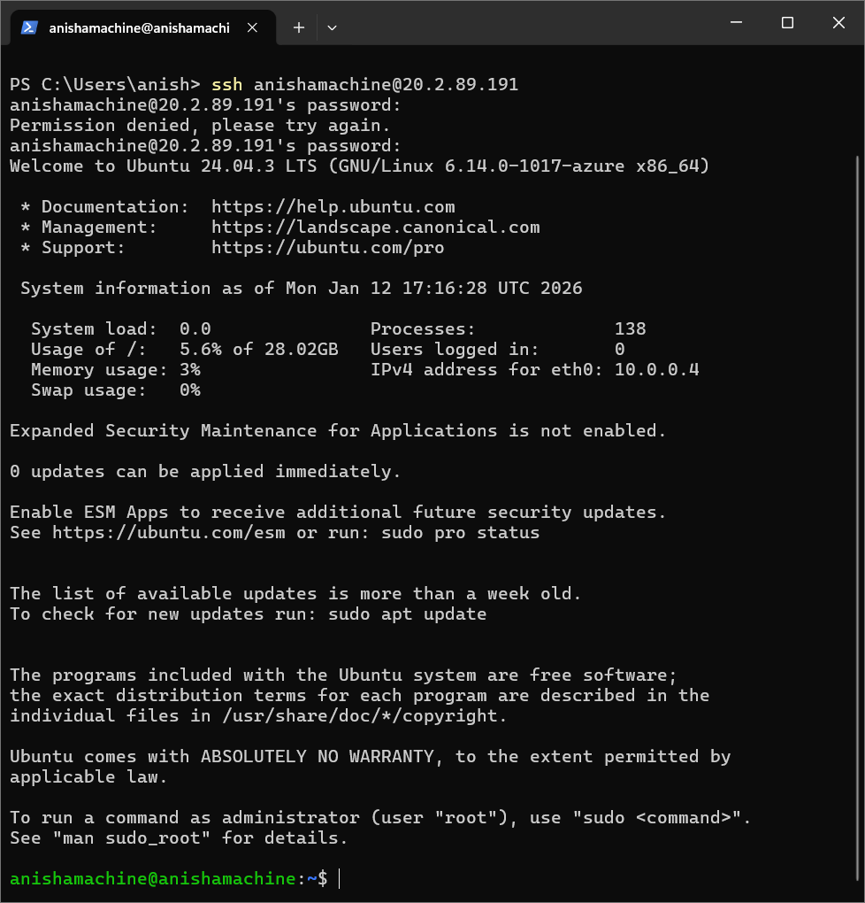
- Replace <vm-public-ip> with the actual IP shown in the portal.

Install Nginx and Host a Static Website

On the VM (Ubuntu):
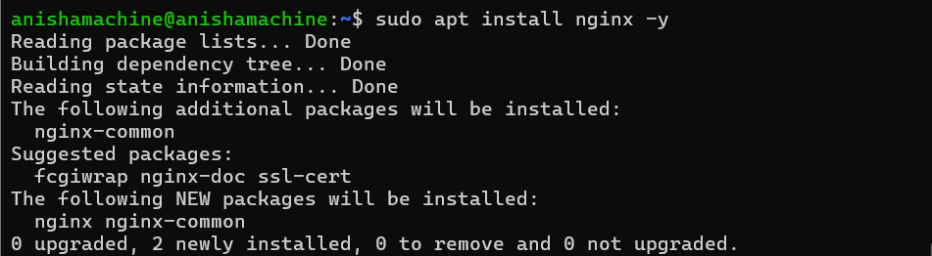
Verify that NGINX is running:
sudo systemctl status nginx
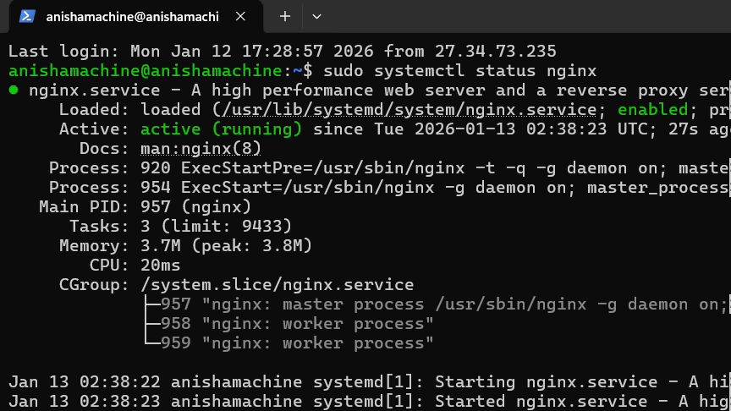
2. clone GitHub repo to the Virtual Machine
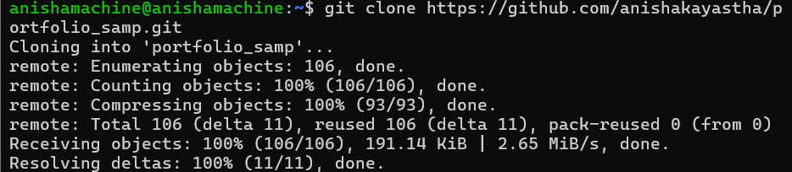

Run the Project & Install Dependencies
Go into the project folder:
cd repository
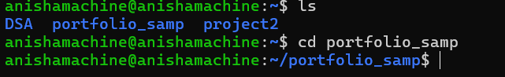

Install dependencies (examples):
Node.js (Frontend/Backend)
Install node (sudo apt install nodejs):
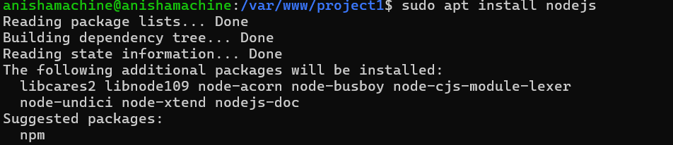

npm install
a. Install npm inside VM
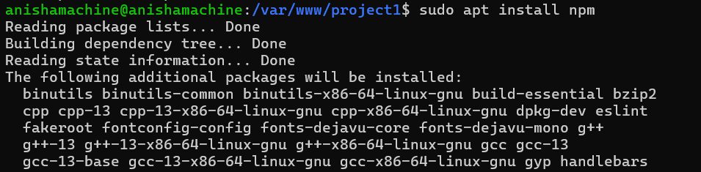

- Install npm package
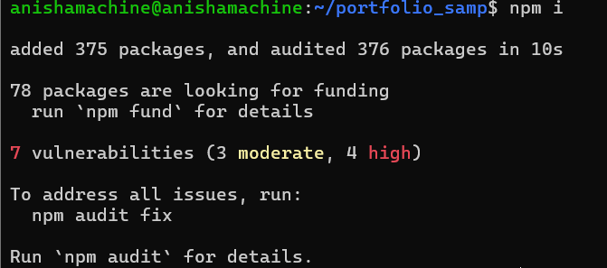

5. Identify the Port the Project Runs On
Start the project once to see the running port.
Examples:

Node.js
npm run dev or npm start
# Usually 3000 or 5000[ for vite its 8080 ]
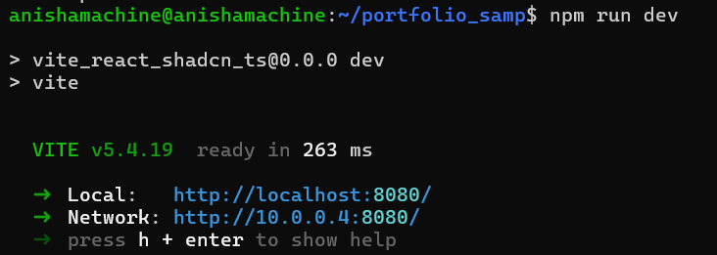
Note the port number (e.g., 8080).

6. Create a NGINX Site Configuration File
Go to NGINX's site-available directory:
cd /etc/nginx/sites-available/

Create a config file for your project:
sudo nano project1.conf
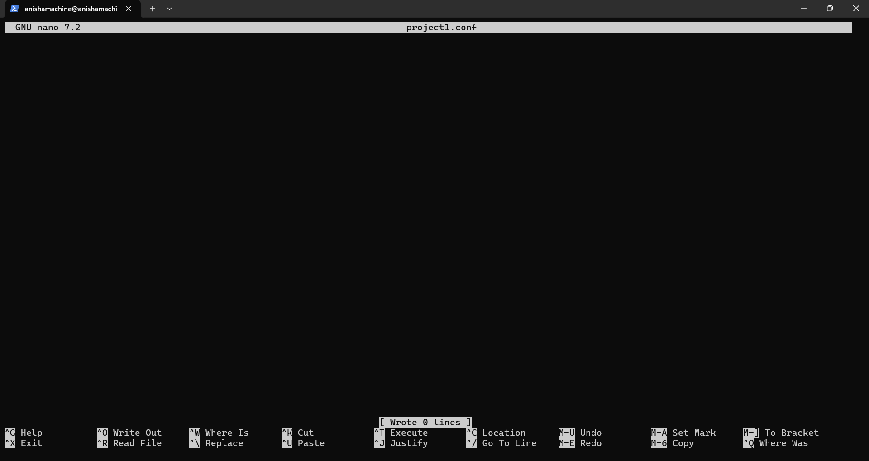
(Adjust port and folder paths as needed)
server {
listen 80;
server_name anisha-web.duckdns.org.
location / {
proxy_pass http:// 113.199.231.29# Your app port
proxy_set_header Host $host;
proxy_set_header X-Real-IP $remote_addr;
proxy_set_header X-Forwarded-For $proxy_add_x_forwarded_for;
proxy_set_header X-Forwarded-Proto $scheme;
}
}
Example
== We need a domain name for this purpose, so we are using the free duckdns.org domain for the lab.
- Assign public ip to the duck-dns
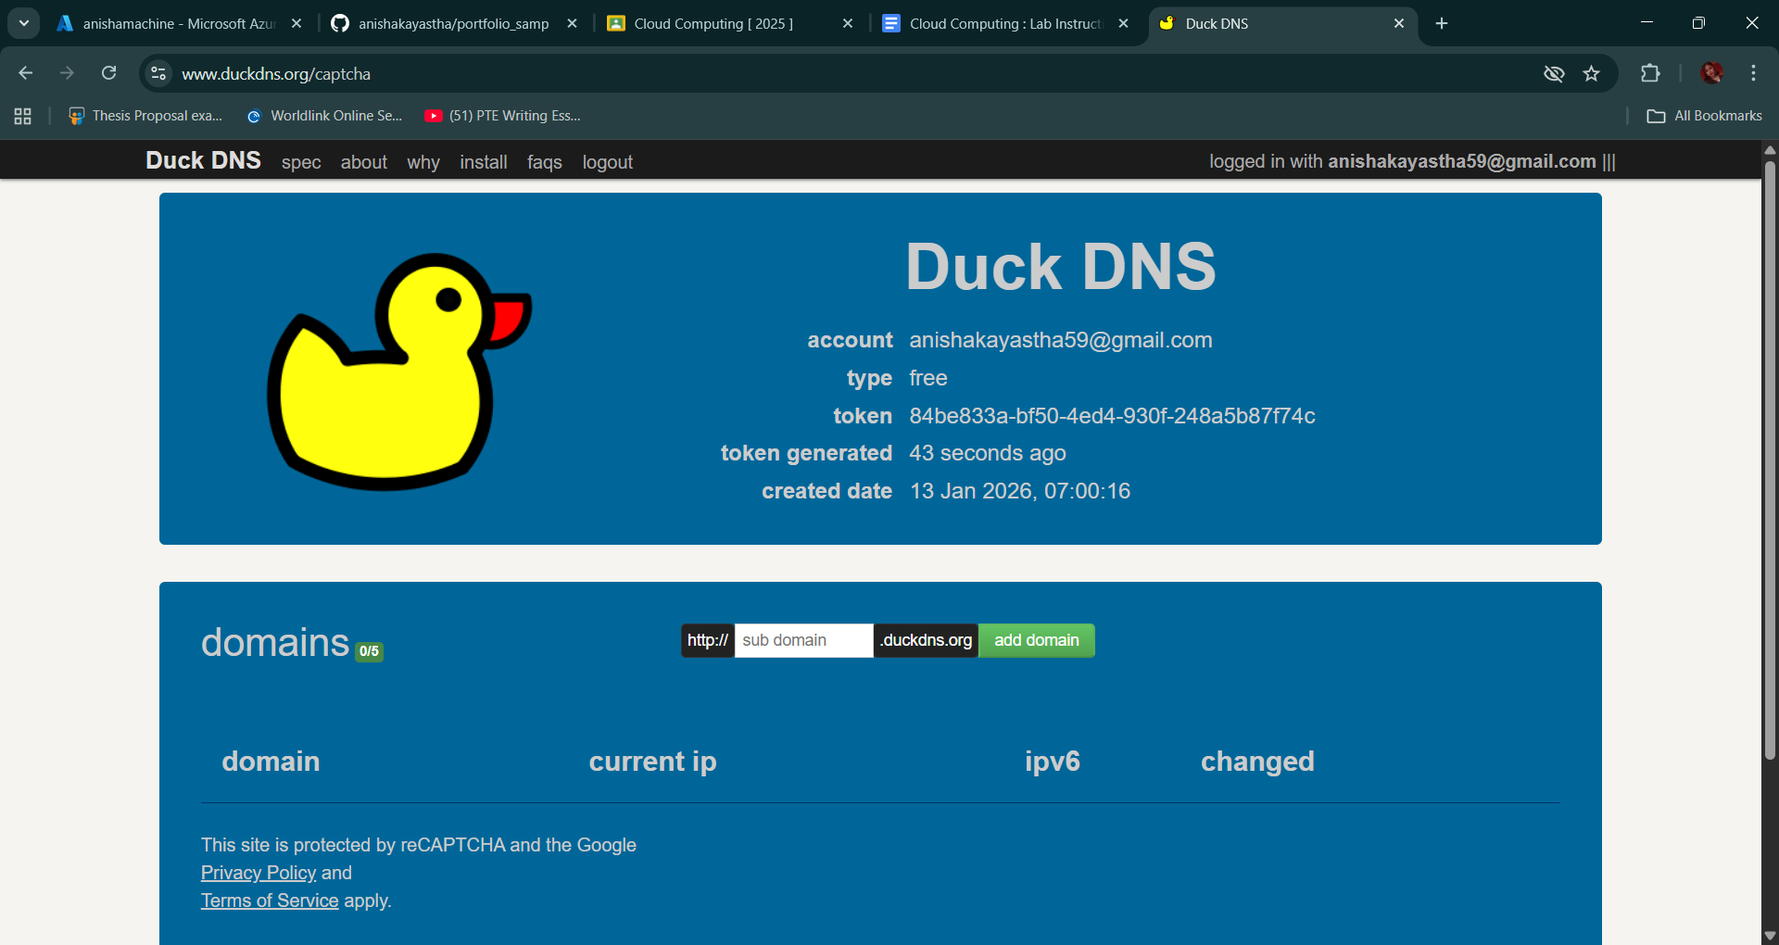
Assign public ip to the duck-dns
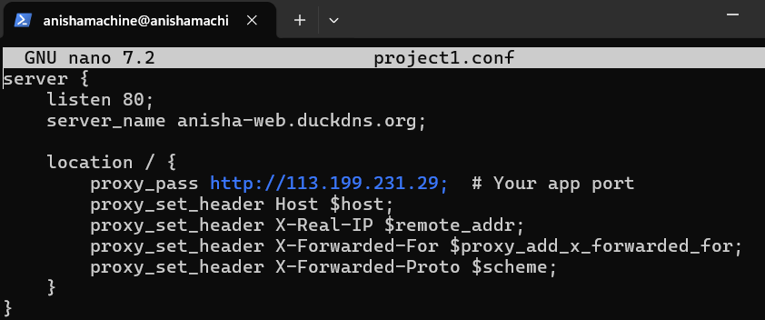For Save Changes [ Ctrl + O -> Enter -> Ctrl + X ]

7. Create a Symlink to Enable the Site
Link your config from sites-available to sites-enabled:
sudo ln -s /etc/nginx/sites-available/project1.conf /etc/nginx/sites-enabled/

8. Test NGINX Configuration
Check for syntax errors:
sudo nginx -t
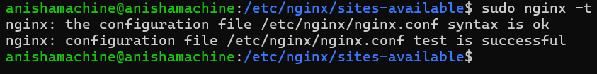
If everything is OK, proceed.

9. Reload or Restart NGINX
Apply the changes:
sudo systemctl reload nginx
Or full restart:
sudo systemctl restart nginx

Check the domain you have configure to see apply changes on the domain you configured
anisha-web.duckdns.org
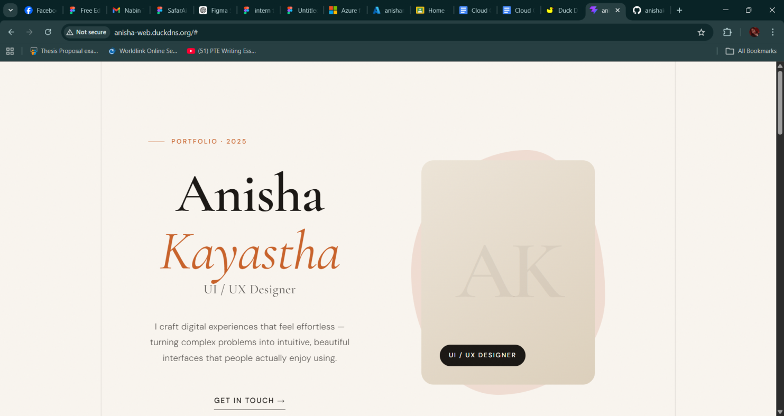

Code to Teach Thread Programming (Python)
import threading
import time
counter = 0
lock = threading.Lock()
def increase():
global counter
for _ in range(1000000):
with lock:
counter += 1
t1 = threading.Thread(target=increase)
t2 = threading.Thread(target=increase)
t1.start()
t2.start()
t1.join()
t2.join()
print("Final Counter:", counter)

Practical Task Programming Example (AsyncIO)
import asyncio
async def download(server):
print(f"Starting download from {server}")
await asyncio.sleep(2)
print(f"Finished download from {server}")
async def main():
tasks = [
download("Server 1"),
download("Server 2"),
download("Server 3")
]
await asyncio.gather(*tasks)
asyncio.run(main())

Practical Python Mini MapReduce
from collections import defaultdict
# MAP
def mapper(text):
for word in text.split():
yield (word.lower(), 1)

# SHUFFLE
def shuffle(pairs):
grouped = defaultdict(list)
for word, count in pairs:
grouped[word].append(count)
return grouped

# REDUCE
def reducer(grouped):
return {word: sum(counts) for word, counts in grouped.items()}

text = "cat dog cat tiger dog cat"
mapped = list(mapper(text))
grouped = shuffle(mapped)
reduced = reducer(grouped)

print(reduced)

