1. Android Environment Setup
Create a simple Android application named HelloMobile using Android Studio. Configure the SDK and emulator, run the application on the emulator, and display “Hello Mobile Programming” on the screen.

Code:
MainActivity.java
package com.example.hellomobile;
import android.os.Bundle;
import androidx.activity.EdgeToEdge;
….……………
public class MainActivity extends AppCompatActivity {
@Override
protected void onCreate(Bundle savedInstanceState) {
super.onCreate(savedInstanceState);
EdgeToEdge.enable(this);
setContentView(R.layout.activity_main);
….………………………..
………………………………
}
}
activity_main.xml
<?xml version="1.0" encoding="utf-8"?>
<androidx.constraintlayout.widget.ConstraintLayout xmlns:android=" "
xmlns:app=" "
android:layout_width="match_parent"
android:layout_height="match_parent"
tools:context=".MainActivity">
<TextView
android:layout_width="wrap_content"
android:layout_height="wrap_content"
android:text="Hello Mobile Programming"
android:textSize="24sp"
android:textStyle:”bold”/>
</androidx.constraintlayout.widget.ConstraintLayout>
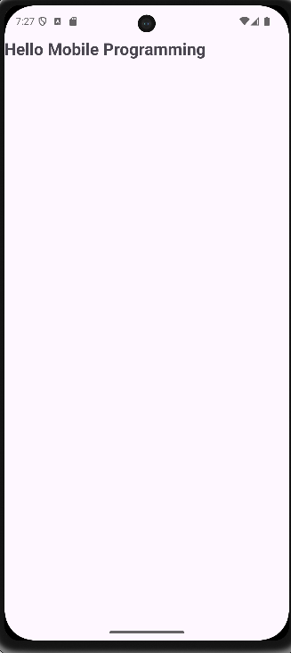

2. User Interface Design Using Layouts
Design an Android UI using LinearLayout, RelativeLayout (or ConstraintLayout), and include TextView, EditText, and Button. Set layout attributes such as orientation, margin, padding, and gravity
COde:
MainActivity.java
import android.os.Bundle;
import androidx.activity.EdgeToEdge;
….……………………………
public class MainActivity extends AppCompatActivity {
@Override
protected void onCreate(Bundle savedInstanceState) {
super.onCreate(savedInstanceState);
EdgeToEdge.enable(this);
setContentView(R.layout.activity_main);
….………………………..
………………………………
}
}
activity_main.xml(ConstraintLayout)
<androidx.constraintlayout.widget.ConstraintLayout
xmlns:android=" " xmlns:app=" "
android:id="@+id/main"
android:layout_width="match_parent"
android:layout_height="match_parent"
android:padding="16dp">

<TextView
android:id="@+id/tvTitle"
android:layout_width="wrap_content"
android:layout_height="wrap_content"
android:text="Hello Mobile Programming"
android:textSize="24sp"
android:layout_margin="16dp"
app:layout_constraintTop_toTopOf="parent"
app:layout_constraintStart_toStartOf="parent"
app:layout_constraintEnd_toEndOf="parent" />

<EditText
android:id="@+id/etName"
android:layout_width="0dp"
android:hint="Enter your name"
android:layout_margin="16dp"
app:layout_constraintTop_toBottomOf="@id/tvTitle"
….……………………………./>

<Button
android:text="Submit"
android:layout_margin="16dp"
app:layout_constraintTop_toBottomOf="@id/etName"
….………………………….. />
</androidx.constraintlayout.widget.ConstraintLayout>

activity_main.xml(LinearLayout)
<LinearLayout xmlns:android=" "
android:layout_width="match_parent"
android:layout_height="match_parent"
android:id="@+id/main"
android:orientation="vertical"
android:gravity="center"
android:padding="16dp">

<TextView
android:layout_width="wrap_content"
android:layout_height="wrap_content"
android:text="Hello Mobile Programming"
android:textSize="24sp"
android:layout_margin="10dp" />

<EditText
android:hint="Enter your name"
android:layout_margin="10dp"
android:padding="10dp" />

<Button
android:text="Submit"
android:layout_margin="10dp" />

</LinearLayout>

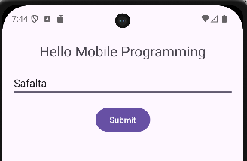

3. Event Handling and Resource Management
Create an Android application with a Button. When the button is clicked, display a message using string resources and change the background color using color resources. Use a drawable resource for the button icon.
Code:
Strings.xml

<resources>
<string name="app_name">HelloMobile</string>
<string name="button_text">Submit</string>
<string name="message_text">Hello! Button clicked!</string>
</resources>
Colors.xml
<resources>
<color name="white">#FFFFFF</color>
<color name="light_blue">#87CEEB</color>
<color name="button_color">#FF6200EE</color>
</resources>
ic_button_icon.xml
<vector xmlns:android=" "
….………………>
<path
android:pathData="M12,2L15,8H9L12,2zM12,22a1,1 0,1 1,0-2 1,1 0,0 1,0 2z"/>
</vector>
MainAcitivity.java
import android.widget.*;
….………………………
….………………………
public class MainActivity extends AppCompatActivity {
@Override
protected void onCreate(Bundle savedInstanceState) {
super.onCreate(savedInstanceState);
EdgeToEdge.enable(this);
setContentView(R.layout.activity_main);
final LinearLayout mainLayout = findViewById(R.id.main);
Button button = findViewById(R.id.buttonClick);
button.setOnClickListener(new Button.OnClickListener() {
@Override
public void onClick(android.view.View v) {
Toast.makeText(MainActivity.this, getString(R.string.message_text), Toast.LENGTH_SHORT).show();
mainLayout.setBackgroundColor(ContextCompat.getColor(MainActivity.this, R.color.light_blue));
}
});
}
}
Activity_main.xml
<LinearLayout xmlns:android=" "
android:layout_width="match_parent"
android:layout_height="match_parent"
android:id="@+id/main"
android:orientation="vertical"
android:gravity="center"
android:padding="16dp"
android:background="@color/white">

<TextView
android:layout_width="wrap_content"
android:layout_height="wrap_content"
android:text="Mobile Programming"
android:textSize="24sp"
android:layout_margin="10dp" />

<EditText
android:layout_width="match_parent"
android:hint="Enter your name"
android:padding="10dp"
….…………………../>

<EditText
android:hint="Enter your password"
android:inputType="textPassword"
….……………………………../>

<Button
android:id="@+id/buttonClick"
android:text="@string/button_text"
android:drawableLeft="@drawable/ic_button_icon"
android:backgroundTint="@color/button_color"
android:textColor="@color/white"
android:layout_margin="10dp" />
</LinearLayout>
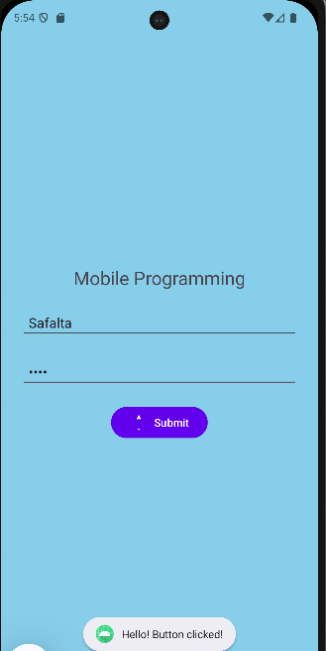
4. Activity and Intent Implementation
Develop an Android application with two activities. Enter text in the first activity and pass it to the second activity using an explicit intent. Display the received text in the second activity
COde:
MainActivity.java
import android.widget.*;
….……………………..
public class MainActivity extends AppCompatActivity {
EditText editText;
Button button;
@Override
protected void onCreate(Bundle savedInstanceState) {
super.onCreate(savedInstanceState);
setContentView(R.layout.activity_main);
editText = findViewById(R.id.editTextMessage);
button = findViewById(R.id.btnSend);
button.setOnClickListener(new View.OnClickListener() {
@Override
public void onClick(View view) {
String message = editText.getText().toString();
Intent intent = new Intent(MainActivity.this, SecondActivity.class);
intent.putExtra("MESSAGE_KEY", message);
startActivity(intent);
}
});
}
}

activity_main.xml
<LinearLayout xmlns:android=" "
android:gravity="center"
android:orientation="vertical"
android:padding="20dp">

<EditText
android:id="@+id/editTextMessage"
android:layout_width="match_parent"
android:layout_height="wrap_content"
android:hint="Enter text" />

<Button
android:id="@+id/btnSend"
android:text="Send to Second Activity"
android:layout_marginTop="10dp" />

</LinearLayout>

SecondActivity.java
import android.widget.*;
….……………………..
public class SecondActivity extends AppCompatActivity {
TextView textView;
@Override
protected void onCreate(Bundle savedInstanceState) {
super.onCreate(savedInstanceState);
setContentView(R.layout.activity_second);
textView = findViewById(R.id.textViewResult);
String receivedText = getIntent().getStringExtra("MESSAGE_KEY");
textView.setText(receivedText);
}
}
activity_second.xml
<LinearLayout xmlns:android=" "
android:layout_width="match_parent"
android:layout_height="match_parent"
android:gravity="center"
android:orientation="vertical"
android:padding="20dp">

<TextView
android:id="@+id/textViewResult"
android:layout_height="wrap_content"
android:text="Received text appears in these activity"
android:textSize="18sp"
….………………… />

</LinearLayout>
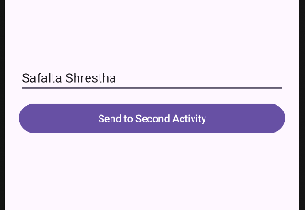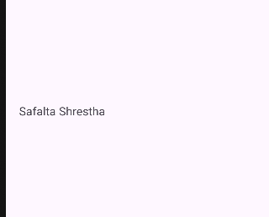

5. Fragment, Menu, and Dialog Implementation
Create an Android application using fragments. Implement an options menu and display an alert dialog when a menu item is selected.
Code:
MainActivity.java
import android.view.*;
….……………………
public class MainActivity extends AppCompatActivity {
@Override
protected void onCreate(Bundle savedInstanceState) {
super.onCreate(savedInstanceState);
setContentView(R.layout.activity_main);
getSupportFragmentManager()
.beginTransaction()
.replace(R.id.fragment_container, new com.example.hellomobile.MyFragment())
.commit();
}
@Override
public boolean onCreateOptionsMenu(Menu menu) {
getMenuInflater().inflate(R.menu.menu_main, menu);
return true;
}
@Override
public boolean onOptionsItemSelected(MenuItem item) {
int id = item.getItemId();
if (id == R.id.menu_about) {
showAlertDialog();
return true;
}

if (id == R.id.menu_exit) {
finish();
return true;
}

return super.onOptionsItemSelected(item);
}
private void showAlertDialog() {
AlertDialog.Builder builder = new AlertDialog.Builder(this);
builder.setTitle("About");
builder.setMessage("This app demonstrates Fragment, Menu, and Alert Dialog implementation.");
builder.setPositiveButton("OK", null);
builder.show();
}
}

activity_main.xml
<FrameLayout
android:id="@+id/fragment_container"
android:layout_width="match_parent"
android:layout_height="match_parent" />

MyFragment.java
import androidx.fragment.app.Fragment;
import android.view.*;
….…………………………….
public class MyFragment extends Fragment {
public MyFragment() { }
@Override
public View onCreateView(LayoutInflater inflater, ViewGroup container,
Bundle savedInstanceState) {
return inflater.inflate(R.layout.fragment_my, container, false);
}}
fragment_my.xml
<FrameLayout
android:layout_width="match_parent"
android:layout_height="match_parent"
android:gravity="center"
….……………….>
<TextView
android:layout_width="wrap_content"
android:layout_height="wrap_content"
android:text="This is a Fragment"
android:textSize="20sp"
….………………………… /> </FrameLayout>
menu_main.xml
<menu >
<item
android:id="@+id/menu_about"
android:title="About"
app:showAsAction="never" />
<item
android:id="@+id/menu_exit"
android:title="Exit"
app:showAsAction="never" /> </menu>

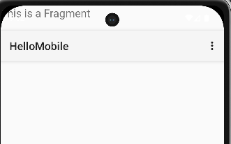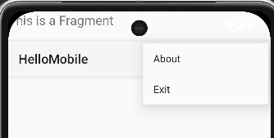

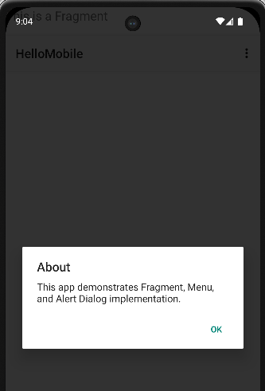

6. RecyclerView Implementation
Create an Android application that displays a list of items (e.g., names or products) using RecyclerView with a custom adapter and ViewHolder.
COde:
MainActivity.java
import androidx.recyclerview.widget.*;
………………………………………..
public class MainActivity extends AppCompatActivity {
RecyclerView recyclerView;
String[] foodList = {"Mobile Phone", "Charger", "USB Cable", "Power Bank", "Earphones","Speaker"};
String[] foodPriceList = {"15000", "800", "400", "1200","900", "2000"};
@Override
protected void onCreate(Bundle savedInstanceState) {
super.onCreate(savedInstanceState);
setContentView(R.layout.activity_main);
recyclerView = findViewById(R.id.recyclerView);
recyclerView.setLayoutManager(new GridLayoutManager(this, 2));
recyclerView.setAdapter(new MyAdapter(foodList, foodPriceList));
}
}
activity_main.xml
<LinearLayout
android:layout_width="match_parent"
android:layout_height="match_parent"
android:orientation="vertical"
android:fitsSystemWindows="true">

<androidx.recyclerview.widget.RecyclerView
android:id="@+id/recyclerView"
……………………………./>
</LinearLayout>

MyAdapter.java
import android.view.*;
import android.widget.*;
….…………………………
public class MyAdapter extends RecyclerView.Adapter<MyAdapter.ViewHolder> {
String[] foodList;
String[] foodPriceList;
public MyAdapter(String[] foodList, String[] foodPriceList) {
this.foodList = foodList;
this.foodPriceList = foodPriceList;
}
public static class ViewHolder extends RecyclerView.ViewHolder {
TextView txtName, txtPrice;
public ViewHolder(View itemView) {
super(itemView);
txtName = itemView.findViewById(R.id.txtName);
txtPrice = itemView.findViewById(R.id.txtPrice);
}
}
@Override
public ViewHolder onCreateViewHolder(ViewGroup parent, int viewType) {
View view = LayoutInflater.from(parent.getContext())
.inflate(R.layout.item_row, parent, false);
return new ViewHolder(view);
}
@Override
public void onBindViewHolder(ViewHolder holder, int position) {
holder.txtName.setText(foodList[position]);
holder.txtPrice.setText(foodPriceList[position]);
}
@Override
public int getItemCount() {
return foodList.length;
}
}
item_row.xml
<LinearLayout
android:layout_width="match_parent"
android:layout_height="wrap_content"
android:orientation="vertical"
android:padding="16dp">
<TextView
android:id="@+id/txtName"
android:layout_width="wrap_content"
android:textSize="16sp"
android:textStyle="bold"
….………………………../>
<TextView
android:id="@+id/txtPrice"
android:textSize="14sp"
….……………………………/>
</LinearLayout>
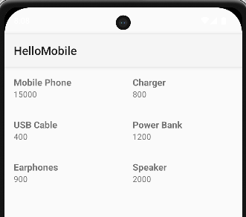
7. SQLite Database Integration
Develop an Android application to store user information (ID, Name, Email) using SQLite. Implement insert, update, delete, and view operations and display the records in a list.
Code:
MainActivity.java
import android.database.Cursor;
import android.widget.*;
….……………………
public class MainActivity extends AppCompatActivity {
DBHelper myDb;
EditText editId, editName, editEmail;
Button btnAdd, btnView, btnUpdate, btnDelete;
@Override
protected void onCreate(Bundle savedInstanceState) {
super.onCreate(savedInstanceState);
setContentView(R.layout.activity_main);
myDb = new DBHelper(this);

editId = findViewById(R.id.editId);
editName = findViewById(R.id.editName);
editEmail = findViewById(R.id.editEmail);
btnAdd = findViewById(R.id.btnAdd);
btnView = findViewById(R.id.btnView);
btnUpdate = findViewById(R.id.btnUpda te);
btnDelete = findViewById(R.id.btnDelete);
addData();
viewAll();
updateData();
deleteData();
}

public void addData() {
btnAdd.setOnClickListener(v -> {
boolean inserted = myDb.insertData(
editName.getText().toString(),
editEmail.getText().toString()
);

Toast.makeText(MainActivity.this,
inserted ? "Data Inserted" : "Insert Failed",
Toast.LENGTH_SHORT).show();
});
}

public void viewAll() {
btnView.setOnClickListener(v -> {
Cursor res = myDb.getAllData();
if (res.getCount() == 0) {
showMessage("Error", "No Data Found");
return;
}

StringBuilder buffer = new StringBuilder();
while (res.moveToNext()) {
buffer.append("ID: ").append(res.getString(0)).append("\n");
buffer.append("Name: ").append(res.getString(1)).append("\n");
buffer.append("Email: ").append(res.getString(2)).append("\n\n");
}

showMessage("User Data", buffer.toString());
});
}

public void updateData() {
btnUpdate.setOnClickListener(v -> {
boolean isUpdated = myDb.updateData(
editId.getText().toString(),
editName.getText().toString(),
editEmail.getText().toString()
);

Toast.makeText(MainActivity.this,
isUpdated ? "Data Updated" : "Update Failed",
Toast.LENGTH_SHORT).show();
}); }

public void deleteData() {
btnDelete.setOnClickListener(v -> {
Integer deletedRows = myDb.deleteData(editId.getText().toString());
Toast.makeText(MainActivity.this,
deletedRows > 0 ? "Data Deleted" : "Delete Failed",
Toast.LENGTH_SHORT).show();
});
}

public void showMessage(String title, String message) {
AlertDialog.Builder builder = new AlertDialog.Builder(this);
builder.setCancelable(true);
builder.setTitle(title);
builder.setMessage(message);
builder.show();
}
}

activity_main.xml
<LinearLayout
android:layout_width="match_parent"
android:layout_height="match_parent"
android:orientation="vertical"
android:padding="16dp"
android:fitsSystemWindows="true">

<EditText
android:id="@+id/editId"
android:hint="ID"
android:inputType="number"
….………………./>

<EditText
android:id="@+id/editName"
android:hint="Name"
….…………………………/>
<EditText
android:id="@+id/editEmail"
android:hint="Email"
android:inputType="textEmailAddress"
….……………………………. />
<Button
android:id="@+id/btnAdd"
android:text="Add"
.…………………………/>
<Button
android:id="@+id/btnUpdate"
android:text="Update"
….……………………. />
<Button
android:id="@+id/btnDelete"
android:text="Delete"
….……………………………/>

<Button
android:id="@+id/btnView"
android:text="View"
….……………. />
</LinearLayout>

DBHelper.java
import android.database.Cursor;
import android.database.sqlite.*;
….………………………………….
public class DBHelper extends SQLiteOpenHelper {

public static final String DB_NAME = "UserDB.db";
public static final String TABLE_NAME = "users";
public static final String COL_1 = "ID";
public static final String COL_2 = "NAME";
public static final String COL_3 = "EMAIL";

public DBHelper(Context context) {
super(context, DB_NAME, null, 1);
}

@Override
public void onCreate(SQLiteDatabase db) {
db.execSQL("CREATE TABLE users (ID INTEGER PRIMARY KEY AUTOINCREMENT, NAME TEXT, EMAIL TEXT)");
}

@Override
public void onUpgrade(SQLiteDatabase db, int oldVersion, int newVersion) {
db.execSQL("DROP TABLE IF EXISTS users");
onCreate(db);
}

public boolean insertData(String name, String email) {
SQLiteDatabase db = this.getWritableDatabase();
ContentValues cv = new ContentValues();
cv.put(COL_2, name);
cv.put(COL_3, email);
long result = db.insert(TABLE_NAME, null, cv);
return result != -1;
}

public boolean updateData(String id, String name, String email) {
SQLiteDatabase db = this.getWritableDatabase();
ContentValues cv = new ContentValues();
cv.put(COL_2, name);
cv.put(COL_3, email);
db.update(TABLE_NAME, cv, "ID=?", new String[]{id});
return true;
}

public Integer deleteData(String id) {
SQLiteDatabase db = this.getWritableDatabase();
return db.delete(TABLE_NAME, "ID=?", new String[]{id});
}

public Cursor getAllData() {
SQLiteDatabase db = this.getWritableDatabase();
return db.rawQuery("SELECT * FROM users", null);
}
}
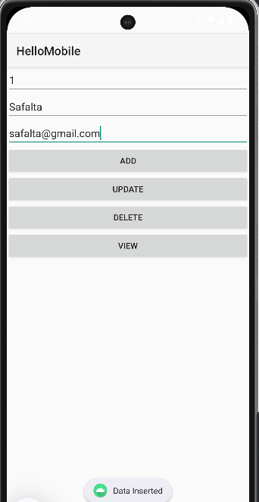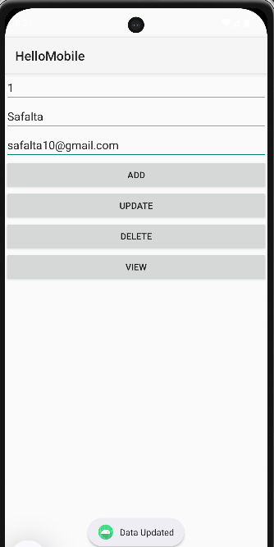
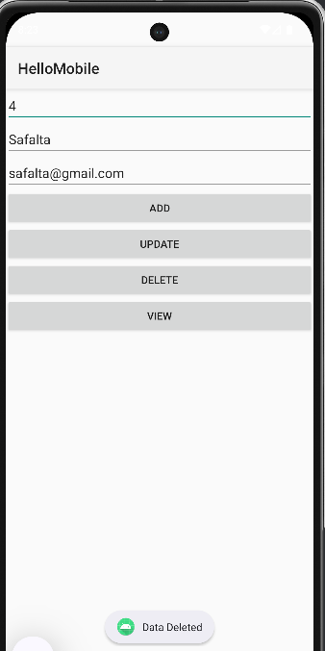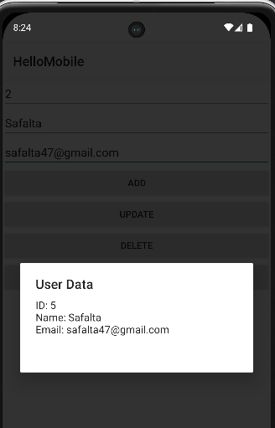
8. API Integration
Create an Android application that fetches JSON data from a public REST API and displays the data in a RecyclerView

