**Research Proposal**

**Title:** Electricity Demand Forecasting Using Time Series Analysis and Machine Learning Models

**Team Name:** Snipers

**Team Members:**

1. Abdallah Ahmed Abdallah
2. Ammar Yasser
3. Yara
4. Mohamed Yasser Ahmed
5. Mohamed Yasser Mohamed
6. Mario Rafat

**Under Supervision of**

Prof. Dr. Maha A. Hassanein

**Problem Definition**:  
 Electricity demand is governed by intricate patterns influenced by daily cycles (e.g., morning and evening peaks), seasonal variations (e.g., higher demand in summer or winter due to cooling or heating requirements), and external environmental factors such as temperature, humidity, and wind speed. These fluctuations present a significant challenge for utility providers, as they must accurately predict demand to maintain grid stability, minimize energy wastage, and optimize resource allocation.

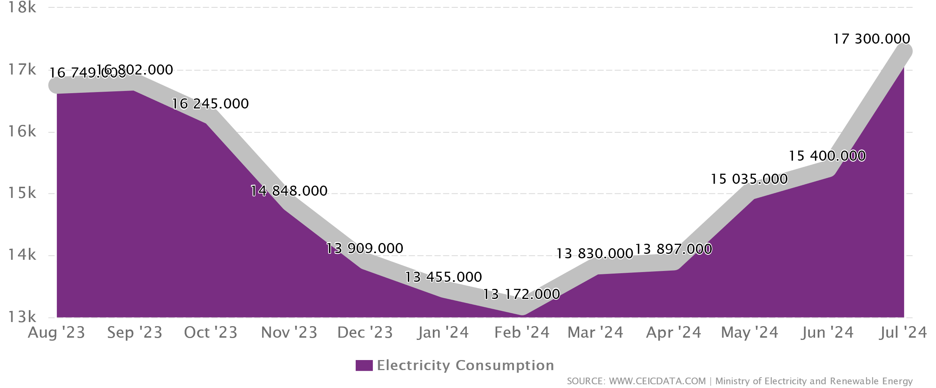

The rapid growth in the adoption of renewable energy sources, such as solar and wind, adds an additional layer of complexity. Unlike conventional energy sources, renewable energy production is intermittent and weather-dependent, introducing variability in supply. This variability necessitates precise demand forecasting to align supply with demand and prevent power shortages or overproduction.

Inaccurate forecasts can lead to grid imbalances, increased operational costs, and reliance on backup systems, such as costly and less environmentally friendly fossil fuel plants. Additionally, extreme weather events and temperature anomalies further exacerbate forecasting challenges, making it crucial to understand and model the dynamic relationships between weather factors and electricity usage.

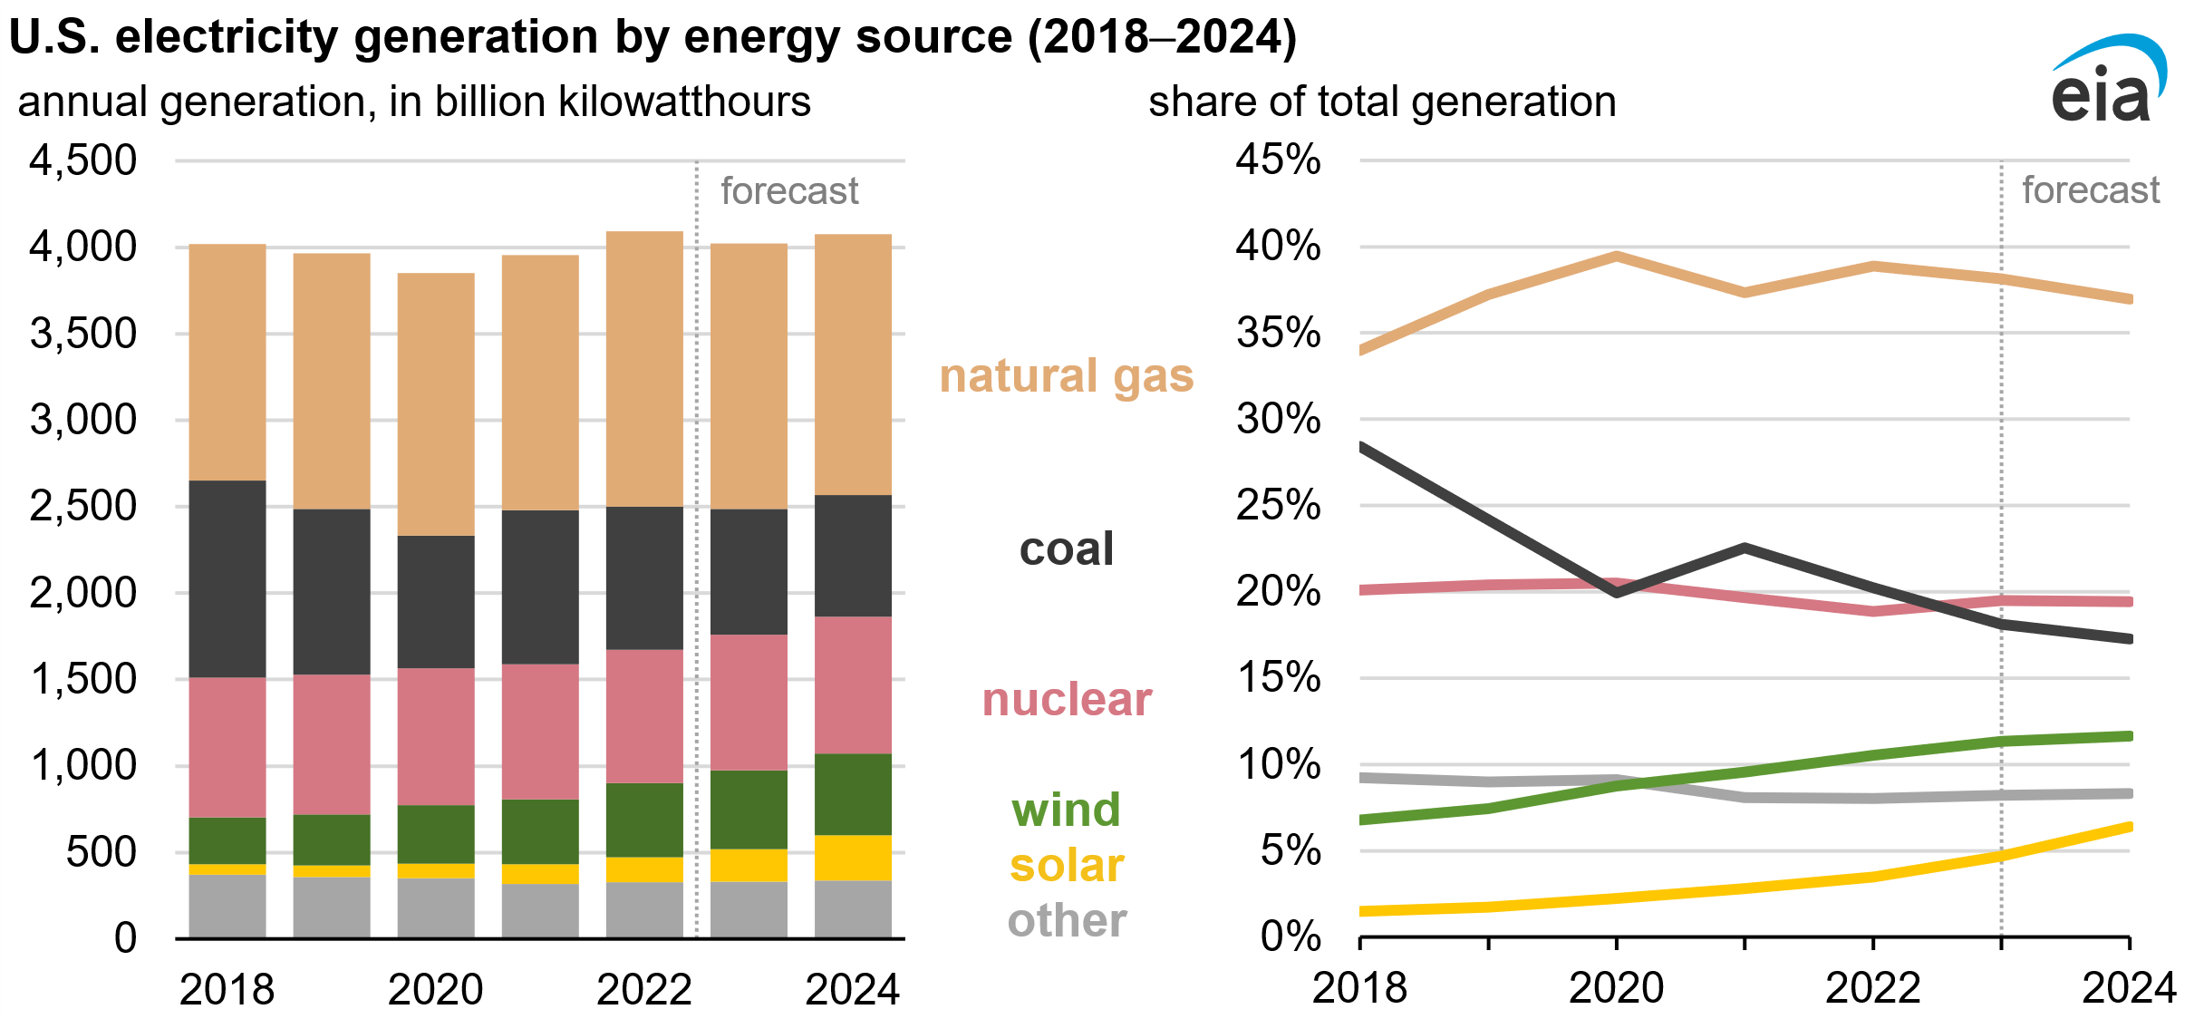

This research aims to address these challenges by developing an advanced forecasting model that integrates traditional time series analysis techniques (e.g., ARIMA) with cutting-edge machine learning models (e.g., Long Short-Term Memory Networks, or LSTMs). By leveraging historical electricity demand data, weather information, and modern statistical methods, the research seeks to deliver accurate, scalable, and reliable forecasts that support the transition to a sustainable and efficient energy grid.

**Proposed Methodology:**

This paper utilizes

**ARIMA Model of Forecasting**

ARIMA, which stands for **Autoregressive Integrated Moving Average**, combines three components: **Autoregressive (AR)**, **Integrated (I)**, and **Moving Average (MA)**. It is a highly effective technique for forecasting stable time series data. By integrating past data and incorporating an autoregressive component, ARIMA predicts future trends. This process involves taking previous values of a variable and applying specific parameters to estimate the expected change from its current value. However, analyzing seasonal trends can be complex and variable.

The purpose of ARIMA-based analysis is to create a model that accurately captures the patterns in past and future time series data. The methods used in estimating ARIMA models aim to determine appropriate metrics that describe the underlying structure of the series. The general ARIMA model is denoted as:

**ARIMA(p, d, q)(P, D, Q)**

the parameters p, d, and q define the structure of the model:

1. **p:** The number of **autoregressive (AR) terms**
   * It represents the number of lagged observations included in the model.
   * For example, if p=2, the model uses the past two values of the time series to predict the current value.
   * Identified using the **Partial Autocorrelation Function (PACF)** plot.
2. **d:** The degree of differencing
   * This indicates how many times the data needs to be differenced to make it stationary (removing trends or seasonality).
   * For instance, if the original data is not stationary and differencing once makes it stationary, d=1.
3. **q:** The number of **moving average (MA) terms**
   * It represents the number of lagged forecast errors used to predict future values.
   * For example, if q=1, the model uses the previous period's forecast error to improve predictions.
   * Identified using the **Autocorrelation Function (ACF)** plot.

**ARIMA Process**

The ARIMA modeling process consists of three main steps:

1. **Auto-Regressive (AR):** Uses lagged values of the time series to predict future values.
2. **Integrated (I):** Removes trends or seasonal components from the data through differencing.
3. **Moving Average (MA):** Provides a smoothed series by addressing forecast errors using past observations.

To determine the AR (p) terms, the **Partial Autocorrelation Function (PACF)** plot is analyzed. For instance, if PACF lag 1 is significantly above the significance threshold, as shown in Figure 1(a), it suggests p=1. Similarly, the **Autocorrelation Function (ACF)** plot helps identify the MA (q) terms. An MA term represents the lag of forecast errors. The ACF plot reveals the number of terms required to eliminate autocorrelation from the stationary series. For instance, if lag 1 is significant, as observed in Figure 1(b), q=1.

The **d value** ensures the time series becomes stationary. In cases where the series achieves stationarity after one differencing step, d=1.

Figure 1(a) Partial Autocorrelation (PCAF) Figure 1(b) Autocorrelation (ACD)

**PROPOSED MODEL—LSTM**

Long short-term memory (LSTM) network is a part of deep learning field. The LSTM networks are an extension of Recurrent Neural Networks (RNN) specially developed to overcome the vanishing gradient problem and capture long term dependency in sequential data. The RNN fails in storing data for long period of time hence it is not capable to handle long term dependency. Now the LSTM is introduced by the design without altering training model as vanishing gradient problem is removed completely. Figure [2](https://ietresearch.onlinelibrary.wiley.com/doi/full/10.1049/gtd2.13132#gtd213132-fig-0003) shows the architecture of LSTM network, where is hidden state (new), *ht*-1 is hidden state (previous), *Ct* is new cell state, *Ct-1* is previous cell state, and *Xt* is input data. This model also helpful in handling continuous value and noise. LSTMs offer several advantages over hidden Markov models (HMMs), eliminating the need to maintain a predetermined set of states. Unlike HMMs, which have a fixed number of states, LSTMs are equipped with a wide range of adjustable parameters, including learning rates, input biases, and output biases. These parameters provide flexibility and control during the learning process, enabling the network to adapt and improve its performance. Consequently, LSTMs offer a more powerful and flexible framework for modelling sequential data compared to the constraints imposed by HMMs.

Figure 2

**Appendix:**

LSTM Cells equations:

it​ ​​=σ(Wi​⋅[ht−1​,xt​]+bi​)

ft​ =σ(Wf​⋅[ht−1​,xt​]+bf​)

ot​ =σ(Wo​⋅[ht−1​,xt​]+bo​)

Ct =tanh(Wc​⋅[ht−1​,xt​]+bc​)

​​Ct​ =ft​∗Ct−1​+it​∗Ct​​

ht =ot​∗tanh(Ct​)​