Results

1. +1 per step

Training:

Seed: 30

Episodes taken to train: 402

Energy taken to train: 35468.73 J

Seed: 61

Episodes taken to train: 376

Energy taken to train: 60756.88 J

Testing (all other params are 0, theta is varying):

0: Total power – 428.23 J

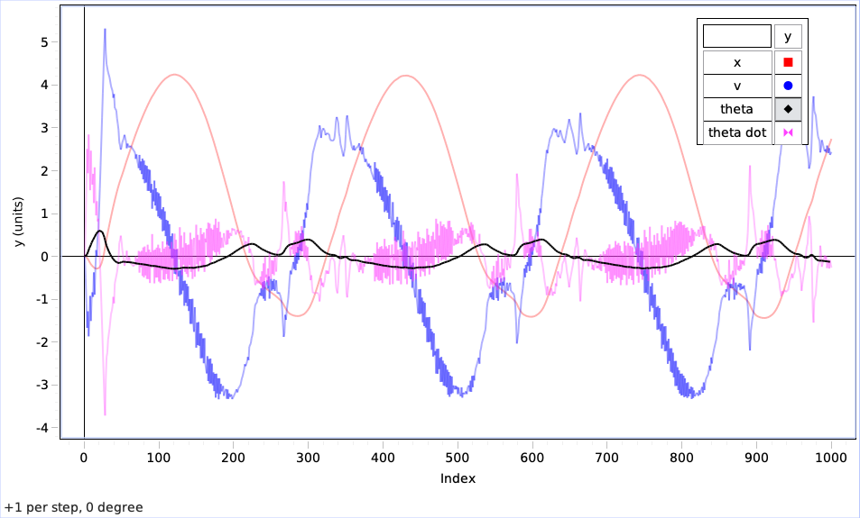

10: Total power – 441.86 J

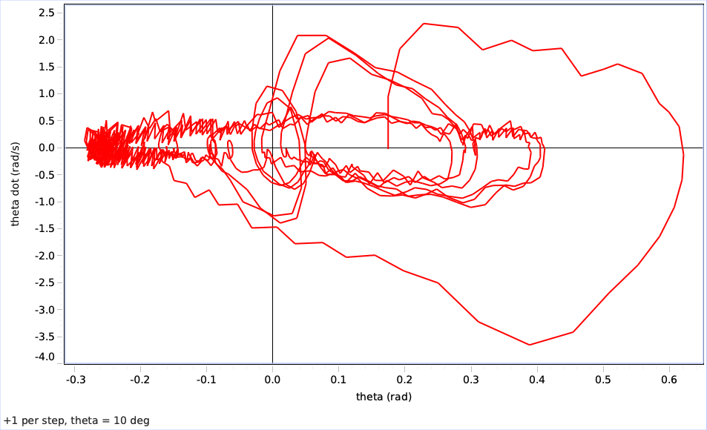

20: Total power – 470.05 J

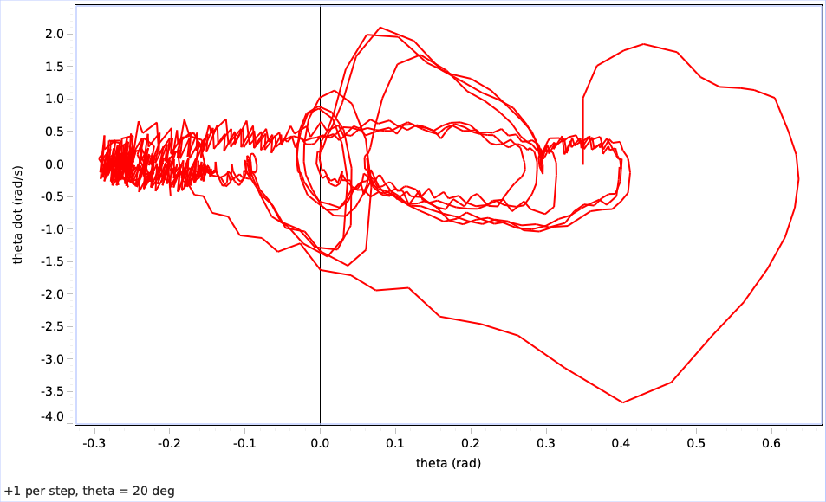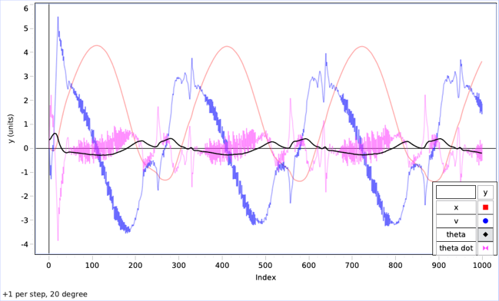  
30: Total power – 455.90 J

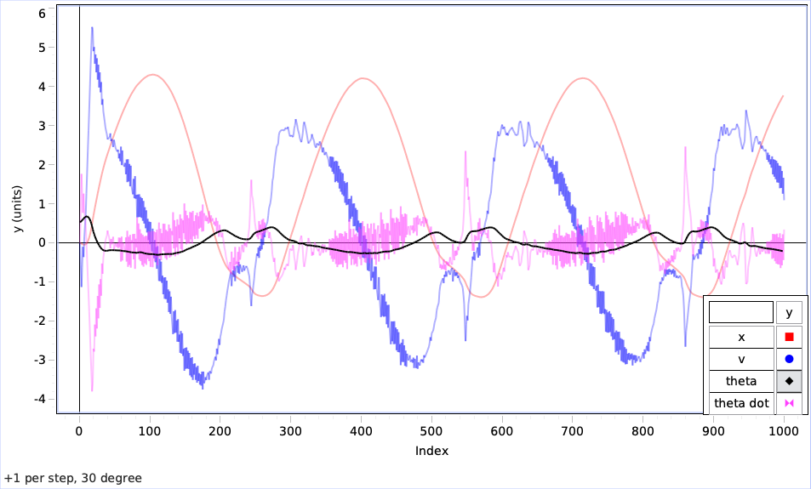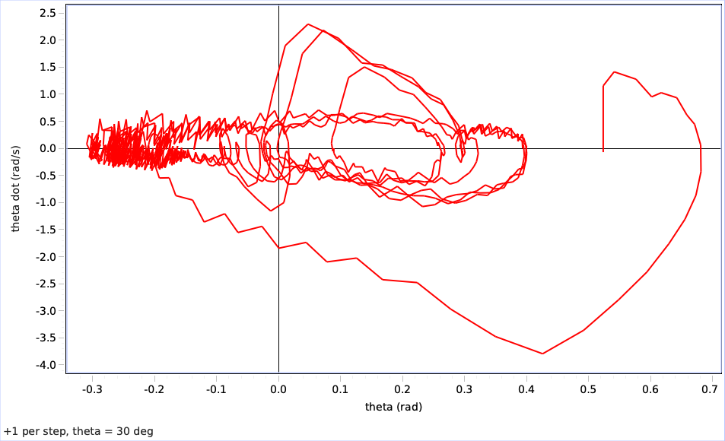

40: Total power - 500.55 J

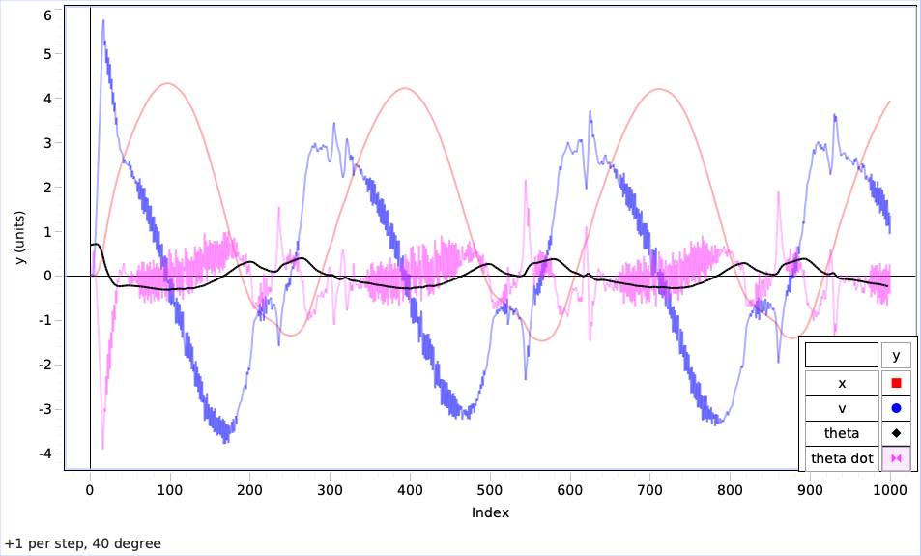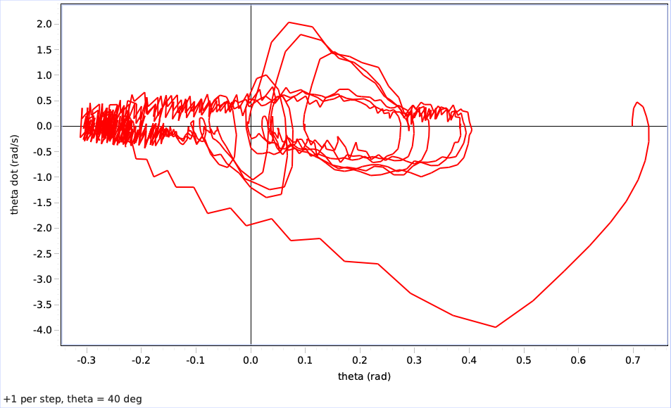

50: Total power – 479.10 J

