**DASHBOARD OF HEALTH CARE ASSISTANT**

Login with the HealthAssistant operator and follow the navigation as shown in the below screenshots.

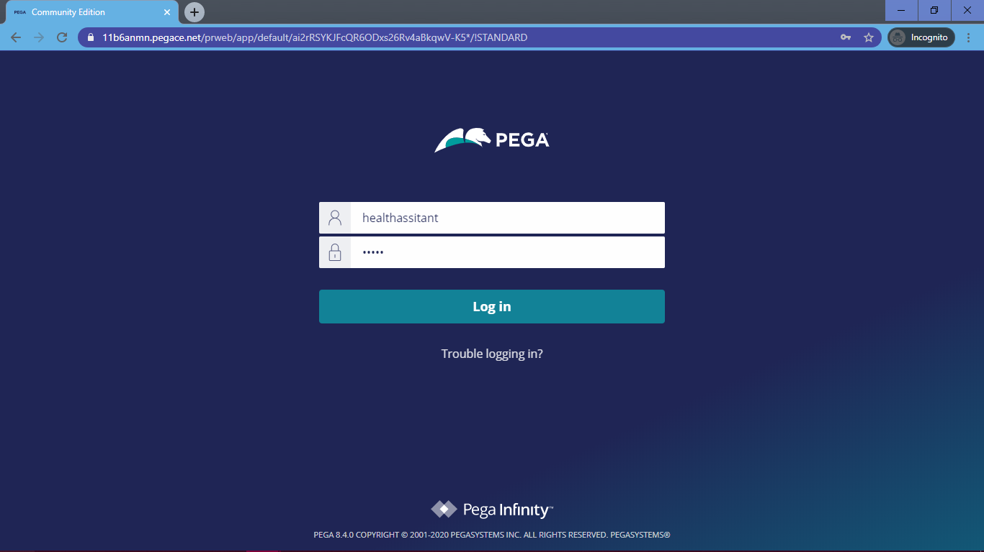

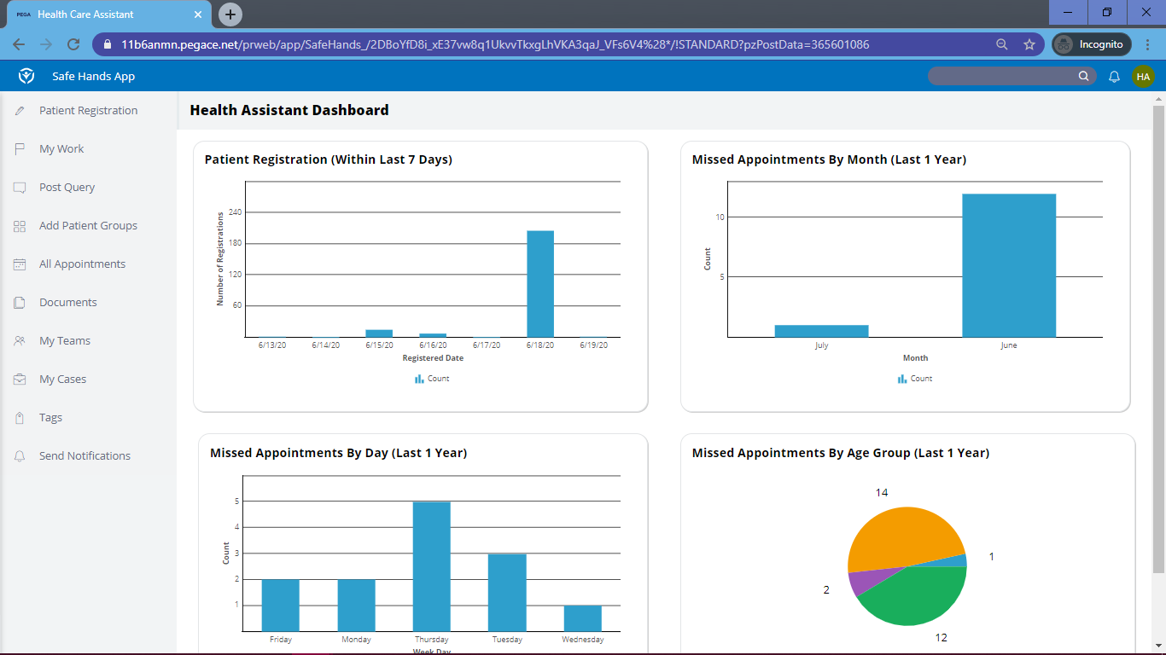

The first report shows the number of patients who were successfully registered by the health care assistant for the last 7 days from the current date.

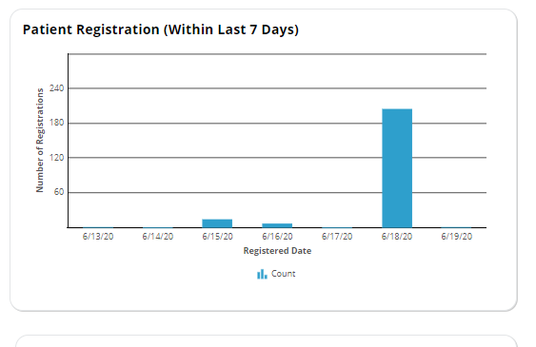

The below graph gives the number of appointments missed by the patients who have successfully scheduled appointment but have cancelled or withdrawn the appointments. This report is on monthly basis for the past 1 year.

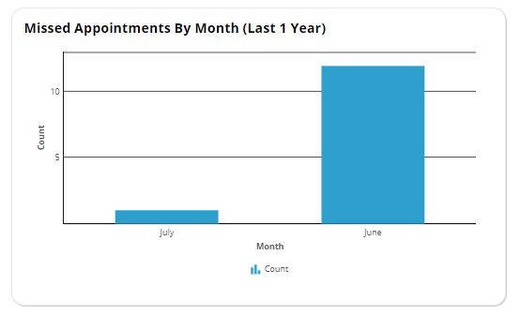

The below graph gives the number of appointments missed by the patients who have successfully scheduled appointment but have cancelled or withdrawn the appointments. This report is on day wise for the past 1 year.

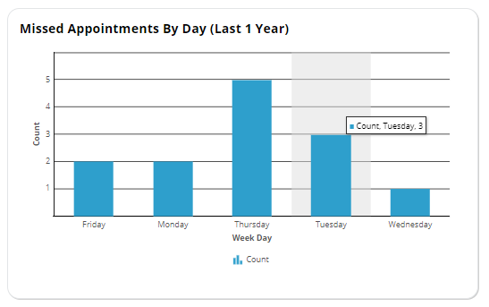

The below graph gives the number of appointments missed by the patients who have successfully scheduled appointment but have cancelled or withdrawn the appointments. This report is based on age group of the patients for the past 1 year.

