Trying to sync gradle -> error
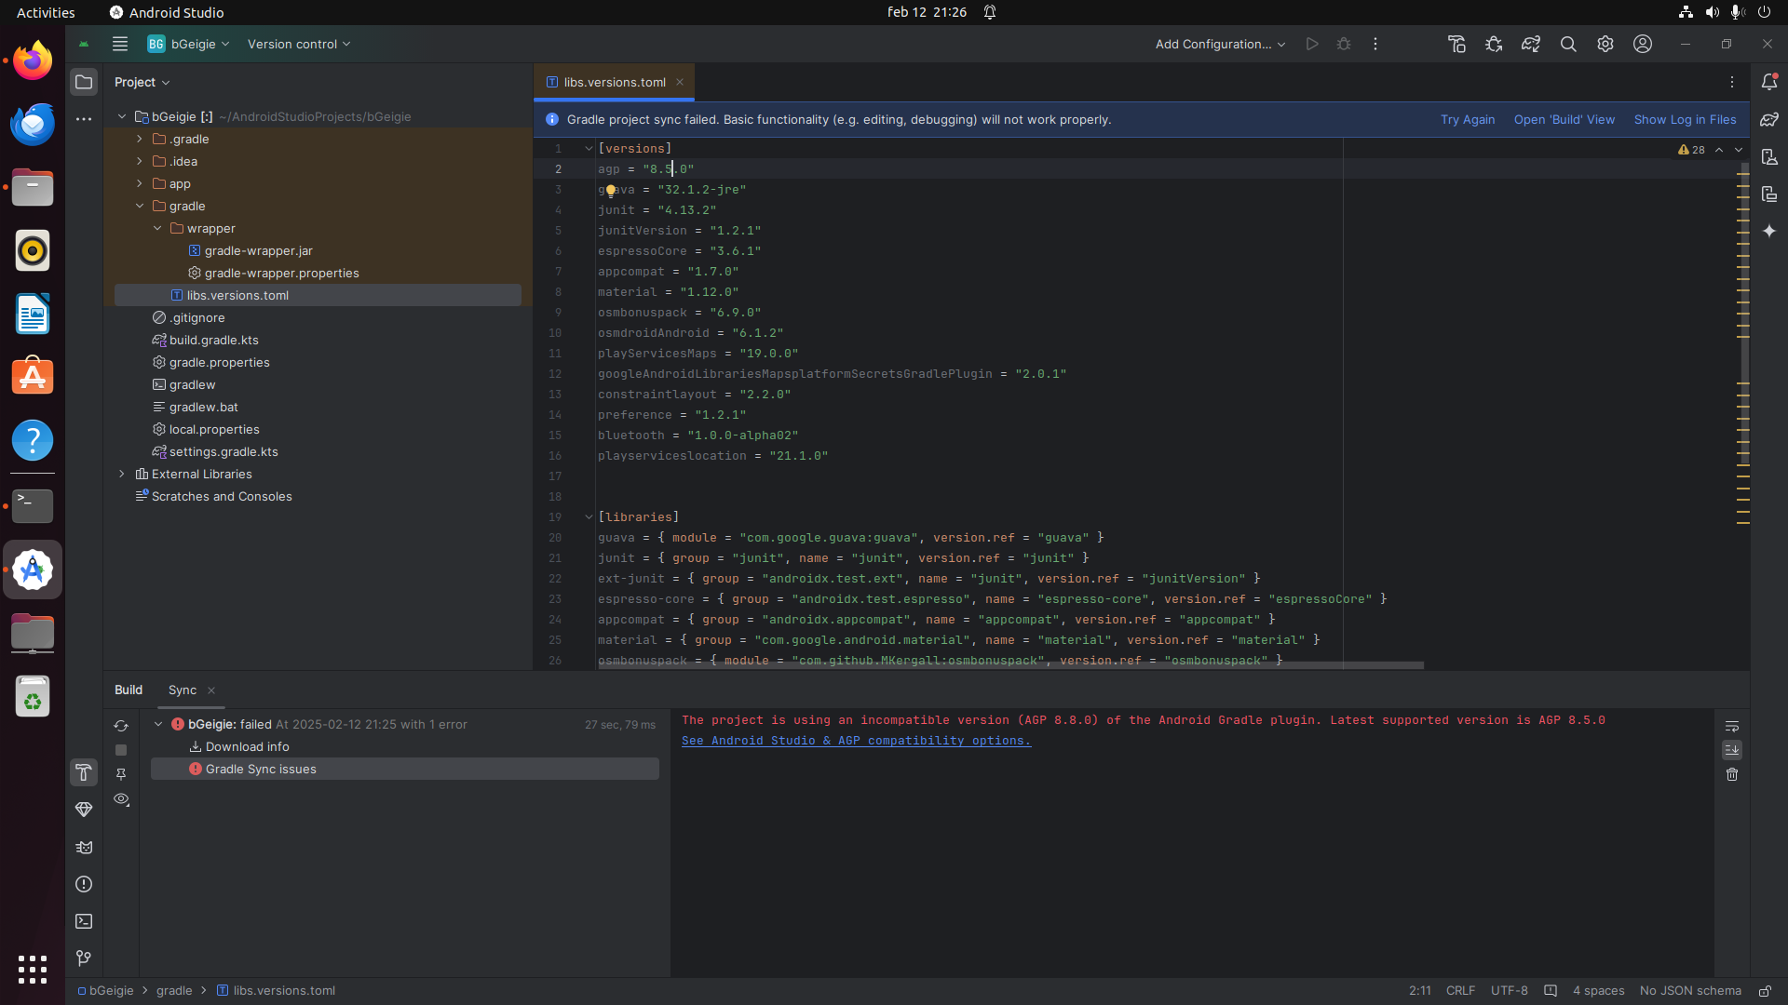
Cure: Lowering AGP version (for some reason)

Sync again -> New error:
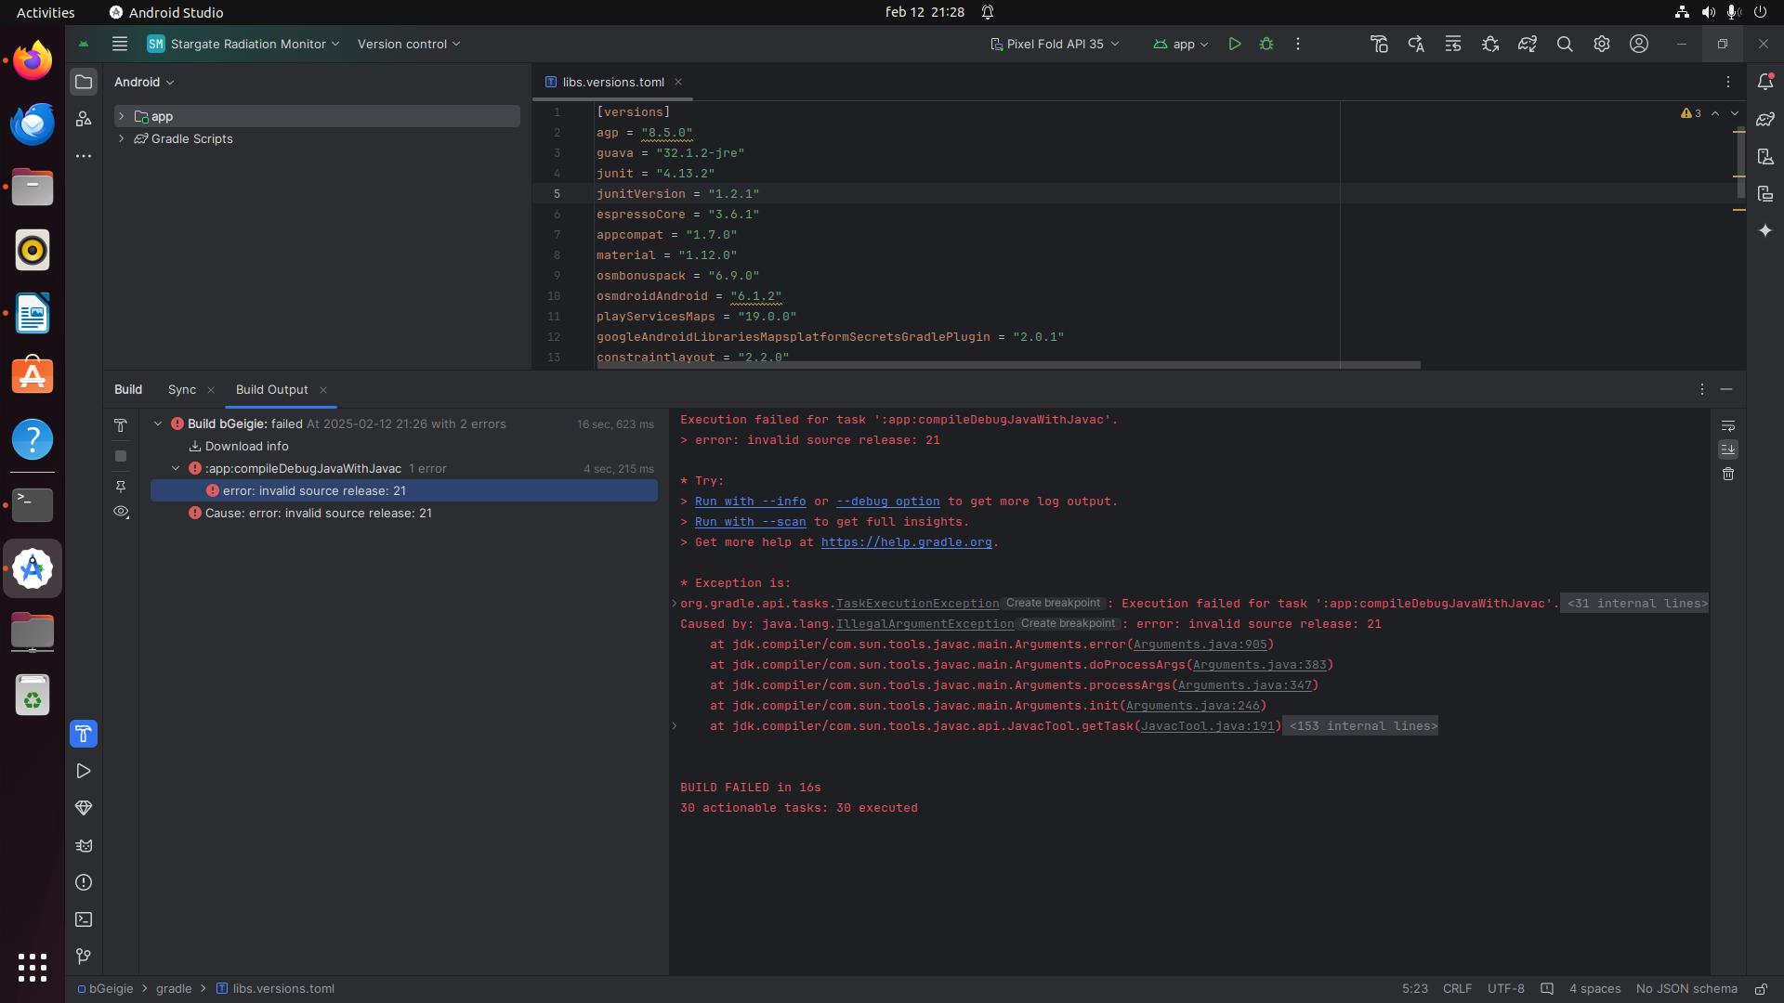

Cure: Simply lower to java 17 (I am sure installing Java 21 would have worked also)
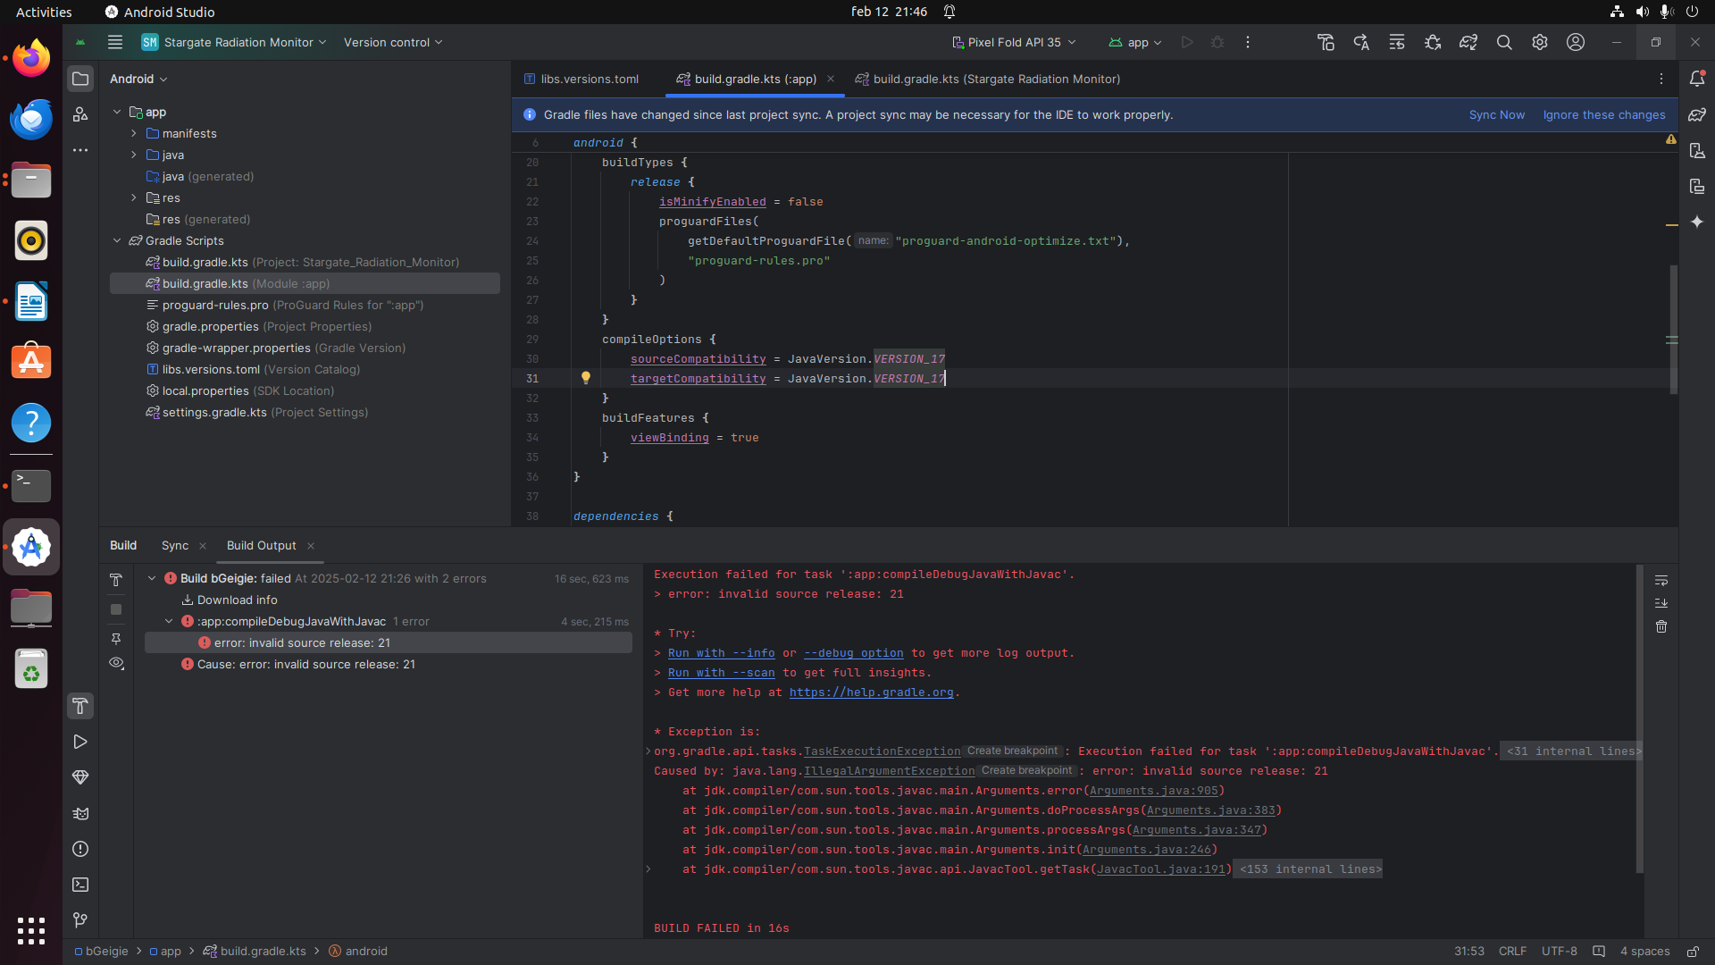
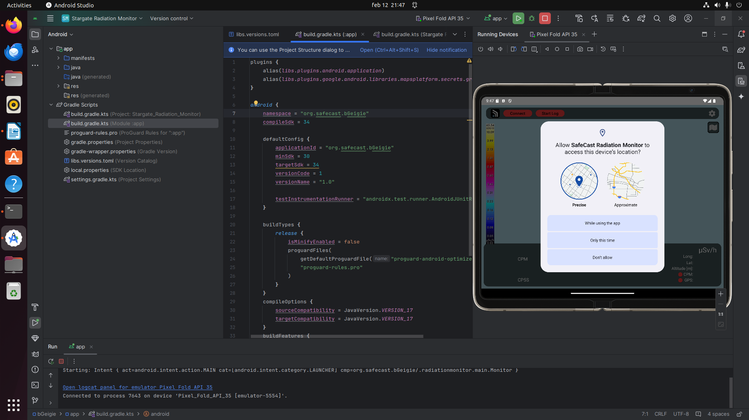
Sync again and run -> Now it works.

