Physics Open Lab (Italy)

Transimpedance amplifier
https://physicsopenlab.org/2017/09/27/trans-impedance-amplifier/

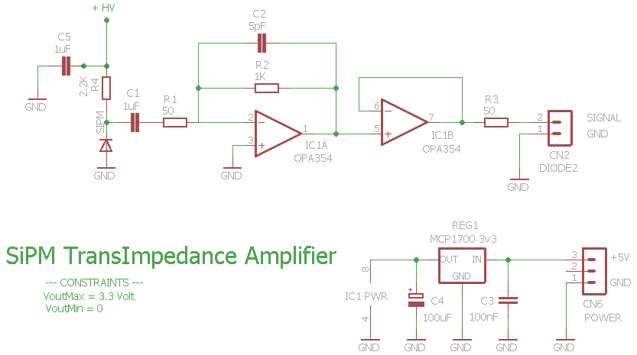
OPA2354 (Dual 8-SOIC)

https://www.digikey.ca/en/products/detail/texas-instruments/OPA2354AIDDAR/1572223

Front-end Electronics for SiPM

https://physicsopenlab.org/2017/11/28/front-end-electronics-for-sipm/

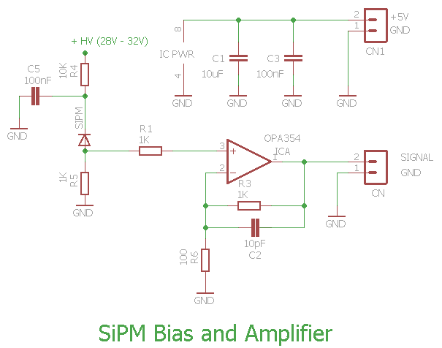

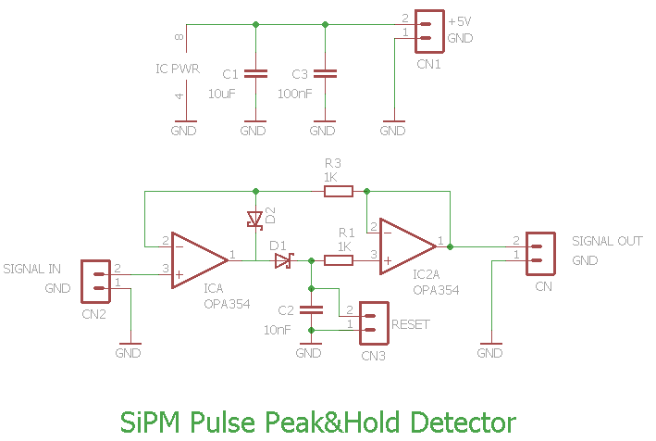
sdfsdf

Espressif esp32-s3 (used in M5Stack CoreS3)
Datasheet
https://documentation.espressif.com/esp32-s3_datasheet_en.html
https://documentation.espressif.com/esp32-s3_datasheet_en.pdf
Technical Reference Manual
https://documentation.espressif.com/esp32-s3_technical_reference_manual_en.pdf

