

**Game Framework Project**

**Submitted To:**

**Dr. Awais Hassan**

**Submitted By:**

**Muhammad Safee ullah, 2020-CS-13**

**Department of Computer Sicence**

**University of Engineering and Technonlogy Lahore**

**Framework for Making Platformer Games**

Table of Contents

Problem Statement: 3

Previous Solution: 3

Solution/Current Approach: 3

Design Decision: 3

UML Diagram: 3

Code: 4

Form1: 4

Game: 4

GameObject: 5

IMovement: 5

MovementWithKey: 5

MovementRight: 6

MovementLeft: 6

ObjectFactory: 7

ObjectType: 10

# Problem Statement:

We want to make a dynamic level generation mechanism that user can use to add and define custom level backgrounds from word files.

# Previous Solution:

No previous attempt to solve this problem.

# Solution/Current Approach:

## Design Decision:

We used a file to read the level istead of defining everything in our program

## UML Diagram:

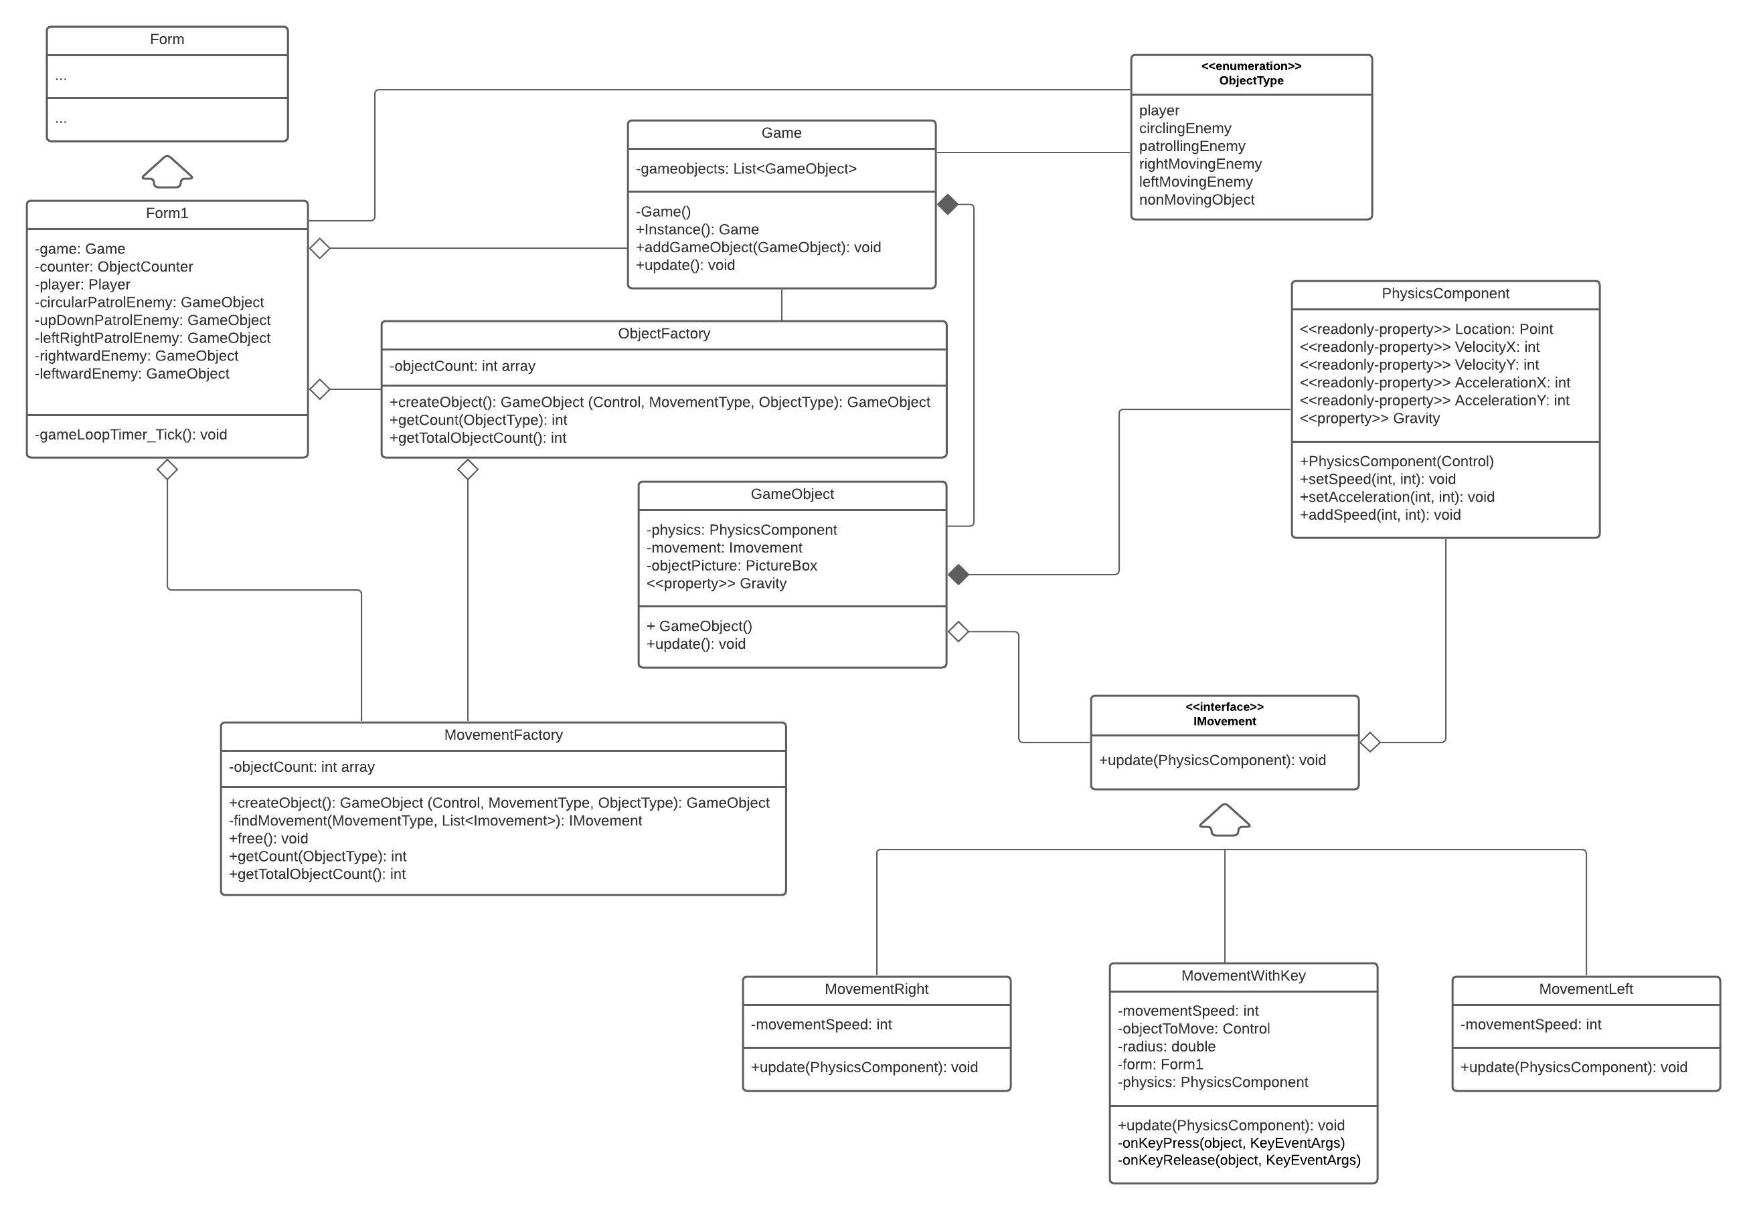

# Code:

### Form1:

public partial class Form1 : Form

{

Game game;

ObjectFactory factory;

MovementFactory movementFactory;

public Form1()

{

InitializeComponent();

game = Game.Instance();

factory = ObjectFactory.Instance();

movementFactory = MovementFactory.Instance();

game.addGameObject(factory.createObject(playerPictureBox, MovementType.keyBoard, ObjectType.player, 0));

game.addGameObject(factory.createObject(CircularPictureBox, MovementType.left, ObjectType.circlingEnemy));

game.addGameObject(factory.createObject(UDPatrolPictureBox, MovementType.left, ObjectType.patrollingEnemy));

game.addGameObject(factory.createObject(LRPatrolPictureBox, MovementType.right, ObjectType.patrollingEnemy));

game.addGameObject(factory.createObject(rightwardPictureBox, MovementType.right, ObjectType.rightMovingEnemy));

game.addGameObject(factory.createObject(leftwardPictureBox, MovementType.left, ObjectType.leftMovingEnemy));

}

private void gameLoopTimer_Tick(object sender, EventArgs e)

{

game.update();

objectCountLabel.Text = $"Objects: {factory.getTotalObjectsCount()}, Movements: Left:{movementFactory.getCount(MovementType.left)} Right:{movementFactory.getCount(MovementType.right)} KeyBoard:{movementFactory.getCount(MovementType.keyBoard)}";

}

}

### Game:

public class Game

{

List<GameObject> gameObjects = new List<GameObject>();

private static Game gameInstance;

private static readonly object locker = new object();

private Game() { }

public static Game Instance()

{

lock (locker)

{

if (gameInstance == null) gameInstance = new Game();

return gameInstance;

}

}

public void addGameObject(GameObject gameObject)

{

gameObjects.Add(gameObject);

}

public void update()

{

foreach (GameObject gameObject in gameObjects)

{

gameObject.update();

}

}

}

### GameObject:

public class GameObject

{

protected PhysicsComponent physics;

protected IMovement objectMovement;

MovementFactory movementFactory;

public float Gravity { get => physics.Gravity; set => physics.Gravity = value; }

internal GameObject(Control objectPicture, IMovement objectMovement, float objectGravity = 1)

{

//for creating object from a component

physics = new PhysicsComponent(objectPicture, objectGravity);

this.objectMovement = objectMovement;

movementFactory = MovementFactory.Instance();

}

public virtual void update()

{

objectMovement.update(physics);

physics.update();

//Refresh();

}

~GameObject() => movementFactory.free(objectMovement);

}

### IMovement:

// Interface for using in game objects

public interface IMovement

{

public MovementType MovementType { get; }

public bool IsExclusive { get; }

void update(PhysicsComponent physics);

}

### MovementWithKey:

public class MovementWithKey : Movement, IMovement

{

PhysicsComponent physics;

int movementSpeed = 5;

bool firstTimeCheck;

public MovementWithKey():base(MovementType.keyBoard, true) { }

public void update(PhysicsComponent physics)

{

physics.Gravity = -1;

if (!firstTimeCheck)

{

this.physics = physics;

physics.ObjectForm.KeyDown += new KeyEventHandler(keyDownHandler);

physics.ObjectForm.KeyUp += new KeyEventHandler(keyUpHandler);

firstTimeCheck = true;

}

}

private void keyDownHandler(object sender, KeyEventArgs e)

{

if(physics.VelocityX + physics.VelocityY < movementSpeed)

{

if (e.KeyCode == Keys.Up) physics.setSpeed(0, -movementSpeed);

if (e.KeyCode == Keys.Down) physics.setSpeed(0, movementSpeed);

if (e.KeyCode == Keys.Left) physics.setSpeed(-movementSpeed, 0);

if (e.KeyCode == Keys.Right) physics.setSpeed(movementSpeed, 0);

}

}

private void keyUpHandler(object sender, KeyEventArgs e)

{

if (e.KeyCode == Keys.Up) physics.setSpeed(physics.VelocityX, 0);

if (e.KeyCode == Keys.Down) physics.setSpeed(physics.VelocityX, 0);

if (e.KeyCode == Keys.Left) physics.setSpeed(0, physics.VelocityY);

if (e.KeyCode == Keys.Right) physics.setSpeed(0, physics.VelocityY);

}

}

### MovementRight:

public class MovementRight : Movement, IMovement

{

int movementSpeed = 5;

public MovementRight() : base(MovementType.right, false) { }

public void update(PhysicsComponent physics)

{

physics.Gravity = 0;

physics.setSpeed(movementSpeed, 0);

}

}

### MovementLeft:

public class MovementLeft : Movement, IMovement

{

int movementSpeed = 5;

public MovementLeft():base(MovementType.left, false) { }

public void update(PhysicsComponent physics)

{

physics.Gravity = 0;

physics.setSpeed(-movementSpeed, 0);

}

}

### ObjectFactory:

public class ObjectFactory

{

int[] objectCount = new int[10];

MovementFactory movementFactory = MovementFactory.Instance();

private static ObjectFactory factoryInstance;

private static readonly object locker = new object();

private ObjectFactory() { }

public static ObjectFactory Instance()

{

lock (locker)

{

if (factoryInstance == null)

factoryInstance = new ObjectFactory();

return factoryInstance;

}

}

public GameObject createObject(Control objectPicture, MovementType movementType, ObjectType objectType, float objectGravity = 1)

{

objectCount[(int)objectType]++;

return new GameObject(objectPicture, movementFactory.createMovement(movementType), objectGravity);

}

public int getCount(ObjectType objectType) => objectCount[(int)objectType];

public int getTotalObjectsCount()

{

int count = 0;

foreach (int objCount in objectCount) count += objCount;

return count;

}

}

public class MovementFactory

{

static MovementFactory factoryInstance;

private static readonly object locker = new object();

List<IMovement> available = new List<IMovement>();

List<IMovement> occupied = new List<IMovement>();

int[] movementCount = new int[3];

private MovementFactory() { }

public static MovementFactory Instance()

{

lock (locker)

{

if (factoryInstance == null) factoryInstance = new MovementFactory();

return factoryInstance;

}

}

public IMovement createMovement(MovementType movementType)

{

IMovement movement = findMovement(movementType, available);

if (movement != null)

{

if (movement.IsExclusive)

{

available.Remove(movement);

occupied.Add(movement);

}

return movement;

}

else

{

lock (locker)

{

IMovement newMovement;

if (movementType == MovementType.right) newMovement = new MovementRight();

else if (movementType == MovementType.left) newMovement = new MovementLeft();

else newMovement = new MovementWithKey();

if (newMovement.IsExclusive) occupied.Add(newMovement);

else available.Add(newMovement);

movementCount[(int)newMovement.MovementType]++;

return newMovement;

}

}

}

public int getCount(MovementType movementType) => movementCount[(int)movementType];

public int getTotalMovementCount()

{

int count = 0;

foreach (int movCount in movementCount) count += movCount;

return count;

}

IMovement findMovement(MovementType typeToLookFor, List<IMovement> listToSearch)

{

foreach(IMovement movement in listToSearch)

if (movement.MovementType == typeToLookFor) return movement;

return null;

}

public void release(IMovement movement)

{

if (movement.IsExclusive)

{

occupied.Remove(movement);

available.Add(movement);

}

}

}

### CollisionDetector:

using System;

using System.Collections.Generic;

using System.Text;

namespace SectionA2020CS13Framework

{

public class CollisionDetector

{

ObjectType first, second;

ICollisionBehavior behavior;

public CollisionDetector(ObjectType first, ObjectType second, ICollisionBehavior behavior)

{

this.first = first;

this.second = second;

this.behavior = behavior;

}

public void check(List<GameObject> objects)

{

for (int i = 0; i < objects.Count - 1; i++)

for (int j = i + 1; j < objects.Count; j++)

{

GameObject firstObject = objects[i];

GameObject secondObject = objects[j];

if (firstObject.Type == first && secondObject.Type == second

&& firstObject.collidesWith(secondObject))

{

behavior.apply(firstObject, secondObject);

}

}

}

}

}

### ICollisionBehavior:

public interface ICollisionBehavior

{

public void apply(GameObject first, GameObject second);

}

### DeleteObject:

using System;

using System.Collections.Generic;

using System.Windows.Forms;

namespace SectionA2020CS13Framework

{

public class DeleteObject : ICollisionBehavior

{

Game game;

ObjectType typeToDelete;

public DeleteObject(Game game, ObjectType typeToDelete)

{

this.game = game;

this.typeToDelete = typeToDelete;

}

public void apply(GameObject first, GameObject second)

{

if(first.Type == typeToDelete)

{

first.removeSelf();

game.removeGameObject(first);

GC.Collect();

}

else if (second.Type == typeToDelete)

{

second.removeSelf();

game.removeGameObject(second);

GC.Collect();

}

}

}

}

### ObjectType:

public enum ObjectType

{

player,

circlingEnemy,

patrollingEnemy,

rightMovingEnemy,

leftMovingEnemy,

nonMovingObject

}

public enum MovementType

{

keyBoard,

right,

left

}