Multi-Sensor Deep Learning Fusion for Glacial Lake Tracking and GLOF Hazard Assessment in the Hunza Valley, Gilgit-Baltistan
Deliverable 2 — Methodology and Experimental Setup
Muhammad Ali Saleem, Junaid Minhas, and Safee Akmal
Deep Learning for Perception — Semester Research Project, [FILL: Department, University]
[FILL: email addresses]
Before you submit — delete this box
Fill the yellow placeholders under the title.
This document contains Section III (Methodology and Experimental Setup) with the required subsections: Proposed Methodology, Model Architecture, Dataset and Preprocessing, Training Configuration and Evaluation Metrics. It describes exactly what notebooks/glof_pipeline.ipynb does.
Section numbering (III) matches the complete paper; if your instructor wants it numbered as 3, change the heading only.

III. METHODOLOGY AND EXPERIMENTAL SETUP

A. Proposed Methodology
The proposed approach is an early-fusion U-Net [1] with a ResNet-18 encoder [2] that segments glacial-lake water from co-registered Sentinel-1 SAR, Sentinel-2 optical and Copernicus DEM inputs, compared against two identical U-Nets that receive only optical inputs (baseline) or only radar and terrain inputs (ablation). The workflow (Fig. 1) has six stages: (1) acquisition of every available acquisition in event-centred and seasonal windows from Google Earth Engine [3]; (2) co-registration of all modalities on a common 10 m grid; (3) automatic generation of water labels from optical data; (4) training of the optical-only baseline, the radar-only ablation and the fusion model, each with three random seeds; (5) evaluation of all models on held-out years, under clear conditions and under simulated complete cloud cover; and (6) application of the fusion model to every date — including dates with radar only — to derive lake-area and growth-rate time series and a transparent hazard index that is compared against the documented events. The final objective is therefore threefold: a performance comparison (RQ1), a robustness test when optical data are missing (RQ1), and a retrospective event analysis (RQ2, RQ3).
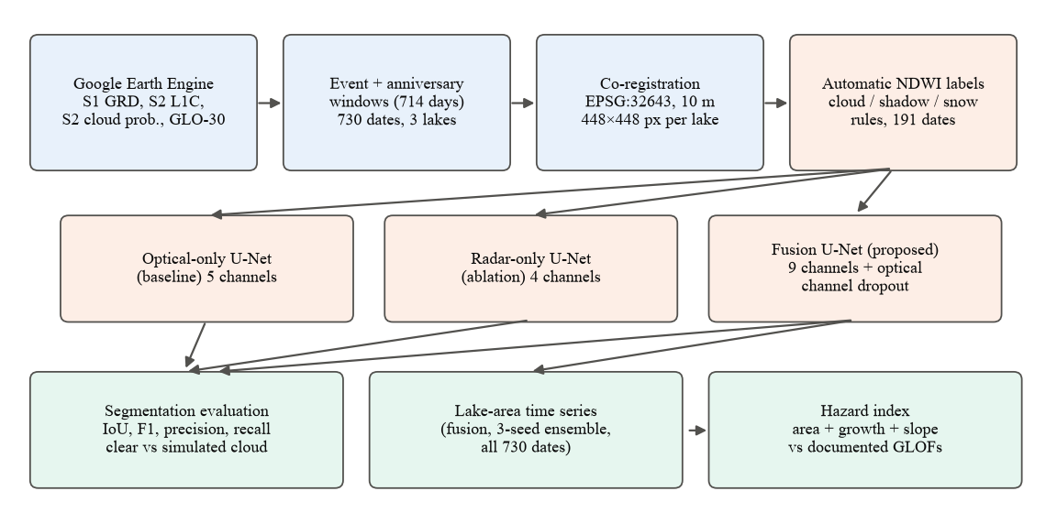
Fig. 1. Overview of the proposed pipeline. Blue: data acquisition and preparation; orange: labels and models; green: outputs. The optical-only and radar-only models are used for the comparison only; the fusion model (3-seed ensemble) produces the time series and hazard index. All models use a ResNet-18 encoder, balanced crop sampling and three training seeds.

1) Study sites:
The study covers three sites in the Hunza basin (Table I, Fig. 2). Shishper and Khurdopin are the two event sites. For the Passu comparison site we verified on Sentinel-2 imagery that Passu Glacier has no persistent lake at its terminus during 2017–2022; the monitored water body is therefore Borith Lake, the perennial lake immediately south of the Passu Glacier terminus, which had no outburst in the study period. All site centres were located on the imagery because the approximate coordinates in our earlier project plan were 1–7 km off the lakes.
TABLE I
STUDY SITES
Site | Lake type | Centre (lat, lon) | Documented event(s) | Role
Shishper | Ice-dammed (surging glacier blocks a side valley) | 36.358°N, 74.568°E | Repeated drainage from 2019 [4]; 29 May 2020; 7 May 2022 [5] | Event site
Khurdopin | Surge-dammed (Shimshal River) | 36.361°N, 75.449°E | Formed Mar 2017; drainage onset ≈ 21 Jul 2017, drained by 3 Aug 2017 [6] | Event site
Passu (Borith Lake) | Perennial lake beside Passu Glacier | 36.432°N, 74.862°E | No outburst during 2017–2022 | Comparison site

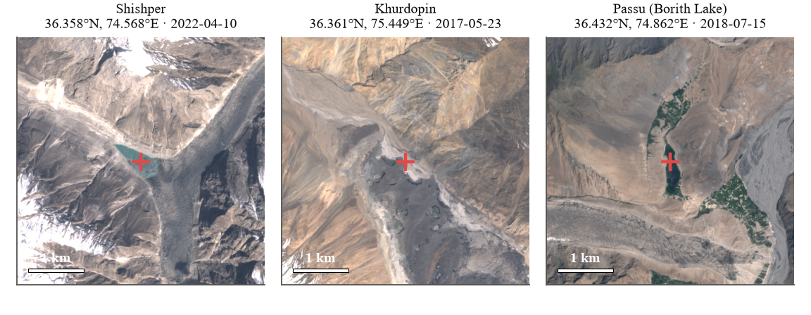
Fig. 2. The three 4.48 × 4.48 km study boxes (Sentinel-2 true colour). The cross marks the lake point used to identify the lake when measuring its area.

B. Model Architecture
All three models share the U-Net architecture shown in Fig. 3. The encoder is a ResNet-18 that reduces the input resolution in five steps (to 1/32) while increasing the number of feature channels to 512; residual connections make the encoder easy to optimise. The decoder upsamples in five steps, concatenating at each step the encoder feature map of the same resolution (skip connection) and applying two 3 × 3 convolutions with batch normalisation and ReLU. A final 1 × 1 convolution and a sigmoid output the per-pixel water probability.
Rationale. U-Net is the standard architecture for pixel-wise segmentation from limited labels, its skip connections preserve the sharp lake shorelines needed for accurate area, and it is the architecture used by the closest regional fusion study [7]. ResNet-18 was chosen over deeper encoders because the labelled set is small (137 training images) and training has to fit a free Colab GPU; with 14.3 M parameters the model trains in minutes. The encoder is initialised with ImageNet weights [8]; for inputs with more than three channels, the pretrained filters of the first convolution are cycled over the additional channels and rescaled (segmentation-models-pytorch default [9]), and all layers are fine-tuned.
Early fusion. In the fusion model the nine channels of Table II are stacked at the input, so the network learns joint optical–radar–terrain features from the first layer. Early fusion is the simplest fusion strategy, keeps the models architecturally identical (only the first convolution differs), and therefore isolates the effect of the inputs. A radar-only U-Net that receives only the four radar and terrain channels serves as an ablation: comparing it with the optical-only and fusion models shows whether fusion adds anything beyond each sensor alone. To make the fusion model usable on cloudy and radar-only dates, it is trained with optical-channel dropout: for 30% of training crops all five optical channels are set to zero, forcing the network to also learn to segment water from SAR and terrain alone.
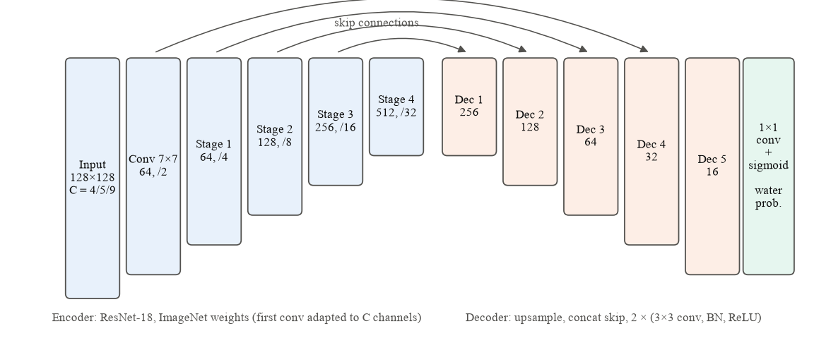
Fig. 3. U-Net with ResNet-18 encoder. Numbers give feature channels and down-sampling factor; C = 5 for the optical-only, C = 4 for the radar-only and C = 9 for the fusion model.
TABLE II
MODEL INPUT CHANNELS
# | Channel | Source | Unit / range | Optical | Radar | Fusion
1 | B2 (blue) | Sentinel-2 | TOA reflectance, 0–1 | ✓ |  | ✓
2 | B3 (green) | Sentinel-2 | TOA reflectance, 0–1 | ✓ |  | ✓
3 | B4 (red) | Sentinel-2 | TOA reflectance, 0–1 | ✓ |  | ✓
4 | B8 (NIR) | Sentinel-2 | TOA reflectance, 0–1 | ✓ |  | ✓
5 | NDWI | Derived from B3, B8 | −1 to 1 | ✓ |  | ✓
6 | VV backscatter | Sentinel-1 | dB |  | ✓ | ✓
7 | VH backscatter | Sentinel-1 | dB |  | ✓ | ✓
8 | Elevation | Copernicus DEM | m a.s.l. |  | ✓ | ✓
9 | Slope | Derived from DEM | degrees |  | ✓ | ✓

C. Dataset and Preprocessing

1) Data sources:
All data are open and accessed through the Earth Engine Python API (Table III). Sentinel-2 Level-1C top-of-atmosphere reflectance is used instead of Level-2A surface reflectance because Level-2A coverage over the Karakoram is incomplete in 2017–2018, which includes the Khurdopin event. Sentinel-1 GRD scenes in Earth Engine are already calibrated, terrain-corrected and converted to decibels; we do not repeat these steps. For each site one orbit direction is used throughout (the direction with more scenes: ascending for Shishper, descending for Khurdopin and Passu) so that viewing geometry is constant.
TABLE III
DATA SOURCES
Data | Earth Engine collection | Bands used | Resolution | Role
Sentinel-1 GRD [10] | COPERNICUS/S1_GRD | VV, VH (dB), IW mode | 10 m | Cloud-independent water signal
Sentinel-2 L1C [11] | COPERNICUS/S2_HARMONIZED | B2, B3, B4, B8 (TOA reflectance) | 10 m | Optical bands, NDWI, labels
S2 cloud probability [12] | COPERNICUS/S2_CLOUD_PROBABILITY | probability (%) | 10 m (from 20 m) | Cloud mask (not a label)
Copernicus DEM [13] | COPERNICUS/DEM/GLO30 | Elevation; slope (derived) | 30 m → 10 m | Terrain channels; slope rule; hazard feature

2) Temporal sampling:
Sentinel-2 revisits about every five days and Sentinel-1 every 6–12 days, so daily data do not exist. Instead, every acquisition is taken inside the windows of Table IV: a dense window from 90 days before to 45 days after each documented event, and ±15-day windows around each event's calendar date (7 May, 29 May and 21 July) in every year from 2017 to 2022. The same windows are applied to all three sites, so each site has observations in every event period and in the same season of years without an event. Every Sentinel-2 day whose mosaic covers at least 95% of the site box is downloaded and paired with the nearest Sentinel-1 scene within ±6 days; Sentinel-1 days without a Sentinel-2 acquisition are downloaded as radar-only dates. This yields 730 dates (Fig. 4, Table V). Sentinel-1B failed on 23 December 2021 [14], so radar coverage in 2022 is sparser.
TABLE IV
ACQUISITION WINDOWS (IDENTICAL FOR ALL SITES)
Window | Dates | Days | Purpose
Khurdopin event | 22 Apr – 4 Sep 2017 | 136 | 90 d before / 45 d after drainage onset (21 Jul 2017)
Shishper 2020 event | 29 Feb – 5 Aug 2020 | 159 | Around the 29 May 2020 drainage (merged with anniversary)
Shishper 2022 event | 6 Feb – 21 Jun 2022 | 136 | Around the 7 May 2022 GLOF
Anniversaries (May) | 22 Apr – 13 Jun, 2018, 2019, 2021 | 3 × 53 | Same season as the May events, no event
Anniversaries (July) | 6 Jul – 5 Aug, 2018, 2019, 2021, 2022 | 4 × 31 | Same season as the July event, no event
Total | 10 windows | 714 | Applied identically to all three sites

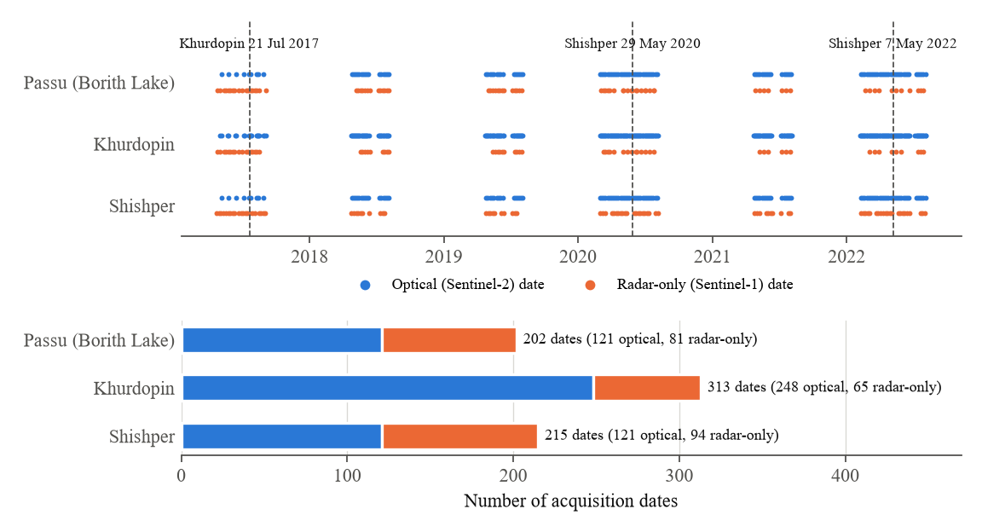
Fig. 4. Temporal sampling. Top: every acquisition date per site, split into optical (Sentinel-2) and radar-only (Sentinel-1) dates; dashed lines mark the documented events. Bottom: number of dates per site.

3) Co-registration:
For each site a 448 × 448 pixel box (4.48 × 4.48 km) centred on the lake point is defined on a 10 m grid in UTM zone 43N (EPSG:32643). All layers are requested from Earth Engine directly on this grid, so the modalities share CRS, transform, resolution and shape by construction. Same-day Sentinel-2 granules and same-pass Sentinel-1 slices are mosaicked. The 30 m DEM is resampled bilinearly (it is therefore not native 10 m terrain); other layers use nearest-neighbour resampling. Slope is computed from the DEM. Arrays are stored as float16 (cloud probability as uint8).

4) Cloud masking:
A pixel is treated as cloud when the Sentinel-2 cloud probability [12] is at least 60%. Cloud components smaller than 1,000 pixels (0.1 km²) are discarded because they are mostly false detections on bright rock and snow.

5) Automatic label generation:
No source provides lake outlines for the three sites at the event dates, and hand-digitising hundreds of dates was not feasible, so water labels are generated automatically from Sentinel-2 using NDWI [15]:
$NDWI = \frac{G − NIR}{G + NIR}$ (1)
where G and NIR are bands B3 and B8. A pixel is labelled water when NDWI > 0.2, NIR reflectance < 0.12 (excludes snow, ice and cloud), green reflectance > 0.03 (excludes deep shadow) and DEM slope < 20° (excludes steep shadowed cliffs); water components smaller than 50 pixels are removed. Only near-clear images are labelled: at most 10% cloud in the box and at most 40% very bright (snow or haze) pixels. Pixels within 150 m of cloud are marked ignore and excluded from the loss and from scoring. These thresholds were tuned by visual inspection of label overlays after a first version labelled cloud shadows as water. Of 490 optical dates, 191 received labels (Table V); Fig. 5 shows examples. Frozen or snow-covered lake surfaces are labelled as land, which is a known limitation of this labelling strategy.
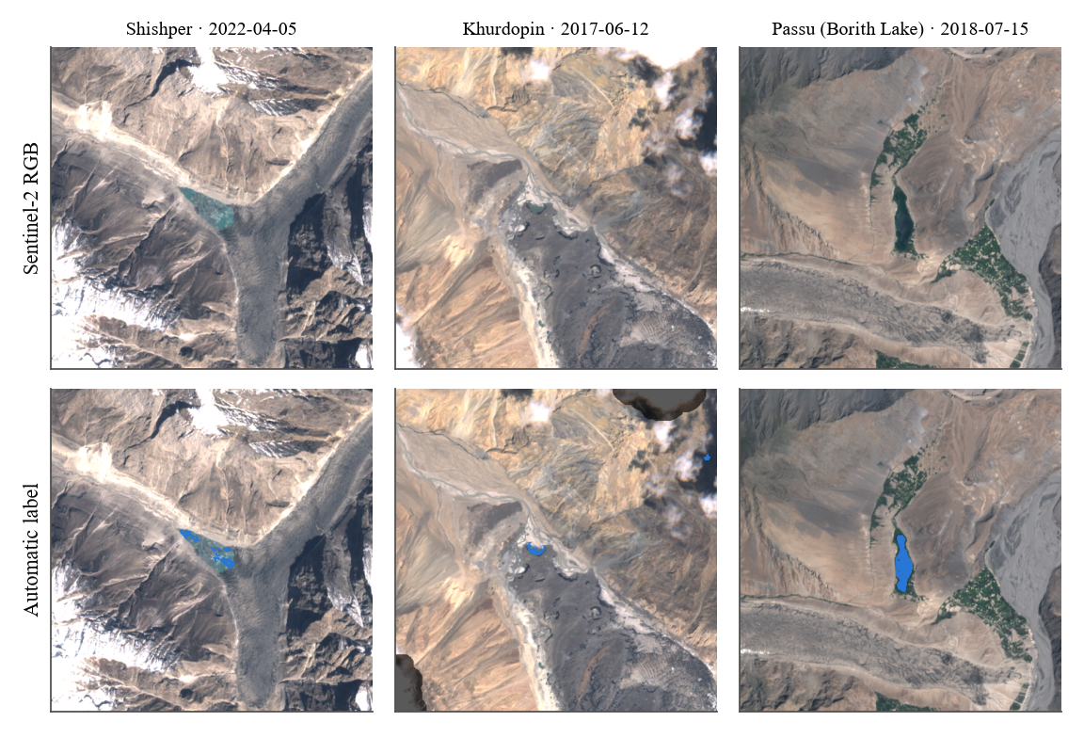
Fig. 5. Examples of automatic labels (blue = water, darkened = cloud buffer, ignored). Shishper lake before the 2022 GLOF, the Khurdopin dammed lake in June 2017, and Borith Lake.

6) Input normalisation:
Each channel is standardised with the mean and standard deviation computed on 60 randomly sampled training images. After standardisation, the optical channels are set to zero (the channel mean) wherever the cloud mask is set and on radar-only dates, and missing values (e.g. no Sentinel-1 scene within ±6 days) are set to zero.

7) Train / test split:
Neighbouring dates of the same lake are nearly identical, so a random split would leak information. The split is therefore by year: labelled dates from 2019 and 2021 form the test set (54 images) and those from 2017, 2018, 2020 and 2022 form the training set (137 images; Table V). No separate validation set is used: hyper-parameters were fixed in advance, the learning-rate schedule is fixed, and no early stopping or model selection is performed, so the test years are never used for any training decision.
TABLE V
DATASET COMPOSITION AND YEAR-WISE SPLIT
Site | Dates (all) | Optical / radar-only | Labelled | Train (2017, 2018, 2020, 2022) | Test (2019, 2021)
Shishper | 215 | 121 / 94 | 40 | 27 | 13
Khurdopin | 313 | 248 / 65 | 99 | 73 | 26
Passu (Borith) | 202 | 121 / 81 | 52 | 37 | 15
Total | 730 | 490 / 240 | 191 | 137 | 54

8) Augmentation:
Training uses 128 × 128 crops from the full site images — half of them centred on a random lake-water pixel (Section III-D) — with random horizontal and vertical flips. The fusion model additionally uses optical-channel dropout (Section III-B). Rotations by arbitrary angles are not used because SAR geometry depends on the look direction.

D. Training Configuration
All three models use the configuration in Table VI. The loss combines binary cross-entropy and soft Dice and is computed only over valid (non-ignored) pixels; with p the predicted probability, y the label and m the validity mask:
$ℒ = \frac{Σ m·BCE(p, y)}{N} + 1 − \frac{2 Σ m·p·y + 1}{Σ m·p + Σ m·y + 1}$ (2)
The Dice term counteracts the strong class imbalance (lake water occupies a few percent of each image), while the cross-entropy term provides stable per-pixel gradients. Training stability is supported by ImageNet initialisation, cosine learning-rate annealing, which lowers the step size smoothly towards the end of training, the masked loss, which prevents cloud pixels with unreliable labels from producing gradients, and data augmentation. Optical-channel dropout also acts as a regulariser that prevents the fusion model from relying on NDWI alone.
Balanced sampling and seeds. In preliminary single-seed runs, models sometimes converged to predicting no water anywhere — lake water covers well under 1% of the pixels and most random crops contain none — and results changed substantially between otherwise identical runs. We therefore centre half of the training crops on a randomly chosen lake-water pixel (balanced crop sampling; 74 of the 137 training images contain water) and train every model with three seeds. Each seed has its own random-number generator, so the batches seen by one model do not depend on which models were trained before it. Results are reported as mean ± standard deviation across seeds, and the mean predicted probability of the three fusion seeds (an ensemble) is used for the time series.
TABLE VI
TRAINING CONFIGURATION
Setting | Value
Framework | PyTorch [16] + segmentation-models-pytorch [9]
Architecture | U-Net, ResNet-18 encoder (ImageNet weights [8]), 1 output channel
Input channels | 5 (optical-only) / 4 (radar-only) / 9 (fusion)
Training input | 128 × 128 crops of the 448 × 448 site images: 50% centred on a random lake-water pixel (balanced sampling), 50% random
Batch size | 16
Iterations | 3,000 on GPU (≈ 29 epoch-equivalents of 137 images); 1,500 if run on CPU
Optimiser | Adam [17], initial learning rate 1 × 10⁻³, no weight decay
LR schedule | Cosine annealing to 0 over all iterations [18]
Loss | Masked binary cross-entropy + soft Dice [19] (cloud pixels ignored)
Augmentation | Random horizontal and vertical flips (p = 0.5 each)
Optical-channel dropout | Fusion only: all 5 optical channels zeroed for 30% of crops
Decision threshold | 0.5 on the sigmoid output
Random seeds | 3 per model (0, 1, 2); PyTorch seed and a separate NumPy generator per seed
Time-series prediction | Fusion model, mean probability of its 3 seeds (ensemble)
Hardware | Google Colab, NVIDIA Tesla T4 GPU (16 GB)

E. Evaluation Metrics

1) Segmentation:
Predictions are evaluated on the valid (non-cloud) pixels of the test images using intersection-over-union (IoU), F1-score (Dice), precision and recall, with TP, FP and FN the numbers of true-positive, false-positive and false-negative water pixels:
$IoU = \frac{TP}{TP + FP + FN}, F1 = \frac{2TP}{2TP + FP + FN}$ (3)
$Precision = \frac{TP}{TP + FP}, Recall = \frac{TP}{TP + FN}$ (4)
IoU is the standard segmentation metric and directly reflects errors in lake extent, which is the quantity used downstream. F1 is reported for comparability with the literature reviewed in Section II. Precision and recall separate over-detection (e.g. shadows or wet ice classified as water) from under-detection (e.g. turbid or partly frozen lakes). Overall accuracy is not used because it would be dominated by the land class. Many test images contain no lake water (Khurdopin after 2017, Shishper after each drainage); per-image IoU is undefined for them, and averaging it would score a correct "no water" prediction as zero. The main results are therefore pixel-pooled metrics, for which TP, FP and FN are summed over all test pixels of a site (or of all sites) before the metric is computed. Pixel-pooled metrics are computed separately for each training seed and reported as mean ± standard deviation across the three seeds. In addition, per-image metrics are reported as mean ± standard deviation over the test images that contain water (pooled over seeds), and the false-positive area is reported for test images without water.

2) Robustness to missing optical data:
To test the cloud-robustness motivation directly, the models are also evaluated after setting all optical channels of the test images to zero (simulated complete cloud cover), using the same labels. The optical-only model then receives no information, the fusion model can use SAR and terrain, and the radar-only model is unaffected because it never sees optical data.

3) Time series:
The fusion model (mean probability of its three seeds) is applied to all 730 dates. Lake area Aₜ on date t is the number of predicted water pixels in connected components that touch a 400 m neighbourhood of the lake point, multiplied by the pixel area (100 m²); this excludes rivers and other water in the box. Area is smoothed with a centred rolling median over three observations (Ãₜ), and the growth rate is computed over roughly 30 days:
$G_{t} = \frac{Ã_{t} − Ã_{t′}}{t − t′} × 30$ (5)
where t′ is the latest date at least 30 days before t; growth is not computed when t − t′ exceeds 60 days (gaps between windows).

4) Hazard index:
Following the multi-criteria idea of Muneeb et al. [20] in a reduced, transparent form, the hazard index combines three features: smoothed lake area, positive growth rate and the mean DEM slope along the lake outline. Each is min–max normalised over all sites and dates to give a, g and s in [0, 1], and the index is their equal-weight mean:
$H_{t} = \frac{a_{t} + g_{t} + s_{t}}{3}$ (6)
Equal weights are a modelling assumption, not fitted to the events. For each documented event the index of all three sites is compared over the 90 days before the event date (mean and maximum), and plotted against days relative to the event. This is a retrospective evaluation, not an early-warning system.

REFERENCES
[1] O. Ronneberger, P. Fischer, and T. Brox, "U-Net: Convolutional networks for biomedical image segmentation," in Proc. MICCAI, LNCS vol. 9351, 2015, pp. 234–241.
[2] K. He, X. Zhang, S. Ren, and J. Sun, "Deep residual learning for image recognition," in Proc. IEEE CVPR, 2016, pp. 770–778.
[3] N. Gorelick, M. Hancher, M. Dixon, S. Ilyushchenko, D. Thau, and R. Moore, "Google Earth Engine: Planetary-scale geospatial analysis for everyone," Remote Sensing of Environment, vol. 202, pp. 18–27, 2017.
[4] G. Khan, S. Ali, et al., "Expansion of Shishper Glacier lake and recent glacial lake outburst flood (GLOF), Gilgit-Baltistan, Pakistan," Environmental Science and Pollution Research, 2021.
[5] S. Ullah et al., "An integrated approach for GLOF hazard, vulnerability and risk assessment in the Karakoram Mountain Range of northern Pakistan," Journal of Mountain Science, 2025.
[6] J. F. Steiner, P. D. A. Kraaijenbrink, S. G. Jiduc, and W. W. Immerzeel, "Brief communication: The Khurdopin glacier surge revisited – extreme flow velocities and formation of a dammed lake in 2017," The Cryosphere, vol. 12, no. 1, pp. 95–101, 2018, doi: 10.5194/tc-12-95-2018.
[7] S. Ali et al., "Deep learning model to detect glacial lakes using high-resolution optical and radar satellite images," Remote Sensing Applications: Society and Environment, 2025.
[8] J. Deng, W. Dong, R. Socher, L.-J. Li, K. Li, and L. Fei-Fei, "ImageNet: A large-scale hierarchical image database," in Proc. IEEE CVPR, 2009, pp. 248–255.
[9] P. Iakubovskii, "Segmentation Models Pytorch," GitHub repository, 2019. [Online]. Available: https://github.com/qubvel/segmentation_models.pytorch
[10] R. Torres et al., "GMES Sentinel-1 mission," Remote Sensing of Environment, vol. 120, pp. 9–24, 2012.
[11] M. Drusch et al., "Sentinel-2: ESA's optical high-resolution mission for GMES operational services," Remote Sensing of Environment, vol. 120, pp. 25–36, 2012.
[12] A. Zupanc, "Improving cloud detection with machine learning," Sentinel Hub Blog (s2cloudless), 2017. [Online]. Available: https://medium.com/sentinel-hub/improving-cloud-detection-with-machine-learning-c09dc5d7cf13
[13] European Space Agency, "Copernicus DEM — Global and European Digital Elevation Model (COP-DEM)," 2021, doi: 10.5270/ESA-c5d3d65.
[14] European Space Agency, "Mission ends for Copernicus Sentinel-1B satellite," ESA Applications, Aug. 2022. [Online]. Available: https://www.esa.int
[15] S. K. McFeeters, "The use of the Normalized Difference Water Index (NDWI) in the delineation of open water features," International Journal of Remote Sensing, vol. 17, no. 7, pp. 1425–1432, 1996.
[16] A. Paszke et al., "PyTorch: An imperative style, high-performance deep learning library," in Advances in Neural Information Processing Systems, vol. 32, 2019.
[17] D. P. Kingma and J. Ba, "Adam: A method for stochastic optimization," in Proc. ICLR, 2015.
[18] I. Loshchilov and F. Hutter, "SGDR: Stochastic gradient descent with warm restarts," in Proc. ICLR, 2017.
[19] F. Milletari, N. Navab, and S.-A. Ahmadi, "V-Net: Fully convolutional neural networks for volumetric medical image segmentation," in Proc. 3DV, 2016, pp. 565–571.
[20] F. Muneeb, S. U. Baig, J. A. Khan, and M. F. Khokhar, "Inventory and GLOF susceptibility of glacial lakes in Hunza River Basin, Western Karakorum," Remote Sensing, vol. 13, no. 9, art. 1794, 2021.

