Multi-Sensor Deep Learning Fusion for Glacial Lake Tracking and GLOF Hazard Assessment in the Hunza Valley, Gilgit-Baltistan
Deliverable 4 — Final Research Paper
Muhammad Ali Saleem, Junaid Minhas, and Safee Akmal
Deep Learning for Perception — Semester Research Project, [FILL: Department, University]
[FILL: email addresses]
Before you submit — delete this box
Complete research paper (Deliverable 4) with the results of the Colab run (notebooks/glof_pipeline.ipynb; all numbers are also in results/metrics/). Submit it together with the executed notebook.
Remaining placeholders: affiliation and e-mails under the title, the author-to-site mapping under Author Contributions, and the venue of the Thati & Ari reference. Delete this box, then export to PDF (or transfer the text into the IEEE LaTeX template).

Abstract—Glacial lake outburst floods (GLOFs) are among the most destructive hazards in high-mountain Asia, and the Hunza Valley of Gilgit-Baltistan, Pakistan, has experienced repeated, well-documented events within a single decade. Optical satellite monitoring is interrupted by cloud exactly when lakes change fastest, while synthetic aperture radar (SAR) observes through cloud but is noisier. We present a reproducible Google Earth Engine pipeline that co-registers Sentinel-1 SAR, Sentinel-2 optical and Copernicus DEM data on a common 10 m grid and samples every available acquisition in 90-day pre-event / 45-day post-event windows and seasonal anniversary windows (730 dates) at three sites: the ice-dammed Shishper lake, the surge-dammed Khurdopin lake and Borith Lake as a comparison site next to Passu Glacier. Water labels are generated automatically from Sentinel-2 NDWI with cloud, shadow and snow rules (191 labelled dates). Optical-only, radar-only and early-fusion U-Nets (ResNet-18 encoder, balanced crop sampling, three seeds each) are compared on held-out years. The fusion model is the most accurate and the most stable: pixel-pooled IoU 0.778 ± 0.005, against 0.521 ± 0.214 for optical-only and 0.487 ± 0.007 for radar-only, and it is the best model at every site. With all optical inputs removed it retains an IoU of 0.503 ± 0.015, close to the radar-only model, while the optical-only model fails; neither radar-based model recovers the small Shishper and Khurdopin lakes without optical data. Lake-area time series from the fusion ensemble reproduce the drainage of Shishper lake after 29 May 2020 and 7 May 2022 and of Khurdopin lake in July 2017. A transparent equal-weight hazard index ranked the large, stable comparison lake highest in all three pre-event windows; an exploratory per-lake normalised version, added after this result, peaked at the event lake before all three events.
Index Terms—Glacial lake outburst flood (GLOF), Sentinel-1, Sentinel-2, sensor fusion, semantic segmentation, U-Net, time series, hazard assessment, Karakoram

I. INTRODUCTION

A. Importance
Glacial lake outburst floods (GLOFs) are sudden releases of water stored behind ice or moraine dams. They can travel tens of kilometres downstream within hours, destroying bridges, roads, farmland and settlements with little or no warning. A global assessment estimated that around 15 million people live within 50 km of a glacial lake and within 1 km of a potential flood channel, with High Mountain Asia the most exposed region [1]. At the same time, glacial lakes are growing rapidly: global glacial-lake volume increased by roughly 48% between 1990 and 2018 [2]. The Hunza Valley in the Karakoram range of Gilgit-Baltistan, Pakistan, is one of the most glacier-active valleys in the world and has experienced repeated, well-documented events within a single decade. The surging Khurdopin Glacier dammed the Shimshal River in 2017; the resulting lake formed in March and drained in late July–early August 2017 [3]. The ice-dammed lake in front of the surging Shishper Glacier drained repeatedly from 2019 onwards [4], and on 7 May 2022 its outburst destroyed the Hassanabad bridge on the Karakoram Highway [5]. These events are recent, documented and recurring, which makes the Hunza basin both a priority for monitoring and an unusually good natural laboratory for testing monitoring methods.

B. Background
Satellite remote sensing is the only practical way to monitor remote glacial lakes repeatedly. Optical sensors such as Sentinel-2 [6] provide 10 m multispectral imagery every few days, and water is readily separated from land using spectral indices such as the Normalized Difference Water Index (NDWI) [7]. However, optical observation fails under cloud, and cloud is frequent in the Karakoram exactly in the spring and summer months when lakes fill and drain. Synthetic aperture radar (SAR) from Sentinel-1 [8] observes the surface through cloud and in darkness, and calm water appears dark because it reflects the radar pulse away from the sensor; SAR, however, is affected by speckle noise and by layover and shadow in steep terrain. A digital elevation model (DEM) adds terrain context, since lakes form on gentle slopes in valley floors. Deep convolutional networks, in particular the encoder–decoder U-Net [9], have become the standard tool for pixel-wise segmentation of such imagery, and several studies have shown that SAR and optical data carry complementary information about glacial lakes [10], [11], [12]. Cloud platforms such as Google Earth Engine [13] now make multi-sensor archives accessible without manual downloading, which makes dense multi-year time series feasible for a small team.

C. Problem Statement
Despite this progress, there is no SAR + optical + DEM deep-learning pipeline that tracks Hunza-basin glacial lakes at event-scale temporal density and feeds the tracked extents directly into a hazard score that is checked against more than one documented GLOF. Optical-only monitoring leaves gaps precisely around events, and hazard assessments in the basin still start from static, manually prepared inventories.

D. Research Gap
The literature reviewed in Section II splits into two strands that rarely meet. Detection studies build increasingly accurate segmentation models — including SAR–optical fusion and foundation models — but almost never check their output against a real outburst. Hazard and susceptibility studies validate against Hunza-basin events but start from lake inventories that were compiled beforehand, rather than from lake extents measured by the model itself [14], [15]. Moreover, the well-documented 2017 Khurdopin drainage [3] has not been used as a machine-learning validation case, and no study evaluates a single pipeline against several events in the same basin.

E. Evidence
The numbers gathered in this review make the gap concrete. The only fusion-based detection study set in this region reports about 89% detection accuracy but is not tested on Hunza-basin lakes or against a hazard outcome [12]. A side-by-side sensor comparison in Bhutan found that SAR alone reached an F1-score of 0.74 against 0.91 for high-resolution optical imagery on the same lakes [11], which is exactly the motivation for fusing rather than replacing optical data. The Hunza-basin susceptibility study by Muneeb et al. [14] reports high scores for Shishper (0.94) and Passu (0.69) but uses a static inventory, and the Shishper 2022 risk assessment of Ullah et al. [5] reproduces the measured flood but relies on field data rather than an automated pipeline. Foundation-model approaches report the highest segmentation scores (IoU up to 0.96) but have not been run on Hunza-basin lakes [16], [17].

F. Aims and Objectives
This project aims to close the gap at a scale that fits one semester and a three-person team, with one site owned end-to-end by each member. The specific objectives are to:
- build a reproducible pipeline that acquires and co-registers Sentinel-1, Sentinel-2 and Copernicus DEM data over three Hunza-basin sites for every available acquisition in event-centred and seasonal windows;
- train and compare an optical-only U-Net baseline, a radar-only ablation and an early-fusion SAR + optical + DEM U-Net, including under simulated complete cloud cover;
- convert the fusion model's per-date lake masks — including radar-only dates — into lake-area and growth-rate time series;
- combine these measurements with terrain slope into a transparent hazard index; and
- test retrospectively whether the index rises before the documented Khurdopin (2017) and Shishper (2020, 2022) events while remaining lower at the comparison site over the same periods.
The objectives correspond to three research questions. RQ1: Does SAR + optical + DEM fusion change segmentation accuracy (IoU, F1) relative to optical-only and radar-only models, and how robust is each model when optical data are unavailable? RQ2: What lake-area and growth-rate patterns are observed at the three sites, and how do they behave around each documented event? RQ3: Does the hazard index behave differently before the documented events than at the comparison site over the same periods? These are research questions, not predetermined conclusions; the retrospective analysis is not an operational early-warning system.

II. LITERATURE REVIEW
We reviewed nineteen studies published between 2018 and 2026; fifteen of them appeared in 2022 or later. Table I, Table II and Table III summarise, for each study, the method, dataset and region, evaluation metrics, reported performance and main limitation. The studies are grouped into rule-based and single-sensor detection (Table I), fusion and foundation-model detection (Table II), and inventory, hazard and event-documentation studies (Table III).
TABLE I
LITERATURE SURVEY (PART I): RULE-BASED AND SINGLE-SENSOR DETECTION STUDIES
Ref. (Author) | Year | Method | Dataset / Region | Metrics | Performance | Key limitation(s)
Wangchuk & Bolch [10] | 2020 | Random Forest, rule-based (GLakeMap) | S1 + S2 + DEM; 8 alpine sites (HMA, Alps, Andes) | Per-site validation | High agreement with reference outlines; no single global accuracy | Thresholds need site-specific tuning; not a learned deep model
Kaushik et al. (GLNet) [18] | 2022 | Deep CNN | Multispectral + thermal + microwave + DEM | Accuracy | 0.98 | Needs many auxiliary layers; transferability not independently confirmed
Thati & Ari [19] | 2024 | U-Net | Landsat-8; Chandra-Bhaga basin (107 lakes) | P, R, F1 | P 95.98%, R 95.23%, F1 94.23% | Single optical sensor; small basin; no SAR
Yin et al. [20] | 2024 | Improved YOLOv5-Seg (attention) | Sentinel-2; High Mountain Asia (23,108 lakes) | P, R, mAP@0.5, F1 | P 0.95, R 0.93, mAP 0.96, F1 0.94 | Optical-only, cloud-sensitive; not evaluated in Karakoram
Zhang et al. [21] | 2026 | U-Net + interference-mask framework | Optical (Landsat/S2-class); Hindu Kush-Karakoram-Himalaya, 2000–2022 | Change statistics | 325 additional lakes; area +72.58 ± 6.20 km² | Segmentation accuracy not disclosed; optical-only
Adhikari & Regmi [22] | 2025 | EfficientNet-B3, time-series segmentation | Sentinel-1 only (5-yr archive); 4 Nepal lakes | Acc, F1, IoU, P, R | Acc 0.9958, F1 0.9538, IoU 0.9130 | SAR-only; 4 lakes; preprint

TABLE II
LITERATURE SURVEY (PART II): FUSION, MULTISOURCE AND FOUNDATION-MODEL DETECTION STUDIES
Ref. (Author) | Year | Method | Dataset / Region | Metrics | Performance | Key limitation(s)
Ali et al. [12] | 2025 | U-Net, input-level SAR + optical fusion | S1 + S2 + PlanetScope; Karakoram & Hindu Kush | Detection accuracy | ≈ 89% | Few Karakoram training lakes; not tested in Hunza basin
Mustafa et al. [23] | 2024 | Machine learning, multisource | S1 + S2 + DEM; Passu/Batura glaciers, Hunza | Not disclosed | Not disclosed at abstract level | Accuracy unavailable; one glacier; no hazard score
Pathak et al. [24] | 2025 | Random Forest | S1 + S2 + SRTM DEM (+ PlanetScope); Himachal Pradesh | Classification accuracy | 93.69% (S1+S2+DEM); 94.44% with Planet | Confuses glaciers with supraglacial lakes; classical ML
Xu et al. [11] | 2024 | DeepLabv3+ per sensor (not fused) | S1, S2, PlanetScope, Landsat-8; Bhutan (2,563 lakes) | F1 | F1 0.74 (S1) to 0.91 (Planet RGB) | Sensors tested separately, not a fusion model
Jiang et al. [16] | 2025 | Prithvi-based U-ViT geo-foundation model | S1 + S2 fusion; North Pakistan (NPK) dataset | F1 | 0.894 (vs < 0.80 for CNN baselines) | Heavy compute; two regional datasets only
Abdrash (CryoSentinel) [17] | 2026 | TerraMind foundation model + UperNet | S1 + S2 + DEM; Central Asia (Tien Shan) | IoU | Val. 0.9557; held-out spatial 0.9082 | Non-peer-reviewed preprint; not Karakoram

TABLE III
LITERATURE SURVEY (PART III): INVENTORY, TIME-SERIES, HAZARD AND EVENT-DOCUMENTATION STUDIES
Ref. (Author) | Year | Method | Dataset / Region | Metrics | Performance | Key limitation(s)
Shugar et al. [2] | 2020 | Automated Landsat water classification (Google Earth Engine) | Global glacial lakes, 1990–2018 | Area / volume change | Global lake volume ≈ +48% (1990–2018) | Multi-year composites; optical-only; no event-scale tracking
Kumar & Vijay [25] | 2026 | Automated inventory from fused Landsat-8 + S1/S2 + Copernicus DEM | High Mountain Asia, region-wide | Positional accuracy | Median displacement 8.12 m (≈ 0.8 S2 pixel) | Geometric accuracy only; no IoU/F1
Rawlins et al. (GLO) [26] | 2026 | Automated deep-learning framework | S1 + S2; Nepal & transboundary catchments, 2017–2024 | F1 | 0.80–0.92 | Annual product; Nepal focus; not Gilgit-Baltistan
Muneeb et al. [14] | 2021 | Analytic Hierarchy Process (multi-criteria) | Sentinel-2 + SRTM DEM + expert weights; Hunza River Basin | Qualitative vs observed expansion | Susceptibility: Shishper 0.94, Passu 0.69 | Subjective weights; static inventory; no deep learning
Ullah et al. [5] | 2025 | Integrated hazard–vulnerability–risk framework | Field + remote sensing; Shishper event of 7 May 2022 | Measured flow depth/velocity | Reproduces observed flood behaviour | Needs field data; no automated detection
Abbas et al. [15] | 2025 | 13 ML / DL / hybrid susceptibility models | Geospatial factors; Central Karakoram National Park | AUC (ROC) | Best AUC 0.83 (GBM); hybrids 0.81 | Relies on a pre-existing lake inventory
Steiner et al. [3] | 2018 | Remote sensing (DEM, Landsat, Planet), feature tracking | Khurdopin Glacier, Shimshal; 2017 surge | Measured flow velocities | Documents surge and dammed-lake formation/drainage in 2017 | Descriptive; no segmentation model or hazard score

A. Critical Discussion

1) Rule-based and classical machine learning:
Rule-based and classical machine-learning approaches — the random-forest GLakeMap of Wangchuk and Bolch [10], the multisource random forest of Pathak et al. [24] and the Passu/Batura study of Mustafa et al. [23] — are interpretable and need little training data, and they were the first to show that Sentinel-1, Sentinel-2 and DEM data are complementary for lakes. Their weakness is reliance on hand-set thresholds and engineered features that must be re-tuned for each site, and they confuse glaciers with supraglacial lakes [24].

2) Single-sensor deep learning:
CNN and U-Net models trained on one sensor reach high scores: F1 of about 0.94 on Landsat-8 [19] and Sentinel-2 [20], and 0.95 with SAR alone on four targeted Nepal lakes [22]. Large-scale optical frameworks such as Zhang et al. [21] extend mapping to the whole Hindu Kush-Karakoram-Himalaya. Optical models, however, inherit optical's core weakness — they cannot see through cloud — while SAR-only models are tested on very few lakes. The GLNet model [18] reaches 0.98 accuracy but depends on several auxiliary data layers whose availability limits transfer.

3) Multi-sensor fusion:
Genuine fusion remains rare. Ali et al. [12] fuse SAR and optical channels at the input level with a U-Net in the Karakoram and Hindu Kush and are the closest match to this project's method, but they report accuracy only (≈ 89%) and do not test Hunza-basin lakes. Xu et al. [11] evaluate each sensor separately rather than fusing them, yet provide the clearest evidence that SAR alone (F1 0.74) trails optical (F1 0.91), which argues for fusion rather than replacement.

4) Foundation models:
Geo-foundation models fuse SAR and optical data through large pretrained transformer backbones and report the strongest numbers in this review: F1 0.894 on the North Pakistan dataset [16] and IoU up to 0.9557 for CryoSentinel [17]. Neither has been run on Hunza-basin lakes, both are computationally heavy for a semester project, and CryoSentinel is an unreviewed preprint validated only in Central Asia.

5) Inventories and time series:
Inventory and time-series products document the large-scale trend of lake growth [2] and are becoming automated and multi-sensor [25], [26]. They are typically annual or multi-year snapshots, report geometric or change statistics rather than segmentation metrics, and do not resolve the weeks around an outburst.

6) Hazard assessment and event documentation:
On the hazard side, Muneeb et al. [14] and Abbas et al. [15] reach reasonable predictive performance (AUC up to 0.83) but treat the lake inventory as given rather than measured. Ullah et al. [5] go furthest in validating against a real event — the measured 2022 Shishper flood — but start from field data. Steiner et al. [3] document Khurdopin's 2017 event directly; it is a remote-sensing account with no model attached, which is precisely why it has not yet been used as a machine-learning test case.

B. Research Gap
Three gaps stand out. First, detection and hazard scoring are built and tested separately: fusion-based detection studies [12] do not check their output against a real outburst, and hazard studies [14], [5], [15] start from prepared lake data rather than a model's own tracking. Second, no reviewed study tests a lake-tracking-to-hazard pipeline against more than one confirmed event in the same basin; Khurdopin's 2017 drainage [3] has never been paired with Shishper's outbursts [4], [5] as a multi-event validation set. Third, existing time-series products are annual and optical, so the weeks around an event — often cloud-covered — are not resolved; a comparison site observed over the same periods is also missing.

C. Problem Statement
There is currently no SAR + optical + DEM fusion pipeline that tracks Hunza-basin glacial lakes at event-scale temporal density and feeds that tracking directly into a hazard score checked against more than one documented GLOF. This project addresses the gap by building one shared fusion model, applying it to every available Sentinel-1 and Sentinel-2 acquisition around the Khurdopin (2017) and Shishper (2020, 2022) events and in the same seasons of other years, and testing whether a simple, transparent hazard index rises before these events while staying lower at a comparison site next to Passu Glacier over the same periods.

III. METHODOLOGY AND EXPERIMENTAL SETUP

A. Proposed Methodology
The proposed approach is an early-fusion U-Net [9] with a ResNet-18 encoder [27] that segments glacial-lake water from co-registered Sentinel-1 SAR, Sentinel-2 optical and Copernicus DEM inputs, compared against two identical U-Nets that receive only optical inputs (baseline) or only radar and terrain inputs (ablation). The workflow (Fig. 1) has six stages: (1) acquisition of every available acquisition in event-centred and seasonal windows from Google Earth Engine [13]; (2) co-registration of all modalities on a common 10 m grid; (3) automatic generation of water labels from optical data; (4) training of the optical-only baseline, the radar-only ablation and the fusion model, each with three random seeds; (5) evaluation of all models on held-out years, under clear conditions and under simulated complete cloud cover; and (6) application of the fusion model to every date — including dates with radar only — to derive lake-area and growth-rate time series and a transparent hazard index that is compared against the documented events. The final objective is therefore threefold: a performance comparison (RQ1), a robustness test when optical data are missing (RQ1), and a retrospective event analysis (RQ2, RQ3).
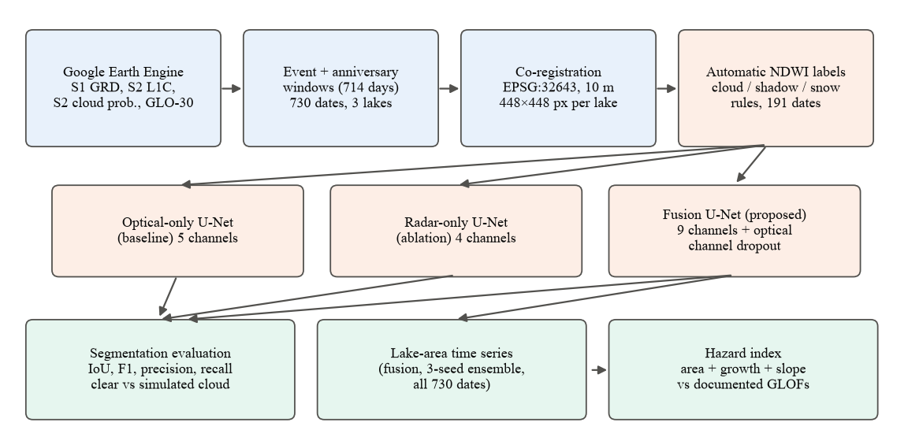
Fig. 1. Overview of the proposed pipeline. Blue: data acquisition and preparation; orange: labels and models; green: outputs. The optical-only and radar-only models are used for the comparison only; the fusion model (3-seed ensemble) produces the time series and hazard index. All models use a ResNet-18 encoder, balanced crop sampling and three training seeds.

1) Study sites:
The study covers three sites in the Hunza basin (Table IV, Fig. 2). Shishper and Khurdopin are the two event sites. For the Passu comparison site we verified on Sentinel-2 imagery that Passu Glacier has no persistent lake at its terminus during 2017–2022; the monitored water body is therefore Borith Lake, the perennial lake immediately south of the Passu Glacier terminus, which had no outburst in the study period. All site centres were located on the imagery because the approximate coordinates in our earlier project plan were 1–7 km off the lakes.
TABLE IV
STUDY SITES
Site | Lake type | Centre (lat, lon) | Documented event(s) | Role
Shishper | Ice-dammed (surging glacier blocks a side valley) | 36.358°N, 74.568°E | Repeated drainage from 2019 [4]; 29 May 2020; 7 May 2022 [5] | Event site
Khurdopin | Surge-dammed (Shimshal River) | 36.361°N, 75.449°E | Formed Mar 2017; drainage onset ≈ 21 Jul 2017, drained by 3 Aug 2017 [3] | Event site
Passu (Borith Lake) | Perennial lake beside Passu Glacier | 36.432°N, 74.862°E | No outburst during 2017–2022 | Comparison site

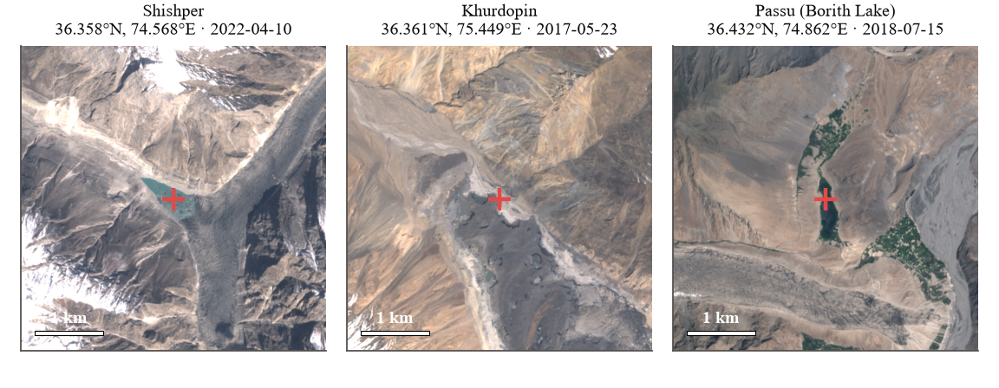
Fig. 2. The three 4.48 × 4.48 km study boxes (Sentinel-2 true colour). The cross marks the lake point used to identify the lake when measuring its area.

B. Model Architecture
All three models share the U-Net architecture shown in Fig. 3. The encoder is a ResNet-18 that reduces the input resolution in five steps (to 1/32) while increasing the number of feature channels to 512; residual connections make the encoder easy to optimise. The decoder upsamples in five steps, concatenating at each step the encoder feature map of the same resolution (skip connection) and applying two 3 × 3 convolutions with batch normalisation and ReLU. A final 1 × 1 convolution and a sigmoid output the per-pixel water probability.
Rationale. U-Net is the standard architecture for pixel-wise segmentation from limited labels, its skip connections preserve the sharp lake shorelines needed for accurate area, and it is the architecture used by the closest regional fusion study [12]. ResNet-18 was chosen over deeper encoders because the labelled set is small (137 training images) and training has to fit a free Colab GPU; with 14.3 M parameters the model trains in minutes. The encoder is initialised with ImageNet weights [28]; for inputs with more than three channels, the pretrained filters of the first convolution are cycled over the additional channels and rescaled (segmentation-models-pytorch default [29]), and all layers are fine-tuned.
Early fusion. In the fusion model the nine channels of Table V are stacked at the input, so the network learns joint optical–radar–terrain features from the first layer. Early fusion is the simplest fusion strategy, keeps the models architecturally identical (only the first convolution differs), and therefore isolates the effect of the inputs. A radar-only U-Net that receives only the four radar and terrain channels serves as an ablation: comparing it with the optical-only and fusion models shows whether fusion adds anything beyond each sensor alone. To make the fusion model usable on cloudy and radar-only dates, it is trained with optical-channel dropout: for 30% of training crops all five optical channels are set to zero, forcing the network to also learn to segment water from SAR and terrain alone.
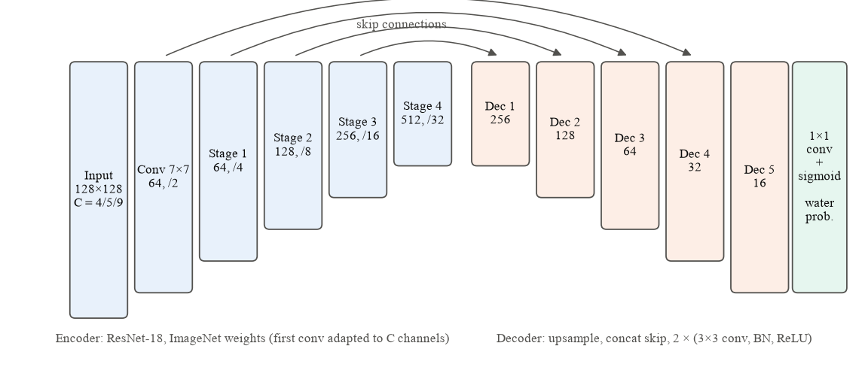
Fig. 3. U-Net with ResNet-18 encoder. Numbers give feature channels and down-sampling factor; C = 5 for the optical-only, C = 4 for the radar-only and C = 9 for the fusion model.
TABLE V
MODEL INPUT CHANNELS
# | Channel | Source | Unit / range | Optical | Radar | Fusion
1 | B2 (blue) | Sentinel-2 | TOA reflectance, 0–1 | ✓ |  | ✓
2 | B3 (green) | Sentinel-2 | TOA reflectance, 0–1 | ✓ |  | ✓
3 | B4 (red) | Sentinel-2 | TOA reflectance, 0–1 | ✓ |  | ✓
4 | B8 (NIR) | Sentinel-2 | TOA reflectance, 0–1 | ✓ |  | ✓
5 | NDWI | Derived from B3, B8 | −1 to 1 | ✓ |  | ✓
6 | VV backscatter | Sentinel-1 | dB |  | ✓ | ✓
7 | VH backscatter | Sentinel-1 | dB |  | ✓ | ✓
8 | Elevation | Copernicus DEM | m a.s.l. |  | ✓ | ✓
9 | Slope | Derived from DEM | degrees |  | ✓ | ✓

C. Dataset and Preprocessing

1) Data sources:
All data are open and accessed through the Earth Engine Python API (Table VI). Sentinel-2 Level-1C top-of-atmosphere reflectance is used instead of Level-2A surface reflectance because Level-2A coverage over the Karakoram is incomplete in 2017–2018, which includes the Khurdopin event. Sentinel-1 GRD scenes in Earth Engine are already calibrated, terrain-corrected and converted to decibels; we do not repeat these steps. For each site one orbit direction is used throughout (the direction with more scenes: ascending for Shishper, descending for Khurdopin and Passu) so that viewing geometry is constant.
TABLE VI
DATA SOURCES
Data | Earth Engine collection | Bands used | Resolution | Role
Sentinel-1 GRD [8] | COPERNICUS/S1_GRD | VV, VH (dB), IW mode | 10 m | Cloud-independent water signal
Sentinel-2 L1C [6] | COPERNICUS/S2_HARMONIZED | B2, B3, B4, B8 (TOA reflectance) | 10 m | Optical bands, NDWI, labels
S2 cloud probability [30] | COPERNICUS/S2_CLOUD_PROBABILITY | probability (%) | 10 m (from 20 m) | Cloud mask (not a label)
Copernicus DEM [31] | COPERNICUS/DEM/GLO30 | Elevation; slope (derived) | 30 m → 10 m | Terrain channels; slope rule; hazard feature

2) Temporal sampling:
Sentinel-2 revisits about every five days and Sentinel-1 every 6–12 days, so daily data do not exist. Instead, every acquisition is taken inside the windows of Table VII: a dense window from 90 days before to 45 days after each documented event, and ±15-day windows around each event's calendar date (7 May, 29 May and 21 July) in every year from 2017 to 2022. The same windows are applied to all three sites, so each site has observations in every event period and in the same season of years without an event. Every Sentinel-2 day whose mosaic covers at least 95% of the site box is downloaded and paired with the nearest Sentinel-1 scene within ±6 days; Sentinel-1 days without a Sentinel-2 acquisition are downloaded as radar-only dates. This yields 730 dates (Fig. 4, Table VIII). Sentinel-1B failed on 23 December 2021 [32], so radar coverage in 2022 is sparser.
TABLE VII
ACQUISITION WINDOWS (IDENTICAL FOR ALL SITES)
Window | Dates | Days | Purpose
Khurdopin event | 22 Apr – 4 Sep 2017 | 136 | 90 d before / 45 d after drainage onset (21 Jul 2017)
Shishper 2020 event | 29 Feb – 5 Aug 2020 | 159 | Around the 29 May 2020 drainage (merged with anniversary)
Shishper 2022 event | 6 Feb – 21 Jun 2022 | 136 | Around the 7 May 2022 GLOF
Anniversaries (May) | 22 Apr – 13 Jun, 2018, 2019, 2021 | 3 × 53 | Same season as the May events, no event
Anniversaries (July) | 6 Jul – 5 Aug, 2018, 2019, 2021, 2022 | 4 × 31 | Same season as the July event, no event
Total | 10 windows | 714 | Applied identically to all three sites

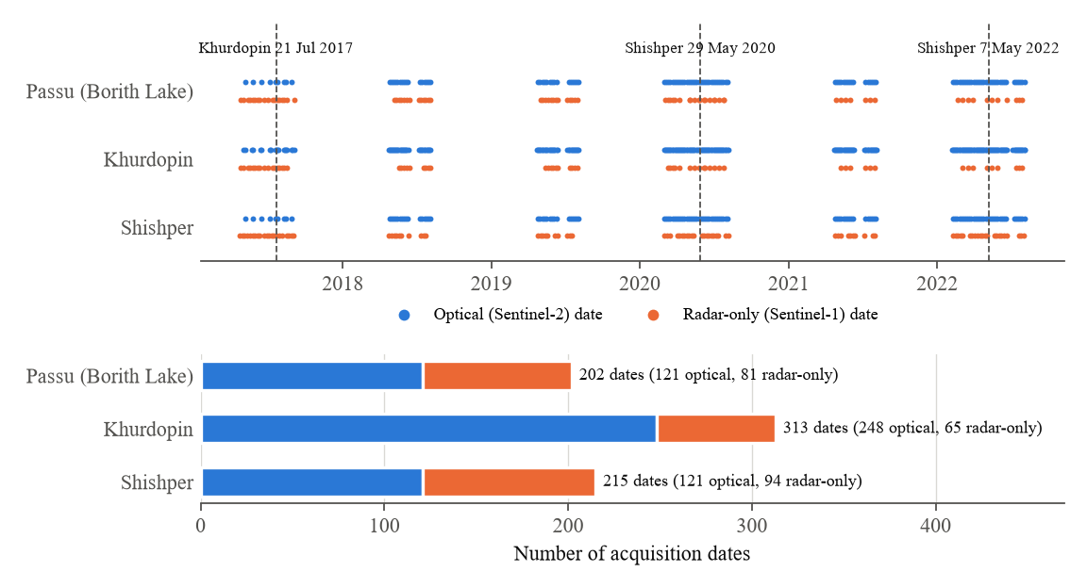
Fig. 4. Temporal sampling. Top: every acquisition date per site, split into optical (Sentinel-2) and radar-only (Sentinel-1) dates; dashed lines mark the documented events. Bottom: number of dates per site.

3) Co-registration:
For each site a 448 × 448 pixel box (4.48 × 4.48 km) centred on the lake point is defined on a 10 m grid in UTM zone 43N (EPSG:32643). All layers are requested from Earth Engine directly on this grid, so the modalities share CRS, transform, resolution and shape by construction. Same-day Sentinel-2 granules and same-pass Sentinel-1 slices are mosaicked. The 30 m DEM is resampled bilinearly (it is therefore not native 10 m terrain); other layers use nearest-neighbour resampling. Slope is computed from the DEM. Arrays are stored as float16 (cloud probability as uint8).

4) Cloud masking:
A pixel is treated as cloud when the Sentinel-2 cloud probability [30] is at least 60%. Cloud components smaller than 1,000 pixels (0.1 km²) are discarded because they are mostly false detections on bright rock and snow.

5) Automatic label generation:
No source provides lake outlines for the three sites at the event dates, and hand-digitising hundreds of dates was not feasible, so water labels are generated automatically from Sentinel-2 using NDWI [7]:
$NDWI = \frac{G − NIR}{G + NIR}$ (1)
where G and NIR are bands B3 and B8. A pixel is labelled water when NDWI > 0.2, NIR reflectance < 0.12 (excludes snow, ice and cloud), green reflectance > 0.03 (excludes deep shadow) and DEM slope < 20° (excludes steep shadowed cliffs); water components smaller than 50 pixels are removed. Only near-clear images are labelled: at most 10% cloud in the box and at most 40% very bright (snow or haze) pixels. Pixels within 150 m of cloud are marked ignore and excluded from the loss and from scoring. These thresholds were tuned by visual inspection of label overlays after a first version labelled cloud shadows as water. Of 490 optical dates, 191 received labels (Table VIII); Fig. 5 shows examples. Frozen or snow-covered lake surfaces are labelled as land, which is a known limitation of this labelling strategy.
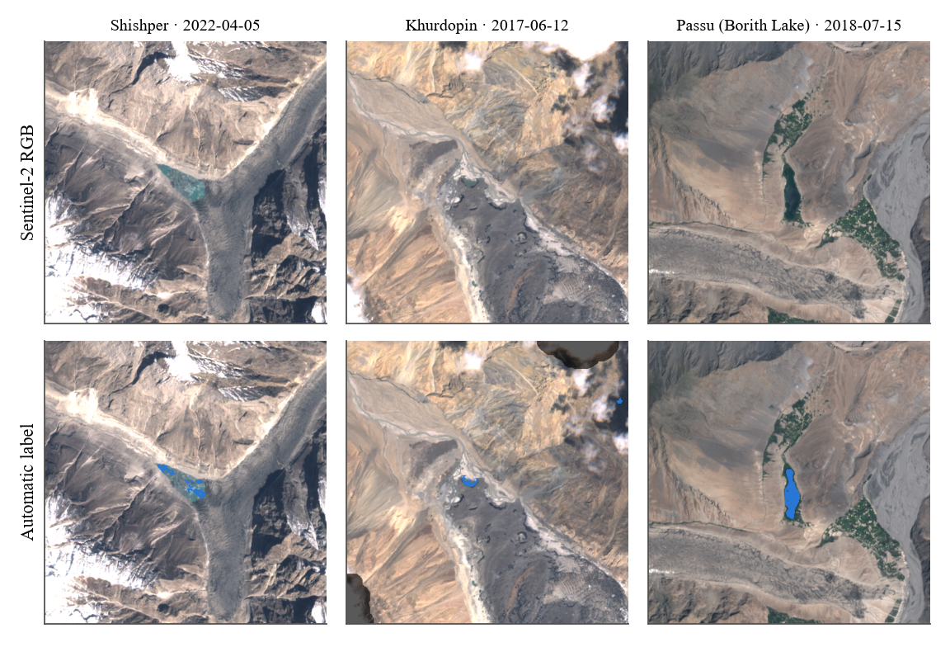
Fig. 5. Examples of automatic labels (blue = water, darkened = cloud buffer, ignored). Shishper lake before the 2022 GLOF, the Khurdopin dammed lake in June 2017, and Borith Lake.

6) Input normalisation:
Each channel is standardised with the mean and standard deviation computed on 60 randomly sampled training images. After standardisation, the optical channels are set to zero (the channel mean) wherever the cloud mask is set and on radar-only dates, and missing values (e.g. no Sentinel-1 scene within ±6 days) are set to zero.

7) Train / test split:
Neighbouring dates of the same lake are nearly identical, so a random split would leak information. The split is therefore by year: labelled dates from 2019 and 2021 form the test set (54 images) and those from 2017, 2018, 2020 and 2022 form the training set (137 images; Table VIII). No separate validation set is used: hyper-parameters were fixed in advance, the learning-rate schedule is fixed, and no early stopping or model selection is performed, so the test years are never used for any training decision.
TABLE VIII
DATASET COMPOSITION AND YEAR-WISE SPLIT
Site | Dates (all) | Optical / radar-only | Labelled | Train (2017, 2018, 2020, 2022) | Test (2019, 2021)
Shishper | 215 | 121 / 94 | 40 | 27 | 13
Khurdopin | 313 | 248 / 65 | 99 | 73 | 26
Passu (Borith) | 202 | 121 / 81 | 52 | 37 | 15
Total | 730 | 490 / 240 | 191 | 137 | 54

8) Augmentation:
Training uses 128 × 128 crops from the full site images — half of them centred on a random lake-water pixel (Section III-D) — with random horizontal and vertical flips. The fusion model additionally uses optical-channel dropout (Section III-B). Rotations by arbitrary angles are not used because SAR geometry depends on the look direction.

D. Training Configuration
All three models use the configuration in Table IX. The loss combines binary cross-entropy and soft Dice and is computed only over valid (non-ignored) pixels; with p the predicted probability, y the label and m the validity mask:
$ℒ = \frac{Σ m·BCE(p, y)}{N} + 1 − \frac{2 Σ m·p·y + 1}{Σ m·p + Σ m·y + 1}$ (2)
The Dice term counteracts the strong class imbalance (lake water occupies a few percent of each image), while the cross-entropy term provides stable per-pixel gradients. Training stability is supported by ImageNet initialisation, cosine learning-rate annealing, which lowers the step size smoothly towards the end of training, the masked loss, which prevents cloud pixels with unreliable labels from producing gradients, and data augmentation. Optical-channel dropout also acts as a regulariser that prevents the fusion model from relying on NDWI alone.
Balanced sampling and seeds. In preliminary single-seed runs, models sometimes converged to predicting no water anywhere — lake water covers well under 1% of the pixels and most random crops contain none — and results changed substantially between otherwise identical runs. We therefore centre half of the training crops on a randomly chosen lake-water pixel (balanced crop sampling; 74 of the 137 training images contain water) and train every model with three seeds. Each seed has its own random-number generator, so the batches seen by one model do not depend on which models were trained before it. Results are reported as mean ± standard deviation across seeds, and the mean predicted probability of the three fusion seeds (an ensemble) is used for the time series.
TABLE IX
TRAINING CONFIGURATION
Setting | Value
Framework | PyTorch [33] + segmentation-models-pytorch [29]
Architecture | U-Net, ResNet-18 encoder (ImageNet weights [28]), 1 output channel
Input channels | 5 (optical-only) / 4 (radar-only) / 9 (fusion)
Training input | 128 × 128 crops of the 448 × 448 site images: 50% centred on a random lake-water pixel (balanced sampling), 50% random
Batch size | 16
Iterations | 3,000 on GPU (≈ 29 epoch-equivalents of 137 images); 1,500 if run on CPU
Optimiser | Adam [34], initial learning rate 1 × 10⁻³, no weight decay
LR schedule | Cosine annealing to 0 over all iterations [35]
Loss | Masked binary cross-entropy + soft Dice [36] (cloud pixels ignored)
Augmentation | Random horizontal and vertical flips (p = 0.5 each)
Optical-channel dropout | Fusion only: all 5 optical channels zeroed for 30% of crops
Decision threshold | 0.5 on the sigmoid output
Random seeds | 3 per model (0, 1, 2); PyTorch seed and a separate NumPy generator per seed
Time-series prediction | Fusion model, mean probability of its 3 seeds (ensemble)
Hardware | Google Colab, NVIDIA Tesla T4 GPU (16 GB)

E. Evaluation Metrics

1) Segmentation:
Predictions are evaluated on the valid (non-cloud) pixels of the test images using intersection-over-union (IoU), F1-score (Dice), precision and recall, with TP, FP and FN the numbers of true-positive, false-positive and false-negative water pixels:
$IoU = \frac{TP}{TP + FP + FN}, F1 = \frac{2TP}{2TP + FP + FN}$ (3)
$Precision = \frac{TP}{TP + FP}, Recall = \frac{TP}{TP + FN}$ (4)
IoU is the standard segmentation metric and directly reflects errors in lake extent, which is the quantity used downstream. F1 is reported for comparability with the literature reviewed in Section II. Precision and recall separate over-detection (e.g. shadows or wet ice classified as water) from under-detection (e.g. turbid or partly frozen lakes). Overall accuracy is not used because it would be dominated by the land class. Many test images contain no lake water (Khurdopin after 2017, Shishper after each drainage); per-image IoU is undefined for them, and averaging it would score a correct "no water" prediction as zero. The main results are therefore pixel-pooled metrics, for which TP, FP and FN are summed over all test pixels of a site (or of all sites) before the metric is computed. Pixel-pooled metrics are computed separately for each training seed and reported as mean ± standard deviation across the three seeds. In addition, per-image metrics are reported as mean ± standard deviation over the test images that contain water (pooled over seeds), and the false-positive area is reported for test images without water.

2) Robustness to missing optical data:
To test the cloud-robustness motivation directly, the models are also evaluated after setting all optical channels of the test images to zero (simulated complete cloud cover), using the same labels. The optical-only model then receives no information, the fusion model can use SAR and terrain, and the radar-only model is unaffected because it never sees optical data.

3) Time series:
The fusion model (mean probability of its three seeds) is applied to all 730 dates. Lake area Aₜ on date t is the number of predicted water pixels in connected components that touch a 400 m neighbourhood of the lake point, multiplied by the pixel area (100 m²); this excludes rivers and other water in the box. Area is smoothed with a centred rolling median over three observations (Ãₜ), and the growth rate is computed over roughly 30 days:
$G_{t} = \frac{Ã_{t} − Ã_{t′}}{t − t′} × 30$ (5)
where t′ is the latest date at least 30 days before t; growth is not computed when t − t′ exceeds 60 days (gaps between windows).

4) Hazard index:
Following the multi-criteria idea of Muneeb et al. [14] in a reduced, transparent form, the hazard index combines three features: smoothed lake area, positive growth rate and the mean DEM slope along the lake outline. Each is min–max normalised over all sites and dates to give a, g and s in [0, 1], and the index is their equal-weight mean:
$H_{t} = \frac{a_{t} + g_{t} + s_{t}}{3}$ (6)
Equal weights are a modelling assumption, not fitted to the events. For each documented event the index of all three sites is compared over the 90 days before the event date (mean and maximum), and plotted against days relative to the event. This is a retrospective evaluation, not an early-warning system.

IV. EXPERIMENTS AND RESULTS
The experiments are organised around the research questions (Table X). All experiments use the data, split and configuration of Section III. The three models were each trained with three seeds on a Google Colab NVIDIA Tesla T4 GPU with identical settings and data; they differ only in their input channels and in the optical-channel dropout of the fusion model. Unless stated otherwise, values are means ± standard deviations across the three seeds.
TABLE X
OVERVIEW OF EXPERIMENTS
ID | Experiment | Purpose | RQ
E1 | Data availability and reference series | Characterise the sampled data and the label-derived reference lake areas | RQ2
E2 | Optical-only vs radar-only vs fusion | Compare the three U-Nets on held-out years (3 seeds each) | RQ1
E3 | Simulated complete cloud cover | Test segmentation when all optical channels are removed | RQ1
E4 | Lake-area time series | Track lake area with the fusion ensemble on all 730 dates | RQ2
E5 | Hazard-index behaviour | Compare the index of event and comparison sites before each event | RQ3

A. E1: Data Availability and Reference Series
Purpose: to characterise the data available around each event and to establish a model-independent reference. The download produced 730 dates: 215 for Shishper (121 optical, 94 radar-only), 313 for Khurdopin (248 optical, 65 radar-only) and 202 for Passu/Borith Lake (121 optical, 81 radar-only) (Fig. 4). Khurdopin has about twice as many optical dates as the other sites, most likely because it lies where adjacent Sentinel-2 orbits overlap. Radar-only dates make up 33% of all dates. Only 191 of 490 optical dates (39%) are clear enough to be labelled, which quantifies how strongly cloud and snow limit optical monitoring in these windows.
Fig. 6 shows the lake area measured directly from the automatic labels (clear dates only). The documented events are already visible (Table XI): the Shishper lake had water on 30 April 2022 and none on 10 May 2022, three days after the 7 May GLOF; it had water on 25 May 2020 and none by 29 June 2020; and the Khurdopin lake was present from late May to 12 June 2017 and gone by 27 July 2017. The Shishper lake also held water in May 2019 and was empty by late July 2019, consistent with its repeated drainage [4]. Borith Lake stayed between 0.075 and 0.121 km² (interquartile range). Label-derived areas underestimate the event lakes because frozen and very turbid parts of the lakes are not labelled as water.
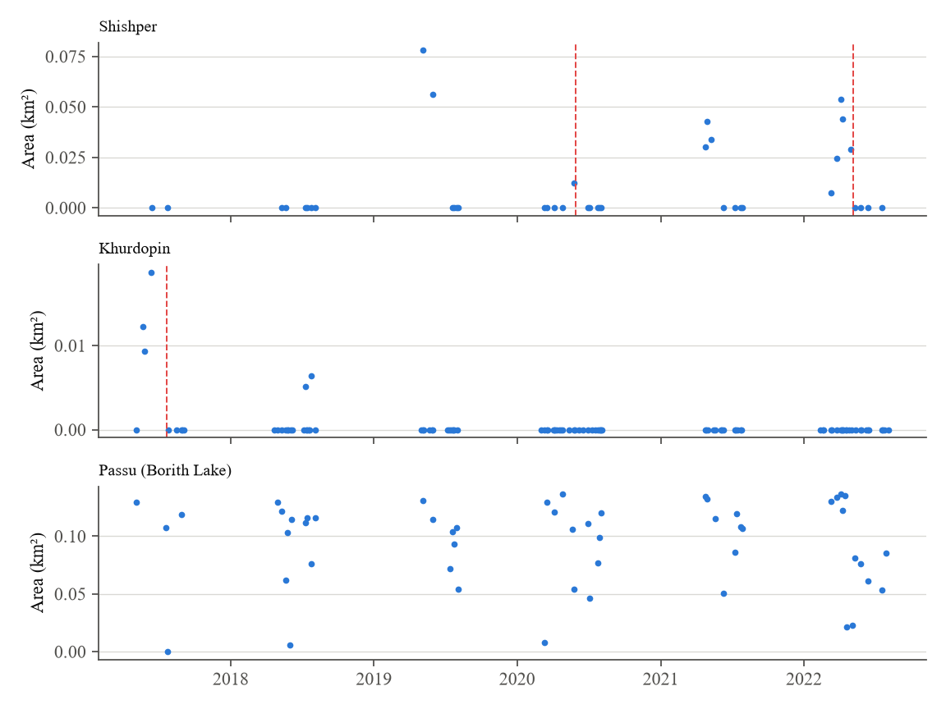
Fig. 6. Reference lake area derived from the automatic labels (clear optical dates only). Dashed red lines mark documented events (Khurdopin 21 Jul 2017; Shishper 29 May 2020 and 7 May 2022).
TABLE XI
LABEL-DERIVED LAKE AREA AROUND DOCUMENTED EVENTS
Event | Last labelled water before event | First labelled date after event
Khurdopin drainage, 21 Jul 2017 | 12 Jun 2017: 0.019 km² | 27 Jul 2017: 0 km²
Shishper drainage, 29 May 2020 | 25 May 2020: 0.012 km² | 29 Jun 2020: 0 km²
Shishper GLOF, 7 May 2022 | 30 Apr 2022: 0.029 km² (max 0.054 km² on 5 Apr) | 10 May 2022: 0 km²
Borith Lake (comparison) | Median 0.107 km² (IQR 0.075–0.121), 52 dates | No event

B. E2: Optical-only, Radar-only and Fusion Models
Purpose: to answer the first part of RQ1. Of the 54 held-out images from 2019 and 2021, 31 contain lake water and 23 do not. Table XII reports pixel-pooled metrics over all test images, Table XIII the IoU of every seed and of the 3-seed ensemble, Table XIV and Fig. 7 the pooled IoU per site, Table XV per-image metrics on the images that contain water, and Table XVI false positives on the images without water.
The fusion model is the best model on every metric under clear conditions, with a pixel-pooled IoU of 0.778 ± 0.005 (F1 0.875), against 0.521 ± 0.214 for the optical-only model and 0.487 ± 0.007 for the radar-only model. It is also the most stable: its three seeds lie between 0.773 and 0.782, whereas one optical-only seed reached only 0.275 against 0.645 and 0.644 for the other two. The fusion model combines the higher recall of optical data (0.896) with the higher precision of the radar-and-terrain model (0.856 versus 0.702), while the optical-only model has the lowest precision (0.643) and produces false positives on the most water-free images (6.3 of 23 on average). Per site, the fusion model is best everywhere, and its advantage is largest on the two event lakes: Shishper 0.601 against 0.155 (optical-only) and 0.082 (radar-only), and Khurdopin 0.513 against 0.251 and 0.000. On Borith Lake all models perform better (fusion 0.870, optical-only 0.690, radar-only 0.610). Averaging the three seeds' probabilities (ensemble) changes the results little for the fusion model (0.785) but raises the optical-only model to 0.650, because it removes the effect of the failed seed.
TABLE XII
PIXEL-POOLED SEGMENTATION RESULTS ON HELD-OUT YEARS (ALL 54 TEST IMAGES; MEAN ± SD OVER 3 SEEDS)
Condition | Model | IoU | F1 | Precision | Recall
Clear | Optical-only (5 ch) | 0.521 ± 0.214 | 0.666 ± 0.204 | 0.643 ± 0.293 | 0.752 ± 0.011
Clear | Radar-only (4 ch) | 0.487 ± 0.007 | 0.655 ± 0.006 | 0.702 ± 0.035 | 0.615 ± 0.020
Clear | Fusion (9 ch) | 0.778 ± 0.005 | 0.875 ± 0.003 | 0.856 ± 0.023 | 0.896 ± 0.019
Simulated cloud | Optical-only (5 ch) | 0.000 ± 0.000 | 0.000 ± 0.000 | 0.000 ± 0.000 | 0.000 ± 0.000
Simulated cloud | Radar-only (4 ch) | 0.487 ± 0.007 | 0.655 ± 0.006 | 0.702 ± 0.035 | 0.615 ± 0.020
Simulated cloud | Fusion (9 ch) | 0.503 ± 0.015 | 0.669 ± 0.013 | 0.788 ± 0.028 | 0.581 ± 0.014
Best value per condition in bold. Clear = original inputs; simulated cloud = all five optical channels set to zero. The radar-only model has no optical inputs, so its two rows are identical.
TABLE XIII
PIXEL-POOLED IOU PER TRAINING SEED AND OF THE 3-SEED ENSEMBLE
Condition | Model | Seed 0 | Seed 1 | Seed 2 | 3-seed ensemble
Clear | Optical-only | 0.645 | 0.644 | 0.275 | 0.650
Clear | Radar-only | 0.479 | 0.492 | 0.489 | 0.497
Clear | Fusion | 0.773 | 0.779 | 0.782 | 0.785
Simulated cloud | Radar-only | 0.479 | 0.492 | 0.489 | 0.497
Simulated cloud | Fusion | 0.516 | 0.505 | 0.486 | 0.512

TABLE XIV
PIXEL-POOLED IOU PER SITE (MEAN ± SD OVER 3 SEEDS)
Site (test images / with water) | Optical, clear | Radar-only | Fusion, clear | Fusion, sim. cloud
Shishper (13 / 8) | 0.155 ± 0.039 | 0.082 ± 0.041 | 0.601 ± 0.007 | 0.065 ± 0.013
Khurdopin (26 / 8) | 0.251 ± 0.011 | 0.000 ± 0.000 | 0.513 ± 0.046 | 0.000 ± 0.000
Passu / Borith (15 / 15) | 0.690 ± 0.306 | 0.610 ± 0.020 | 0.870 ± 0.003 | 0.643 ± 0.022
All sites (54 / 31) | 0.521 ± 0.214 | 0.487 ± 0.007 | 0.778 ± 0.005 | 0.503 ± 0.015

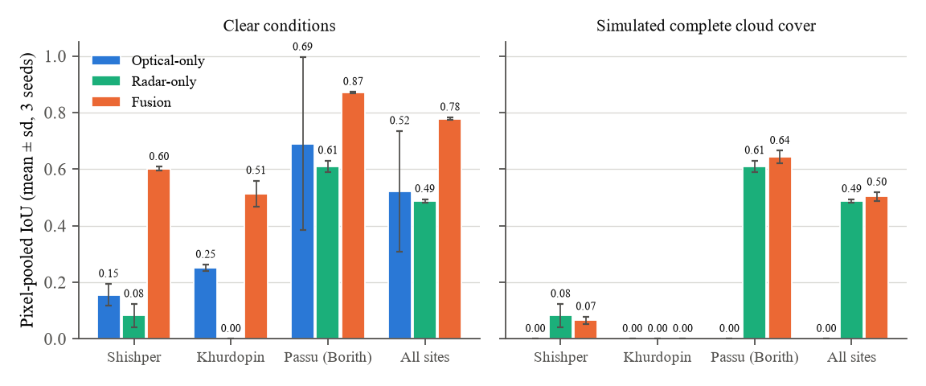
Fig. 7. Pixel-pooled IoU per site (mean ± sd over three seeds) of the optical-only, radar-only and fusion models under clear conditions and with all optical channels removed (simulated complete cloud cover).
TABLE XV
PER-IMAGE RESULTS ON THE 31 TEST IMAGES CONTAINING WATER (MEAN ± SD OVER IMAGES AND SEEDS)
Condition | Model | IoU | F1 | Precision | Recall
Clear | Optical-only | 0.493 ± 0.340 | 0.586 ± 0.336 | 0.581 ± 0.333 | 0.682 ± 0.347
Clear | Radar-only | 0.327 ± 0.316 | 0.408 ± 0.365 | 0.439 ± 0.365 | 0.450 ± 0.428
Clear | Fusion | 0.704 ± 0.217 | 0.804 ± 0.180 | 0.782 ± 0.195 | 0.853 ± 0.155
Simulated cloud | Fusion | 0.324 ± 0.345 | 0.388 ± 0.394 | 0.433 ± 0.409 | 0.409 ± 0.437

TABLE XVI
FALSE POSITIVES ON THE 23 TEST IMAGES WITHOUT WATER
Condition | Model | Images without water | Images with any false positive (mean of 3 seeds) | Mean false-positive area (km²)
Clear | Optical-only | 23 | 6.3 | 0.0114
Clear | Radar-only | 23 | 2.0 | 0.0003
Clear | Fusion | 23 | 3.3 | 0.0002
Simulated cloud | Optical-only | 23 | 0 | 0
Simulated cloud | Fusion | 23 | 0 | 0

C. E3: Robustness to Simulated Cloud Cover
Purpose: to answer the second part of RQ1. With all optical channels removed, the optical-only model predicts no water at all, whereas the fusion model retains a pixel-pooled IoU of 0.503 ± 0.015 — 65% of its clear-condition value — with high precision (0.788) and moderate recall (0.581), and no false positives on images without water. This is close to, and slightly above, the radar-only model (0.487 ± 0.007): without optical inputs the fusion model behaves like a radar model, which is what optical-channel dropout trains it to do. The robustness is strongly site-dependent (Table XIV): on Borith Lake the fusion model keeps an IoU of 0.643 (radar-only 0.610), but on the small event lakes neither radar-based model works without optical data (Shishper 0.065 and 0.082; Khurdopin 0 for both).

D. Qualitative Results
Fig. 8 shows the 3-seed ensemble predictions of all models on four held-out dates. On Shishper (6 May 2019) the automatic label covers only part of the turquoise lake; the fusion model detects the main lake body most completely, the optical-only model captures a smaller part of it, and the radar-only model detects only small fragments. With optical inputs removed, the fusion model still finds a small part of the lake. On Khurdopin (26 July 2021) the label contains only a tiny water patch on the river at the image edge, which only the fusion model detects. On Borith Lake (29 July 2021) all models match the label closely; without optical inputs the fusion model recovers the lake outline with one small false positive at the image edge, and the radar-only model adds a few small false detections on the river. On the drained Shishper lake (25 July 2019) all models correctly predict no water.
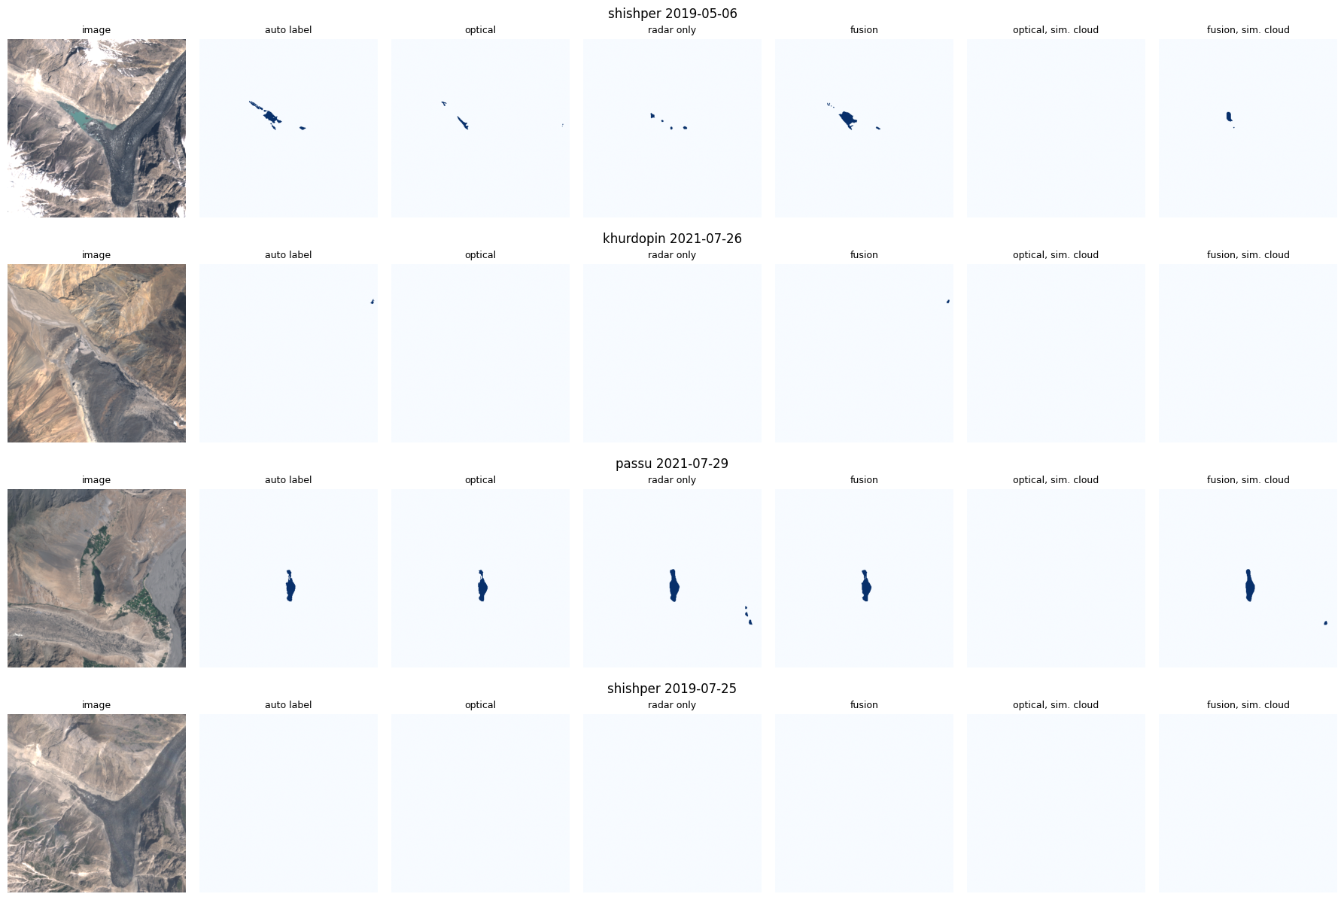
Fig. 8. Qualitative results on held-out dates (3-seed ensembles). Columns: Sentinel-2 image, automatic label, optical-only, radar-only and fusion predictions, and the optical-only and fusion models with all optical channels removed (simulated cloud).

E. E4: Lake-Area Time Series
Purpose: to answer RQ2. Fig. 9 shows the lake area derived by the fusion ensemble for all 730 dates, coloured by data source, and Table XVII summarises the series. At Shishper, lake water appears on spring dates before each event — about 0.02 km² in April 2020 and 0.02–0.04 km² in March–April 2022 — and the area is zero on every date after 29 May 2020 and after 7 May 2022, apart from one cloudy-date detection of about 0.024 km² in June 2022. The lake also appears in May 2019 (up to about 0.09 km²) and spring 2021 (about 0.04–0.05 km²) and is gone by mid-summer in both years; in May 2019 and spring 2022 some radar-only dates also detect it. At Khurdopin, 0.01–0.02 km² are detected in May–June 2017 and nothing after the July 2017 drainage apart from isolated detections below 0.01 km². Borith Lake is detected at 0.10–0.15 km² on most dates, with optical and radar-only dates now in agreement, and with drops on several early-spring dates when the lake is frozen or snow-covered. A single cloudy date in April 2020 gives a spurious 0.10 km² at Shishper.
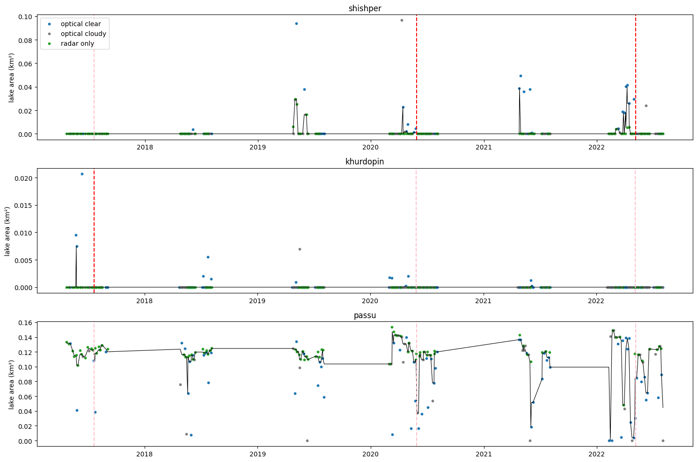
Fig. 9. Lake area from the fusion model (3-seed ensemble) at the three sites (points coloured by source: optical clear, optical cloudy, radar only; black line: 3-point rolling median). Red dashed lines: events at that site; pink: events at the other sites.
TABLE XVII
SUMMARY OF LAKE-AREA TIME SERIES (FUSION ENSEMBLE; AREAS READ FROM THE SERIES IN THE CORRESPONDING FIGURE)
Site | Dates: optical clear / cloudy / radar-only | Lake area before event (fusion ensemble) | After event
Shishper | 56 / 65 / 94 | ≈ 0.02 km² (Apr 2020); ≈ 0.02–0.04 km² (Mar–Apr 2022) | 0 on all dates after 29 May 2020 and after 7 May 2022 (one cloudy-date detection of ≈ 0.024 km² in Jun 2022)
Khurdopin | 127 / 121 / 65 | ≈ 0.01–0.02 km² (May–Jun 2017) | 0 after Jul 2017; only isolated detections < 0.01 km² in later years
Passu (Borith) | 67 / 54 / 81 | 0.10–0.15 km² on most dates (no event) | —

F. E5: Hazard-Index Behaviour
Purpose: to answer RQ3. Fig. 10 plots the main hazard index of all three sites against days relative to each event, and Table XVIII reports its mean and maximum over the 90 days before each event. The event site did not score highest in any window: Borith Lake had the highest mean and maximum before the Shishper 2020 event (0.479 and 0.626, against 0.200 and 0.313 for Shishper), before the Shishper 2022 GLOF (0.419 and 0.864, against 0.223 and 0.470) and before the Khurdopin 2017 drainage (0.453 and 0.516, against 0.193 and 0.243 for Khurdopin). Shishper's index nevertheless rose clearly above its baseline in the weeks before both of its events, peaking about 22 days before the 2022 GLOF.
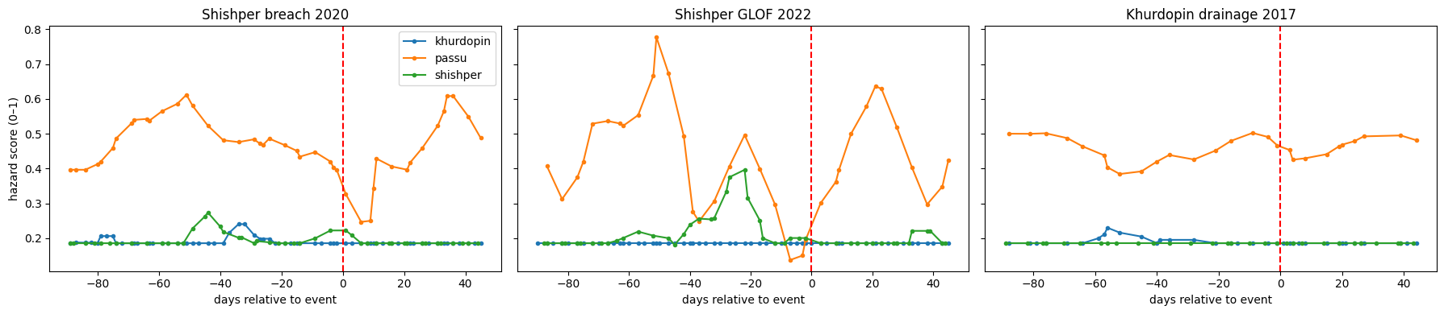
Fig. 10. Main hazard index (area, growth and slope, min–max normalised across all sites) of the three sites in the 90 days before and 45 days after each documented event (3-point rolling mean).
Exploratory follow-up. Because the main index compares absolute lake areas across lakes, we added — after seeing the result above — a per-lake index that compares each lake with its own normal state (mean of the within-lake z-scores of smoothed area and positive growth; slope omitted). This analysis was not planned and is reported as exploratory. With it, the event lake reaches the highest maximum in all three windows (Table XVIII, Fig. 11): Shishper 4.446 before the 2020 event (Borith 1.172), Shishper 7.079 before the 2022 GLOF (Borith 3.231) and Khurdopin 17.619 before the 2017 drainage (Borith 0.439). The event lake also has the highest mean before the 2022 and 2017 events, but not before the 2020 event (Borith 0.153 against −0.015). The peaks occur about 40 days (Shishper 2020), 22 days (Shishper 2022) and 55 days (Khurdopin 2017) before the events.
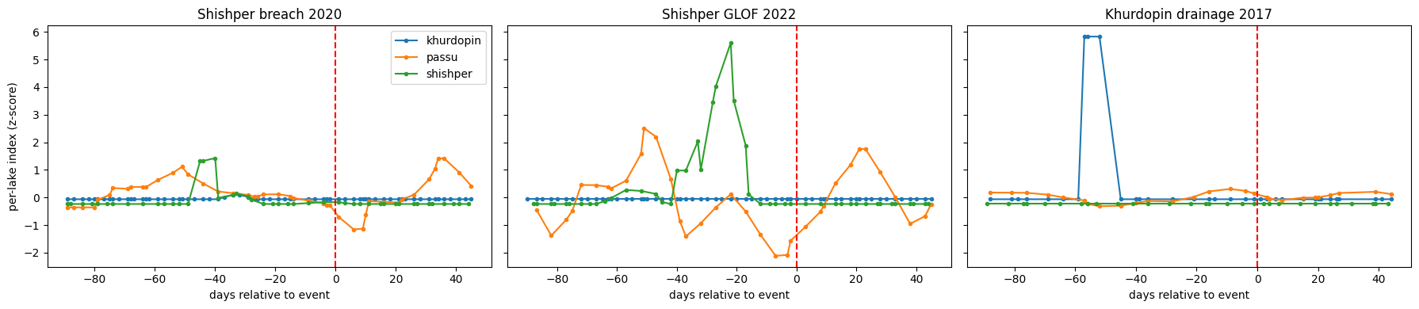
Fig. 11. Exploratory per-lake hazard index (within-lake z-scores of area and positive growth) of the three sites around each documented event (3-point rolling mean).
TABLE XVIII
HAZARD INDICES IN THE 90 DAYS BEFORE EACH EVENT
Event window (90 d before) | Site | Main index: mean | Main index: max | Per-lake index: mean | Per-lake index: max
Khurdopin 2017 | Khurdopin (event) | 0.193 | 0.243 | 0.781 | 17.619
 | Shishper | 0.185 | 0.185 | −0.233 | −0.233
 | Passu (Borith) | 0.453 | 0.516 | 0.009 | 0.439
Shishper 2020 | Shishper (event) | 0.200 | 0.313 | −0.015 | 4.446
 | Khurdopin | 0.192 | 0.276 | −0.050 | 0.179
 | Passu (Borith) | 0.479 | 0.626 | 0.153 | 1.172
Shishper 2022 | Shishper (event) | 0.223 | 0.470 | 0.660 | 7.079
 | Khurdopin | 0.185 | 0.185 | −0.061 | −0.061
 | Passu (Borith) | 0.419 | 0.864 | −0.229 | 3.231
Highest value per event window and index in bold. Per-lake index: exploratory analysis added after the main result.

G. Computational Performance
Table XIX lists model size and run times. The three models have practically the same size — they differ only in the number of input channels of the first convolution — and train in about three minutes per seed on a T4 GPU, so the accuracy and stability gained by fusion come at no meaningful computational cost (5% longer training, 2.5 ms more per image). The full experiment (nine training runs, evaluation and time series) runs in about 35 minutes on a free Colab GPU; on a 4-thread laptop CPU a training step takes about 2.6 s, which makes CPU training impractical.
TABLE XIX
COMPUTATIONAL COST
Quantity | Optical-only | Radar-only | Fusion
Input channels | 5 | 4 | 9
Trainable parameters | 14,334,481 | 14,331,345 | 14,347,025
Training time per seed, 3,000 iterations (T4 GPU) | 3.11 ± 0.02 min | 3.10 ± 0.00 min | 3.25 ± 0.00 min
Inference per 448 × 448 image (T4 GPU) | 26.3 ms | 26.0 ms | 28.8 ms
Peak GPU memory during training* | 0.83 GB | 1.18 GB | 1.53 GB
Training step, batch 16 (4-thread CPU) | ≈ 2.6 s | ≈ 2.6 s | ≈ 2.6 s
Data download (Earth Engine, 730 dates) | ≈ 13 min (shared)
*Peak memory was measured while models trained earlier in the same session were still held in GPU memory, so it increases with training order (optical, radar, fusion) and overstates the per-model requirement.

H. Results Summary
The fusion model achieved the best segmentation at every site and on every metric under clear conditions (pixel-pooled IoU 0.778 ± 0.005, F1 0.875), ahead of the optical-only (0.521 ± 0.214) and radar-only (0.487 ± 0.007) models, and it was the most stable across seeds. With all optical inputs removed it retained an IoU of 0.503, slightly above the radar-only model, while the optical-only model failed; no model detected the small event lakes from radar alone (RQ1). The fusion-ensemble time series reproduced the timing of the Shishper drainages of May 2020 and May 2022 and the Khurdopin drainage of July 2017 (RQ2). The main hazard index ranked the comparison lake highest in all three pre-event windows, whereas an exploratory per-lake index peaked at the event lake before all three events (RQ3).

V. DISCUSSION

A. Interpretation of Findings
Fusion versus single sensors. The fusion model is better than both single-sensor models, not just better than the weaker of the two, which shows that optical and radar–terrain inputs are complementary for this task. The optical-only model finds lake water readily (recall 0.752) but also marks dark streams, wet debris and shadowed slopes as water (precision 0.643, false positives on 6.3 of 23 water-free images). The radar-and-terrain model is more precise (0.702) but misses much of the water (recall 0.615), especially on small and turbid lakes. Fusion keeps the strengths of both (precision 0.856, recall 0.896). The gain is largest at Shishper and Khurdopin, where the lakes are small, turbid or partly frozen and sit next to steep, shadowed slopes — exactly where optical reflectance alone is ambiguous.
A caveat on the clear-sky comparison. Part of this advantage has a less favourable explanation. The automatic labels include a terrain rule (slope < 20°), and only the radar-only and fusion models receive slope as an input. They can therefore learn this part of the labelling rule directly, while the optical-only model must infer it from reflectance. The labels also derive from optical NDWI, which favours the optical inputs. The clear-sky comparison is thus measured against labels that partly mirror each model's inputs; independent, hand-drawn reference masks would be needed to separate genuine skill from agreement with the labelling rules.
Stability. Lake water covers well under 1% of the pixels. In our first single-seed runs this let models converge to predicting no water anywhere, and results changed substantially between otherwise identical runs: the fusion model's IoU under simulated cloud was 0.33 in one run and 0 in another. Balanced crop sampling and three seeds made the fusion and radar-only models stable (seed standard deviations of 0.005 and 0.007), but one optical-only seed still partly failed (IoU 0.275). Single-run comparisons of segmentation models on data this imbalanced should therefore be treated with caution, and reporting several seeds is necessary rather than optional.
Robustness to missing optical data. Without optical inputs the fusion model performs almost exactly like the radar-only model (0.503 against 0.487), which is what optical-channel dropout trains it to do: in a third of training crops it must segment water from VV, VH and terrain alone. Calm open water is a specular reflector and appears dark in radar, and the DEM restricts plausible water to low-slope valley floors, so Borith Lake — a larger perennial lake with calm water — is still segmented well (0.643). The small event lakes are not: they are only about 0.01–0.10 km² and narrow relative to 10 m radar pixels and speckle, lie in deep valleys with radar shadow and layover, and are often partly frozen, turbid or wind-roughened, which raises backscatter. Fusion therefore removes the complete dependence on clear skies for lakes like Borith Lake, but not yet for the small lakes that actually produced the floods.
Event-scale tracking. The fusion-ensemble series reproduce the timing of all three documented drainages, in agreement with the label-derived reference and the documented events [3], [4], [5]: the Shishper lake fills in spring and its area falls to zero immediately after 29 May 2020 and 7 May 2022, and the Khurdopin lake disappears after July 2017. Optical and radar-only dates agree at Borith Lake, and some radar-only dates detect the Shishper lake, which adds observations during cloudy periods. The detected areas of the event lakes remain smaller than their visible extent because the labels — and therefore the models — exclude frozen and very turbid water.
Hazard index. The main index did not separate the event lakes from the comparison site, because each feature is min–max normalised across all sites: the area term is dominated by Borith Lake, the largest lake, whether or not it is changing, and fluctuations in its series register as growth. Comparing each lake with its own normal state reverses the picture: in the exploratory per-lake index the event lake has the highest peak before all three events, driven by the rapid spring growth of the Shishper lake in 2020 and 2022 and the appearance of the Khurdopin lake in 2017. This supports the view that change relative to a lake's own baseline, rather than absolute size, is the relevant hazard signal. The result must, however, be read with care. The per-lake index was designed after the main result was known, and z-scores are naturally large for lakes that are usually empty, so for Khurdopin the index largely signals that a lake exists at all. It is a hypothesis to be tested on other lakes, not a validated method.

B. Relation to the Objectives
Objective (i) — a reproducible multi-sensor pipeline — was achieved: 730 co-registered dates over 714 days of windows were retrieved for three sites from Google Earth Engine in about 13 minutes, and the complete experiment runs in about 35 minutes on a free Colab GPU. Objective (ii) — comparing optical-only, radar-only and fusion U-Nets — was achieved under identical conditions with three seeds per model: fusion is the most accurate and most stable model at every site (IoU 0.778 against 0.521 and 0.487), and the only optical-capable model that still works without optical data (0.503). Objective (iii) — lake-area time series — was achieved for all sites, and the series capture the timing of all three documented drainages. Objective (iv) — a transparent hazard index — was implemented with equal weights over three features. Objective (v) — retrospective evaluation against the documented events — was not met by the main index, which ranked the comparison site highest in all three windows; an exploratory per-lake index met it for the peak values in all three windows, but this needs confirmation on independent events.

C. Limitations
- Automatic labels. Labels come from optical NDWI and terrain rules rather than manual digitisation. They miss frozen and very turbid lake surfaces, may include small wet-ice or shadow patches, and share information with the model inputs (NDWI with the optical models; slope with the radar-only and fusion models). No manual reference masks were produced to quantify label error.
- Small and imbalanced data. 191 labelled images from three sites; only 31 of the 54 test images contain water, and the event lakes are small. Results may not generalise to other lake types or valleys.
- No validation set. Hyper-parameters were fixed in advance and no early stopping or model selection was performed; three seeds quantify training variability, but not sensitivity to hyper-parameters.
- Comparison site. Passu Glacier had no persistent lake in 2017–2022, so Borith Lake was used; it is a larger perennial lake of different origin, which also affects the cross-site normalisation of the main hazard index.
- Radar processing. No speckle filtering or radar shadow/layover masking was applied to Sentinel-1, and Sentinel-1B's failure in December 2021 reduced radar sampling in 2022.
- Other data limitations. The 30 m DEM is resampled to 10 m, and Sentinel-2 L1C top-of-atmosphere reflectance is not atmospherically corrected.
- Hazard index. Equal weights and three features are assumptions, not calibrated values; only three events are available; the evaluation is retrospective and the per-lake index is post hoc. Neither index is an early-warning system.

D. Future Work
- Manually digitise 10–20 reference masks per site, including frozen and turbid states, and evaluate all models against these independent masks instead of rule-based labels.
- Test the per-lake normalised hazard index, specified in advance, on other documented GLOF lakes in the Karakoram, with a sensitivity analysis over weights and normalisation.
- Improve radar-only segmentation of small lakes: Refined-Lee speckle filtering, DEM-based layover/shadow masks, multi-temporal radar inputs, and more radar training examples of the event lakes.
- Compare early fusion with feature-level fusion and with a pretrained geo-foundation model [16], and evaluate on real cloud-covered dates using higher-resolution reference imagery.
- Add a separate validation year for model selection and hyper-parameter tuning, and use more seeds.

VI. CONCLUSION
This work connected two strands of glacial-lake research that are usually separate — multi-sensor deep-learning detection and GLOF hazard assessment — in a single, reproducible pipeline for the Hunza basin. Every Sentinel-1 and Sentinel-2 acquisition in event-centred and seasonal windows was co-registered with the Copernicus DEM for the Shishper and Khurdopin event lakes and a comparison site next to Passu Glacier (730 dates). Trained with balanced crop sampling and three seeds, an early-fusion U-Net with a ResNet-18 encoder was the most accurate and most stable model at every site (pixel-pooled IoU 0.778 ± 0.005, against 0.521 ± 0.214 for optical-only and 0.487 ± 0.007 for radar-only). Without optical data it retained an IoU of 0.503, but like the radar-only model it could not detect the small event lakes from radar alone. Its lake-area time series reproduced the drainage of the Shishper lake after 29 May 2020 and 7 May 2022 and of the Khurdopin lake in July 2017. A transparent hazard index based on absolute lake area ranked the large, stable comparison lake highest before every event, whereas an exploratory index that compares each lake with its own normal state peaked at the event lake before all three events.
Relative to the state of the art, the contribution is not a new architecture — foundation models report higher segmentation scores elsewhere [16], [17] — but a validation setting that the literature lacked: optical, radar and fused models evaluated against three documented outbursts and a comparison site in the same basin, at event-scale temporal density, with fully open data and code. The results indicate that radar–optical fusion improves lake mapping on these lakes and makes it possible through cloud for larger lakes, that reliable results on such imbalanced data require multiple training seeds, and that hazard signals must be normalised per lake. Independent reference masks and validation on further events are the next steps towards automated GLOF monitoring in the Karakoram.

AUTHOR CONTRIBUTIONS
All authors jointly designed the study and built the shared pipeline. [FILL: name] was responsible for the Shishper site, [FILL: name] for the Khurdopin site and [FILL: name] for the Passu comparison site, including data checks, time-series analysis and the corresponding results.

REFERENCES
[1] C. Taylor, T. R. Robinson, S. Dunning, J. R. Carr, and M. Westoby, "Glacial lake outburst floods threaten millions globally," Nature Communications, vol. 14, art. 487, 2023, doi: 10.1038/s41467-023-36033-x.
[2] D. H. Shugar et al., "Rapid worldwide growth of glacial lakes since 1990," Nature Climate Change, vol. 10, pp. 939–945, 2020, doi: 10.1038/s41558-020-0855-4.
[3] J. F. Steiner, P. D. A. Kraaijenbrink, S. G. Jiduc, and W. W. Immerzeel, "Brief communication: The Khurdopin glacier surge revisited – extreme flow velocities and formation of a dammed lake in 2017," The Cryosphere, vol. 12, no. 1, pp. 95–101, 2018, doi: 10.5194/tc-12-95-2018.
[4] G. Khan, S. Ali, et al., "Expansion of Shishper Glacier lake and recent glacial lake outburst flood (GLOF), Gilgit-Baltistan, Pakistan," Environmental Science and Pollution Research, 2021.
[5] S. Ullah et al., "An integrated approach for GLOF hazard, vulnerability and risk assessment in the Karakoram Mountain Range of northern Pakistan," Journal of Mountain Science, 2025.
[6] M. Drusch et al., "Sentinel-2: ESA's optical high-resolution mission for GMES operational services," Remote Sensing of Environment, vol. 120, pp. 25–36, 2012.
[7] S. K. McFeeters, "The use of the Normalized Difference Water Index (NDWI) in the delineation of open water features," International Journal of Remote Sensing, vol. 17, no. 7, pp. 1425–1432, 1996.
[8] R. Torres et al., "GMES Sentinel-1 mission," Remote Sensing of Environment, vol. 120, pp. 9–24, 2012.
[9] O. Ronneberger, P. Fischer, and T. Brox, "U-Net: Convolutional networks for biomedical image segmentation," in Proc. MICCAI, LNCS vol. 9351, 2015, pp. 234–241.
[10] S. Wangchuk and T. Bolch, "Mapping of glacial lakes using Sentinel-1 and Sentinel-2 data and a random forest classifier: Strengths and challenges," Science of Remote Sensing, vol. 2, art. 100008, 2020.
[11] X. Xu et al., "Combined use of multi-source satellite imagery and deep learning for automated mapping of glacial lakes in the Bhutan Himalaya," Science of Remote Sensing, vol. 10, art. 100157, 2024.
[12] S. Ali et al., "Deep learning model to detect glacial lakes using high-resolution optical and radar satellite images," Remote Sensing Applications: Society and Environment, 2025.
[13] N. Gorelick, M. Hancher, M. Dixon, S. Ilyushchenko, D. Thau, and R. Moore, "Google Earth Engine: Planetary-scale geospatial analysis for everyone," Remote Sensing of Environment, vol. 202, pp. 18–27, 2017.
[14] F. Muneeb, S. U. Baig, J. A. Khan, and M. F. Khokhar, "Inventory and GLOF susceptibility of glacial lakes in Hunza River Basin, Western Karakorum," Remote Sensing, vol. 13, no. 9, art. 1794, 2021.
[15] F. Abbas et al., "Glacial lake outburst flood (GLOF) susceptibility mapping in Central Karakoram National Park: A comparative study of machine learning, deep learning, and hybrid models," Natural Hazards (in press) / SSRN Electronic Journal, 2025.
[16] D. Jiang, S. Li, I. Hajnsek, M. A. Siddique, W. Hong, and Y. Wu, "Glacial lake mapping using remote sensing Geo-Foundation Model," International Journal of Applied Earth Observation and Geoinformation, vol. 136, art. 104371, 2025, doi: 10.1016/j.jag.2025.104371.
[17] A. Abdrash, "CryoSentinel: A multimodal foundation-model segmenter for glacial lakes in High Mountain Asia from Sentinel-1 SAR, Sentinel-2 optical, and Copernicus DEM imagery," EarthArXiv preprint (not peer reviewed), 2026.
[18] S. Kaushik et al., "Automated mapping of glacial lakes using multisource remote sensing data and deep convolutional neural network," International Journal of Applied Earth Observation and Geoinformation, vol. 115, art. 103085, 2022.
[19] J. Thati and S. Ari, "Glacier lakes detection utilizing remote sensing integration with satellite imagery and advanced deep learning method," 2024. [FILL: verify venue, volume and pages]
[20] L. Yin et al., "Using the improved YOLOv5-Seg network and Sentinel-2 imagery to map glacial lakes in High Mountain Asia," Remote Sensing, vol. 16, no. 12, art. 2057, 2024.
[21] H. Zhang et al., "An advanced deep learning framework for mapping glacial lakes and its application in the Hindu Kush-Karakoram-Himalaya region," Journal of Hydrology, vol. 664, Part B, 2026.
[22] P. Adhikari and S. R. Regmi, "Targeted semantic segmentation of Himalayan glacial lakes using time-series SAR: Towards automated GLOF early warning," arXiv preprint arXiv:2512.24117, 2025.
[23] H. Mustafa et al., "Integrating multisource data and machine learning for supraglacial lake detection: Implications for environmental management and sustainable development goals in high mountainous regions," Journal of Environmental Management, vol. 370, art. 122490, 2024.
[24] B. Pathak et al., "Automated mapping of glacial lakes in Himachal Pradesh using multi source remote sensing data and machine learning," Scientific Reports, vol. 15, art. 36619, 2025.
[25] R. Kumar and S. Vijay, "Automated satellite-based glacial lake inventory and change detection in High Mountain Asia," Scientific Reports, vol. 16, art. 5760, 2026, doi: 10.1038/s41598-026-35446-0.
[26] L. D. Rawlins, C. S. Watson, M. B. Chand, et al., "Glacial Lake Observatory (GLO): Annual dataset of glacial lakes in Nepal and transboundary catchments (2017–2024)," Earth System Science Data, vol. 18, pp. 5143–5165, 2026, doi: 10.5194/essd-18-5143-2026.
[27] K. He, X. Zhang, S. Ren, and J. Sun, "Deep residual learning for image recognition," in Proc. IEEE CVPR, 2016, pp. 770–778.
[28] J. Deng, W. Dong, R. Socher, L.-J. Li, K. Li, and L. Fei-Fei, "ImageNet: A large-scale hierarchical image database," in Proc. IEEE CVPR, 2009, pp. 248–255.
[29] P. Iakubovskii, "Segmentation Models Pytorch," GitHub repository, 2019. [Online]. Available: https://github.com/qubvel/segmentation_models.pytorch
[30] A. Zupanc, "Improving cloud detection with machine learning," Sentinel Hub Blog (s2cloudless), 2017. [Online]. Available: https://medium.com/sentinel-hub/improving-cloud-detection-with-machine-learning-c09dc5d7cf13
[31] European Space Agency, "Copernicus DEM — Global and European Digital Elevation Model (COP-DEM)," 2021, doi: 10.5270/ESA-c5d3d65.
[32] European Space Agency, "Mission ends for Copernicus Sentinel-1B satellite," ESA Applications, Aug. 2022. [Online]. Available: https://www.esa.int
[33] A. Paszke et al., "PyTorch: An imperative style, high-performance deep learning library," in Advances in Neural Information Processing Systems, vol. 32, 2019.
[34] D. P. Kingma and J. Ba, "Adam: A method for stochastic optimization," in Proc. ICLR, 2015.
[35] I. Loshchilov and F. Hutter, "SGDR: Stochastic gradient descent with warm restarts," in Proc. ICLR, 2017.
[36] F. Milletari, N. Navab, and S.-A. Ahmadi, "V-Net: Fully convolutional neural networks for volumetric medical image segmentation," in Proc. 3DV, 2016, pp. 565–571.

