Dataset Description and Data Sources
Multi-Sensor Deep Learning Fusion for Glacial Lake Tracking and GLOF Hazard Assessment in the Hunza Valley, Gilgit-Baltistan
Muhammad Ali Saleem, Junaid Minhas, and Safee Akmal
Deep Learning for Perception — Semester Research Project, [FILL: Department, University]
[FILL: email addresses]
Before you submit — delete this box
Fill the yellow placeholders under the title. All counts, dates and figures in this document come from the real data downloaded for the project (Google Earth Engine, 730 dates).
If you re-run the notebook and your counts differ, update Tables IV and V accordingly (notebook sections 4–6 print them).

I. OVERVIEW
This project detects and tracks glacial lakes in the Hunza basin, Gilgit-Baltistan, Pakistan, by fusing synthetic aperture radar (SAR), optical and terrain data, and uses the resulting lake-area time series in a transparent GLOF hazard index. Three sites are studied: the ice-dammed Shishper lake and the surge-dammed Khurdopin lake, both with documented outbursts, and Borith Lake next to Passu Glacier as a comparison site without an outburst in the study period. The dataset consists of (1) co-registered Sentinel-1, Sentinel-2 and Copernicus DEM rasters for every available acquisition in event-centred and seasonal windows between 2017 and 2022, (2) automatically generated water labels, and (3) documented event records used for evaluation. All sources are free and openly licensed and are accessed programmatically through Google Earth Engine [1].

II. STUDY AREA
Each site is a 448 × 448 pixel box (4.48 × 4.48 km) at 10 m resolution in UTM zone 43N (EPSG:32643), centred on the lake (Table I, Fig. 1). The lake centres were located on Sentinel-2 imagery. For the Passu comparison site, inspection of 2017–2022 imagery showed no persistent lake at the Passu Glacier terminus; Borith Lake, the perennial lake immediately south of the terminus, is therefore used.
TABLE I
STUDY SITES
Site | Lake type | Centre (lat, lon) | Documented event(s) | Role
Shishper | Ice-dammed (surging glacier blocks a side valley) | 36.358°N, 74.568°E | Repeated drainage from 2019 [2]; 29 May 2020; 7 May 2022 [3] | Event site
Khurdopin | Surge-dammed (Shimshal River) | 36.361°N, 75.449°E | Formed Mar 2017; drainage onset ≈ 21 Jul 2017, drained by 3 Aug 2017 [4] | Event site
Passu (Borith Lake) | Perennial lake beside Passu Glacier | 36.432°N, 74.862°E | No outburst during 2017–2022 | Comparison site

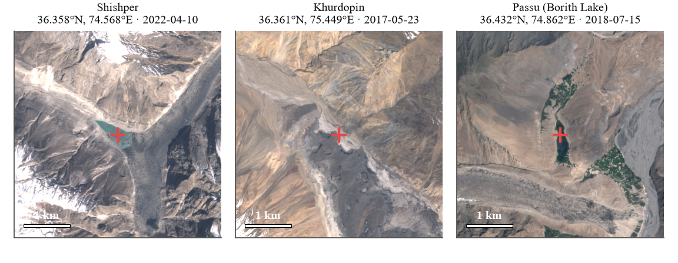
Fig. 1. The three study boxes in Sentinel-2 true colour. The cross marks the lake point used to separate the lake from other water when measuring its area.

III. RAW SATELLITE IMAGERY
Table II lists the data sources. Sentinel-1 GRD [5] provides a cloud-independent water signal (calm water is dark in VV and VH). Earth Engine scenes are already calibrated, terrain-corrected and in decibels; one orbit direction per site is used for consistent geometry (ascending for Shishper, descending for Khurdopin and Passu). Sentinel-2 Level-1C [6] provides the blue, green, red and near-infrared bands at 10 m; Level-1C is used instead of Level-2A because Level-2A coverage over the Karakoram is incomplete in 2017–2018, the period of the Khurdopin event. The Sentinel-2 cloud probability product [7] is used only to mask clouds, never as a label. The Copernicus DEM GLO-30 [8] provides elevation and slope; it is resampled bilinearly from 30 m to the 10 m grid and is therefore not native 10 m terrain.
TABLE II
DATA SOURCES (ALL VIA GOOGLE EARTH ENGINE)
Data | Earth Engine collection | Bands used | Resolution | Role
Sentinel-1 GRD [5] | COPERNICUS/S1_GRD | VV, VH (dB), IW mode | 10 m | Cloud-independent water signal
Sentinel-2 L1C [6] | COPERNICUS/S2_HARMONIZED | B2, B3, B4, B8 (TOA reflectance) | 10 m | Optical bands, NDWI, labels
S2 cloud probability [7] | COPERNICUS/S2_CLOUD_PROBABILITY | probability (%) | 10 m (from 20 m) | Cloud mask (not a label)
Copernicus DEM [8] | COPERNICUS/DEM/GLO30 | Elevation; slope (derived) | 30 m → 10 m | Terrain channels; slope rule; hazard feature

IV. SAMPLING STRATEGY AND DATA VOLUME
Satellites do not image the sites daily: Sentinel-2 revisits about every five days and Sentinel-1 every 6–12 days (12 days after the failure of Sentinel-1B on 23 December 2021 [9]). Instead of a few hand-picked dates, the dataset takes every acquisition in the windows of Table III: 90 days before to 45 days after each documented event, and ±15 days around each event's calendar date in every year from 2017 to 2022. The same windows are used for all three sites, so every site is observed during every event period and in the same season of years without an event.
TABLE III
ACQUISITION WINDOWS (IDENTICAL FOR ALL SITES)
Window | Dates | Days | Purpose
Khurdopin event | 22 Apr – 4 Sep 2017 | 136 | 90 d before / 45 d after drainage onset (21 Jul 2017)
Shishper 2020 event | 29 Feb – 5 Aug 2020 | 159 | Around the 29 May 2020 drainage (merged with anniversary)
Shishper 2022 event | 6 Feb – 21 Jun 2022 | 136 | Around the 7 May 2022 GLOF
Anniversaries (May) | 22 Apr – 13 Jun, 2018, 2019, 2021 | 3 × 53 | Same season as the May events, no event
Anniversaries (July) | 6 Jul – 5 Aug, 2018, 2019, 2021, 2022 | 4 × 31 | Same season as the July event, no event
Total | 10 windows | 714 | Applied identically to all three sites

A Sentinel-2 day is kept when its mosaic covers at least 95% of the box; it is paired with the nearest Sentinel-1 scene within ±6 days. Sentinel-1 days without a Sentinel-2 acquisition are kept as radar-only dates. In total the dataset contains 730 dates (490 optical, 240 radar-only; Table IV, Fig. 2), about 886 MB as compressed float16 arrays.
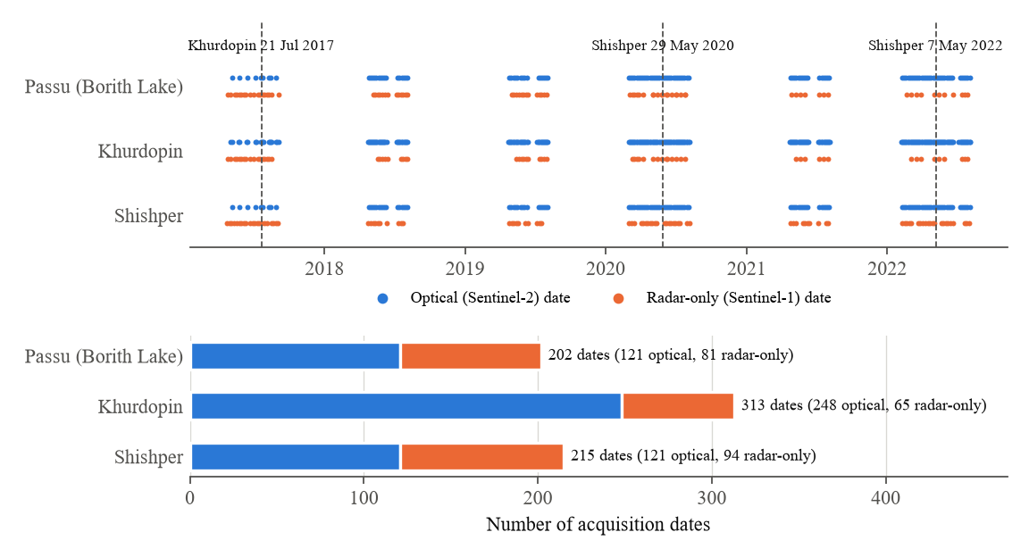
Fig. 2. Temporal sampling of the dataset. Top: every acquisition date per site (optical and radar-only); dashed lines mark documented events. Bottom: number of dates per site.
TABLE IV
DATASET COMPOSITION AND YEAR-WISE TRAIN/TEST SPLIT
Site | Dates (all) | Optical / radar-only | Labelled | Train (2017, 2018, 2020, 2022) | Test (2019, 2021)
Shishper | 215 | 121 / 94 | 40 | 27 | 13
Khurdopin | 313 | 248 / 65 | 99 | 73 | 26
Passu (Borith) | 202 | 121 / 81 | 52 | 37 | 15
Total | 730 | 490 / 240 | 191 | 137 | 54

V. LABELS
No existing source provides lake outlines for the three sites at the event dates, so water labels are generated automatically from Sentinel-2 using the NDWI [10], (G − NIR) / (G + NIR). A pixel is labelled water when NDWI > 0.2, NIR reflectance < 0.12 (excludes snow, ice and cloud), green reflectance > 0.03 (excludes deep shadow) and slope < 20° (excludes steep shadowed cliffs); components smaller than 50 pixels are removed. Images with more than 10% cloud (cloud probability ≥ 60%, specks < 0.1 km² ignored) or more than 40% very bright pixels are not labelled, and pixels within 150 m of cloud are marked ignore. Radar-only dates are never labelled. This yields 191 labelled dates (Table V); Fig. 3 shows examples.
TABLE V
LABELLED DATES PER SITE AND YEAR
Site | Optical dates | Labelled | 2017 | 2018 | 2019 | 2020 | 2021 | 2022
Shishper | 121 | 40 | 2 | 6 | 6 | 10 | 7 | 9
Khurdopin | 248 | 99 | 9 | 16 | 13 | 24 | 13 | 24
Passu (Borith) | 121 | 52 | 4 | 10 | 7 | 11 | 8 | 12
Total | 490 | 191 | 15 | 32 | 26 | 45 | 28 | 45

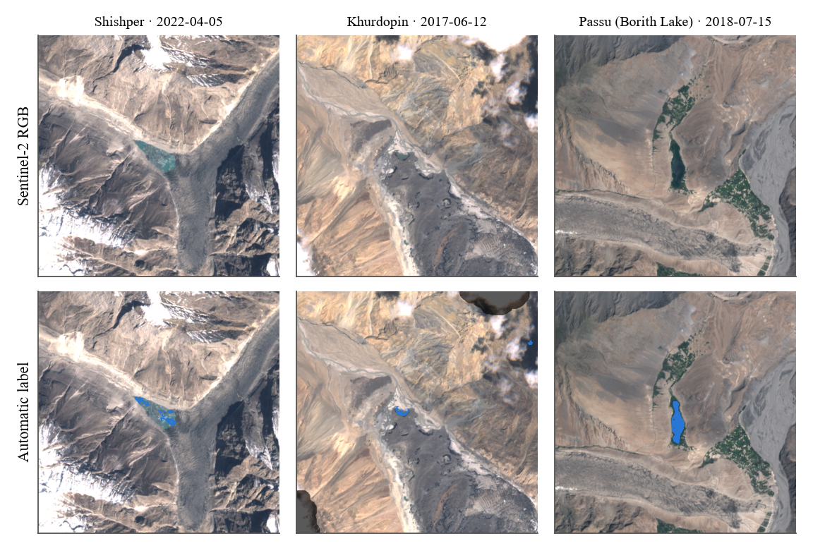
Fig. 3. Examples of automatic labels (blue = water, darkened = ignored cloud buffer).
Lake area measured directly from these labels already shows the documented events (Fig. 4): water at Shishper on 30 April 2022 and none on 10 May 2022, water on 25 May 2020 and none by 29 June 2020, and the Khurdopin lake present in May–June 2017 and gone by 27 July 2017. Label-derived areas underestimate the event lakes because frozen and very turbid lake surfaces are not labelled as water.
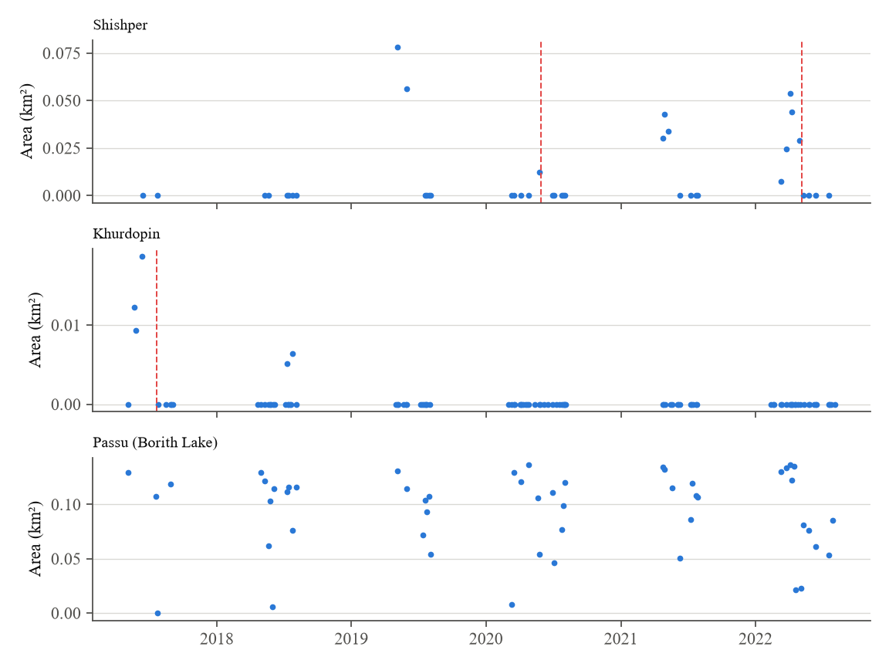
Fig. 4. Lake area derived from the automatic labels on clear dates. Dashed lines: documented events.

VI. EVENT RECORDS
The documented events used for evaluation are listed in Table VI. They are taken from peer-reviewed sources; the Passu comparison site has no documented outburst during the study period.
TABLE VI
DOCUMENTED EVENTS USED FOR EVALUATION
Site | Event | Date(s) | Source
Khurdopin | Lake formation behind surging glacier | March 2017 | [4]
Khurdopin | Drainage onset → lake fully drained | ≈ 21 Jul 2017 → 3 Aug 2017 | [4]
Shishper | Repeated drainage of the ice-dammed lake | 2019 onwards; 29 May 2020 | [2]
Shishper | GLOF destroying the Hassanabad bridge (KKH) | 7 May 2022 | [3]
Passu (Borith Lake) | No outburst in the study period | 2017–2022 | Sentinel-2 inspection (this work)

VII. JUSTIFICATION
- Coverage of the research question. Sentinel-1, Sentinel-2 and a DEM are the minimum set needed to test whether radar–optical–terrain fusion helps when optical data are obscured by cloud.
- Temporal density around events. Taking every acquisition in event-centred windows, plus radar-only dates, gives the observations needed to see lakes fill and drain — something annual inventories cannot provide.
- Built-in comparison. Identical windows at all sites provide same-period observations of non-event sites for every event.
- Labelling burden. Automatic NDWI labels make it possible to label 191 dates without manual digitisation, at the cost of label noise that is documented in Section IX.
- Access and reproducibility. All data are free, open and retrievable with one notebook; the full download takes about 13 minutes.

VIII. ACCESS AND REPRODUCIBILITY
Data are retrieved with the Earth Engine Python API using ee.data.computePixels, which returns arrays directly on the defined 10 m grid. The notebook glof_pipeline.ipynb contains the complete acquisition code; it stores one compressed file per date and site plus a static DEM/slope file and a plan file listing all dates, and it skips existing files so that interrupted downloads can be resumed. Copernicus Sentinel and DEM data are free and openly licensed under the Copernicus data policy; use through Earth Engine requires a registered (non-commercial) Earth Engine project.

IX. KNOWN LIMITATIONS
- Labels are derived from optical rules, so they favour optical inputs, miss frozen or turbid lake surfaces, and may contain small shadow or wet-ice errors.
- No additional speckle filtering is applied to Sentinel-1; radar shadow in steep terrain can resemble water.
- The DEM is static and 30 m; slope near narrow lakes is smoothed.
- Sentinel-1B stopped on 23 December 2021, so 2022 radar sampling is sparser.
- Khurdopin's lake was small and short-lived, so few labelled dates contain water there.
- Borith Lake is a perennial lake of different origin from the event lakes, which limits it as a comparison site.

REFERENCES
[1] N. Gorelick, M. Hancher, M. Dixon, S. Ilyushchenko, D. Thau, and R. Moore, "Google Earth Engine: Planetary-scale geospatial analysis for everyone," Remote Sensing of Environment, vol. 202, pp. 18–27, 2017.
[2] G. Khan, S. Ali, et al., "Expansion of Shishper Glacier lake and recent glacial lake outburst flood (GLOF), Gilgit-Baltistan, Pakistan," Environmental Science and Pollution Research, 2021.
[3] S. Ullah et al., "An integrated approach for GLOF hazard, vulnerability and risk assessment in the Karakoram Mountain Range of northern Pakistan," Journal of Mountain Science, 2025.
[4] J. F. Steiner, P. D. A. Kraaijenbrink, S. G. Jiduc, and W. W. Immerzeel, "Brief communication: The Khurdopin glacier surge revisited – extreme flow velocities and formation of a dammed lake in 2017," The Cryosphere, vol. 12, no. 1, pp. 95–101, 2018, doi: 10.5194/tc-12-95-2018.
[5] R. Torres et al., "GMES Sentinel-1 mission," Remote Sensing of Environment, vol. 120, pp. 9–24, 2012.
[6] M. Drusch et al., "Sentinel-2: ESA's optical high-resolution mission for GMES operational services," Remote Sensing of Environment, vol. 120, pp. 25–36, 2012.
[7] A. Zupanc, "Improving cloud detection with machine learning," Sentinel Hub Blog (s2cloudless), 2017. [Online]. Available: https://medium.com/sentinel-hub/improving-cloud-detection-with-machine-learning-c09dc5d7cf13
[8] European Space Agency, "Copernicus DEM — Global and European Digital Elevation Model (COP-DEM)," 2021, doi: 10.5270/ESA-c5d3d65.
[9] European Space Agency, "Mission ends for Copernicus Sentinel-1B satellite," ESA Applications, Aug. 2022. [Online]. Available: https://www.esa.int
[10] S. K. McFeeters, "The use of the Normalized Difference Water Index (NDWI) in the delineation of open water features," International Journal of Remote Sensing, vol. 17, no. 7, pp. 1425–1432, 1996.

