**PROJECT MANAGEMENT SYSTEM FOR FINAL YEAR STUDENTS**

**SRC**

**Group members:**

1. Safeena Akhter-04072312008 (Team Lead)
2. Haleema Sadia-04072312010 (Team Member 2)
3. Masooma Muhammadi-04072312030 (Team Member 3)

**Submission date:** 3/10/2025

**Supervised by:** Dr. Onaiza Maqbool

**Department of Computer Science**

**QUAID-E-AZAM UNIVERSITY,ISLAMABAD**

**Signature Page**

|  |  |  |
| --- | --- | --- |
| **Name** | **Role** | **Signature** |
|  |  |  |
| Safeena Akhter | Team Leader |  |
| Haleema Sadia | Team member |  |
| Masooma Muhammadi | Team member |  |

**Change History:**

|  |  |  |  |
| --- | --- | --- | --- |
| **VERSION** | **DATE** | **AUTHOR** | **CHANGES MADE** |
| 2.0 | 3/8/2025 | Haleema Sadia | Initial Draft |
| 2.1 | 3/9/2025 | Haleema Sadia | Edit, Review Document and add team Leader and Member 3 tasks. |
| 2.2 | 3/9/2025 | Masooma Muhammadi | Add Missing things in use case description |

**Remarks:**



**Preface:**

This document outlines the project SRC for the development of a Project Management System for the Department of Computer Science at Quaid-i-Azam University.

Table of Contents

1.Specific Requirement

1.1 Use Case Diagram……………………………………………………………………4

1.2 Use Case Description………………………………………………………………5

1.2.1 Use Case UC1…………………………………………………………………...5

1.2.2 Use Case UC2……………………………………………………………………6

1.2.3 Use Case UC3……………………………………………………………………8

1.2.4 Use Case UC4……………………………………………………………………9

1.2.5 Use Case UC5..…………………………………………………………………10

1.2.6 Use Case UC6..…………………………………………………………………10

1.2.7 Use Case UC7..…………………………………………………………………11

**List of Diagrams:**

Diagram 1: Use Case Diagram (BY SAFEENA AKHTER)

|  |
| --- |
|  |

* 1. **Use Case Diagram:**

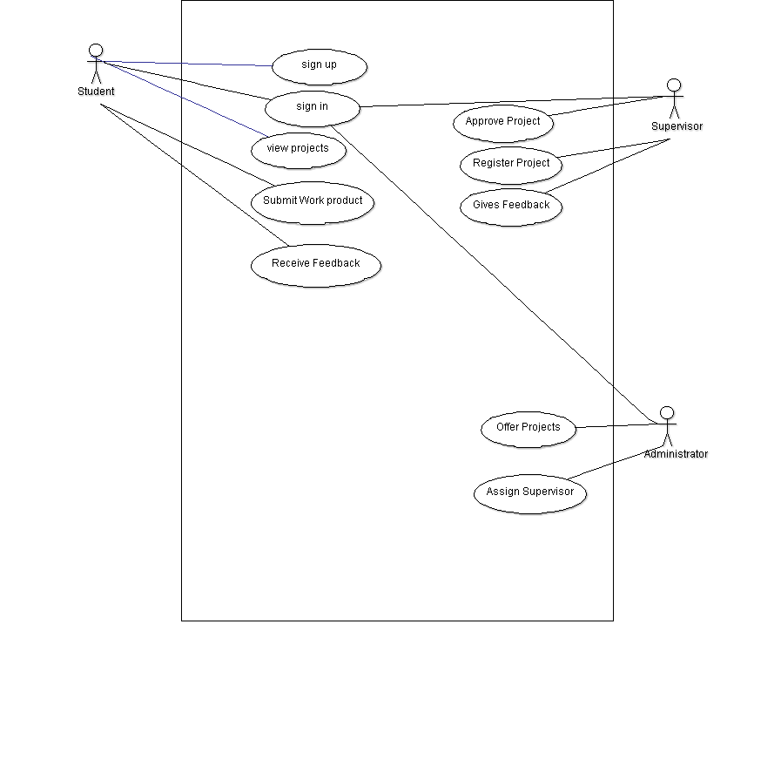**By: Safeena Akhter**

**Usecase description by Haleema Sadia**

**UC1: Register Account**

**Primary Actor:**

* Student
* Supervisor
* Administrator

**Stakeholders and Interests:**

* **Student:** Wants an easy registration process to access projects.
* **Supervisor:** Needs smooth registration to manage and review student work.
* **Administrator:** Requires a seamless registration system for managing users and projects.

**Pre-Conditions:**

* The user must have a valid email address.
* The user must have a valid password (added)
* The user must be on the registration page.

**Post-Condition:**

* The system successfully registers the user and provides confirmation.

**Input:**

* First Name, Last Name, Email, Mobile Number, Password, Role (Administrator, Supervisor, Student), Additional Documents (if required).

**Output:**

* Successful registration and system access.

**Main Success Scenario (Basic Flow):**

1. The actor navigates to the registration page.
2. The actor enters their first and last name.
3. Actor then clicks "Continue" option.
4. The actor navigates to next page.
5. Actor enters an email, mobile number, and password.
6. The actor clicks on "Continue" option.
7. The system sends a confirmation code to the entered email.
8. Actor enters the code and clicks on “Continue” option.
9. The Actor selects their username and role (Student, Supervisor or Administrator).
10. The user fills in additional required details based on their role.
11. The actor submits the registration form.
12. The system verifies and saves the account.
13. Actor receives a confirmation message.

**Alternative Scenarios:**

1. **System failure:** If the system fails, to ensure recovery of data, the software saves the existing data of the actor’s registration and the user can resume registration.
2. **Invalid Data Entry:**

**Short names:** First and last names must have at least 4 characters, otherwise error

message is displayed.

1. **Email verification failure:** The user can request a new code after 30 seconds.
2. **Email format incorrect:** The system highlights the field if the email is missing “@”,

Or “.com”

1. **File format restrictions**: Documents must be in PDF format.
2. **Invalid Phone Number:** The system requires an 11-digit mobile number

**Special Requirements:**

* A feedback section must be available to improve the registration process.
* The registration form must have a clear layout with easily readable fonts (minimum size 12)

**Frequency of occurrence:** Registration happens whenever a new user joins the system.

**Use Case UC2: Sign In**

**Primary Actor:**

* Student
* Supervisor
* Administrator

**Stakeholders and Interests:**

* **Student:** Wants quick access to view projects.
* **Supervisor:** Needs access to review and manage projects.
* **Administrator:** Manages actors and system settings.

**Pre-Conditions:**

* The user must be registered.
* The system must be available.

**Post-Condition:**

* The user gains access to their dashboard.

**Input:**

* Email
* Password

**Output:**

* Successful login and system access.

**Main Success Scenario:**

1. The actor opens the login page.
2. Actor’s enters their email and password.
3. The system verifies credentials.
4. Actor is redirected to their dashboard.

**Alternative Scenarios:**

1. **Incorrect credentials:** The system displays an error message incorrect username/e-mail or password. Please try again.
2. **Forgot password:** The actor can reset their password via email./ mobile phone number
3. **System failure:** The system doesn’t navigate to new screen on pressing the sign in option, then the actor should be notified and asked to try again later.

**Frequency of Occurrence:** Every time when actor’s wants to sign in.

**Use Case UC3: View Projects**

**Primary Actor:**

* Student
* Supervisor

**Stakeholders and Interests:**

* **Student:** Wants to see assigned projects and requirements.
* **Supervisor:** Needs to track and manage projects.

**Pre-Conditions:**

* The user must be logged in.
* Projects must be available.

**Post-Conditions:**

* The user successfully views project details.

**Input:**

* None (System fetches assigned projects automatically)

**Output:**

* Displayed project list with details.

**Main Success Scenario:**

1. The user navigates to the "Projects" section.
2. The system displays assigned projects.
3. The user selects a project to view details.

**Alternative Scenarios:**

1. **No projects available:** The system displays a message.
2. **System failure:** The user is asked to try again later.

**Use Case UC4: Submit Work Product**

**Primary Actor:**

* Student

**Stakeholders and Interests:**

* **Student:** Wants to submit work for review.
* **Supervisor:** Needs to access student submissions.

**Pre-Conditions:**

* The student must be logged in.
* The project must be assigned.

**Post-Conditions:**

* The submission is uploaded successfully.

**Input:**

* File Upload (PDF, DOCX)

**Output:**

* Confirmation message for submission.

**Main Success Scenario:**

1. The student navigates to "Submit Work."
2. The student selects the project.
3. The student uploads the required file.
4. The system verifies the file format.
5. The submission is stored in the system.
6. The student receives a confirmation message.

**Alternative Scenarios:**

1. **Invalid file format:** The system asks for a valid format.
2. **Internet Failure:** If **file upload is interrupted due to internet failure,** the system should allow users to **resume the upload instead of restarting.**

**Use Case UC5: Receive Feedback**

**Primary Actor:**

* Student

**Stakeholders and Interests:**

* **Student:** Wants feedback to improve their work.
* **Supervisor:** Provides guidance on student submissions.

**Pre-Conditions:**

* The student must have submitted work.

**Post-Conditions:**

* The student successfully views feedback.

**Input:**

* None (Feedback is stored in the system)

**Output:**

* Displayed feedback and suggestions.

**Main Success Scenario:**

1. The student navigates to "Feedback."
2. The system displays feedback from the supervisor.

**Alternative Scenarios:**

1. **No feedback available:** The system informs the student.

**Use Case UC6: Assign Projects**

**Primary Actor:**

* Administrator

**Stakeholders and Interests:**

* **Administrator:** Manages project assignments.
* **Students/Supervisors:** Need assigned projects.

**Pre-Conditions:**

* The administrator must be logged in.

**Post-Conditions:**

* Projects are assigned successfully.

**Input:**

* Project details
* Student/Supervisor selection

**Output:**

* Confirmation message.

**Main Success Scenario:**

1. The administrator navigates to "Assign Projects."
2. The administrator selects a project and assigns a supervisor.
3. The project is saved and assigned.

**Alternative Scenarios:**

1. **No supervisors available:** The system displays an error.

**Use Case UC7: Manage Users**

**Primary Actor:**

* Administrator

**Stakeholders and Interests:**

* **Administrator:** Needs to manage actors efficiently.

**Pre-Conditions:**

* The administrator must be logged in.
* They must have access (added)

**Post-Conditions:**

* Actors records are updated successfully.

**Input:**

* Actors details (Add, Remove, Edit)

**Output:**

* Updated actors list.

**Main Success Scenarios:**

1. The administrator navigates to "Manage Users."
2. The administrator adds actor’s accounts.
3. The administrator removes actor’s accounts.
4. The administrator edits actor’s accounts.
5. The system updates the actor’s database.

**Alternative Scenarios:**

1. **Invalid user details:** The system prompts for corrections.

**Use Case UC8: Select Project (added)**

**Primary Actor:**

* Student
* Supervisor

**Stakeholders and Interests:**

* **Student:** Wants to select a project that aligns with their interests and career goals.
* **Supervisor:** Needs to ensure students select projects based on their expertise and availability.

**Pre-Conditions:**

* The student must be logged in.
* The student must have access to the list of available projects.
* Projects must be assigned or available for selection.

**Post-Conditions:**

* The student successfully selects a project.
* The supervisor is notified of the student’s project selection.

**Input:**

* Selection of a project from the available list.

**Output:**

* Confirmation of the project selection.
* Updated project status in the system (e.g., "Assigned").

**Main Success Scenario (Basic Flow):**

1. The student opens the "Select Project" section.
2. The system displays a list of available projects.
3. The student browses through the available projects.
4. The student selects a project that interests them.
5. The system confirms selection and assigns the project to the student.
6. The supervisor is notified of the student's selection.

**Alternative Scenarios:**

1. **No projects available:**
   * If no projects are available for selection, the system displays a message indicating that there are no projects currently available.
2. **Project already selected:**
   * If the project has already been selected by another student, the system informs the student and prompts them to choose another project.
3. **System failure:**
   * If there is an issue with the system displaying the available projects, the student is asked to try again later or contact support.

**Special Requirements:**

* The project list must be regularly updated by the administrator to ensure it reflects the latest available projects.
* The project selection page must have a clear, user-friendly interface.

**Frequency of Occurrence:**

* Occurs when a student is looking to select or switch their assigned project