Project management system for final year students

**SRS Author and Team Members Signature:**

Submitted by:

Group 4

Team Lead:

Safeena Akhter

Team Members:

Haleema Sadia (member2)

Masooma Muhammadi (Member3)

Submission Date:

26/03/2025

Submitted To:

Dr. Onaiza Maqbool

Course:

Software Construction

|  |  |  |
| --- | --- | --- |
| **Name** | **Role** | **Signature** |
| Safeena Akhter | Team leader |  |
| Haleema Sadia | Team Member |  |
| Masooma Muhammadi | Team Member |  |

**Stakeholder**

X

Dr. Onaiza Maqbool

Professor, Qau Islamabad

**Change History:**

|  |  |  |  |
| --- | --- | --- | --- |
| **VERSION** | **DATE** | **AUTHOR** | **CHANGES MADE** |
| 5.0 | 3/26/2025 | Safeena Akhter | Initial Draft |
|  |  |  |  |
|  |  |  |  |

**Preface:**

This document outlines the project SRS for the development of a Project Management System for the Department of Computer Science at Quaid-i-Azam University.

Table of Contents

1. Introduction 5

1.1 Purpose 5

1.2 Scope 5

1.3 Objectives 5

2. Overall Description 6

2.1 System Functions 6

3. Special Requirements 6

3.1 Functional Requirements 6

3.2 Non-Functional Requirements 20

4. Supporting Material 21

Data Dictionary : 21

Domain Model: 24

Use case diagram: 25

System Sequence Diagram: 27

# 1. Introduction

## 1.1 Purpose

The purpose of this document is to define the requirements for the Project Management System for the Department of Computer Science. The system aims to facilitate communication between students and supervisors throughout the project duration, ensuring efficient tracking, submission, and feedback mechanisms.

## 1.2 Scope

The Project Management System will be a web-based platform that enables students to register their projects with supervisors, submit multiple versions of their work products, and receive feedback from their supervisors. The system will support functionalities such as project listing, supervisor assignment, file uploads, and feedback mechanisms. The target users are final semester students and faculty supervisors.

## 1.3 Objectives

* To create a platform for students to register and manage their academic projects.
* To enable supervisors to track project progress and provide feedback.
* To allow multiple versions of work products to be submitted.
* To ensure a structured and streamlined communication process between students and supervisors.
* To provide an intuitive interface for students and supervisors to track progress.
* To implement a document submission system with version control for project tracking.
* To ensure system security with authentication and role-based access control.
* To automate key processes such as reminders and notifications for deadlines.

# 2. Overall Description

## 2.1 System Functions

* **Project Registration:** Students can select their projects under a specific supervisor.
* **Work Product Submission:** Students can upload different versions of their work.
* **Feedback Mechanism:** Supervisors can review and provide feedback on submitted work.
* **Project Listing:** Allows students and supervisors to view assigned projects.
* **User Authentication:** Secure login system for students and supervisors.
* **Notification System:** Alerts users regarding project updates and feedback.
* **Sign In & Sign Up:** Secure login system for students, supervisors, and administrators.
* **Explore Project:** Students can view available projects before selecting one.
* **Register Project:** Supervisor register their projects so that students can select from it.
* **Supervisor Approves Project:** Supervisors review and approve project registration requests.
* **Submit Work Product:** Students can upload multiple versions of their work.
* **Receive Feedback:** Supervisors can review and provide feedback on submitted work
* **Admin Manage Users:** Admin can manage student and supervisor accounts.

# 3. Special Requirements

## 3.1 Functional Requirements

UC1: Register Account

**Primary Actor:**

* Student
* Supervisor
* Administrator

**Stakeholders and Interests:**

* **Student:** Wants an easy registration process to access projects.
* **Supervisor:** Needs smooth registration to manage and review student work.
* **Administrator:** Requires a seamless registration system for managing users and projects.

**Pre-Conditions:**

* The user must have a valid email address.
* The user must have a valid password (added)
* The user must be on the registration page.

**Post-Condition:**

* The system successfully registers the user and provides confirmation.

**Input:**

* First Name, Last Name, Email, Mobile Number, Password, Role (Administrator, Supervisor, Student), Additional Documents (if required).

**Output:**

* Successful registration and system access.

**Main Success Scenario (Basic Flow):**

1. The actor navigates to the registration page.
2. The actor enters their first and last name.
3. Actor then clicks "Continue" option.
4. The actor navigates to next page.
5. Actor enters an email, mobile number, and password.
6. The actor clicks on "Continue" option.
7. The system sends a confirmation code to the entered email.
8. Actor enters the code and clicks on “Continue” option.
9. The Actor selects their username and role (Student, Supervisor or Administrator).
10. The user fills in additional required details based on their role.
11. The actor submits the registration form.
12. The system verifies and saves the account.
13. Actor receives a confirmation message.

**Alternative Scenarios:**

1. **System failure:** If the system fails, to ensure recovery of data, the software saves the existing data of the actor’s registration and the user can resume registration.
2. **Invalid Data Entry:**

**Short names:** First and last names must have at least 4 characters, otherwise error

message is displayed.

1. **Email verification failure:** The user can request a new code after 30 seconds.
2. **Email format incorrect:** The system highlights the field if the email is missing “@”,

Or “.com”

1. **File format restrictions**: Documents must be in PDF format.
2. **Invalid Phone Number:** The system requires an 11-digit mobile number

**Special Requirements:**

* A feedback section must be available to improve the registration process.
* The registration form must have a clear layout with easily readable fonts (minimum size 12)

**Frequency of occurrence:** Registration happens whenever a new user joins the system.

**Use Case UC2: Sign In**

**Primary Actor:**

* Student
* Supervisor
* Administrator

**Stakeholders and Interests:**

* **Student:** Wants quick access to view projects.
* **Supervisor:** Needs access to review and manage projects.
* **Administrator:** Manages actors and system settings.

**Pre-Conditions:**

* The user must be registered.
* The system must be available.

**Post-Condition:**

* The user gains access to their dashboard.

**Input:**

* Email
* Password

**Output:**

* Successful login and system access.

**Main Success Scenario:**

1. The actor opens the login page.
2. Actor’s enters their email and password.
3. The system verifies credentials.
4. Actor is redirected to their dashboard.

**Alternative Scenarios:**

1. **Incorrect credentials:** The system displays an error message incorrect username/e-mail or password. Please try again.
2. **Forgot password:** The actor can reset their password via email./ mobile phone number
3. **System failure:** The system doesn’t navigate to new screen on pressing the sign in option, then the actor should be notified and asked to try again later.

**Frequency of Occurrence:** Every time when actor’s wants to sign in.

**Use Case UC3: Explore Projects**

**Primary Actor:**

* Student

**Stakeholders and Interests:**

* **Student:** Wants to explore available projects and understand their details before registration.

**Pre-Conditions:**

* The user must be logged in to access the project list.
* At least one project must be available in the system.

**Post-Conditions:**

* The system **retrieves and displays** the list of projects with key details, including **title, description, assigned supervisor, and status.**
* The Student can access and read project details without any errors.

**Input:**

* None (The system automatically fetches available projects).

**Output:**

* A list of **available projects** with essential details displayed on the screen.

**Main Success Scenario:**

1. The student navigates to the **"Projects"** section in the system.
2. The system retrieves and displays all available projects with details (title, description, assigned supervisor, and current status).
3. The student selects a project to view more details.

**Alternative Scenarios:**

1. **No Available Projects:**
   * The system detects that no projects are available for viewing.
   * The system displays a message: *"*Currently, no projects are available. Please check back later."
2. **Permission Issue:**

* The student attempts to view projects but lacks permission as it already taken by another student.
* System displays: “**Access Denied: This project has already been registered by another student. Please choose a different available project.”**

1. **System Failure:**
   * A temporary issue prevents projects from loading.
   * The system displays an error: *"Unable to retrieve projects. Please try again later."*

**Use Case UC4: Submit Work Product**

**Primary Actor:**

* Student

**Pre-Conditions:**

* The student must be logged into the system.
* The student must have an assigned project with submission access.

**Post-Conditions:**

* The system stores the submitted file without uploading errors and makes it accessible to the supervisor for review.

**Input:**

* File Upload (PDF, DOCX,ZIP)

**Output:**

* Confirmation message for successful submission.

**Main Success Scenario:**

1. The student navigates to "Submit Work" in the system.
2. The student selects their assigned project.
3. The student uploads the required file(Work product).
4. The system verifies the file format to ensure it is an allowed format (PDF, DOCX, ZIP).
5. The system stores the submission in the database.
6. The student receives a confirmation message stating that the work product document has been submitted and stored in the system.

**Alternative Scenarios:**

1. **Invalid File Format:**
   * The system detects an unsupported file format.
   * The system displays an error message: “Invalid file format. Please upload a PDF, DOCX or ZIP.”
   * The student is prompted to re-upload a valid file.
2. **Internet Failure During Upload:**
   * The system detects an interrupted connection.
   * The system saves the upload progress.
   * Once the internet is restored, the system prompts the student to resume the upload instead of restarting.

**Use Case UC5: Receive Feedback**

**Primary Actor:**

* **Student**

**Pre-Conditions:**

* **The student is logged into the system.**
* **The student has already submitted a work product for review.**
* **The supervisor has provided feedback on the submitted work.**

**Post-Conditions:**

* **The student has reviewed the feedback provided by the supervisor.**

**Input:**

* **None**

**Output:**

* **Displayed feedback text or attached review file.**

**Main Success Scenario:**

1. **The student navigates to the "Feedback" section.**
2. **The system retrieves the feedback stored for the student.**
3. **The system displays the feedback provided by the supervisor.**
4. **The student reviews the feedback and can use it for project improvements.**

**Alternative Scenario:**

* **No Feedback Available: If the supervisor has not provided feedback, then the system displays: “Please check back later.”**
* **System Failure While Loading Feedback: If the feedback fails to load, the student receives an error message: “An error occurred. Please try again later.”**

**Use Case UC6: Manage Users**

**Primary Actor:**

* Administrator

**Stakeholders and Interests:**

* **Administrator:** Needs to manage actors efficiently.

**Pre-Conditions:**

* The administrator must be logged in.
* They must have access (added)

**Post-Conditions:**

* Actors records are updated successfully.

**Input:**

* Actors details (Add, Remove, Edit)

**Output:**

* Updated actors list.

**Main Success Scenarios:**

1. The administrator navigates to "Manage Users."
2. The administrator adds actor’s accounts.
3. The administrator removes actor’s accounts.
4. The administrator edits actor’s accounts.
5. The system updates the actor’s database.

**Alternative Scenarios:**

1. **Invalid user details:** The system prompts for corrections.

**Use Case UC7: Select Project (added)**

**Primary Actor:**

* Student
* Supervisor

**Stakeholders and Interests:**

* **Student:** Wants to select a project that aligns with their interests and career goals.
* **Supervisor:** Needs to ensure students select projects based on their expertise and availability.

**Pre-Conditions:**

* The student must be logged in.
* The student must have access to the list of available projects.
* Projects must be assigned or available for selection.

**Post-Conditions:**

* The student successfully selects a project.
* The supervisor is notified of the student’s project selection.

**Input:**

* Selection of a project from the available list.

**Output:**

* Confirmation of the project selection.
* Updated project status in the system (e.g., "Assigned").

**Main Success Scenario (Basic Flow):**

1. The student opens the "Select Project" section.
2. The system displays a list of available projects.
3. The student browses through the available projects.
4. The student selects a project that interests them.
5. The system confirms selection and assigns the project to the student.
6. The supervisor is notified of the student's selection.

**Alternative Scenarios:**

1. **No projects available:**
   * If no projects are available for selection, the system displays a message indicating that there are no projects currently available.
2. **Project already selected:**
   * If the project has already been selected by another student, the system informs the student and prompts them to choose another project.
3. **System failure:**
   * If there is an issue with the system displaying the available projects, the student is asked to try again later or contact support.

**Special Requirements:**

* The project list must be regularly updated by the administrator to ensure it reflects the latest available projects.
* The project selection page must have a clear, user-friendly interface.

**Frequency of Occurrence:**

* Occurs when a student is looking to select or switch their assigned project

**Use Case UC8: Give Feedback**

**Primary Actor:**

* Supervisor

**Stakeholders and Interests:**

* **Supervisor:** Wants to review student submissions and provide constructive feedback.
* **Student:** Needs feedback to improve their work and meet project requirements.

**Pre-Conditions:**

* The supervisor must be logged into the system.
* The student must have **submitted** a work product.

**Post-Conditions:**

* The system confirms that feedback has been stored and immediately notifies the student to check the feedback of their relevant work product.

**Input:**

* Text feedback
* Optional file attachment (PDF, DOCX)

**Output:**

* Confirmation message stating: **"Your feedback has been recorded and is now visible to the student."**
* The system notifies the student via email or dashboard alert.

**Main Success Scenario:**

1. The supervisor navigates the "Work Submissions" section.
2. The system displays a list of student-submitted work products.
3. The supervisor selects a submission to review.
4. The supervisor enters feedback in the provided text field.
5. (Optional) The supervisor uploads an attachment for additional feedback.
6. The supervisor submits the feedback.
7. The system stores the feedback and notifies the student.

**Alternative Scenarios:**

1. **No Submissions Available:**
   * The system displays a message: **"No work products available for feedback."**
   * The supervisor is redirected to the dashboard.
2. **System Failure During Submission:**
   * The system fails to store feedback due to an error.
   * The supervisor receives a message: **"Feedback submission failed. Please try again later."**
3. **Internet Connection Failure:**

* The system detects a network issue during feedback submission.
* The system temporarily saves the feedback draft.
* Once the internet is restored, the system prompts the supervisor to **"Resume Submission"** instead of restarting.

**Use Case UC9 : Register Project**

**Primary Actor:**

* Supervisor

**Pre-conditions:**

* The supervisor must be logged into the system.
* The project registration period must be open.

**Post-conditions:**

* The project is registered in the system.
* The project is now available for student selection.

**Input:**

* Project Title
* Project Description
* Required Skills
* Supervisor Name

**Output:**

* Project stored in the database.
* Confirmation message displayed to the supervisor.

**Main Success Scenario:**

1. The supervisor logs into the system and navigates to the "Register Project" section.
2. The system displays the project registration form.
3. The supervisor enters project details (title, description, required skills).
4. The supervisor submits the project registration form.
5. The system validates the data and checks for duplicate project titles.
6. The system stores the project in the database.
7. The system confirms successful registration.

**Alternative Scenarios:**

* **Missing Fields:** If the supervisor does not complete all required fields, the system prompts them to enter missing details.
* **Duplicate Project Name:** If the project name already exists, the system asks the supervisor to provide a different name.
* **System Failure:** If the system crashes, project details are saved as a draft for later submission.

**Use Case UC 10 : Approve Project**

**Primary Actor:**

* Supervisor

**Pre-conditions:**

* The supervisor must be logged into the system.
* The project must be in "Pending Approval" status.

**Post-conditions:**

* The project is either approved, rejected, or marked for modifications.
* The student receives a notification of the decision.

**Input:**

* Project details
* Student justification
* Supervisor’s decision (Approve, Reject, Request Modifications)

**Output:**

* Updated project status
* Student receives approval/rejection notification

**Main Success Scenario:**

1. The supervisor logs into the system and navigates to the "Pending Project Approvals" section.
2. The system displays a list of students who have registered projects.
3. The supervisor selects a project to review.
4. The system displays the student’s details, selected project, and justification.
5. The supervisor evaluates the student’s capability and project suitability.
6. The supervisor selects one of the following options:
   * **Approve:** If the student is suitable for the project.
   * **Reject:** If the project is not suitable for the student.
   * **Request Modifications:** If the student needs to refine their justification.
7. The system updates the project status accordingly.
8. The system notifies the student of the supervisor’s decision.

**Alternative Scenarios:**

* **Student Not Qualified:** If the student lacks the required skills, the supervisor rejects the request with feedback.
* **Project Already Assigned:** If another student has already been approved for the same project, the supervisor must reassign the student.
* **System Failure:** If the system crashes, the supervisor’s progress is saved.

## 3.2 Non-Functional Requirements

* **Security:** Data encryption for secure communication and storage, Secure document uploads with encryption, ensure only authorized users can view/edit feedback
* **Usability:** Intuitive UI for easy navigation and interaction for student and supervisor, clear layout for feedback tracking.
* **Scalability:** Should handle multiple student-supervisor interactions efficiently, Optimize database for increasing uploads, efficient handling of frequent alerts.
* **Performance:** Fast response times for uploads and feedback retrieval

# 4. Supporting Material

**4.1 Models**

* **Use Case Diagram:** Shows interactions between students, supervisors, and the system.
* **System Sequence Diagram:** Illustrates the process of use cases .
* **Domain model:** Defines system classes , attributes and their relationships.
* **Data dictionary:** contains the information of all the data used in project with it’s constraints/conditions and purpose of using the particular data.

## Data Dictionary :

|  |  |  |  |  |  |
| --- | --- | --- | --- | --- | --- |
| **Data**  **Element name** | **Definition** | **Data Type** | **Length / Size** | **Example** | **Conditions**  **(Constraints)** |
| **User First Name** | First Name of the User. | string | 10 | Haleema | First Name should be string, and its length must be less than 10 and greater than 0 |
| **User Last Name** | Last Name of the User. | string | 10 | Sadia | Last Name should be string, and its length must be less than 10 and greater than 0. |
| **User Email** | Email address of User. | string | 30 | halimsabbcy  @gmail.com | Applicant Email must be in string, have @, .com, gmail, and must be less than or equal to 30 characters. |
| **User Password** | Password for logging in and registration. | string | 12 | halsad_2004 | Password should be string, contain alphanumeric characters and must be greater than 0 and less than 13. |
| **User Gender** | Gender of the User. | string | 7 | Female | It should be in string format, and it must be of less than 8 characters. |
| **User Contact Number** | Phone number of User for contacting. | Integer | 11 | 0335965010 | Applicant contact number must be in integer format and its length must be equal to 11 integers. |
| **User ID** | Unique identifier for each user(student, supervisor, admin) | integer | 11 | 04072312010 | Must be unique and auto-incremented |
| **User Role** | Role of the user in the system(student,  Supervisor, administrator) | string | 10 | Student | (Must be one of: 'Student', 'Supervisor', 'Admin') [CHECK constraint applied] |
| **Project ID** | Unique identifier for each project | integer | 10 | 1000 | Must be unique and auto-incremented |
| **Project Title** | Title of the project | string | 50 | Final Year Project Management system | Must be in string format, max 50 characters |
| **Project Description** | Brief summary of project | Text | __ | System for managing final year projects in which students submit many versions of work products and supervisor gives feedback | Can be null |
| **Project Status** | Current status of the project | string | 15 | In Progress | (Must be one of: 'Pending', 'In Progress', 'Completed')  [CHECK constraint applied] |
| |  |  | | --- | --- | | **Project Start Date** |  | | Date when the project starts | Date | __ | 2025-03-01 | Must be in YYYY-MM-DD format |
| **Project End Date** | Expected project completion date | Date | __ | 2025-05-01 | |  |  | | --- | --- | | Must be greater than Project Start Date |  | |
| **Student ID** | Unique identifier for a student | integer | __ | 1001 | Must exist as a User ID , Foreign key |
| **Supervisor ID** | Unique identifier for a supervisor | integer | __ | 2001 | Must exist as a User id, Supervisor ID as a Foreign Key. |
| **Submission ID** | Unique identifier | Integer | 10 | 3001 | Auto-Incremented, unique |
| **Project ID** | Project related to the submission | Integer | 10 | 1000 | Must exist in Project Table |
| **Student ID** | Student who submitted work | Integer | 11 | 04072312008 | Must exist in User Table (Role='Student') |
| **File Name** | |  | | --- | |  |   Name of the submitted file | String | 100 | work_v1.pdf | NOT NULL ,must be PDF, DOCX, or ZIP |
| **Submission Date** | Date of submission | Date Time | - | 2025-03-10 12:30:00 | Must be in YYYY-MM-DD  &  HH:MM:SS format |
| **Status** | Submission status | String | - | Pending | CHECK ('Pending', 'Reviewed', 'Approved') |
| **Feedback ID** | Unique identifier | Integer | 10 | 6001 | Auto-Incremented,  unique |
| **Submission ID** | Submission for which feedback is given. | Integer | 10 | 3000 | Must exist in Project  Table |
| **Supervisor ID** | Supervisor who provided feedback. | Integer | 11 | 80011 | Must exist in User Table (Role='Supervisor') |
| **Feedback Text** | |  | | --- | |  |   Comments or review on the submission | Text | - | Improve Code Structure. | Can be Null,  Text format |
| **File Attachment** | Optional feedback file. | VARCHAR | 255 | Feedback.pdf | Must be **PDF, DOCX**  or NULL |
| **Feedback Date** | Date and time when feedback was given. | Date  Time | - | Pending | Default: CURRENT_  TIMESTAMP |

## Domain Model:

|  |
| --- |
| user |
| Name string  Integer  Email string  Passward string |
|  |

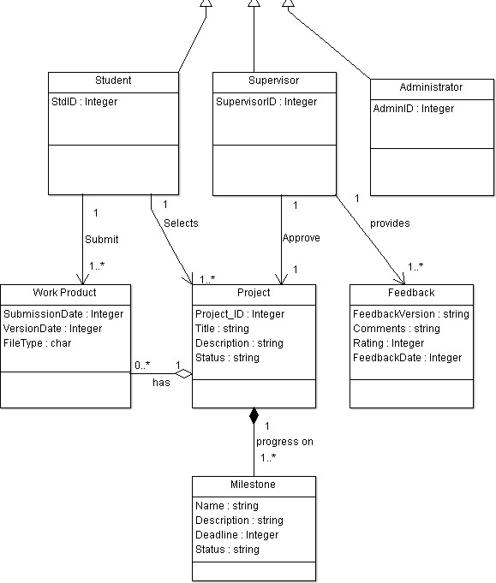

## Use case diagram:

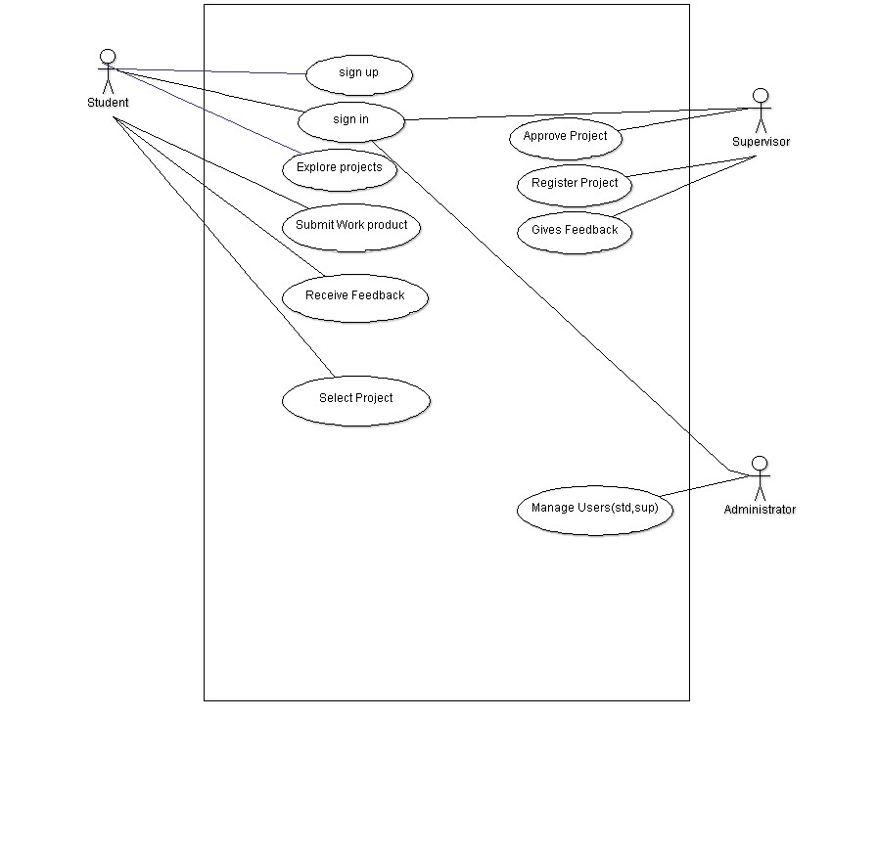

## System Sequence Diagram:

Explore Projects SSD:

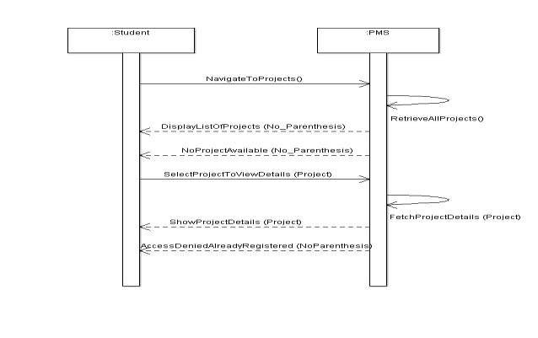

Submit Work Product SSD:

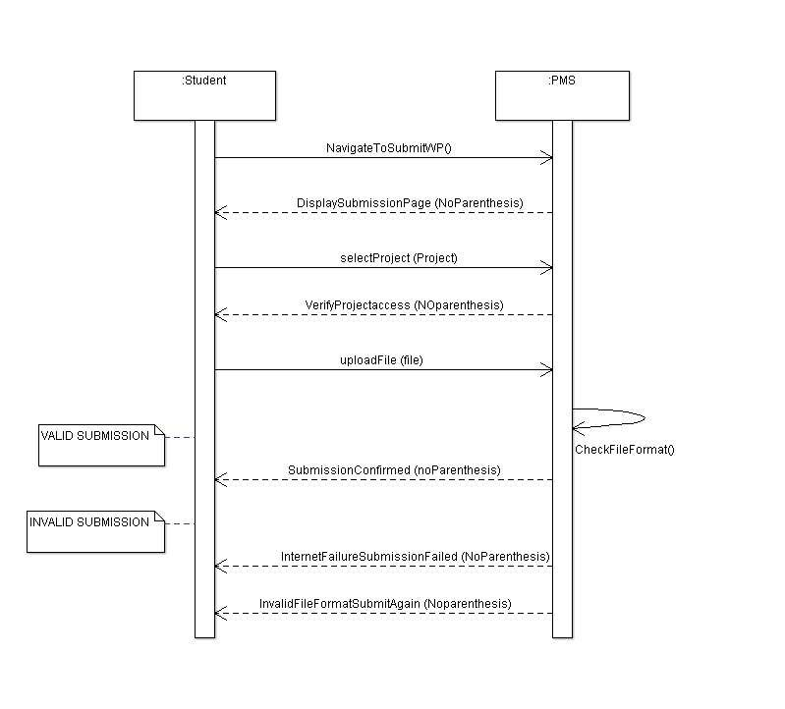

Gives Feedback SSD: Register Project SSD:

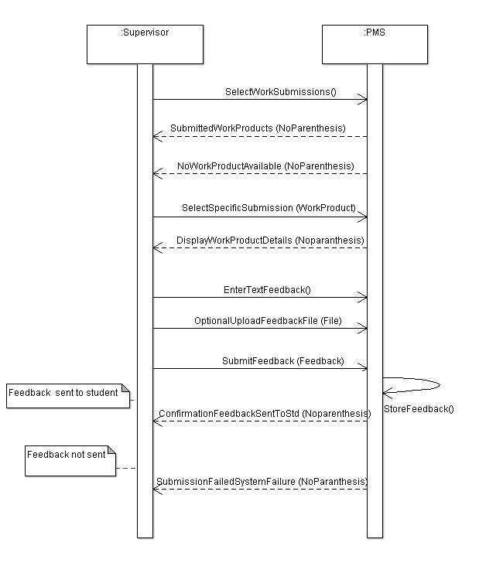

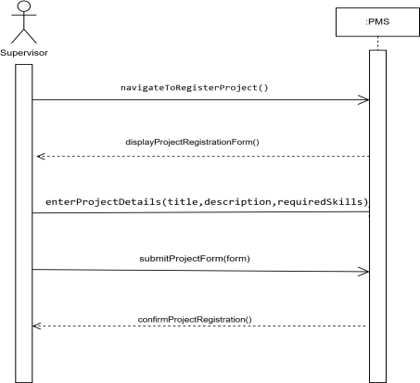

Approve Project SSD:

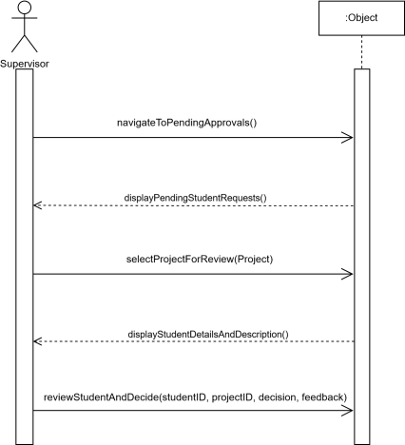

Receive Feedback SSD:

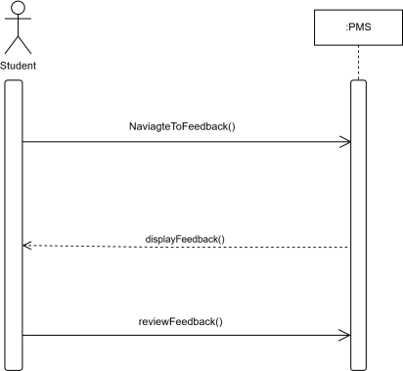

Select Project SSD

Manage User SSD:

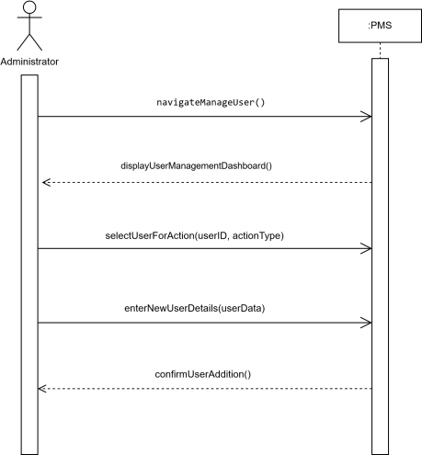

**Conclusion:**

The **Project Management System** for final-year students is designed to streamline project tracking, submission, and feedback between students and supervisors. This document provides a comprehensive overview of the requirements for the Project Management System, ensuring clear understanding and implementation guidelines for developers.