[1]- Lerner, I., Armstrong, B. C., & Frost, R. (2014). What can we learn from learning models about sensitivity to letter order in visual word recognition? Journal of Memory and Language, 77, 40–58. https://doi.org/10.1016/j.jml.2014.09.002
Dataset creation
An investigation of the modulation of the TL effect by allography in the Arabic language was conducted by creating five datasets which consisted of 478 words of length ranging from five to ten. 'Target' consists of the words as they appear in their original form. The ‘TL-Allog’ dataset includes target words with transposed letters and unchanged allographs. The transposition of one or two letters of target words causes allographs to be altered in the 'TL+Allog' dataset. 'Subl-Allog' comprises target words with substituted letters and unchanged allographs. In the 'Subl+Allog' dataset, one or two letters of target words were substituted such that the allographs were changed. An instance of the various dataset values is shown below:
Dataset Name | Word
Target | الانفصالية
TL-Allog | الانصفالية
TL+Allog | الافنصالية
Subl-Allog | الانضقالية
Subl+Allog | الاقتصالية
Table 1:
Simulation 1 - id, pos, allog -> orth
Input Representation
Depending on its position in a word, each Arabic letter takes on a different shape. In Table 2, we summarize the different letters that generate words in our dataset and how they appear at the beginning, middle, or end of those words. The standalone shape of the letter, as well as the number of possible shapes, are provided. It is possible to classify letters into three categories based on the number of shapes they have. For letters belonging to class 1, there is only one shape, while for letters belonging to class 2, there are two shapes, and for letters belonging to class 3, there are four shapes.
The orthographic input representations generated for words in the datasets encode identity, position and allography information separately. The identity of input words is represented by the 35 standalone letter units described in Table 2. For example, in the word ‘أبعثر’, the units representing the letters ﺃ, ر, ب, ع, and ث have the value 1, whereas all other units have the value 0. The position input representation contains 100 units since our dataset has a maximum word length of 10. The letters are sorted alphabetically and graded according to their relative position within the word. Accordingly, the letters in the word ‘أبعثر’ are encoded as [3, 5, 4, 2, 1] based on their sorted order ['ﺃ', 'ﺑ', 'ﺜ', 'ﺮ', 'ﻌ']. The encoded position information is converted into a binary representation of ten units, with each positional unit turned on and the other units turned off. As a result, '3' is encoded as '0010000', '2' is encoded as '0100000', and so on. There will be zeros encoded in the ninth and tenth positions of the eight-letter words and zeros encoded in the tenth position of the nine-letter words. The allographic information is represented by 115 units, which sum up the shapes shown in Table 2. The class 1 letters are represented by a single node, class 2 letters by two nodes, and class 3 letters by four nodes. The unit representing 'ﺑ' is turned on and units for [ب, ـب, ـبـ] is turned off for the letter ‘ب’ in the word ‘أبعثر’. Similarly, for the letter ‘أ’, only the unit for ‘أ’ is turned on and unit for ‘ـأ’ is turned off since the letter appears at the beginning of the word ‘أبعثر’. All the units are kept off for letters absent in the dataset word.

No | s-alone | terminal | medial | initial | shapes | class
1 | ء | ء | ء | ء | 1 | 1
2 | أ | ـأ | ـأ | أ | 2 | 2
3 | ؤ | ـؤ | ـؤ | ؤ | 2 | 2
4 | إ | ـإ | ـإ | إ | 2 | 2
5 | ئ | ـئ | ـئـ | ئـ | 4 | 3
6 | ا | ـا | ـا | ا | 2 | 2
7 | ب | ـب | ـبـ | بـ | 4 | 3
8 | ة | ـة | ـة | ة | 2 | 2
9 | ت | ـت | ـتـ | تـ | 4 | 3
10 | ث | ـث | ـثـ | ثـ | 4 | 3
11 | ج | ـج | ـجـ | جـ | 4 | 3
12 | ح | ـح | ـحـ | حـ | 4 | 3
13 | خ | ـخ | ـخـ | خـ | 4 | 3
14 | د | ـد | ـد | د | 2 | 2
15 | ذ | ـذ | ـذ | ذ | 2 | 2
16 | ر | ـر | ـر | ر | 2 | 2
17 | ز | ـز | ـز | ز | 2 | 2
18 | س | ـس | ـسـ | سـ | 4 | 3
19 | ش | ـش | ـشـ | شـ | 4 | 3
20 | ص | ـص | ـصـ | صـ | 4 | 3
21 | ض | ـض | ـضـ | ضـ | 4 | 3
22 | ط | ـط | ـطـ | طـ | 4 | 3
23 | ظ | ـظ | ـظـ | ظـ | 4 | 3
24 | ع | ـع | ـعـ | عـ | 4 | 3
25 | غ | ـغ | ـغـ | غـ | 4 | 3
26 | ف | ـف | ـفـ | فـ | 4 | 3
27 | ق | ـق | ـقـ | قـ | 4 | 3
28 | ك | ـك | ـكـ | كـ | 4 | 3
29 | ل | ـل | ـلـ | لـ | 4 | 3
30 | م | ـم | ـمـ | مـ | 4 | 3
31 | ن | ـن | ـنـ | نـ | 4 | 3
32 | ه | ـه | ـهـ | هـ | 4 | 3
33 | و | ـو | ـو | و | 2 | 2
34 | ى | ـى | ـى | ى | 2 | 2
35 | ي | ـي | ـيـ | يـ | 4 | 3

Table 2:
Output Representation

One hot-encoded word vectors of 203 units make up the output layer. To produce the output representation of words, one-hot encoded letters of the input words are concatenated. It involves mapping letters to integers and creating binary vectors with all zeros excluding the integer index. Since all the 35 standalone letters in Table 2 are considered, the binary vectors produced during one-hot encoding of letters are 35 units in length. The letter ‘ت’, for example, is encoded as ‘00000000000000000000000001000’. The output representation of the word ‘أبعثر’ is formed by concatenating the one-hot vectors of the letters ﺃ, ر, ب, ع, and ث in the order in which they appear within the word.
Network Architecture – Simulation 1
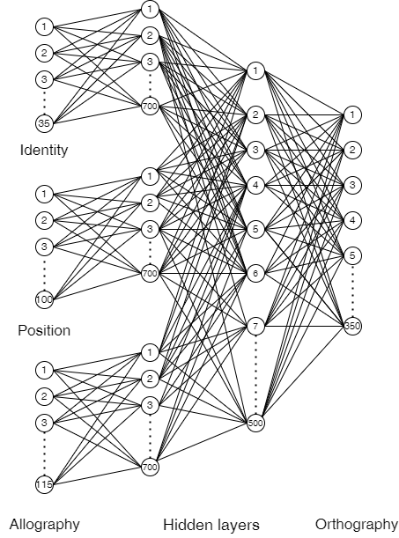
Fig 1: Simulation 1 Architecture
Architecture Details
Simulation 1 illustrates how the neural network maps position, identity and allography inputs separately to one hot encoded output. Before the input representations of the identity, position and allography of letters are passed to the output layer, an additional hidden layer of 500 units and three separate hidden layers of 700 units process input representations of the identity, position and allography of letters. As opposed to the hidden layer 1, which learns identity, position and allography separately, the hidden layer 2 learns both simultaneously. A layer's net input is the sum of activity in the preceding layer, plus any bias connections, multiplied by the weight of the connections between the layers. The output of a unit is a sigmoidal function of its net input.
Training and Testing
An orthographic representation and a one hot representation for 478 target words of varying lengths were generated for training purpose. During forward propagation, the orthographic inputs were provided to the network to propagate the activations and generate the output. By comparing this output with the required output, the mean square error was calculated. During backward propagation, the network weight values were adjusted based on the error calculated after every epoch. The network was trained on the ‘Target’ dataset until the slope of the error approached zero. Upon reaching the threshold, each word's orthographic input triggered an orthographic representation for each unit corresponding to its target. To reach the threshold stopping condition, the training corpus required approximately 50 epochs.
From the training dataset 'Target', four datasets - TL+Allog, TL-Allog, Subl+Allog, and Subl-Allog were derived for testing. Testing involved comparing the trained network's output when presented with words created from letter-transpositions and letter substitutions with and without allographic changes. During transpositions, internal letters of training data switched positions to induce allographic changes in TL+Allog. Two or more internal letters were replaced during substitution to change the allography in Subl+Allog. No allographic variation was caused by transpositions and substitutions in the TL-Allog and SubL-Allog data.
After the network was tested, the orthographic output activated by the words in the test dataset was compared to the words in the 'Target' training set. An analysis of the correlation between the output produced by the testing items and the output produced by the target items was conducted. For instance, the correlation between the outputs generated by the target item ‘الانفصالية ‘was compared with the outputs generated by its TL-Allog item ‘الانصفالية ‘, TL+Allog item ‘الافنصالية ‘, Subl-Allog item ‘الانضقالية ‘and Subl+Allog item ‘الاقتصالية ‘to study the impact of allography on letter transpositions and substitutions in Arabic. It is assumed that this correlation reflects the level of facilitation the transposed and substituted word with allographic changes will bring about on the original word. As shown in Figure 1b, TL priming effects are computed as the difference of the mean correlations between letter-transposition and letter-substitution conditions. In contrast to non-allographic datasets, priming due to allographs appears to be much stronger than in non-allographic datasets. All the experiments were conducted multiple times to ensure robustness to weight initializations (similar to Plaut, 2002).
Results
The correlation distance between datasets and targets, and the TL priming effect, for Words, are shown below
 | Subl+Allog | Subl-Allog | TL+Allog | TL-Allog |  |  | TL+Allog |  | TL-Allog
Target | 0.28 | 0.25 | 0.14 | 0.07 |  | Subl+Allog | 0.21 | Subl-Allog | 0.20

Correlation value, r = corr (A, B) | Correlation distance = 1 - r
  A | B | r
  Target | Subl+Allog | 0.72
  Target | Subl-Allog | 0.75
  Target | TL+Allog | 0.86
  Target | TL-Allog | 0.93
  Subl+Allog | TL+Allog | 0.79
  Subl-Allog | TL-Allog | 0.80
  A | B | 1 - r
  Target | Subl+Allog | 0.28
  Target | Subl-Allog | 0.25
  Target | TL+Allog | 0.14
  Target | TL-Allog | 0.07
  Subl+Allog | TL+Allog | 0.21
  Subl-Allog | TL-Allog | 0.20

Table 3: Correlation between targets and primes

Pair | TL-Priming (TL - SubL)
|Subl+Allog - TL+Allog| | 0.14
|Subl-Allog - TL-Allog| | 0.18

Table 4: TL-Priming effects modulated by allography
#simulation 2 id+pos+allog -> orth
Input and output Representation
The TL effects modulated by allography studied in simulation 2 combines identity, position and allography information at the input layer. During the input vector generation, 115 letter nodes were considered, since only one letter belongs to class 1, 11 letters belong to class 2, and 23 letters belong to class 3. Each letter in the word is represented by ten units, as our dataset included words with lengths ranging from five to ten. It is imperative to note that for every Xth letter in the word, all units other than the Xth unit in the 10-unit representation are zeroes, where X ranges from 1 to 10. For instance, the letter ' ر' in the word ' ارتجلت' is at the second position and was encoded as '0100000. The letters in the vocabulary that do not appear in the input word are encoded as all zeroes i.e. ‘0000000’. Henceforth, this letter-encoded representation concatenated in alphabetical order generates the word input representation. The use of this representation enabled the identity, allography and position information to be fed together, the letter shapes and locations to be differentiated at the same time. Simulation 2 uses the same output representation as simulation 1.
Network Architecture – Simulation 2
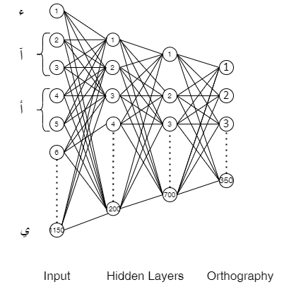
Fig 3: Simulation2 Architecture
Architecture Details
The network in simulation 2 consists of an input layer, 2 hidden layers, and an output layer. The input layer consisting of 1150 nodes was passed through 1200 hidden units, followed by a hidden layer with 700 units activated by ReLU to produce the 350-unit output.
The network was trained on the ‘Target’ dataset until the slope of the error approached zero. During forward propagation, the inputs were provided to the network to propagate the activations and generate the output. During backward propagation, the network weight values were adjusted based on the error calculated after every epoch. As part of testing, we examined the trained network's output when exposed to words created by letter-transposition and substitution(s) with and without allographic changes generated from the training words. The four datasets ‘TL+Allog’,’TL-Allog’,’Subl+Allog’, and ‘Subl-Allog’ were used as test sets. The latent vector outputs generated by the encoder for every dataset were analysed. The correlation distance between the output vectors produced by the testing items and the output vectors produced by the target was calculated.

Results
Correlation distance between datasets and targets, and the TL priming effect, for Words is shown below
 | Subl+Allog | Subl-Allog | TL+Allog | TL-Allog |  |  | TL+Allog |  | TL-Allog
Target | 0. 21 | 0.23 | 0.24 | 0.25 |  | Subl+Allog | 0.14 | Subl-Allog | 0.18

Table 5: Correlation between targets and primes

Pair | TL-Priming (TL - SubL)
|TL+Allog - Subl+Allog | | 0.03
|TL-Allog - Subl-Allog | | 0.02

Table 6: TL-Priming effects modulated by allograph
Correlation distance = 1 - r | Correlation value, r = corr (A, B)
  A | B | r
  Target | Subl+Allog | 0.21
  Target | Subl-Allog | 0.23
  Target | TL+Allog | 0.24
  Target | TL-Allog | 0.25
  Subl+Allog | TL+Allog | 0.14
  Subl-Allog | TL-Allog | 0.18
  A | B | 1 - r
  Target | Subl+Allog | 0.79
  Target | Subl-Allog | 0.77
  Target | TL+Allog | 0.76
  Target | TL-Allog | 0.75
  Subl+Allog | TL+Allog | 0.86
  Subl-Allog | TL-Allog | 0.82

Simulation 3: id, pos -> orth
Input and output Representation
The orthographic input representations generated for words in the datasets encode identity information separately from position information like Lerner, I., Armstrong, B. C., & Frost, R. (2014) [1]. The identity of input words is represented by the 35 standalone letter units described in Table 2. For example, in the word ‘أبعثر’, the units representing the letters ﺃ, ر, ب, ع, and ث have the value 1, whereas all other units have the value 0. The position input representation contains 100 units since our dataset has a maximum word length of 10. The letters are sorted alphabetically and graded according to their relative position within the word. Accordingly, the letters in the word ‘أبعثر’ are encoded as [3, 5, 4, 2, 1] based on their sorted order ['ﺃ', 'ﺑ', 'ﺜ', 'ﺮ', 'ﻌ']. The encoded position information is converted into a binary representation of ten units, with each positional unit turned on and the other units turned off. As a result, '3' is encoded as '0010000', '2' is encoded as '0100000', and so on. There will be zeros encoded in the ninth and tenth positions of the eight-letter words and zeros encoded in the tenth position of the nine-letter words. Simulation 3 uses the same output representation as simulation 1
Architecture
Simulation 3 illustrates how the neural network maps position and identity inputs separately to one hot encoded output. Before the input representations of the identity and position of letters are passed to the output layer, an additional hidden layer of 500 units and two separate hidden layers of 700 units process input representations of the identity and position of letters. As opposed to the hidden layer 1, which learns identity and position separately, the hidden layer 2 learns both simultaneously. A layer's net input is the sum of activity in the preceding layer, plus any bias connections, multiplied by the weight of the connections between the layers. The output of a unit is a sigmoidal function of its net input.
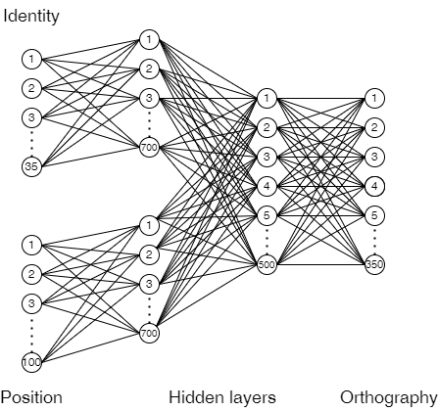
Fig 5: Simulation3 Architecture
Results
The correlation distance between datasets and targets, and the TL priming effect, for Words, are shown below
 | Subl+Allog | Subl-Allog | TL+Allog | TL-Allog |  |  | TL+Allog |  | TL-Allog
Target | 0.273 | 0.252 | 0.0947 | 0.0945 |  | Subl+Allog | 0.22 | Subl-Allog | 0.21

Correlation value, r = corr (A, B) | Correlation distance = 1 - r
  A | B | r
  Target | Subl+Allog | 0.727
  Target | Subl-Allog | 0.748
  Target | TL+Allog | 0.9053
  Target | TL-Allog | 0.9055
  Subl+Allog | TL+Allog | 0.78
  Subl-Allog | TL-Allog | 0.79
  A | B | 1 - r
  Target | Subl+Allog | 0.273
  Target | Subl-Allog | 0.252
  Target | TL+Allog | 0.0947
  Target | TL-Allog | 0.0945
  Subl+Allog | TL+Allog | 0.22
  Subl-Allog | TL-Allog | 0.21

Table 7: Correlation between targets and primes

Pair | TL-Priming (TL - SubL)
|TL+Allog - Subl+Allog | | 0.1783
|TL-Allog - Subl-Allog | | 0.1575

Table 8: TL-Priming effects modulated by allography

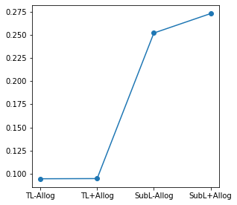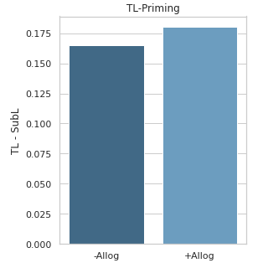
Fig 6b: TL priming effects observed in Simulation 1
#simulation 4 id+pos, allog->orth
Simulation 4
Input Representation
The TL effects modulated by allography studied in simulation 4 combine identity and position information as one input and process allography as the next input. The identity+position encoding uses a 350-unit representation since each standalone identity letter in Table 2 is represented by ten positional units, as our dataset includes words with lengths ranging from five to ten. This letter-encoded representation concatenated in alphabetical order generates the first input for the simulation. The different allographic letter shapes are represented using the 115-unit allographic input.
Network Architecture
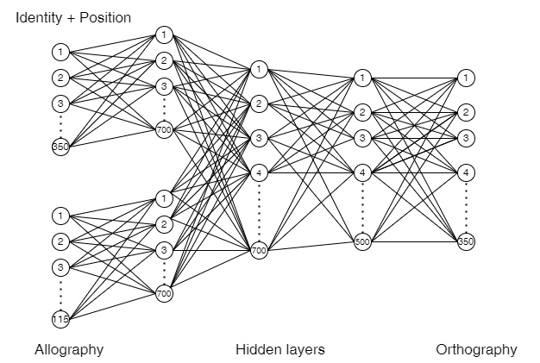
Fig 7: Simulation3 Architecture
The identity+position input and allographic input was processed separately by 700 hidden units in layer 2. Its output was combined and processed by another 700 hidden units in layer 3. This output was processed by 500 hidden units before it was forwarded to the output layer.
Results
Correlation distance between datasets and targets, and the TL priming effect, for Words is shown below
 | Subl+Allog | Subl-Allog | TL+Allog | TL-Allog |  |  | TL+Allog |  | TL-Allog
Target | 0.24 | 0. 26 | 0.22 | 0.18 |  | Subl+Allog | 0.18 | Subl-Allog | 0.19

Correlation value, r = corr (A, B) | Correlation distance = 1 - r
  A | B | r
  Target | Subl+Allog | 0.76
  Target | Subl-Allog | 0.74
  Target | TL+Allog | 0.78
  Target | TL-Allog | 0.82
  Subl+Allog | TL+Allog | 0.82
  Subl-Allog | TL-Allog | 0.81
  A | B | 1 - r
  Target | Subl+Allog | 0.24
  Target | Subl-Allog | 0.26
  Target | TL+Allog | 0.22
  Target | TL-Allog | 0.18
  Subl+Allog | TL+Allog | 0.18
  Subl-Allog | TL-Allog | 0.19

Table 4: Correlation between targets and primes

Pair | TL-Priming (TL - SubL)
|TL+Allog - Subl+Allog | | 0.02
|TL-Allog - Subl-Allog | | 0.08

Table 5: TL-Priming effects modulated by allography
Simulation 5
The simulation 5 illustrates how the neural network maps position, identity and allography inputs separately to semantic output. Hence, simulation 5 used an input representation similar to simulation 1. The output layer uses a 300-unit semantic representation of input words. The semantic vector of words was generated from a word2vec model trained on Common Crawl and Wikipedia files. For training, a CBOW model with position-weights, in a dimension of 300, with a character n-gram of length 5, a window of size 5, and ten negatives was used. For each token, the model produces 300-dimensional vector outputs. The output vectors represent words within a meaningful space, where the distance between the vectors indicates how semantically similar the words are.
Network Architecture
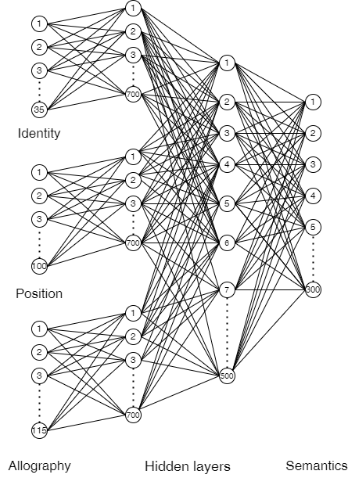
Architecture Details
Simulation 1 illustrates how the neural network maps position, identity and allography inputs separately to semantic vectors. Before the input representations of the identity, position and allography of letters are passed to the output layer, an additional hidden layer of 500 units and three separate hidden layers of 700 units process input representations of the identity, position and allography of letters. As opposed to the hidden layer 1, which learns identity, position and allography separately, the hidden layer 2 learns both simultaneously. A layer's net input is the sum of activity in the preceding layer, plus any bias connections, multiplied by the weight of the connections between the layers. The output of a unit is a sigmoidal function of its net input.
Simulation 6
The neural network demonstrates how it maps position, identity, and allography inputs together to produce semantic output in Simulation 6. The Simulation 6 uses an input representation similar to Simulation 2. The network consists of an input layer, 2 hidden layers, and an output layer. The input layer consisting of 1150 nodes was passed through 1200 hidden units, followed by a hidden layer with 700 units activated by ReLU to produce the 300-unit semantic output.
Architecture
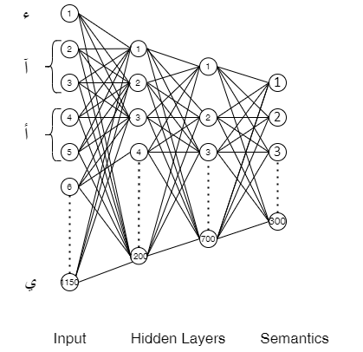
Simulation 7
Simulation 7 uses the same input representation of Simulation 3 and the output representation resembles Simulation 5. Simulation 7 illustrates how the neural network maps position and identity inputs separately to semantic vectors. Before the input representations of the identity and position of letters are passed to the output layer, an additional hidden layer of 500 units and two separate hidden layers of 700 units process input representations of the identity and position of letters. As opposed to the hidden layer 1, which learns identity and position separately, the hidden layer 2 learns both simultaneously. A layer's net input is the sum of activity in the preceding layer, plus any bias connections, multiplied by the weight of the connections between the layers. The output of a unit is a sigmoidal function of its net input.
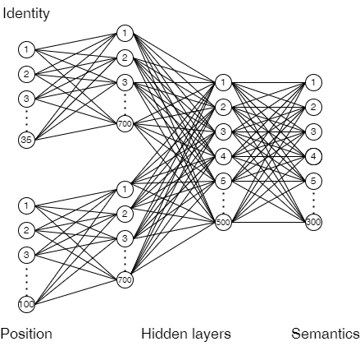
Simulation 8
In simulation 4 both the identity and position information are fed together at the input layer as one input, allography as the next input to study the TL effects modulated by allography against semantics. Hence, an input representation similar to simulation 4 is followed. The output layer uses a 300-unit semantic representation of input words from word2vec model trained on Common Crawl and Wikipedia files.
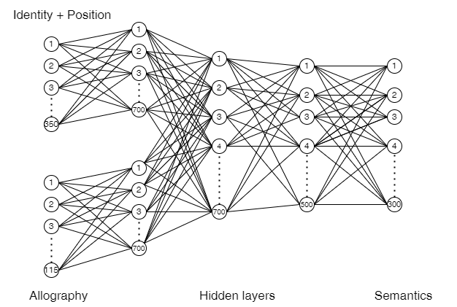
Result for Simulation 4-8
Correlation distance between datasets and targets, and the TL priming effect, for Words is shown below
 | Subl+Allog | Subl-Allog | TL+Allog | TL-Allog |  |  | TL+Allog |  | TL-Allog
Target | 0.7 | 0. 7 | 0.7 | 0.7 |  | Subl+Allog | 0. | Subl-Allog | 0

Pair | TL-Priming (TL - SubL)
TL+Allog - Subl+Allog | 0
TL-Allog - Subl-Allog | 0

Table 5: TL-Priming effects modulated by allography
Simulation x

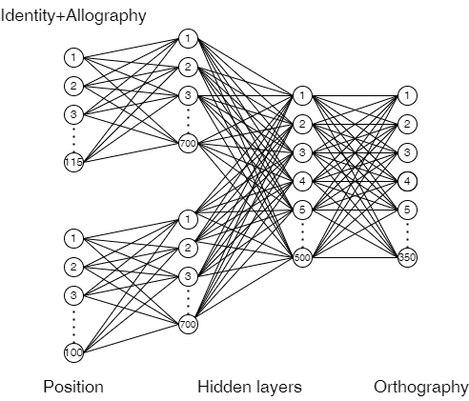
Result for Simulation x
Correlation distance between datasets and targets, and the TL priming effect, for Words is shown below
 | Subl+Allog | Subl-Allog | TL+Allog | TL-Allog |  |  | TL+Allog |  | TL-Allog
Target | 0.28 | 0. 25 | 0.18 | 0.09 |  | Subl+Allog | 0.21 | Subl-Allog | 0.22

Pair | TL-Priming (TL - SubL)
TL+Allog - Subl+Allog | 0.10
TL-Allog - Subl-Allog | 0.16

Table 5: TL-Priming effects modulated by allography

