**List three Linux Distributions**

* Ubuntu
* Red Hat
* Kubuntu

**What is the man command used for?**

System-wide documentation system that provides short reference manuals (pages) for individual  
commands, API functions, concepts, configuration file syntax, file formats and is organized in sections  
(1 for user commands, 2 for system calls...). That's the traditional Unix documentation system

*man command in Linux is used to display the user manual of any command that we can run on  
the terminal.

**What is the difference between rm and rmdir using man command?**

* rmdir: remove empty directory
* rm: remove file

**Create the following hierarchy under your home directory:**

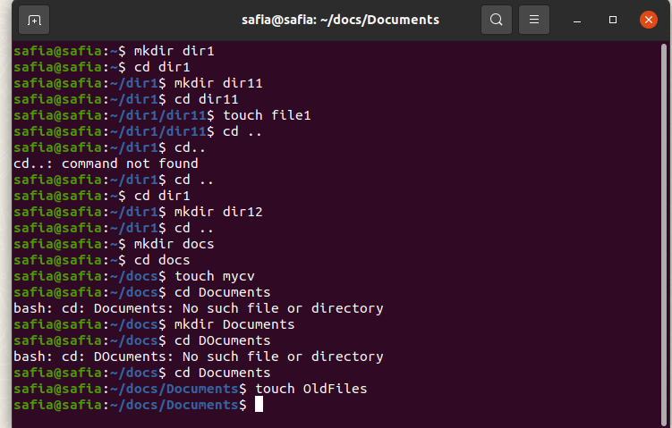

**Remove dir11 with rmdir in one-step. What did you notice? And how did you overcome that?**



**Then remove OldFiles using rmdir –p command. State what happened to the hierarchy (Note: you are in your home directory).**



**The output of the command pwd was /home/user. Write the absolute and relative path for the file mycv**

Absolute: *home/*safia/docs

Relative: ../docs

**5. Copy the /etc/passwd file to your home directory making its name is mypasswd** **6. Rename this new file to be oldpasswd**

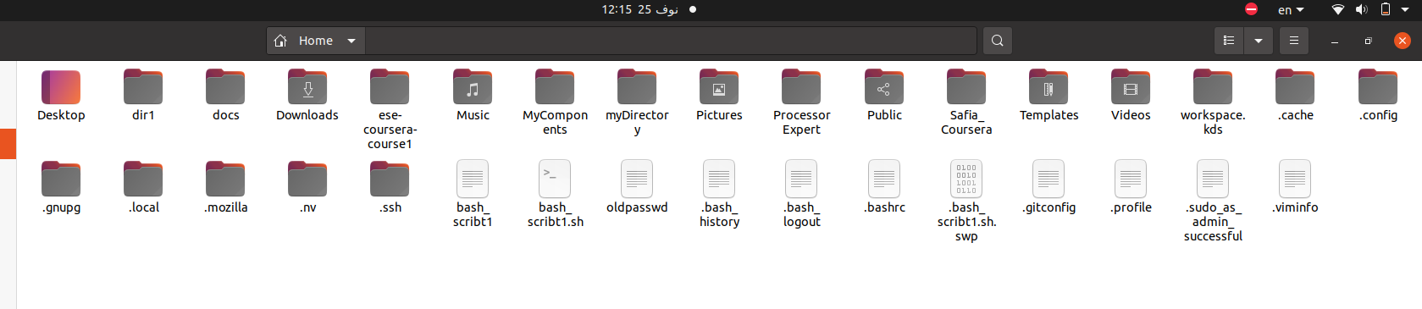**You are in /usr/bin, list four ways to go to your home directory**

1- cd /home/safia

2- cd

3- cd ~

4- cd $HOME

**8- List Linux commands in /usr/bin that start with letter w**

* w
* wall
* watch
* wget

**9- What command type are used for? (from the slide)**

Display information about command type

**10- Show 2 types of command file in /usr/bin that start with letter c**

chmod

clear

**11- Using man command find the command to read file. (Note: man take option)**

cat file_name

nl file_name

**12- What is the usage of apropos command?**

apropos command helps the user when they don’t remember the exact command but knows a few keywords related to the command that define its uses or functionality. It searches the Linux man page with the help of the keyword provided by the user to find the command and its functions.