# Computer Networks

## OSI and TCP/IP Model PART (1)

Basics of computer networks.

Why do we need layers?

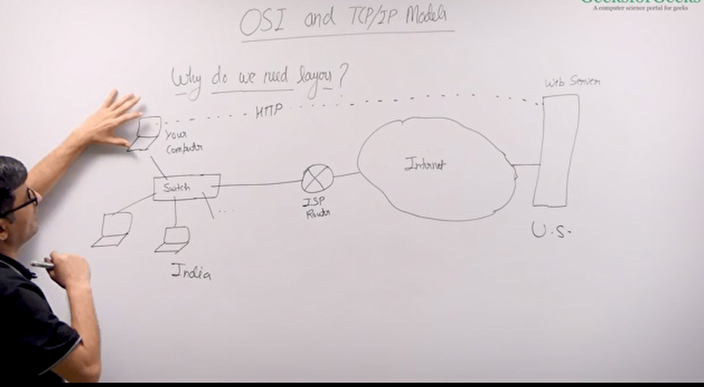

Switch – It is device that connects local area network. It connects computer within a small network. i.e. Office network.

The switch is then connected to a router, which connects your network to another network. Here the router is connecting you to the internet. The web server is connected to the internet also. And this is how you connect to the web server.

There are lots of things that happens when you connect to a website. i.e. connection establishment, finding a path to the web server, talking to the web server, deciding a format of the request, deciding a format of the response, then processing that format, making efficient use of the bandwidth, adding new devices etc.

How do we manage these things?

We have different types of protocol.

Protocol

Protocol are a set of rules, which are used by two devices to communicate to each other. These set of rule are decided typically by the headers. The headers specify the content of the message and how this message to be processed.

IP, TCP, UDP, HTTP, SMTP, …

Your server uses HTTP and your browser uses HTTP.

Organize these protocols into layers to manage them efficiently.

HTTP is an application layer protocol. What it means is HTTP does not have to implement anything that is provided by the lower layer protocol the transport layer protocol. Assumes that all the transport layer protocol is readily available.

Internet can be considered as a huge collection of protocols and layers.

Sender sends (headers) -> process (headers) receiver

## OSI model

There are 7 layers in OSI model. EACH LAYER ATTATCHES ITS OWN HEADER AND SEND IN TO THE NEXT LAYER.

1. Application
2. Transportation
3. Session
4. Transport
5. Network
6. Data Link
7. Physical

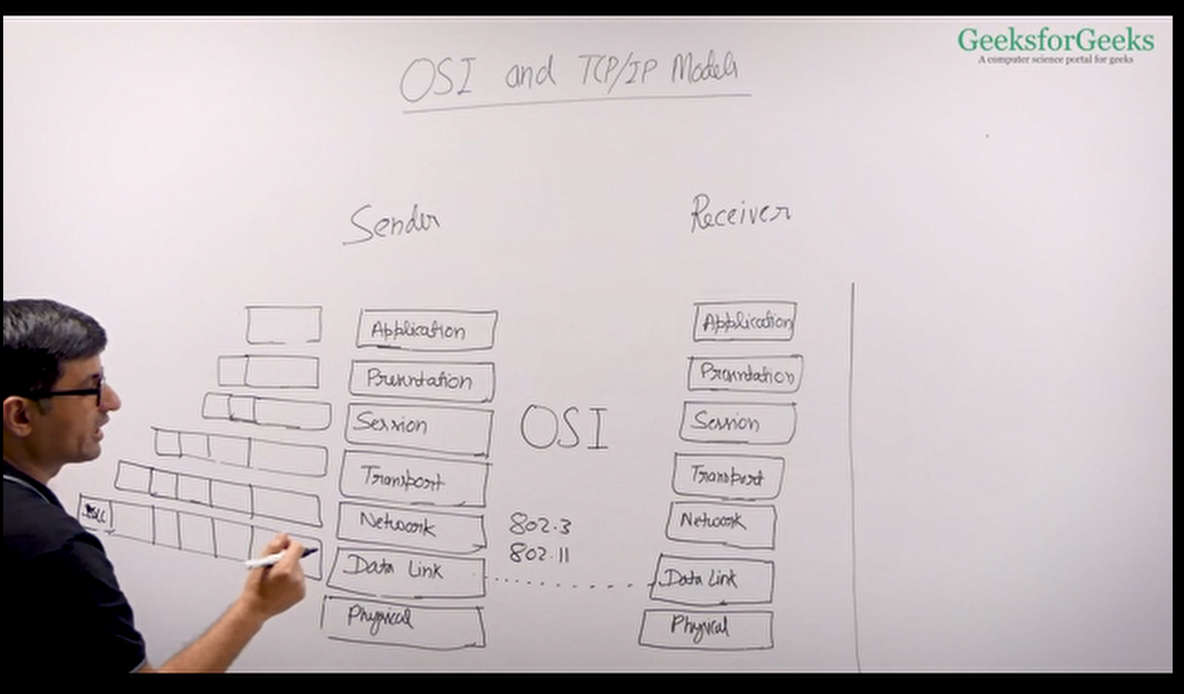

Both sender and receiver has all the 7 layers. Sender sends the message with its own header for each layer and the receiver receives the data and each header of the sender is processed by the corresponding layer of the receiver and then sent upwards.

After each layer processes and removes the corresponding headers there is only the application layer message is left, here it is the HTTP protocol. So, the application layer only needs to implement the HTTP to communicate with each other. ENCAPSULATION is happening here.

The 7 layer model is a theoretical model. And it is never implemented. The model that is actually used is TCP/IP model, which is a four layer model.

OSI => 7 layers

TCP/IP => 4 layers

Physical layer – physical media. i.e. fibre optic, twisted pair, etc. Not really related to computer science.

Data Link – It is responsible for one to one connections. For example switch, wi-fi etc

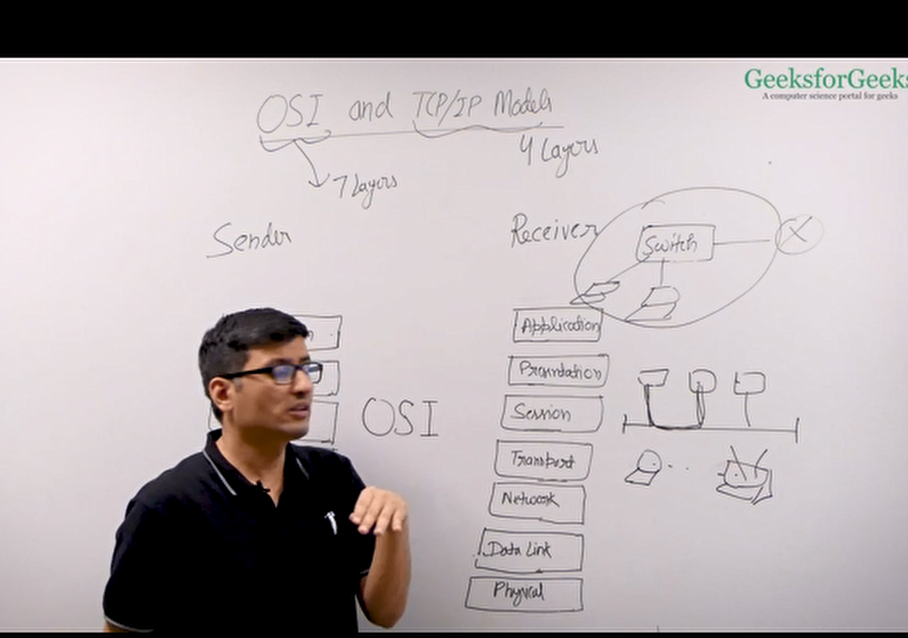

Error handling, flow control, access to the shared medium must be controlled as there might be collisions here, similarly in wireless multiple device might be trying to access the same access point, which can create collisions here, collision handling.

Data link layer provides one device to another device communication. Maybe using switch or shared media or a wireless media

## OSI and TCP/IP Model PART (2)

### Network Layer

If you want to connect to a device, which is not directly connected to you, maybe some server in some other country, you need to have services of network layer. Network layer routes your message or data from your local network to some distance network. It helps finding the routes to the distant networks. Routers are network layer devices.

Network layer is implemented by the IP protocol.