**PF LAB #4,5 ASSIGNMENTS**

**SAFIULLAH KHAN**

**25K-0036**

**BAI-1A**

**Question 1:**

**Question 2:**

**Question 3:**

**Question 4:**

**Question 5:**

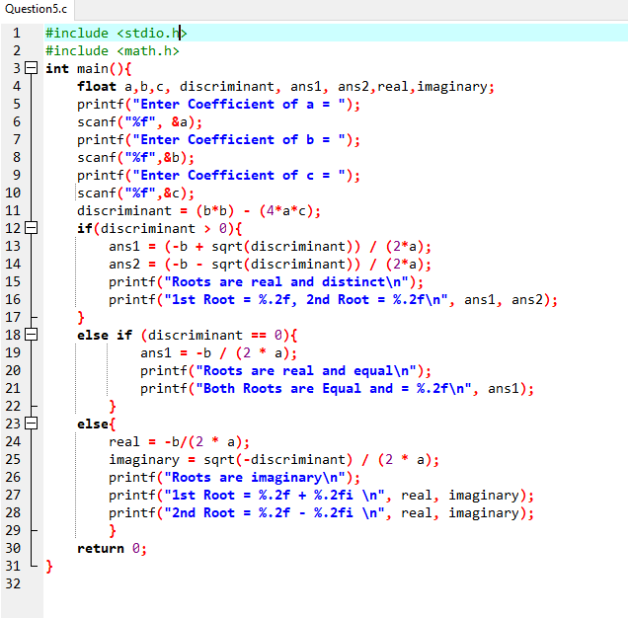

**Question 6:**

**Question 7:**

**Question 8:**

**Question 9:**

**Question 10:**

