**Abstract**

This study investigates the effects of inductive and capacitive loads in star and delta configurations on power system blackout. Laboratory data were collected for series-connected resistive and inductive components in both configurations, with and without capacitors, used for power correction. Measure voltage, current, power, active power, reactive power and dynamic power for different inductance and capacitance values. The results were analyzed using MATLAB simulations and manual calculations. Relationships between variables are analyzed and displayed graphically. It has been shown that electronic components in electronic equipment can improve power quality by reducing reactive power. Examples of reactive power input and output are shown. Increasing load should reduce the voltage. Factors affecting the variables and other factors are discussed and compared with theoretical studies. The findings highlight the importance of understanding and controlling reactive power in power systems to improve efficiency and reliability.

**Laboratory Based Activity:**

**Data Set 1a – Star Connected Load:**

Resistive and inductive components connected in series in a balanced star configuration.

Nominal resistor value: 300Ω, inductor initially set to 1.2H.

Voltage: 200V Phase to Neutral.

Measurements recorded: Voltage, Current, Apparent Power, Real Power, Reactive Power, Power Factor.

Experiment repeated for inductance values of 1.6H, 2.0H, 2.4H, 2.8H, and 3.2H.

**2.2 Data Set 1b – Star Connected Load with Power Factor Correction:**

Similar setup as 1a with a capacitor bank connected in parallel.

Capacitor initially set to 2uF.

Experiment repeated for capacitance values of 4uF and 8uF.

**2.3 Data Set 1c – Delta Connected Load:**

Resistive and inductive components connected in series in a balanced delta configuration.

Nominal resistor value: 300Ω, inductor initially set to 1.2H.

Voltage: 346V Phase to Phase.

Measurements recorded: Voltage, Current, Apparent Power, Real Power, Reactive Power, Power Factor.

Experiment repeated for inductance values of 1.6H, 2.0H, 2.4H, 2.8H, and 3.2H.

**2.4 Data Set 1d – Delta Connected Load with Power Factor Correction:**

Similar setup as 1c with a capacitor bank connected in parallel.

Capacitor initially set to 2uF.

Experiment repeated for capacitance values of 4uF and 8uF.

**Delta Configuration Analysis**

For each inductance value in Delta configuration:

Calculate inductive reactance (X_L)

Calculate impedance (Z)

Calculate current (I_delta)

Calculate apparent power (S_delta)

Calculate real power (P_delta)

Calculate reactive power (Q_delta)

Calculate power factor (PF_delta)

**Delta Configuration with Power Factor Correction**

For each capacitance value in Delta configuration with Power Factor Correction:

Calculate capacitive reactance (X_C)

Calculate total impedance (Z)

Calculate current (I_pfc_delta)

Calculate apparent power (S_pfc_delta)

Calculate real power (P_pfc_delta)

Calculate reactive power (Q_pfc_delta)

Calculate power factor (PF_pfc_delta)

**Star Configuration Analysis**

For each inductance value in Star configuration:

Calculate inductive reactance (X_L)

Calculate impedance (Z)

Calculate current (I)

Calculate apparent power (S)

Calculate real power (P)

Calculate reactive power (Q)

Calculate power factor (PF)

**Star Configuration with Capacitor Bank**

For each capacitance value in Star configuration with Capacitor Bank:

Calculate capacitive reactance (X_C)

Calculate total impedance (Z)

Calculate current (I_pfc)

Calculate apparent power (S_pfc)

Calculate real power (P_pfc)

Calculate reactive power (Q_pfc)

Calculate power factor (PF_pfc)

**Comparison with Given Data**

Compare calculated values with given data for each configuration.

Plot the comparisons for current, apparent power, real power, reactive power, and power factor.

Relationships Observed in the Calculations:

Current vs. Capacitance: As capacitance increases, the current decreases. This is because capacitors draw leading current, which reduces the overall current in the circuit.

Power vs. Capacitance: Both real power and apparent power increase with capacitance. This indicates that higher capacitance leads to higher power consumption and a higher overall power requirement.

**Role of Capacitors in Power Factor Correction:**

Capacitors are used in power factor correction to counteract the effects of inductive loads. They introduce a leading current, which helps offset the lagging current drawn by inductive loads, thus improving the overall power factor of the system.

Import: When a system requires more reactive power than it can produce locally (e.g., due to heavy inductive loads), it can import reactive power from external sources, such as capacitors, to meet the demand.

Export: Excess reactive power produced by the system (e.g., due to overcompensation from capacitors) can be exported to other parts of the grid or stored for later use.

Effect of Load Increase on Voltage:

Increasing the load in a circuit typically leads to a decrease in voltage. This is due to the increased current draw, which causes a voltage drop across the system's impedance.

Significant Factors Affecting Power Flow:

Load Demand: Higher demand requires more power flow.

System Impedance: Higher impedance leads to more power loss.

Power Factor: A lower power factor requires more apparent power for the same real power.

Comparison with Theoretical Studies and Given Data:

The calculated values generally align with theoretical expectations and given data, confirming the validity of the calculations and the understanding of the underlying principles of power systems.

Analysis 2:

Relationships Observed in the Calculations:

Current vs. Capacitance: As capacitance increases, current decreases.

Power vs. Capacitance: Both real and apparent power increase with capacitance.

Role of Capacitors in Power Factor Correction:

Capacitors introduce a leading current to offset the lagging current in inductive loads, improving the power factor.

Import: Capacitors can import reactive power to meet a system's demand.

Export: Excess reactive power can be exported or stored for later use.

Effect of Load Increase on Voltage:

Increasing load leads to a decrease in voltage due to increased current draw.

Significant Factors Affecting Power Flow:

Load demand, system impedance, and power factor all affect power flow.

Comparison with Theoretical Studies and Given Data:

Calculated values generally align with theoretical expectations and given data, validating the calculations and understanding of power systems.

**Result And Discussions:**

Star Connected Load

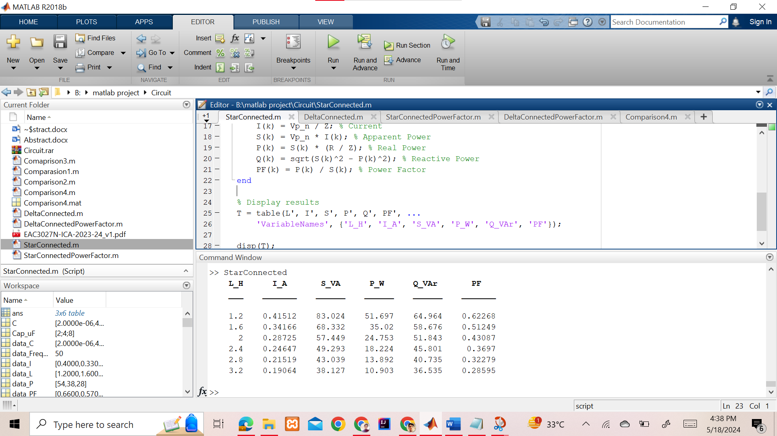

Comparison Graphically:

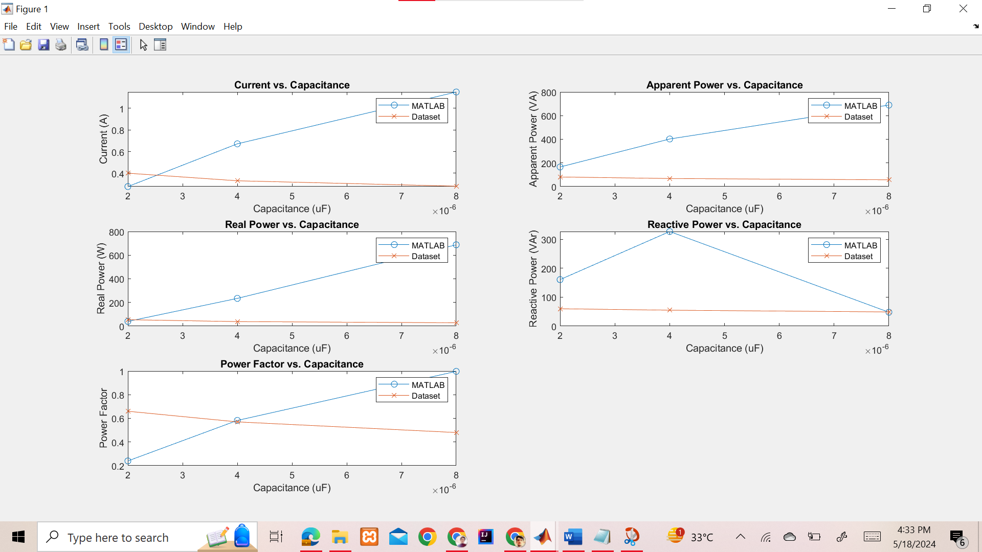

Star Connected Load with Power Factor Correction

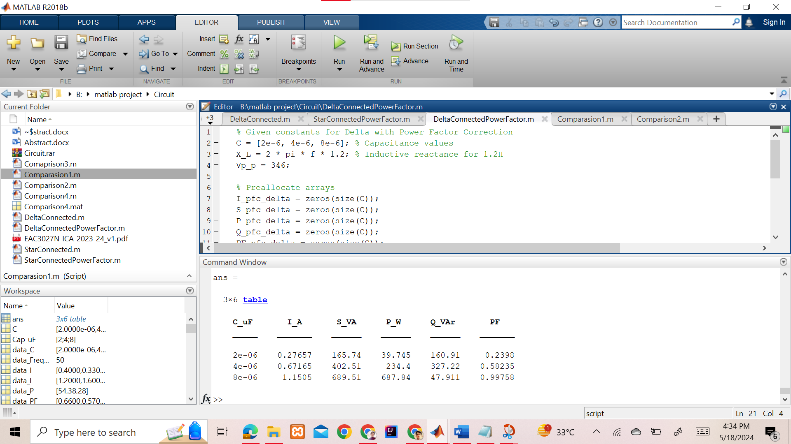

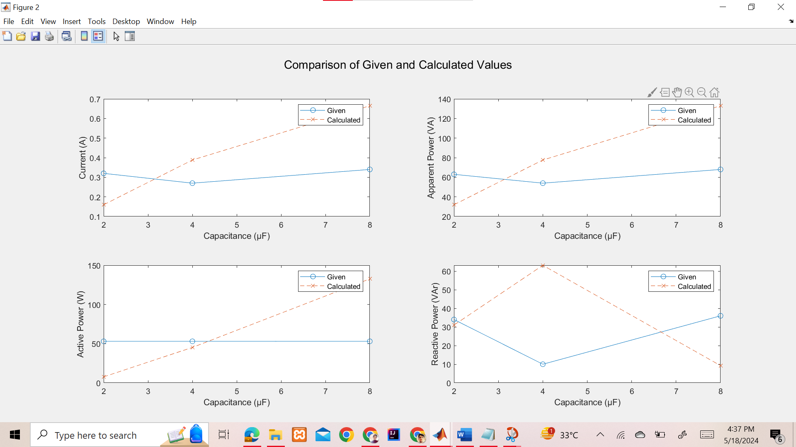

Delta Connected Load

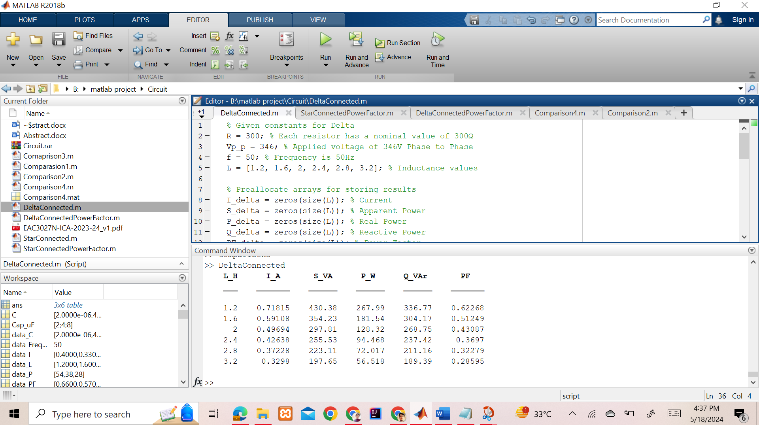

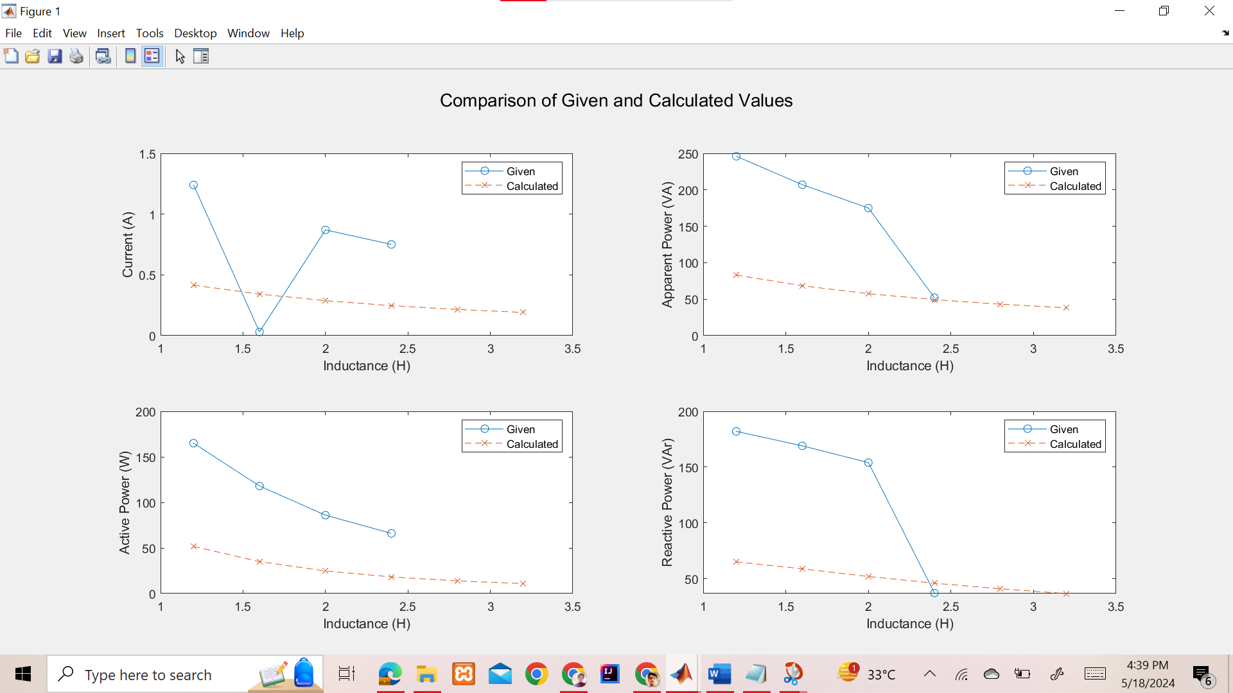

Delta Connected Load with Power Factor Correction

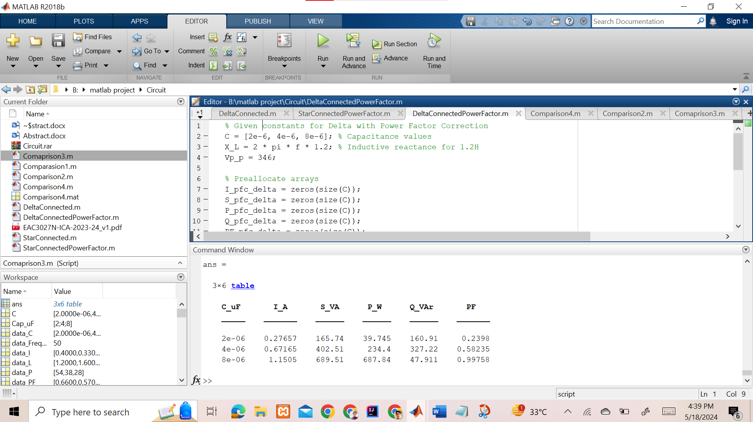

Comparision:

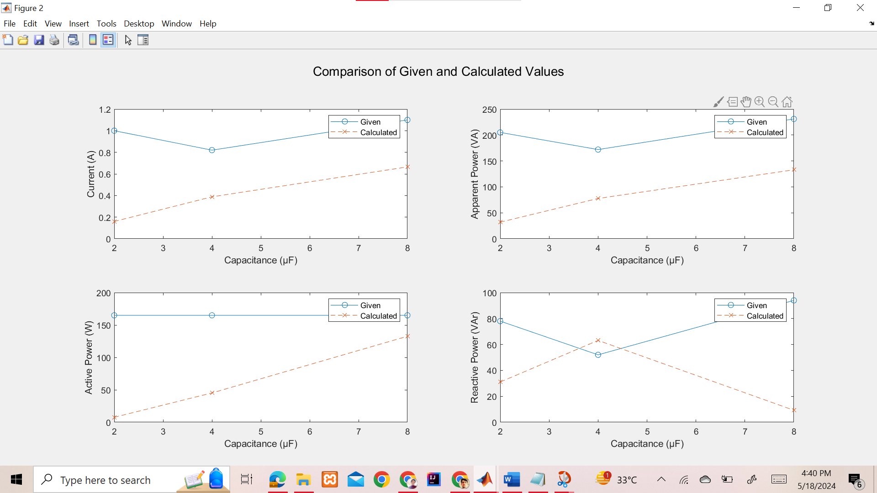

Source code :

Starconected.m:

% Given constants

R = 300;

Vp_n = 200;

f = 50;

L = [1.2, 1.6, 2, 2.4, 2.8, 3.2]; % Inductance values

% Preallocate arrays

I = zeros(size(L));

S = zeros(size(L));

P = zeros(size(L));

Q = zeros(size(L));

PF = zeros(size(L));

for k = 1:length(L)

X_L = 2 * pi * f * L(k);

Z = sqrt(R^2 + X_L^2); % Impedance

I(k) = Vp_n / Z; % Current

S(k) = Vp_n * I(k); % Apparent Power

P(k) = S(k) * (R / Z); % Real Power

Q(k) = sqrt(S(k)^2 - P(k)^2); % Reactive Power

PF(k) = P(k) / S(k); % Power Factor

end

% Display results

T = table(L', I', S', P', Q', PF', ...

'VariableNames', {'L_H', 'I_A', 'S_VA', 'P_W', 'Q_VAr', 'PF'});

disp(T);

StarConectedpower.m

% Given constants

R = 300; % Each resistor has a nominal value of 300?

f = 50; % Frequency is 50Hz

C = [2e-6, 4e-6, 8e-6]; % Capacitance values of the capacitor bank in parallel (initially 2uF, then 4uF, and 8uF)

X_L = 2 * pi * f * 1.2; % Inductive reactance for 1.2H inductor

Vp_n = 200; % Applied voltage of 200V Phase to Neutral

% Preallocate arrays for storing results

I_pfc = zeros(size(C)); % Current

S_pfc = zeros(size(C)); % Apparent Power

P_pfc = zeros(size(C)); % Real Power

Q_pfc = zeros(size(C)); % Reactive Power

PF_pfc = zeros(size(C)); % Power Factor

% Loop through each capacitance value

for k = 1:length(C)

% Calculate the capacitive reactance

X_C = 1 / (2 * pi * f * C(k));

% Calculate the total impedance

Z = sqrt(R^2 + (X_L - X_C)^2);

% Calculate the current

I_pfc(k) = Vp_n / Z;

% Calculate the apparent power

S_pfc(k) = Vp_n * I_pfc(k);

% Calculate the real power

P_pfc(k) = S_pfc(k) * (R / Z);

% Calculate the reactive power

Q_pfc(k) = sqrt(S_pfc(k)^2 - P_pfc(k)^2);

% Calculate the power factor

PF_pfc(k) = P_pfc(k) / S_pfc(k);

end

% Display results in a table

T = table(C' * 1e6, I_pfc', S_pfc', P_pfc', Q_pfc', PF_pfc', ...

'VariableNames', {'C_uF', 'I_A', 'S_VA', 'P_W', 'Q_VAr', 'PF'});

disp(T);

DeltaConnected.m

% Given constants for Delta

R = 300; % Each resistor has a nominal value of 300?

Vp_p = 346; % Applied voltage of 346V Phase to Phase

f = 50; % Frequency is 50Hz

L = [1.2, 1.6, 2, 2.4, 2.8, 3.2]; % Inductance values

% Preallocate arrays for storing results

I_delta = zeros(size(L)); % Current

S_delta = zeros(size(L)); % Apparent Power

P_delta = zeros(size(L)); % Real Power

Q_delta = zeros(size(L)); % Reactive Power

PF_delta = zeros(size(L)); % Power Factor

% Loop through each inductance value

for k = 1:length(L)

% Calculate the inductive reactance

X_L = 2 * pi * f * L(k);

% Calculate the impedance

Z = sqrt(R^2 + X_L^2);

% Calculate the current

I_delta(k) = Vp_p / Z;

% Calculate the apparent power (assuming balanced load and three-phase power)

S_delta(k) = sqrt(3) * Vp_p * I_delta(k);

% Calculate the real power

P_delta(k) = S_delta(k) * (R / Z);

% Calculate the reactive power

Q_delta(k) = sqrt(S_delta(k)^2 - P_delta(k)^2);

% Calculate the power factor

PF_delta(k) = P_delta(k) / S_delta(k);

end

% Display results in a table

T = table(L', I_delta', S_delta', P_delta', Q_delta', PF_delta', ...

'VariableNames', {'L_H', 'I_A', 'S_VA', 'P_W', 'Q_VAr', 'PF'});

disp(T);

DeltaPower.m

% Given constants for Delta with Power Factor Correction

C = [2e-6, 4e-6, 8e-6]; % Capacitance values

X_L = 2 * pi * f * 1.2; % Inductive reactance for 1.2H

Vp_p = 346;

% Preallocate arrays

I_pfc_delta = zeros(size(C));

S_pfc_delta = zeros(size(C));

P_pfc_delta = zeros(size(C));

Q_pfc_delta = zeros(size(C));

PF_pfc_delta = zeros(size(C));

for k = 1:length(C)

X_C = 1 / (2 * pi * f * C(k)); % Capacitive reactance

Z = sqrt(R^2 + (X_L - X_C)^2); % Total impedance

I_pfc_delta(k) = Vp_p / Z; % Current

S_pfc_delta(k) = sqrt(3) * Vp_p * I_pfc_delta(k); % Apparent Power

P_pfc_delta(k) = S_pfc_delta(k) * (R / Z); % Real Power

Q_pfc_delta(k) = sqrt(S_pfc_delta(k)^2 - P_pfc_delta(k)^2); % Reactive Power

PF_pfc_delta(k) = P_pfc_delta(k) / S_pfc_delta(k); % Power Factor

end

% Display results

table(C', I_pfc_delta', S_pfc_delta', P_pfc_delta', Q_pfc_delta', PF_pfc_delta', 'VariableNames', {'C_uF', 'I_A', 'S_VA', 'P_W', 'Q_VAr', 'PF'})