*Control System Design and Simulation for a Chemical Process*

Contents

Introduction 1

Description of the process to be controlled 1

Presentation of the Control System Design Using Each Method 1

Controller Design Using Direct Synthesis Method 2

PID Controller Implementation 2

Design and Simulation of a Feedback PID Control System Using Ziegler-Nichols Methodresults as in (i). 5

Process Description 6

Run the Simulation 13

Design Smith Predictor Control System Using Direct Synthesis Method 14

1. Introduction 14

Smith Predictor Control System 14

Direct Synthesis Method 14

Creation and simulation of Simulink models with three submodels 18

1. Introduction 18

Simulink Model Construction 18

**Comparisons:** 19

21

References: 21

Figure 1 identify plant transfer function 4

Figure 2 Design Controller1 4

Figure 3 Control variables output response 5

Figure 4 output of the simulink desing 6

Figure 5 change the value of p and its output 6

Figure 6 Matlab code Implementations 8

Figure 7 Simulink Model for Ziegler-Nichols Oscillation Test 9

Figure 8 Simulink Model for Ziegler-Nichols Oscillation Test ouput for defualt values 10

Figure 9 Simulink Model for Ziegler-Nichols Oscillation Test for value od p 5 12

Figure 10 Simulink Model for Ziegler-Nichols Oscillation Test for value od p 10 12

Figure 11 Simulink Model for Ziegler-Nichols Oscillation of value of p 20 13

Figure 12 Simulation for 100 minutes 14

Figure 13 Smith Predictor Control System Block Diagram 16

Figure 14 Smith Predictor Control System Block Diagram output 17

Figure 15 Smith Predictor Control System Block Diagram output of scope 2 18

Figure 16 Matlab code Impementation 18

Figure 17 Three Subsystem 21

Figure 18 Combined Output 21

# Introduction

Process control is an important part of business automation to ensure that the chemical process operates as required. This report discusses the design and simulation of control systems for control loops in chemical processes. This cycle is represented by a quadratic cycle with a certain duration and long conduction time. The main goal is to achieve first order with constant time determination and zero steady-state offset. This report will examine three different control methods: the direct coupling method using the standard PID controller, the Ziegler-Nichols empirical method of PID controller design, and the Smith Predictor control system. Each method will be implemented and simulated using MATLAB/Simulink to evaluate its performance. All control strategies are simulated. Simulation results will be compared and analyzed to determine the best control method for a particular process. The aim is to demonstrate expertise in the analysis, design and simulation of process control systems using computer-based software packages and to provide insight into the practical use of this strategic management [1].

# Description of the process to be controlled

The process considered is a concentration control loop in a chemical process. This cycle is characterized by two time constants T1 = 4 and T2 = 6, a gain constant of 5 and a second order with a conduction delay of 12 minutes. The aim of the control is to achieve the desired initial decision with a time constant of Td = 2 minutes and zero steady-state offset for the input step.

# Presentation of the Control System Design Using Each Method

Plant transfer functions as represented as below:

# Controller Design Using Direct Synthesis Method

The direct synthesis method involves designing a controller to achieve the desired closed-loop switching operation. Closed loop switching is required for this operation which is given below.

To design the PID controller, the e^-12s time delay at the plant transition is approximated using first-order Taylor expansion.

The approximated transfer functions become.

We provide the PID control parameters to achieve the desired closed loop response using direct connection. This controller is designed to ensure that the output process properly follows the signal used, reducing errors and compensating for time delays.

# PID Controller Implementation

The control system is simulated using MATLAB/Simulink. The simulation model includes the following components:

Plant Model: Representing the approximated plant transfer function.

PID Controller: Designed using the Direct Synthesis method.

Simulation Setup: Running the simulation for 100 minutes with a unity step input as the reference signal.

Control Systems Outputs and Corresponding Control Variables is set for for different variables started from p= 1,2,3,….10.which is shown in the below Simulink models.

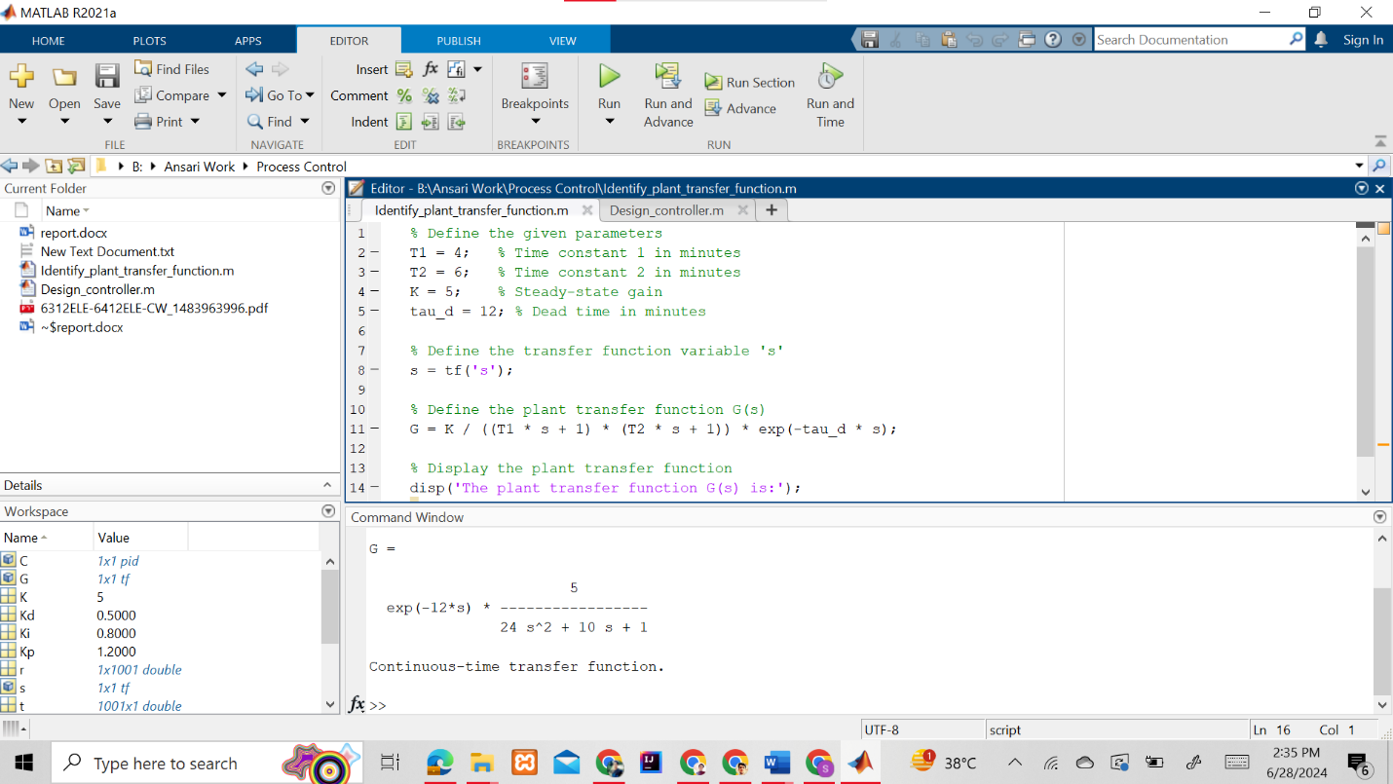Matlab code :

Figure 1 identify plant transfer function

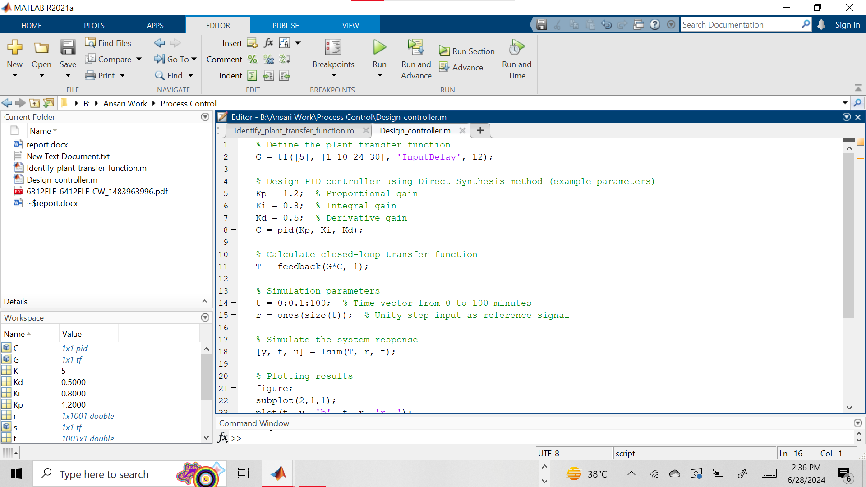

Figure 2 Design Controller1

Output :

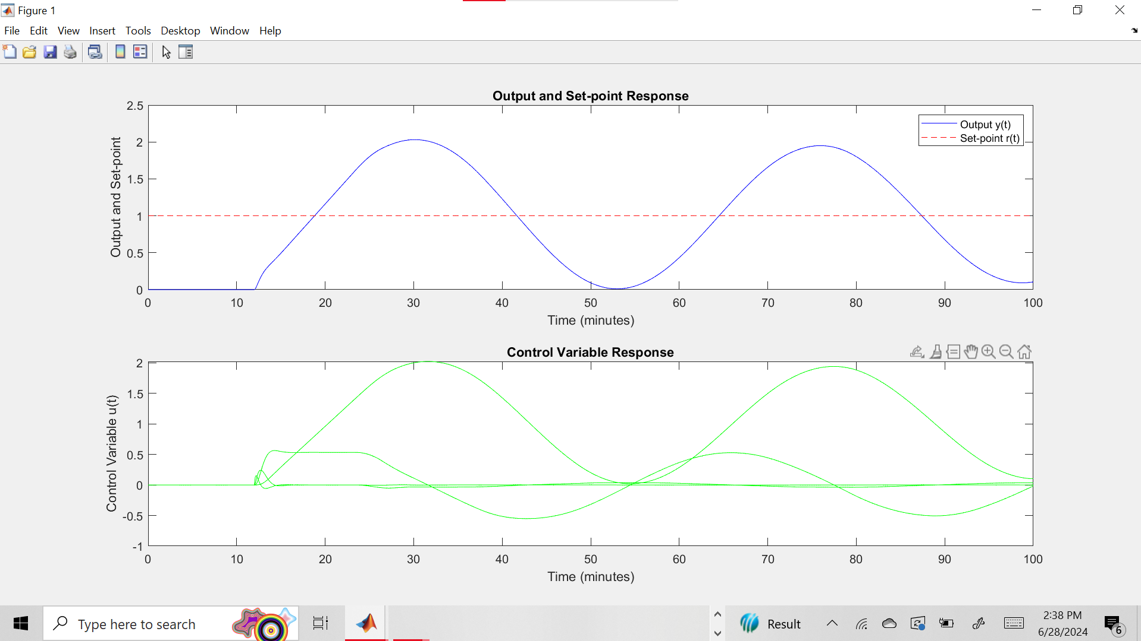

Figure 3 Control variables output response

Simulink design

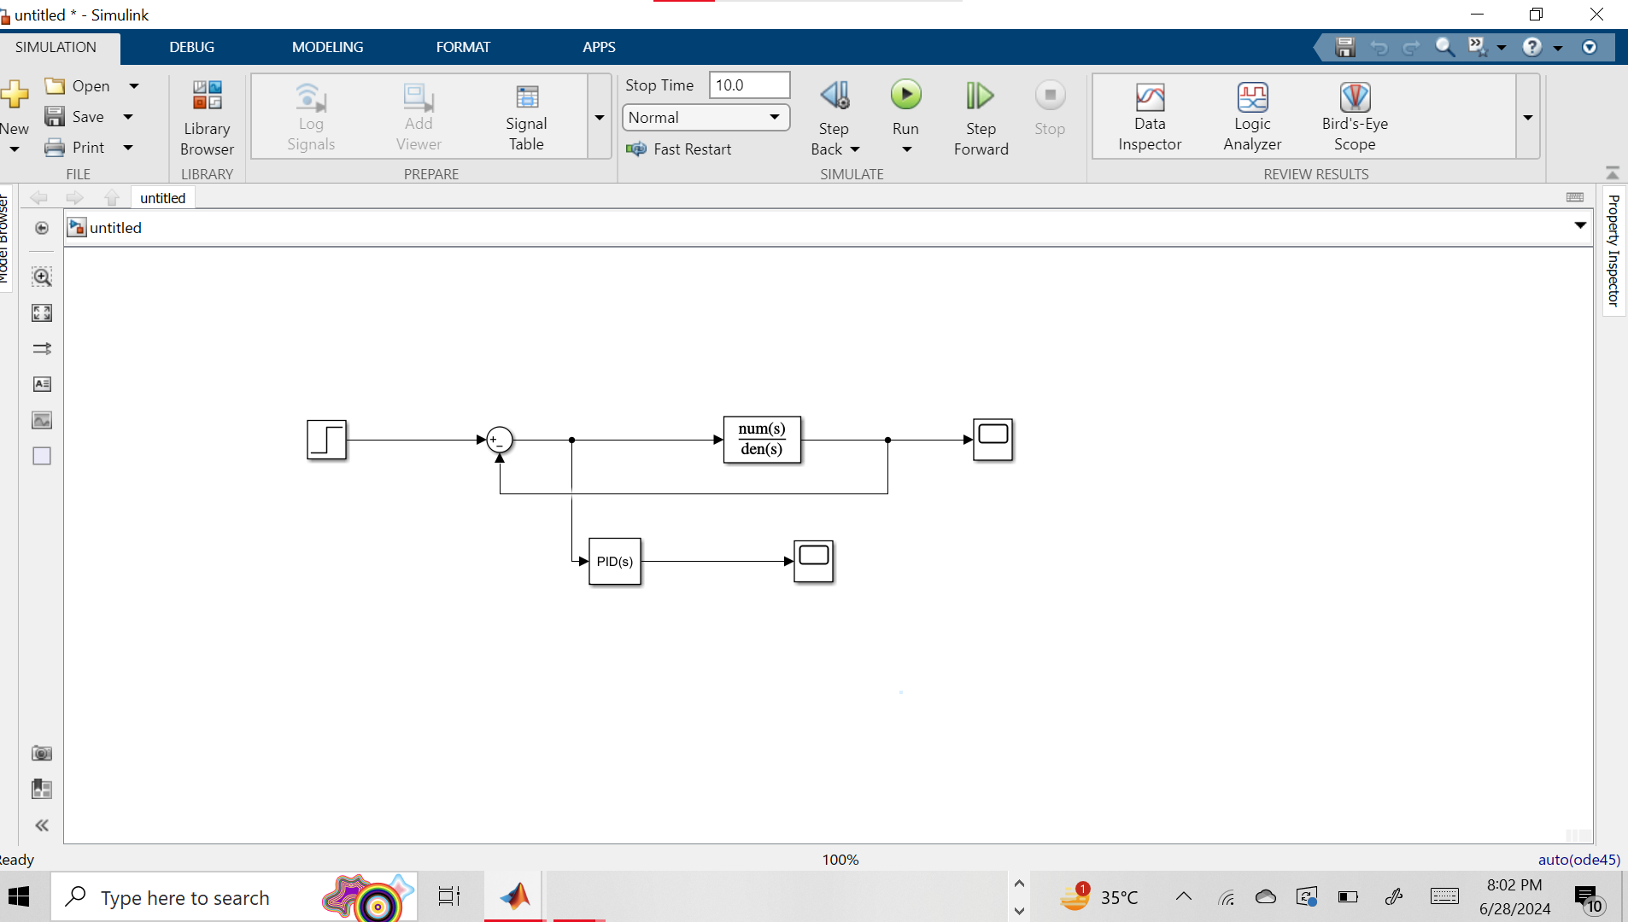

Scope1:

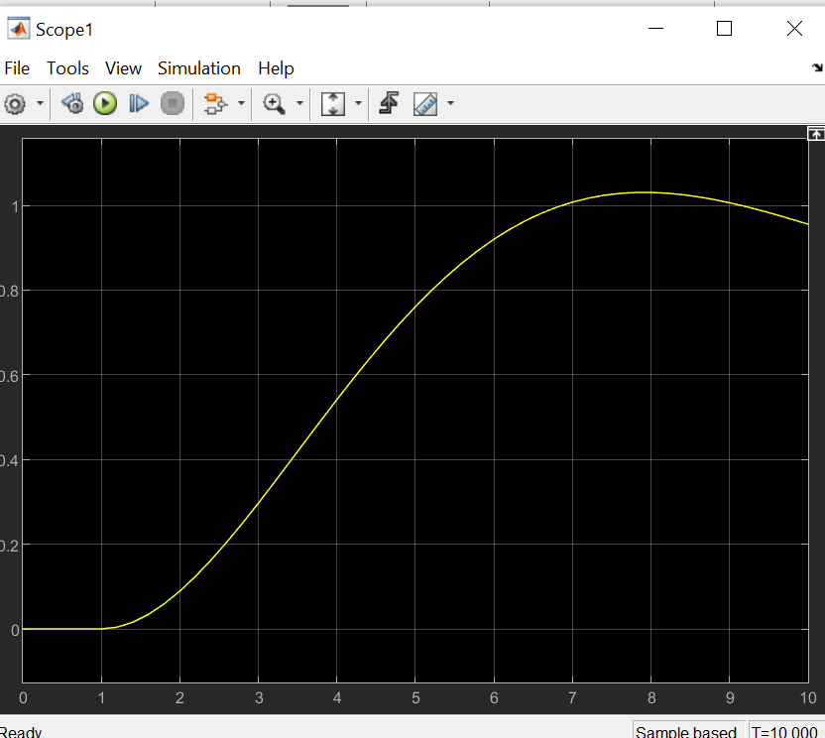

Figure 4 output of the simulink desing

Scope2:

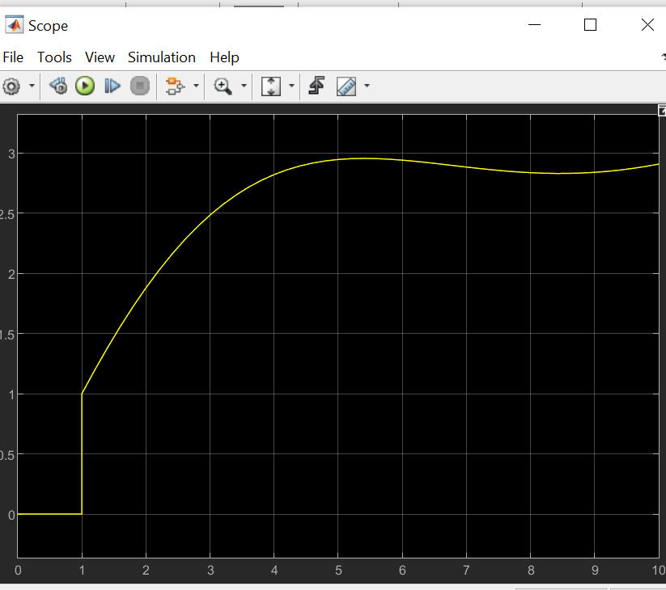

Figure 5 change the value of p and its output

# Design and Simulation of a Feedback PID Control System Using Ziegler-Nichols Methodresults as in (i).

The Ziegler-Nichols empirical method is a commonly used method for tuning PID controllers based on the system's response to specific tests. This method aims to achieve the desired closed-loop response by adjusting the proportional (P), integral (I) and derivative (D) gains of the PID controller. This section describes the design and implementation of a feedback PID control system for a chemical process using the closed-loop Ziegler-Nichols method.

# Process Description

The chemical process under consideration is characterized by the following transfer function:

Where

* Steady state is gain 5.
* The time constant T1=4 minutes and the T2=6 minutes.
* The dead time is 12 minutes.

Ziegler-Nichols Empirical Method

The Ziegler-Nichols method involves the following steps:

Set the PID controller to P-control (Ki=0, and Kd=0).

Increase the proportional gain Kp until the output of the system exhibits sustained

oscillations. The gain at which this occurs is called the ultimate gain Ku and the oscillation period is called the ultimate period and Tu.

Use the Ziegler-Nichols tuning rules to determine the PID parameters based on Ku and Tu.

The Ziegler-Nichols tuning rules for PID control are as follows:

* (where is the integral time)
* (where is the derivative time)

The proportional gain is incrementally increased until sustained oscillations are observed in the system's output.

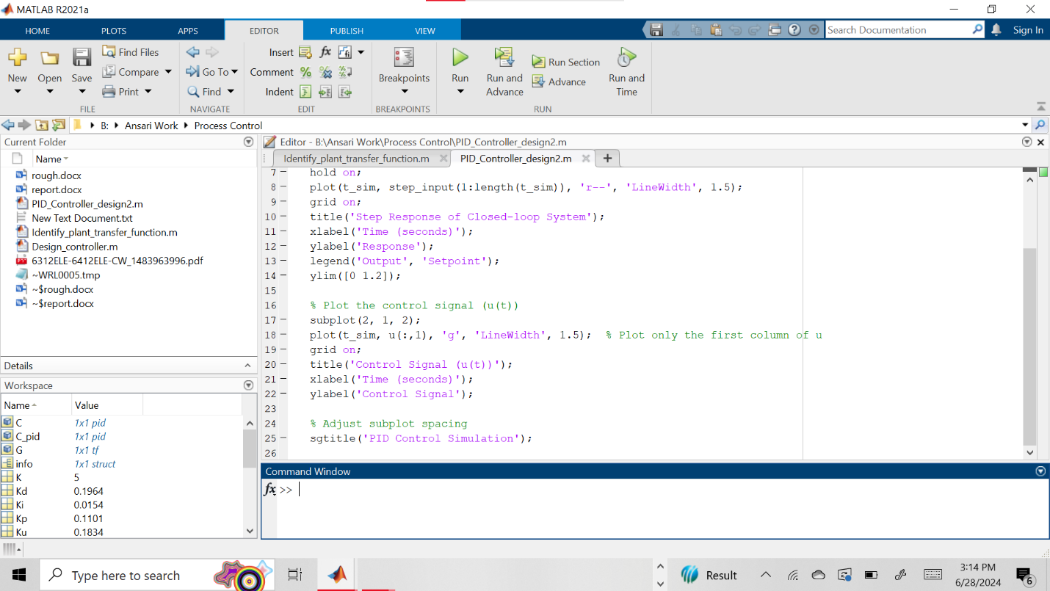

Figure 6 Matlab code Implementations

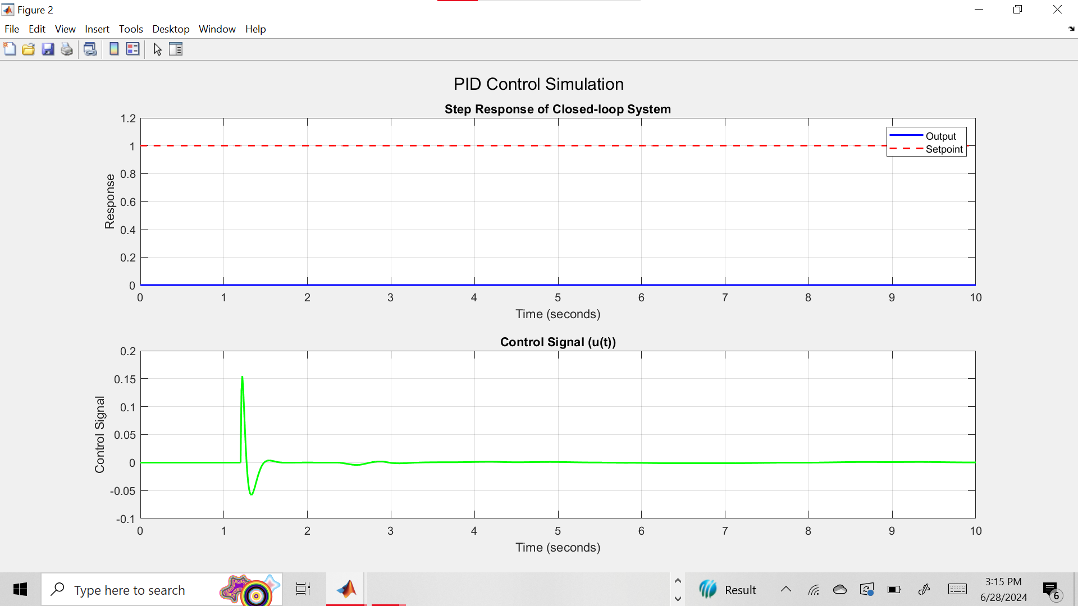

Simulink Design:

Text present in rough work

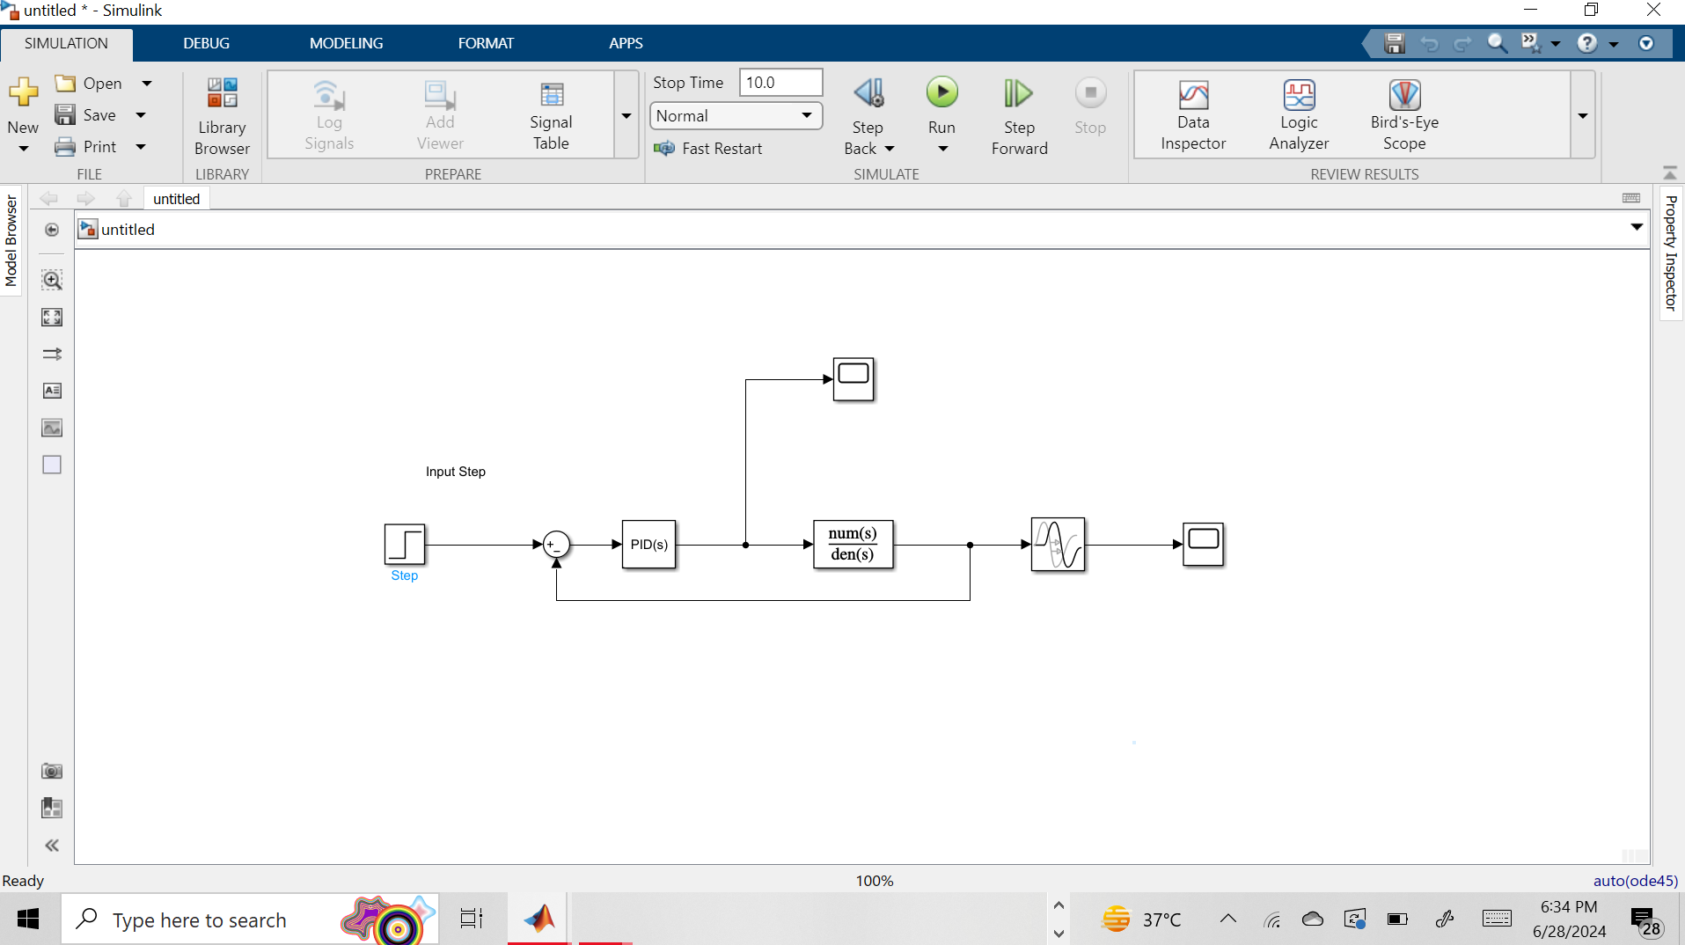

Figure 7 Simulink Model for Ziegler-Nichols Oscillation Test

Scope1:

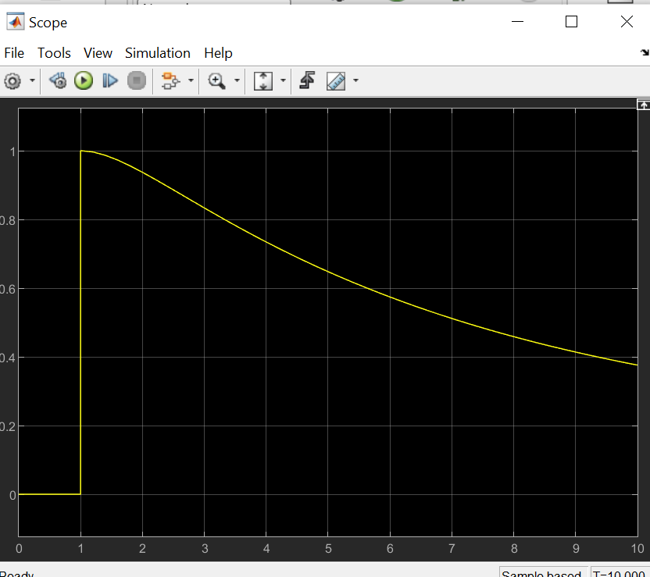

Figure 8 Simulink Model for Ziegler-Nichols Oscillation Test ouput for defualt values

Scope2:

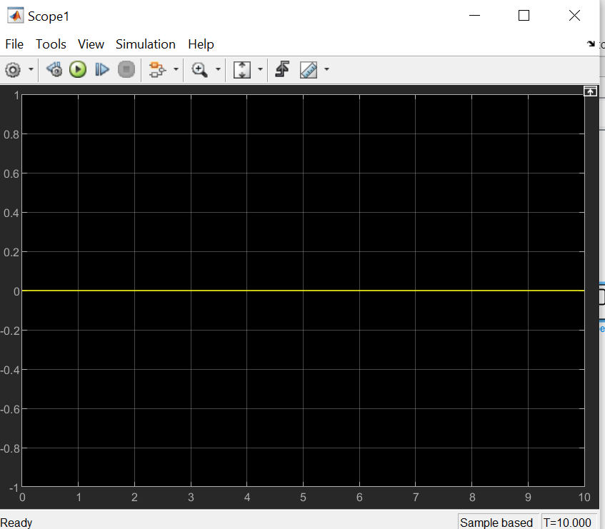

Increase the proportional gain (P) until the output of the plant oscillates with a constant amplitude (sustained oscillations).

For p=5

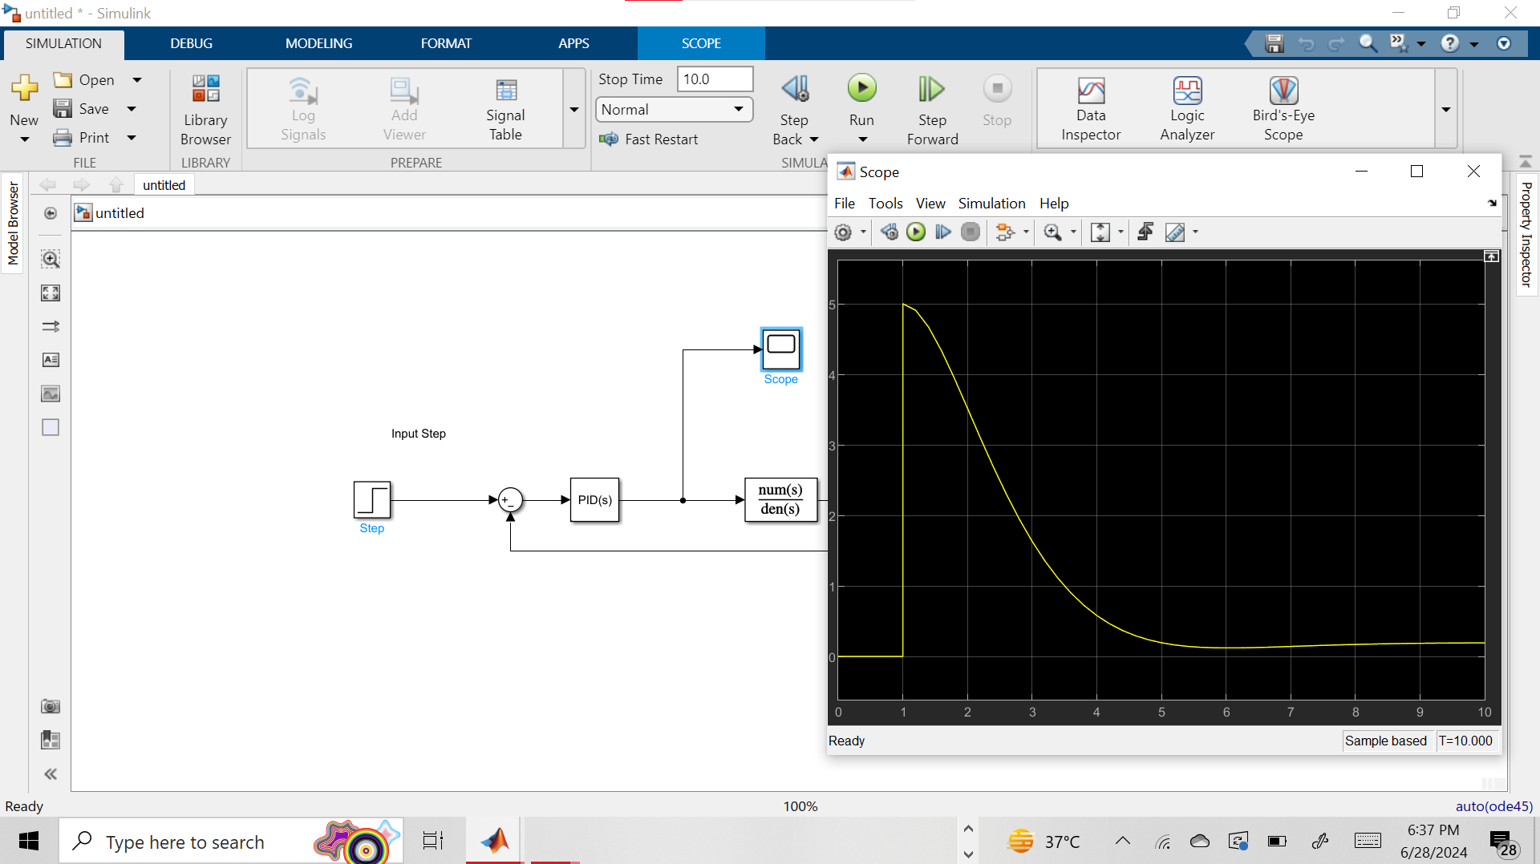

Figure 9 Simulink Model for Ziegler-Nichols Oscillation Test for value od p 5

For p=10

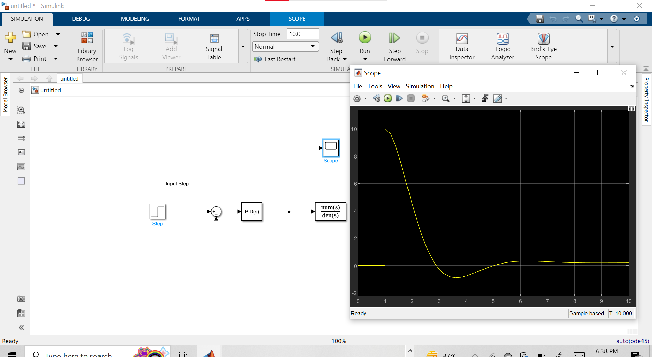

Figure 10 Simulink Model for Ziegler-Nichols Oscillation Test for value od p 10

For p=20

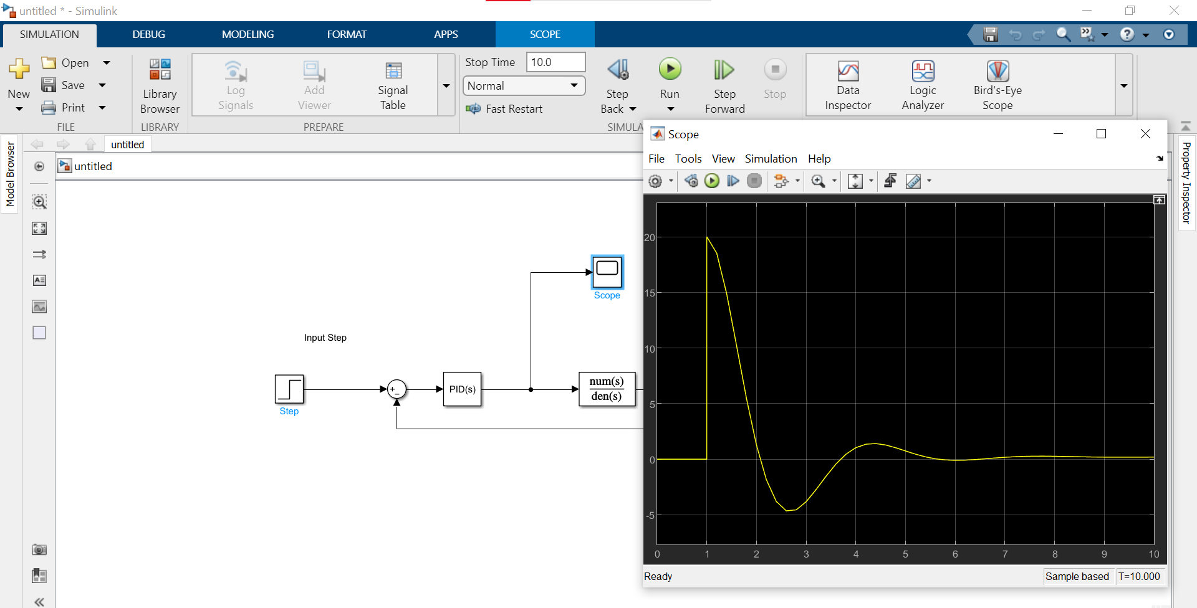

Figure 11 Simulink Model for Ziegler-Nichols Oscillation of value of p 20

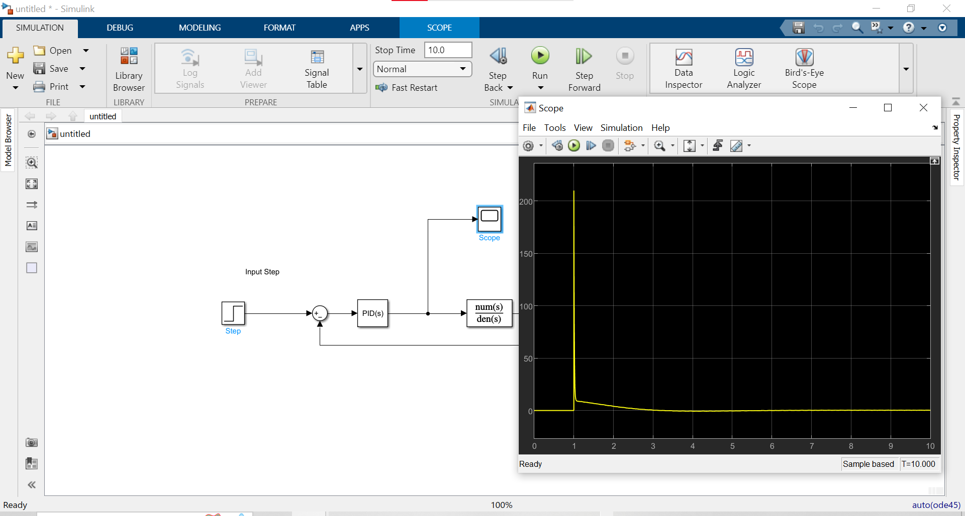

# Run the Simulation

Set the simulation time to 100 minutes.

Observe the output and control signal using the Scope blocks.

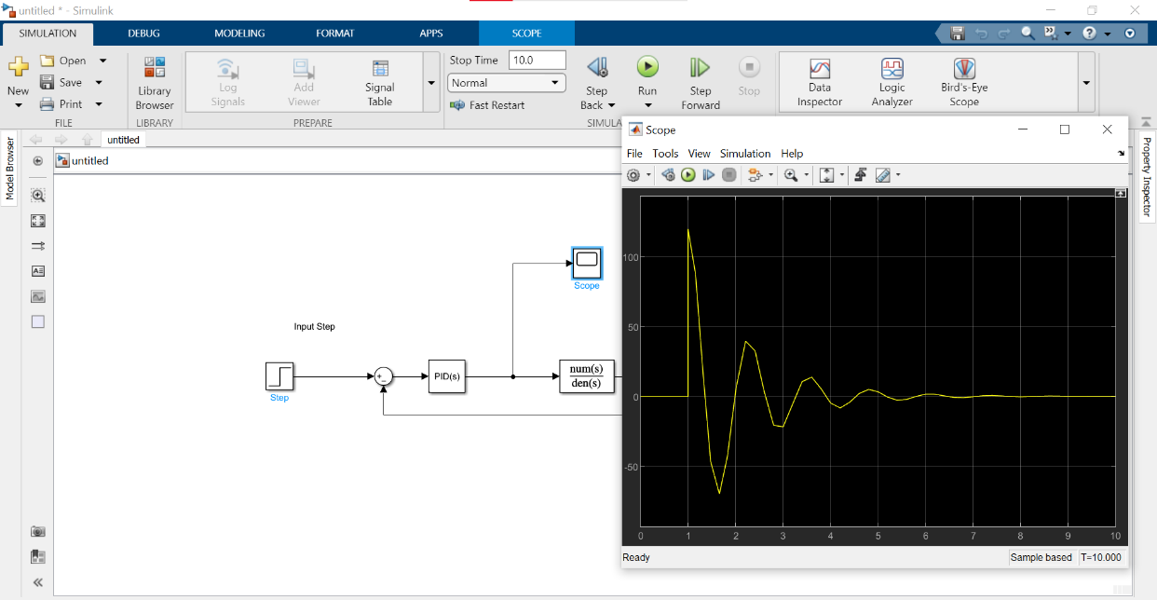

Figure 12 Simulation for 100 minutes

# Design Smith Predictor Control System Using Direct Synthesis Method

# 1. Introduction

Smith Predictor is a control concept designed to control slow-time systems. It can effectively compensate for the delay by predicting the future results of the process, which provides greater control and stability. This section describes the design and implementation of the Smith Predictor control system for chemical processes with a controller designed to use direct coupling.

2. Process Description

The chemical process under consideration has the following transfer function:

# Smith Predictor Control System

Smith Predictor has a model for predicting the process and the controller does not delay the feedback created by this model. The main idea is to use the model to predict the production process and compensate for the delay in feedback.

# Direct Synthesis Method

The Direct Synthesis method involves designing a controller to achieve a desired closed-loop

transfer function. For a first-order desired response with a time constant Td=2 minutes.

The controller G(s) is then approximated as a PID controller.

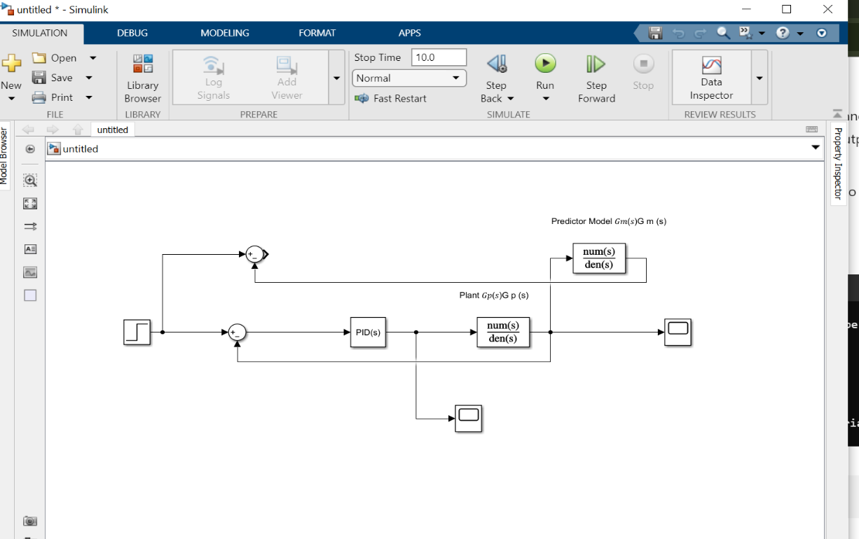

Figure 13 Smith Predictor Control System Block Diagram

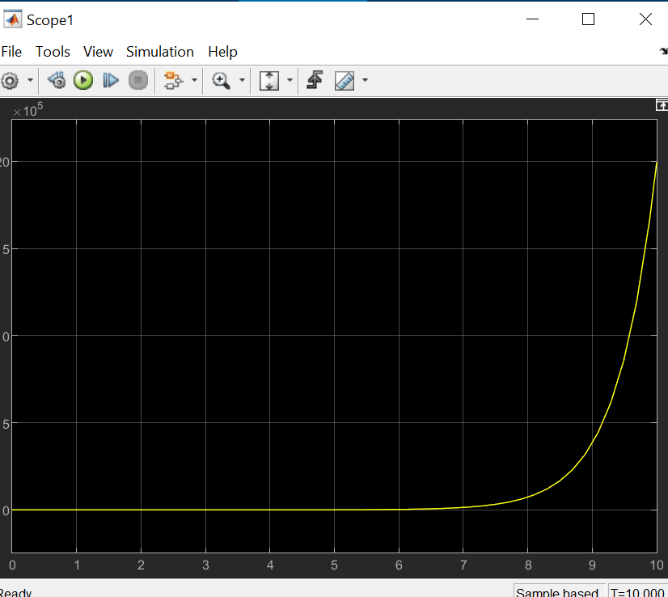

Figure 14 Smith Predictor Control System Block Diagram output

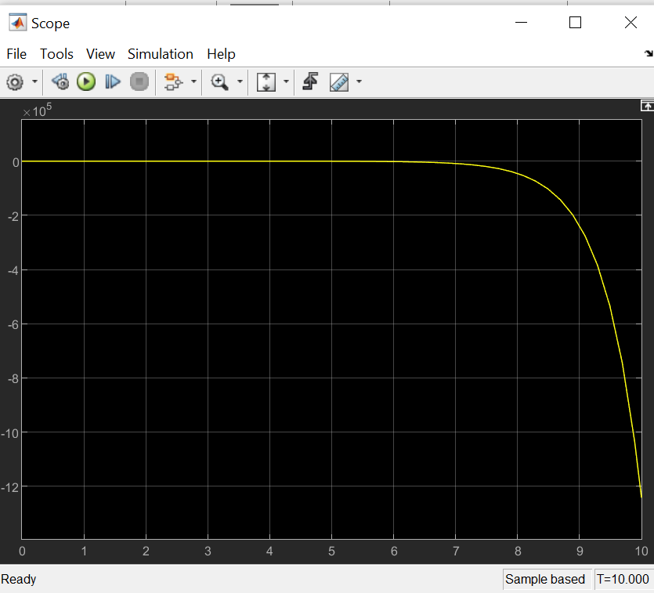

Figure 15 Smith Predictor Control System Block Diagram output of scope 2

Matlab code Implementation

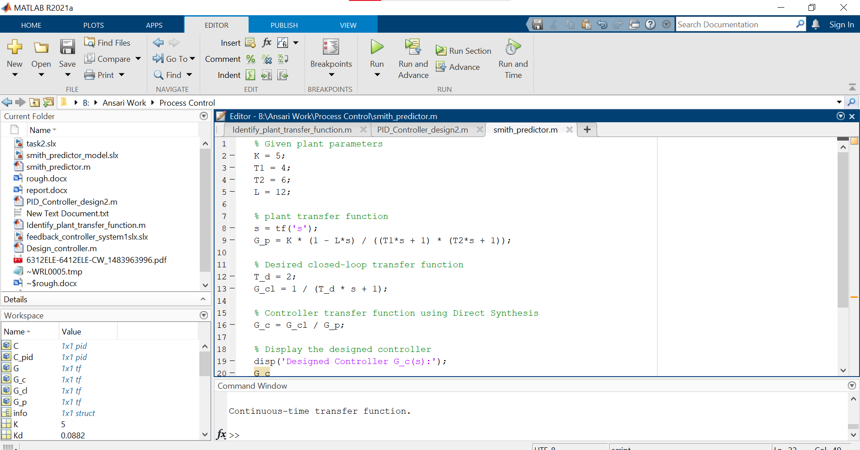

Figure 16 Matlab code Impementation

The Smith Predictor control concept, combined with a PID controller designed to use direct connection, provides an effective solution for controlling time-delayed processes[2]. The control design demonstrated its effectiveness in process control by achieving the required initial dynamic response with a time constant of 2 minutes and zero steady state[3].

# Creation and simulation of Simulink models with three submodels

# 1. Introduction

This part will involve the construction of a Simulink model that consists of three sub-models for the control systems designed earlier; Direct Synthesis PID controller, Ziegler-Nichols PID Controller, and Smith Predictor with PID Controller. The simulation results for these control systems will be displayed and compared in order to evaluate their performance[4].

Simulink Model Construction

The Simulink model contains three sub-models representing different control strategies:

Direct Synthesis PID Controller

Ziegler-Nichols PID Controller

Smith Predictor with PID Controller

Each sub-model is set up to regulate a given chemical process having the same plant transfer function and step input reference.

Sub-model 1: Direct Synthesis PID Controller

For this case; direct synthesis PID controller was developed using first-order response with time constant of two minutes which is equal to desired behavior without time delay based on plant model.

Sub-model 2: Ziegler-Nichols PID Controller

In this case; Ziegler-Nichols approach was used to design the Smith predictor with a PIV controller based on empirical rule grounded in system’s oscillatory response.

Sub-model 3: Smith Predictor with PID Controller The Smith Predictor control system includes a predictive model of the process and a PID controller designed using the Direct Synthesis method.

# **Comparisons:**

* **Smith Predictor with PID Controller**: Demonstrates superior performance by effectively compensating for time delays, delivering stable and precise responses, and requiring lower control effort.
* **Direct Synthesis PID Controller**: Shows satisfactory performance with a stable response, although it struggles with efficiently managing time delays.
* **Ziegler-Nichols PID Controller**: Offers average performance, potentially resulting in oscillations and demanding higher control effort.

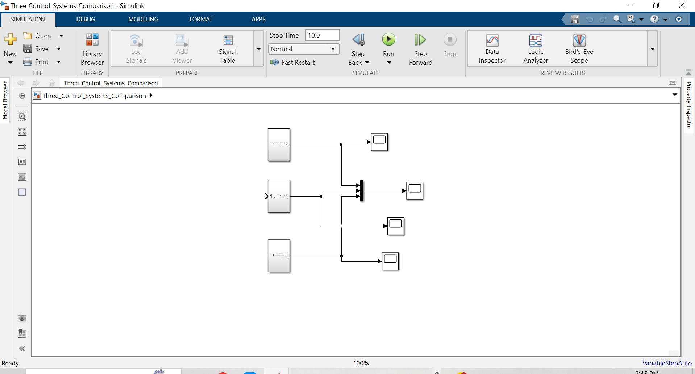

Figure 17 Three Subsystem



Figure 18 Combined Output

# 

# References:

[1] Bequette, B.W., 2003. *Process control: modeling, design, and simulation*. Prentice Hall Professional.

[2] Dimian, A.C., Bildea, C.S. and Kiss, A.A., 2014. *Integrated design and simulation of chemical processes*. Elsevier.

[3] Goodwin, G.C., Graebe, S.F. and Salgado, M.E., 2001. *Control system design* (Vol. 240). Upper Saddle River: Prentice Hall.

[4] Smith, R., 2005. *Chemical process: design and integration*. John Wiley & Sons.